Vulkan Lab 4 – Lighting Fundamentals (Vulkan 1.3)

SMART Objectives
- Understand a Core Lighting Model: Explain and implement the components of the reflection models (Ambient, Diffuse, and Specular).
- Model Lights and Materials: Represent light sources (position, colour) and surface material properties (reflectivity) in your data structures and shaders.
- Work with Vertex Normals: Understand the critical role of normal vectors in lighting and how to correctly add them to your vertex data and input layout.
- Compare Lighting Techniques: Differentiate between the principles and visual results of per-vertex and per-pixel lighting.
- Pass Data to the Fragment Shader: Configure your vertex shader to pass interpolated data

(like world position and normals) to the fragment shader for high-quality, per-pixel calculations

Completed Tasks

Exercise 1. Preparing for Lighting

Output

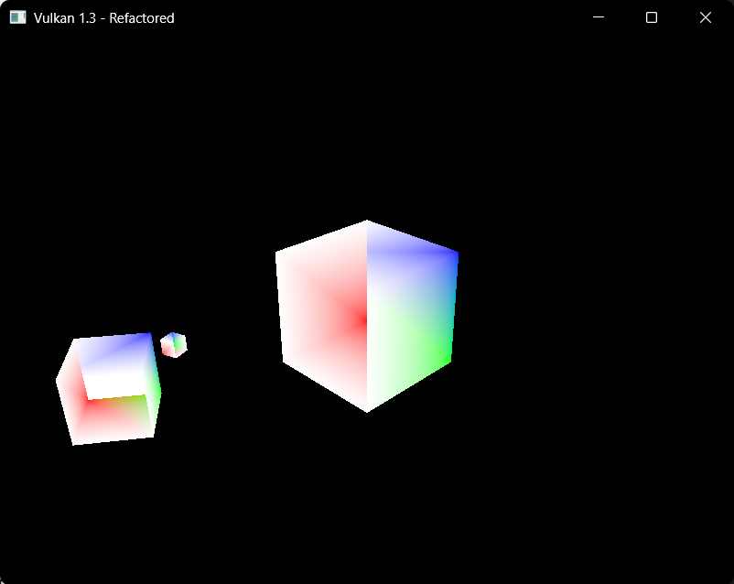

Code

struct Vertex {
glm::vec3 pos;
glm::vec3 color;
glm::vec3 normal;

static VkVertexInputBindingDescription getBindingDescription() {
VkVertexInputBindingDescription bindingDescription{};
bindingDescription.binding = 0;
bindingDescription.stride = sizeof(Vertex);
bindingDescription.inputRate = VK_VERTEX_INPUT_RATE_VERTEX;
return bindingDescription;
}
//normal attribute description
static std::array<VkVertexInputAttributeDescription, 3> getAttributeDescriptions() {
std::array<VkVertexInputAttributeDescription, 3> attributeDescriptions{};
attributeDescriptions[0] = { 0, 0, VK_FORMAT_R32G32B32_SFLOAT, offsetof(Vertex, pos) };
attributeDescriptions[1] = { 1, 0, VK_FORMAT_R32G32B32_SFLOAT, offsetof(Vertex, color) };
attributeDescriptions[2] = { 2, 0, VK_FORMAT_R32G32B32_SFLOAT, offsetof(Vertex, normal) };
return attributeDescriptions;
}

};

struct UniformBufferObject {
alignas(16) glm::mat4 model;
alignas(16) glm::mat4 view;
alignas(16) glm::mat4 proj;
alignas(16) glm::vec3 lightPos;
alignas(16) glm::vec3 eyePos;
};

Shader.vert

layout(binding = 0) uniform UniformBufferObject {
mat4 model;
mat4 view;
mat4 proj;
vec3 lightPos;
vec3 eyePos;
} ubo;

Reflection

In this exercise it was more so adding the pre-requisites to calculate lighting. In order to do this in the vertex struct we add a vector for normals, and we modify the vkIndexDescription so in order to add normals there as well. In the ubo struct there’s two more vectors that are added for the light and eye pos which is later on modified in the vertex shader.

Although, the output hasn’t change It’s because all these variables aren’t really used at the moment since we are not calculating lighting and it will be done in the later exercises this is mainly the set up for it really.

Exercise 2. Per-Vertex Diffuse Lighting

Output

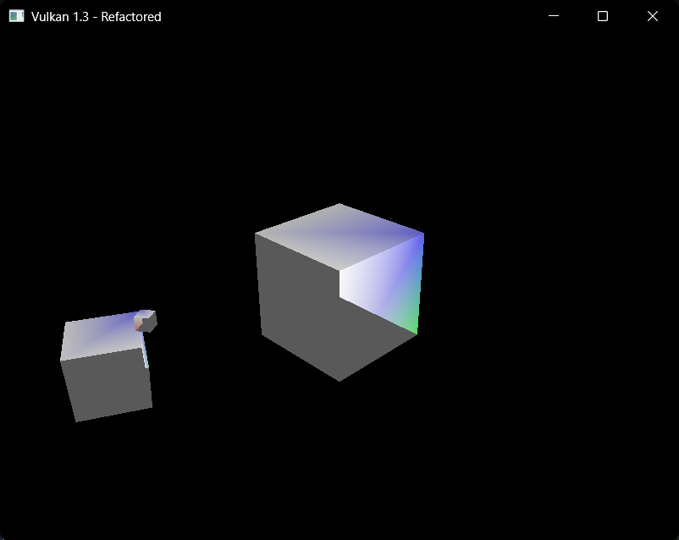

Different lighting

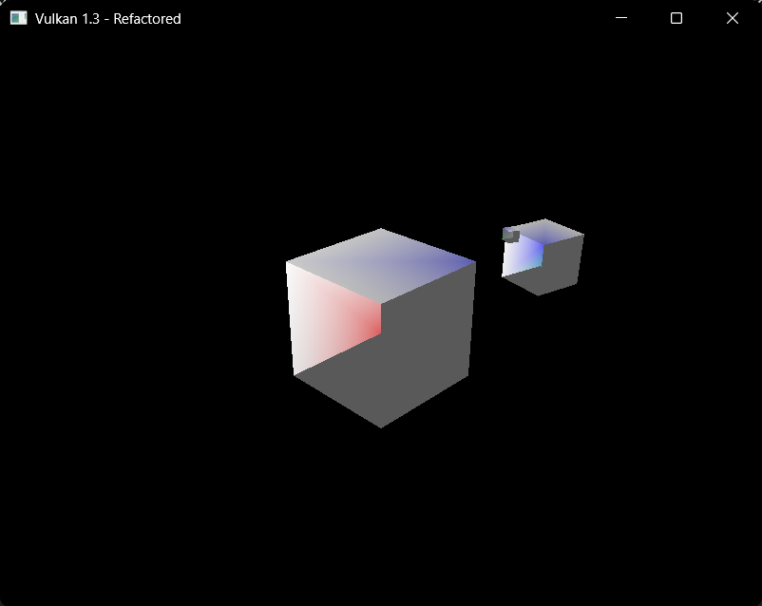

Code

Main code

//hard coded cube: verticies

std::vector<Vertex> vertices = {

//front face

// front face +z

{ { -0.5f, -0.5f, 0.5f },{ 1.0f, 0.0f, 0.0f },{ 0.0f, 0.0f, 1.0f } },

{ { 0.5f, -0.5f, 0.5f },{ 0.0f, 1.0f, 0.0f },{ 0.0f, 0.0f, 1.0f } },

{ { 0.5f, 0.5f, 0.5f },{ 0.0f, 0.0f, 1.0f },{ 0.0f, 0.0f, 1.0f } },

{ { -0.5f, -0.5f, 0.5f },{ 1.0f, 0.0f, 0.0f },{ 0.0f, 0.0f, 1.0f } },

{ { 0.5f, 0.5f, 0.5f },{ 0.0f, 0.0f, 1.0f },{ 0.0f, 0.0f, 1.0f } },

{ { -0.5f, 0.5f, 0.5f },{ 1.0f, 1.0f, 1.0f },{ 0.0f, 0.0f, 1.0f } },

// back face -z

{ { 0.5f, -0.5f, -0.5f },{ 0.0f, 1.0f, 0.0f },{ 0.0f, 0.0f, -1.0f } },

{ { -0.5f, -0.5f, -0.5f },{ 1.0f, 0.0f, 0.0f },{ 0.0f, 0.0f, -1.0f } },

{ { -0.5f, 0.5f, -0.5f },{ 1.0f, 1.0f, 1.0f },{ 0.0f, 0.0f, -1.0f } },

{ { 0.5f, -0.5f, -0.5f },{ 0.0f, 1.0f, 0.0f },{ 0.0f, 0.0f, -1.0f } },

{ { -0.5f, 0.5f, -0.5f },{ 1.0f, 1.0f, 1.0f },{ 0.0f, 0.0f, -1.0f } },

{ { 0.5f, 0.5f, -0.5f },{ 0.0f, 0.0f, 1.0f },{ 0.0f, 0.0f, -1.0f } },

// left face -x

{ { -0.5f, -0.5f, -0.5f },{ 1.0f, 0.0f, 0.0f },{ -1.0f, 0.0f, 0.0f } },

{ { -0.5f, -0.5f, 0.5f },{ 1.0f, 1.0f, 1.0f },{ -1.0f, 0.0f, 0.0f } },

{ { -0.5f, 0.5f, 0.5f },{ 1.0f, 1.0f, 1.0f },{ -1.0f, 0.0f, 0.0f } },

{ { -0.5f, -0.5f, -0.5f },{ 1.0f, 0.0f, 0.0f },{ -1.0f, 0.0f, 0.0f } },

{ { -0.5f, 0.5f, 0.5f },{ 1.0f, 1.0f, 1.0f },{ -1.0f, 0.0f, 0.0f } },

{ { -0.5f, 0.5f, -0.5f },{ 1.0f, 1.0f, 1.0f },{ -1.0f, 0.0f, 0.0f } },

// right face +x

{ { 0.5f, -0.5f, 0.5f },{ 1.0f, 1.0f, 1.0f },{ 1.0f, 0.0f, 0.0f } },

{ { 0.5f, -0.5f, -0.5f },{ 0.0f, 1.0f, 0.0f },{ 1.0f, 0.0f, 0.0f } },

{ { 0.5f, 0.5f, -0.5f },{ 0.0f, 0.0f, 1.0f },{ 1.0f, 0.0f, 0.0f } },

{ { 0.5f, -0.5f, 0.5f },{ 1.0f, 1.0f, 1.0f },{ 1.0f, 0.0f, 0.0f } },

{ { 0.5f, 0.5f, -0.5f },{ 0.0f, 0.0f, 1.0f },{ 1.0f, 0.0f, 0.0f } },

{ { 0.5f, 0.5f, 0.5f },{ 1.0f, 1.0f, 1.0f },{ 1.0f, 0.0f, 0.0f } },

// top face +y

{ { -0.5f, 0.5f, 0.5f },{ 1.0f, 1.0f, 1.0f },{ 0.0f, 1.0f, 0.0f } },

{ { 0.5f, 0.5f, 0.5f },{ 1.0f, 1.0f, 1.0f },{ 0.0f, 1.0f, 0.0f } },

{ { 0.5f, 0.5f, -0.5f },{ 0.0f, 0.0f, 1.0f },{ 0.0f, 1.0f, 0.0f } },

{ { -0.5f, 0.5f, 0.5f },{ 1.0f, 1.0f, 1.0f },{ 0.0f, 1.0f, 0.0f } },

{ { 0.5f, 0.5f, -0.5f },{ 0.0f, 0.0f, 1.0f },{ 0.0f, 1.0f, 0.0f } },

{ { -0.5f, 0.5f, -0.5f },{ 1.0f, 1.0f, 1.0f },{ 0.0f, 1.0f, 0.0f } },

// Bottom face -y

{ { -0.5f, -0.5f, -0.5f },{ 1.0f, 0.0f, 0.0f },{ 0.0f, -1.0f, 0.0f } },

{ { 0.5f, -0.5f, -0.5f },{ 0.0f, 1.0f, 0.0f },{ 0.0f, -1.0f, 0.0f } },

{ { 0.5f, -0.5f, 0.5f },{ 1.0f, 1.0f, 1.0f },{ 0.0f, -1.0f, 0.0f } },

{ { -0.5f, -0.5f, -0.5f },{ 1.0f, 0.0f, 0.0f },{ 0.0f, -1.0f, 0.0f } },

{ { 0.5f, -0.5f, 0.5f },{ 1.0f, 1.0f, 1.0f },{ 0.0f, -1.0f, 0.0f } },

{ { -0.5f, -0.5f, 0.5f },{ 1.0f, 1.0f, 1.0f },{ 0.0f, -1.0f, 0.0f } }

};

//cube indicies

std::vector<uint32_t> indices = {

0,1,2,3,4,5,

6,7,8,9,10,11,

12,13,14,15,16,17,

18,19,20,21,22,23,

24,25,26,27,28,29,

30,31,32,33,34,35

};

Shader.vert

#version 450

layout(binding = 0) uniform UniformBufferObject {

mat4 model;

mat4 view;

mat4 proj;

vec3 lightPos;

vec3 eyePos;

} ubo;

layout(push_constant) uniform PushConstants {

mat4 model;

} pushConstants;

layout(location = 0) in vec3 inPosition;

layout(location = 1) in vec3 inColor;

layout(location = 2) in vec3 inNormal;

layout(location = 0) out vec3 fragColor;

void main()

{

vec3 worldPos = (pushConstants.model * vec4(inPosition, 1.0)).xyz;

vec3 worldNormal = mat3(transpose(inverse(pushConstants.model))) * inNormal;

vec3 lightColor = vec3(1.0f, 1.0f, 1.0f);

vec3 ambientMaterial = vec3(0.1f, 0.2f, 0.1f);

vec3 normal = normalize(worldNormal);

vec3 lightDir = normalize(ubo.lightPos - worldPos);

float diff = max(dot(normal, lightDir), 0.0);

vec3 diffuse = diff * lightColor;

fragColor = ambientMaterial * lightColor;

fragColor += inColor * diffuse;

gl_Position =

ubo.proj *

ubo.view *

pushConstants.model *

vec4(inPosition, 1.0);

}

Reflection

In this exercise it was more so about implementing per-vertex diffused lighting on a model inside of the vertex shader.

In order to do this the vertex shader had to be modified and inside of the main method we calculate the lighting and the ambient material and lighting. This is used to light a model in a specific way (e.g., being darker on the far edges than up close).
This took me a while to implement since I needed to modify the cube to render it correctly with each vertex needing to include normals as well.

Overall, I know now how to do per-vertex diffuse lighting (idk if it is the same in OpenGL compared to vulkan)

Exercise 3: Per-Fragment Diffuse Lighting

Output

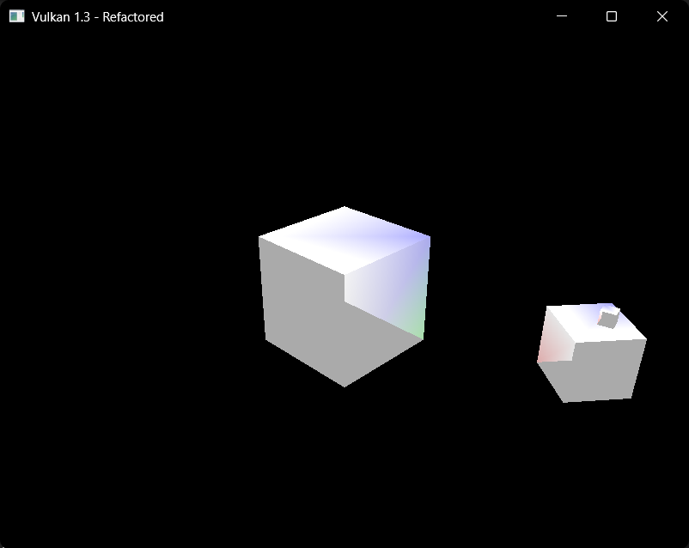

Code

Shader.frag

#version 450

layout(binding = 0) uniform UniformBufferObject {
mat4 model;
mat4 view;
mat4 proj;
vec3 lightPos;
vec3 eyePos;
} ubo;

layout(location = 0) in vec3 fragColor;
layout(location = 1) in vec3 fragWorldPos;
layout(location = 2) in vec3 fragWorldNormal;

layout(location = 0) out vec4 outColor;

void main()
{
vec3 lightColor =
vec3(1.0);

vec3 ambientMaterial =
vec3(0.1);

vec3 normal =
normalize(fragWorldNormal);

vec3 lightDir =
normalize(
ubo.lightPos -
fragWorldPos
);

float diff =
max(
dot(normal, lightDir),
0.0
);

vec3 diffuse =
diff * lightColor;

vec3 result =
ambientMaterial * lightColor;

result +=
fragColor * diffuse;

outColor =
vec4(result, 1.0);
}

Shader.vertex

#version 450

layout(binding = 0) uniform UniformBufferObject {
mat4 model;
mat4 view;
mat4 proj;
vec3 lightPos;
vec3 eyePos;
} ubo;

layout(push_constant) uniform PushConstants {
mat4 model;
} pushConstants;

layout(location = 0) in vec3 inPosition;
layout(location = 1) in vec3 inColor;
layout(location = 2) in vec3 inNormal;

layout(location = 0) out vec3 fragColor;
layout(location = 1) out vec3 fragWorldPos;
layout(location = 2) out vec3 fragWorldNormal;

void main()
{
vec4 worldPosition =
pushConstants.model *
vec4(inPosition, 1.0);

fragWorldPos =
worldPosition.xyz;

fragWorldNormal =
mat3(
transpose(
inverse(pushConstants.model)
)
) * inNormal;

fragColor = inColor;

gl_Position =
ubo.proj *
ubo.view *
worldPosition;
}

Main.cpp

void HelloTriangleApplication::createDescriptorSetLayout() {
VkDescriptorSetLayoutBinding uboLayoutBinding{};
uboLayoutBinding.binding = 0;
uboLayoutBinding.descriptorCount = 1;
uboLayoutBinding.descriptorType = VK_DESCRIPTOR_TYPE_UNIFORM_BUFFER;
uboLayoutBinding.stageFlags = VK_SHADER_STAGE_VERTEX_BIT | VK_SHADER_STAGE_FRAGMENT_BIT; //for both vertex and frag

VkDescriptorSetLayoutCreateInfo layoutInfo{};
layoutInfo.sType = VK_STRUCTURE_TYPE_DESCRIPTOR_SET_LAYOUT_CREATE_INFO;
layoutInfo.bindingCount = 1;
layoutInfo.pBindings = &uboLayoutBinding;

if (vkCreateDescriptorSetLayout(device, &layoutInfo, nullptr, &descriptorSetLayout) != VK_SUCCESS) {
throw std::runtime_error("Failed to create descriptor set layout!");
}
}

Reflection

We are now rendering in the fragment shader rather than the vertex shader. I messed around with the lighting values so it looks a bit different compared to before but the main difference now is that each pixel now is affected by light instead of each vertex which makes it easier to render.

(I will probably mess around with this later on)

Exercise 4: Adding Per-Vertex Specular Lighting

Output

Code

Reflection

Exercise 5: Adding Per-Fragment Specular Lighting

Output

Code

Reflection

Exercise 6: Multiple Lights and Materials

Output

Code

Reflection

