Vulkan Lab 1 - Simple Shapes and Mesh Fundamentals (Vulkan 1.3)
| Next: Vulkan lab 2 →

SMART Objectives
- Understand how core Vulkan architecture works
- How GPU recourses like uniform buffers are managed
- Implementing 3D geometric primitives by using both vertex and index buffers
- Modifying the graphics pipeline (wireframe, transformations) and topology
- How to manage 3D transformations to render multiple objects in a scene

Completed Tasks

Exercise 1. Drawing Two Triangles without the use of vertex indices

Output

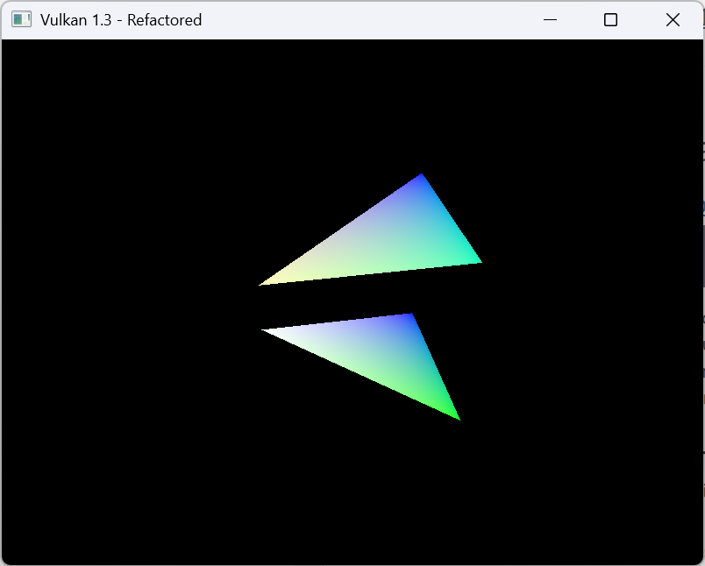

Code

Triangle code

//first triangle
//position //back //colour
{{-0.5f, -0.5f, -0.5f}, {1.0f, 0.0f, 0.0f}}, //0
{{0.5f, -0.5f, -0.5f}, {0.0f, 1.0f, 0.0f}}, //1
{{0.5f, 0.5f, -0.5f}, {0.0f, 0.0f, 1.0f}}, //2
{{-0.5f, 0.5f, -0.5f}, {1.0f, 1.0f, 1.0f}}, //3

//second triangle
//position //front //colour
{{-0.5f, -0.5f, 0.5f}, {1.0f, 1.0f, 0.5f} }, //4
{{0.5f, -0.5f, 0.5f}, {0.0f,1.0f,0.5f}}, //5
{{0.5f, 0.5f, 0.5f}, {0.0f,0.0f,1.0f}}, //6
{{-0.5f, 0.5f, 0.5f}, {1.0f,1.0f,1.0f}}, //7

const std::vector<uint16_t> Quad_indices = {
//front
0, 1, 2, 2, 3, 0,
};

Draw buffer code
vkCmdDraw(commandBuffer, 6, 1, 1, 1 ); //should now be able to draw two triangles aka 6 vertices

Reflection
In this exercise I had to draw two individual triangles by using vkCmdDraw().
The drawing of the triangles was easy enough since I just had to duplicate the first triangle and change the xyz coords. It feels a bit similar to OpenGL the main difference is that I need to use the vkCmdDraw() in order to draw 6 vertices that the triangle needs.

Exercise 2. Draw two squares using an index buffer

OUTPUT Image

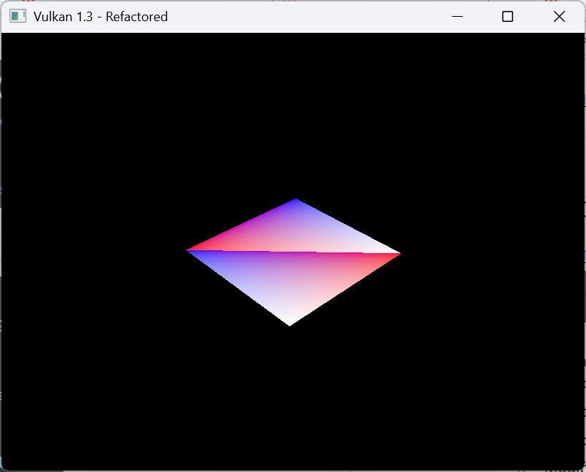

Code
Triangle
const std::vector<Vertex> Quad_vertices = {
//first triangle
//position //back //colour
{{-0.5f, -0.5f, -0.5f}, {1.0f, 0.0f, 0.0f}}, //0
{{0.5f, -0.5f, -0.5f}, {0.0f, 1.0f, 0.0f}}, //1
{{0.5f, 0.5f, -0.5f}, {0.0f, 0.0f, 1.0f}}, //2
{{-0.5f, 0.5f, -0.5f}, {1.0f, 1.0f, 1.0f}}, //3

//second triangle (square)
//position //front //colour
{{-0.5f, -0.5f, 0.5f}, {1.0f, 1.0f, 0.5f} }, //4
{{0.5f, -0.5f, 0.5f}, {0.0f,1.0f,0.5f}}, //5
{{0.5f, 0.5f, 0.5f}, {0.0f,0.0f,1.0f}}, //6
{{-0.5f, 0.5f, 0.5f}, {1.0f,1.0f,1.0f}}, //7

};
const std::vector<uint16_t> Quad_indices = {
//front
0, 1, 2, 2, 3, 0,
//back
4, 5, 6, 6, 7, 4,
};

vkCmdDrawIndexed(commandBuffer, static_cast<uint16_t>(indices.size()), 1, 0, 0, 0);

Reflection

Exercise two now uses the index buffer and as a result both triangles are now in the same position and use the same colour pallete. It’s interesting seeing the difference between vkCmdDrawIndex vs vkCmdDraw.

Since vkCmdDrawIndex it draws from a separate index buffer which makes it so you don’t run into the problem of having to draw the primitive twice (rendering each point as well) you can instead reuse each verticies and reduce duplicated vertex data. This becomes more effective with more complex models with a lot more tris. VkCmdDraw instead draws vertices from the vertex buffer in sequence.

Exercise 3: Draw the four walls of a cube

Output
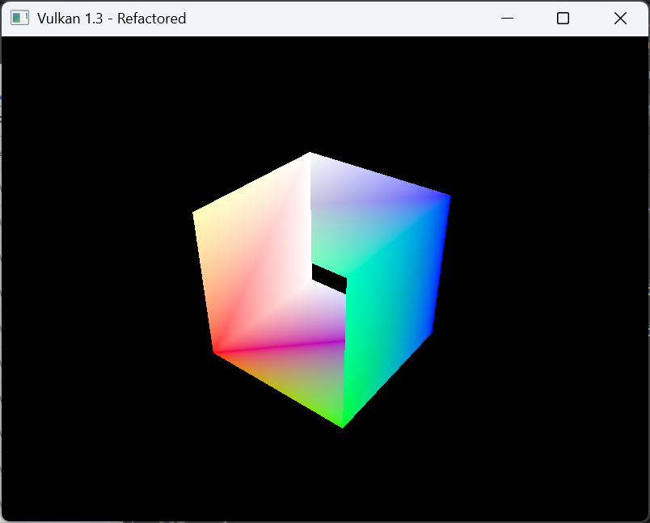

Code
Drawing Square
//square
const std::vector<Vertex> Quad_vertices = {
//first triangle
//position //back //colour
{{-0.5f, -0.5f, -0.5f}, {1.0f, 0.0f, 0.0f}}, //0
{{0.5f, -0.5f, -0.5f}, {0.0f, 1.0f, 0.0f}}, //1
{{0.5f, 0.5f, -0.5f}, {0.0f, 0.0f, 1.0f}}, //2
{{-0.5f, 0.5f, -0.5f}, {1.0f, 1.0f, 1.0f}}, //3

//second triangle
//position //front //colour
{{-0.5f, -0.5f, 0.5f}, {1.0f, 1.0f, 0.5f} }, //4
{{0.5f, -0.5f, 0.5f}, {0.0f,1.0f,0.5f}}, //5
{{0.5f, 0.5f, 0.5f}, {0.0f,0.0f,1.0f}}, //6
{{-0.5f, 0.5f, 0.5f}, {1.0f,1.0f,1.0f}}, //7

};

//first and second trianlge for square shape
//drawing cube now
const std::vector<uint16_t> Quad_indices = {
//front
0, 1, 2, 2, 3, 0,
//back
4, 5, 6, 6, 7, 4,
//left side
0,3,7,7,4,0,
//right
1,5,6,6,2,1

};

Enabling to draw cube
vkCmdDrawIndexed(commandBuffer, static_cast<uint32_t>(indices.size()), 1, 0, 0, 0); //should draw cube now

Reflection

In this section you needed to draw a 3D cube with its 4 walls. It was originally a bit hard to figure out this was mainly due to having to draw the points and vertices a bit differently compared to OpenGL, furthermore it would only load as a 2D square that was until I realized I had to make the draw index buffer larger.
Overall, it was quite interesting, but it will take a while to get used to how different Vulkan works compared to OpenGL, at least in that drawing stuff seems be a lot more manual.

Exercise 4: Wireframe Rendering

Output
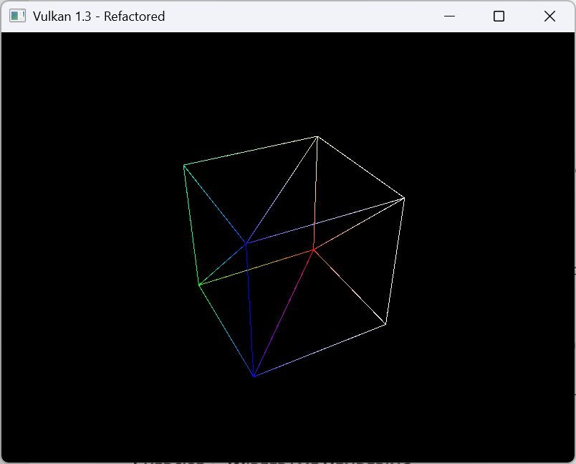

Code
rasterizer.polygonMode = VK_POLYGON_MODE_LINE;

Reflection
In this task I had to change VK_POLYGON_MODE_FILL to VK_POLYGON_MODE_LINE.
This results in the cube being rendered in wireframe (vertices and lines) instead of solid colours (faces, vertices and lines). It is quite similar to how it works in OpenGL as well with this line GL_FRONT_AND_BACK, GL_LINE to render wireframe and GL_FRONT_AND_BACK, GL_FILL to render solid shapes, meaning that there are some similarities between OpenGL and Vulkan at least in how to render a wireframe object.

However, there are some differences in that Vulkan also renders the triangles that make up the cube instead of just the lines of the cube like in OpenGL.

Exercise 5: Render the cube vertices as points

Output
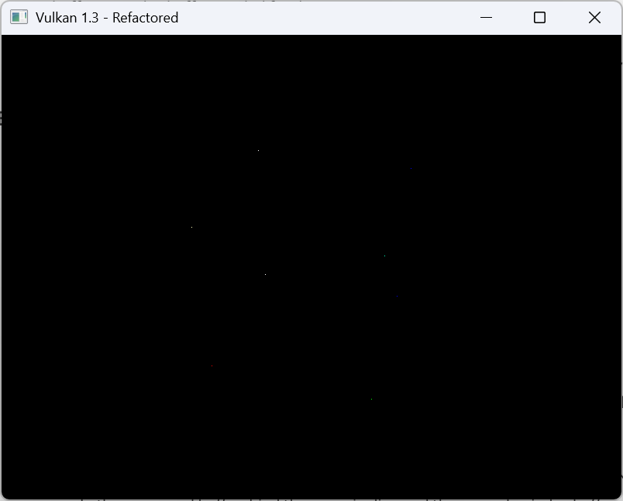

Code

inputAssembly.topology = VK_PRIMITIVE_TOPOLOGY_POINT_LIST; // render tris = triangle list, render points = point list

vkCmdDraw(commandBuffer, 8, 1, 0, 0 ); //should now be able to draw two triangles aka 6 vertices, to render cube draw 8 verticies

Reflection

In this task I have learned how to change the topology from VK_PRIMITIVE_TOPOLOGY_TRIANGLE_LIST to VK_PRIMITIVE_TOPOLOGY_POINT_LIST and by changing the draw method to be vkCmdDraw(commandBuffer, 8, 1, 0, 0) it enables to draw each separate point of the cube instead of the entire object like before. I don’t believe this could be done in OpenGL but I need to check again.

Exercise 6: Render the cube edges as lines

Output
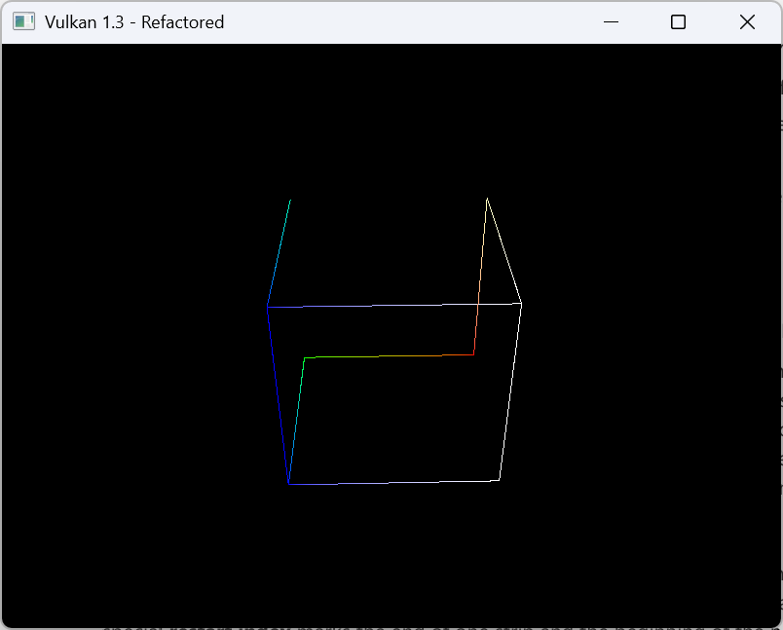

Code

inputAssembly.topology = VK_PRIMITIVE_TOPOLOGY_LINE_LIST;
vkCmdDrawIndexed(commandBuffer, static_cast<uint32_t>(indices.size()), 24, 1, 0, 0);

Reflection

In this exercise, the main goal was to draw the cube edges instead of the points/triangles. In order to do this inputAssembly.topology = VK_PRIMITIVE_TOPOLOGY_LINE_LIST was used and by using that and vkCmdDrawIndexed(commandBuffer, static_cast<uint32_t>(indices.size()), 24, 1, 0, 0) it should render 12 individual lines of the cube. However, some lines are missing and it’s only 9 lines in total. This isn’t due to them being culled out since I did disable culling and I am unsure what causes this.

Exercise 7: Triangle strips

Output
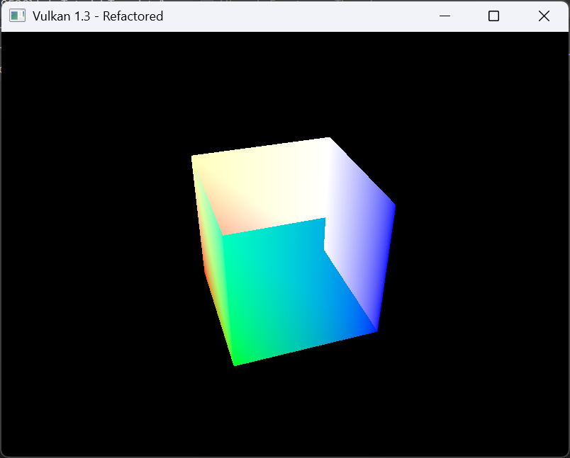

Code

Const std::vector<uint16_t> Quad_indices = {

//drawing index triangle strips
//0xFFFF tells vulkan to stop reading this line and move to the next
//front
0, 1, 3,2, 0xFFFF,
//back
4,5, 7, 6, 0xFFFF,
//left
0, 4, 3, 7, 0xFFFF,
//right
1,5, 2, 6, 0xFFFF,
//bottom
0, 1, 4, 5, 0xFFFF,
//top
3,2,7,6
}
inputAssembly.topology = VK_PRIMITIVE_TOPOLOGY_TRIANGLE_STRIP; // render tris = triangle list, render points = point list, render lines = line list
inputAssembly.primitiveRestartEnable = VK_TRUE; //need to turn this from false to true (relates to 0xFFFF thing)
rasterizer.polygonMode = VK_POLYGON_MODE_FILL; // wireframe mode = line, regular mode = fill
vkCmdDrawIndexed(commandBuffer, static_cast<uint32_t>(indices.size()), 1, 0, 0, 0); //should draw cube now (uint32), 24 objects (should render 12 lines of cube, only renders 9 lines Task 6 stuff). We're back to rendering cube normally

Reflection

In this task we are rendering triangle strips instead of the old method of drawing triangle lines to make up a cube. For this to happen, we add 0xFFFF which makes Vulkan stop reading that index line and then move to the next one and by using VK_PRIMITIVE_TOPOLOGY_TRIANGLE_STRIP and enabling primitive restart. The reason why we want to use triangle strips instead of lines is that strips is less memory intensive and it works through defining the first three vertices of a triangle with each new vertex combing with two of the older vertices.
This is unlike line topology where it treats each verticies as a connected line.
Overall performance doesn’t seem to be quite different between the two it might be due to how GPU works like optimizations?

Exercise 8: Drawing multiple cubes using instanced drawing

Output
5 cubes rendered in one scene

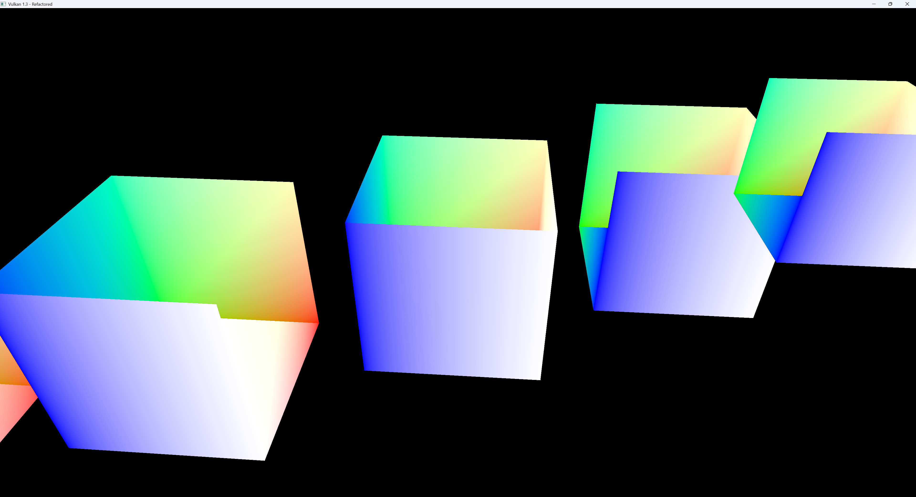

Code

vkCmdDrawIndexed(commandBuffer, static_cast<uint32_t>(indices.size()), 5, 0, 0, 0); //renders 5 cubes

Shader.vert
#version 450

layout(binding = 0) uniform UniformBufferObject {
mat4 model;
mat4 view;
mat4 proj;
} ubo;

layout(location = 0) in vec3 inPosition;
layout(location = 1) in vec3 inColor;

layout(location = 0) out vec3 fragColor;

void main() {
vec3 offset = vec3(gl_InstanceIndex * 1.5 - 3.0, 0.0, 0.0);

vec4 worldPosition = ubo.model * vec4(inPosition, 1.0);
worldPosition.xyz += offset;

gl_Position = ubo.proj * ubo.view * ubo.model * worldPosition;
fragColor = inColor;
}

Reflection

In this exercise we are drawing multiple objects in one scene instead of just one. To do this the vkcmdDrawIndex we draw for example 5 instances of one cube and then in the shader code we modify it so each of these cubes have a unique position. Overall, the way of doing this is a bit strange since you need to add the positions of new cubes in the vertex shader when in OpenGL, I don’t think you did that and it was in a regular class. The Vulkan method at least I can sort of understand why it’s like this since you just need to modify the shader code to add new positions and you can add more objects (model matrix) in the scene from the index code.

Exercise 9: Drawing two cubes using push constants

Output
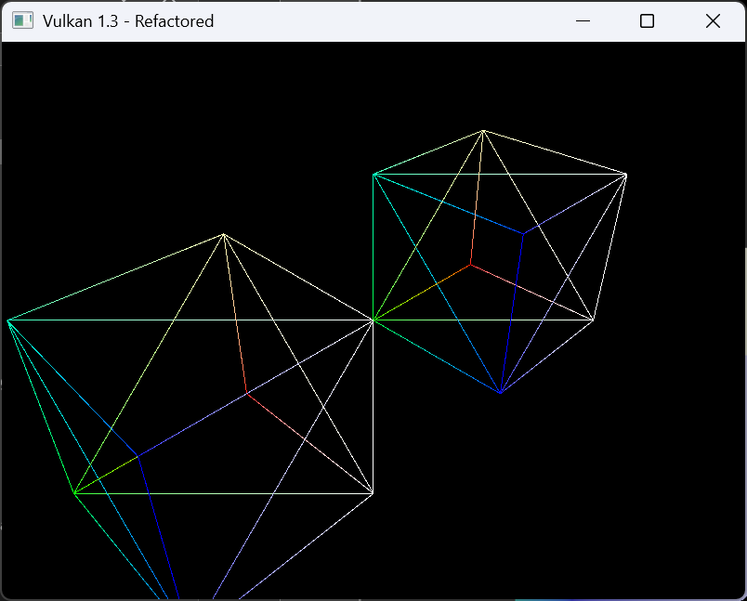

Code
struct UniformBufferObject {
//alignas(16) glm::mat4 model;
alignas(16) glm::mat4 view;
alignas(16) glm::mat4 proj;
};
//used to pass model matrix to vert shader for each model (e.g., 2 cubes)
struct ModelPushConstant {
glm::mat4 model;
};

//needed for drawing multiple objects
VkPushConstantRange pushConstantRange{};
pushConstantRange.stageFlags = VK_SHADER_STAGE_VERTEX_BIT;
pushConstantRange.offset = 0;
pushConstantRange.size = sizeof(ModelPushConstant);

//draw first cube
ModelPushConstant pushUBO{};
pushUBO.model = glm::translate(glm::mat4(1.0f), glm::vec3(-1.0f, 0.0f, 0.0f));
vkCmdPushConstants(commandBuffer, pipelineLayout, VK_SHADER_STAGE_VERTEX_BIT, 0, sizeof(ModelPushConstant), &pushUBO);

//vkCmdDraw(commandBuffer, 8, 1, 0, 0 ); //should now be able to draw two triangles aka 6 vertices, to render cube draw 8 verticies
vkCmdDrawIndexed(commandBuffer, static_cast<uint32_t>(indices.size()), 1, 0, 0, 0); //should draw cube now (uint32), 24 objects (should render 12 lines of cube, only renders 9 lines Task 6 stuff). We're back to rendering cube normally, renders 5 cubes now

//draw second cube
pushUBO.model = glm::translate(glm::mat4(1.0f), glm::vec3(1.0f, 0.0f, 0.0f));
vkCmdPushConstants(commandBuffer, pipelineLayout, VK_SHADER_STAGE_VERTEX_BIT, 0, sizeof(ModelPushConstant), &pushUBO);
vkCmdDrawIndexed(commandBuffer, static_cast<uint32_t>(indices.size()), 1, 0, 0, 0); //should draw cube now (uint32), 24 objects (should render 12 lines of cube, only renders 9 lines Task 6 stuff). We're back to rendering cube normally, renders 5 cubes now

shader.vert

#version 450

layout(binding = 0) uniform UniformBufferObject {
mat4 view;
mat4 proj;
} ubo;

layout(push_constant) uniform PushConstants {
mat4 model;
} pushConstants;

layout(location = 0) in vec3 inPosition;
layout(location = 1) in vec3 inColor;

layout(location = 0) out vec3 fragColor;

void main() {

gl_Position = ubo.proj * ubo.view * pushConstants.model * vec4(inPosition, 1.0);
fragColor = inColor;
}

Reflection

In this task it was about drawing two identical wireframe cubes side by side and drawn via their own unique model matrix that is then passed onto the shader.
In order to do this, there was quite a lot that needed to be done most notably redoing the c++ UBO structs to remove the model tag and instead be a sperate struct, then requiring to modify the graphics pipeline to make Vulkan know that you want two separate objects that are reusable and finally drawing two cubes with pushUBO.
From what I can understand doing it this way is more efficient and it makes so you can add a lot more models easier than the previous way in exercise 8.

Beyond the Lab (Optional)

Navigation:
- Vulkan lab 2

