Approval Dokumen
Berdasarkan hal-hal tersebut di atas, dengan ini yang bertandatangan di bawah ini menyatakan mengetahui, menerima dan menyetujui usulan proposal dan uji kelayakan yang tercantum dalam Dokumen Blueprint Proyek Implementasi Sistem Informasi ERP Modul Material Management.

Sukoharjo,……..

PT Project Manager  () | PT Head  ()

Tujuan Dokumen
Dokumen ini mendokumentasikan kebutuhan fungsional dan non-fungsional dari modul Sistem Informasi ERP PT ... yang menggambarkan solusi management Aplikasi Sistem Informasi ERP pada PT .... Secara spesifik dokumen ini akan menjelaskan proses bisnis di bidang proyek.

Dokumen ini akan menjadi suatu dasar dan pedoman untuk aktivitas Implementasi Aplikasi Sistem Informasi ERP di PT ...

Pengawasan Dokumen
Informasi Dokumen

Nama Dokumen | Blueprint Sistem Informasi ERP - Material Management
Identifikasi | Bidang Proyek
Nama Proyek | Sistem Informasi ERP PT ...
Perusahaan | PT ...
Pembuat Dokumen | PT ...
Versi Dokumen | 1
Status Dokumen | Dokumen Awal
Tanggal Rilis

Riwayat Perubahan Dokumen

Versi | Tanggal | Perubahan | PIC
1

Riwayat Pemeriksaan dan Persetujuan Dokumen

Tanggal | Nama | Jabatan/Posisi | Catatan

DAFTAR ISI
Contents
Approval Dokumen 2
Tujuan Dokumen 3
Pengawasan Dokumen 4
DAFTAR ISI 5
BAB I PENDAHULUAN 8
1.1 Tujuan 8
1.2 Spesifikasi Sistem 8
BAB II DESKRIPSI PROSES BISNIS 9
2.1 Deskripsi Umum Alur Proses 9
2.2 Diagram Alur Bisnis 9
2.2.1 Purchase Request (PR) 9
2.2.1 Purchase Return & SJBB 9
2.2.1 Stock Adjustment 9
2.2.1 Stock Transfer (Antar Gudang) 9
2.2.1 Stock Conversion (BOM / Template) 9
2.3 Hak Akses 10
BAB III SPESIFIKASI DATA & INTEGRASI 11
3.1 Kebutuhan Database 11
3.1.1 supplier_groups 11
3.1.1 supplier_centers 11
3.1.1 suppliers 11
3.1.1 materials 11
3.1.1 warehouses 12
3.1.1 purchase_requests 12
3.1.1 purchase_request_details 12
3.1.1 purchase_orders 12
3.1.1 purchase_order_details 13
3.1.1 goods_receipts 13
3.1.1 goods_receipt_details 13
3.1.1 purchase_invoices 14
3.1.1 purchase_invoice_details 14
3.1.1 supplier_payments 14
3.1.1 supplier_payment_details 15
3.1.1 purchase_returns 15
3.1.1 purchase_return_details 16
3.1.1 sjbb 16
3.1.1 stock_adjustments 16
3.1.1 stock_adjustment_details 16
3.1.1 stock_transfers 17
3.1.1 stock_transfer_details 17
3.1.1 material_templates 17
3.1.1 material_template_details 17
3.1.1 stock_conversions 17
3.2 Integrasi Modul 18
BAB IV DESKRIPSI KEBUTUHAN ANTARMUKA 19
4.1 Kebutuhan Antarmuka Modul Material Management 19
4.1.1 Supplier Master 19
4.1.2 Supplier Group 19
4.1.3 Supplier Center 19
4.1.4 Supplier Balance Summary 20
4.1.5 Purchase Request 20
-Purchase Request List 20
-Purchase Request Fulfilment Report 21
4.1.6 Purchase Order 21
-Purchase Order List 21
-Purchase Fulfillment Report 21
-Daily Purchase Order Report 22
4.1.7 Purchase Invoice 22
-Purchase Invoice List 22
-Daily Purchase Invoice Report 22
-Monthly Purchase by Supplier Report 23
4.1.8 STBJ 23
4.1.9 Supplier Payment 23
-Supplier Payment List 23
-Supp. Outstanding List 24
-Daily Supplier Payment Report 24
-Daily Supplier Payment ListPurchase Return 24
4.1.10 Purchase Return List 25
4.1.11 SJBB 25
4.1.12 Stock Adjustment 26
-Stock Adjustment Use 26
-Stock Adjustment List 26
-Daily Stock Adjustment Report 27
-Daily Stock Adjustment Track Report 27
-Daily Stock Adjustment Cost Report 27
4.1.13 Stock Transfer 28
-Stock Transfer List 28
-Daily Stock Transfer Report 28
-Stock Transfer Fulfilment 28
4.1.14 Stock Convertion 28
4.1.15 Material Template 28

BAB I PENDAHULUAN

Tujuan
Pengembangan dan Implementasi sistem Enterprise Resource Planning (ERP) di Perusahaan PT ... bertujuan untuk meningkatkan efisiensi operasional dan integrasi antar divisi. Sistem ERP yang kami kembangkan akan mencakup beberapa divisi penting, yaitu Material Management, Operasional, HRD, Management, Gudang, Purchasing, QHSE, Procon, Tax, Finance dan Accounting. Dalam sistem ERP memiliki beberapa tujuan utama, antara lain :
    - Sebagai tindaklanjut dari testimoni pengguna bahwa aplikasi ERP sangat berguna, perancangan aplikasi yang dilakukan agar nantinya dapat memberikan manfaat optimal melalui fitur-fiturnya
    - Mengintegrasikan seluruh proses bisnis yang ada di setiap divisi ke dalam sistem yang terkoordinasi dan terpusat
    - Meningkatkan Efisiensi Operasional
    - Meningkatkan akurasi pencatatan keuangan dan transparansi laporan keuangan di divisi Accounting dan Finance
    - Meningkatkan kemampuan dalam pelaporan dan analisis data dari semua divisi untuk mendukung pengambilan keputusan yang lebih baik

Spesifikasi Sistem
Berikut adalah spesifikasi yang digunakan untuk penerapan Sistem Informasi ERP pada PT ... 2025 :
- Sistem ERP adalah Sistem berbasis website
- Bahasa Pemograman yang digunakan adalah PHP dengan framework Laravel
- Database yang digunakan adalah PostgreSQL
- Server yang ada menggunakan …
- MultiPlatform sehingga dapat diakses dengan Device Apapun.
- MultiOS sehingga dapat diakses dengan menggunakan Operating System apapun
- Default Browser yang digunakan yakni Mozilla Firefocx dan Google Chrome

BAB II
DESKRIPSI PROSES BISNIS

Deskripsi Umum Alur Proses
Modul Material Management mengelola seluruh proses pengadaan dan pengelolaan persediaan, dimulai dari pembuatan Purchase Request (PR) sebagai permintaan pembelian yang harus melalui proses persetujuan. Setelah disetujui, sistem menghasilkan Purchase Order (PO) kepada supplier, kemudian barang yang dikirim diterima melalui proses STBJ (Goods Receipt) sebagai dasar pembaruan stok dan verifikasi kesesuaian pesanan. Selanjutnya supplier menerbitkan Purchase Invoice yang menjadi dasar proses Supplier Payment, baik melalui pembayaran reguler maupun Down Payment (DP). Apabila terdapat barang yang tidak sesuai, sistem mendukung proses Purchase Return yang didokumentasikan menggunakan SJBB sebagai bukti perpindahan barang. Selain itu, sistem menyediakan fitur Stock Adjustment untuk penyesuaian stok, Stock Transfer untuk perpindahan barang antar gudang, serta Stock Conversion berbasis Bill of Material (BOM) untuk mengubah bahan baku menjadi produk jadi. Seluruh transaksi yang memengaruhi persediaan akan secara otomatis memperbarui Stock Ledger sehingga saldo stok selalu akurat dan dapat ditelusuri secara real-time.

Diagram Alur Bisnis

Purchase Request (PR)

Purchase Return & SJBB
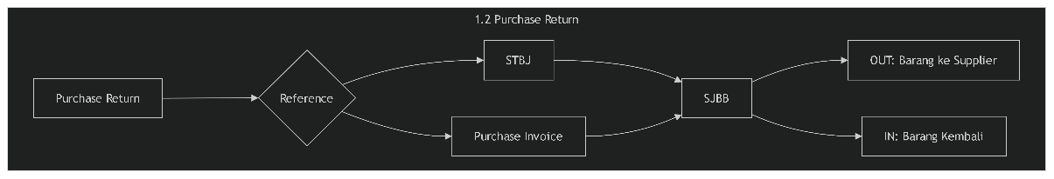

Stock Adjustment
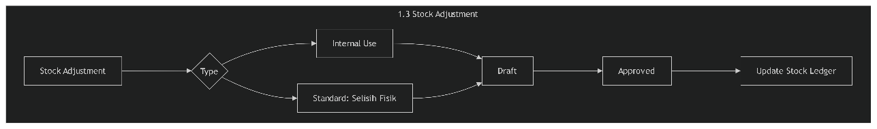

Stock Transfer (Antar Gudang)
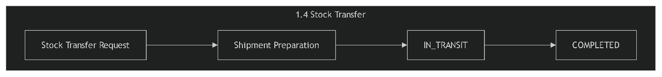

Stock Conversion (BOM / Template)
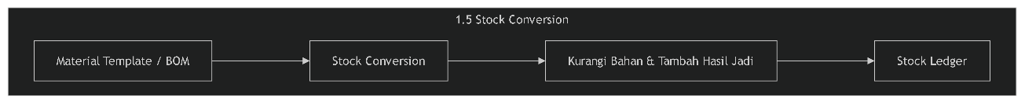

Hak Akses

BAB III
SPESIFIKASI DATA & INTEGRASI

Kebutuhan Database

supplier_groups
Field | Definition
Id | char 26 / ULID / Primary Key
code | varchar 50, Unique
name | varchar 100
description | text, Nullable
`created_at`, `updated_at`, `deleted_at`

supplier_centers
Field | Definition
id | char 26, Primary Key
code | varchar 50, Unique
name | varchar 100
`created_at`, `updated_at`, `deleted_at`

suppliers
Field | Definition
id | char 26, Primary Key
supplier_code | varchar 50, Unique
name | varchar 150
supplier_group_id | foreign key -> `supplier_groups.id`
supplier_center_id | foreign key -> `supplier_centers.id`
phone | varchar 30
email | varchar 100
address | text
term_of_payment | integer, TOP Hari
status | boolean / tinyint
`created_at`, `updated_at`, `deleted_at`

materials
Field | Definition
id | char 26, Primary Key
item_code | varchar 50, Unique
item_name | varchar 150
category_id | foreign key
unit_id | foreign key
cost_price | decimal 15,2
min_stock | decimal 12,2
max_stock | decimal 12,2
status | boolean
`created_at`, `updated_at`, `deleted_at`

warehouses
Field | Definition
id | char 26, Primary Key
warehouse_code | varchar 50, Unique
warehouse_name | varchar 100
location | text
`created_at`, `updated_at`, `deleted_at`

purchase_requests
Field | Definition
id | char 26, Primary Key
pr_number | varchar 50, Unique
pr_date | date
requester_user_id | foreign key -> `users.id`
department | varchar 100
status | enum: 'DRAFT', 'PENDING', 'APPROVED', 'REJECTED', 'FULFILLED'
note | text
`created_at`, `updated_at`, `deleted_at`

purchase_request_details
Field | Definition
id | char 26, Primary Key
purchase_request_id | foreign key -> `purchase_requests.id`
material_id | foreign key -> `materials.id`
qty_requested | decimal 12,2
qty_fulfilled | decimal 12,2, default 0
unit_id | foreign key
notes | text
`created_at`, `updated_at`

purchase_orders
Field | Definition
id | char 26, Primary Key
po_number | varchar 50, Unique
po_date | date
supplier_id | foreign key -> `suppliers.id`
purchase_request_id | foreign key -> `purchase_requests.id`, Nullable
payment_term_days | integer
subtotal | decimal 15,2
tax_amount | decimal 15,2
discount_amount | decimal 15,2
total_amount | decimal 15,2
status | enum: 'DRAFT', 'APPROVED', 'PARTIAL', 'CLOSED', 'CANCELLED'
note | text
`created_at`, `updated_at`, `deleted_at`

purchase_order_details
Field | Definition
id | char 26, Primary Key
purchase_order_id | foreign key -> `purchase_orders.id`
material_id | foreign key -> `materials.id`
qty_ordered | decimal 12,2
qty_received | decimal 12,2, default 0
unit_price | decimal 15,2
discount | decimal 15,2
tax | decimal 15,2
subtotal | decimal 15,2
`created_at`, `updated_at`

goods_receipts
Field | Definition
id | char 26, Primary Key
stbj_number | varchar 50, Unique
stbj_date | date
supplier_id | foreign key -> `suppliers.id`
purchase_order_id | foreign key -> `purchase_orders.id`
warehouse_id | foreign key -> `warehouses.id`
sj_supplier_number | varchar 100, No Surat Jalan Supplier
note | text
`created_at`, `updated_at`, `deleted_at`

goods_receipt_details
Field | Definition
id | char 26, Primary Key
stbj_id | foreign key -> `goods_receipts.id`
material_id | foreign key -> `materials.id`
qty_received | decimal 12,2
qty_accepted | decimal 12,2
qty_rejected | decimal 12,2
unit_id | foreign key
note | text
`created_at`, `updated_at`

purchase_invoices
Field | Definition
id | char 26, Primary Key
invoice_number | varchar 50, Unique
invoice_date | date
due_date | date
supplier_id | foreign key -> `suppliers.id`
purchase_order_id | foreign key -> `purchase_orders.id`, Nullable
stbj_id | foreign key -> `goods_receipts.id`, Nullable
currency | varchar 10, default 'IDR'
rate | integer, exchange rate terhadap IDR, default 1
total | decimal 15,2, total invoice dalam foreign currency
paid_amount | decimal 15,2, total yang sudah dibayar, default 0
outstanding | decimal 15,2, derived: total - paid_amount
term | varchar 50, payment term e.g. Net 14, Net 30
status | enum: 'DRAFT', 'PENDING', 'APPROVED', 'REJECTED', 'PAID'
note | text
`created_at`, `updated_at`, `deleted_at`

purchase_invoice_details
Field | Definition
id | char 26, Primary Key
purchase_invoice_id | foreign key -> `purchase_invoices.id`
material_id | foreign key -> `materials.id`
qty | decimal 12,2
unit_price | decimal 15,2
subtotal | decimal 15,2
`created_at`, `updated_at`

supplier_payments
Field | Definition
id | char 26, Primary Key
payment_number | varchar 50, Unique
payment_date | date
supplier_id | varchar 50
supplier_name | varchar 150
currency | varchar 10
rate | integer, exchange rate terhadap IDR, default 1
invoice_date | date, tanggal invoice terkait
subtotal | decimal 15,2, total sebelum diskon
discount_percent | decimal 5,2, persentase diskon
discount_amount | decimal 15,2, nominal diskon
lain_lain | decimal 15,2, biaya lain-lain
total_payment | decimal 15,2, total akhir: subtotal - diskon + lain-lain
total_paid | decimal 15,2, total yang sudah dibayarkan
account_id | varchar 50, nomor rekening
account | varchar 100, nama bank/rekening
user_name | varchar 150
complete_date | date, Nullable
stbj_number | varchar 50
invoice_number | varchar 50
note | text
note_detail | text, catatan detail
payment_type | varchar 20
status | enum: 'DRAFT', 'PENDING', 'APPROVED', 'REJECTED', 'PAID'
`created_at`, `updated_at`, `deleted_at`

supplier_payment_details
Field | Definition
id | char 26, Primary Key
supplier_payment_id | foreign key -> `supplier_payments.id`
purchase_invoice_id | foreign key -> `purchase_invoices.id`
amount_paid | decimal 15,2
`created_at`, `updated_at`

purchase_returns
Field | Definition
id | char 26, Primary Key
return_number | varchar 50, Unique
return_date | date
warehouse | varchar 100
supplier_id | varchar 50
supplier_name | varchar 150
currency | varchar 10, default 'IDR'
term | varchar 50
discount_percent | decimal 5,2
discount_amount | decimal 15,2
total_return_amount | decimal 15,2, dihitung dari items - diskon
user_name | varchar 150
account | varchar 100
price_list | varchar 50
note | text
status | enum: 'DRAFT', 'APPROVED', 'COMPLETED'
items | array of objects: material, qty, unit, price
`created_at`, `updated_at`, `deleted_at`

purchase_return_details
Field | Definition
id | char 26, Primary Key
purchase_return_id | foreign key -> `purchase_returns.id`
material_id | foreign key -> `materials.id`
qty_returned | decimal 12,2
unit_price | decimal 15,2
subtotal | decimal 15,2
`created_at`, `updated_at`

sjbb
Field | Definition
id | char 26, Primary Key
sjbb_number | varchar 50, Unique
sjbb_date | date
supplier_id | foreign key -> `suppliers.id`
type | enum: 'IN', 'OUT'
status | varchar 50
notes | text
`created_at`, `updated_at`, `deleted_at`

stock_adjustments
Field | Definition
id | char 26, Primary Key
adjustment_number | varchar 50, Unique
adjustment_date | date
warehouse_id | foreign key -> `warehouses.id`
adjustment_type | enum: 'STANDARD', 'INTERNAL_USE'
reason | text
status | enum: 'DRAFT', 'APPROVED'
`created_at`, `updated_at`, `deleted_at`

stock_adjustment_details
Field | Definition
id | char 26, Primary Key
stock_adjustment_id | foreign key -> `stock_adjustments.id`
material | varchar 150, nama material
system_qty | decimal 12,2
physical_qty | decimal 12,2
qty_diff | decimal 12,2, derived: system_qty - physical_qty
cost_per_unit | decimal 15,2
total_cost_diff | decimal 15,2, derived: qty_diff * cost_per_unit
`created_at`, `updated_at`

stock_transfers
Field | Definition
id | char 26, Primary Key
transfer_number | varchar 50, Unique
transfer_date | date
from_warehouse_id | foreign key -> `warehouses.id`
to_warehouse_id | foreign key -> `warehouses.id`
status | enum: 'REQUESTED', 'PREPARED', 'IN_TRANSIT', 'COMPLETED', 'CANCELLED'
notes | text
`created_at`, `updated_at`, `deleted_at`

stock_transfer_details
Field | Definition
id | char 26, Primary Key
stock_transfer_id | foreign key -> `stock_transfers.id`
material_id | foreign key -> `materials.id`
qty_requested | decimal 12,2
qty_shipped | decimal 12,2, default 0
qty_received | decimal 12,2, default 0
`created_at`, `updated_at`

material_templates
Field | Definition
id | char 26, Primary Key
template_code | varchar 50, Unique
template_name | varchar 150
target_material_id | foreign key -> `materials.id`
target_output_qty | decimal 12,2
description | text
`created_at`, `updated_at`, `deleted_at`

material_template_details
Field | Definition
id | char 26, Primary Key
material_template_id | foreign key -> `material_templates.id`
raw_material_id | foreign key -> `materials.id`
qty_needed | decimal 12,2
unit_id | foreign key
`created_at`, `updated_at`

stock_conversions
Field | Definition
id | char 26, Primary Key
conversion_number | varchar 50, Unique
conversion_date | date
warehouse_id | foreign key -> `warehouses.id`
material_template_id | foreign key -> `material_templates.id`
output_qty_produced | decimal 12,2
notes | text
`created_at`, `updated_at`, `deleted_at`
    - stock_ledgers
Field | Definition
id | char 26, Primary Key
material_id | foreign key -> `materials.id`
warehouse_id | foreign key -> `warehouses.id`
reference_type | varchar 50: 'STBJ', 'PURCHASE_RETURN', 'STOCK_ADJUSTMENT', 'STOCK_TRANSFER', 'STOCK_CONVERSION'
reference_id | char 26
qty_in | decimal 12,2, default 0
qty_out | decimal 12,2, default 0
balance_qty | decimal 12,2
cost_price | decimal 15,2
`created_at`

Integrasi Modul

BAB IV
DESKRIPSI KEBUTUHAN ANTARMUKA

Kebutuhan Antarmuka Modul Material Management
Pemakai atau user yang berinteraksi dengan Sistem Informasi ERP melalui antarmuka pemakai (user interface) yang dapat diakses melalui browser pada komputer. Berikut ini adalah rincian modul-modul & fitur yang tercakup dalam Sistem Informasi ERP
- Material Management PT ... Tahun 2025.

Supplier Master
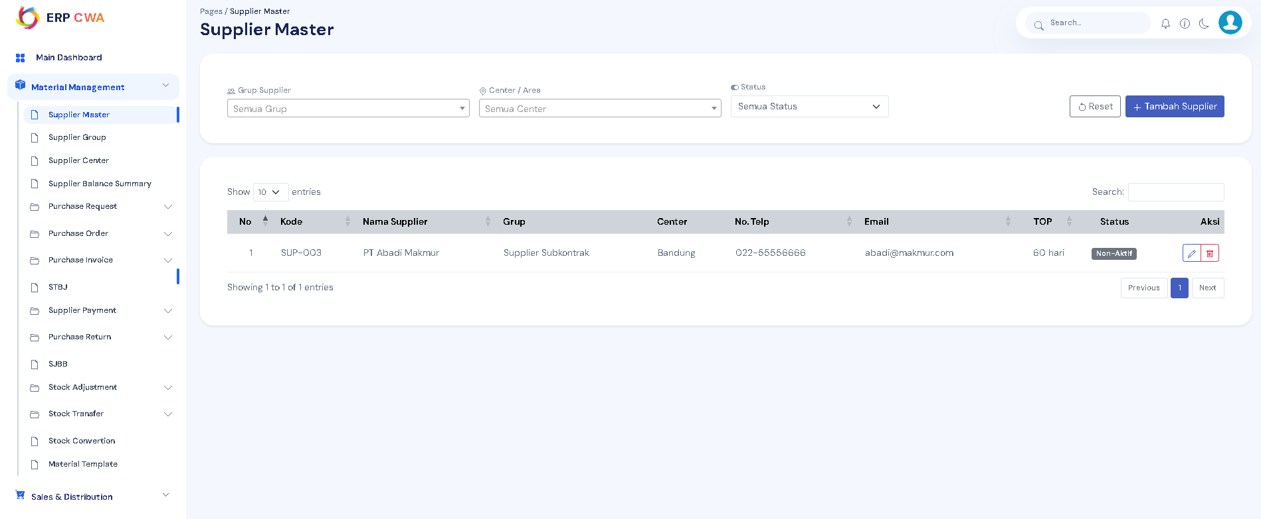

Supplier Group
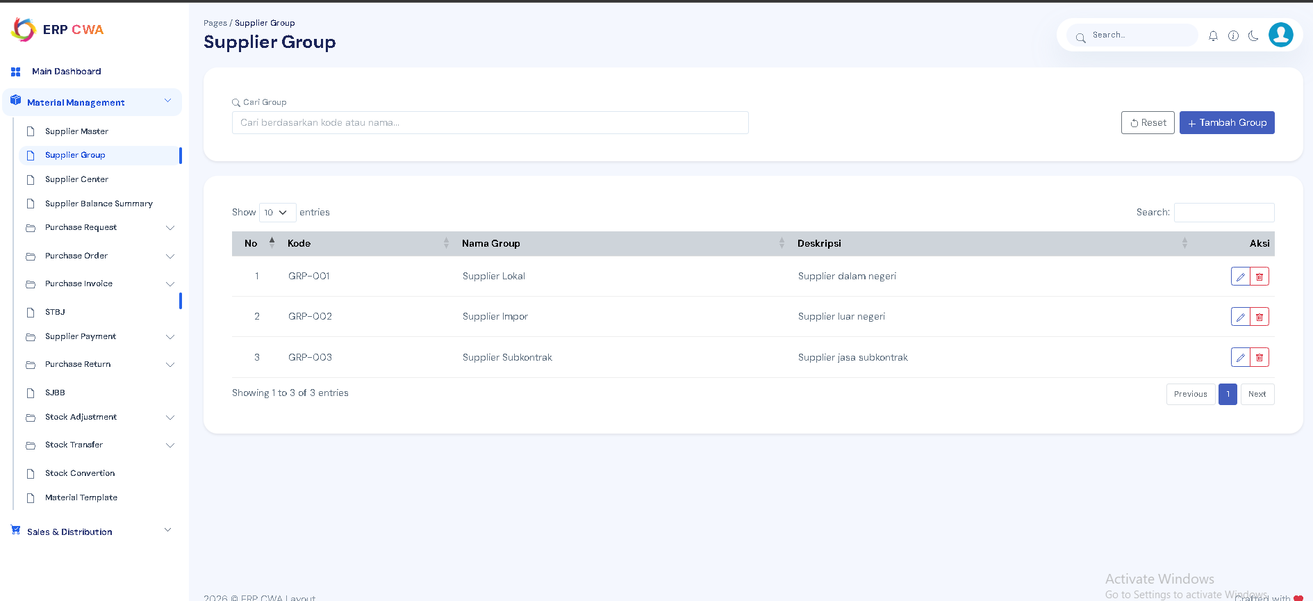

Supplier Center
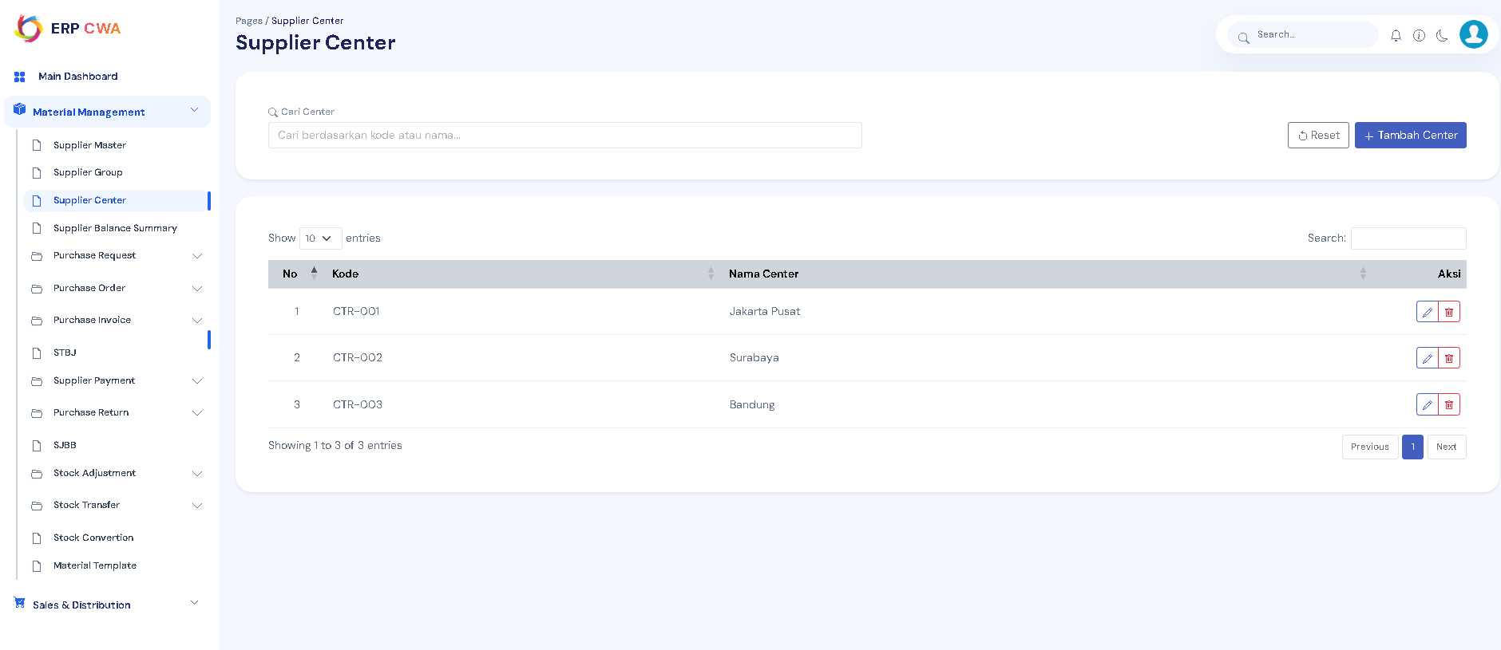

Supplier Balance Summary
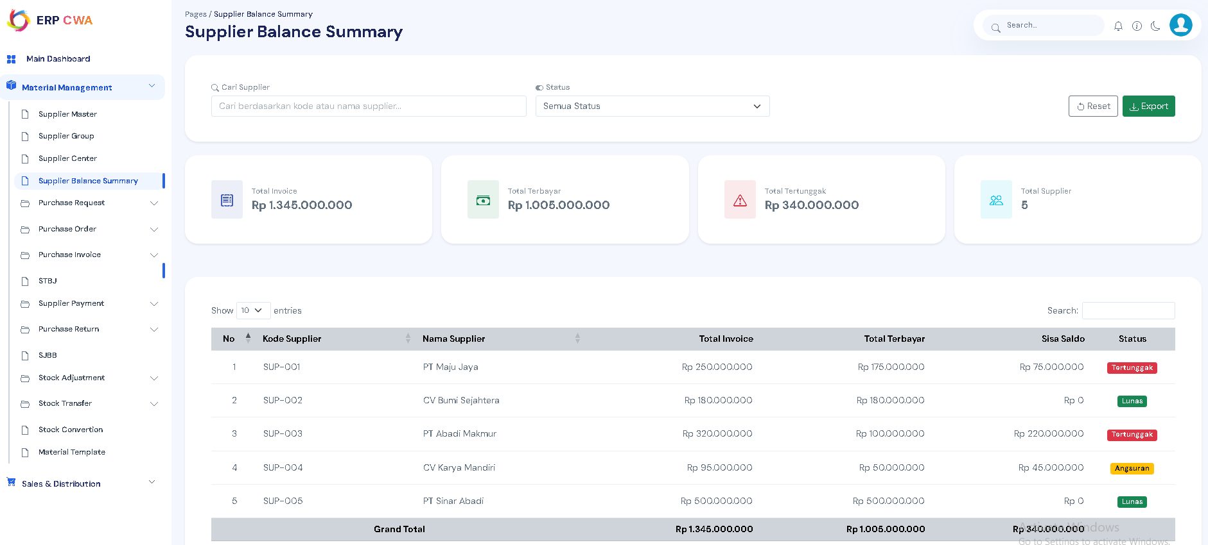

Purchase Request

-Purchase Request List
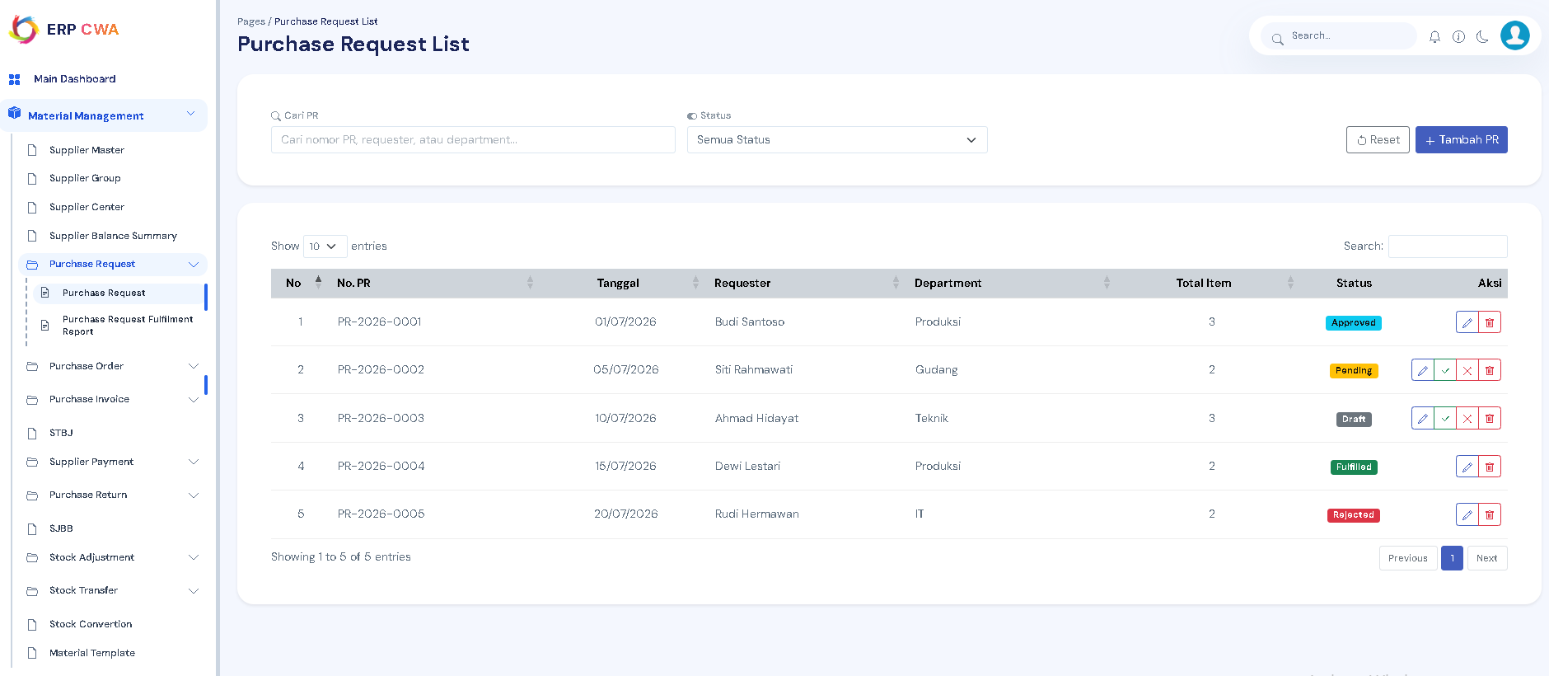
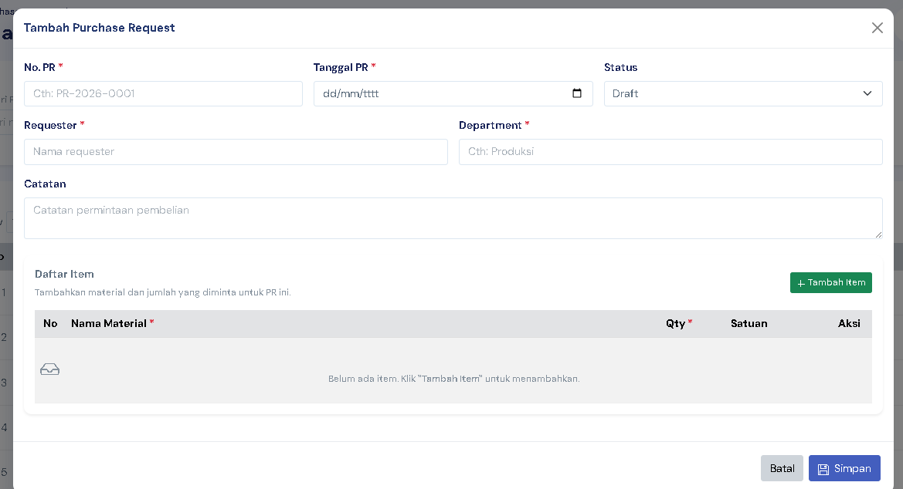

-Purchase Request Fulfilment Report
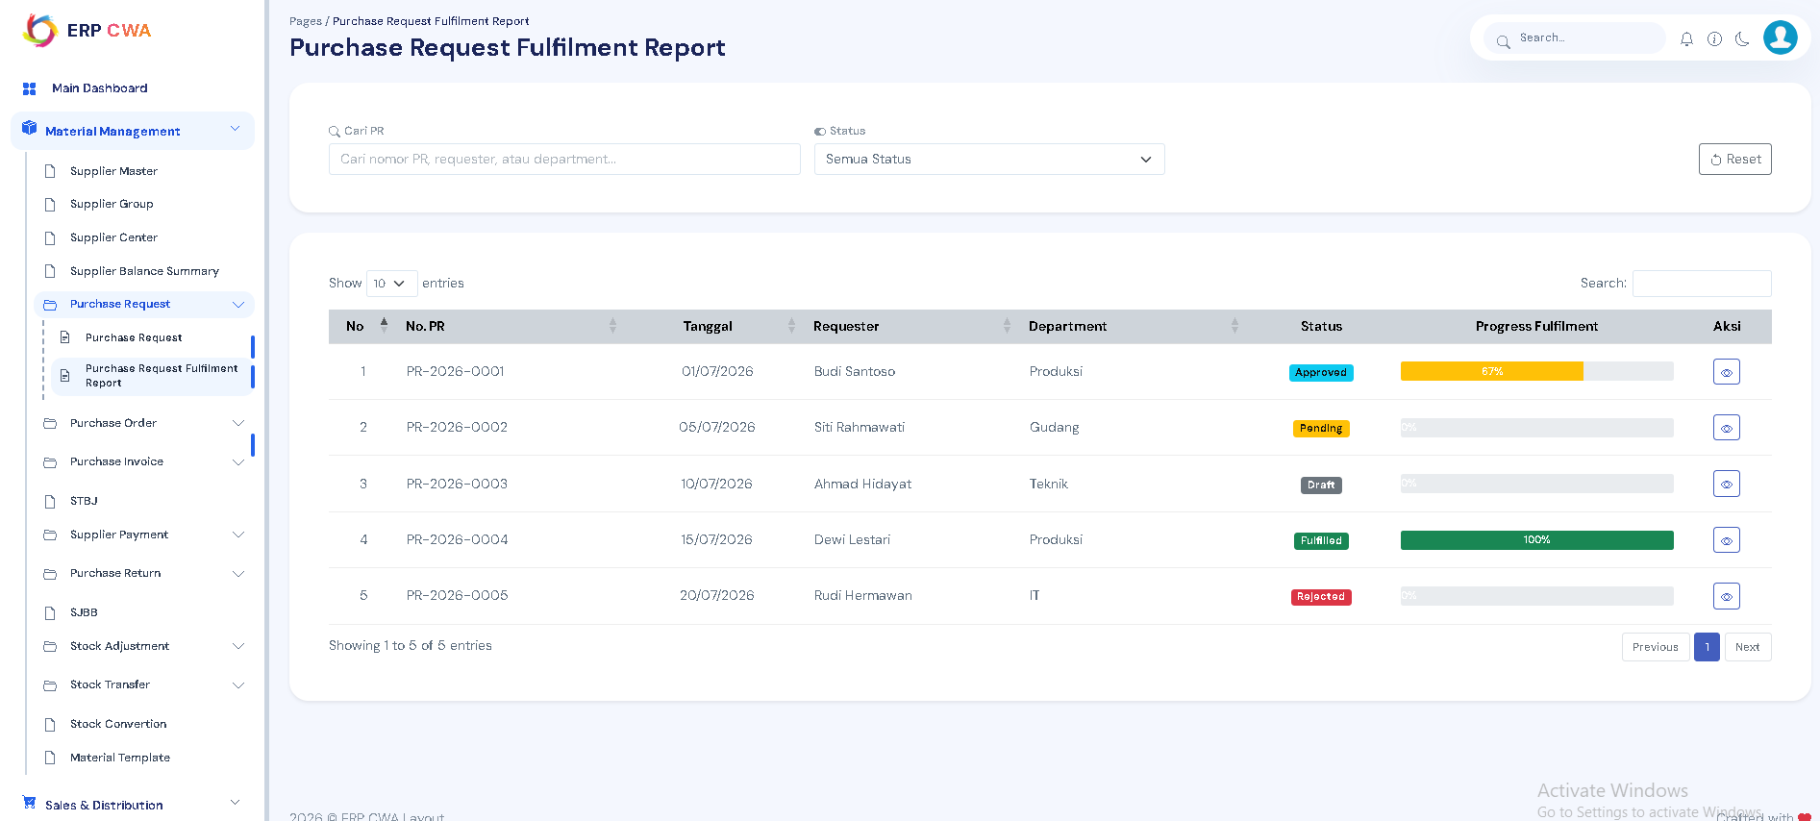

Purchase Order

-Purchase Order List
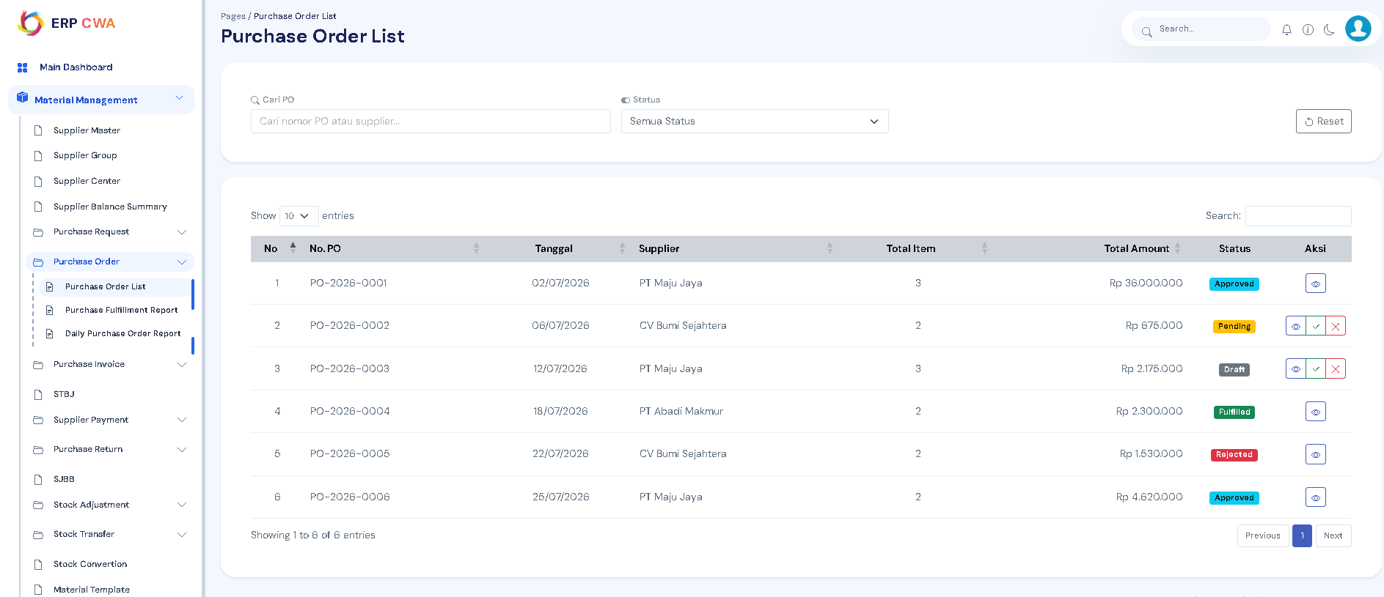

-Purchase Fulfillment Report
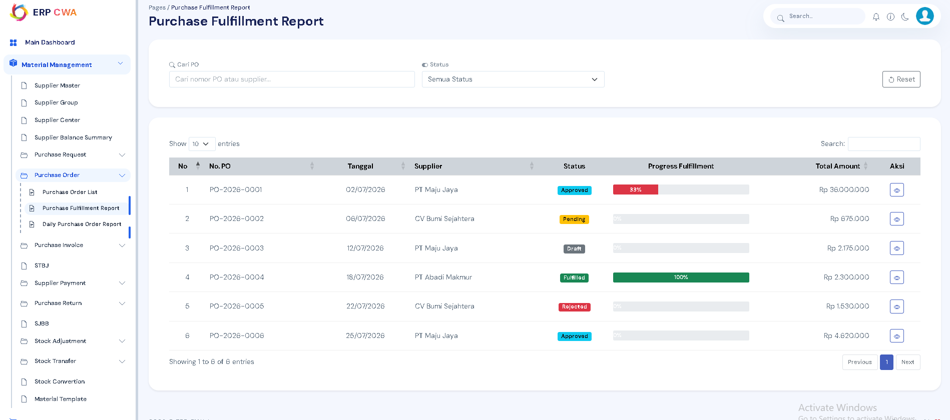

-Daily Purchase Order Report
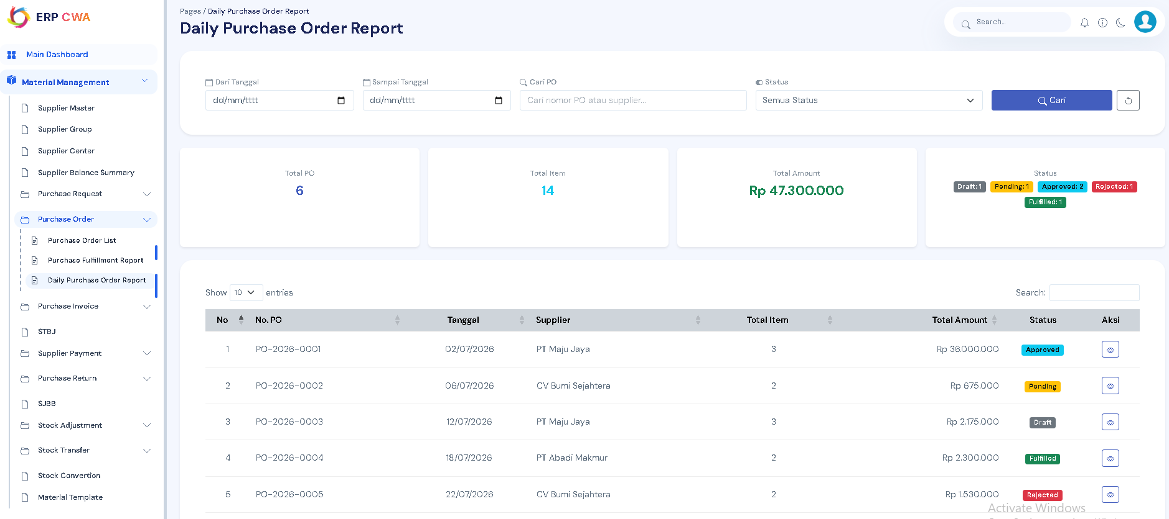

Purchase Invoice

-Purchase Invoice List
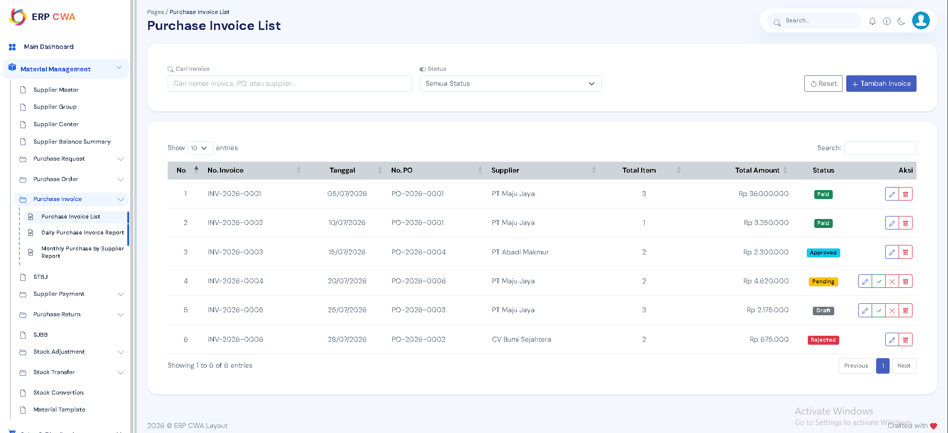

-Daily Purchase Invoice Report
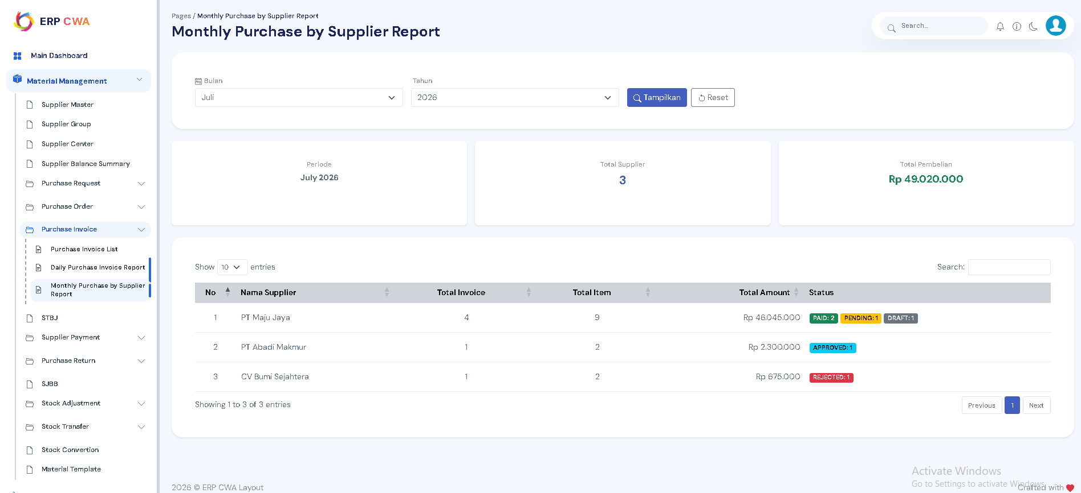

-Monthly Purchase by Supplier Report
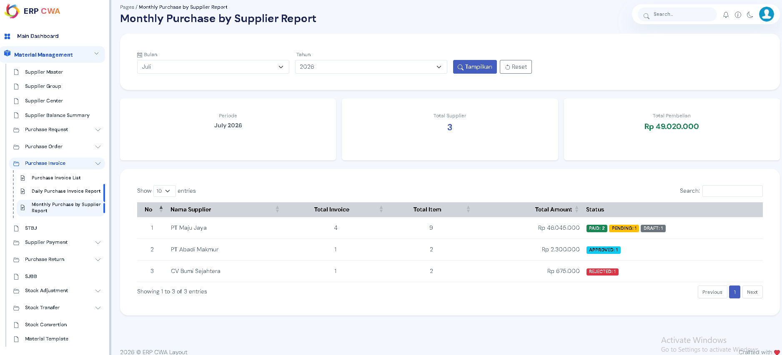

STBJ
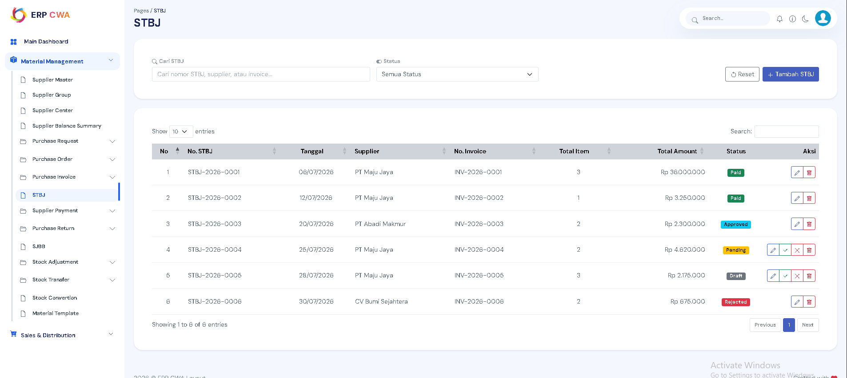

Supplier Payment

-Supplier Payment List
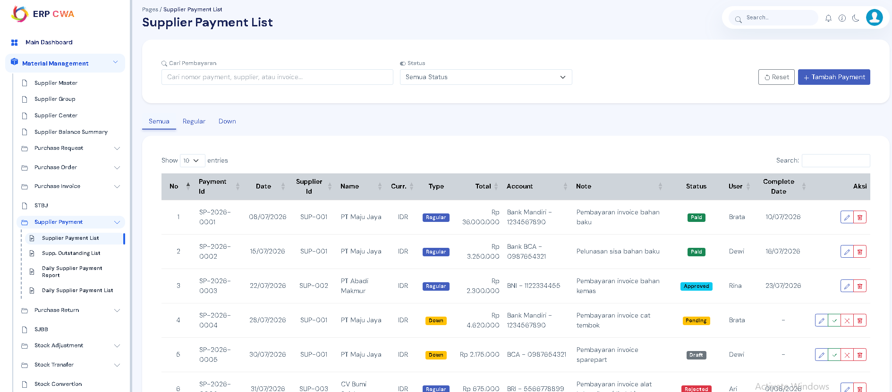

-Supp. Outstanding List
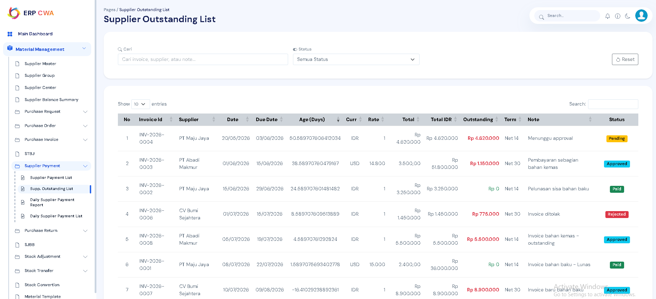

-Daily Supplier Payment Report
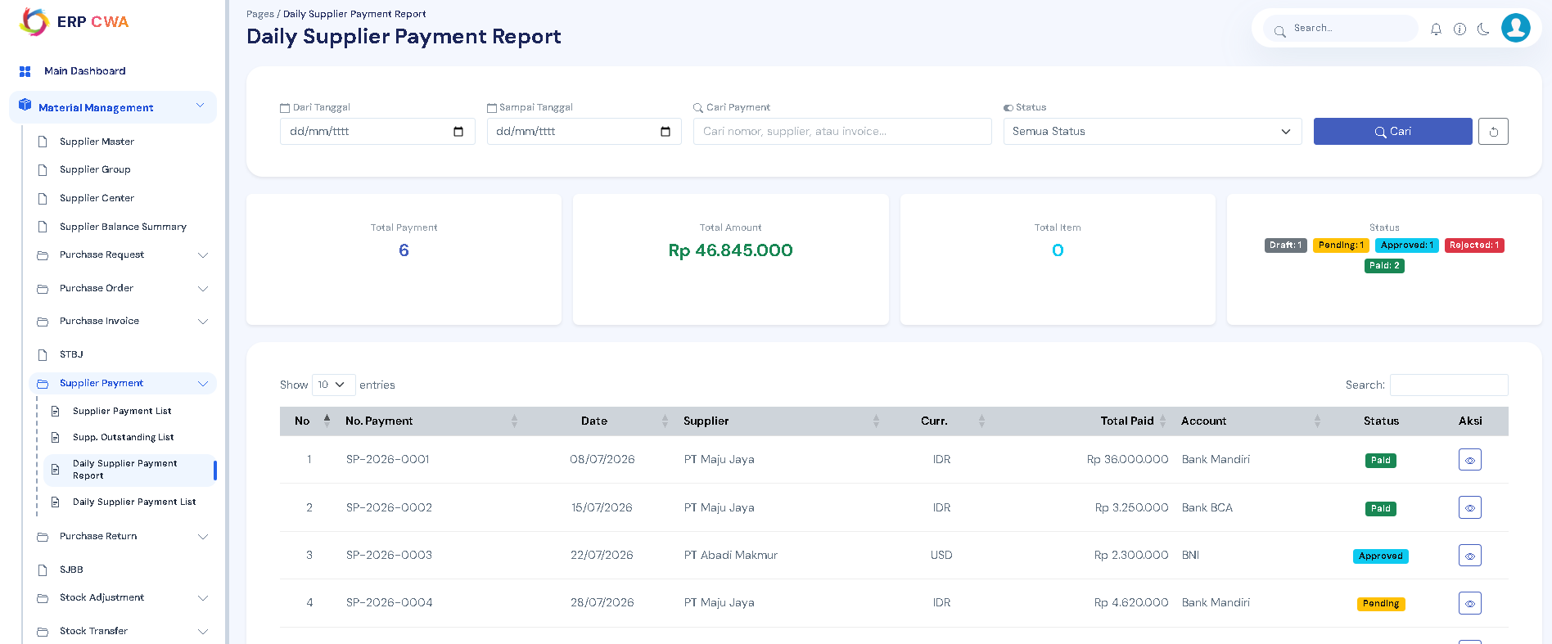

-Daily Supplier Payment ListPurchase Return
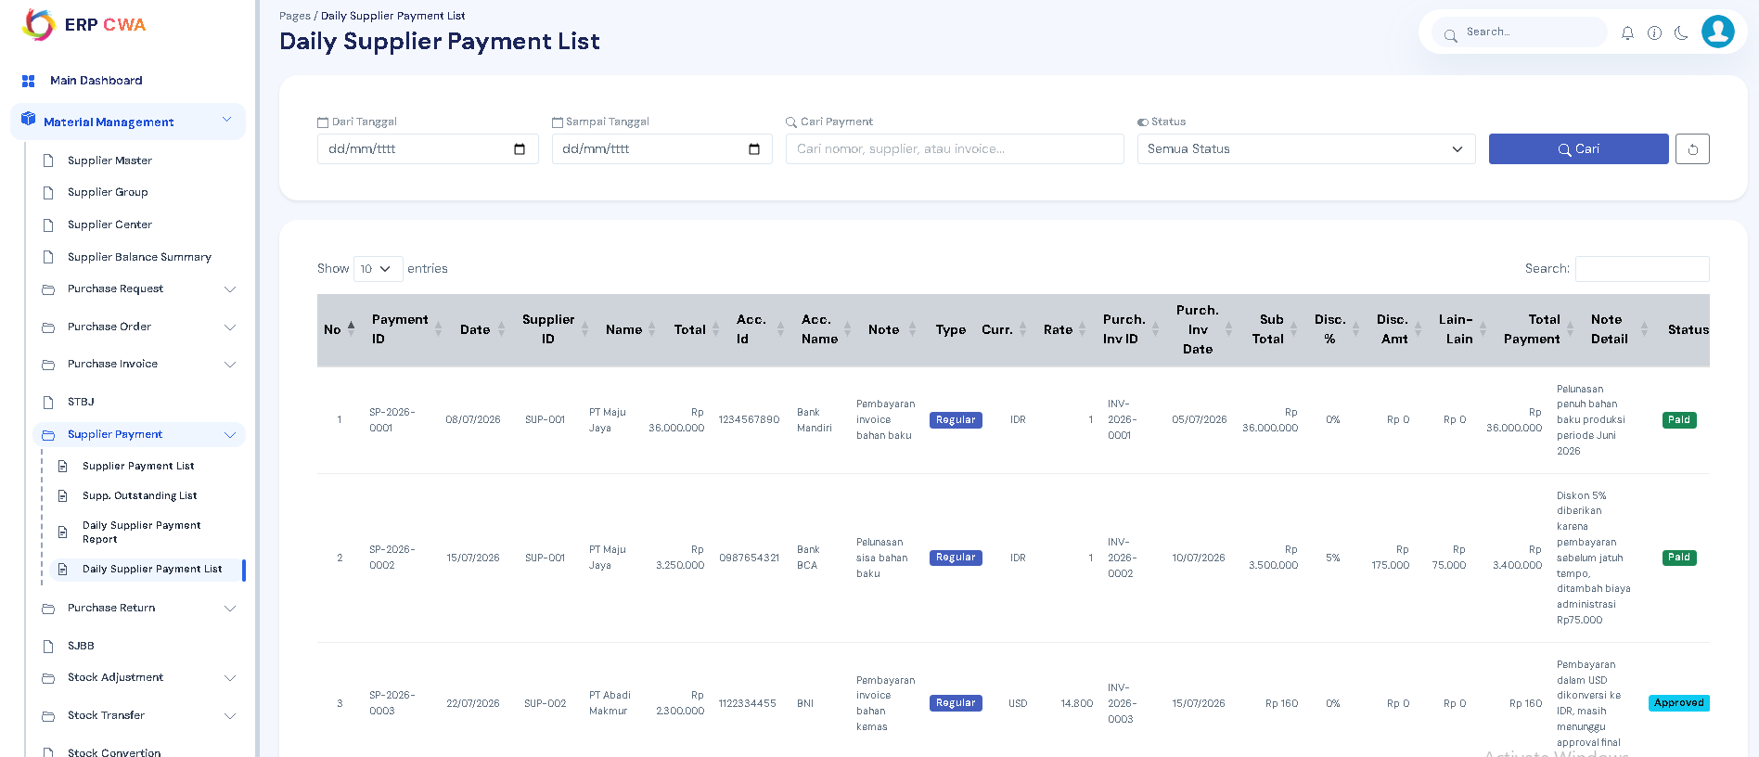

Purchase Return List
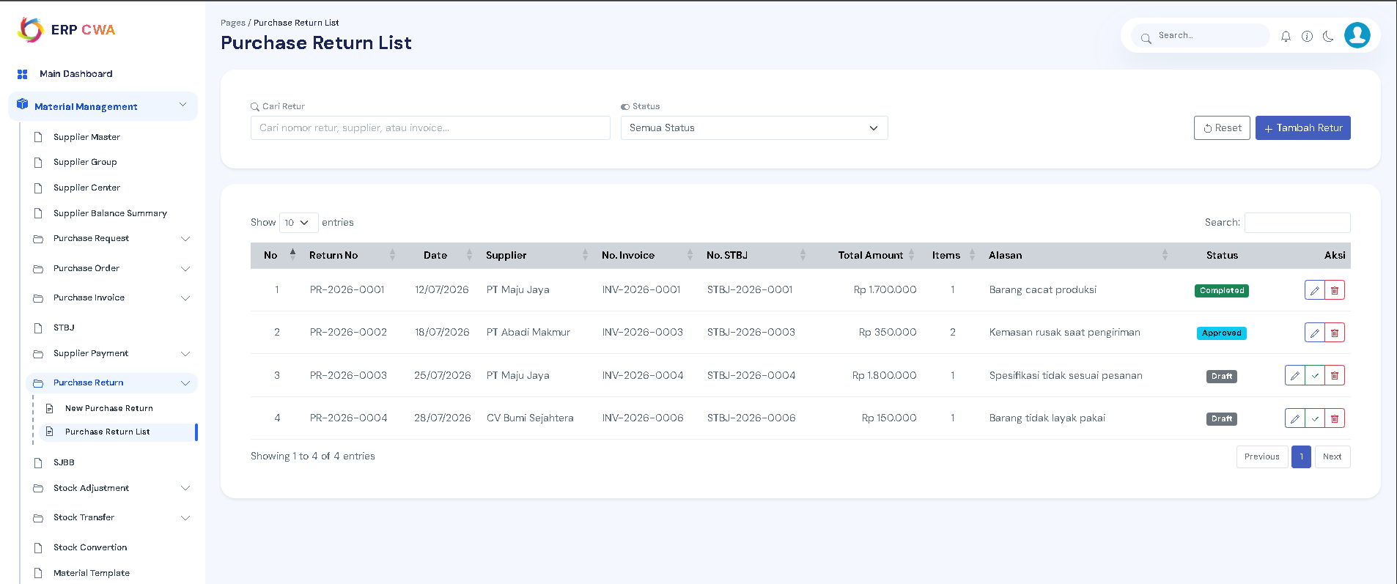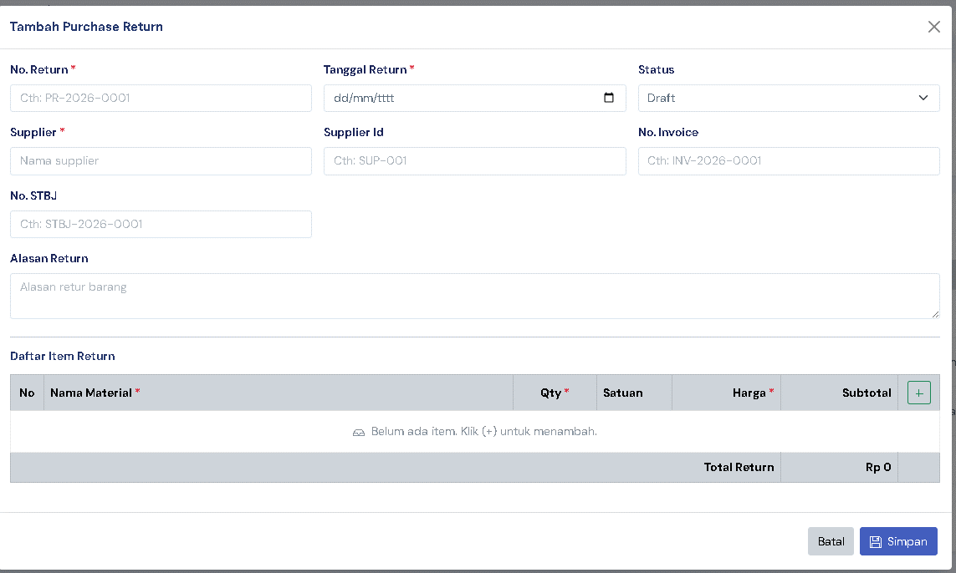

SJBB
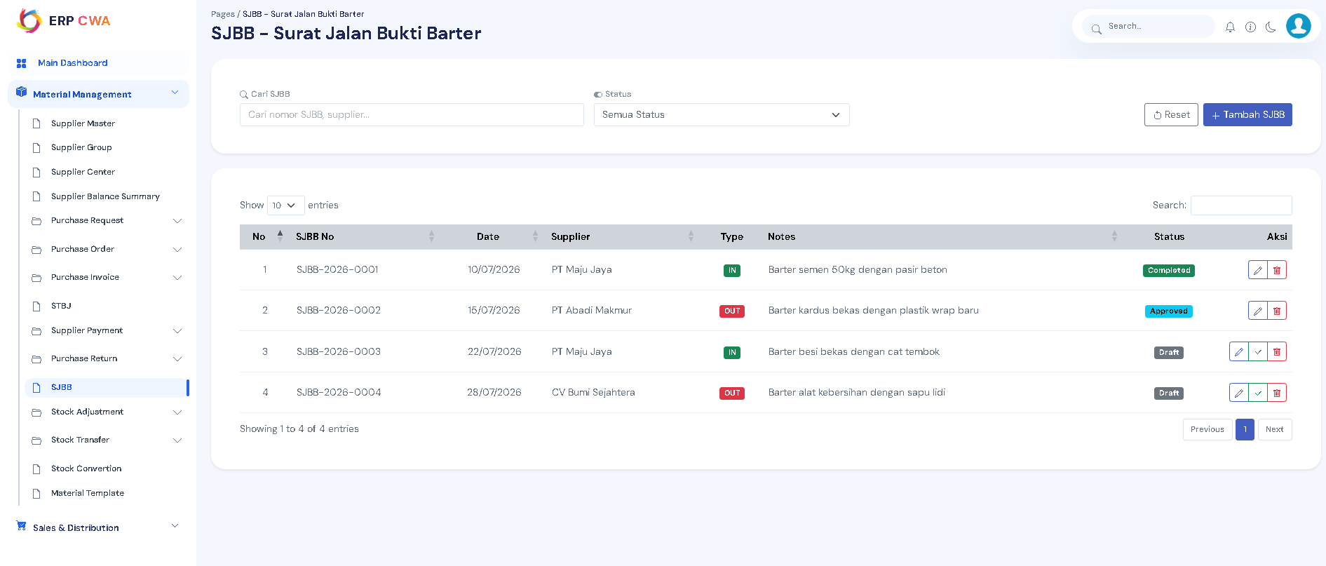
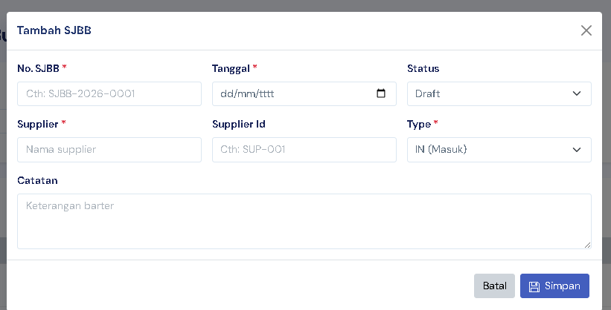

Stock Adjustment

-Stock Adjustment Use
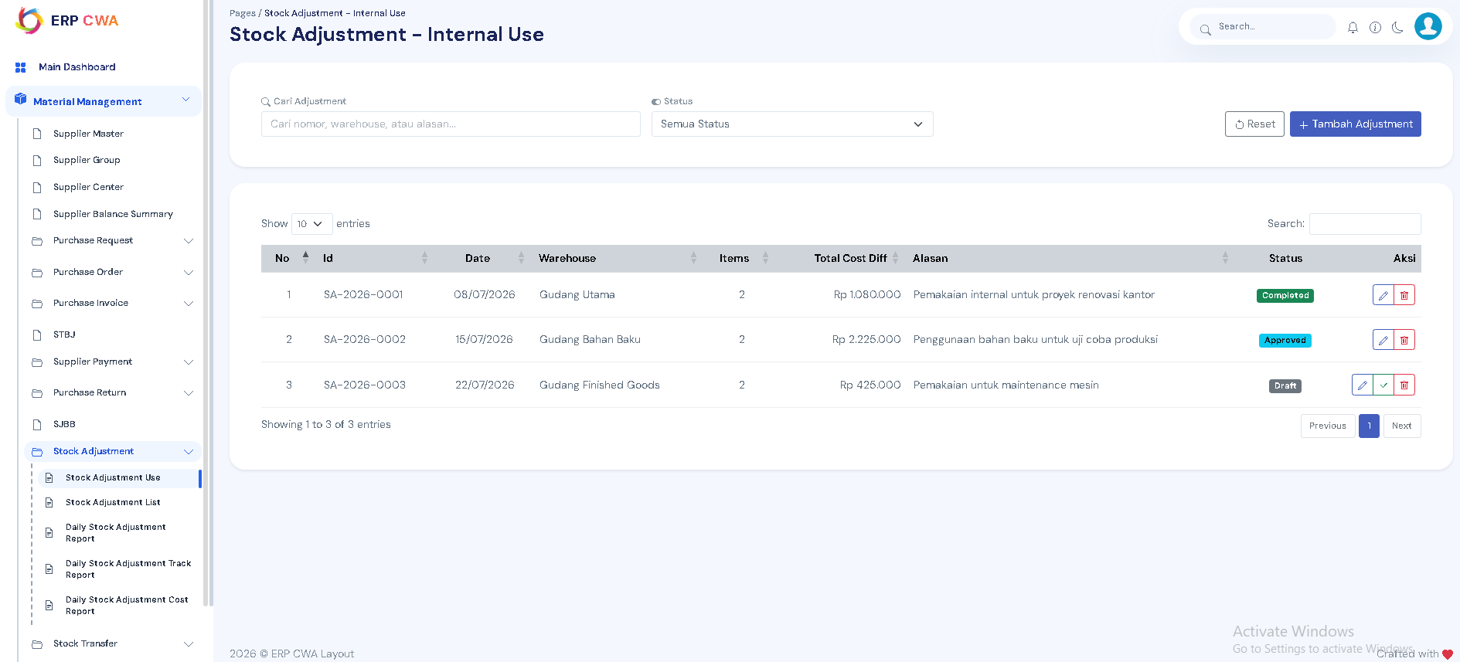

-Stock Adjustment List
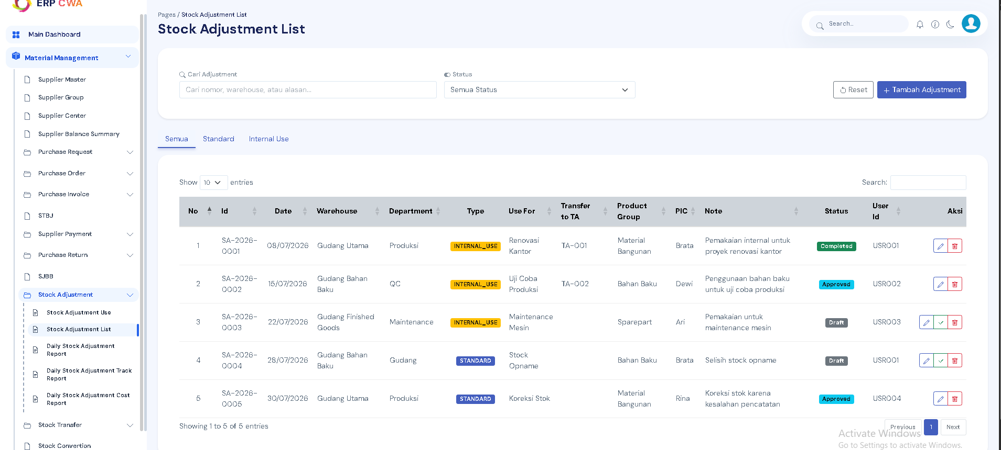

-Daily Stock Adjustment Report
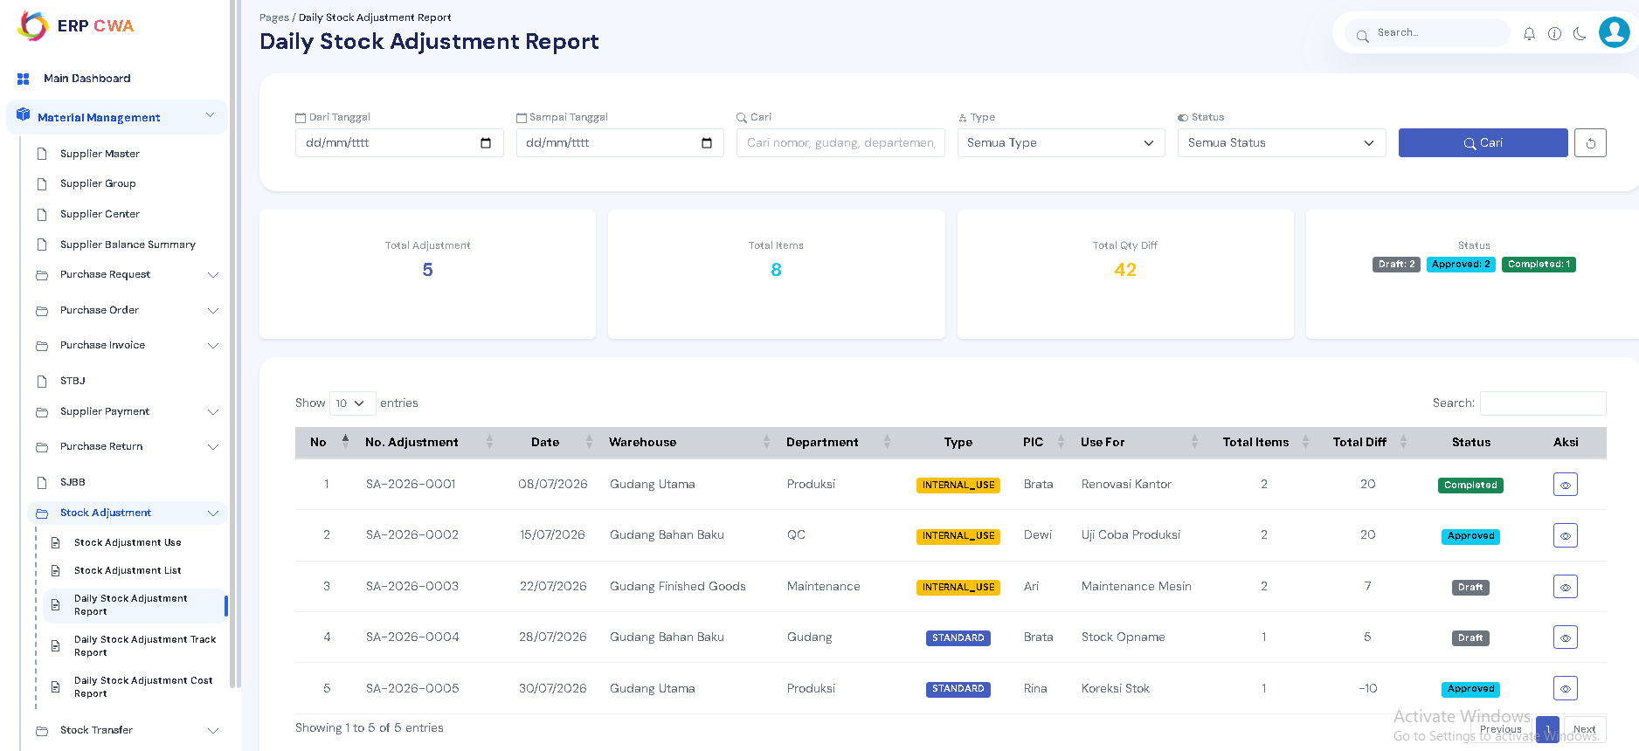

-Daily Stock Adjustment Track Report
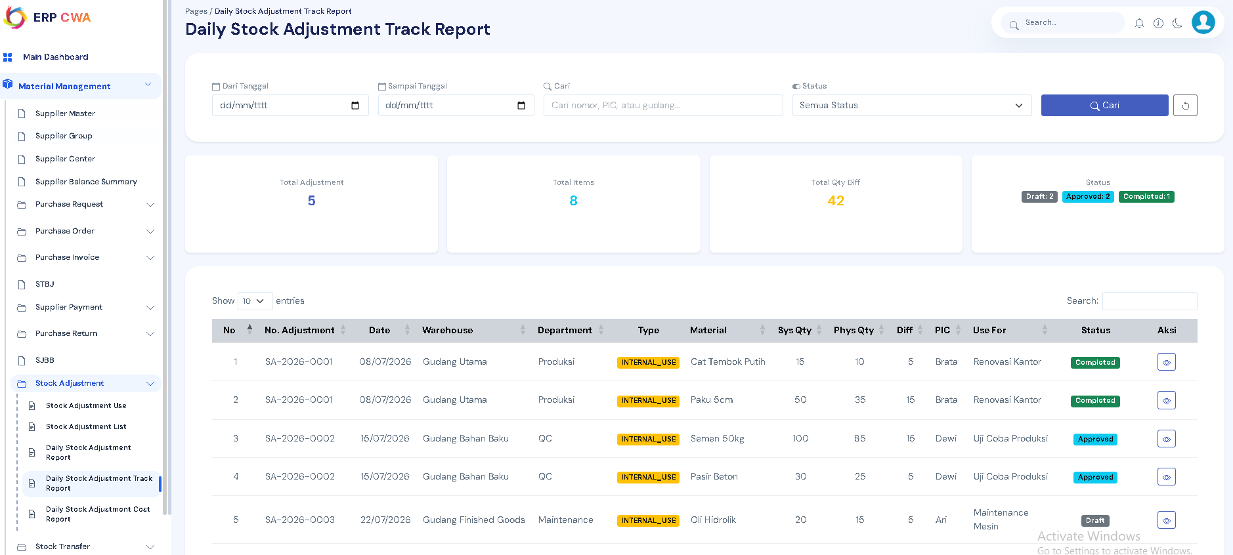

-Daily Stock Adjustment Cost Report
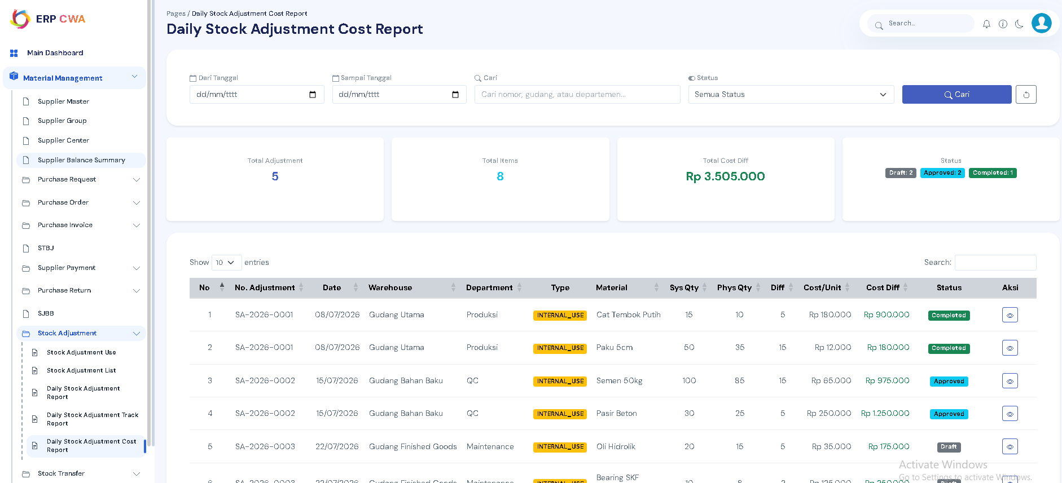

Stock Transfer

-Stock Transfer List
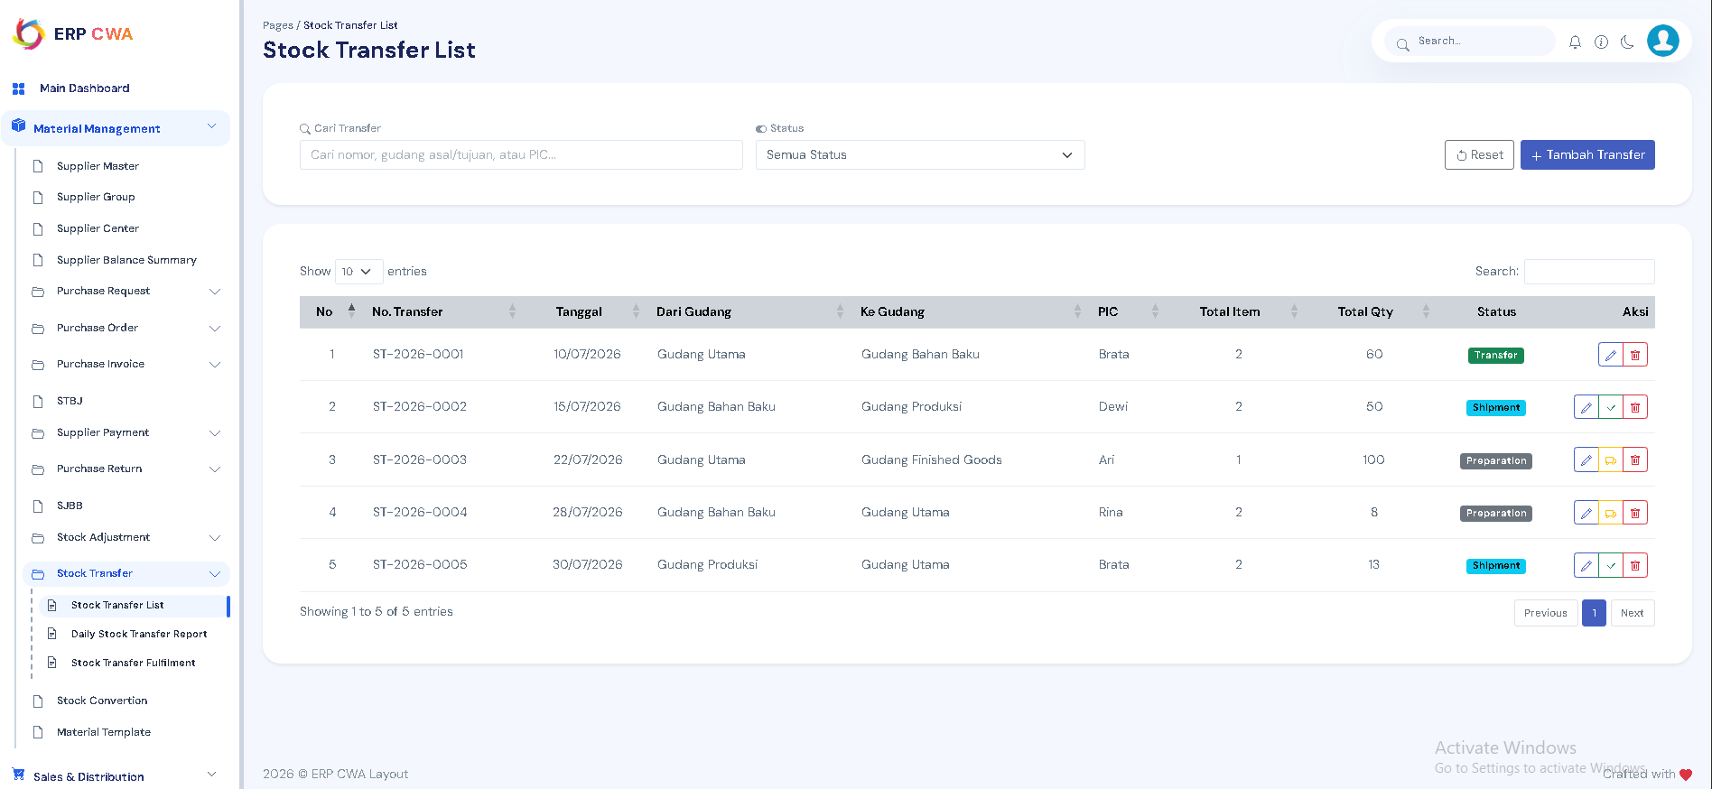

-Daily Stock Transfer Report
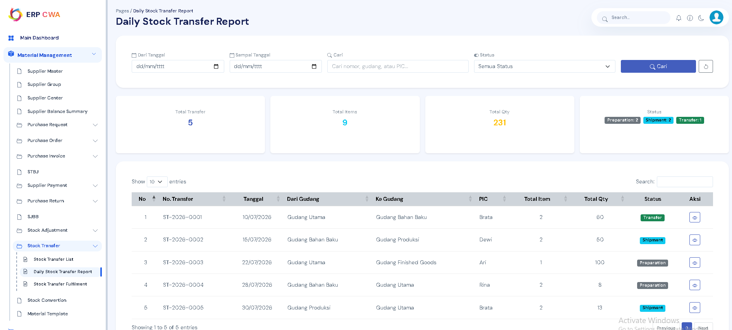

-Stock Transfer Fulfilment
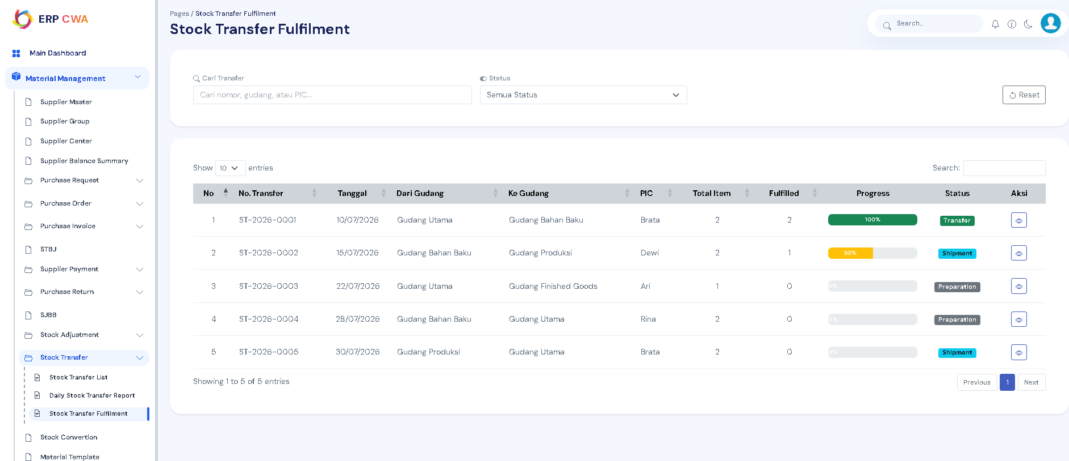

Stock Convertion

Material Template

