+ Git flow = the set of guidelines that developers can follow, there are not the rules.
+ It is a standard for an ideal project.
+ It is referred to as “Branching Model”.

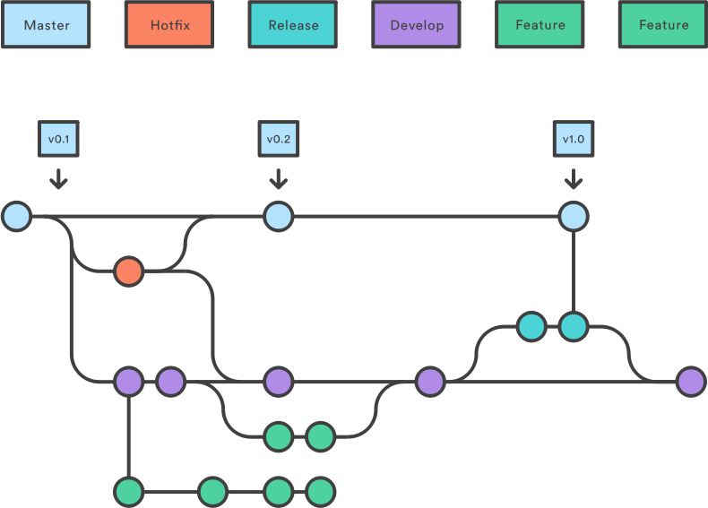
There can be following types of branches:
- Master
- Develop
- Hotfixes
- Release branches
- Feature branches

1. The main branches

Two of the branching model’s branches are considered as main branches of the project:
+ master
+ develop
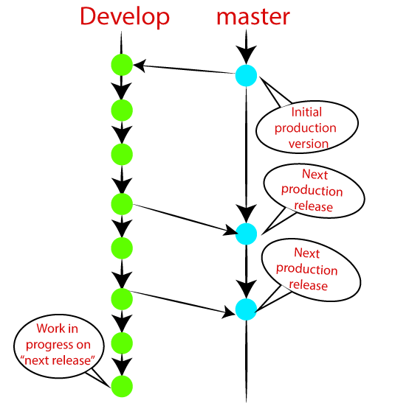

Master:
+ contains all the history of final changes, final version of the project
+ local master branch always up to date with the remote master branch
+ if you edited the master branch of group project, your changes would affect everyone, there will be merge conflict

Develop:
+ parallel to the master branch, also considered as the main branch of the project
+ this branch contains the latest delivered development changes for the next release.
+ it is also called as a “integration branch”
+ at release time, develop branch should be merged with master and tagged with a release version

2. Supportive branches

The development model needs a variety of support branches for the parallel development, tracking of features, assist in quick fixing and release. These branches have a limited lifetime and are removed after the uses

• Feature branches
• Release branches
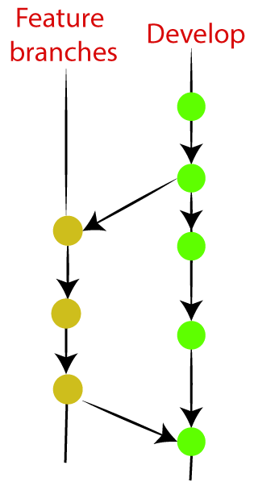
• Hotfix branches

Release branches
+ is created for support of a new version release
+ release branch will contain the predetermined amount of the feature branch
+ should be deployed to a staging server for testing
+ developers are allowed for minor bug fixing and preparing meta-data for a release on this branch. After all these tasks ,it can be merged with the develop branch.
+ when all the targeted features are created, then it can be merged with the develop branch
Hotfix branch
+ arise due to immediate action on the project.
+ in case of a critical bug in a production version, a hotfix branch may branch off in your project
+ after fix the bug, this branch can be merged with the master branch with a tagThe release branch will contain the predetermined amount of the feature branch.

