SAPTaskBar is an analogue of the standard windows taskbar, only heavily customized to the needs of SAP GUI users, makes working with SAP more enjoyable and productive.

If you regularly have about ten or more SAP GUI windows open on various systems, you need this program.

Enough already confused in the windows, bring orderliness and convenience to your work.



SAPTaskBar

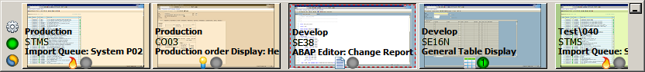

Содержание

[Introduction](#_Introduction)

[SAP systems, entry and navigation](#_SAP_systems,_entry)

[Filtering SAP GUI buttons and windows by SAP systems](#_Filtering_SAP_GUI)

[Configure SAP systems list](#_Configure_SAP_systems)

[Operations with groups of marked buttons](#_Operations_with_groups)

[Selecting a marker to mark buttons](#_Selecting_a_marker)

[Installing an icon on a button](#_Installing_an_icon)

[Assigning an icon to the window title text](#_Assigning_an_icon)

[Quick view of window contents](#_Quick_view_of)

[Settings menu](#_Settings_menu)

[Icon in notification area](#_Icon_in_notification)

[Main settings](#_Main_settings)

[Other settings](#_Other_settings)

[Automatic SAP GUI tuning](#_Automatic_SAP_GUI)

[Tools and components used in development](#_Tools_and_components)

[LICENSE TO USE AND DISTRIBUTION](#_LICENSE_TO_USE)

# Introduction

The following words are often used in the text below:

* Panel - refers to the taskbar of the SAPTaskBar program
* Button - means the button corresponding to the SAP GUI window on the taskbar
* Window - means SAP GUI window
* System - a combination of: SAP system + Client (mandant)

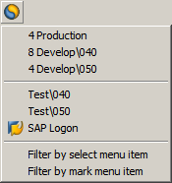

Open systems of SAP

When you select an item, the panel will scroll so that the buttons of the corresponding system become visible

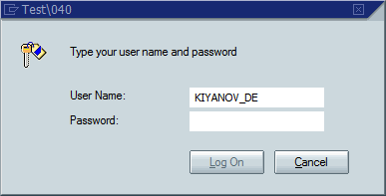

(The shortcut login option has been used)

Launch of SAP Logon

Changes the behavior when selecting a menu item with an already open system, instead of scrolling, the buttons and windows of the SAP GUI of the respective systems are hidden/displayed. For a description, see the following item

The menu appears when you click the button

Login to another SAP system

Number of SAP GUI windows opened in the system

# SAP systems, entry and navigation

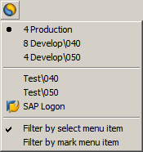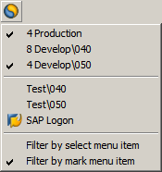

The filtering mode for **one** selected system is turned on. Hidden buttons and windows of all systems except one selected

Hidden are the buttons and windows of these systems

The buttons and windows of this system is displayed

The menu appears when you click the button

The filtering mode for the selected systems is turned on. Hidden buttons and windows of all systems except the selected (marked)

The menu appears when you click the button

The buttons and windows of this systems are displayed

The buttons and windows of this system is hidden

# Filtering SAP GUI buttons and windows by SAP systems

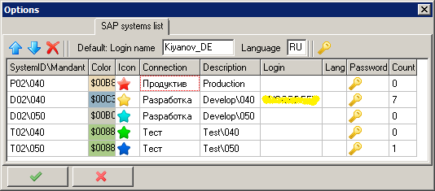

You can configure the parameters for displaying and logging in to SAP systems on the "SAP systems list" tab in the program settings (C:\Users\Kiyanov_DE\Desktop\Lazarus\img\1441028770_settings1_16x16.png\SAP systems list). To login into corresponding SAP system, a shortcut is automatically created and then executed, more information about shortcuts can be found here: <https://www.google.com/?gws_rd=ssl#newwindow=1&q=sap+shortcut+site:help.sap.com>

Rows are added to the systems list automatically when the program detects the SAP GUI window with a **new** system. In the list you can fill input/correct fields:

* Description – is filled in automatically, but can be corrected, is displayed on the button
* Login – used at login, if not filled, the value «Default login name» is used
* Language – the login language, if not filled, the value «Default language» is used
* Color – the background color under the window thumbnail is visible at the edges, if the window is not expanded to full screen, it is automatically adjusted to the main color of the system window, but can be fixed.
* Icon – from the drop-down list you can select an icon for the selected system, which will be displayed on the button
* Password – from the drop-down list you can call up a dialog for entering a password to enter the selected system, the specified password is automatically entered when entering the selected system. The entered passwords are stored in a separate configuration file in encrypted form, if necessary, you can specify your password to encrypt this file

You can also adjust the order of the systems in the list, the buttons on the panel are displayed and grouped in the same order.

Move selected row up

Move selected row down

**Delete** selected row

The number of windows opened in the corresponding system

Text from SAP Logon

The settings shown here apply only to the SAPTaskBar program and cannot in any way affect or change the settings and operation of the SAP Logon and / or SAP GUI programs

# Configure SAP systems list

Entering a «master» password for encrypting a file with passwords for SAP systems

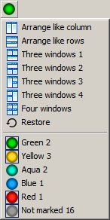

Location for more than one windows

Location for three windows

Location for four windows

Restore the original position of the windows

Displayed window groups

Displayed window groups

Hidden window groups

Automatically placing SAP GUI windows on the screen, whose buttons are marked with the current marker

Hiding / showing windows marked with a marker of the corresponding group (icons of displayed groups are marked)

The menu appears when you click the button

Number of buttons marked with this marker

# Operations with groups of marked buttons

The icon on the button corresponds to the current marker

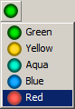

# Selecting a marker to mark buttons

The menu pops up when the **right** mouse button is pressed above the button.

After selecting an item from the menu, the icon on the button will change to the selected marker.

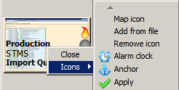

# Installing an icon on a button

Above the button, the pop-up menu, the "Icons" item.

Assigning an icon to the window title text, see the following item

Loads icon from any file in png format and size 16x16. After downloading, the file is added to the list of icons, and the next time it can be selected from it.

Deletion of a previously assigned icon

Button mark icon. Unlike the «Map icon» item, the assignment is not saved, it is applied only to the specific button selected at the current time, ie, for example, after restarting the program, the icons assigned in this way will no longer be displayed.

Installed icon

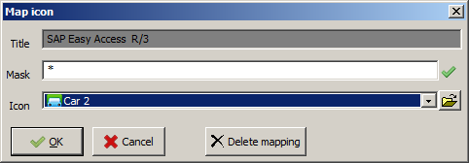

# Assigning an icon to the window title text

The title text of the window for which the icon is being assigned (not editable)

Select an icon from the drop-down list

You can download an icon from a file in png format, image size 16x16

**Delete** a previously created assignment

To assign an icon to the text of a window title - enter a mask. Symbol "\*", for skip any sequence of characters and symbol "+", for skip one arbitrary symbol. **The mask must correspond to the text of the window title for which the icon is assigned.**

Button, becomes active if the icon is selected

# Quick view of window contents

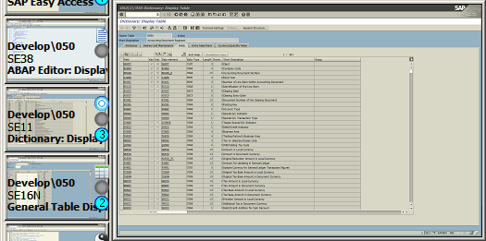

Point the mouse cursor at the desired button and press Ctrl + Alt, a quick view window will appear next to the button.

The size of the window can be adjusted by stretching its borders with the mouse.

quick view window



Ctr+Alt+

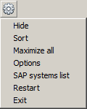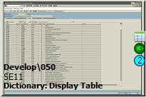

Maximizes all visible SAP GUI windows

Opens the settings window with the "Main" tab.

Opens the settings window with the "SAP systems list" tab.

Restarting the program (for example, if it was buggy)

Terminate the program



Closes SAP GUI window

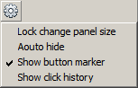

Only for marked buttons. Puts buttons with the same marker next to the selected button.

The history of button presses, the order of clicks is counted from the last button pressed, can be called by pressing Ctrl + Alt

The menu pops up when you right-click on the button

Puts buttons in the order of the systems, needed, for example, if the buttons were moved manually

Меню в The menu appears when you click the button

ыпадает при нажатии на кнопку

[Assigning an icon to a button](#_Installing_an_icon)

# Settings menu

Popup menu above button

# Icon in notification area

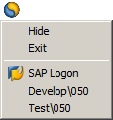

Windows taskbar notification area icon

Hide panel

Exit from the program



Вход в систему SAP

The menu appears when you right-click on the icon

Double-clicking on the icon will display the panel if it was hidden

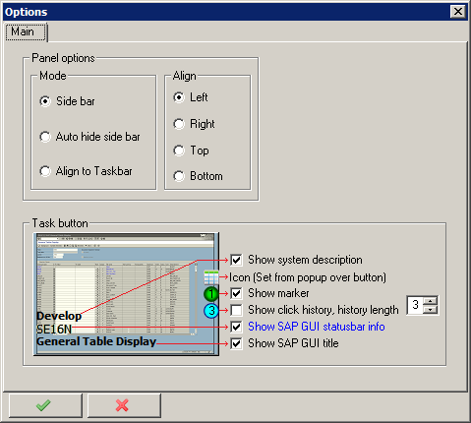

The panel can be located on either side of the screen

Fixed panel on the edge of the screen, during installation, changes the working area of the screen

Automatically hiding / showing panel - the panel appears on the screen when the mouse cursor moves to the corresponding edge of the screen and hides when the mouse cursor moves away from the panel

The panel is located along the standard windows taskbar, is displayed when you click the "SAPTaskBar" task button in the standard windows task bar and automatically hides when the mouse cursor moves away from the panel

# Main settings

The history of button presses, the order of clicks is counted from the last button pressed, can be called by pressing Ctrl + Alt

This functionality was removed due to instability

# Other settings

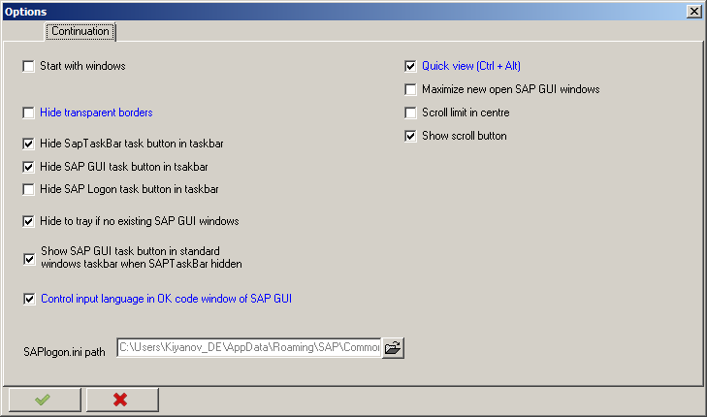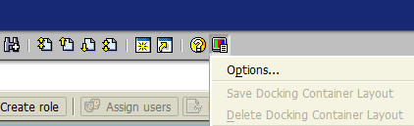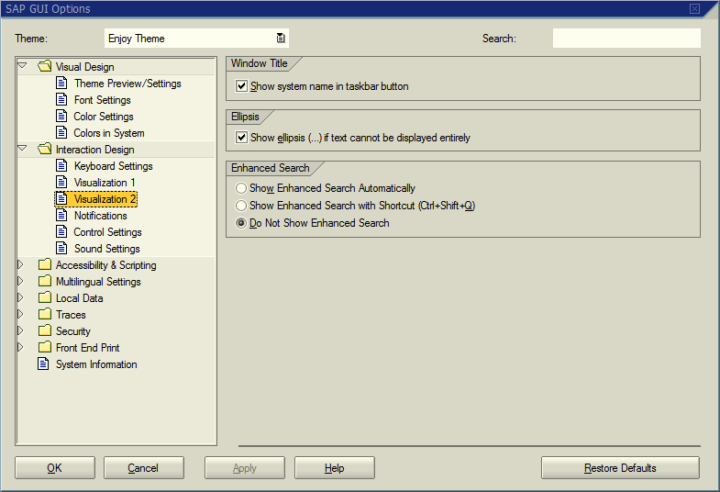

# Automatic SAP GUI tuning

For grouping buttons by systems and clients - this checkbox is automatically set at program start

# Tools and components used in development

* Developed using the **Lazarus IDE** www.lazarus-ide.org
* Some icons are taken from www.aha-soft.com site
* Use the library for Pascal language:
* FPC libraries like RTL, FCL and LCL and also some bundled packages as part of Lazarus IDE
* Graphics32 www.graphics32.org

# LICENSE TO USE AND DISTRIBUTION

The MIT License (MIT)

Copyright (c) 2016 Kiyanov Dmitry

Permission is hereby granted, free of charge, to any person obtaining a copy

of this software and associated documentation files (the "Software"), to deal

in the Software without restriction, including without limitation the rights

to use, copy, modify, merge, publish, distribute, sublicense, and/or sell

copies of the Software, and to permit persons to whom the Software is

furnished to do so, subject to the following conditions:

The above copyright notice and this permission notice shall be included in all

copies or substantial portions of the Software.

THE SOFTWARE IS PROVIDED "AS IS", WITHOUT WARRANTY OF ANY KIND, EXPRESS OR

IMPLIED, INCLUDING BUT NOT LIMITED TO THE WARRANTIES OF MERCHANTABILITY,

FITNESS FOR A PARTICULAR PURPOSE AND NONINFRINGEMENT. IN NO EVENT SHALL THE

AUTHORS OR COPYRIGHT HOLDERS BE LIABLE FOR ANY CLAIM, DAMAGES OR OTHER

LIABILITY, WHETHER IN AN ACTION OF CONTRACT, TORT OR OTHERWISE, ARISING FROM,

OUT OF OR IN CONNECTION WITH THE SOFTWARE OR THE USE OR OTHER DEALINGS IN THE

SOFTWARE.