**Biostatistics**

**Lab 1**

*Tasks*

Install R and R Studio. Install Packages.

*Introduction*

The goal of today’s lab is to get R and R Studio installed and functioning on your computer. Once this has been accomplished, we will install a number of what are called “packages”. When you initially install R and R Studio, you install a “base” version of the program. It has a number of functions built in. The packages are extra functions that you can add on to base R to expand its functionality. It is similar to when you buy a new computer. A new computer often comes with some programs pre-installed. Other programs you have to install yourself. Which new programs you install will depend on how you will be using the computer. Similarly, we will install the R packages that will be necessary for the work we want to do. If you continue to use R in your personal research, you will likely install more packages in order to accomplish specific tasks.

*Installing Base R*

We will begin by installing the base R program.

Go to the R website: https://www.r-project.org

Next, click on the blue link **download R**

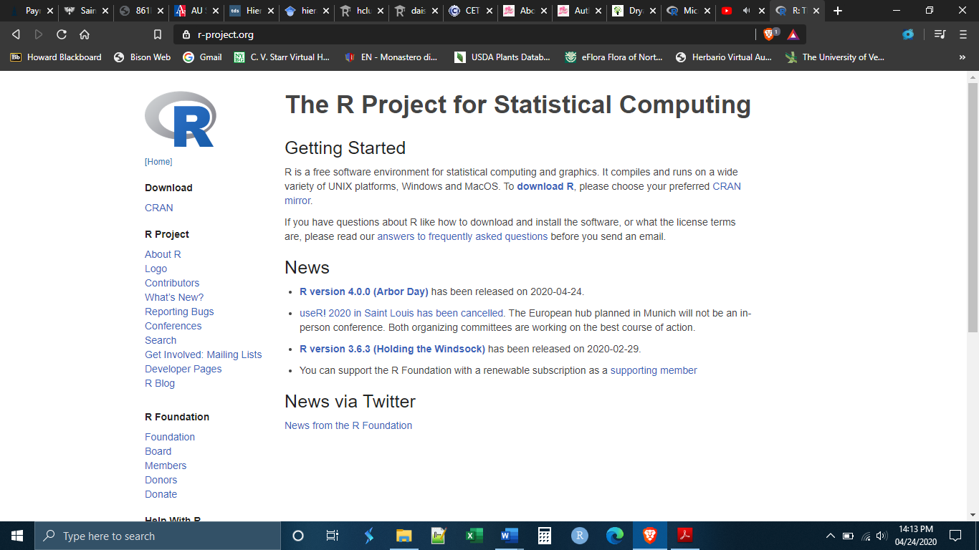

You will be taken to a new screen, asking you to choose which CRAN Mirror you want to download R from. CRAN is an acronym for “Comprehensive R Archive Network”. Basically, there are a number of places in the world where the R installation files are kept and you have to choose which one you want to download from. Hypothetically, they are all regularly updated and should be the same, but it is best practice to choose one that is physically close to you.

Scroll down and choose one of the CRAN Mirrors in the United States by clicking on the link.

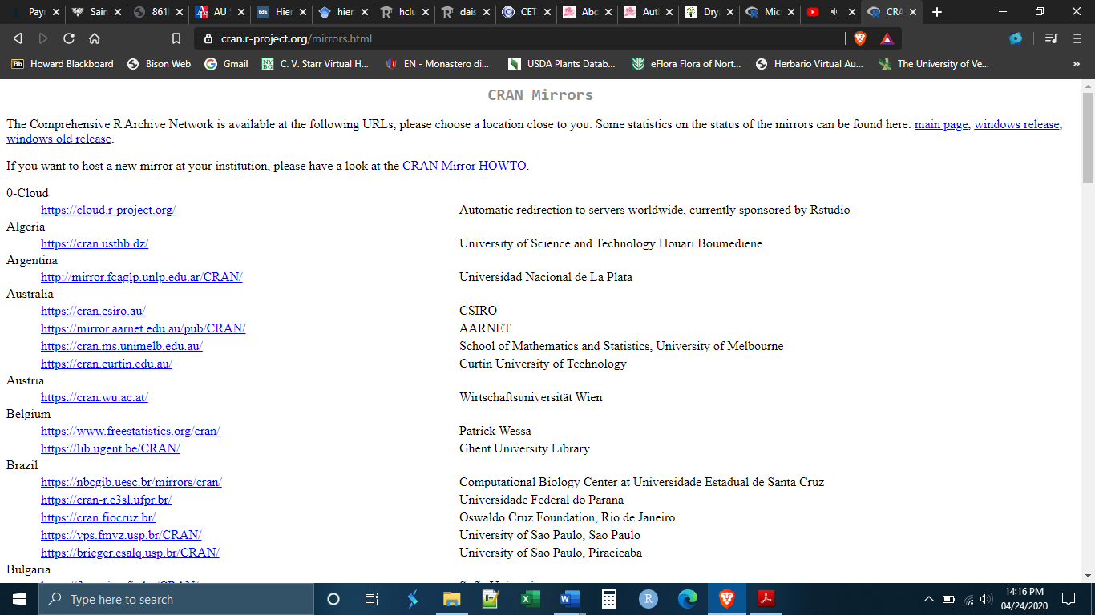

Once you have established a secure connection with a CRAN server you will get a new screen asking you which version of R you would like to install. Click on the link corresponding to the system that your computer is running (i.e. Linux, Windows, or Mac)

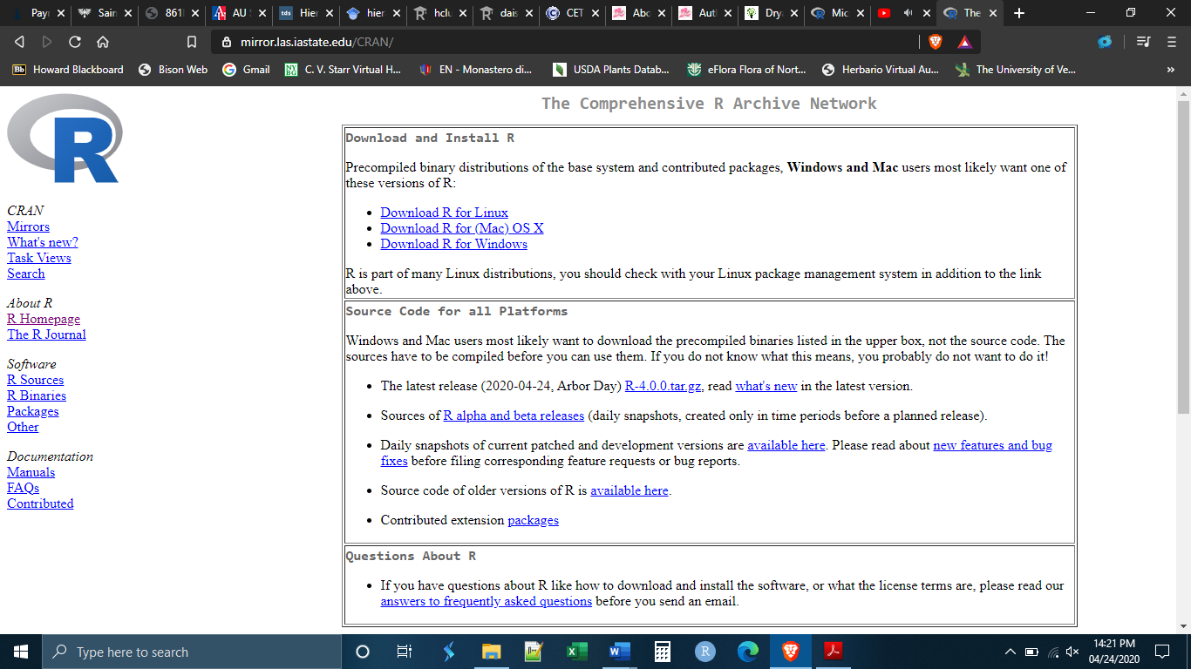

If you are running Windows, you will be sent to another screen asking which files you would like to download. Choose “Install R for the first time” or “base”.

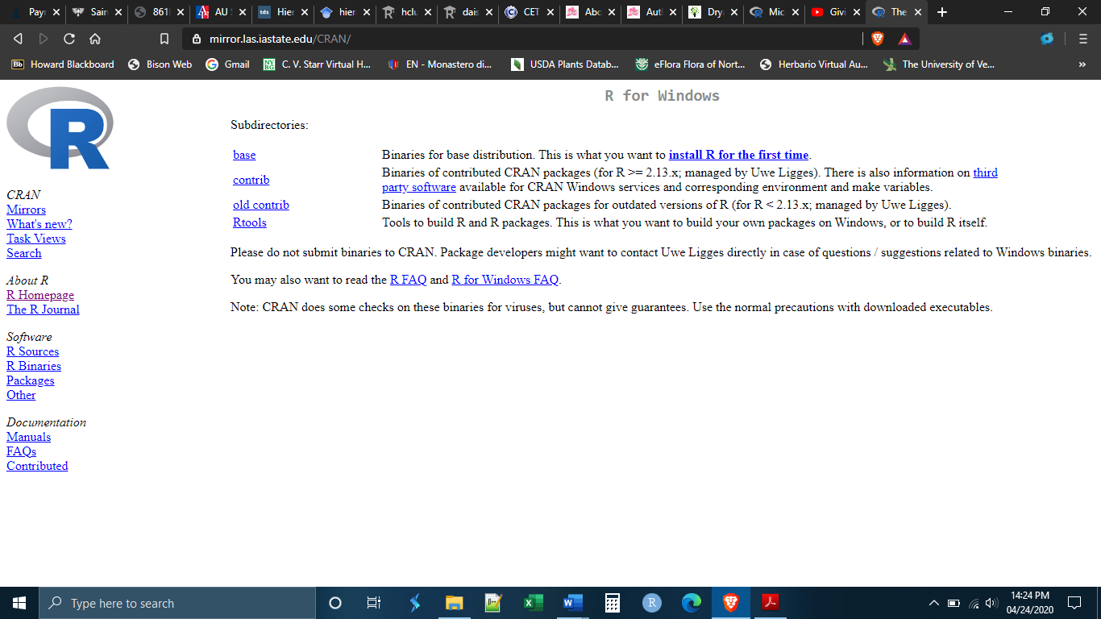

You will be brought to this page, click on “Download R 4.0.0”

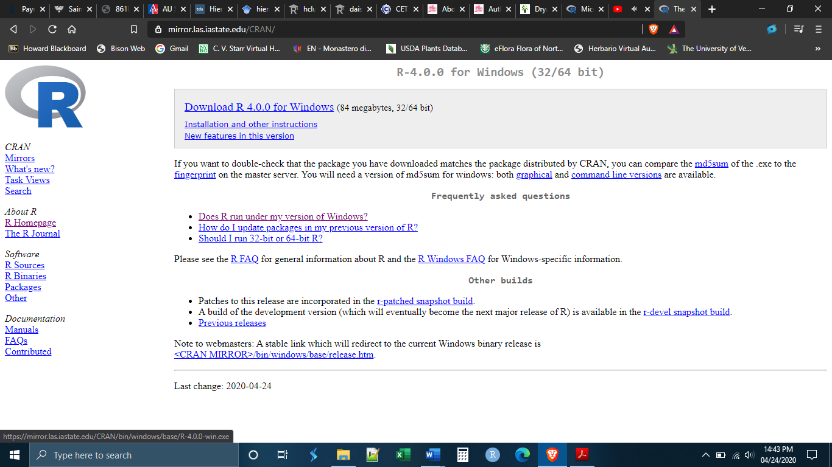

If you are using a Mac, the most recent release of R, has two different versions depending on Mac OS. You can select the appropriate version of R based on your OS. Alternately, you can choose to install the most recent version of R that works on all Mac OS - R 3.6.2.

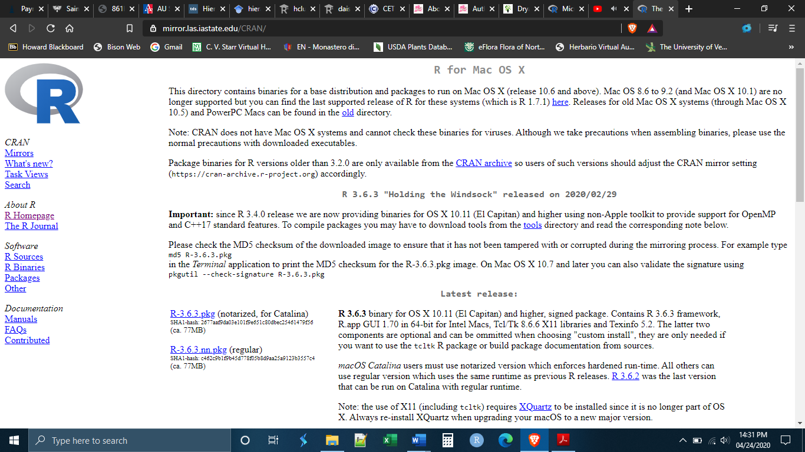

Once you have downloaded the file, go to your downloads folder, or wherever you have set downloads to go, and run the .exe file to install the software. You may be prompted to give R permission to install itself, click yes.

This will install base R on your computer.

*Installing R Studio*

You can run base R alone, without ever installing R Studio. Yet, base R has a number of inconveniences and limitations, and, because it is simply a command line prompt, it can be a bit intimidating especially for beginners. R Studio is a user interface built on top of base R that makes using R feel more like using other programs that we are used to. It also makes doing a number of things in R much easier. In this class, we will only use R within R Studio.

In order to install R Studio, go to the website: https://rstudio.com/products/rstudio/download/

Scroll down the page until you get to the download selection. Choose R Studio desktop version.

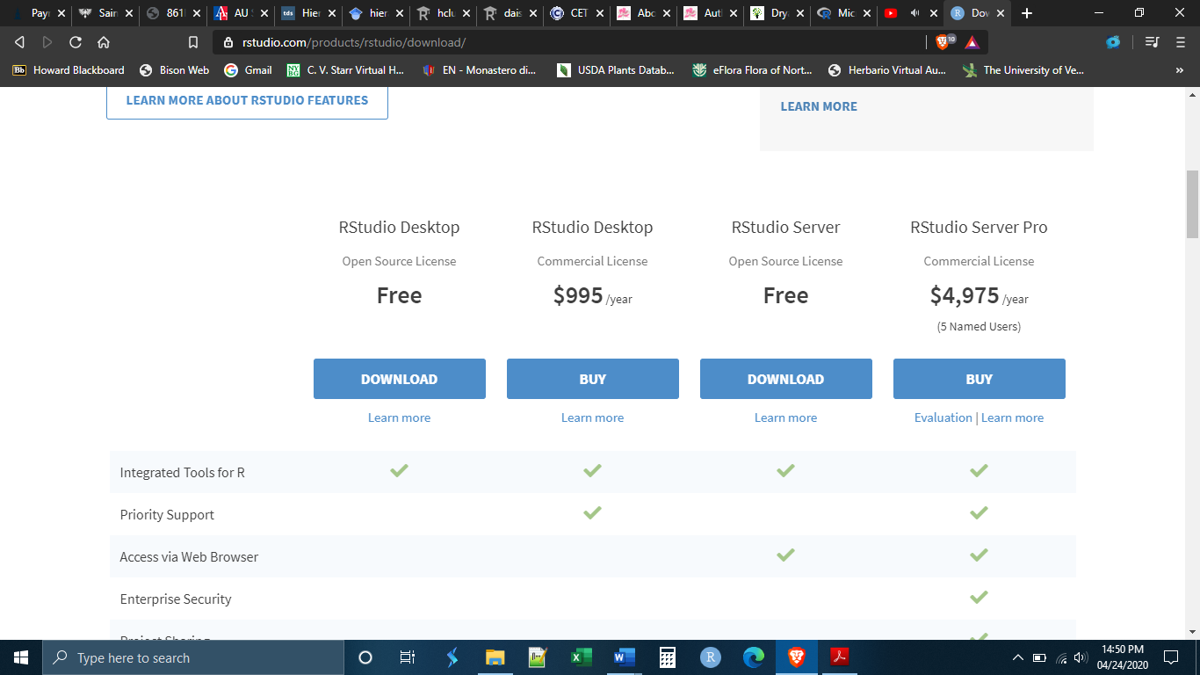

The website will make a download recommendation for your particular system. Click on the blue download button to download the installation files. Notice that step 1 is to install base R. We have just done this so there is no need to do it again. Remember that R Studio is built on top of base R. You cannot run R Studio without base R.

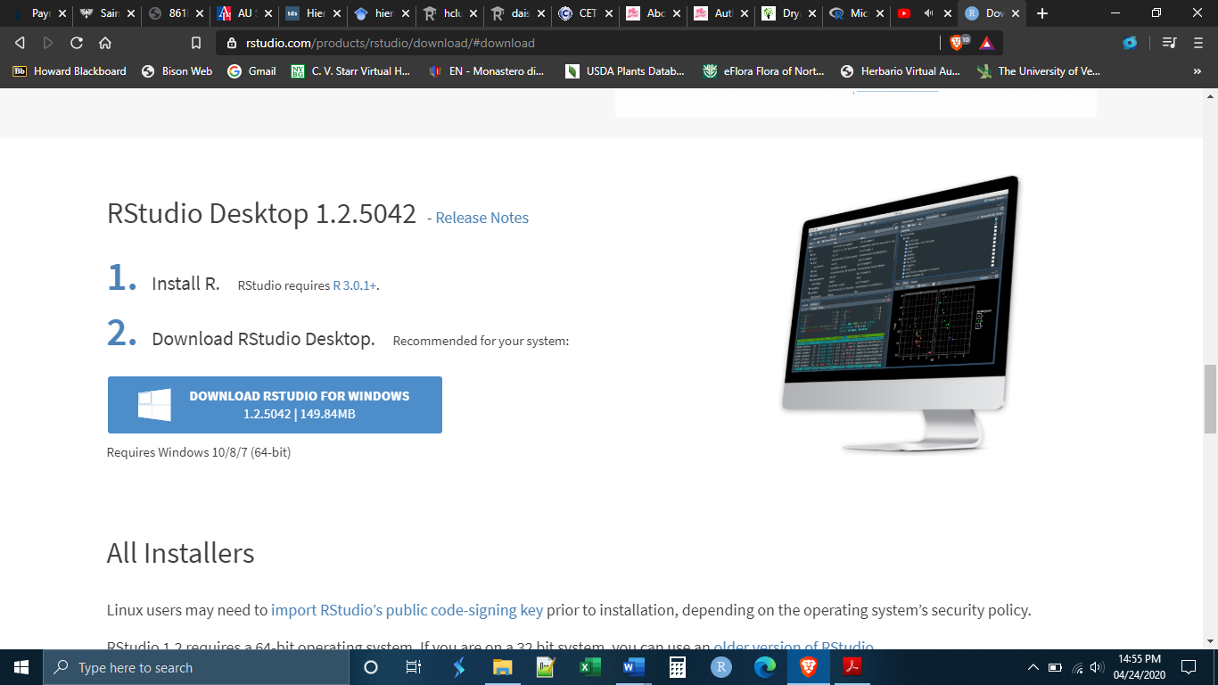

Once you have downloaded the file, go to your downloads folder, or wherever you have set downloads to go, and run the .exe file to install the software. You may be prompted to give R Studio permission to install itself, click yes. You may also be asked if you want to create a desktop icon, this is up to you but may be helpful in finding R Studio in the future.

This will install R Studio on your computer.

*Installing Packages*

As stated above, packages greatly expand the functionality of R. There are more than 15,000 R packages that you can download and use, and there are more developed every day. Because R is free and open source, packages can be written by ordinary researchers in order to perform tasks that they perform frequently. Some researchers make their packages publicly available to download and use through secure repositories like GitHub. In many cases, packages have been approved by the R Project and can be downloaded and installed directly within R.

As you can imagine, because the majority of the R packages are written by different people, most of whom do not know each other, not all of the R packages work well together. You might want to use one package and then take the output and feed it into another package, only to find out that the first package does not output in the format that the second package requires. These kinds of headaches can be common, particularly if you are using packages developed by other researchers. The packages that we will install today are packages meant to avoid those problems. We will be installing the core packages of the “tidyverse”. The tidyverse is a collection of packages that have all of the functionality needed to do basic statistical work (importing data, manipulating data, graphing data, etc.) *and* which all work together with each other. They were developed largely by a man named Hadley Wickham who has advocated for a particular way of doing statistical analysis. Most of what we will do in this class will fall inside the philosophy that he has advocated for.

To install the packages, you will first need to open R Studio. If you made a desktop icon, you can open R Studio like any other program by double-clicking the desktop icon. If you did not make a desktop icon you will need to find where your computer has installed it. It should have been installed with your other programs. In Windows, you can try the search bar if you cannot find it. On a Mac you can search through the “Finder” icon.

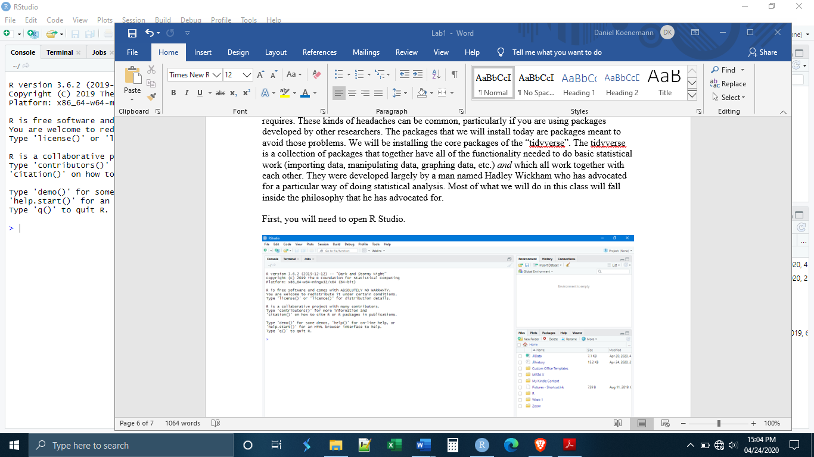

Once opened, R Studio will look something like this:

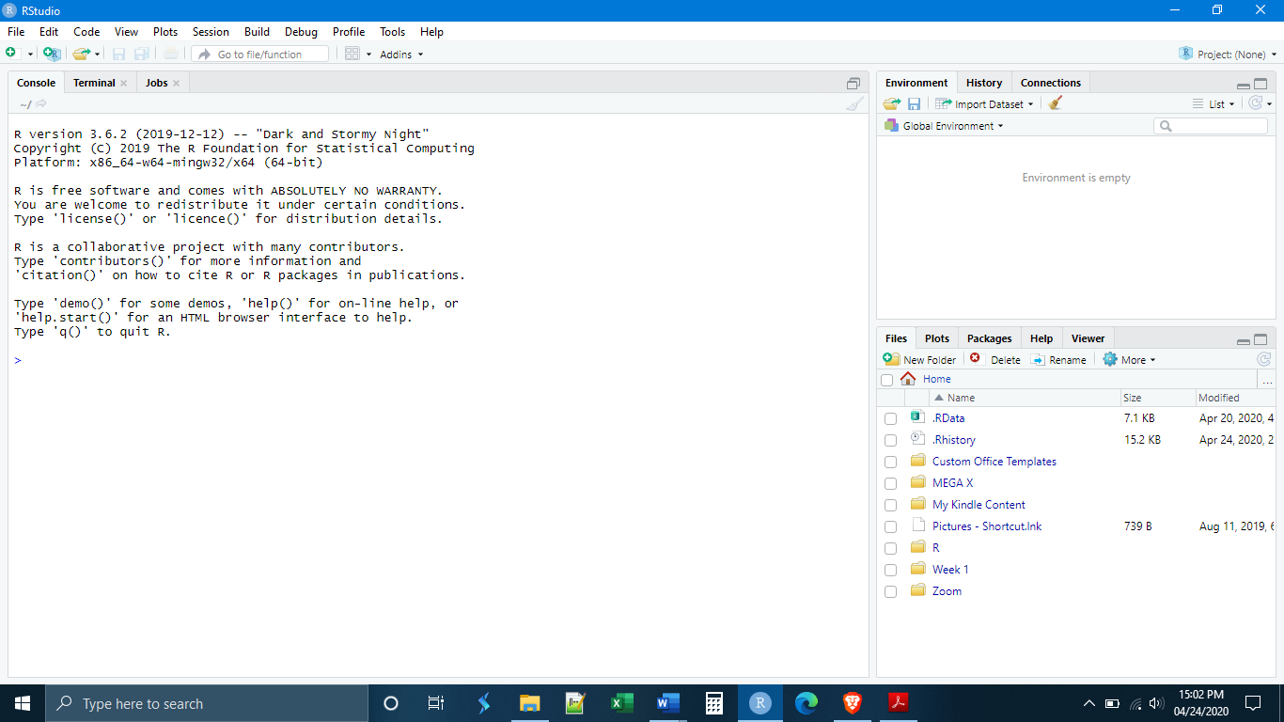

We will have a full tour of the R Studio layout tomorrow, for now I simply want to install the packages. You will see that most of the screen is taken up by a large panel on the left side. This is the console, where commands can be entered. It is here that we will install our packages. To do this, execute the following lines of code. Each line needs to be typed (or copy-pasted) into the console, then press the “enter” key on your keyboard, then wait for the package to be installed. Each line must be done one at a time.

install.packages(“rmarkdown”)

install.packages(“knitr”)

install.packages(“tidyverse”)

install.packages(“magrittr”)

install.packages(“data.table”)

install.packages(“kableExtra”)

optional

install.packages(“tinytex”)