**R and Ecology**

*Tasks*

Use R Studio to Illustrate Concepts from Real Datasets

*Introduction*

We had a basic introduction to ggplot last time we met. The goal for today is to reinforce some of the concepts from lecture, illustrating ecological principles, using real data collected by others. The data that we will be using comes from this paper:

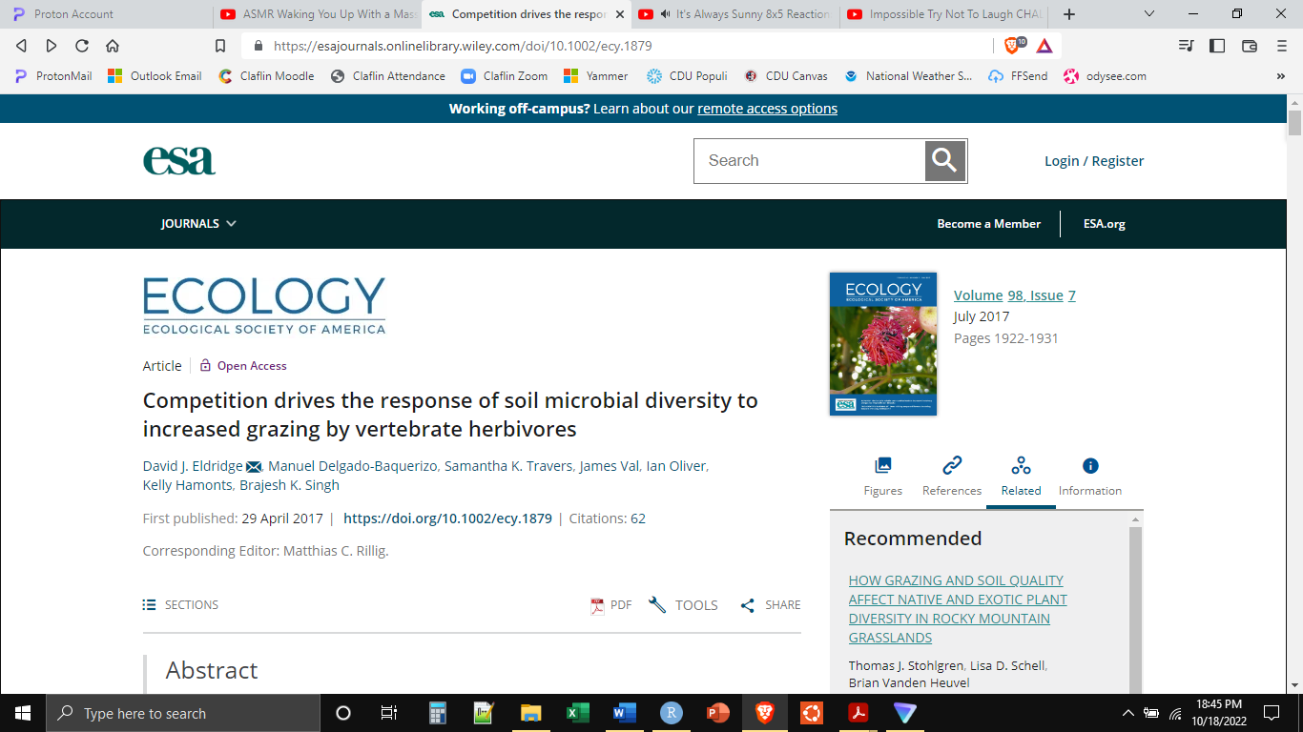

These authors examined bacterial and fungal assemblages in three different ecological communities in in Australia. These three communities are the Blackbox community, the Redgum community, and the Cypress community. The three communities are named for their dominant vegetative elements. The “blackbox” tree is a species of Eucalyptus which grows in a largely savanna-like biome on southeastern Australia.

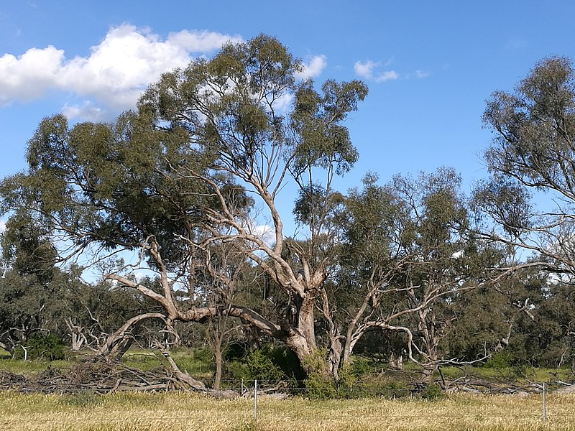

**“Blackbox” *Eucalyptus largiflorens* (By MargaretRDonald - Own work, CC BY-SA 4.0, https://commons.wikimedia.org/w/index.php?curid=65268861)**

The Cypress-pine is a species of tree in the cypress family (Cupressaceae), but not in the same genus as the Cypress that we have in South Carolina. Similarly, the environmental conditions that this tree grows under are substantially different than the swamp habitat of many of the Cypress trees of the American South. Below you can see it growing in a similar savanna or open woodland in Australia.

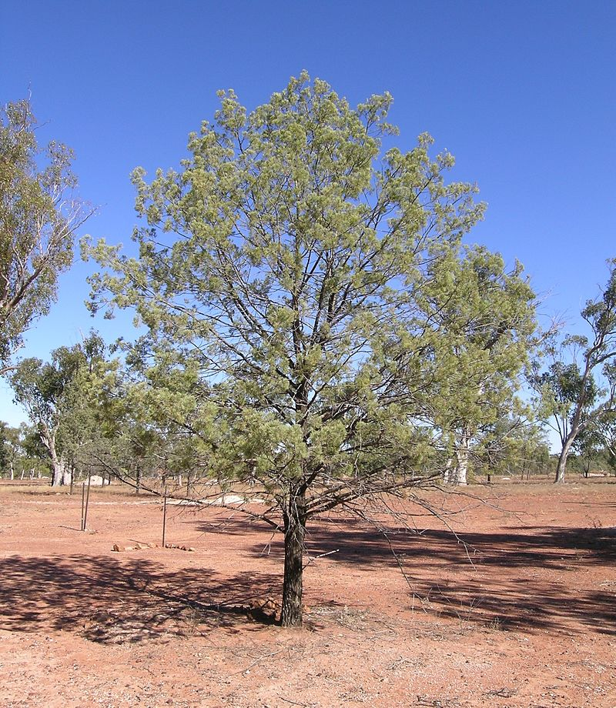

**“Cypress-pine” *Callitris glaucophylla* (By Cgoodwin, CC BY-SA 3.0, https://commons.wikimedia.org/w/index.php?curid=6991980)**

The final community is the Redgum community. These trees are also members of the *Eucalyptus* genus. Unlike the Blackbox *Eucalyptus*, however, the Redgum will only grow near a water source, such as a river.

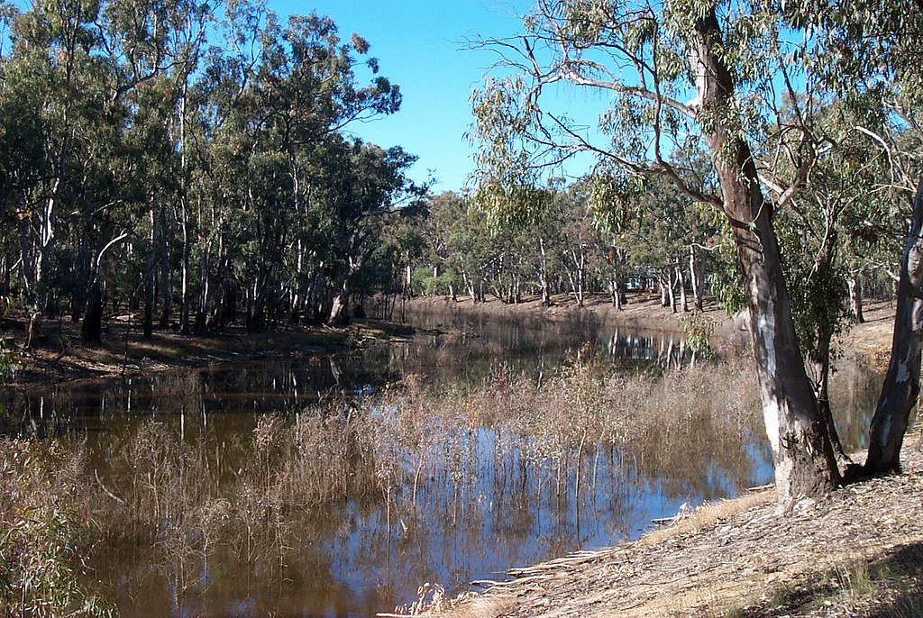

**“Redgum” *Eucalyptus camaldulensis* (By NathanHurst at the English-language Wikipedia, CC BY-SA 3.0, https://commons.wikimedia.org/w/index.php?curid=68034339)**

Within each of these communities, there are also various different sub-communities, which the authors termed “patches”. Just viewing the images above, there are areas near and under the trees, and there are open areas. There are areas with and without grass, etc.

Each of these three communities is subject to a variety of environmental pressures. Some of these pressures come from native species such as Kangaroos. However, since the arrival of European settlers, much of the open woodlands and savannas of Australia have been used for the grazing of livestock, including cows, sheep, and (unintentionally) rabbits. What the authors had hoped to do, was determine how the pressures of intermittent livestock grazing, a kind of disturbance, influenced the community that was already present.

For our purposes, these data allow us to look at niche partitioning, competitive exclusion, the intermediate disturbance hypothesis, and the relationship between environmental complexity and community diversity. And, the results might not be exactly what we expect.

*Set-Up*

Begin by creating a new folder, this time “Lab11” which we will use for all our files for this week. Second, download from Moodle all of the data files necessary for the lab this week and save them in this same folder. The files that will be most important for today are Dryad_Eldridge_Ecology.csv.

Start R Studio and open a new R Notebook file. Save this file in the “Lab11” folder where the data files are. Delete the text that comes in the notebook template, and use the first chunk to load libraries.



The first thing we need to do is read in the data and do some cleaning. We need to select a subset of the variables, rename some of the variables, and factorize some of the variables.



Now that the data are in the form that we want. Let’s use the data to get a better understanding of these communities. Since the authors of this study have divided up the landscape into a series of patches within the basic community types, let’s examine some of the differences between those patches. One way to look at those differences is through acidity (pH).

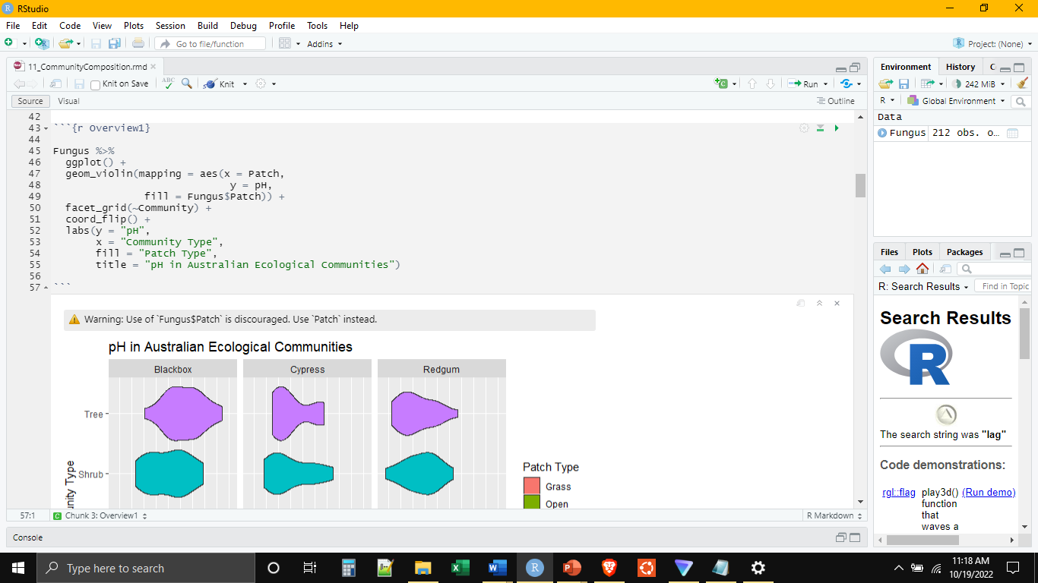

From the images, we saw that the different communities also had different plant covers, which we can quantify from their data.

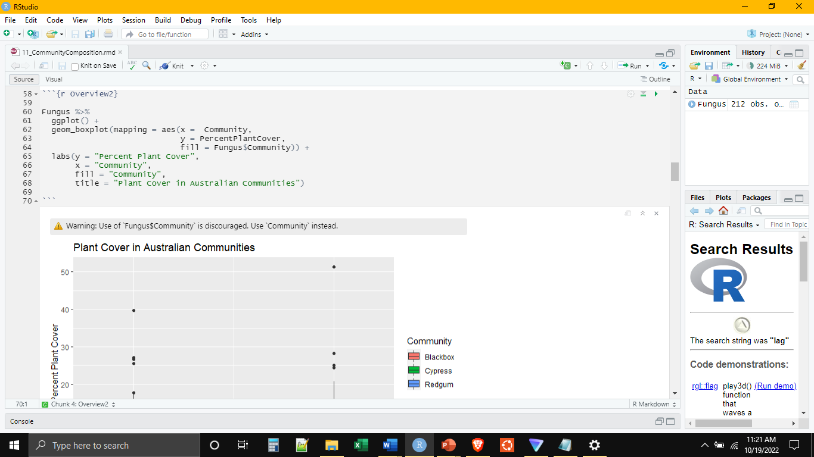

Similarly, the authors measured the plant richness in each patch and community. In this case, the richness is simply a count of the number of plant species present. We can see how the number of plant species present varies among the different patches and communities.

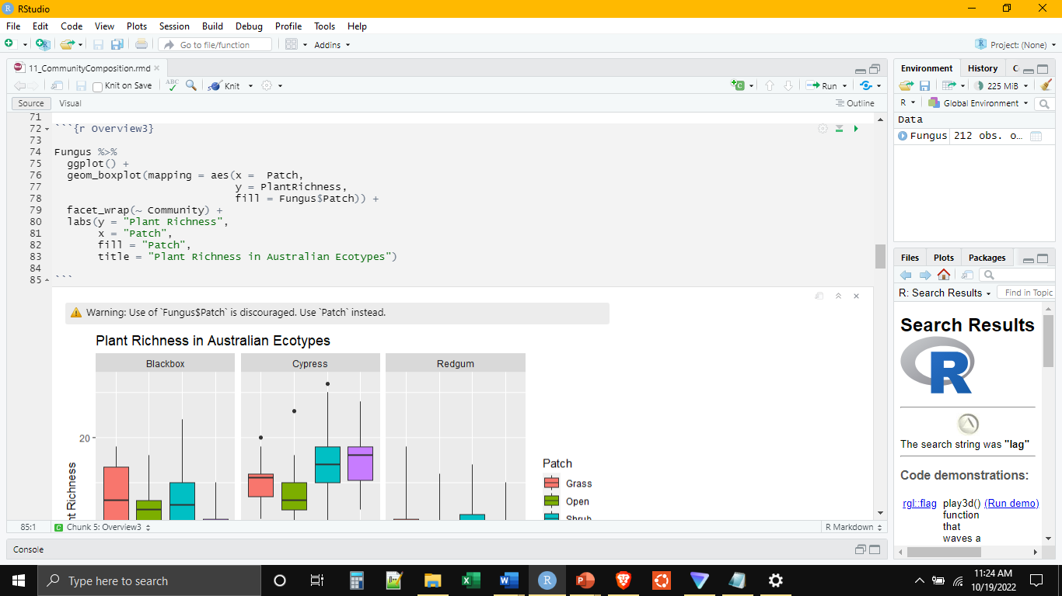

The authors were most interested in the microbial and fungal assemblages present in these patches and communities. Fungi can be divided into a few major types. Two of these types are the Ascomycetes and the Basidiomycetes. The differences are in part microscopic. But there are some general differences between the two. The Ascomycetes are a strange collection of fungi, some of which are extremely harmful to humans, and some of which are very valuable to humans (most antibiotics come from this group). Ascomycetes also are the major fungal collaborators in lichens (which are fungus + bacteria symbionts). The Basidiomycetes form the recognizable fungi that we are familiar with, such as mushrooms.

Let’s look at the differences in fungal abundance between these groups.

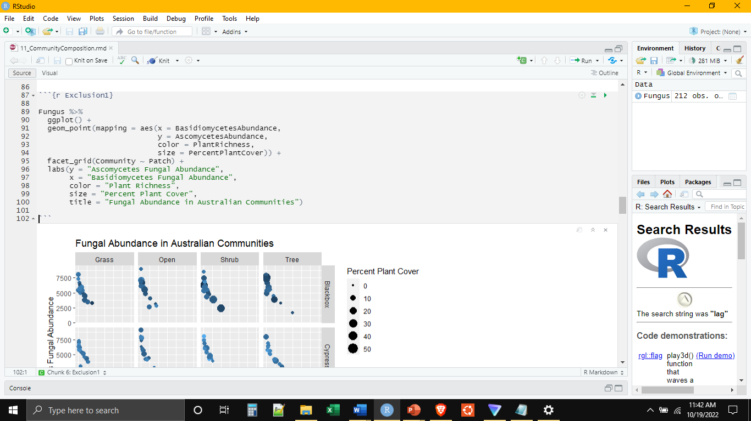

This plot suggests a couple of things. It shows that the ascomycetes and basidiomycetes seem to occupy fundamentally different spaces. When there are high abundances of ascomycetes there are low abundances of basidiomycetes and vice versa. The first plot that we made today, indicated that one reason for this could be niche partitioning. The different communities and patches did have some differences in soil pH. But the differences were not pronounced, and we might consider looking for another explanation.

What about competitive exclusion. Is it possible that one group is outcompeting the other under certain conditions? One such condition could be the amount of carbon in the soil (which get’s there by dead and decaying matter). Let’s plot soil carbon against Fungal abundance.

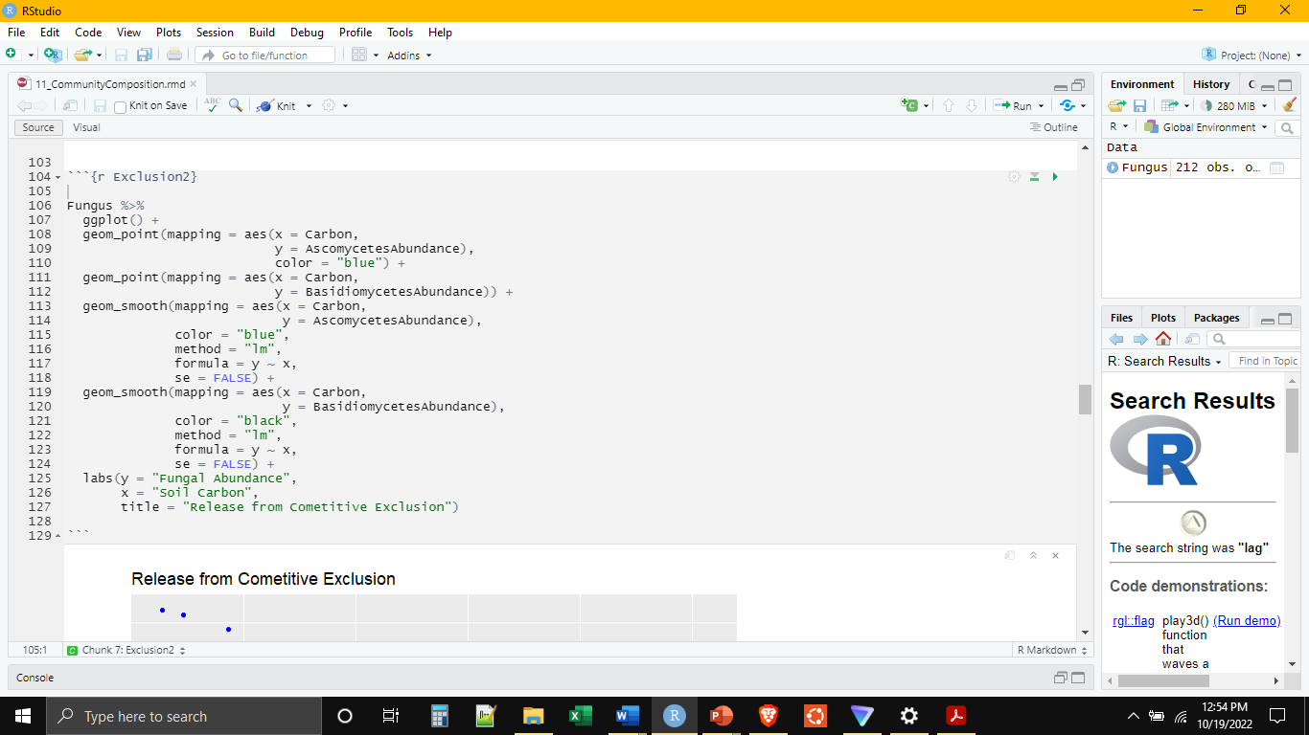

In this case we see that, at low levels of soil carbon, the ascomycetes dominate in abundance. But that when soil carbon increases, the basidiomycetes are able to coexist with the ascomycetes. Soil carbon tends to increase, or at least is more reliable, when grazing animals are present, both through the disturbance they cause as well as the animal droppings.

What appears to be happening here is that ascomycetes outcompete basidiomycetes at low carbon levels, but the introduction of a disturbance and carbon modifies the environment releases the competitive constraint on the basidiomycetes to allow for the coexistence of the different fungal types.

Let’s change gears. We can also use these same data to look at the relationship between environmental complexity and community diversity. For example, let’s plot plant species richness against bacterial species richness, calculated using the Shannon index.

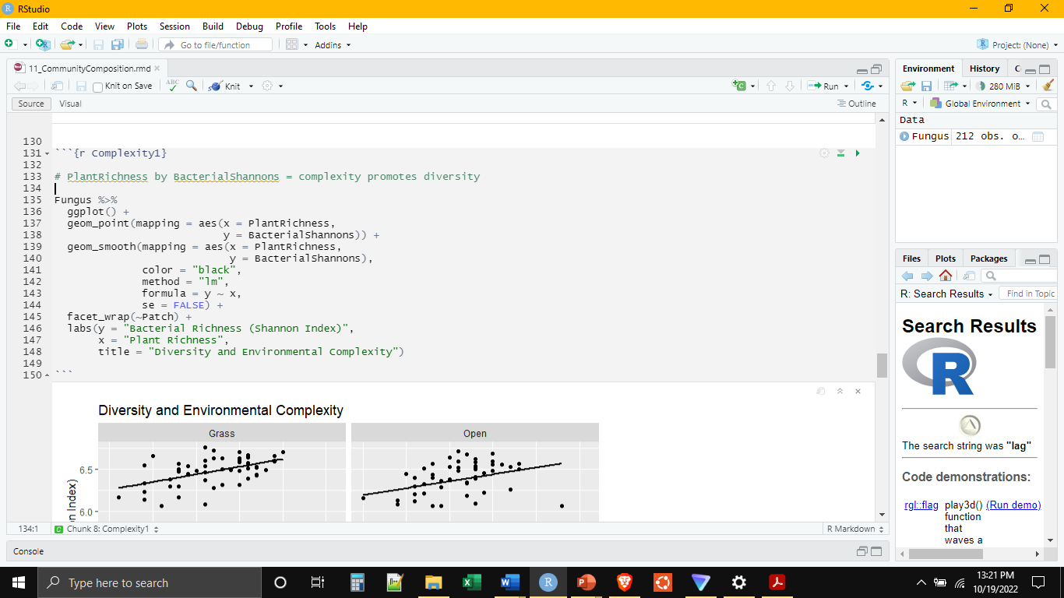

We can see that with increasing diversity in plant community, the diversity of the bacterial assemblage also increases. Let’s see if the same is true with respect to plant ground cover.

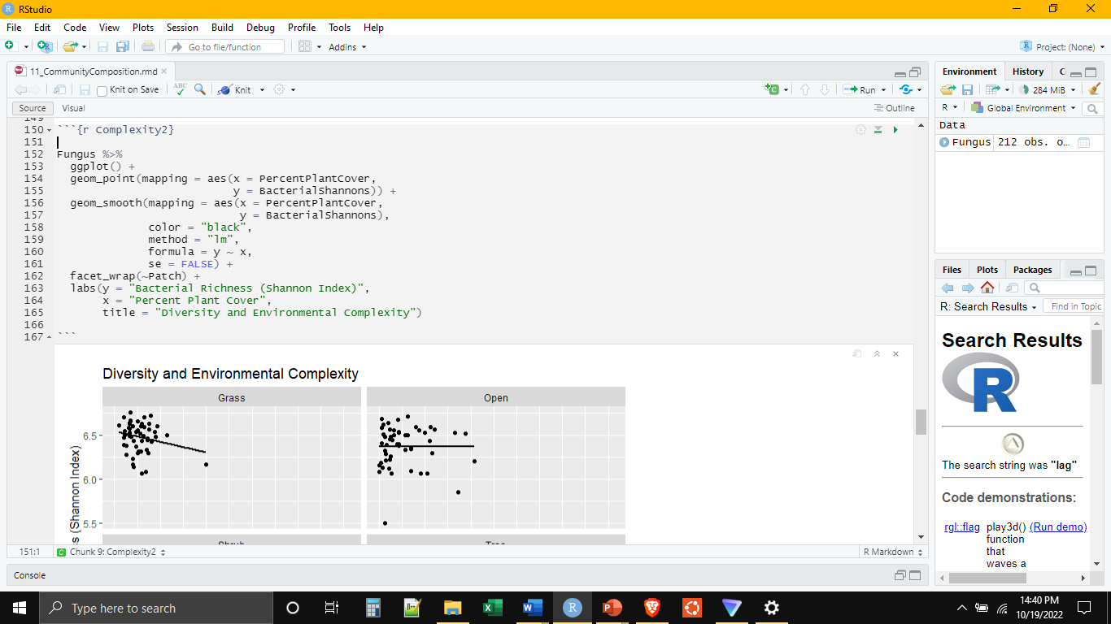

As proof of lab completion. Please save and upload your RMD file to Moodle.