**Small Unmanned Aerial Vehicles (Micro-UAVs – Drones) in Plant Ecology1**

Author list (order not yet determined):

Pamela G. Thompson2

Ben G. Weinstein3

Monica Grasty2

Brendan Kohrn2

Tina Schroyer2

Mitchell B. Cruzan2

1Received ____ Revision accepted _____

2Department of Biology, Portland State University, PO Box 751, Portland, Oregon 97207

3Department of Ecology and Evolution, Stony Brook University, Stony Brook, New York 11794

4Author for correspondence.

**Abstract**

*Premise of the Study:* Low-elevation surveys with small aerial drones (micro-UAVs) may be used to provide maps of vegetation over small- to medium-sized geographic regions. We provide an overview of regulations, methods, and procedures for conducting surveys and illustrate some of the methods with an example of a vegetation survey of a 16-hectare region of vernal pool habitat.

*Methods:* Aerial images were obtained by flying a small drone along transects over the area of interest. Images were corrected for lens distortion and were used to create a composite image (orthomosaic) and a digital elevation model (DEM). Vegetation classification was conducted by combining spectral and elevation information.

*Results:* We were able to create a vegetation map for the entire region from the images captured. Comparison of our map to points that had been ground-truthed confirmed that our classification methods were generally accurate.

*Discussion:* The example survey demonstrates that small aerial drones are capable of gathering large amounts of information on the distribution of vegetation and individual species with minimal impact to sensitive habitats. Low elevation aerial surveys have potential for a wide range of applications in plant ecology.

Keywords: aerial survey, drone, landscape ecology, micro-UAV, UAS, vegetation mapping.

**Introduction**

Quantifying the distribution and abundance of plants is of fundamental importance in plant ecology. Our ability to estimate plant distributions over large areas (i.e. several hectares) using traditional approaches (transect or quadrat methods) is generally limited because of the time and expense required. Intensive plant surveys may also result in unacceptable levels of disturbance to sensitive ecosystems due to soil compaction, disruption of soil organic layers, trampling, and vegetation damage. While remote sensing via satellites provides information on landforms and the general distribution of vegetation types, it is unlikely to provide adequate spatial or temporal resolution for determining the distributions of individual species. Moreover, available of satellite images may not represent optimal phenological stages for the identification of different species and vegetation types. Manned aircraft surveys can have increased resolution, but are prohibitively expensive for most investigations. Utilization of micro-UAVs (Unmanned Aerial Vehicles; UAS – Unmanned Aerial Systems; small aerial drones) may provide adequate levels of image detail to estimate the distribution of individual plant species or vegetation types over several hectares at a relatively low cost. Our goal in this protocol note is to describe the advantages and limitations of aerial drone surveys in estimating plant distributions at fine spatial and temporal scales. We describe a number of factors researchers should consider for planning aerial drone surveys. An example is provided to illustrate the application of micro-UAV surveys for the estimation of the distribution and abundances of vegetation types and plant species across a sixteen-hectare area of vernal pool habitat in Southern Oregon, USA.

**General Considerations for Data Collection with UAVs**

The prospect of using drones for vegetation sampling is exciting because of the large amount of information that can be collected with minimal effort. On the other hand, there are many limitations to this approach that should be considered before investing in the equipment necessary to conduct micro-UAV surveys. Researchers should begin by carefully considering whether their goals are a good match for the acquisition of data from aerial images obtained from micro-UAVs. Suitable applications include surveys of the distribution and abundance of individual species or vegetation types, and aerial sampling of sensitive habitats or terrain that is difficult to access. Conducting aerial surveys using small drones greatly expands the size of the area that can be assessed with minimal disruption of sensitive plants and vegetation. By obtaining a high density of images researchers can construct composite images (orthomosaic) and digital elevation models (DEMs) of the vegetation and landforms over a geographic area of interest. In the following sections we discuss some general advantages and limitations of using small drones in ecological research.

*What are the legal limitations for conducting research using UAVs?* Before engaging in any research activities using UAVs you should check with local and federal regulations. Currently, the Federal Aviation Administration (FAA) of the United States (USA) considers research activities to fall under the same set of rules as commercial use of drones. Researchers (or their associated institutions) in the USA are required to obtain a waiver under an existing Certificate of Authorization (COA). Waivers generally apply the same rules as those governing recreational use of drones (i.e. guidelines for hobbyists flying remote-control model aircraft weighing more than 0.25 kg). These include:

1. Maximum elevation is 120 m above the local terrain.
2. The aircraft must remain within the un-aided visual line-of-site of the pilot at all times.
3. UAVs are required to remain clear of manned aircraft and are not allowed to fly within 8 km of any airport.
4. Flights are not allowed in close vicinity to people.
5. UAVs must weigh less than 25 kg.
6. Drones weighing more than 0.25 kg must be registered with the FAA.

In addition to the above rules, waivers under the FAA generally require that a licensed aircraft pilot be present if the drone is being used for research activities. Drones should only be flown away from buildings and large concentrations of people. Researchers should also be careful to obtain permission from land owners and managers before engaging in data collection activities. Any use of drones for monetary compensation is considered commercial use and is strictly regulated by the FAA. Researchers may use images that have been obtained during recreational use of drones if they are offered free of charge. These regulations are being updated so researchers should check with local and federal agencies before engaging in research activities with UAVs.

*What type of equipment will I need?* The diversity of small drones available for recreational use has increased dramatically since 2010, and many of these are suitable for research. Of these, hovering UAVs with four (quadcopters), six (hexcopter), or eight (octocopter) propellers are the easiest to fly and have a number of features that are advantageous for conducting aerial surveys. These aircraft are extremely stable in flight and more expensive models have GPS tracking systems that allow them to maintain position at a specific location and altitude. The drone’s flight time on a single charge will set an upper limit to the area that can be sampled. Quadcopters tend to be the most efficient and currently can fly for more than 20 minutes on a single battery.

At a minimum, you will need a drone that is capable of carrying a small camera that can be programed to take photographs every few seconds. More sophisticated UAVs have cameras mounted on gimbal systems that stabilize the camera as the craft pitches during flight. More expensive UAVs also provide video feeds from the onboard-camera to the pilot along with information on altitude, flight speed, and distance from the point of origin (home) for the current flight. Other features that can be useful include automatic homing when the battery charge falls too low, and when the signal from the controller is lost. In some models the home location can either be set as a fixed point or it can move with the location of the controller. Some manufacturers implement additional safety features such as “no-fly” zones within 8 km of airports and federal buildings.

The second major consideration for equipment is the camera. Many ready-to-fly drones have integrated high-resolution cameras that are perfectly suitable for research. These systems have the advantage of constant video feeds to the pilot and provide manual control of the camera position and image capture during flight. Cameras need to be as light as possible as drones have a limited payload capacity and additional weight will reduce flight time. A wide-angle lens provides coverage of a large area at a moderate elevation. The images captured from wide-angle lenses can be corrected for distortion with standard software applications and are suitable for construction of orthomosaics and DEMs (see below). Some cameras can easily be customized to remove internal filters to allow detection of a broader spectral range, which is particularly important for some types of vegetation classification methods that utilize ratios of reflectance in the visual and UV ranges (e.g., NDVI, see below). Cameras capable of capturing images in a number of different formats (e.g., JPEG and raw formats such as TIFF) as well as video capture are the most suitable for research applications. For construction of orthomosaic images it is imperative that the camera is capable of storing metadata with each image including GPS coordinates and flight elevation above the home (controller) location. Considerations of image resolution along with elevation and limitations on flight duration are discussed below.

*What is an appropriate geographic scale for micro-UAV aerial surveys?* The most important factor to consider is whether the geographic scale of your study is suitable for micro-UAV surveys. The majority of small aerial drones generally are currently limited to a flight time of 15 to 20 minutes for each battery. Depending on the flight elevation and density of photographs, several batteries may be required to perform surveys. Furthermore, depending on local and federal regulations the, flight distance from the pilot is limited because the vehicle must be maintained within line-of-sight at all times. Based on the experiences of the authors, flight distances will generally be limited to less than 200 m from the pilot. This distance could be extended if the pilot could move in the direction of the flight path, but this will generally not be advisable on foot as walking in rough terrain while trying to track the drone would be difficult and dangerous. Depending on the number, spacing, and elevation of photographs (see below), and under current regulations in the United States, the feasible limits to ecological surveys using micro-UAVs is probably less than forty hectares at the upper limit, and more reasonably would be within five to twenty hectares. Surveys of larger areas are feasible with the use of mini-UAVs, which are commonly used in agricultural applications. These vehicles are considerably more expensive than micro-UAVs and require special waivers from federal agencies. In this protocol note we focus on applications of small drones, but many of the principles we discuss can be extended for the use of larger vehicles.

*How can I identify organisms and objects from aerial images?* There is a large amount of literature discussing the analysis of remote imaging data from satellites and maned aircraft (). The typical goal of these applications is vegetation and landform classification over relatively large geographic areas. The ability to discriminate among plant species and habitats may depend on the phenological stage of plants. Plant species with distinctive spectral values for their flowers or fruiting structures may be easily distinguished at particular times of the year. Phenologies may vary considerably because of variation in microenvironments, so it is advisable to conduct a sequence of surveys over the same area at different times to capture more accurate estimates of plant distributions. Incorporating spectra outside the visible range may require using specialized photographic equipment, but may also be achieved by simple modifications of standard cameras as described above. Testing spectral profiles of the vegetation and plant species of interest with hand-held cameras is advisable prior to investing in micro-UAV technologies. Species identification that requires morphological measurement or non-spectral characters such as leaf shape or growth form may be less suited to aerial surveys.

*What are the best strategies for image collection?* One of the primary considerations for ecological surveys with small UAVs is the density and elevation of images over the region of interest. Reconstruction of orthomosaics and DEMs requires a high density of images that\ provide overlapping views of landscape features from multiple angles. The typical sampling strategy establishes a grid of aerial transects. The UAV is either flown at a constant speed along transects in automatic image capture mode, or is flown manually between imaging grid points. The former strategy can be facilitated by software that allows programing flights based on multiple GPS coordinates. Manual flights may be necessary if the time required to store large images is greater than a few seconds. This is particularly true of raw image formats such as TIF, which may require ten seconds or more to process. Whether lower resolution image formats can be used will depend on the flight elevation above ground and the level of detail needed to identify objects from images. Some small UAVs may not allow the association of the metadata needed for orthomosaic construction (i.e. GPS coordinates and flight elevation) with all imager formats, so it may be necessary to use raw images.

Minimal imaging densities will depend on the flight elevation along with the topographic relief and complexity of vegetation. Higher densities of images may be needed to ensure that there is adequate image overlap in portions of the landscape that are between large bushes or trees (Fig. 1). In this depiction, larger gaps in the orthomosaic will be generated when the density of aerial images is lower. Higher densities of images are necessary to cover landscapes that include gaps between shrubs or trees, and this problem becomes more acute when openings in the vegetation are smaller than the height of shrubs.

The potential for taller trees and shrubs to block the view of vegetation features within gaps can be minimized by flying at an elevation that is at least three times the average height of the canopy (Fig. 2). While larger areas are covered by images as the elevation increases, there is also a loss of resolution of smaller objects on the ground. The loss of acuity at higher elevations can be compensated by capturing images with higher pixel densities; however, image size is limited by the characteristics of the CCD chip within the camera, and larger images will require longer times for processing and storage. The optimal flight elevation for aerial surveys will necessarily be a compromise between maximize coverage and image acuity for the identification of vegetation and landform features.

The combination of flight elevation, spacing between images along transects, and limitations of processing times for large images need to be considered to determine optimal sampling strategies. Based on the experience of the authors, the distance between images on the sampling grid should be half the flight elevation or less, and depending on the complexity of the vegetation topography, it may be necessary to use higher densities of sampling points. Researchers should also consider the fact that coverage is necessarily lower at the edge of the sampling grid, so the area sampled should exceed the geographic region of interest. Some of these factors may not need to be considered if low-resolution images with rapid capture times can be used. The image capture and data storage characteristics of the UAV and resolution of small objects at different elevations and image capture modes should be tested before designing the sampling grid. In any case, it is better to err on the side of higher density sampling grids and higher resolution images to insure adequate coverage of and identification of vegetation and landform features within the geographic region of interest.

Aerial imaging grid designs will also depend on the topography of the terrain being sampled. It is easiest to sample relatively flat areas where a single-elevation grid can be established. Conducting aerial surveys over flat terrain is relatively easy when using UAVs that have GPS positioning capabilities, which are capable of holding a relatively constant elevation above sea level. For sloping terrains it may be necessary to conduct stratified sampling at different elevations along the slope (Fig. 3). Each sampling grid should have good overlap with others to facilitate orthomosaic image and DEM construction. The goal is to keep the distance between the camera and the ground within a range that allows adequate resolution of vegetation features, so steeper slopes will require more overlapping grids. More complicated terrains such as valleys and curved slopes may require larger numbers of sampling grids to provide adequate coverage and resolution of objects on the ground.

When developing sampling strategies researchers should keep in mind the limits imposed by the flight duration of the aircraft on a single battery charge and the maximum distance that can be flown while maintaining visual contact. Based on the experience of the authors, a small drone such as the DJI Phantom models (DJI, Shenzheng, China) flying under 50 m elevation can be visually tracked up to 200 m distance from the operator under most weather conditions. By flying in both directions away from the controller, transects that are 400 m in length can be sampled. Using programmed flight plans at slow speeds (e.g., 3 m per second), low-resolution images can be captured at frequencies of 10 m or less. Capturing of high resolution images will require more time for processing and positioning of the aircraft, although it is not necessary to sample exact positions and grid locations can be approximate. Transect sampling is facilitated by using a drone with GPS positioning capabilities as the distance between the aircraft and the operator are provided during flight. Manual sampling can also be made more efficient by capturing images at alternate grid locations during flight along transects in two directions. Taking into account the amount of time required to position the aircraft at the proper elevation at the initiation of sampling and for landing upon return, a single battery charge may be enough to sample two to three 400 m transects in automatic mode and perhaps one transect when manually capturing high-resolution images at a spacing of 10 m or more. Batteries generally require several hours to charge so several batteries and flights over several days may be required to sample larger areas.

*What are the best sampling procedures?* Prior to data collection the UAV should be flown to test its imaging and flight capabilities. The drone should only be flown in dry weather and calm wind conditions in areas that are clear of buildings and large concentrations of people. Operators should practice flying the drone to test the camera’s image resolution at different elevations. Drones with GPS and integrated cameras generally provide a manual flight controller and are capable of video/data feeds to a digital device during flight. At least two people will be required to safely fly the UAV; one person should act as pilot and maintain visual contact with the aircraft and the second should use the digital device to monitor the video feed, operate the camera, and track the drone’s position. Under some circumstances a third person may be required to help maintain visual contact with the drone, to watch for potential hazards, and to ensure that the drone remains clear of other aircraft, buildings, tall trees, and people.

Once a preliminary sampling strategy has been developed it is best to image a portion of your area of interest to determine whether the imaging density provides adequate coverage for construction of orthomosaics and DEMs. Researchers should also record GPS coordinates of major features and of representative plants or vegetation cover to allow for ground-truthing for classification from the aerial images.

*How do I process and analyze image data?* The analysis of drone photography can be separated into three stages: georectification, orthomosaic and classification. Most UAVs with integrated camera systems return images that are sequentially numbered, and tagged with spatial and temporal data. Our goal is to turn these images into a single stitched map known as an orthomosaic. Individual images are first georectifiedto establish their location on the earth’s surface. . Rectified images are then used to create an orthomosaic with a computer vision technique known as structure-through-motion (Dandois and Ellis 2010). Point features are extracted from each image, and the algorithm searches for the greatest number of overlaps between images for each of the point features. A greater the overlap in images will lead to greater number of matching features, and create a more complete final orthomosiac. Insufficient overlap will lead to grainy or ragged orthomosaic with holes where the algorithm was unable to find a match among the pool of supplied images. In the example provided below we used AgiSoft PhotoScan software (AgiSoft LLC, St Petersburg, Russia) to georectify images and to create the orthomosaic and DEM of a region of a vernal pool landscape in southern Oregon.

Once we created the orthomosaic, our goal was to associate each cell in the spectral raster with a habitat classification. There are two main approaches for landscape classification; unsupervised methods use multivariate clustering algorithms to group similar cells based on spectral values. These ordination approaches, such as K-means classification, depend on defining a preset number of groups. For example, in the example described below, we were interested in delineating trees, shrubs, swale and hummock landclasses. The K-means algorithm iteratively looks for the best grouping of pixels which minimizes the mean similarity among K classes. This method is robust to derivations and requires no training data, but will fail when confronted with highly overlapping or highly non-symmetrical classes (Pielou 1984). Alternatively, supervised classification methods are a family of machine-learning techniques that use training data to learn about classes. Supervised methods, such as neural networks, are gaining popularity due their flexibility and greater accuracy (Guisan et al. 2000, Elith et al. 2008). In a supervised classification, a researcher collects GPS points from the field for each of the classes. The algorithm is than trained on these data points, and then classifies the spectral raster based on the characteristics of those training sets (Papes et al. 2013). While supervised methods are often more accurate than unsupervised methods, the need for training data can be difficult in sparsely sampled ecological landscapes.

**Example – Creating a Vegetation Map of the Whetstone Savanna**

*Methods –* To illustrate some of the procedures for conducting vegetation mapping with UAVs we surveyed the Whetstone savanna, which is an upland prairie vernal pool site in Southern Oregon that is managed by The Nature Conservancy. We used images collected by recreationists that provided coverage of a 16-hectare (400 x 400 m) region of savanna that consists of a mosaic of vernal pools (swales) that are separated by hummocks, hedges of buckbrush (*Ceanothus cuneatus*), and scattered Oregon oaks (*Quercus garryana*). Our goal was to generate a vegetation map of the region from an orthomosaic and DEM for the analysis of gene flow using landscape genetic methods.

Recreationists flew a micro-UAV with an integrated camera (DJI Phantom Vision + with a 14 megapixel camera mounted on a motion-stabilized gimbal) at 30 m elevation along 400 m transects that were spaced every 15 m. Camera mode was set to …. The center-point of each transect was located using a hand-held GPS and used as the home location for each flight. Raw images (TIFF) were captured every 15 m along transects. The capture and processing of each image required 10 to 15 s. Consequently, sampling the entire area required multiple flights and used eight to ten batteries for each of two sampling sessions that were conducted over a two-day period. All flights were conducted during the morning on partly-cloudy days with calm winds.

We conducted georectification, orthomosaic, and DEM creation using AgiSoft Photoscan software (AgiSoft LLC).

* Number of images used.
* Software settings

To classify our prairie landscape we used a kmeans classier on a combination of the elevation (DEM) and spectral values to delineate four classes (trees, bushes, scale and hummock). We first separated the DEM into three classes (‘Tree’, ‘bush’, swale/hummock), and then separated the areas classified as swale/ hummock in the DEM using the spectral values. The resulting map (Figure X) has four classes and provides a high resolution habitat map based on the drone collected imagery. For the greatest clarity, we include the R scripts in Appendix 1 to facilitate further adoption of these tools. https://github.com/bw4sz/Drone/blob/master/Kmean.md.

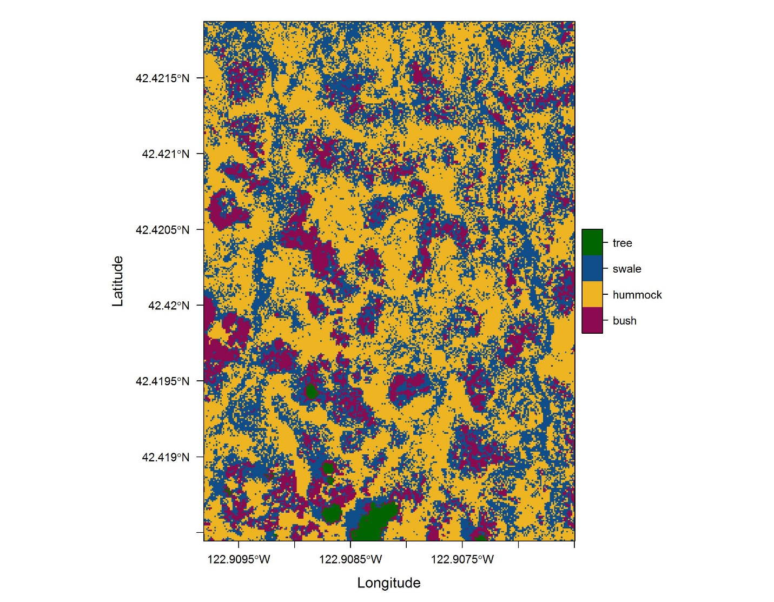

*Results and Discussion –* The

It is also possible to utilize spectra in the infrared range to obtain unique spectral profiles for some plant species (e.g., diagnosing plant disease <http://www.ncbi.nlm.nih.gov/pmc/articles/PMC4283508/>).

* Phenological surveys.
* Documenting changes in vegetation distributions, disturbance, success of restoration efforts, etc.

*Conclusions –* The

Literature Cited

Dandois, J. P., and E. C. Ellis. 2010. Remote Sensing of Vegetation Structure Using Computer Vision. Remote Sensing 2:1157–1176.

Elith, J., J. R. Leathwick, and T. Hastie. 2008. A working guide to boosted regression trees. The Journal of animal ecology 77:802–13.

Guisan, A., A. Guisan, N. E. Zimmermann, and N. E. Zimmermann. 2000. Predictive habitat distribution models in ecology. Ecological Modelling 135:147–186.

Papes, M., R. Tupayachi, P. Martinez, A. Townsend Peterson, G. P. Asner, and G. V. N. Powell. 2013. Seasonal variation in spectral signatures of five general of rainforest trees. IEEE Journal of Selected Topics in Applies Earth Observations and Remote Sensing 6:339–350.

Pielou, Evelyn C. *The interpretation of ecological data: a primer on classification and ordination*. John Wiley & Sons, 1984.

Figures and appendices.

