

Individual Assessment Coversheet
To be attached to the front of the assessment.
Campus: Midrand__________________________________________________________________
Faculty: Information Technology_____________________________________________________
Module Code: ITNPA34_____________________________________________________________
Lecturer’s Name: _______________________________________________________
Student Full Name: Dian Kotze_______________________________________________________
Student Number: EDUV4810649______________________________________________________

Indicate | Yes | No
Plagiarism report attached

Declaration:
I declare that this assessment is my own original work except for source material explicitly acknowledged. I also declare that this assessment or any other of my original work related to it has not been previously, or is not being simultaneously, submitted for this or any other course. I am aware of the AI policy and acknowledge that I have not used any AI technology to generate or manipulate data, other than as permitted by the assessment instructions. I also declare that I am aware of the Institution’s policy and regulations on honesty in academic work as set out in the Conditions of Enrolment, and of the disciplinary guidelines applicable to breaches of such policy and regulations.

Signature  Dian Kotze | Date  2026/11/11

Lecturer’s Comments:

Marks Awarded: |  | %
Signature | Date

Eduvos (Pty) Ltd. (formerly Pearson Institute of Higher Education) is registered with the Department of Higher Education and Training as a private higher education institution under the Higher Education Act, 101, of 1997. Registration Certificate number: 2001/HE07/008

Table of Contents
Question 1 4
Question 1.1 4
Question 1.2 6
Question 1.3 8
Question 2 10
Question 2.1 10
Question 2.2 12
Question 2.3 13
Question 3 14
Question 3.1 14
Question 3.2 15
Question 3.3 16
Question 3.4 18
Question 4 20
Question 4.1 20
Question 4.2 22
Question 4.3 26

Question 1

Question 1.1
I loaded research_abstracts.json into a pandas DataFrame. It has 1,138 rows and three columns: DOI, Abstract and Label. There are 900 classical abstracts and only 238 ai abstracts, so the data is imbalanced. Four DOIs were missing, and 13 abstracts were duplicates.
Before cleaning, I checked what noise the abstracts contained. Many had digits (about [689]) and unusual characters such as curly quotes and long dashes (about [443]). Some began with the word “Abstract” ([34]), some ended with publisher copyright lines such as “Copyright © 2008 John Wiley & Sons” ([19]), and a few had maths code or web links.
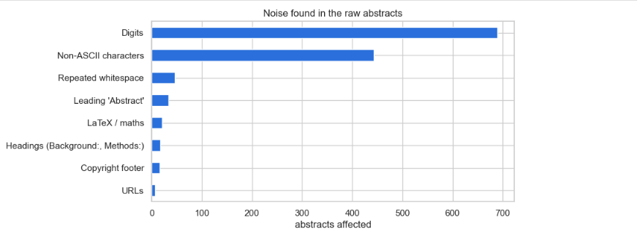I cleaned the rows first. I removed the 13 duplicate abstracts, because a copy appearing in both the training and test sets would make results look better than they are. I also removed 5 abstracts about cosmological inflation in physics, which have nothing to do with prices. That left 1,120 abstracts, with 889 classical and 231 ai.
I then cleaned the text itself. I removed web links, copyright lines, the leading “Abstract” label, headings such as “Background:”, and maths code. I converted the text to lowercase plain ASCII, removed numbers and punctuation, and removed common stopwords such as “the” and “and”. Finally I reduced plurals to their singular form, so “models” becomes “model”. This removed about 45% of the words, so the average abstract fell from about 172 words to about 95.
RAW : This paper develops a dynamic factor model that uses euro area country-specific information on output and inflation to estimate an area-wide measure of the output gap. Our model assumes that output and inflation can be decomposed into country-specific stochastic trends and a common cyclical component. Comovement in the trends is introduced by imposing a factor structure on the shocks to the latent

CLEAN: develop dynamic factor model use euro area country specific information output inflation estimate area wide measure output gap model assume output inflation decomposed country specific stochastic trend common cyclical component comovement trend introduced imposing factor structure shock latent state introduce flexible stochastic volatility specification control heteroscedasticity measurement error

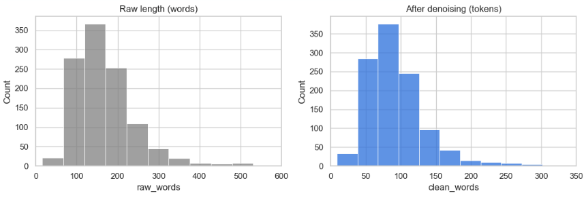

Question 1.2
I split the data into 80% for training (896 abstracts) and 20% for testing (224 abstracts), keeping the same class balance in both. I did this before looking at the features, so that nothing from the test set could influence my choices.
The DOI column was the main question. The prefix of a DOI shows which publisher a paper came from, and it is clearly linked to the label. About 85% of papers with the IEEE prefix (10.1109) are AI papers, but only about 9% of papers with the SSRN prefix (10.2139) are. A chi-square test confirmed the link, with a Cramér’s V of [0.67], which is strong. I still decided not to use it. The DOI tells us where a paper was published, not what it is about, so a model using it would fail on papers from publishers it had not seen. The web page in Question 2 also only receives an abstract, so there would be no DOI to use. As a check, a model using only the DOI scored an F1 of about [0.53] for the ai class, while a model using only the abstract scored about [0.79].
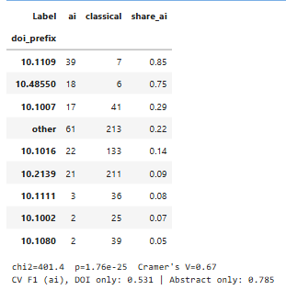
That left the abstract as the feature column and the label as the target. I turned each abstract into numbers using TF-IDF, which gives a word a higher weight when it appears often in one abstract but rarely across the others. I then ranked the words by how strongly they separate the two classes using a chi-square test. The words that point most to AI papers were machine, neural, network, learning, algorithm and LSTM. I also tried simple features such as abstract length and average word length. They were weak, with a correlation of only about [0.12] with the label, compared with about [0.48] for the single word “machine”. So the useful information is in the vocabulary, and the final features are the TF-IDF values of the cleaned abstract.
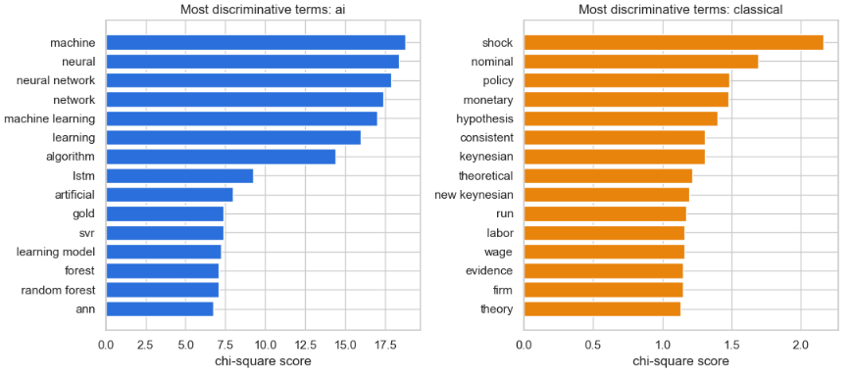

Question 1.3
For the baseline I used TF-IDF with a Multinomial Naive Bayes classifier. I also checked a model that always predicts the majority class, to see what a model with no skill would score. Because only about 21% of abstracts are AI papers, accuracy is misleading on its own, so I focused on precision, recall and F1 for the ai class.
Measure | Training | Test
Accuracy | 0.855 | 0.830
Precision (ai) | 1.00 | 1.00
Recall (ai) | 0.30 | 0.17
F1 (ai) | 0.46 | 0.30
ROC-AUC | 0.975 | 0.917

Five-fold cross-validation on the training set gave an accuracy of about [0.815] and an F1 for the ai class of about [0.18].
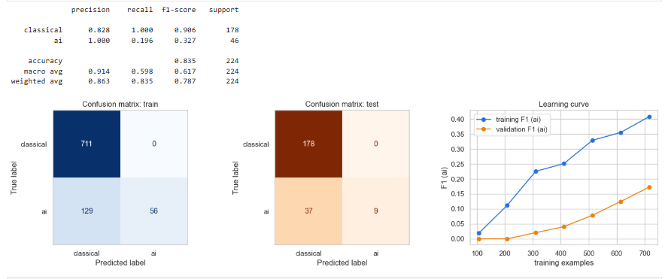
The model does not learn the AI class well. Its training accuracy of 0.855 looks reasonable, but always guessing “classical” already gives 0.795, so most of that score comes from the class imbalance. Training F1 for the AI class is only 0.46, so the model under-fits the minority class.
The model is not over-fitting. Test accuracy (0.830) is close to training accuracy, and cross-validation gave a similar result. The real problem is recall. Every paper the model calls AI really is AI, but it finds only about 17% of the AI papers, which is 8 out of 46 in the test set. For a screening tool that is a serious weakness, because it would hide most of the relevant papers.
The ROC-AUC of 0.92 shows that the model does rank the abstracts sensibly. The issue is that its decisions lean towards the majority class. The learning curve is low for both training and validation and still rising, which means the model needs a lot of data to overcome the imbalance. This is why Question 2 uses models and settings that handle the imbalance better.

Question 2

Question 2.1
I trained five models using the same TF-IDF features and default settings: Logistic Regression, Linear SVM, Complement Naive Bayes, Random Forest and Gradient Boosting. I compared them with 5-fold cross-validation on the training set and used the test set only at the end.
Model | CV F1 (ai) | Test recall (ai) | Test F1 (ai)
Baseline Naive Bayes | 0.18 | 0.17 | 0.30
Logistic Regression | 0.34 | 0.41 | 0.59
Complement Naive Bayes | 0.67 | 0.59 | 0.72
Random Forest | 0.72 | 0.63 | 0.77
Gradient Boosting | 0.74 | 0.72 | 0.80
Linear SVM | 0.76 | 0.70 | 0.80

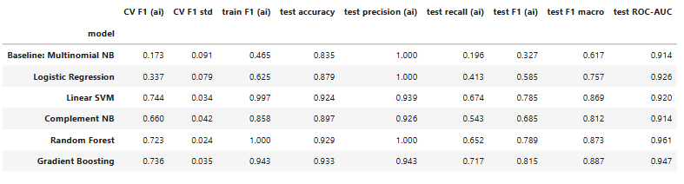

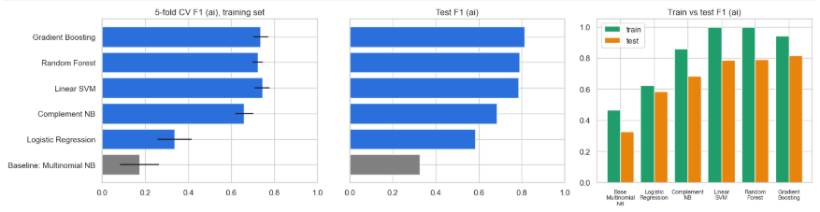
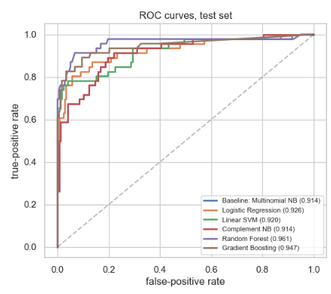

Every model except plain Logistic Regression was clearly better than the baseline. Logistic Regression did badly because it follows the majority class when it is left at its default settings. The Linear SVM had the best cross-validated F1, so I chose it to improve further. I picked it on the cross-validation score and not the test score, so that the test set stayed a fair final check. Random Forest never wrongly flagged a classical paper, but it missed more than a third of the AI papers. Random Forest and Gradient Boosting also scored much higher on the training data than on the test data, which suggests mild over-fitting, while the linear models were steadier.

Question 2.2
The extra improvement I chose was hyperparameter tuning with grid search. Instead of tuning only the classifier, I tuned the whole pipeline. The grid tried unigrams against unigrams plus bigrams, three values of the minimum word frequency, sublinear term weighting on or off, five values of the SVM’s regularisation strength C, and whether to give the rare AI class a higher weight. That made [120] combinations, each checked with 5-fold cross-validation on the training data and scored by the F1 of the AI class.
The best setting used C = [0.3], balanced class weights, a minimum word frequency of [2], unigrams only and sublinear weighting.
Model | CV F1 (ai) | Test recall (ai) | Test F1 (ai)
Linear SVM, default | 0.76 | 0.70 | 0.80
Linear SVM, tuned | 0.80 | 0.78 | 0.82

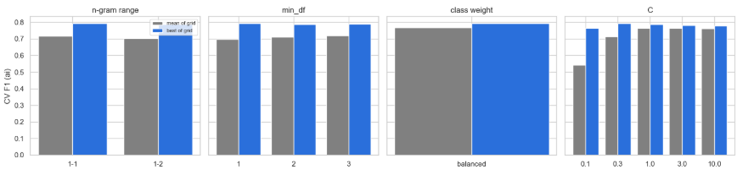
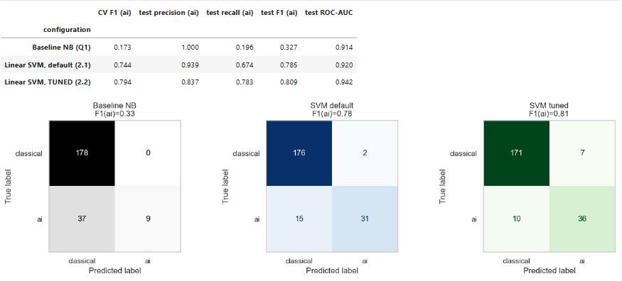
Tuning raised the cross-validated F1 from about 0.76 to 0.80 and the test F1 from about 0.80 to 0.82. Recall for AI papers went from 0.70 to 0.78, with a small drop in precision. For a screening tool, finding more relevant papers matters more than a few extra false alarms, so this is a good trade. The grid results show that the class weighting gave most of the gain, which confirms that the imbalance was the main weakness of the baseline. The improvement over the default SVM is small, and the test set contains only 46 AI abstracts, so a difference of about 0.03 could be chance. The cross-validation numbers are more reliable than the single test split.

Question 2.3
I refitted the tuned Linear SVM on all 1,120 cleaned abstracts and saved it as model.joblib. A plain SVM does not give probabilities, so I added a calibration step that turns its scores into probabilities.
The interface is a Streamlit page, app.py, laid out like the example image. It has the title “Researchly Research Abstract Classifier”, a text box for the abstract, a “Classify Abstract” button, and a result that says either “artificial intelligence” or “classical research”, together with the probability. The page cleans the text with the same function used in the notebook before it predicts. It runs with pip install -r requirements.txt followed by streamlit run app.py.
One limitation is that the model was trained only on inflation abstracts, so it learns the vocabulary of machine learning versus econometrics. On abstracts from other fields it may be less reliable.

Question 3

Question 3.1
I read the five files in research_corpus.zip into a pandas DataFrame with the article number, file name, full text, character count and word count. The articles are about research methods, not artificial intelligence. Article 1 is about mixed methods research, article 2 about the researcher’s position in qualitative research, article 3 about developmental research in instructional design, article 4 about the use of Cronbach’s alpha in science education, and article 5 about triangulation in qualitative research. They have 5,602, 2,416, 3,828, 5,922 and 4,027 words.
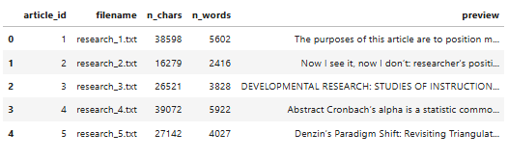

Question 3.2
The articles came from PDFs, so they have their own kind of noise. I rejoined words that were split across lines by a hyphen, and removed in-text references such as “(Guba, 1990)”, footnote numbers, web links and e-mail addresses. I then lowercased the text, removed numbers and punctuation, removed stopwords and publishing words such as “journal” and “university”, and reduced plurals to their singular form. Each article shrank to roughly 43 to 47% of its original length: for example article 1 went from 5,602 words to 2,578 tokens, and article 4 from 5,922 to 2,804.
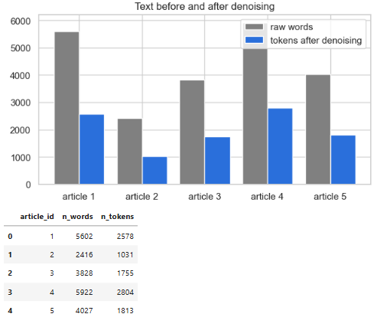
Article 1 also contains some repeated passages. I removed the repeated sentences before summarising.

Question 3.3
For the first article I used TextRank, a method that picks the most important sentences. It splits the article into sentences ([69] after removing repeats), turns each one into a TF-IDF vector, and links sentences that are similar to each other. An algorithm similar to Google’s PageRank then scores each sentence by how well connected it is, and the top five, kept in their original order, make the summary.

SUMMARY OF ARTICLE 1

- The purposes of this article are to position mixed methods research (mixed research is a synonym) as the natural complement to traditional qualitative and quantitative research, to present pragmatism as offering an attractive philosophical partner for mixed methods research, and to provide a framework for designing and conducting mixed methods research.

- Both sets of purists view their paradigms as the ideal for research, and, implicitly if not explicitly, they advocate the incompatibility thesis, which posits that qualitative and quantitative research paradigms, including their associated methods, cannot and should not be mixed.

- We hope the field will move beyond quantitative versus qualitative research arguments because, as recognized by mixed methods research, both quantitative and qualitative research are important and useful.

- Mixed methods research as the third research paradigm can also help bridge the schism between quantitative and qualitative research.

- For example, qualitative researchers should be free to use quantitative methods, and quantitative researchers should be free to use qualitative methods.

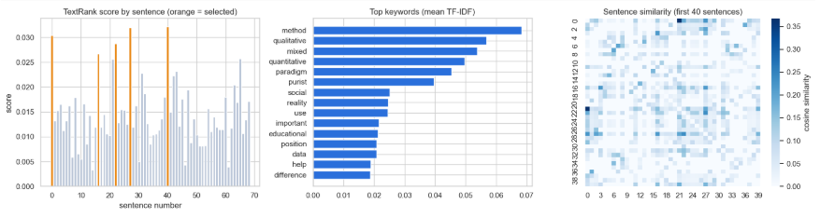
The summary says the article presents mixed methods research as a third option between quantitative and qualitative research. It describes the argument between purists on each side, who say the two cannot be mixed, and presents pragmatism as the reason they can. The keyword chart agrees, with mixed, method, qualitative and quantitative among the top words.

Question 3.4
For the other four articles I used a different method, a centroid-based summary with Maximal Marginal Relevance. All the sentences from the four articles were turned into TF-IDF vectors, and I found the centroid, which is the average vector and acts as a picture of the combined topic. Each sentence was scored by how close it is to that centroid. Maximal Marginal Relevance then picked eight sentences that are close to the centroid but not too similar to each other, so the summary does not repeat itself. I allowed at most two sentences per article so that the two long articles would not take over.
(article 5) A case study design with at least two data collection methods is one example of methodological triangulation.

(article 4) The Use of Cronbach's Alpha in Science Education Studies It is common to see the reliability of instruments used in published science education studies framed in terms of a statistic known as Cronbach's alpha.

(article 4) However, the literature also includes reports of the development of tests of student knowledge and understanding that cite Cronbach's alpha as an indicator of instrument quality.

(article 3) The second type of developmental study is oriented toward a general analysis of design, development, or evaluation processes, addressed either as a whole or in terms of a particular component.

(article 5) Qualitative Research and Triangulation The application of triangulation (multiple sources of data) can enhance the reliability of the study results and enable one to saturate the data.

(article 3) Other studies in this category focus on only one phase of the design/development/evaluation process, such as Jonassen's case study of using needs assessment data in the development of a university program.

(article 2) Thus, it enhances the quality of the research by allowing researchers to ponder the ways in which who they are may both assist and hinder the process of co-constructing meanings, frees them to handle and present the data better, and consider its complex meanings and contribution to the understanding of social phenomena and of the process involved in knowledge production.

(article 2) Now I see it, now I don't: researcher's position and reflexivity in qualitative research Roni Berger Adelphi University, USA Abstract This article addresses potential effects on reflexivity of researcher's social position (e.g. gender, age, race, immigration status, sexual orientation), personal experiences, and political and professional beliefs.

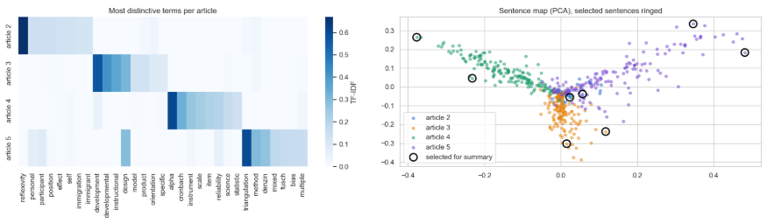The heatmap shows that each article has its own vocabulary. Article 2 stands out for reflexivity, participant and immigrant, article 3 for development and instructional, article 4 for alpha, instrument and item, and article 5 for triangulation, Denzin and Fusch. In the PCA map the sentences from each article form fairly separate groups, and the chosen sentences are spread across them. A weakness of this approach is that whole sentences are copied, so a few of them still contain stray headings.

Question 4

Question 4.1
Five articles are too few for Latent Dirichlet Allocation, so I split each cleaned article into passages of 80 words. This gave [125] passages (article 1 has [32], article 2 has [13], article 3 has [22], article 4 has [35] and article 5 has [23]), and I built a word-count matrix of [1,325] words.
To choose the number of topics I trained models with 2 to 8 topics and compared coherence and perplexity. They did not agree. Coherence was best at [2] topics and perplexity was best at [4]. With only [125] short passages both measures are noisy, so I chose 5 topics, because they were easy to interpret and matched the five articles. This was a judgement call.
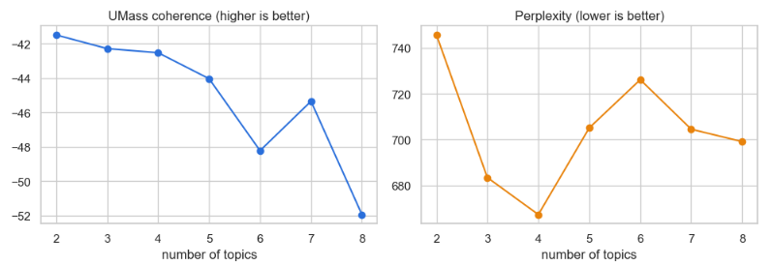
Topic | Main words | What it is about
1 | experience, instructional, reflexivity, development, process | Reflexivity and the researcher’s position
2 | alpha, instrument, Cronbach, value, reliability, scale | Cronbach’s alpha and reliability
3 | method, mixed, qualitative, quantitative, paradigm | Mixed methods and paradigms
4 | data, triangulation, Denzin, multiple, source | Triangulation of data sources
5 | development, process, design, developmental, evaluation | Developmental research and design

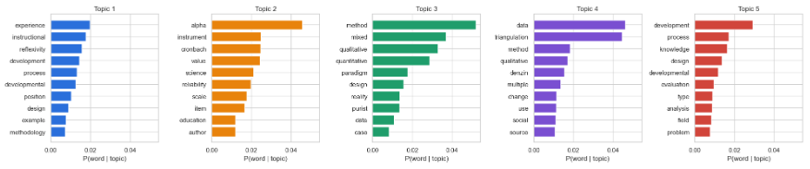Each article was dominated by one topic: article 1 by topic 3 ([55%]), article 2 by topic 1 ([60%]), article 3 by topic 5 ([72%]), article 4 by topic 2 ([78%]) and article 5 by topic 4 ([82%]). So the model found the main theme of each article without being told anything about them. Article 3 also draws on topic 1, because both articles talk about development and process. Article 1 is the most mixed, which fits an article that covers many different methods.
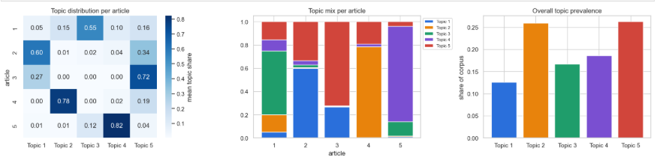

Question 4.2
I used pyLDAvis to build an interactive intertopic distance map, saved as lda_intertopic_map.html. Each circle is a topic, its size shows how common the topic is, and the distance between circles shows how different the topics are. The bars on the right show the most salient words, and a slider changes whether the list favours words that are common overall or words that belong to the selected topic.
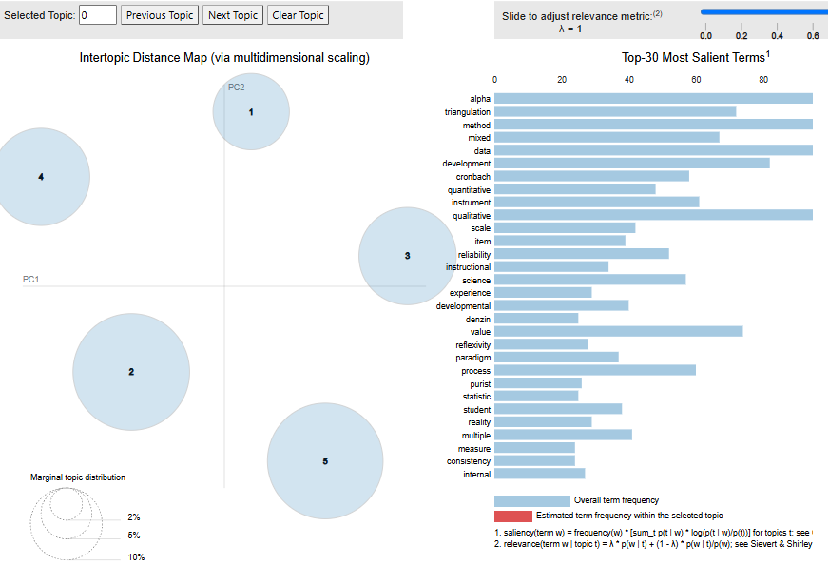

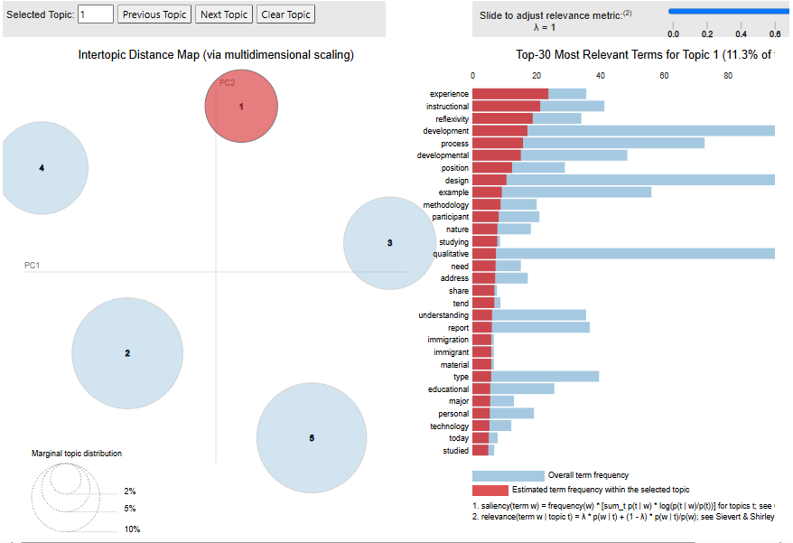

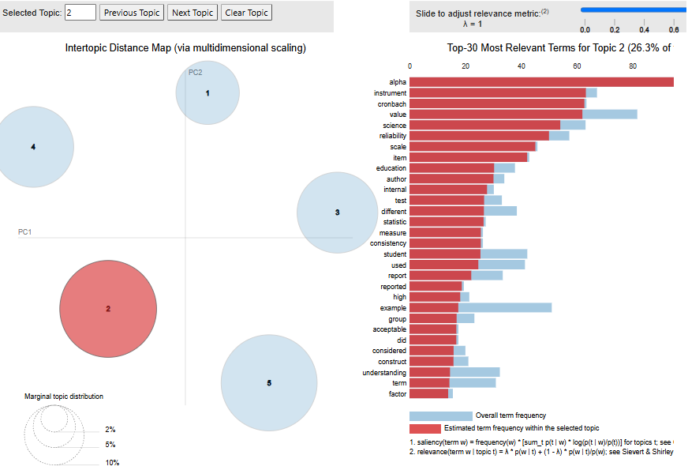
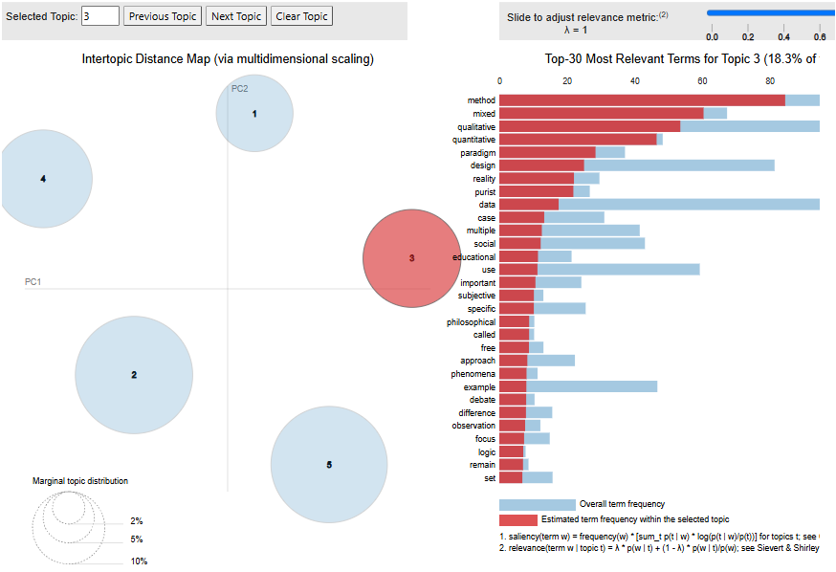
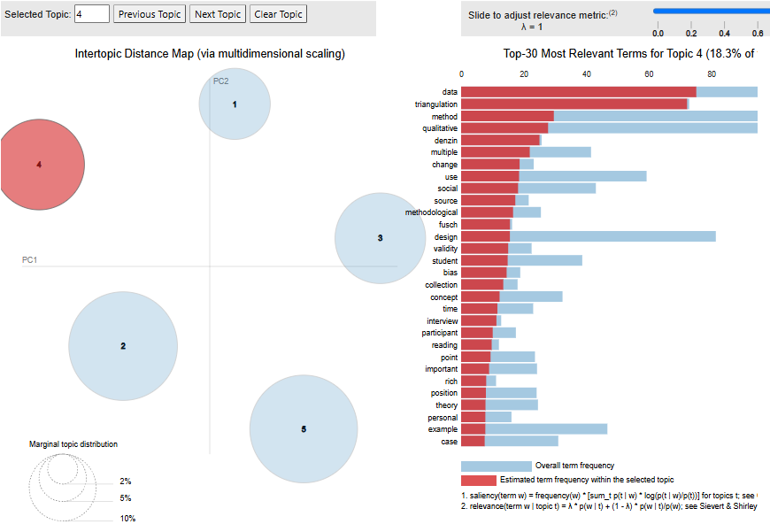
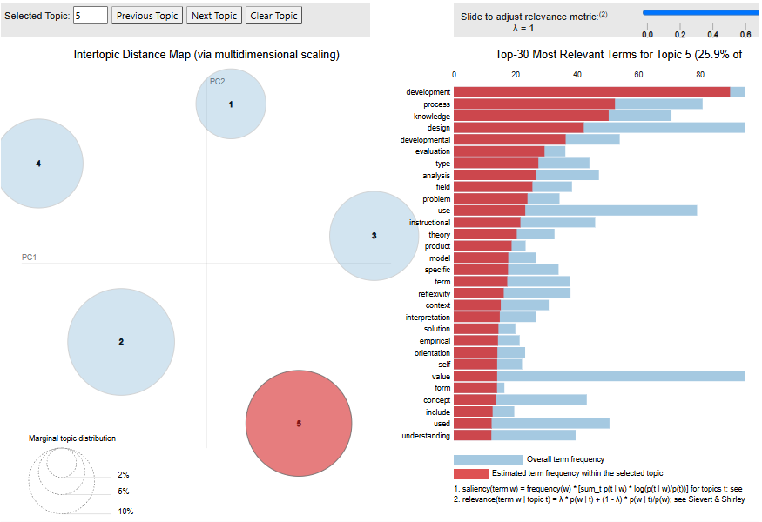

The five circles are well apart and do not overlap, which suggests that the five topics are distinct. The most salient words over the whole corpus include alpha, triangulation, method, mixed, data, development and Cronbach. Topics that sit close together share words. The axes are arbitrary in this kind of layout, so only the relative distances count, and with just five topics even those are approximate.

Question 4.3
I created a GitHub repository, https://github.com/DKotze2018/ITNPA-Assignment-Midrand-EDUV44810649.git ,with four parts:
- data/ contains research_abstracts.json and the research corpus (research_corpus.zip).
- notebooks/ contains the notebooks that show the analysis for Questions 1 to 4 in order, with their outputs saved, along with the intertopic map lda_intertopic_map.html.
- docs/ contains this project documentation for Questions 1 to 4.
- deployment/ contains app.py, model.joblib, requirements.txt and a README. The README explains how to run the web page: install the requirements with pip install -r requirements.txt, start the app with streamlit run app.py, open http://localhost:8501, paste an abstract and click “Classify Abstract”.

