|  |
| --- |
| AMAZE GAMES |
| aMAZE Sky |
| **A game about mazes** |
| Version #02  All work Copyright © 2016 by aMAZE Games.  All rights reserved. |
| **Christine and Douglas** |
|  |



|  |
| --- |
| March 11th 2016 |

**Table of Contents**

I. Game Overview 4

II. Game Mechanics 4

III. Controls 4

IV. Interface Sketch 4

V. Screen Descriptions – Will be included later 7

VI. Characters 7

VII. Enemies 7

VIII. Scoring 8

IX. Sound Index 8

X. Art/Multimedia Index 8

**Version History**

**03/09/2016**

* Document Created
* Added Game Overview, Mechanics, Controls, Characters, Enemies, and Scoring
* Added Company Logo, Name of game

**Game Description**

## Game Overview

*This game takes place in a forest located on an island in the sky. You play as a sky-bear, one of the last of its kind. Your goal is to survive the harsh trials of the forest by collecting various food items, while trying to avoid the many traps that attempt to hinder you on your journey.*

## Game Mechanics

*The game is a maze-survival game in which you will start out with amount of hitpoints. You must collect food items scattered throughout the forest in order to increase your score while trying not to lose all your hitpoints. You will want to avoid traps laid out throughout the world as they will decrease your hitpoints. Once your hitpoints reach zero it is Game Over.*

## Controls

*This game requires the keyboard and a mouse or trackpad.*

***Mouse/Trackpad Control*** *– Allows the player to change the camera perspective of their character. Mouse pointer movement will control where the character looks in the world.*

***Keyboard Control*** *– Allows the player to move around in the world using the following keys:*

***W Key/Up arrow:*** *Moves the player forward in the world*

***S Key/Down arrow:*** *Moves the player backward in the world*

***A Key/Left arrow:*** *Moves the player to the left in the world*

***D Key/Right arrow:*** *Moves the player to the right in the world*

***Spacebar:*** *Allows the player to jump in the world*

## Interface Sketch

Start Screen:

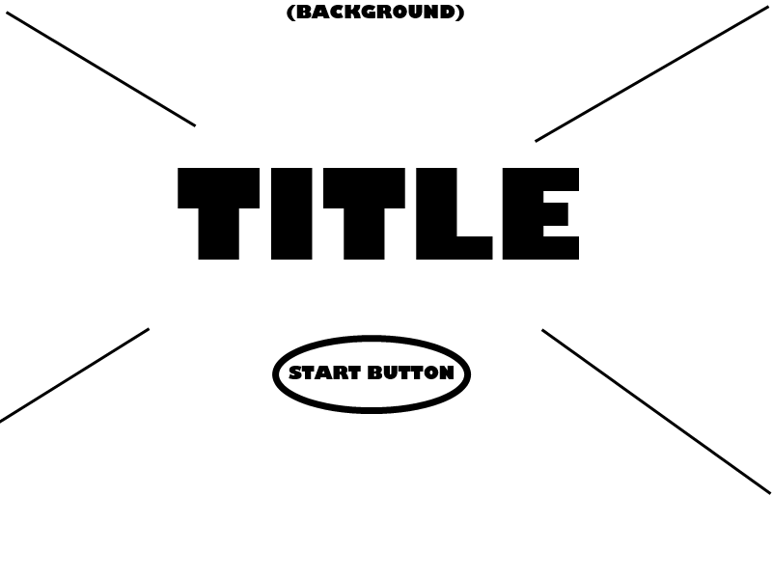

Game Screen:

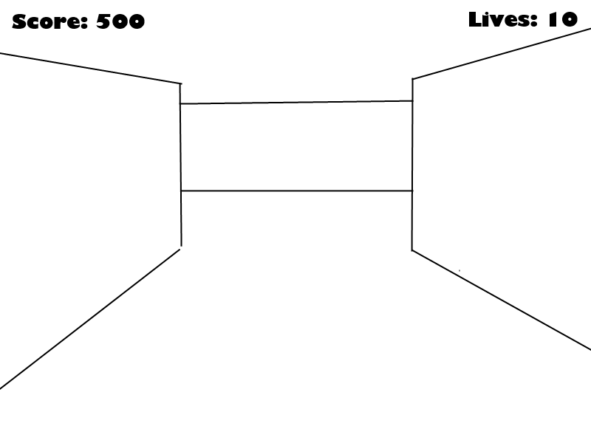

Game Over Screen:

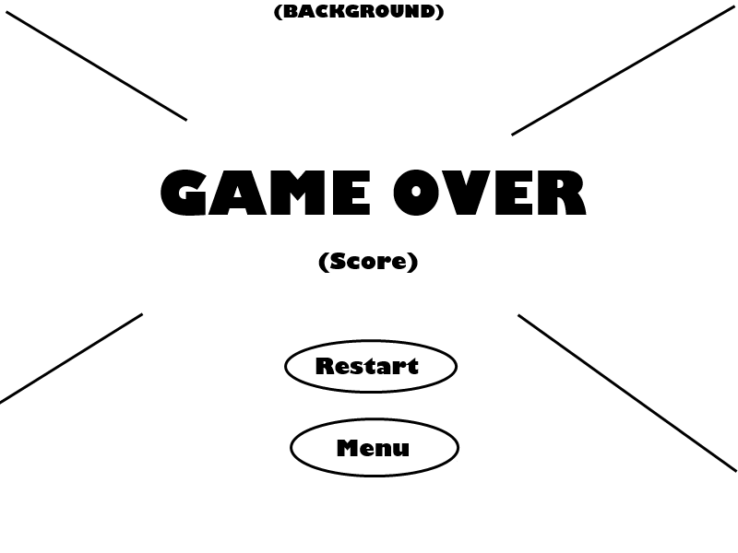

## Screen Descriptions – Will be included later

## Characters

You play as one of the sole surviving sky-bears that reside on the mystical sky forest island.

## Enemies

*Enemies in this game are the traps and hazards found throughout the world. Obstacles will also be laid out to hinder your progress. Enemies are as followed:*

***Large Tree Branch:*** *Falling tree branches that the player should avoid, upon collision will cause you to lose hitpoints.*

***Large Rock:*** *Falling rocks that the player should avoid, upon collision will cause you to lose quite a bit of hitpoints.*

***Pitfall:*** *Holes throughout the island, or a gap that separates the island. If you fall into their holes you will fall from the sky forest and instantly lose all your hitpoints. It is Game Over once you fall.*

## Scoring

*Scoring is calculated based on what you interact and collide with.*

*Collecting the following items will cause you to gain points:*

* *Picnic Basket: Gain 5 Points*
* *Meat: Gain 3 Points*
* *Berries: Gain 1 Point*

## Sound Index – FEEL FREE TO DELETE WHATEVER AND ADD WHATEVER

|  |  |
| --- | --- |
| File Name | Description |
| Collecting.mp3 | Sound played when player collides/picks up an object worth points |
| Collision.mp3 | Sound played when player collides/hits an object causes the player to lose hitpoints. |
|  |  |

## Art/Multimedia Index – FEEL FREE TO DELETE WHATEVER AND ADD WHATEVER

|  |  |
| --- | --- |
| Thumbnail | File Name |
|  | Basket.jpg |
|  | Background.jpg – **PUT SOMETHING ELSE HERE TOO** |
|  | Berry.jpg |
|  | Fallingbranch.jpg |
|  | Floor.jpg OR Grass.jpg – **PICK ONE OR SOMETHING ELSE** |
|  | Rabbit.jpg |
|  | Rock.jpg |
|  | Wall.jpg |
|  |  |