|  |
| --- |
| **Chris frandok Studios** |
| DRAGONSTORY |
| **[The 2D Side Scroller Game]** |
| Version #01  All work Copyright © 2016 by **Chris Frandok** Studio Games.  All rights reserved. |
| **Christine Cho - Douglas Krein - Francis Ofougwuka** |
|  |

|  |
| --- |
| April 4th 2016 |

Table of Contents

Version History 3

Game Description 4

I. Game Overview 4

II. Game Play Mechanics 4

III. Controls 4

IV. Interface Sketch 4

V. Screen Descriptions 10

VI. Game World 10

VII. Levels 10

VIII. Characters 10

IX. Enemies 10

X. Scoring 11

XI. Sound Index 11

XII. Art/Multimedia Index 11

# Version History

# Game Description

## Game Overview

*This game takes place in the sky above the snowy mountain nest of corrupted dragons. You play as an azure dragon trying to escape the corruption. You are trying to save as many other dragons as you can by collecting their eggs to prevent them from getting corrupted as well. Your goal is to find and bring the eggs to a safe home away from the corruption while trying to escape the grasps of the other dragons that have already been corrupted.*

## Game Play Mechanics

*This game is a side scrolling survival game in which you start with a limited amount of health points. You collect eggs that randomly appear while the screen scrolls in order to increase your score. You want to avoid the other dragons to keep your health points from going down. Once your health points hit zero is game over.*

## Controls

*This game requires a mouse or a trackpad to move the player’s character up and down.*

## Interface Sketch

Menu Screen:

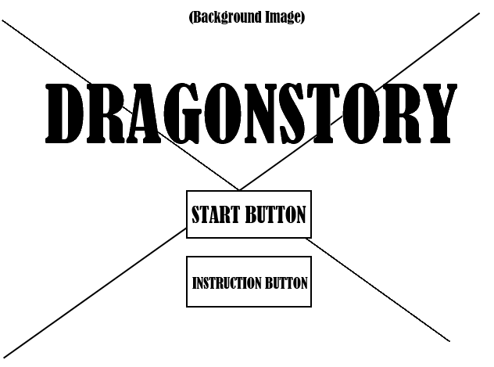

Instruction Screen:

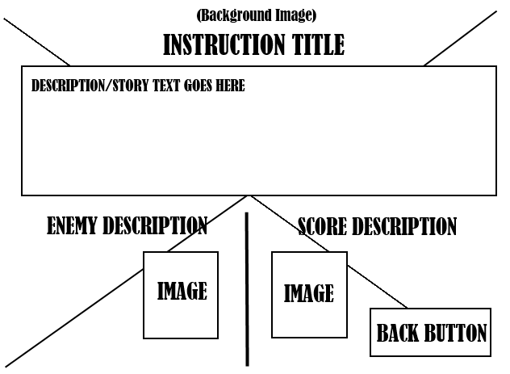

In-Game Screen:

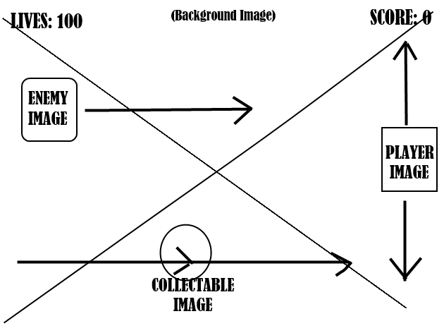

Game Over Screen:

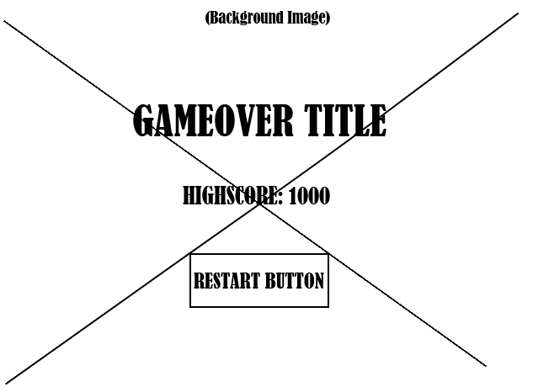

Level 1:

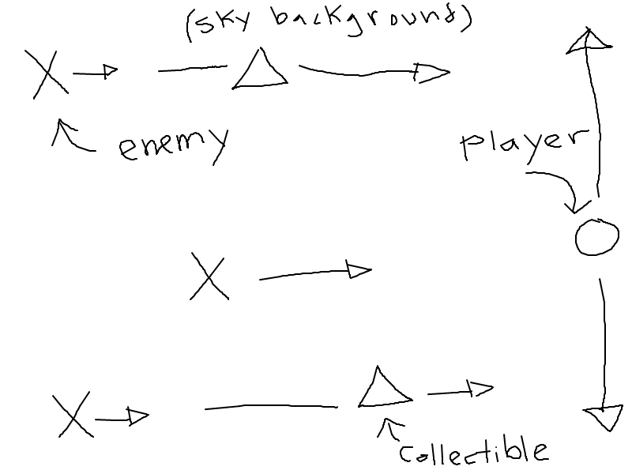

Level 2:

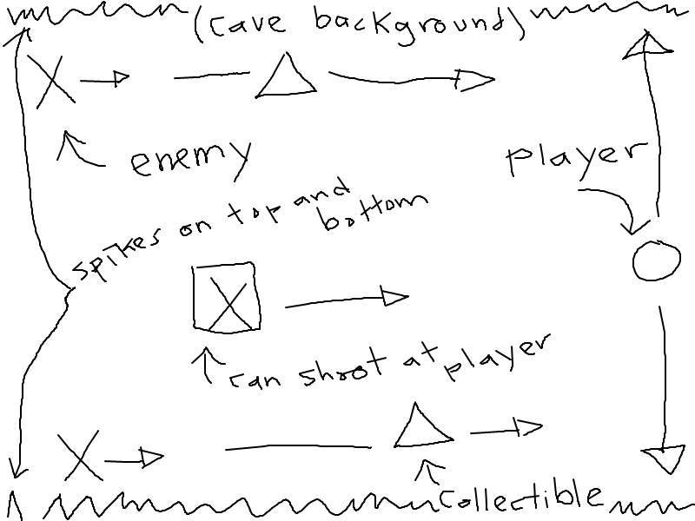

Level 3:

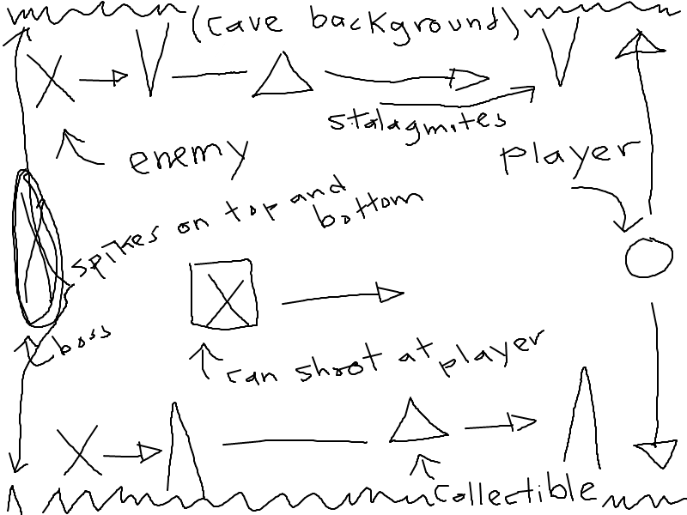

## Screen Descriptions

Menu Screen:

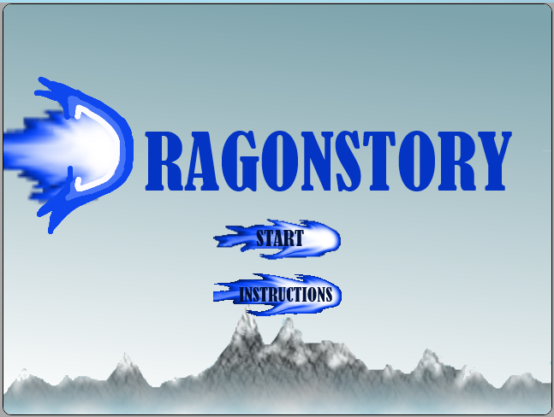

## Game World

*The game starts out in the skies of a snowy mountain above a nest of corrupted dragons, in the nest is a cave full of eggs that require rescuing.*

## Levels

***Level 1:*** *Outside in the skies of a snowy mountains with dragons defending the nest*

***Level 2:*** *In the cave of the snowy mountain full of eggs and some fireball breathing dragons. Spikes are also found on the top and the bottom of the cave.*

***Level 3****: Deeper in the cave of the snow mountain full of eggs and spikes with added stalagmites and a boss.*

## Characters

*You play as an azure dragon trying to escape the pursuit of the corrupted dragons.*

## Enemies

*The enemies of this game are dragons of another colour and stalagmites. You lose health points if you collide with one of them.*

## Scoring

*Scoring is collision based, you get points for every egg you collect.*

## Sound Index

|  |  |
| --- | --- |
| File Name | Description |
| collect.mp3 | Sound played when player collides with the red fire worth points |
| hit.mp3 | Sound played when player collides/hits the blue fireball causing the player to lose health points. |
| background.mp3 | Sound played during the play phase of the game |
| gameover.mp3 | Sound played when the player enter the game over phase of the game |
| opening.mp3 | Sound played when the player starts launches the game |

## Art/Multimedia Index

|  |  |
| --- | --- |
| Thumbnail | File Name |
|  | BackButton.png |
|  | StartButton.png |
|  | InstructionButton.png |
|  | RestartButton.png |
|  | dragonplayer.png |
|  | enemy1.png |
|  | enemy2.png |
|  | enemy3.png |
|  | enemy4.png |
|  | eggs.png |
|  | boss.png |
|  | mountain.png |
|  | stalagmite.png |
|  | spike.png |
|  | cave.png |