Laboratório Controle – aula 03 – 09/07/2015

Aluno: David Maykon Krepsky Silva

Ex 1 – A:

Ex 1 – B:

% G(s)

* num = [m1 b (k1+k2) 0];
* den = [m1\*m2 b\*m2 (m1\*k2 +k1\*m2 + k2\*m2) (b\*k2) (k1\*k2)];

G =

10 s^3 + 0.5 s^2 + 200 s

------------------------------------------

200 s^4 + 10 s^3 + 5000 s^2 + 50 s + 10000

Ex 1 – C :

% Lab - 03 - controle 09/07/15

% Ex 1

clear all

close all

clc

m1 = 10;

m2 = 20;

b = 0.5;

k1 = 100;

k2 = 100;

d1 = [m1 b k1+k2];

d2 = [m2 0 k2];

num = [m1 b (k1+k2) 0];

den = [m1\*m2 b\*m2 (m1\*k2 +k1\*m2 + k2\*m2) (b\*k2) (k1\*k2)];

G = tf(num, den)

step(G);

Saída:

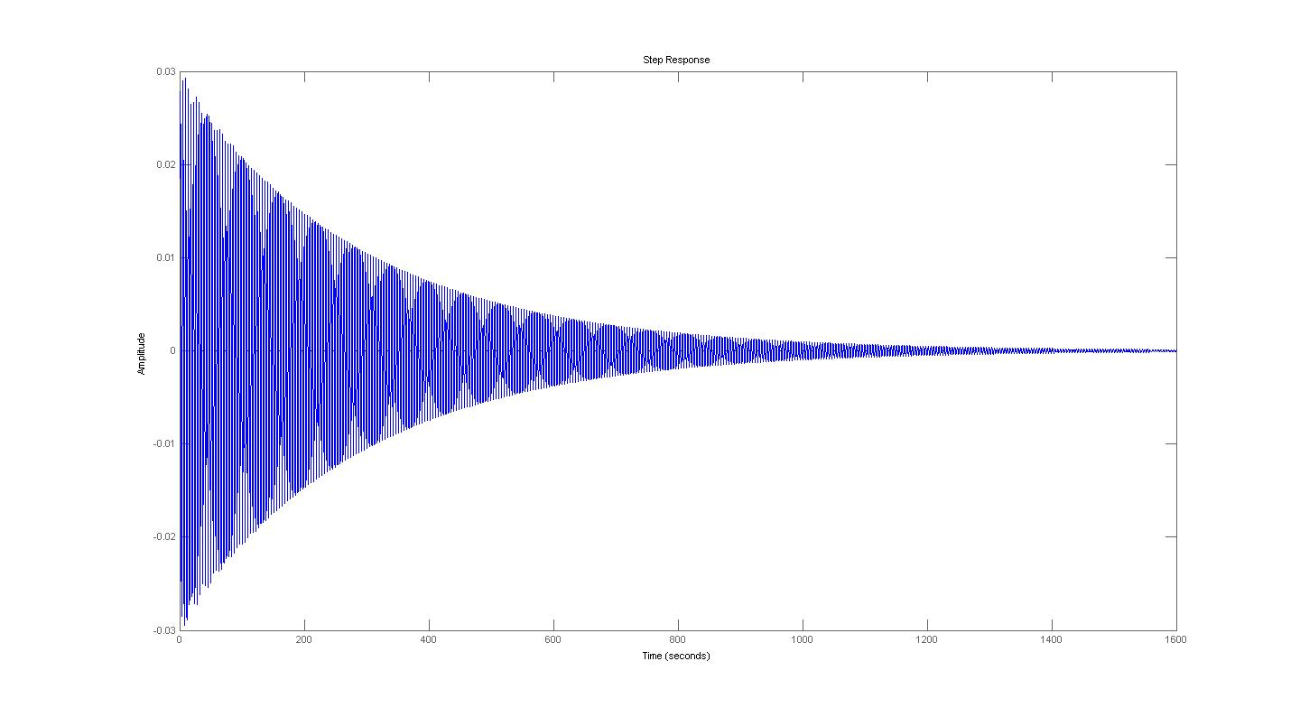

Ex 2: