1. 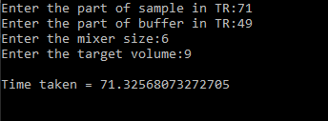First run TVODA_v2.exe which is present in "TVODA-Codes\dist\", this will open a command promt and ask for the inputs as follows:
2. After specifying all the inputs, press enter to generate the output. The output will generate as an .dot file in "TVODA-Codes\dist\", which represents the corresponding dilution graph.
3. The output .dot file can be visualized using an online or an offline platform (eg. graphviz) to visualize the dilution graph, an example output is shown below.

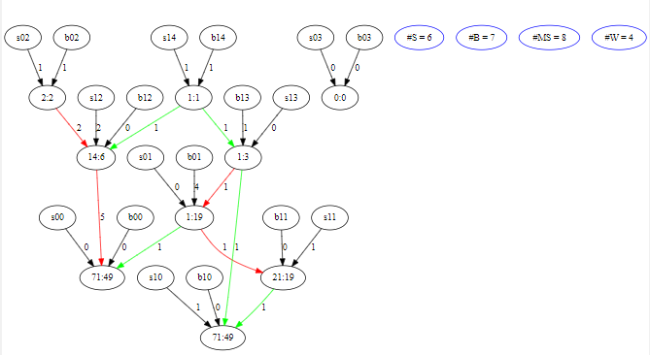

* sij : pure sample node of the i-th skeleton at the j-th depth.
* bij : pure buffer node of the i-th skeleton at the j-th depth.
* The green edges are the intra –skeleton edges and the red edges are inter skeleton edges.

waste count

buffer count

mixing steps

sample count

1. After the completion of the execution the time taken to run the process (in seconds) is shown in the command promt.

