**5.5 DESIGN LAYOUT**

**LOGIN:**

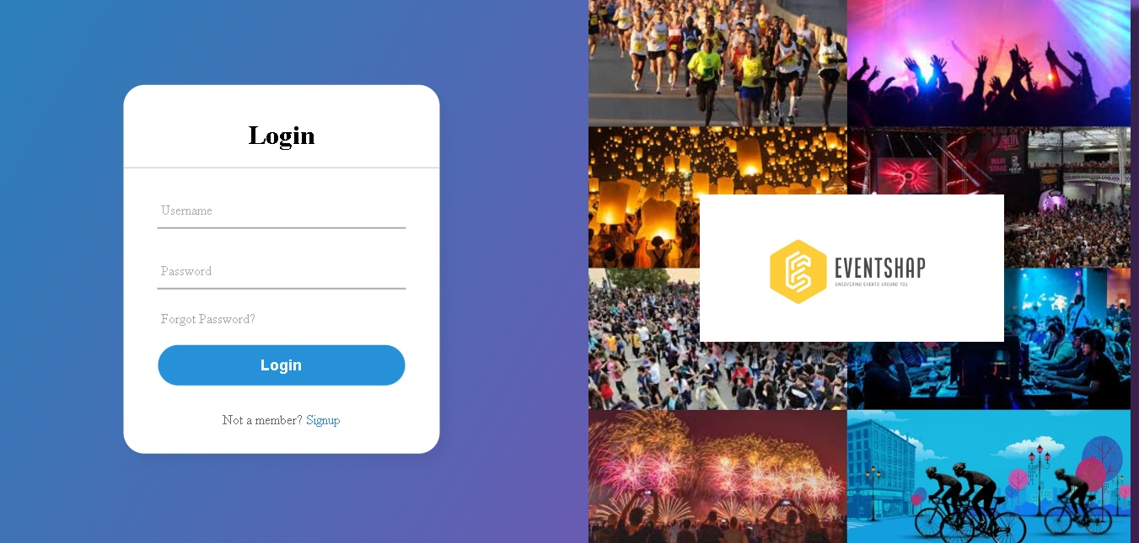

**[Figure 8: Login Page]**

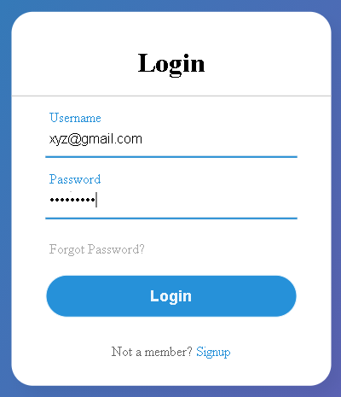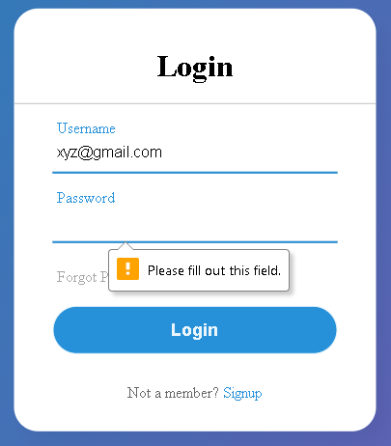

**[Figure 9: Login Page Validation]**