**CHAPTER -1**

**INTRODUCTION**

* 1. **Need of the new system**
* In today’s life, people have many options to enjoy weekends but with many options comes more trouble to choose places nearby.
* It is very time consuming and complex to search such events near surrounding.
* For this people have to gather information as such they don’t know about the events occurring nearby.
* This web application will help people to overcome from such issues and search an immediate result of events occurring nearby.
  1. **Detailed problem definition**
* Here people can get the alternative to search for their choice of favorite events which attracts their interest.
* List of events available on our site will be fully authorized and safe as per today's condition.
* New system will add the better reviews for people who have already experienced our organized events.
* Even people will get a chance to Register online easily as per the quote says first comes first serve.
  1. **Viability of the system**
* In our website people can easily check or go through the events happening nearby on a click.
* It will be a user friendly website.
* No payment charges for any user.
  1. **Presently Available Systems for the same**
* <https://insider.in/online-events-india>



**Figure 1**

* <https://www.whatshot.in/>



**Figure 2**

**1.5 Future Prospects**

* More categories will be added in upcoming time.
* More areas will covered in nearby future.
* Online payment methods will be included.
* Feature like map will be added.

**CHAPTER-2**

**ANALYSIS**

* 1. **Requirement Analysis**

Aim of this website is to understand the exact requirements of the customer and to document them properly. It will also reduce the communication gap between developers and customers.

Types of users in our new system are:-

* Admin
* Event organizer
* Client
* Event manager

**Admin:**

* Admin directs the whole website.
* Looks after the website on regular basis and can make changes.
* They ensure security measures for the users.
* Troubleshoot issues and the outages.
* Incharge of all the panels provided.
* They generate the backups on daily basis.

**Event organizer:**

* Organizes the event panel accordingly.
* Notifies about the upcoming events.
* Terms and conditions of the events.
* Posting about the regular events.

**Client:**

* They must register themselves to the websites.
* Can access areas and features of the website.
* Access to offers and coupons.
* Access to map for locating nearby events.
* Provides feedback system.

**Event manager:**

* Mediator between the Admin and Event organizer.
* Searches for all the nearby event places.
* Deals with the event organizers.
* Schedules the meeting between admin and the event organizers for further procedure.

* 1. **Project Model**
* **Iterative Waterfall Model**

The Iterative waterfall model provides feedback paths from every phase to its preceding phases.

In the Iterative model, iterative process starts with a simple implementation of a small set of the software requirements and iteratively enhances the evolving versions until the complete system is implemented and ready to be deployed.

An iterative life cycle model starts with specifying and implementing part of the software, which is then reviewed to identify further requirements.

* **Iterative Waterfall Model**

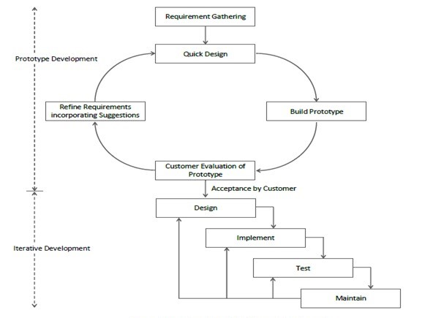

**[Figure 1: Iterative Waterfall Model]**

* **ADVANTAGES**
* The model is more flexible and less costly to change the scope and requirement.
* User gets a chance to experiment with partially developed software.
* This model helps finding exact user requirement.
* Feedback providing at each increment is useful for determining the better final product.
  1. **Schedule Representation**

Generalized project scheduling tools and technique can be applied with little modification to software projects. Project evolution and review technique and critical paths method are two project scheduling method that can be applied to software development. Both techniques are driven by information already developed in earlier project planning activities**.**

**[Table 1: Schedule Representation]**

|  |  |  |
| --- | --- | --- |
| **ACTIVITY** | **START DATE** | **FINISH DATE** |
| **Requirement Analysis** | 01-07-2021 | 15-08-2021 |
| **System Analysis** | 16-08-2021 | 22-09-2021 |
| **System Design** | 23-09-2021 |  |
| **System Coding** |  |  |
| **Testing and Integration** |  |  |

* 1. **Feasibility Study**

1. **Economical Feasibility:**

The system being is economic with respect to client or software development company point of view. It will not take any extra charges or high rates from clients for registration but, for event organizer company charges would be taken.

**2. Technical Feasibility:**

This system will be technically feasible as it runs on PHP which is open source so one will not have to take/pay any licensing.

**3. Legal feasibility:**

This system will be legally feasible as it does not have any functionality that is performed without any permission or illegally.

**4. Environmental feasibility:**

This system is environmentally feasible as it does not require any type of resources that harms nature or human as it runs on server.

**CHAPTER 3**

**DESIGN**

1. **Data Flow Diagram**

* DFD (data flow diagram) is also known as bubble chart or data flow graph.
* DFD’s are very useful in understanding the system and can be effectively used during analysis. It shows flow of data through a system visually. The DFD is a hierarchical graphical model of a system the different processing activities or functions that the system performs and the data interchange among these functions.
* It views a system as a function that transforms the inputs into desired output.
* Each function is considered as a process that consumes some input data and produces some output data.
* Function model can be represented using DFD.
* DFD graphically representing the functions, or processes, which capture, manipulate, store, and distribute data between a system and its environment and between components of a system.
* The visual representation makes it a good communication tool between User and System designer.
* Structure of DFD allows starting from a broad overview and expand it to a hierarchy of detailed diagrams.
* DFD has often been used due to the following reasons:

1. Logical information flow of the system.
2. Determination of physical system construction requirements.
3. Simplicity of notation.
4. Establishment of manual and automated systems requirements.

**[Table 2: Data Flow Diagram Symbols]**

|  |  |
| --- | --- |
| **Symbols** | **Description** |
|  | **Entity:** Entities are external to the system which interacts by inputting the data. |
|  | **System:** It shows the system name. |
|  | **Process:** It shows the part of the system that transforms into outputs. |
|  | **Data Flow:** It passes the data from one part to another. |
|  | **Data Store:** Data store is represented by two parallel lines. It is generally logical file or database. |

**Level 0: Context**

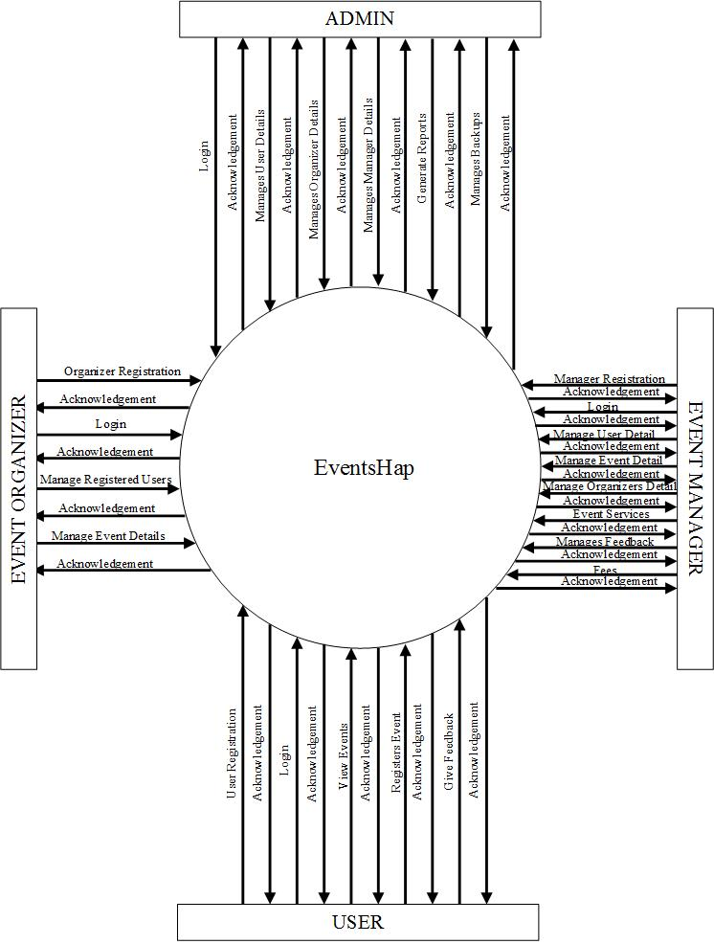

**[Figure 2: CONTEXT LEVEL]**

**Level 1: ADMIN**

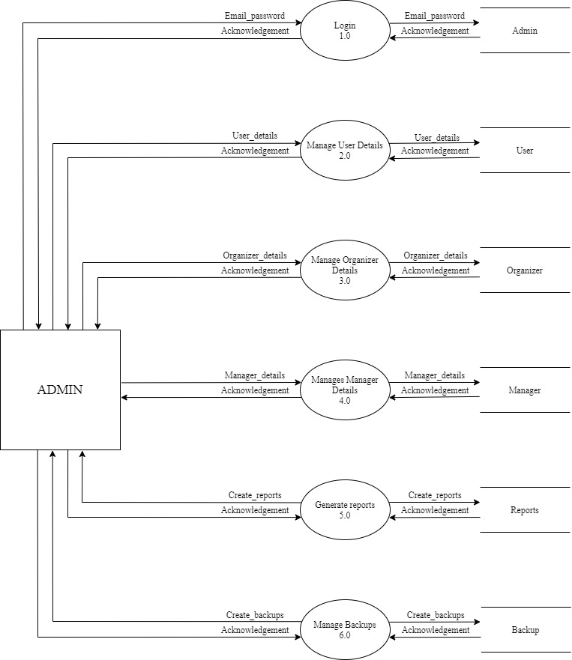

**[Figure 3: DFD Level 1: Admin]**

**Level 1: EVENT ORGANIZER**

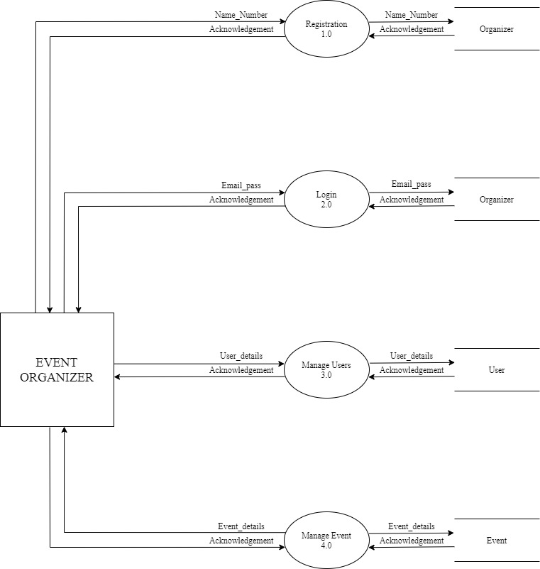

**[Figure 4: DFD Level 1: Event Organizer]**

**Level 1: EVENT MANAGER**

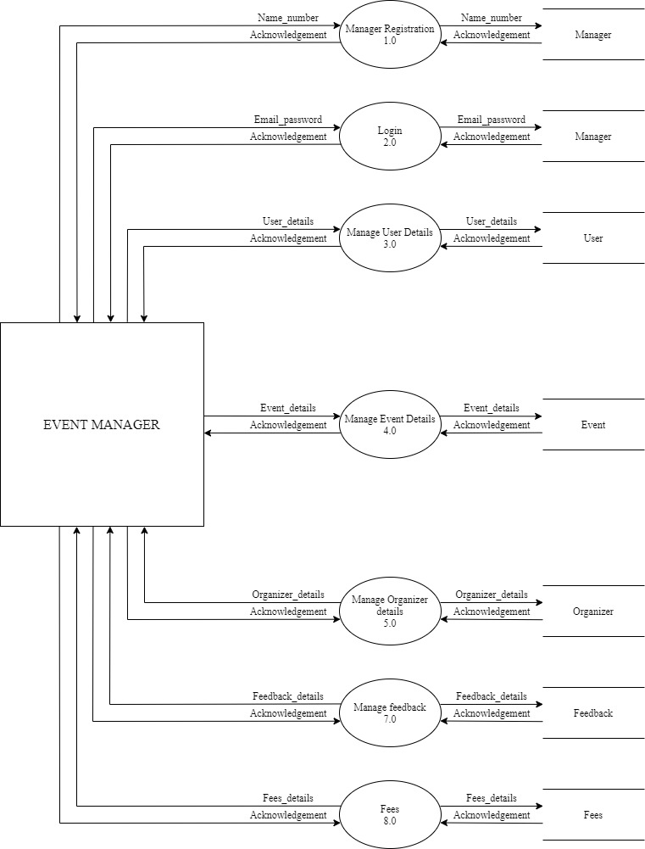

**[Figure 5: DFD Level 1: Event Manager]**

**Level 1: USER**

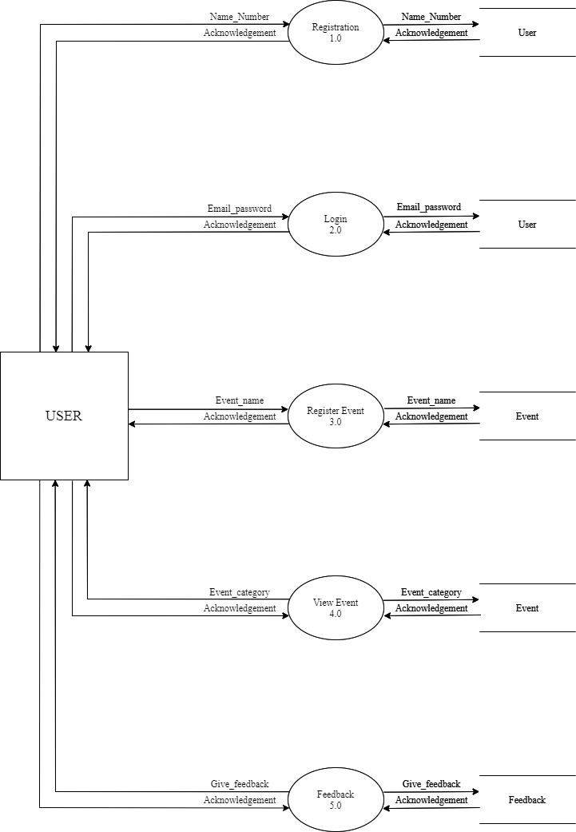

**[Figure 6: DFD Level 1: USER]**

**3.2 ER-Diagram**

An Entity Relationship (ER) Diagram is a type of flowchart that illustrates how “entities” such as people, objects or concepts relate to each other within a system. ER Diagrams are most often used to design or debug relational databases in the fields of software engineering, business information systems, education and research. Also known as ERDs or ER Models, they use a defined set of symbols such as rectangles, diamonds, ovals and connecting lines to depict the interconnectedness of entities, relationships and their attributes. They mirror grammatical structure, with entities as nouns and relationships as verbs.

**[Table 3: ER-Diagram Symbols]**

|  |  |
| --- | --- |
| **Symbols** | **Description** |
|  | **Entity:** Data object is real world entity or thing. It is represented by a rectangle shape. An entity is an object or concept about which you want to store information. |
|  | **Attributes:** An attribute is property of characteristic of an entity. It is represented by oval shape. |
|  | **Relationship:** Entity are connected each other via relations. Generally, relationships in binary because there are two entities are related to each other. |
|  | **Cardinality (One to One):** An  instance of entity A can relate to one instances of entity B. |
|  | **Cardinality (One to Many):** An instance of entity A can relate to one or many instances of B but we can only relate one instance of A. |
|  | **Cardinality (Many to One):** One or more instances of entity A can relate to one instances of B. |
|  | **Cardinality (Many to Many):** One or more instances of entity A can relate to one more instance of entity B. |

**ER-Diagram:**

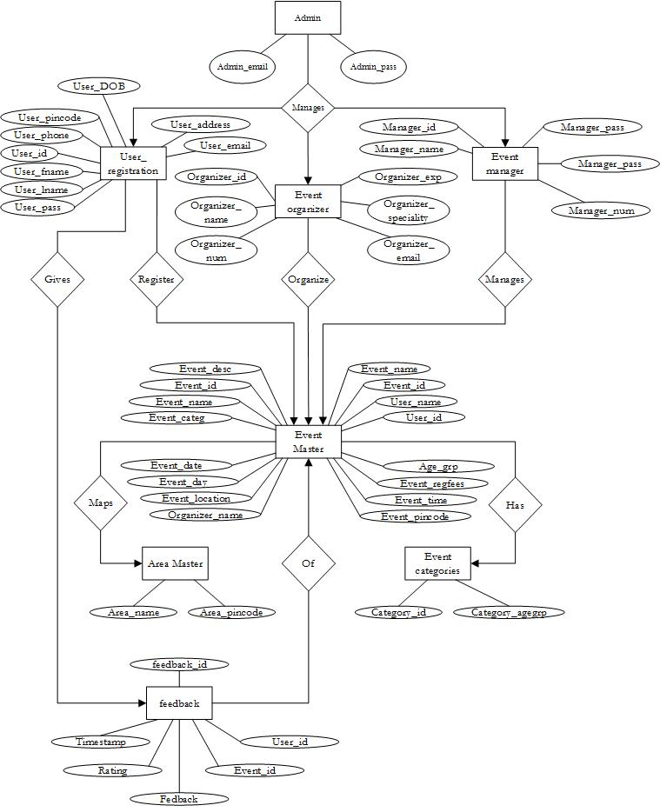

**[Figure 7: ER Diagram]**

**CHAPTER-4**

**DATA DICTIONARY**

### 4.1 Database Dictionary

1. **Table Name:** Admin

**[Table 4:** Admin**]**

|  |  |  |  |  |
| --- | --- | --- | --- | --- |
| **SR.NO** | **FIELD NAME** | **DATATYPE**  **(SIZE)** | **CONSTRAINT** | **DESCRIPTION** |
| 1 | Admin_email | Varchar (20) | Primary key | Store admin’s  email |
| 2 | Admin_pass | Varchar (15) | Unique key | Store admin’s password |

1. **Table Name:** User Registration

**[Table 5:** User Registration]

|  |  |  |  |  |
| --- | --- | --- | --- | --- |
| **SR.NO** | **FIELD NAME** | **DATATYPE**  **(SIZE)** | **CONSTRAINT** | **DESCRIPTION** |
| 1 | User_id | Int (10) | Primary key | Store user’s Id |
| 2 | User_fname | Int (10) | Not null | Store user’s first name |
| 3 | User_lname | Int (10) | Not null | Store user’s last name |
| 4 | User_phone | Int (10) | Unique key | Store user’s phone number |
| 5 | User_email | Varchar (20) | Not null | Store user’s email |
| 6 | User_pass | Varchar (15) | Not null | Store user’s password |
| 7 | User_address | Varchar (30) | Not null | Store user’s address |
| 8 | User_pincode | Int (6) | Unique key | Store user’s pin code |
| 9 | User_DOB | Int (8) | Not null | Store user’s DOB |

1. **Table Name:** User Login

**[Table 6:** User Login]

|  |  |  |  |  |
| --- | --- | --- | --- | --- |
| **SR.NO** | **FIELD NAME** | **DATATYPE**  **(SIZE)** | **CONSTRAINT** | **DESCRIPTION** |
| 1 | User_email | Varchar (20) | Primary key | Store user’s email |
| 2 | User_pass | Varchar (15) | Not null | Store user’s password |

1. **Table Name:** Event Organizer Registration

**[Table 7:** Event Organizer Registration**]**

|  |  |  |  |  |
| --- | --- | --- | --- | --- |
| **SR.NO** | **FIELD**  **NAME** | **DATATYPE**  **(SIZE)** | **CONSTRAINT** | **DESCRIPTION** |
| 1 | Organizer_id | Int (8) | Primary key | Store organizer’s Id |
| 2 | Organizer_name | Varchar (10) | Unique key | Store organizer’s name |
| 3 | Organizer_num | Int (10) | Not null | Store organizer’s  number |
| 4 | Organizer_email | Varchar (50) | Unique key | Store organizer’s email |
| 5 | Organizer_  speciality | Varchar (30) | Unique key | Store organizer’s speciality |
| 6 | Organizer_exp | Varchar (2) | Null | Store organizer’s expirience |

1. **Table Name:** Event Manager Registration

**[Table 8:** Event Manager Registration**]**

|  |  |  |  |  |
| --- | --- | --- | --- | --- |
| **SR.NO** | **FIELD NAME** | **DATATYPE**  **(SIZE)** | **CONSTRAINT** | **DESCRIPTION** |
| 1 | Manager_id | Int (8) | Primary key | Store manager’s Id |
| 2 | Manager_name | Varchar (10) | Not null | Store manager’s name |
| 3 | Manager_num | Int (10) | Not null | Store manager’s number |
| 4 | Manager_email | Varchar (50) | Not null | Store manager’s  email |
| 5 | Manager_pass | Varchar (15) | Not null | Store manager’s password |

1. **Table Name:** Organizer Login

**[Table 9:** Organizer Login**]**

|  |  |  |  |  |
| --- | --- | --- | --- | --- |
| **SR.NO** | **FIELD NAME** | **DATATYPE**  **(SIZE)** | **CONSTRAINT** | **DESCRIPTION** |
| 1 | Organizer_email | Varchar (50) | Primary key | Store organizer’s email |
| 2 | Organizer_pass | Varchar (50) | Not null | Store organizer’s password |

1. **Table Name:** Manager Login

**[Table 10:** Manager Login**]**

|  |  |  |  |  |
| --- | --- | --- | --- | --- |
| **SR.NO** | **FIELD NAME** | **DATATYPE**  **(SIZE)** | **CONSTRAINT** | **DESCRIPTION** |
| 1 | Manager_email | Varchar (50) | Primary key | Store Manager’s email |
| 2 | Manager_pass | Varchar (50) | Not null | Store Manager’s password |

1. **Table Name:** Event Master

**[Table 11:** Event Master**]**

|  |  |  |  |  |
| --- | --- | --- | --- | --- |
| **SR.NO** | **FIELD NAME** | **DATATYPE**  **(SIZE)** | **CONSTRAINT** | **DESCRIPTION** |
| 1 | Event_id | Int (10) | Primary key | Store Event’s Id |
| 2 | Event_name | Varchar (20) | Not null | Store Event’s Name |
| 3 | Event_categ | Varchar (20) | Foreign key | Store Event’s category |
| 4 | Event_date | Int (8) | Not null | Store Event’s date |
| 5 | Event_day | Varchar (10) | Not null | Store Event’s day |
| 6 | Event_location | Varchar (20) | Not null | Store Event’s location |
| 7 | Event_pincode | Int (6) | Foreign key | Store Event’s  pin code |
| 8 | Event_time | Int (10) | Not null | Store Event’s time |
| 9 | Event_regfees | Int (6) | Not null | Store Event’s  Registration fees |
| 10 | Organizer_name | Varchar (20) | null | Store Event’s organizer name |
| 11 | Age_group | Int (2) | Not null | Store Event’s group |
| 12 | Events_desc | Varchar (100) | Not null | Store Event’s description |

1. **Table Name:** Event Category

**[Table 12:** Event Category**]**

|  |  |  |  |  |
| --- | --- | --- | --- | --- |
| **SR.NO** | **FIELD NAME** | **DATATYPE**  **(SIZE)** | **CONSTRAINT** | **DESCRIPTION** |
| 1 | Category_id | Int (20) | Primary key | Store category  Id |
| 2 | Category_name | Varchar (20) | Not null | Store category name |
| 3 | Category_agegrp | Int (2) | Not null | Store category age group |

1. **Table Name:** Area

**[Table 13:** Area**]**

|  |  |  |  |  |
| --- | --- | --- | --- | --- |
| **SR.NO** | **FIELD NAME** | **DATATYPE**  **(SIZE)** | **CONSTRAINT** | **DESCRIPTION** |
| 1 | Area_name | Varchar (20) | Primary Key | Store area name |
| 2 | Area_pincode | Int (6) | Unique Key | Store area pin code |

1. **Table Name:** Event Registration

**[Table 14:** Event Registration**]**

|  |  |  |  |  |
| --- | --- | --- | --- | --- |
| **SR.NO** | **FIELD NAME** | **DATATYPE**  **(SIZE)** | **CONSTRAINT** | **DESCRIPTION** |
| 1 | Event_id | Int (8) | Primary Key | Store event’s  Id |
| 2 | Event_name | Varchar (10) | Unique Key | Store event’s name |
| 3 | User_id | Int (8) | Foreign Key | Store user’s  Id |
| 4 | User_name | Varchar (10) | Unique Key | Store user’s name |

1. **Table Name:** Feedback

**[Table 15:** Feedback]

|  |  |  |  |  |
| --- | --- | --- | --- | --- |
| **SR.NO** | **FIELD NAME** | **DATATYPE**  **(SIZE)** | **CONSTRAINT** | **DESCRIPTION** |
| 1 | Feedback_id | Int (8) | Primary Key | Store feedback Id |
| 2 | User_id | Int (8) | Foreign Key | Store user’s Id |
| 3 | Event_id | Int (8) | Foreign Key | Store event’s Id |
| 4 | Feedback | Varchar (200) | - | Store feedback |
| 5 | Rating | Int (5) | Not null | Store rating |
| 6 | Feedback_  datetime | Timestamp | Not null | Store date and time |

**CHAPTER-5**

**TECHNICAL SPECIFICATION**

**5.1 Hardware Specification:**

* **5.1.1 Ram:** 4GB
* **5.1.2 Hard drive Storage Needed:** 200GB
* **5.1.3 Other Hardware Requirements:** None

**5.2 Platform:**

* **5.2.1 Supported Operating System:** Windows XP and above, LINUX and MacOS is compatible.
* **5.2.2 Programmer Server:** Xampp Apache Server 8.0.10 64-bit.

**5.3 Framework:**

* **5.3.1 Mark-up Language:** HTML4 and HTML5.
* **5.3.2 Programming Language:** PHP 8.0.10v

**5.4 Technical Support:**

* **5.4.1 Front-End:** PHP 8.0.10v
* **5.4.2 Back-End:** MySQL 8.0.26
* **IDE Tools:** Sublime Text3 and Microsoft visual studio code.
* **UML Tools:** Microsoft Office Visio 2019.
* **SRS Tools:** Microsoft Word 2019

**5.5 DESIGN LAYOUT**

**LOGIN:**

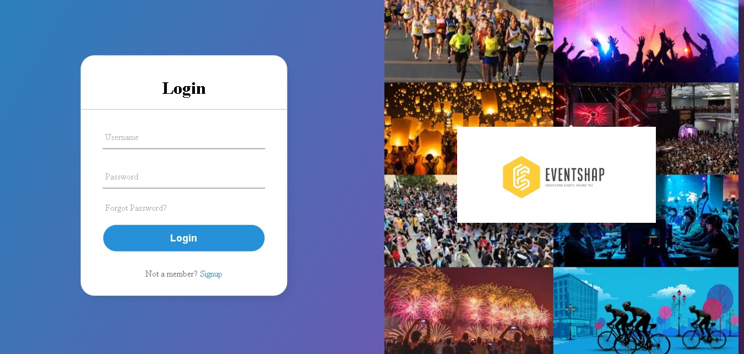

**[Figure 8: Login Page]**

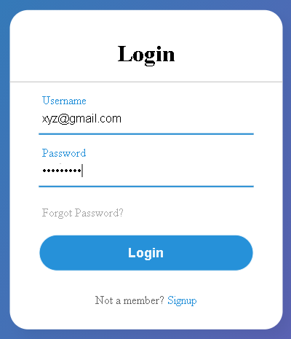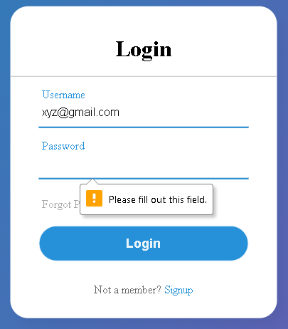

**[Figure 9: Login Page Validation]**

**BIBLIOGRAPHY**

* **BOOK REFERENCES**

1. DYNAMIC WEB PAGE DEVELOPMENT, Third Edition Author: J. B. Patel

Published by : ATUL PRAKASHAN in 2020

1. JAVA PROGRAMMING, Third Edition Author: J. B. Patel,M. R. Thakkar, Sanjy A. Valaki

Published by: ATUL PRAKASHAN in 2021

1. PHP and MySQL Web Development, Fifth Edition Authors: Luke Welling and Laura Thomsan

Published by : Addison-Wesley Professional in 2016

* **WEB REFRENCE**

1. W3school

Link: [*https://www.w3schools.com/tags/default.asp*](https://www.w3schools.com/tags/default.asp)

1. Java T point

Link: [*https://www.javatpoint.com/html-tutorial*](https://www.javatpoint.com/html-tutorial)

1. Tutorials Point

Link: [*https://www.tutorialspoint.com/html/index.htm*](https://www.tutorialspoint.com/html/index.htm)

1. W3resource

Link: [*https://w3resource.com/mysql-exercises/*](https://w3resource.com/mysql-exercises/)