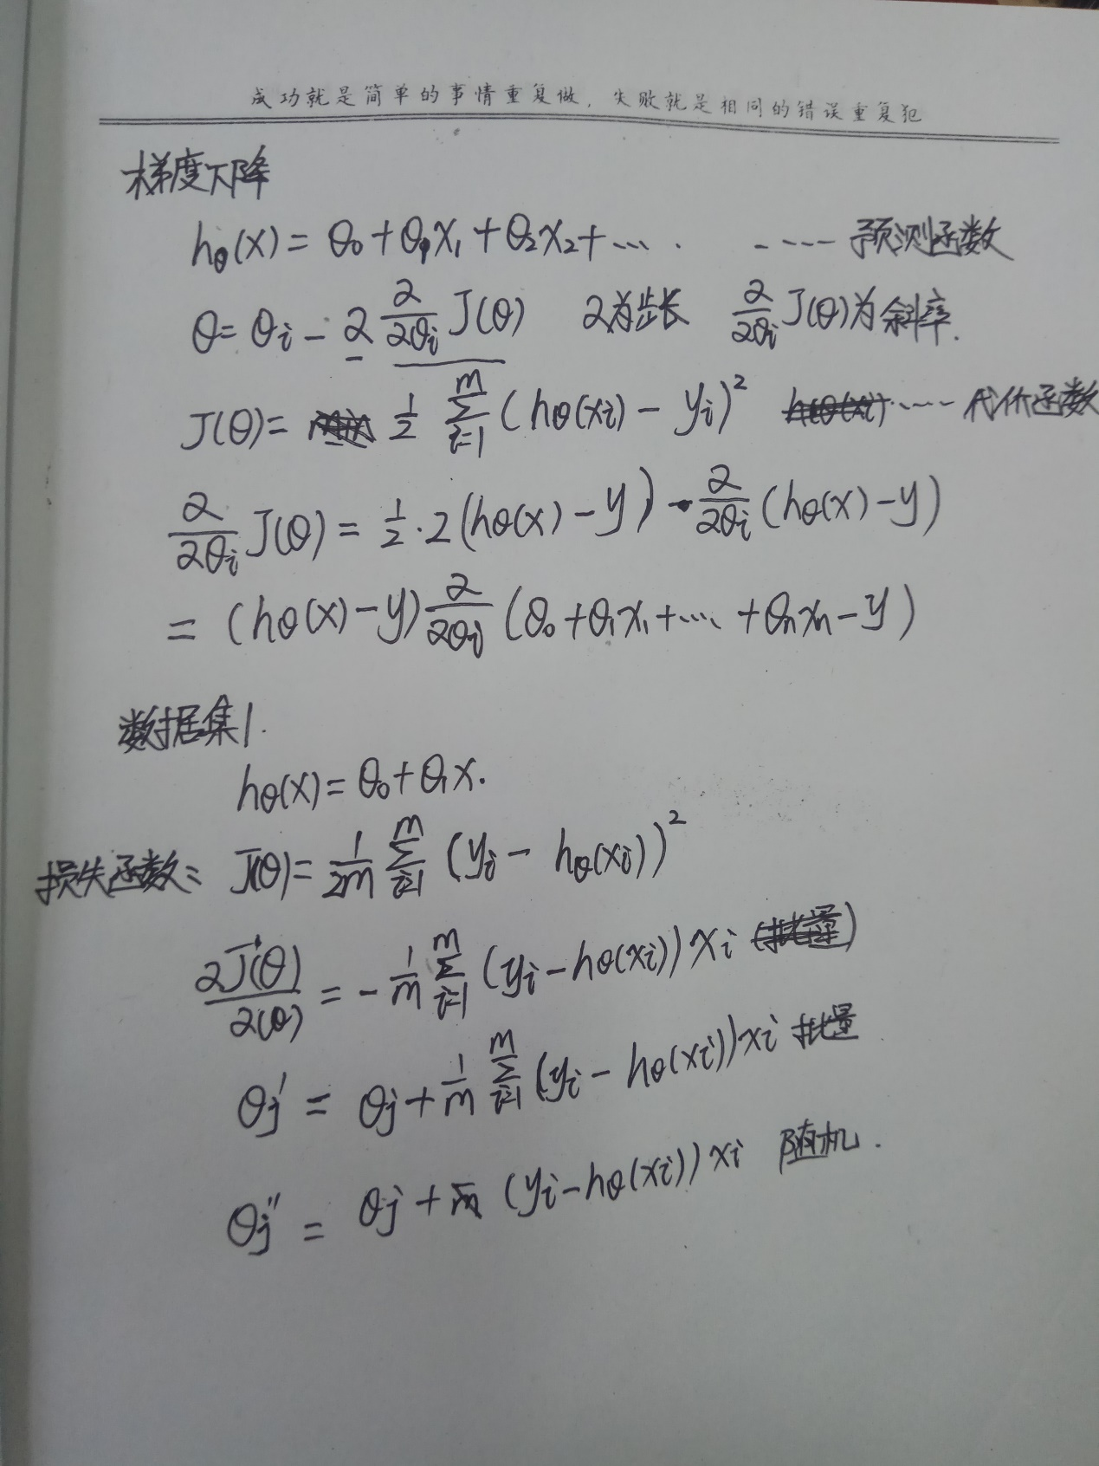

数据集一

代码

import numpy as np

import matplotlib.pyplot as plt

X = [[150, 200, 250, 300, 350, 400, 600]]

Y = [[6450, 7450, 8450, 9450, 11450, 15450, 18450]]

X = np.array(X).T #将X，Y转换成矩阵

Y = np.array(Y).T

plt.scatter(X, Y)

def GD(X, Y, theta, lr=0.00000001, ite=100000):

m = len(Y)

for i in range(ite):

pred = np.dot(X, theta) #X与theta矩阵点乘

theta = theta-(1/m) * lr * (X.T.dot(pred - Y)) #更新

return theta

'''

y=a0+a1x 将表达式换成矩阵运算

y=a0x0+a1x1

y=AX

'''

theta = np.random.randn(2, 1) #theta0与theta1的随机值

th=theta

ite=100000

for i in range(ite):

X_b = np.c_[np.ones((len(X), 1)), X] #矩阵运算将生成的矩阵与X矩阵合并

theta2 = GD(X_b, Y, theta)

th=theta2

plo.scatter(th[0][0],th[1][0])

程序一直没有跑成功，所以图没画出来

数据集二

代码

import numpy as np

import matplotlib.pyplot as plt

X=[[1.1,1.3,1.5,2,2,2.9,3,3.2,3.2,3.7,3.9,4,4,4.1,4.5,4.9,5.1,5.3,5.9,6,6.8,7.1,7.9,8.2,8.7,9,9.5,9.6,10.3,10.5]]

Y=[[39343,46205,37731,43525,39891,56642,60150,54445,64445,57189,63218,55794,56957,57081,61111,67938,66029,83088,81363,93940,91738,98273,101302,113812,109431,105582,116969,112635,122391,121872]]

X = np.array(X).T #将X，Y转换成矩阵

Y = np.array(Y).T

plt.scatter(X, Y)

def GD(X, Y, theta, lr=0.00000001, ite=100000):

m = len(Y)

for i in range(ite):

pred = np.dot(X, theta) #X与theta矩阵点乘

theta -= (1/m) * lr * (X.T.dot(pred - Y)) #更新

return theta

'''

y=a0+a1x1+········……+anxn 将表达式换成矩阵运算

y=a0x0+a1x1+……+anxn

y=AX

'''

theta = np.random.randn(2, 1) #theta0与theta1的随机值

th=theta

ite=100000

for i in range(ite):

X_b = np.c_[np.ones((len(X), 1)), X] #矩阵运算将生成的矩阵与X矩阵合并

theta2 = GD(X_b, Y, theta)

th=theta2

plo.scatter(th[0][0],th[1][0])