Extension Key: ableplayer
Language: en
Keywords: Multimedia, html5, Video
Copyright 2017-2018, BZgA, <dominik.lindner@bzga.de>

This document is published under the Open Content License
available from http://www.opencontent.org/opl.shtml

The content of this document is related to TYPO3
- a GNU/GPL CMS/Framework available from www.typo3.org
Table of Contents
EXT: HTML5 Video Player 1
Introduction 3
What does it do? 3
Screenshots 3
Users manual 4
Administration 5
Use in other extensions 5
.htaccess changes 5
Configuration 6
Reference 6
To-Do list 7
Support the extension 8
ChangeLog 9

Introduction

What does it do?
- A video extension for TYPO3 built on the AblePlayer video player library. Allows you to embed videos in your website using HTML5 with Flash fallback support for non-HTML5 browsers.
- Supports a normal list mode and a gallery mode with small thumbnails
- Based on Tim Lochmüllers html5videoplayer and Ableplayer by Terrill Thompson

Screenshots
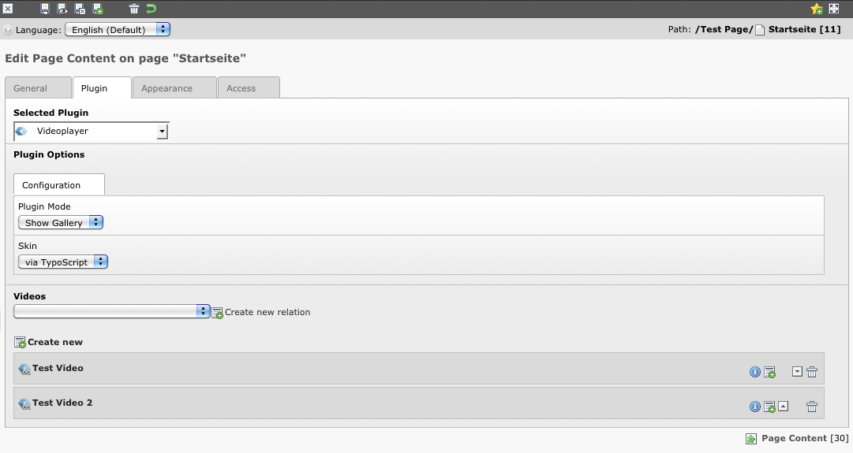
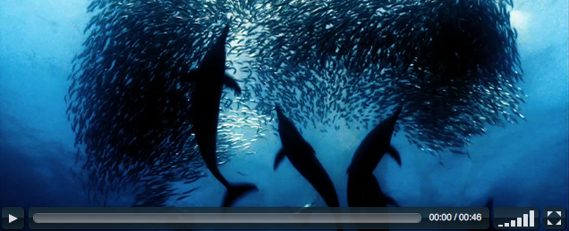

Users manual
- There should be a central storage folder with videos.
- Create, edit and delete videos in this folder.
- To show a video on the web page create a new content element (type plugin) select “html5videoplayer” and choose a video. You can also create new video records directly over the plugin element.
- If you select more than one video, you get a video list. In the plugin configuration you can select the normal list mode or the gallery mode. In the gallery mode you get a thumbnail overview and single detail pages.

Administration
- Install the extensions fluid and extbase via the Extension Manager
- Install the extension html5videoplayer
- Include the static TypoScript template in you main TypoScript template
  - configure the extension via the extension constant editor
- Create a StorageFolder with video records

Use in other extensions

- You can load the ableplayer plugin in other fluid extensions easily with one line of code:
- <f:cObject typoscriptObjectPath="tt_content.list.20.ableplayer_pivideoplayer">{work.movie}</f:cObject>
- The “{work.movie}” part is a comma separated list of video records of uids. You can also use static integers like “2,3,34”

.htaccess changes
If there are problems with the video playback and the “example” video from other remote sources works great, there is probably a misconfiguration in the apache configuration. Add these lines to your .htaccess file to solve the problem:

AddType video/mp4 .mp4
AddType video/ogg .ogv
AddType video/webm .webm
AddType video/x-m4v .m4v
AddType application/ogg .ogg
###Comment - This is to prevent compression of video files, as suggested.
SetEnvIfNoCase Request_URI \.(og[gv]|mp4|m4v|webm)$ no-gzip dont-vary

Configuration
- The complete configuration of the extension can be done via the constant editor.

Reference
- These are the constants of the extension. All properties have the prefix “plugin.html5videoplayer.”
Property: | Data type: | Description: | Default:
view.templateRootPath | String | The root path of the templates | EXT:html5videoplayer/Resources/Private/Templates/
view.partialRootPath | String | The root path of the partials | EXT:html5videoplayer/Resources/Private/Partials/
view.layoutRootPath | String | The root path of the layouts | EXT:html5videoplayer/Resources/Private/Layouts/
persistence.storagePid | int+ | The storage folder for new video elements if the element is created via ExtBase
skipOverview | boolean | If the value is set to true, there is no gallery overview in the gallery mode. The plugin starts with the detail page ob the first video. | false
videoJsCdn | boolean | If the value is true, the JS and CSS is load from the global CDN of videoJS. Set to false to load the local ressources. | true

To-Do list
- Table descriptions
- Track Support / Captions / Subtitles (IRRE)
- Check DB field types

Support the extension
- Support the development of this extension. Check out http://www.fruit-lab.de/#support to get paypal information or the amazon wishlist link. If you want to support the development of VideoJS, visit videojs.com.
- Version 0.4.0 is sponsored by Stefan Schreck / featureladen. Thank you

ChangeLog
Version | Changes:
6.2.2 | Update VideoJS to 4.6.3 and update the YouTube plugin. Add a Wizard Hook to get plugin information in the page module.
6.2.1 | Set dependencies to 6.1.0-6.2.99. Update VideoJS to 4.5.1.
6.2.0 | First Version for 6.2 only. Complete refactoring to change the old classnames to the new namespaces. Futhermore update VideoJS to 4.4.3 and prepare the vimeo integration. Many performance improvements in the plugin registration process, for a better TCA,
1.4.0 | Rework the DB driven mode and change the TCA behaviour. Add the skipHtmlHeaderInformation setting to ignore the HTML header information for video JS (JS and CSS)
1.3.1 | Fix for mobile devices. Enable ytcontrols by default.
1.3.0 | Update VideoJs to 4.3.0 and add the current master of the youtube plugin. Cleanup code and cleanups the upcomming vimeo plugin...
1.2.2 | Fix T3 dependencies. Version 6.1+ only since 0.5.x!!!!
1.2.1 | Fix T3 dependencies. Version 6.1+ only since 0.5.x!!!!
1.2.0 | Upgrade to VideoJS 4.2.1, Fix VideoJS-Tech-bug with vimeo, fix plugin register bug, cleanup same files...
1.1.0 | Preparations for the second Video provider "vimeo". Deactive at the moment... Download T3X Package
1.0.3 | Change Video via TS
1.0.2 | Change private methodes to protected, update doc, add same phpdoc comments, cleanups
1.0.1 | Remove videoJs-error-plugin, fix CDN URL of the videoJs 4.1.0 resource and the YouTube-videos works without workarround now
1.0.0 | Remove videoskin, Update to VideoJs 4.1.0, TYPO3 6.x support, fix flash message, Add YouTube Video Support in html5VideoPlayer (VideoJs Tech), Fix validator for title, fix thumb generation in gallery
0.5.1 | Fix Extension state. First changes for TYPO3 6.x namepsaces.
0.5.0 | New version for TYPO3 6.1.x
0.4.15 | Reorder the video sources in the entry partial (optimize for chrome).
0.4.14 | Add "loop video" to the videos (thanks Christoph) and fix the model phpDoc.
0.4.13 | Add the StripTags ViewHelpers for TYPO3 4.5.x. Bugfix
0.4.12 | Enable crop support for images, teaser in gallery view
0.4.11 | External Urls are now respected for videos and preview image viewhelpers. Thanks: T3 Company UG
0.4.10 | Add T3 6.0 compatibility....
0.4.9 | Feature: Overwrite the video hieght and width in the plugin context (flexform)
0.4.8 | Load the local SWF file, if the CDN option is off and the fallback is loaded. Fix! Thanks to Thomas Schlter
0.4.7 | apache configuration example in the manual. Add manual change log
0.4.6 | Feature: set the position of the current video via constants.
0.4.5 | Remove old usemp4 and flashsource. Optimize TCA. Fix resource path for local ressources. Fix labels and add german translations
0.4.4 | Mark active video via CSS class in gallery mode
0.4.3 | revert collapseAll, because there is a rte IRRE errror
0.4.2 | Add thumb height/width settings, add redirect mode settings, add Resource path settings, set IRRE collapseAll to true
0.4.1 | Fix redirect mode and BE labels
0.4.0 | VideoJS Update von 2.0.2 auf 3.2.0, rebuild ext_autoload, merge locallang's, Renate default-skin, remove deprecated "compactversion", fix header data loading in detail view, different preload modi, add controls enable/disabled, VideoJS via CDN (Externals) default, Description, Default Layout, remove deprecated Error, update documentation
0.3.4 | Fix the Flashparam ViewHelper. Thank you Sven!
0.3.3 | Upload problems, try again: check external URL in the viewhelper.
0.3.1 | Fix repository-withUid bug. Thx to Susanne and Mike for the bug-report
0.3.0 | Update documentation, add gallery mode with TS options and set extension to stable
0.2.2 | Fix flash poster image and autoplay function. Also update to flowplayer 3.2.6. Thanks Frank Frewer!
0.2.1 | Fix skin selection and add skin constant editor options. Fix extbase related bug / backend blocker.
0.2.0 | Bugfix: For T3 4.5 (fix extbase related bug). Feature: FE Check if the static template is included.
0.1.11 | Update Documentation and set dependencies correctly
0.1.10 | Features: Add general Storage Folder (optional) (move videos to one SysFolder). Clear Page cache of related pages (on save)
0.1.9 | fix bug: global install works now (use rui.resource viewhelper), remove stylesheet titles.
0.1.8 | update documentation, update videoJS (2.0.2), remove video encoding (tmpl), refactor template structure
0.1.7 | Remove empty output spaces from TCA. Update videoJS to 2.0.1
0.1.6 | Add Wizicon, fix small bug
0.1.5 | One line fluid to include the Player in other extensions. check out the doc: Use in other extension
0.1.4 | fe fix,change labels,check xhtml_cleaning,change height and width to string (support percentage)
0.1.3 | Add XClass codes, Upd VideoJS 1.1.3, Upd FlowPlayer 3.2.5, optimize TCA, setXClasses
0.1.2 | fixes (JS path, template, dependencies), set beta, documentation dummy (incl. screens)
0.1.1 | First development snapshot of the videojs.com integration for an HTML5 Video Player

