Ext: Backend Notes
Extension Key: benotes
Language: en
Keywords: backend,module,notes
Copyright 2003-2014 Dominik Lindner, <lindner_dominik@gmx.de>
This document is published under the Open Content License
available from http://www.opencontent.org/opl.shtml

The content of this document is related to TYPO3
- a GNU/GPL CMS/Framework available from www.typo3.org
Table of Contents
EXT: Readable name of your extension 1
Introduction 3
What does it do? 3
Screenshots 3
Users manual 4
FAQ 4
Administration 5
FAQ 5
Configuration 6
FAQ 6
Reference 6
Tutorial 7
Known problems 8
To-Do list 9
ChangeLog 10
Important guidelines 11
Issues with Open Office documentation for TYPO3 12
Inserting images 12
Paragraph styles 12
Linking 13
Meta data and updates 13
HowTo: Update a manual to the new layout 13
HowTo: (alternative) Import the styles from another document 14
HowTo: Fix the Table Of Contents when it is empty 14
HowTo: Fix the Table Of Contents when a chapter is missing 14
Help by documentation.openoffice.org 14

Introduction

What does it do?
- This extension sets up a new module “Notes” within the user modules, which enables the editors to write categorized private and public notes. Writing notes is empowered bythe integrated jHtmlArea - WYSIWYG Html Editor jQuery Plugin. Backend Notes is based on Extbase and Fluid and works with typo3 6.x

Screenshots
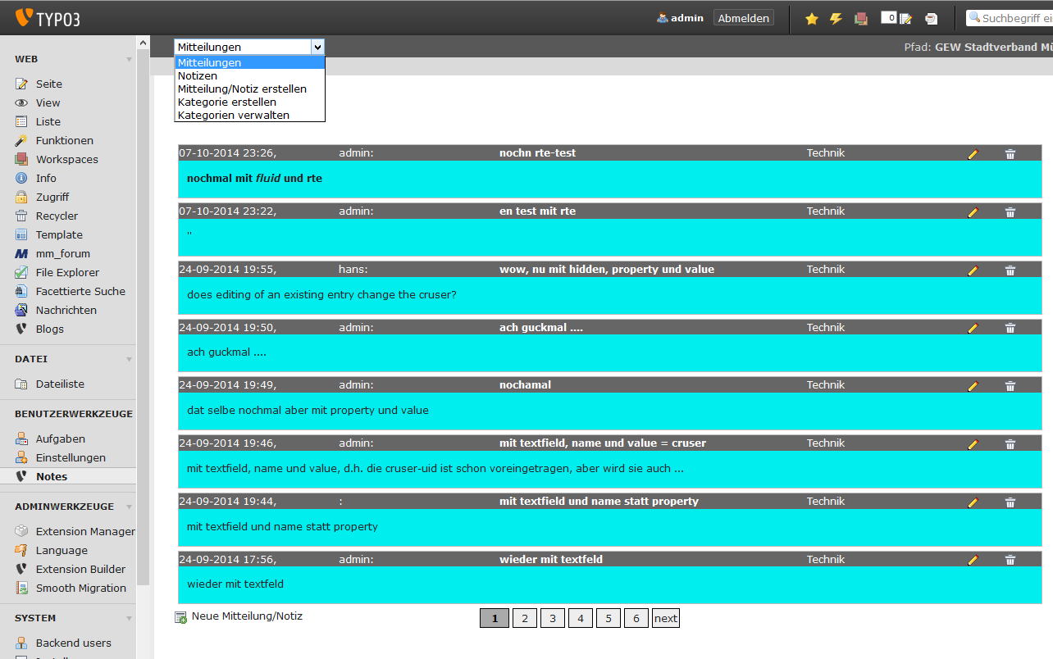
Screenshot: A list of public notes

Users manual
- Go to the new Notes Module at Users->Notes
- Create one or more Categories first by selecting “Create Category“ from the top menu
- Create a new Note by selecting “Create Note” and assign a category to it – you can decide if the Note should be private or public
- Warning! Public Notes can be deleted by everyone!

FAQ
- Can I answer on notes? Not yet, but could be a feature for the future.
- Can I assign notes to certain be_users/be_usergroups? Not yet, but could be a feature for the future.

Administration
- Upload or load extension dl_benotes from TER
- Create a new Sysfolder and remember the Page ID
- Include static Template Backend Notes (benotes) to your Root Template
- Set module.tx_benotes.persistence.storagePid to your Sysfolder ID

FAQ
- None so far.

Configuration
- Configuration is done by TypoScript, see below

FAQ
- I'm getting a fatal error because of missing Page ID! Check if module.tx_benotes.persistence.storagePid is set in the setup section of your root template.

Reference (TypoScript)
- module.tx_benotes.persistence
Property: | Data type: | Description: | Default:
storagePid | string | Page ID(s) of sysfolder, where your notes and categories should be stored; must be set

- module.tx_benotes.view
Property: | Data type: | Description: | Default:
templateRootPath | string | Path to backend view template root | EXT:benotes/Resources/Private/Backend/Templates/
partialRootPath | string | Path to backend view partials root | EXT:benotes/Resources/Private/Backend/Partials/
layoutRootPath | string | Path to backend view layout root | EXT:benotes/Resources/Private/Backend/Layouts/

Example
module.tx_benotes.persistence.storagePid = 120

Known problems
- Up to now, notes can (and should) be edited and deleted by every backend user, who has right to work in the system folder
- TYPO3 Forge link to your project missing

To-Do list
- Assign notes to certain be_users/be_usergroups
- Possibility to answer on notes or relate notes to each other
- Editing/deleting notes should only be possible to their editors.
- TYPO3 Forge link to your project missing

ChangeLog

Version | Changes:
0.1.0 | First working version, still beta so be carefull!

Important guidelines

Issues with Open Office documentation for TYPO3
There are a few important points to make about writing documentation for TYPO3 in Open Office. Please makes sure to follow these.

Inserting images
When you insert images you can either:
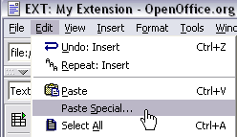
- Make a copy/paste from eg. Photoshop, but it's REALLY IMPORTANT that you insert the image into Open Office by the menu “Edit > Paste Special” and then select “Bitmap”. If you don't do it in this way the image cannot be shown (since it will not be stored as a PNG internally in the SXW file)
- Alternatively you can use the traditional way “Insert > Graphics > From file” and insert an image from your harddrive. In particular use this if the image is photographic (JPG) since the internal storage as PNG is not good for photographs.
Generally please use copy/paste only for screendumps with large areas of similar color (good png-compression) and JPG-files for photographic images. Go for small images, 72 dpi, medium quality.

Paragraph styles
- Use the paragraph style “Text body” for bodytext
- Use “Heading 1” to “Heading 5” for headers. “Heading 1-3” will be recognized as “sections” on typo3.org. “Heading 4-5” is subheaders, where “Heading 5” is preferrably for “Examples”.
- For code listings, use the style “Preformatted Text” (found under “HTML Styles”). For codelistings in tables there is a custom style called “Table Contents/PRE”.
This screenshot shows the only paragraph styles allowed in the documents. The ones grayed out are paragraph styles that are used by default for such as the index table or the footer. The others are the ones you are allowed to use.
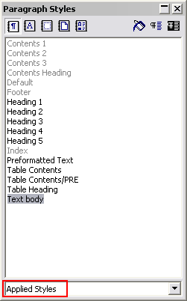

Linking
You can make hyperlinks in the documents as absolute URLs. Use menu “Insert > Hyperlink”

Meta data and updates
There are three fields of meta-data you have to fill in. First of all go to “File > Properties...”.
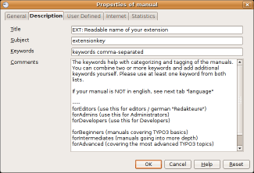
- In the “Description” screen you enter the title of the document. Extension manuals are prefixed “EXT: [extension title]”
- In the “User defined” screen you enter your email address as the first field (named “Email” / ”Info 1”)
- In the “User defined” screen you enter your full name as the second field (named “Author” / ”Info 2”)
Finally you should also insert the correct extension key in the text below the document title, but this is not a meta-data field, just regular text.

HowTo: Update a manual to the new layout
With these steps you get it very fast
- Update the extension doc_template (maybe a new one is out)
- Hit the F11 key to show the styles
- >> Copy everything from your old manual except the title page and the table of contents <<
- Delete contents from new manual but leave the title page and the table of contents there
- Paste your content and check that formatting is correct and images are in place
- Hint: When the header-styles are still in the old layout then clear and re-assign the new style
- Update the page properties with your extension key, e-mail-address, name, language, tagging.
In the moment the language- and tagging-properties are not in use by the TER, but findable by search.
- Reload the table of content (right click update index table)
- Insert your extension key below the document title
Ready.

HowTo: (alternative) Import the styles from another document
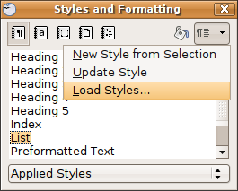
- (!) In some old OpenOffice versions (e.g. 2.4) there's a bug: after the import you need the HowTo “Fix the TOC”
- Load your manual, then hit the F11 key to show the styles
- Klick on the small arrow top-right
- A select box appears , you klick at “Load Styles” and then “From File”
- (!) Check all the boxes
- Navigate to the “doc_template”/doc” folder and switch the file-type to .sxw “OpenOffice.org 1.0 Textdocument”
- Open the manual.sxw, now you can use the new style!

HowTo: Fix the Table Of Contents when it is empty
Maybe the outline numbering is broken (german: “Kapitelnummerierung”).
- Go to menu "Tools” > “Outline Numbering" and apply the missing "Heading" styles to the empty levels.
- Update the TOC, ready.

HowTo: Fix the Table Of Contents when a chapter is missing
- You have changed the styling of a header. Clear the formatting of the header and re-assign the header-style

Help by documentation.openoffice.org
See the international portal for help: http://documentation.openoffice.org

