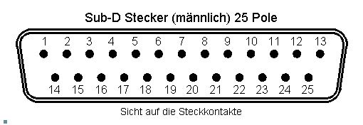
(A) Above
 | Arduino-Mega Pin | Funktion
 | Relais 1 | Switch always closed
 | Relias 1 | Common
 | Relais 1 | Switch always open
 | Relais 2 | Switch always closed
 | Relais 2 | Common
 | Relais 2 | Always open
 | Unused | Unused
 | Unused. | Unused
 | Unused | Unused
 | +5V | +5V
 | I2C SCL | LCD-Display SCL
 | +5V | +5V
 | +12V Main Powersupply 14V Max.
 | A4988 M1 | Stepper Coil 1
 | A4988 M2 | Stepper Coil 1
 | A4988 M3 | Stepepr Coil 2
 | A4988 M4 | Stepper Coil 2
 | Unused | Unused
 | Unused | Unused
 | Unused | Unused
 | A5 | Endsensor / Lightbridge
 | GND | GND
 | I2C SDA | LCD-Display SDA
 | GND | GND
 | 12V GND

Sicht auf die Seite mit den Anschlüssen.

(B) Under
 | Arduino-Mega Pin | Funktion
 | GND | GND
 | RESET | RESET
 | RESET | RESET
 | A6 | FFWD
 | A7 | FRWD
 | A8 | SFWD
 | A9 | SRWD
 | A10 | STSTART
 | A11 | ATSTOP
 | A12 | PTT Manual
 | A13 | MaxOUT (Min. Capacity)
 | A14 | Set to zero
 | A15 | Manual Calibration (Max. Capacity)
 | GND | GND
 | +5V | +5V
 | GND | GND
 | Unused | Unused
 | Unused | Unused
 | Unused | Unused
 | Unused | Unused
 | Unused | Unused
 | Unused | Unused
 | Unused | Unused
 | Unused | Unused
 | Unused | Unused

Cinch (Biderectional Coupler)
A | A0 | Reflected Voltage
B | A1 | Forward Voltage

