CPSC 1100 – LAB 01
BlueJ IDE and Your First Program

You can download a copy of the starter code for the first lab assignment HelloPrinter.java.txt via UTC Learn. From here you can do the rest of the lab assignment by simply modifying this file. You should end up with one source file that you will submit to UTC Learn (HelloPrinter.java). We will be going over this lab assignment during today's lab time. I will take your submitted program and run it to make sure that it works to assign you a grade. It is unacceptable to turn in a program that will not compile.

Task 0: Setting up BlueJ
Make sure you remember these instructions in Task 0. This will be your basic setup for each lab to get started. For every lab assignment we will create a new project.
Open the BlueJ program on your computer. You should see something similar to the following.
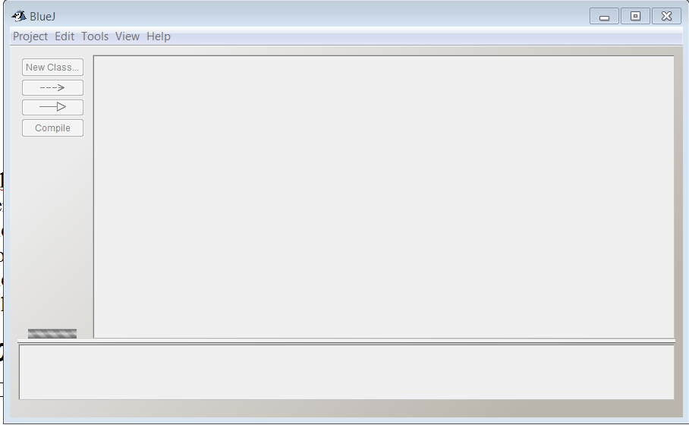
If your screen does not look like this select “Project → Close” or press <ctrl> W. By default BlueJ will open the last project. Since this is a shared computer lab it is possible that an old project is open and you will need to close it before you begin.
Now select “Project → New Project”. Name your project Lab01. BlueJ will create a folder in the location you have selected, with the name Lab01. If you are using a flash-drive you can put your project directly onto your flash-drive. All of your project files will be created within this folder. You MUST remember where you created this project folder because it will contain the file(s) you need to submit for the assignment. Go to windows explorer now and find the folder. Here is what mine looks like. (I used the name CPSC1100-Lab01 for my project). If you are having problems with this step please ask for assistance.
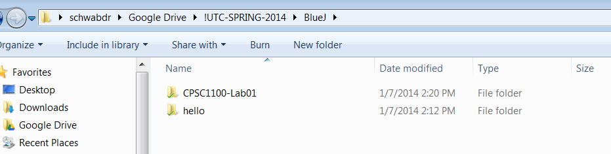
At this point we are ready to create a program using BlueJ. By default BlueJ fills in a lot of starter code for your project. We are going to delete this starter code, and insert our own starter code that can be found on Google Drive. It is in a file called “HelloPrinter.java.txt” and it is listed under the Lab01 section.
Within BlueJ, click on “New Class ...” and name the class “HelloPrinter”. You must name it exactly as shown here (leave off the quotes – see below). Capitalize the proper letters, and no spaces in the name. Click Ok.
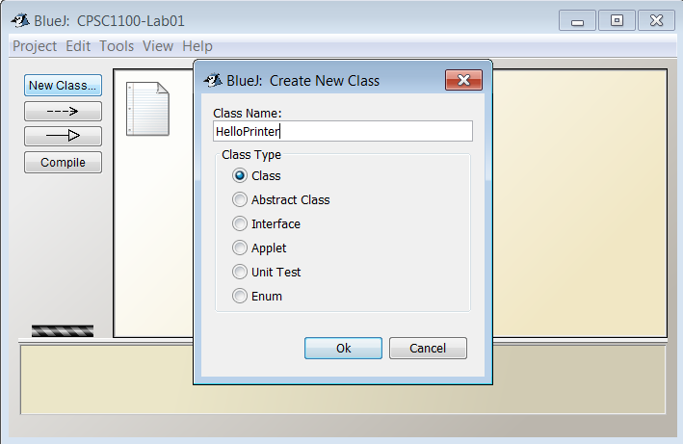

Now you should have a screen that looks like the following.
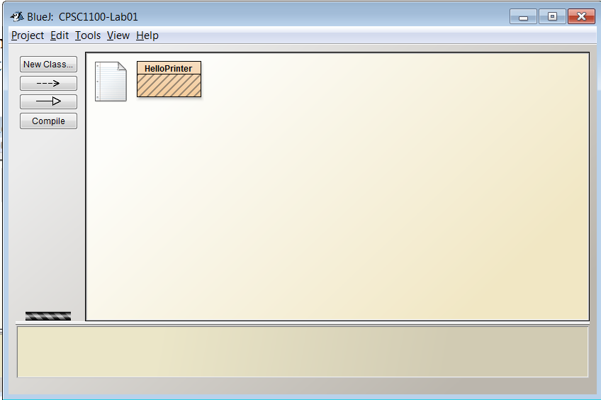
The box above that is labeled “HelloPrinter” is called a Class. Classes are the fundamental building blocks of java programs. We will now add source code to our “HelloPrinter” class that will make our program do interesting things. Double click on the HelloPrinter box and you should have a window pop up that looks like the following.
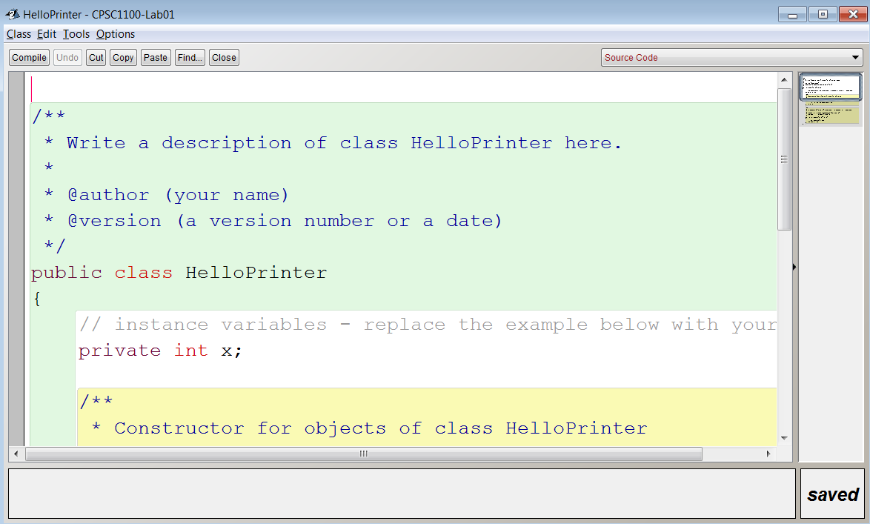
Select all the code in this window (all the text), <ctrl>-A is a shortcut, and delete it. Now, find the file “HelloPrinter.java.txt” on Google Drive. Take all the source code from this file, and copy/paste it into the window that you opened in BlueJ. You should have something like the following when this step is done.
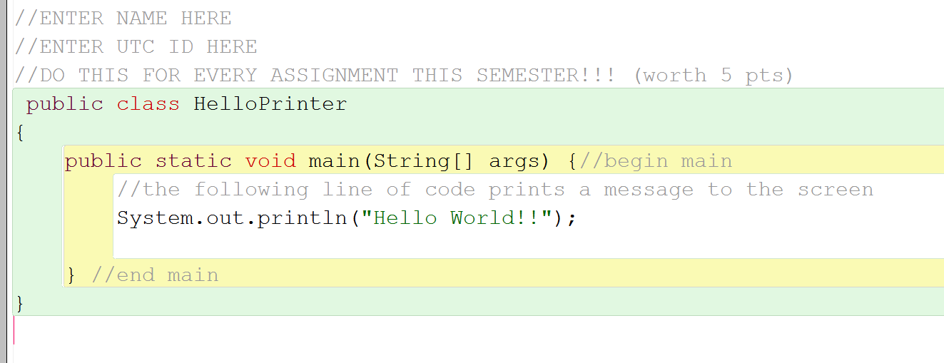

Fill in your name and date at the top of the file. Then click “Compile”. You should click compile often because it makes sure your code is written correctly, and it saves your code. You should get a message at the bottom of your window that looks like the following.
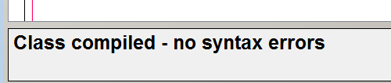
At this point, go back to your main BlueJ window, and right click the “HelloPrinter” class. Select the option “void main(String[] args)”. You should get a pop up box like the following. Click “Ok”. We are calling the “main” method of our HelloPrinter class. (You can see where it says “Method Call” in the dialog box below).
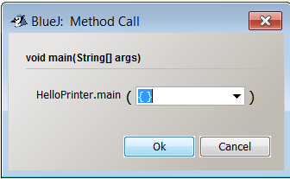
This should pop up a new window (called the Terminal Window) that shows the output of our program. You should have something like the following picture.
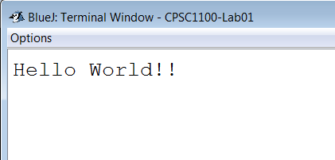
Click on options, and make sure you have two options selected, “Clear Screen at method call” and “Unlimited buffering”. You are now ready to move on to Task 1 below.

Task 1: “Hello World” Program
Modify your program to print a greeting of your choice. (Instead of “Hello World” you should print something else to the screen). Printing out messages to the screen is very important. Often times you need to give a user feedback from your program. Additionally, when you are testing a program you will want to print messages from your program to make sure it is working correctly. (An alternative to this method of testing is to use a debugger which will be covered in a later lab).

Task 2: A Sum of Numbers
Add source code to your java file that prints the sum of the first ten positive integers, 1+2+3...+10. Instead of using a string (such as “hello world”) as a parameter to the “println()” method you can use integers along with the addition operator. (i.e. System.out.println(1+4); will print 5 on the screen).

Task3: A Product of Numbers
Add source code to your Java program that prints the product of the first ten positive integers, 1x2x3...x10. (Use * to indicate multiplication in Java. “*” is <shift> 8). Use a similar idea as to Task2 above.

Task 4: Big Name
Write a Java program that prints your initials in big letters using the asterisk. (See page 27 E1.6). A sample output is given below for my initials. Note that you will have to print one line at a time, so you may want to plan ahead about how many spaces you will use on each line. (Write it out on paper first).
* * * *
* * *
* * *
* * *
* * * *

Task 5: Sales Tax
Write a Java program that prints out the Sales Tax Rates for 5 states of your choice. (You can make up the tax rates yourself). See E1.19 page 29. The println() method will print spaces as well as characters to help you line up your tax rates.
example output:

Sales Tax Rates
-------------------
Alaska: 0%
Hawaii: 4%
Alabama: 5%
Tennessee: 9%
Utah: 7%

Task 6: User Input
See E1.15 from book.
Add the following line of code as the very first line of code in your program at the top.

import javax.swing.JOptionPane;

Now go back to the “main” method of your code, and use the following line of code to input a name from the user. The following line of code pops up a window that asks “What is your name?”. Whatever is typed in by the user will be saved in a variable called “name”. We will cover variables in more detail as the class progresses.

String name = JOptionPane.showInputDialog("What is your name?");

To concatenate two strings in java, we can use the “+” operator. For example:

System.out.println("hello " + "world");

will simply print

hello world

Use this concept to print Hello along with the name input by the code above. (i.e. you will use “Hello ” + name as your parameters to the println method). Don't use quotes around name. Here name represents a variable, that stores a String. We will cover more on the topic of variables as the semester goes on. Additionally, don't forget about the usage of the method, System.out.print(), which will print without starting a new line. (see page 14 in text book).

Task 7: Submit your Program and Output
Once your program is complete, run the program one final time (right click on HelloPrinter and run the main method). Enter a name when your program prompts for it. Then, to save a copy of your output from the Terminal window, click on Options → Save to file … give the file a name (something like lab01-output.txt) and choose a location to save your program's output. I would suggest saving this file in your project directory for Lab01. This is the FIRST of two files you must submit. The SECOND file you must submit is your version of HelloPrinter.java (this is the file where you have been writing code for this lab). See the Submission Instructions document if you have any further questions about submitting your solution.

