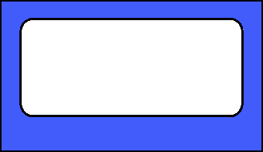

Jimmy

Great effort. You make us all look good!

Anne Marie

"I'm excited to see what you will do next."

Happy Valentines Day!