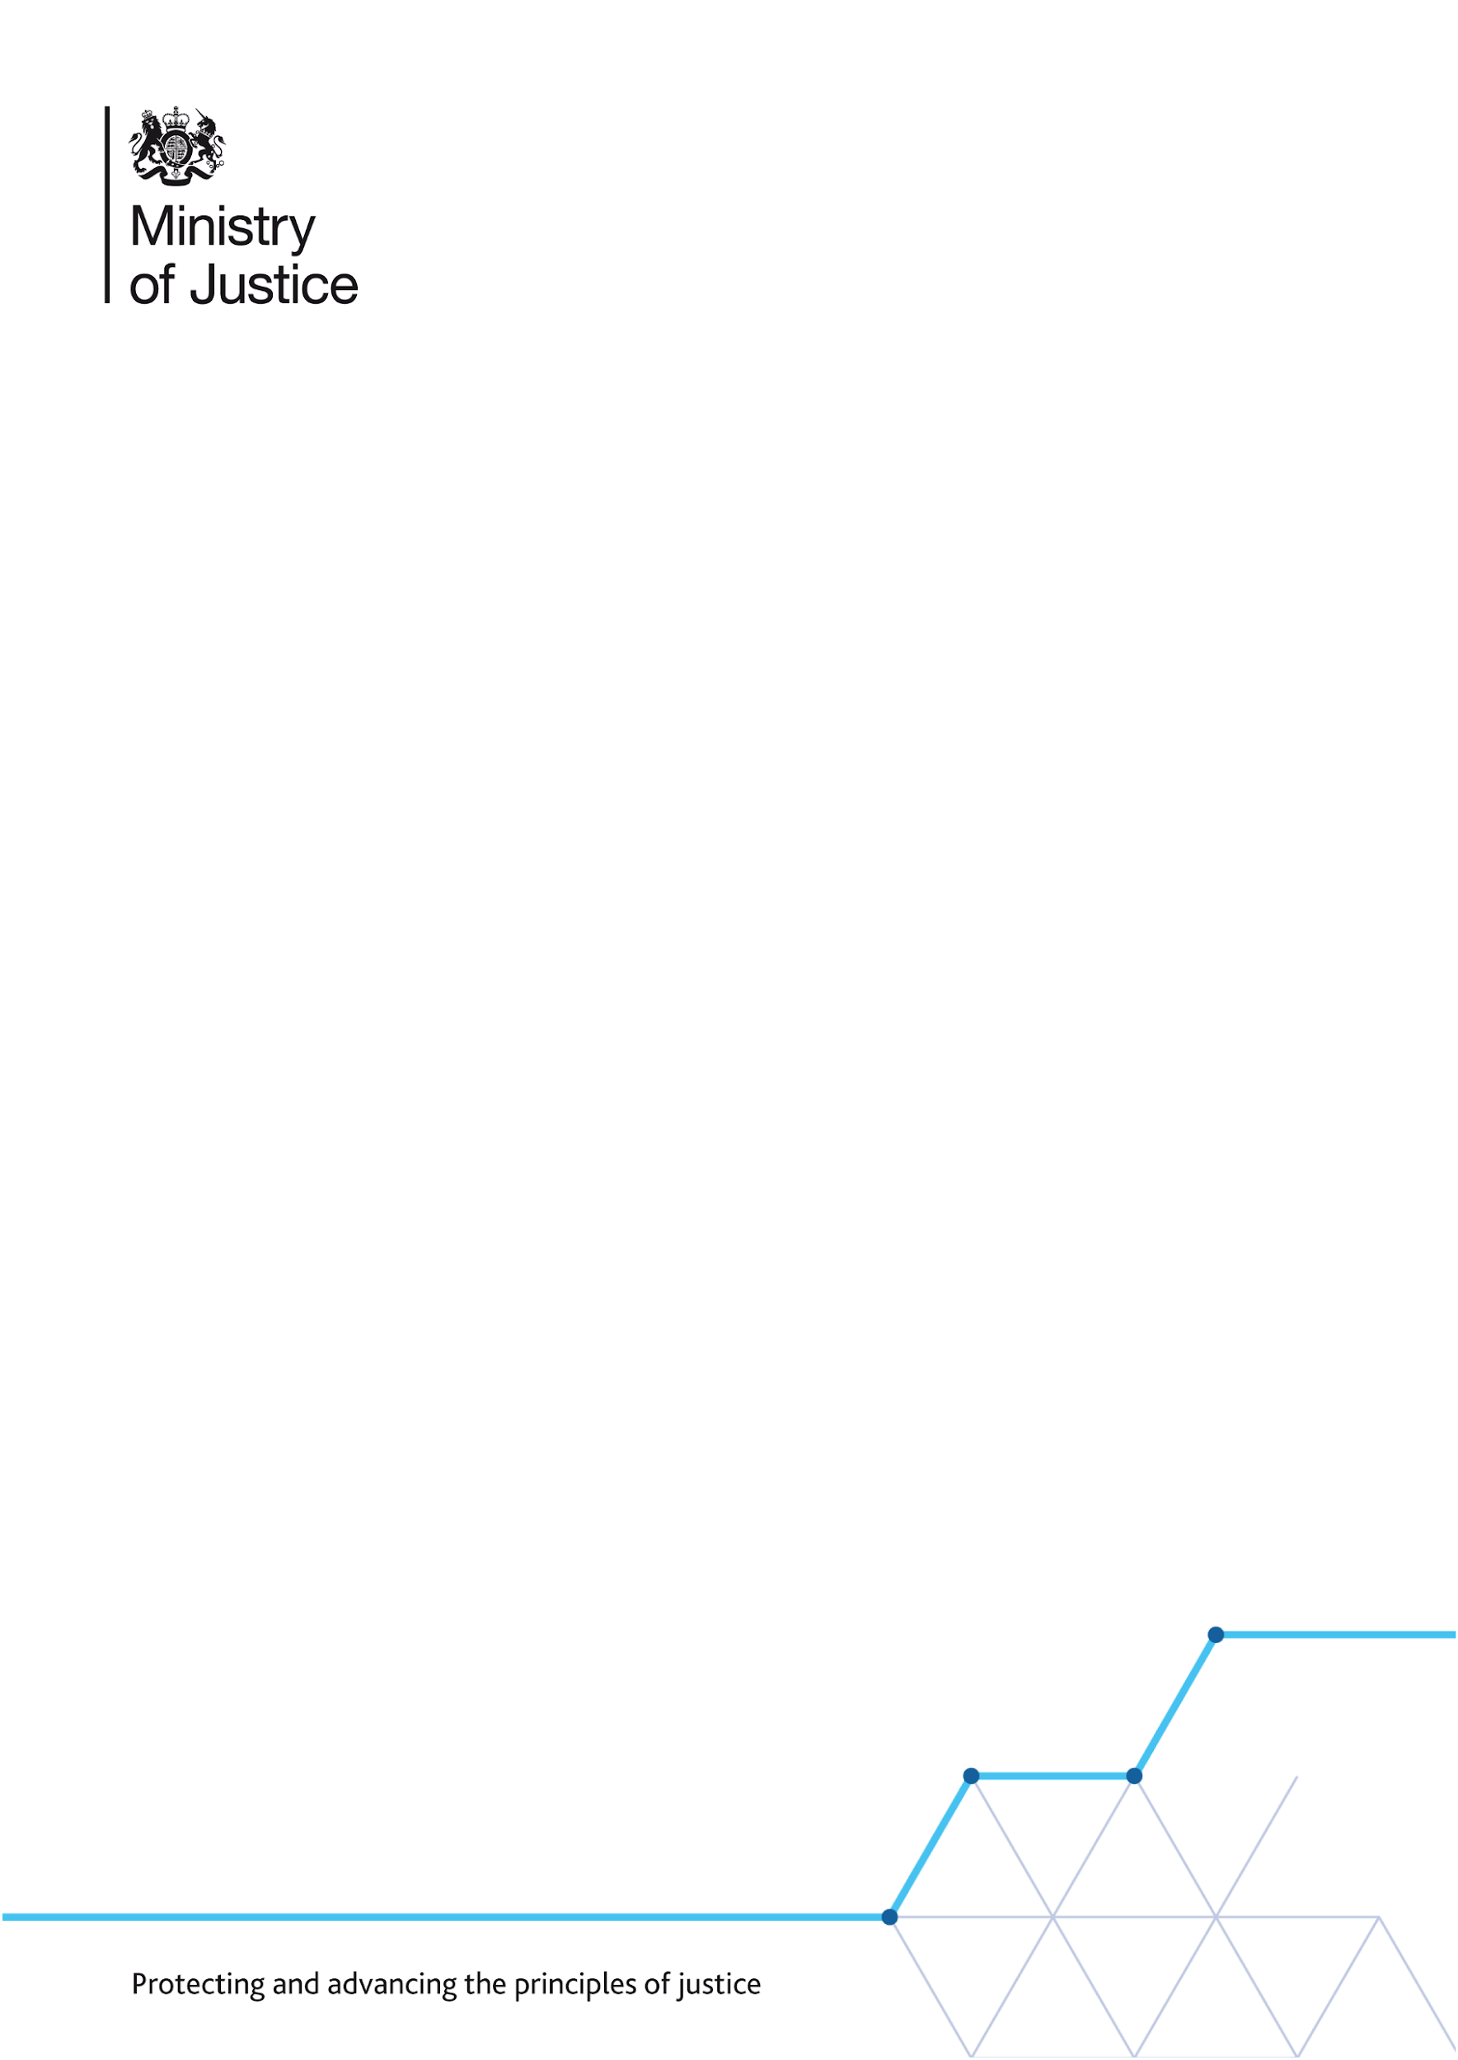

**Recruitment**

**Pre-Employment Screening and National Security Vetting – when recruiting External Candidates**

Frequently Asked Questions for recruiting managers

June 2021

**Contents**

Section 1: Pre-employment screening for directly employed staff

Section 2: Staff recruited from external sources (non-directly employed)

Section 3: National security vetting

Section 4: Applying for NSV

Section 5: Changes to roles or personal circumstances

The processes described in this document are under review as part of MoJ ‘simpler processes’ activities. These FAQs are updated as required.

## Section 1: Pre-employment screening for directly employed staff

**Q1. What is pre-employment screening?**

Pre-employment screening involves a series of checks to help us make informed decisions about the suitability of people to work for the Ministry of Justice and its agencies. These checks ensure:

* compliance with current legislation, e.g. evidence of Right to Work in the UK
* that applicants are who they say they are
* the integrity of the applicant, our organisation and the safety of staff and others in our care.

All individuals working with MoJ will be required to complete a **Baseline Personnel Security Standard** (BPSS) check prior to taking up their role.

In addition, **Disclosure and Barring Service** (DBS) clearances may be required but only where the **role** involves interaction with children or vulnerable adults. These clearances are carried out through either a Standard or an Enhanced check.

**National security vetting** (NSV) may be required but **only** where the role requires counter terrorist check (CTC), security clearance (SC) or developed vetting (DV) clearance. See Section 2 for more information. [NSV](https://intranet.justice.gov.uk/guidance/hr/recruitment/security-vetting/vetting-contact-point-vcp/) is separate and in addition to pre-employment screening checks.

**Q2. What is BPSS?**

BPSS is the minimum level of clearance for all people working across the Civil Service. A BPSS check comprises of the following components/checks:

* Confirmation of right to work in the UK
* Confirmation of ID and address
* Eligibility
* Criminal convictions
* Employment history
* Counter-signatory reference (where relevant)
* Health check (where relevant).

**Q3. How does the vacancy manager know what level of clearance a role requires?**

Vacancy managers **must always** advertise their roles at the **correct level** of clearance required. Levels of clearance are defined by the requirements of the **role** being filled, **not** by the level of clearance the candidate already possesses. Your National Security Vetting Contact (NSVC) can confirm whether the role requires national security vetting in addition to pre-employment checks. Wrongly classifying roles at advert stage will lead to delays in on-boarding.

If you don’t know who your NSVC is, you can search [here](https://intranet.justice.gov.uk/guidance/hr/recruitment/security-vetting/vetting-contact-point-vcp/).

**Q4. What is the process for completing pre-employment checks?**

This depends on how the candidate is being recruited and their level in the organisation.

### Bands A-F (non-SCS) recruited through fair and open recruitment

* All candidates must undergo pre-employment checks relevant to the role.
* SSCL ask applicants to bring their Right to Work (RTW), ID and address documentation to interview.
* Line managers must check these documents, make a note of the document reference numbers and input these into Oleeo, the recruitment website, at the Interview Scores Entered stage.
* If the applicant is successful at interview, SSCL will make a provisional offer and ask the candidate to upload copies of the same RTW, ID and address documents into Oleeo.
* If NSV is required for the role (as indicated by the vacancy manager in the advert), SSCL will also send a link to the candidate so they can complete an on-line security questionnaire on the NSVS portal.

### SCS Grades

* The MoJ SCSBP team work closely with Civil Service Resourcing (CSR), now called Government Recruitment Service (GRS), who manage the SCS recruitment campaigns through open and fair competition.
* GSR notify the MoJ SCSBP Team of the successful candidate at interview stage.
* The MoJ SCSBP team contact the candidate to initiate the on-boarding process and send the candidate forms to complete so that SSCL can prepare and issue their contract.
* SCSBP team also arrange a date to meet the candidate and verify their identity documents. These details are used to complete the Clearance Request Form (CRF) and send this to SSCL via the National Security Vetting Contact (NSVC) in the business area.
* Once SSCL process the CRF Form, a link is sent to the candidate via an email to complete the required security checks on the NSVS portal.

### Non-directly employed staff

See Section 2.

**Q5. How long do the pre-employment and vetting checks take?**

Any clearances can involve multiple teams and depend on the level of check.

If all information and the correct documents have been provided, the average time for the checks to be completed is:

* Baseline Personnel Security Standard (BPSS): average 6 days
* Disclosure Barring Service (DBS) standard checks: New checks: average 5 days
* Disclosure Barring Service (DBS) enhanced checks: New checks: average 6 days
* Counter terrorist check (CTC): New checks: minimum six weeks, averaging six weeks
* Security clearance (SC): New checks: minimum six weeks averaging six weeks
* Developed vetting (DV): New checks: minimum 18 weeks.

Although the majority of DBS enhanced checks are completed in six working days, in some parts of the country police authorities quote a six to seven-week response time.

## Section 2: Staff recruited from external sources (non-directly employed)

All staff joining the MoJ from external sources (non-directly employed) are required to complete a BPSS check.

Non-directly employed workers include the following:

* Consultants
* Contractors
* Agency staff
* Fee-Paid workers

Managers must ensure that these applicants undergo the mandatory BPSS checks covering identity, nationality, immigration, right to work, employment history, and criminal records checks. They can check the results on the BPSS Verification Record form which employers must complete to verify that the checks have been made.

Note that SSCL **will not** conduct these checks.

Further guidance, and a link to the BPSS Verification Form can be found on the MoJ Intranet [here](https://intranet.justice.gov.uk/guidance/security/personnel-security-prior-to-employment/).

**If you have posts that require NSV**

If NSV is required for the role, the vacancy manager must discuss this with their National Security Vetting Contact (NSVC) and obtain a code which needs to be entered on the Clearance Request Form (CRF) submitted to SSCL.

If you don’t know who your NSVC is, you can search [here](https://intranet.justice.gov.uk/guidance/hr/recruitment/security-vetting/vetting-contact-point-vcp/).

* SSCL will only accept requests with a valid vetting reference code provided on the CRF.
* SSCL will send a link to the candidate so they can complete their on-line security questionnaire on the NSVS portal.

To progress NSV applications, SSCL will require evidence of completion of BPSS checks from the contractor/agency before NSV can be started. If you need more information, contact SSCL on 0845 241 5359 (option 1).

## Section 3: National security vetting

**Q1. What is National Security Vetting (NSV)?**

There are 3 levels of national security clearance

* Counter terrorist check (CTC)
* Security clearance (SC)
* Developed vetting (DV)

These are mandatory for certain job roles and locations throughout the MOJ.

You need the appropriate level of national security clearance if:

* you have a proximity to public figures who have been assessed to be at risk from terrorist attack
* you work in a role which has the potential to cause significant damage to MoJ or its assets

**Q2. How long does national security vetting take?**

Typical timings from completion of application are:

* Counter terrorist check (CTC): New checks: minimum six weeks, averaging six weeks
* Security clearance (SC): New checks: minimum six weeks, averaging six weeks
* Developed vetting (DV): New checks: minimum 18 weeks

**Q3. NSV takes too long, can the candidate start at BPSS and apply for NSV once they are in post?**

If NSV is required for a position, candidates should not start until their NSV is confirmed.

In exceptional circumstances, a policy dispensation request can be made (via [MoJGroupSecurity@justice.gov.uk](mailto:MoJGroupSecurity@justice.gov.uk)) to the Cluster 2 Security Unit, who will give a recommendation on whether to grant or refuse the request. Any risk mitigation measures deemed to be required will also be provided for the Senior Security Advisor and the business unit to sign-up to.

Contractors and Agency staff MUST have their NSV in place before they start, contact your NSVC in the first instance. If you do not know who your NSVC is, you can search [here](https://intranet.justice.gov.uk/guidance/hr/recruitment/security-vetting/vetting-contact-point-vcp/).

## Section 4: Applying for NSV

**Q1. I submitted an NSV request several weeks ago, how do I find out where it is?**

Contact the SSCL contact centre on 0845 241 5359 (option 1). SSCL are responsible for the registration and sponsoring of all applications for the NSVS portal.

**Q2. SSCL have told me that they have completed sponsors’ actions, what does that mean?**

It means that your security questionnaire has been forwarded to United Kingdom Security Vetting (UKSV) and the vetting process has started. All actions are complete at MoJ and there are no further actions until UKSV returns the file with a decision.

**Q3. Why is the candidate required to fill in forms on the NSVS portal and provide information that may already be held elsewhere in the recruitment process?**

NSV is a separate process to anything HR-related. For legal reasons, we often have to ask applicants questions to confirm facts. Even if we have that information elsewhere, we still require the applicant to confirm it. It is usually easier to gather everything we need in one process; the alternative would be to repeatedly return for further information. Experience has shown that this causes significant delay, and we don't ask for information that we would not need.

**Q4. What if the candidate doesn’t complete specific dates and details for the Security Questionnaire?**

A. All required information on the Security Questionnaire must be completed in full and to the best of the candidate’s knowledge. If certain dates or information are not known, an explanation should be added in the information box. Missing or incorrect data will delay the application because the file will be referred to a vetting officer who will have to investigate and find the missing data.

**Q5. What happens if the candidate leaves out information?**

For security reasons we cannot give too much detail about the vetting process; however, we can confirm that information is checked in a variety of systems and databases. If information is mis-matched, it forces the file to be referred to a vetting officer and this intervention causes significant delay. Thirteen percent of all NSV cases are rejected because the subject doesn't provide their middle name(s) and it is not unusual for people to put the wrong date of birth. It is crucial that accurate information is provided, it really helps vet people quickly.

**Q6. My candidate completed the national security vetting application some time ago and hasn’t heard anything, who can I check this with?**

SC/CTC takes a minimum of six weeks and DV takes at least 18 weeks. If this time frame has been passed, contact the national security vetting contact who requested clearance and they can contact SSCL for an update.

If you don’t know who your NSVC is you can search [here](https://intranet.justice.gov.uk/guidance/hr/recruitment/security-vetting/vetting-contact-point-vcp/).

**Q7. Why can't candidates use an Apple machine or iPad to submit the NSV security questionnaire?**

NSVS is run by UKSV and there are very strict controls in place to make certain that the information you provide is secure. Apple products work in a different way and UKSV can't be assured by Apple that their platform is secure. We do not expect that will change in the foreseeable future.

## Section 5: Changes to roles or personal circumstances

This section contains information for managers and staff who are already in MoJ and have changes to their roles or personal circumstances:

**Q1. I am a manager and I think a member of my team needs a national security vetting clearance to do a new piece of work. What should I do?**

Talk to your NSVC. All business areas that have at least one member of staff who holds Security Clearance should have one. If you don’t know who it is you can search [here](https://intranet.justice.gov.uk/guidance/hr/recruitment/security-vetting/vetting-contact-point-vcp/).

**Q2. My national security vetting clearance is going to expire soon, what should I do?**

Speak to your NSVC, they will decide if it needs to be renewed and help you start the process off. If you don’t know who it is you can search [here](https://intranet.justice.gov.uk/guidance/hr/recruitment/security-vetting/vetting-contact-point-vcp/).

**Q3. My personal circumstances have changed, who should I advise?**

For all changes in personal circumstances, contact Cluster 2 Personnel Risk Management by emailing [VettingAftercare@cluster2security.gov.uk](mailto:VettingAftercare@cluster2security.gov.uk).

You can find more information [here](https://intranet.justice.gov.uk/guidance/hr/recruitment/security-vetting/reporting-personal-circumstance-changes/).



**© Crown copyright 2021**

This publication is licensed under the terms of the Open Government Licence v3.0 except where otherwise stated. To view this licence, visit [nationalarchives.gov.uk/doc/open-government-licence/version/3](http://nationalarchives.gov.uk/doc/open-government-licence/version/3/) or write to the Information Policy Team, The National Archives, Kew, London TW9 4DU, or email: [psi@nationalarchives.gsi.gov.uk](mailto:psi@nationalarchives.gsi.gov.uk).

Where we have identified any third party copyright information you will need to obtain permission from the copyright holders concerned.