Entry and Exit Search Policy

## Audience:

1. This policy compliments the Ministry of Justice’s overall security policy.
2. This Entry and Exit Search Policy applies to all employees, contractors, partners and service providers, including those on co-located sites and sites owned by other public bodies. This will also include employees of other organisations who are based in, or work at, Ministry of Justice occupied premises.
3. Agencies and **A**rm’s **L**ength **B**odies (ALBs) are expected to comply with this corporate framework but may establish their own arrangements tailored to operational needs and should supplement it with local policy/guidance for any business-specific risk.

## Objective:

1. This policy defines the access controls that are in place when entering and exiting MoJ buildings.

## Scope and Definition:

1. For the purpose of this policy, visitor control and escorting procedures are physical security controls that are intended to protect the MoJ from those wishing to gain unauthorised access and/or cause surreptitious or forced attack.
2. Government organisations must have mechanisms to implement internal and external security controls in a layered fashion that deter or prevent unauthorised access and protect assets, especially those that are critical or sensitive, against forcible or surreptitious attacks.

## Context:

1. The work of the MoJ involves a level of risk that is susceptible to physical threats, including crime and national security threats such as terrorism and espionage. Security risks must be managed effectively, collectively and proportionately to achieve a secure and confident working environment. The MoJ must determine an appropriate security posture for their building and put in place effective and proportionate security controls to reduce the risks to their assets (people, information and infrastructure) to an acceptable level.

## Responsibilities:

1. All employees, contractors, partners, service providers and employees of other organisations who are on Ministry of Justice premises and co-located sites remain accountable for the security, health and safety of themselves, colleagues and the protection of Departmental Assets.

## Policy Statements:

1. The MoJ must:
   * Put in place arrangements to control and monitor access to our estate, including Entry and Exit Search policy; and
   * Have effective plans or procedures in place for dealing with and intercepting unauthorised visitors, intruders or suspicious items. These plans must include the ability to systemically search and cordon off areas of the establishment.
2. This policy has been tailored to reflect the outcomes detailed in the [Government Functional Standard GovS 007: Security](https://assets.publishing.service.gov.uk/government/uploads/system/uploads/attachment_data/file/903904/Government_Security_Standard.pdf) (link is external) and sets out the processes to be completed when organising and overseeing visitor access to the MoJ estate.

*Determining Entry and Exit Access Controls:*

1. MoJ Estates should refer to the government response levels and their individual threat assessments to determine the level and appropriate entry/exit access controls required to manage the security risks to their estate. These controls should form part of a layered defence approach.
2. For high risk estates which contain sensitive information or other valuable assets, there should be a robust pass system to identify the type of visitor and a sign-in procedure. The use of x-ray scanners and searches to minimise the risk of unauthorised and external access to the estate should also be considered.

*Normal working hours:*

1. The building security guards cannot be expected to recognise everyone who has a right to enter a MoJ building. Therefore, staff and contractors should be issued with a photographic pass to enable them to identify themselves and confirm their right of access.
2. Staff and contractors must wear their passes and ensure they are visible when entering and whilst they remain in a MoJ building. Anyone found in a building not wearing either a Common Civil Service Pass (CCSP) or other form of recognised pass should be challenged, with assistance being sought where necessary. Staff and contractors must remove their pass on exiting the building.
3. Staff and contractors should co-operate with any request or enquiry a security guard may have on entering or exiting the building. If comfortable and confident to do so, staff should challenge any member of staff who is seen wearing their pass outside the work premises or report their concern to a security guard.

*Out of Hours:*

1. During the week core access hours with the MoJ are defined as 07:00 to 19:00. Outside of these hours, weekends and public holidays staff must record their name, unit, time of entry and departure, and a contact number in a book provided by security guard at reception. This information must be fully legible.
2. For contractors more stringent controls should be implemented. Their intention to work outside of core hours should be notified with reception within 24 hours advance notice and they should be sponsored by a MoJ unit/employee. All contracted staff must sign in and out when they enter or leave the building.

*Lost/forgotten passes:*

1. Staff who have forgotten or lost their passes and are waiting for a replacement pass to be issued, will be issued an unescorted pass on the basis that they present valid ID at reception where their details will be recorded, and their business unit confirms their identity with reception. Staff are required to wear these passes whilst they remain in the building and must surrender them to reception on leaving.

*Other Government Departments and/or Private Estates*

1. With the introduction of the Common Civil Service Pass (CCSP), staff from the MoJ can access other government departments’ estates for visiting or working purposes.
2. However, staff should be mindful that other government departments may have their own internal policies and entry and exit procedures, which they are required to comply with. For further information regarding the CCSP staff should refer to Annex A.
3. MoJ staff occupying buildings with other government departments or accommodated in privately leased buildings should refer to and follow internal policies and procedures regarding entry and exit searches.

*Line management responsibilities:*

1. The role of a line manager is important and a valuable one. Managers are expected to lead by example and adhere to security requirements, ensuring the safety of staff and the protection of other MoJ assets.
2. Line managers should ensure that as part of the induction process all new starters are made aware of the entry and exit controls to the building and the importance of adhering to these controls. Line managers should also update their staff of any changes as required.

*Guarding Responsibilities*

1. Security guards should check all passes every time any person enters a secure building via reception not only as a means of identifying the person presenting the pass; but also, to ensure that the passes have not been lost and possibly fallen into the hands of unauthorised persons who make improper use of them.
2. When a valid pass is not presented and the use of scanners are available, security should refuse access and direct the individual through scanners and subsequent searches before reporting to reception to obtain a valid building pass.
3. Annex B refers to specific entry search procedures for Sikh visitors wearing the Kirpan.

## Compliance:

1. The level of risk and potential impact to Ministry of Justice information, assets and people will determine the controls to be applied and the degree of assurance required. Ministry of Justice must ensure a baseline of physical security measures are in place at each site and receive annual assurance that such measures are in place to provide appropriate protection to all occupants and assets, and that these measures can be strengthened when required i.e. in response to a security incident or change in the Government Response Level.
2. The implementation of all security measures must be able to provide evidence that the selection was been made in accordance with the appropriate information security standards ISO27001/27002, Physical Security advice taken from the Centre for the Protection of National Infrastructure and [Government Functional Standard GovS 007: Security](https://assets.publishing.service.gov.uk/government/uploads/system/uploads/attachment_data/file/903904/Government_Security_Standard.pdf) (link is external).
3. The constantly changing security landscape has necessarily dictated that Physical Security measures be constantly re-evaluated and tested in order to meet new threats and other emerging vulnerabilities. This policy and subsequent supporting standards will be subject to annual review or more frequently if warranted.

**Physical security advice:**

1. Physical security advice can be obtained by contacting MoJ Group Security: [mojgroupsecurity@justice.gov.uk](mailto:mojgroupsecurity@justice.gov.uk).

**Annex A – Common Civil Service Pass Information Sheet:**

Redacted - contact [MoJGroupSecurity@justice.gov.uk](mailto:MoJGroupSecurity@justice.gov.uk) to obtain the full document.

**Annex B –** **Sikh Visitors**

This guidance provides for reasonable accommodation for religious freedoms as defined by United Kingdom Equalities legislation and the Human Rights Act, while clearly identifying the conditions under which the Kirpan may be worn.

Definition of a Kirpan

The Sikh faith follows a dress code which encompasses the 5 Ks. The Kirpan is one of the 5 Ks. As is the case with all faiths, people follow tenets of their faith to different degrees. Not all Sikhs make a commitment to live by the full Sikh religious code. Therefore, not all Sikhs will wear the turban or carry the Kirpan. However, it should be noted that all baptised Sikhs (Amritdharis) who live by the code are required to wear all 5 Ks. Both men and women can be baptised, and the code is the same.

The 5 Ks are defined as follows:

1. Kesh: Uncut hair, which includes keeping a beard. Baptised Sikhs will have an untrimmed beard which will either be rolled up and tied or free flowing. A turban is usually worn on their heads to cover the uncut hair. Whilst, the turban is mandatory for baptised Sikhs, it is considered to be an integral part of the makeup of the Sikh identity and therefore may be worn by many non-baptised Sikhs.
2. Kara: Steel bangle, predominantly worn on the right wrist. Most Sikhs will wear a Kara.
3. Kanga: A small wooden comb in the hair underneath the turban.
4. Kachera (or kachh or kaccha): Cotton loose boxer style shorts with a draw string waist.
5. Kirpan: Ceremonial sword. There is no fixed style of Kirpan, and it can be anything from a few inches to three feet long. It is kept in a sheath, which is attached to a fabric belt and can be worn over or under clothing. The Kirpan signifies that the wearer is blessed with honour. The Kirpan is worn by baptised Sikhs only.

[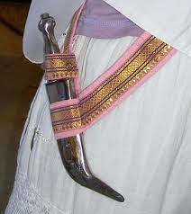](http://www.google.co.uk/imgres?q=kirpan&hl=en&gbv=2&biw=1024&bih=612&tbm=isch&tbnid=wpK8YKsg6SY99M:&imgrefurl=http://www.sikhnet.com/news/united-sikhs-want-ban-wearing-kirpan-airport-staff-revoked&docid=c4ZVjYiAiu0lZM&imgurl=http://www.sikhnet.com/files/news/2011/5-May/kirpan.jpg&w=444&h=500&ei=23oVT42mEMWgOsGF8YQI&zoom=1)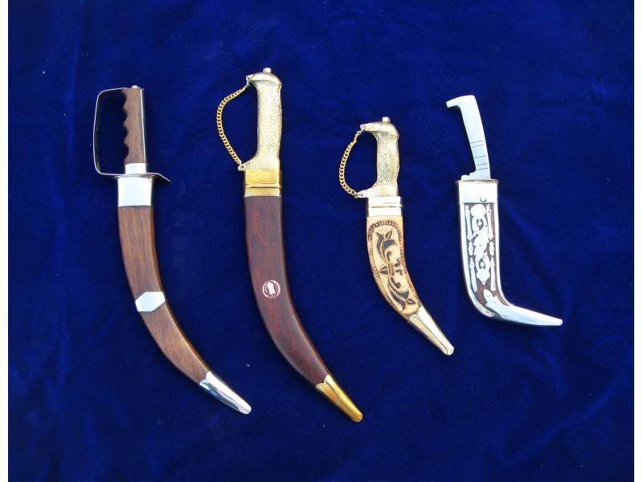

Procedures

A Sikh visitor should not be denied entry into the building for genuinely wearing any article of their faith.

The information about the Kirpan above should be used as a reference guide to enable security guards to satisfy themselves of the visitors’ Sikh faith.

There is no requirement for the removal or confiscation of any articles, particularly the Kirpan, and under normal circumstances, guards should not ask to see items that are not visible.

It should be noted that when a Sikh is required to remove their Kirpan, they must make an immediate visit to the temple for the Kirpan to be blessed. Therefore, Sikh visitors should only be subject to searches and inspections of their Kirpans in exceptional circumstances, where there is a genuine cause for concern to security.

Where a search and inspection are required, guards should note that it may take the Sikh visitor a few moments to pull their Kirpan from underneath their clothes. This could involve pulling the outer clothes out from their trousers and for women this could be more problematic. To accommodate for this permission should be sought from the Sikh visitor to feel the Kirpan while still underneath the clothes; or to take the visitor to one side to provide some privacy during the search. Female Sikh visitors should be searched in private by a female security guard.