**Base run – only using pretrained model (Trained only on cityscapes dataset)**

Hyperparameters : Unchanged since we are only inferring.

**Inference on validation set:**

|  |  |  |  |  |
| --- | --- | --- | --- | --- |
| Dataset | Overall Accu | Mean Accu | FreqW Accu | Mean IoU |
| Cityscapes | 0.958690 | 0.837528 | 0.923539 | 0.762102 |
| KITTI-360 | 0.871972 | 0.689526 | 0.782012 | 0.501176 |

**Ascending order buckets** - finetuning on KITTI-360 dataset – 6 buckets

Hyperparameters : **lr = 1e5, weight_decay = 1e5, epochs = 100**

Data used: **80 images for training and 20 images for validation in each buckets**

**Inference on validation set:**

|  |  |  |  |  |
| --- | --- | --- | --- | --- |
| Dataset | Overall Accu | Mean Accu | FreqW Accu | Mean IoU |
| Cityscapes | 0.909451 | 0.696371 | 0.839545 | 0.605136 |
| KITTI-360 | 0.778356 | 0.594653 | 0.655591 | 0.378764 |

**Base run**

Some images: - Cityscapes (Image--- ground truth – predicted mask)

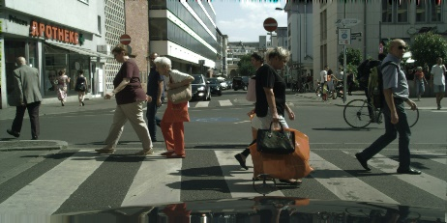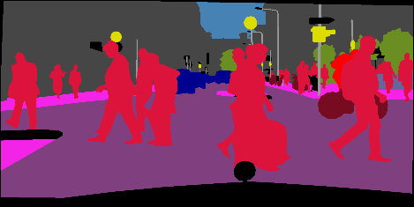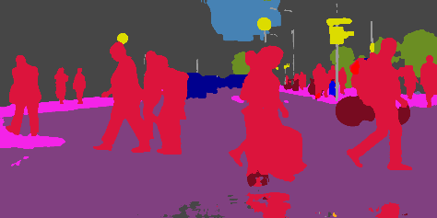

Some images: - KITTI-360

