Cloud File Storage System

Mr. Soham Bharat Patil  Department of Computer Engineering, PHCET , Rasayani  Email: sohambp22hcompe@student.mes.ac.in | Mr. Shubham Patil  Department of Computer Engineering, PHCET , Rasayani  Email: shubhamsp22hcompe@student.mes.ac.in | Mr. Soham U Patil  Department of Computer Engineering, PHCET, Rasayani  Email: sohamup22hcompe@student.mes.ac.in | Ms. Pallavi Marulkar  Department of Computer Engineering, PHCET , Rasayani  Email:  Pallavimarulkar@mes.ac.in

Abstract—The Cloud File Storage System is a web-based solution designed to provide secure, scalable, and efficient file management using a modern technology stack that includes Tailwind CSS, React, Vercel, Firebase, and Next.js. This system allows users to effortlessly store, organize, and access files from any device while ensuring robust data security. It utilizes Next.js for enhanced performance through server-side rendering and dynamic updates, leading to faster load times, and employs Tailwind CSS to create a responsive, visually appealing interface across various devices. Firebase powers the backend by providing authentication, cloud storage, and real-time database features, which enhance both data protection and user verification. Hosted on Vercel, the system dynamically adjusts to ensure consistent performance and efficient integration throughout development. Enhanced security measures, including multi-factor authentication and role-based permissions, protect user data.

Keywords: Tailwind CSS, React, Vercel, Firebase, and Next.js.

- INTRODUCTION
Cloud storage solutions play a crucial role in modern web applications, enabling users to store, manage, and share digital files efficiently. As the demand for secure and scalable storage grows, developers focus on integrating technologies that enhance accessibility, performance, and data protection. This project presents a cloud-based file management system utilizing React, Next.js, Tailwind CSS, Firebase, and Vercel to create a responsive, high-performance, and secure application.
The system employs Next.js to enhance performance through server-side rendering and static page optimization, while React provides a dynamic and interactive interface. Tailwind CSS ensures a lightweight yet flexible design framework. On the backend, Firebase manages authentication, database operations, and secure file storage, while Vercel facilitates seamless deployment with automatic scaling and high availability. By leveraging these tools, the system allows users to store, retrieve, and organize files in a structured and secure manner.
Security and user authentication are fundamental aspects of this platform. Firebase Authentication supports multiple login methods, including email-based authentication and third-party sign-ins, ensuring a secure user verification process. Role-based access controls help safeguard sensitive data, while Firebase Cloud Storage handles file transfers and bandwidth management efficiently. Deploying the application on Vercel guarantees reliable uptime and smooth scalability. With an intuitive interface, fast data processing, and strong security measures, this system offers a practical and user-friendly approach to cloud file storage.
- RELATED WORK
Today’s systems use modern frameworks and deployment platforms—such as Next.js, React, Firebase, and Vercel—to offer serverless, scalable, and real-time file management. Studies have highlighted the benefits of decentralized storage, content delivery networks (CDNs), and automatic scaling, which enhance data accessibility and user experience. Leading cloud storage services such as Google Drive, Dropbox, and OneDrive implement advanced backend architectures to manage authentication, file versioning, and security efficiently. Token-based authentication methods, such as those used in Firebase, provide scalability and secure access, while real-time synchronization through Firebase Firestore ensures data consistency across multiple devices. Additionally, ongoing research explores strategies to optimize front-end performance, further enhancing the responsiveness of cloud storage systems.
Tailwind CSS has emerged as a popular utility-first framework that optimizes the styling process, reducing unnecessary CSS code and improving page load times. Research comparing various CSS frameworks has demonstrated that Tailwind CSS, when used with React and Next.js, provides better performance optimization, component reusability, and faster development cycles. Next.js enhances server-side rendering (SSR) and static site generation (SSG), improving page performance and reducing initial load times, which is critical for cloud storage applications handling large file uploads and downloads.
Deployment and hosting play a crucial role in cloud storage solutions, and Vercel has been widely adopted for its serverless deployment model. Several studies have examined the advantages of serverless computing, emphasizing its cost-effectiveness, automatic scaling, and minimal infrastructure management. Vercel’s integration with Next.js ensures optimized deployment workflows, providing efficient handling of API routes, middleware functions, and edge computing capabilities
Efficient deployment is key to maintaining high application uptime, reducing latency, and managing heavy traffic without performance loss. In cloud file storage, security is a top priority—studies recommend using end-to-end encryption, role-based access controls, and strict permission policies (like those offered by Firebase Security Rules) to prevent unauthorized access, while Next.js API routes add extra protection through request validation and user authentication. Modern cloud storage solutions integrate tools such as Tailwind CSS, React, Next.js, Firebase, and Vercel to achieve scalability, real-time synchronization, and optimized performance, and future research may focus on decentralized storage, blockchain-based authentication, and advanced file organization to further enhance efficiency and security.
- METHODOLOGY

The development of the Cloud File Storage System follows a structured methodology that integrates modern web technologies to ensure efficiency, security, and scalability. The system is built using React for an interactive and dynamic frontend, Next.js for server-side rendering and improved performance, Firebase for backend services including authentication and cloud storage, Vercel for seamless deployment, and Tailwind CSS for a responsive and visually appealing user interface. The methodology is divided into multiple stages, each focusing on critical aspects of system development, including planning, design, implementation, testing, and deployment.

System Planning and Requirement Analysis
The initial phase involved a comprehensive analysis of the system's functional and non-functional requirements. Market research and user feedback were considered to identify essential features such as secure file upload, real-time access, multi-user authentication, and role-based access control. Various cloud storage solutions were examined to determine the most suitable backend services, ensuring efficient data management and security. Firebase was selected due to its seamless integration with React and Next.js, offering real-time database functionality, authentication mechanisms, and cloud storage.

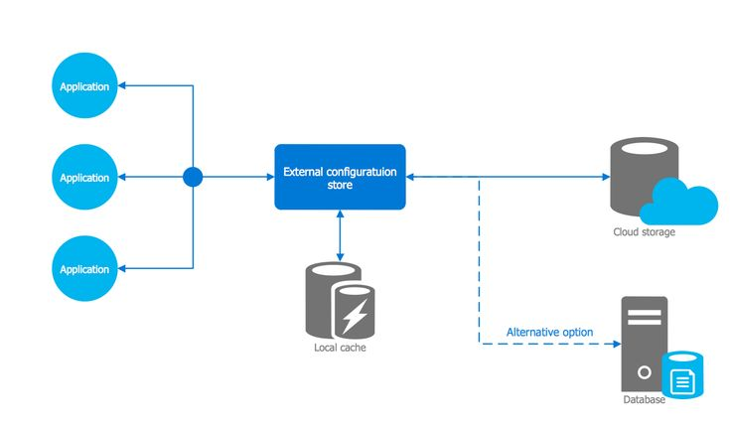
Fig:1 (System Architecture)

System Design and Architecture
The system architecture was designed following a modular and component-based approach to ensure scalability and maintainability. The interface was built using React, with Next.js improving performance through server-side rendering and static page generation. Tailwind CSS was utilized for a responsive layout while minimizing custom styling requirements. On the backend, Firebase handled authentication, file storage, and database operations, offering multiple login options such as email/password and third-party authentication. Secure file storage was ensured through Firebase Cloud Storage with strict access controls for data privacy. The system was deployed on Vercel, enabling seamless continuous integration and deployment with its automated CI/CD pipeline.

Implementation Phase
The implementation phase was carried out in an iterative manner using the Agile development methodology, allowing incremental development and feedback integration. The frontend was built using React components, enabling a seamless user experience through dynamic rendering and state management. Next.js was leveraged to optimize page loading times and improve SEO by pre-rendering content on the server. Firebase functions were utilized to manage user authentication, file storage, and secure database interactions. File uploads were handled through Firebase Storage, enabling users to store various file types with encryption and strong security protocols. Furthermore, role-based access control was implemented to guarantee that only authorized users could access or modify particular files.

Testing and Quality Assurance
The system underwent thorough testing to verify its functionality, performance, and security. Each React component was tested to confirm smooth user interactions, while integration tests ensured proper communication between the frontend and backend. Performance evaluations assessed the system’s ability to manage high user traffic effectively. Security checks were conducted on Firebase settings to safeguard user data and prevent unauthorized access. Furthermore, cross-browser testing was performed to maintain compatibility and consistent functionality across different devices and platforms.

Deployment and Maintenance
Firebase’s real-time database and storage solutions provided continuous availability, reducing latency and improving performance. Continuous monitoring was implemented using Firebase Analytics to observe user activity and identify potential security issues. Regular updates and improvements were scheduled based on user feedback and new technological developments. By adhering to this systematic approach, the Cloud File Storage System strikes a balance between speed, security, and user-friendliness, making it a dependable choice for both personal and business file management. The use of up-to-date technologies ensures that the system remains scalable and can adapt to changing user needs while upholding robust security and efficient performance.
- RESULTS
The cloud file storage system, built using Tailwind CSS, React, Vercel, Firebase, and Next.js, serves as a resilient and user-friendly platform for digital file management. Its design seamlessly integrates both frontend and backend functions, ensuring real-time data synchronization, secure user authentication, and a responsive interface across devices. By utilizing modern web frameworks, the system strikes an effective balance between performance, scalability, and usability, making it a practical solution for managing files in both personal and organizational settings.
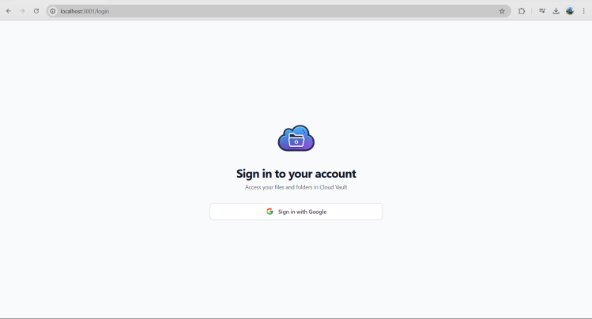
Fig:2 (Login Page)
The image highlights the login interface, where users are prompted to sign in with Google. This page reflects the application’s secure authentication flow, powered by Firebase. The minimal design underscores ease of use, allowing individuals to quickly access their accounts without cumbersome sign-up procedures. Integrating Google authentication also emphasizes the system’s focus on data protection, as it leverages established security protocols to validate user identities.
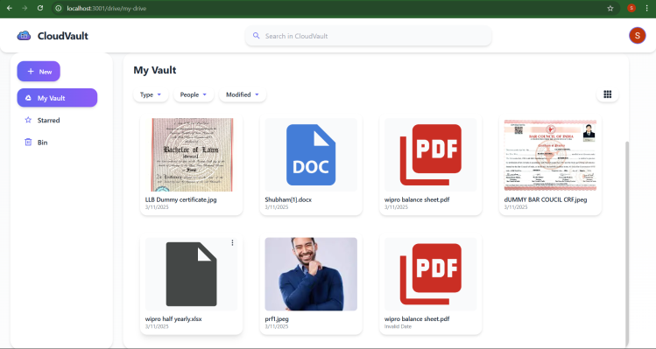
Fig:3 (My Vault Page)
In This image, the main vault interface is displayed. Users can view a grid of uploaded files with clear labels and file type icons. Tailwind CSS contributes to the clean layout and consistent styling, while React ensures smooth rendering of dynamic content. The search bar at the top allows for quick file retrieval, and sorting options based on name or modification date offer flexibility in managing large file repositories. This arrangement underscores the system’s emphasis on straightforward navigation and efficient file handling.
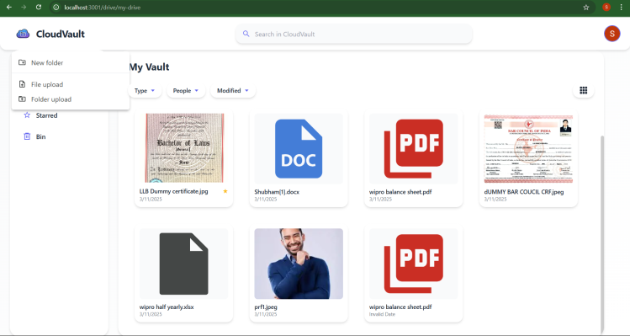
Fig:4 (Uploading File)
This image showcases the file management tools in action, specifically the “New folder,” “File upload,” and “Folder upload” options. By clicking these features, users can seamlessly add new directories, upload individual files, or transfer entire folders. This functionality demonstrates how React’s modular components and Next.js routing work together to deliver an interactive experience, while Firebase manages the underlying data operations. As a result, the system remains responsive and adaptable to various file organization strategies.
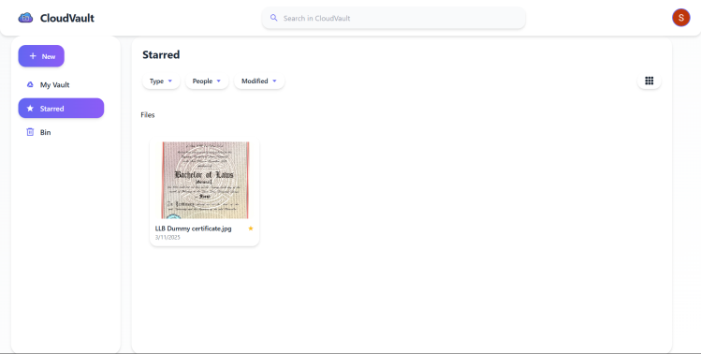
Fig:5 (Starred Page)
In this image, the user has opened the “Starred” section. This feature allows individuals to mark certain files or folders as favorites for quick access. The interface clearly displays any starred items, emphasizing the project’s commitment to convenience and personalized file management. Tailwind CSS styling keeps the design elements consistent, while the Firebase backend ensures that starred files are synced across different devices and sessions.
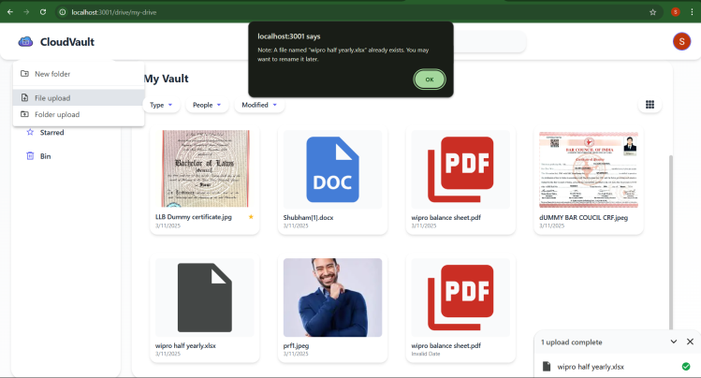
Fig:6 (Rename Alert)
This image illustrates an error notification indicating that a file with the same name already exists. This alert plays a key role in enhancing user experience by preventing accidental data loss. It notifies users to rename files when conflicts are detected, thereby protecting data integrity and keeping storage well-organized.
VI. CONCLUSION

This study presents a cloud-based file storage system that enhances data security, accessibility, and scalability. By leveraging modern web frameworks, the platform enables efficient file management, ensuring users can store, retrieve, and organize data with ease. The system is designed to cater to both individual users and larger enterprises, addressing the increasing reliance on cloud-based storage solutions.

The frontend is structured using React and Tailwind CSS, offering a user-friendly interface that simplifies navigation and file organization. For backend operations, Firebase is utilized to handle authentication, real-time data updates, and secure storage. Next.js improves performance by optimizing content rendering, while Vercel ensures smooth deployment and scalability to accommodate varying user needs.

By integrating these technologies, this project delivers a cloud storage solution that balances security, efficiency, and usability. Potential future enhancements include advanced encryption for improved data protection, AI-powered search capabilities for faster retrieval, and expanded collaboration tools to support team-based workflows. This research lays the groundwork for further advancements in cloud storage innovation and security.
REFERENCES
[1] P. Mell and T. Grance, "The NIST Definition of Cloud Computing," National Institute of Standards and Technology (NIST), Special Publication 800-145, 2011.
[2] J. W. Rittinghouse and J. F. Ransome, Cloud Computing: Implementation, Management, and Security, 2nd ed. Boca Raton, FL, USA: CRC Press, 2016.
[3] Google Cloud, "Overview of Cloud Storage Solutions," 2022. [Online]. Available: https://cloud.google.com/storage.
[4] Dropbox Inc., "Understanding Dropbox: Secure File Storage and Sharing," 2022. [Online]. Available: https://www.dropbox.com.
[5] Microsoft, "Features and Capabilities of OneDrive Cloud Storage," 2022. [Online]. Available: https://www.microsoft.com/en-us/microsoft-365/onedrive/online-cloud-storage.
[6] R. Buyya, C. Vecchiola, and S. T. Selvi, Mastering Cloud Computing: Foundations and Applications Programming, Burlington, MA, USA: Morgan Kaufmann, 2013.
[7] M. Armbrust, A. Fox, R. Griffith, A. D. Joseph, R. Katz, A. Konwinski, et al., "An Analytical Perspective on Cloud Computing," Communications of the ACM, vol. 53, no. 4, pp. 50-58, 2010.
[8] Q. Zhang, L. Cheng, and R. Boutaba, "Current Trends and Research Challenges in Cloud Computing," Journal of Internet Services and Applications, vol. 1, no. 1, pp. 7-18, 2010.
[9] Amazon Web Services, "Comprehensive AWS Cloud Storage Solutions," 2022. [Online]. Available: https://aws.amazon.com/storage.
[10] Cisco Systems, "Best Practices for Cloud Security," 2021. [Online]. Available: https://www.cisco.com/c/en/us/solutions/cloud.html.

