University of Sciences and Technology of Oran « Mohamed Boudiaf » 
Faculty of Natural and Life Sciences
Departement of Applied Molecular Genetics
Discovering Open Source Softwares

Name 1 : Mezzoudj riheb (grp 3)
Name 2 : Meftah Malek nihad (grp3)
Name 3 Habchi Sarah (grp 2)

Mini-projet
• Introduction
The aim of this mini-project is to get more familiar with the basic terminal commands that we've already gone over.
The best way to learn Linux and get more comfortable with it to practice and force yourself to start using it.

• Tools used in this session
If you do have a Linux system installed in your machine, make use of your system terminal. If you are a windows user, we highly recommend the use of ubuntu (please follow the steps in TP).

• Filenames under Linux
Make sure you separate your command name, arguments and options using spaces
Each option is preceded by - (examples: -l, -r, -lh)
Linux is case-sensitive: A and a are different

• Some useful links
http://www.linuxcommand.org/
http://manuals.bioinformatics.ucr.edu/home/linux-basics
http://www.ee.surrey.ac.uk/Teaching/Unix/

• Task 1: instructions
1. Open a terminal in your computer.
2. What directory are you located in when you open the terminal?
3. Which command could you use to check that?
4. What does this command return?
5. What are the possible options that can be used with this command? How can you check that?

• Task 1: Student’s answer
2. (/home/username ou ~)
3. (pwd=print working directory)
4. the pwd command returns the absolute path of the current working directory ; exemple /home/student.
5. for pwd ;common options are :
.-L : logical path (default,follows symbolic links)
.-P : physical path (resolves symbolic links )
And you can use either of these commands : pwd --help or man pwd
. --help shows a short list of options
. man pwd opens the full manual page
• Task 2: instructions

1. Create the above file structure under your home directory using the terminal and write the different command lines to do so.
2. Move to the directory Genetics.
3. Create a sub-directory “ProkaryoticGenetics" inside Genetics.
4. Type the command cd prokaryoticgenetics. What happened? Please explain?
5. Remove the directory “ ProkaryoticGenetics"
6. Move to the directory “TP” using one single command line.
7. List the content of the directory and display the modification date, the owner name, etc.
8. Remove the directory “TP2”
9. Create a directory “FastaFile" under “TP1” without moving to the DLOS directory.
10. Type a single command without specifying any path to move to your home directory.

• Task 2: Student’s answer
- Mkdir username cd Userename
mkdir –p ~/Genetics~/English ~/ DLOS
mkdir –p ~/DLOS/TP/TP1 ~/DLOS/TP/TP2 ~/DLOS/Miniprojet/Manuscript ~/DLOS/Miniprojet/Presentation
- cd ~Username/Genetics
- mkdir ProkaryoticGenetics
- erreur « no such file or directory » linux est sensible a la casse
ProkaryoticGenetics ≠ prokaryoticgenetics
5.rmdir pour supprimer ProkaryoticGenetics :
rmdir Username/Genetics/ProkaryoticGenetics
6.cd ~Username/DLOS/TP
7.Is –I
8.rm –r TP2
9.mkdir ~/DLOS/TP/TP1/FastaFile
10. cd ou cd ~

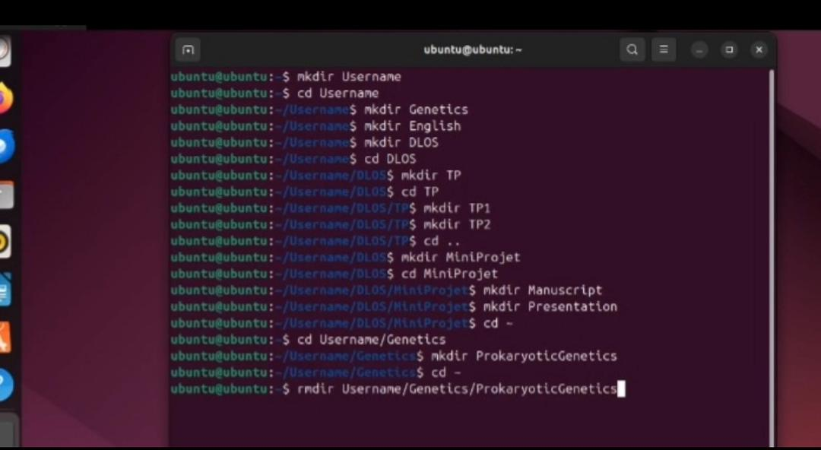
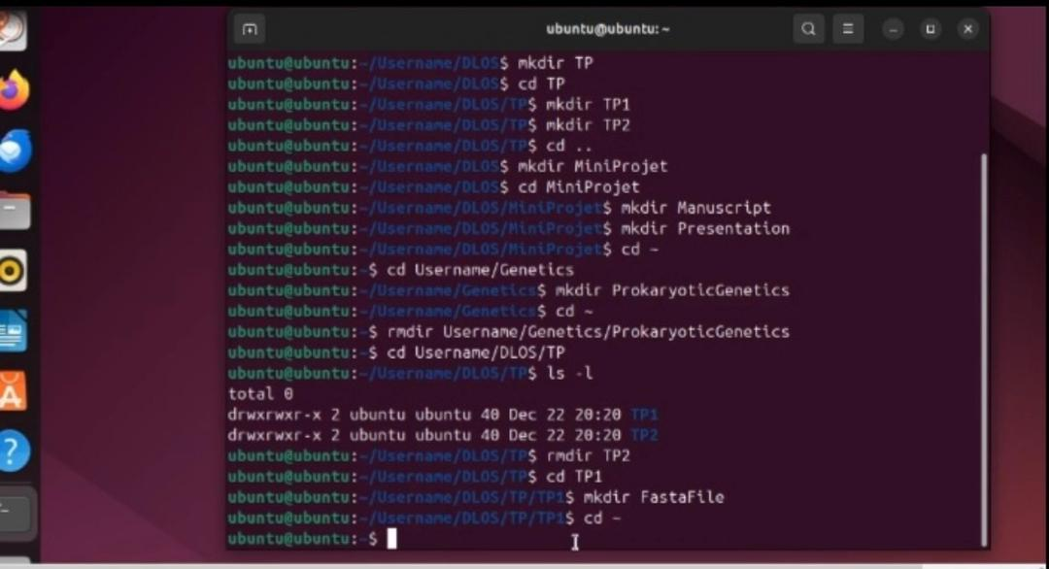

• Task 3 : Get to extract basic information from a fasta like file
• Task 3: instructions (please see the TP1 File/ Slide 53)
1. Create a simple fasta file named "testfasta" under TP1 containing few random sequences

A fasta file is as following:
>seqname
ATCGAGGGGGTTTTGAAGA
>seqname
ATCGTGTGTCAAAA
More information about fasta files format: https://en.wikipedia.org/wiki/FASTA_format
2. Count how many lines do you have in your testfasta? Which command allowed you to do that?
3. Count how many sequences do you have in your fasta. Which command allowed you to do that?

• Task 3: Student’s answer

1. cd ~/DLOS/TP/TP1
cat > testfasta << 'EOF'
>Sequence1
ATCGAGGGGGTTTTGAAGA
>Sequence2
ATCGTGTGTCAAAA
>Sequence3
GGGATCCCTAGATCGAT
>Sequence4
TTTTAAAACCCCGGGG
EOF
2. wc –I TP1/testfasta
wc= word count
-I=count lines
.6 TP1/testfasta (there are 6 lines (3 heders + 3 sequances )
3. counting using :
grep -c "^>" testfasta
Explanation:
• grep searches for text patterns.
• ^> looks for lines that start with > (FASTA headers).
• -c counts the number of matching lines.
So here is 3 sequances in testfasta
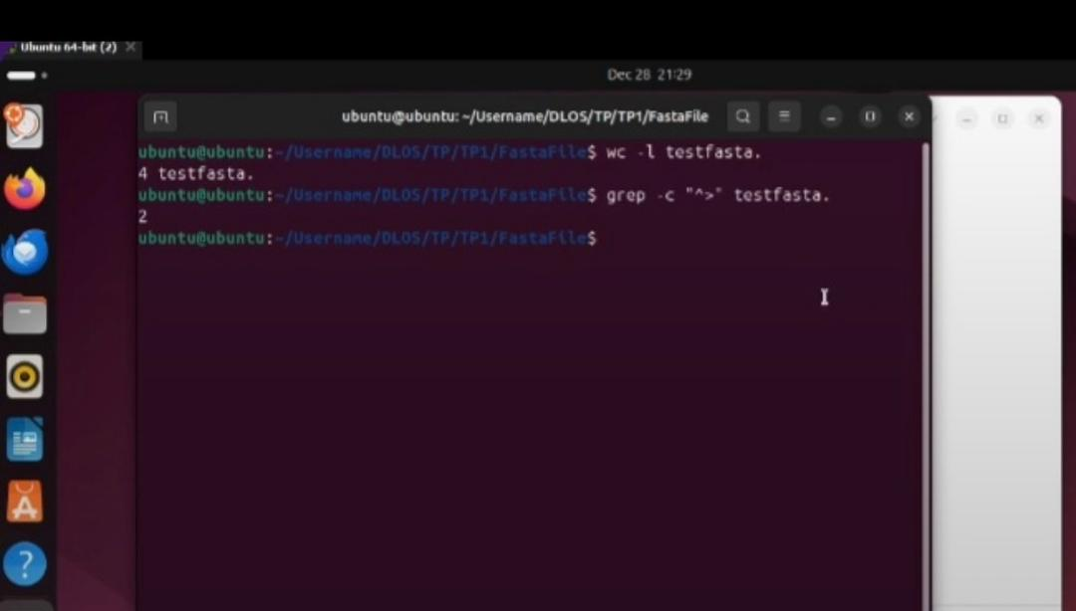

• Task 4 : Set up a private repository on GitHub for your miniproject and provide the access link to your collaborators.

• Task 4: Student’s answer
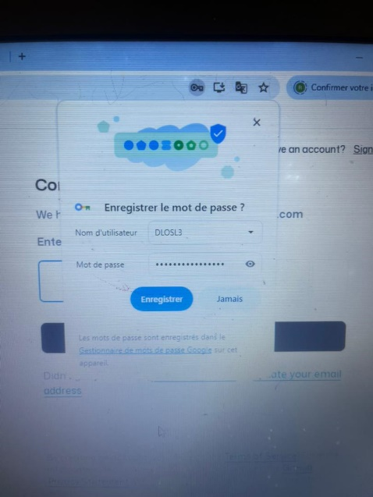
http://github.com/DLOSL3/DLOSL33
