**Exploratory Data Analysis of the Drivers of EV Performance and Consumer Experience & Behavior**

Team members: Ryan Busman, Elaine Kwan, Deb Peters, Nick Watkins

***Assumptions for Project 1:***

* We will focus on cars for this exploration: LDV1 (passenger cars and sports utility vehicles)
* Audience:
  + Vehicle Manufacturers
  + EV Engineers
  + EV sales and marketing
  + Individual consumers
* Definition of an EV care (carandriver.com):
  + **Battery electric vehicles** (BEVs), which run entirely on electricity stored in batteries.
  + **Hybrid electric vehicles (**HEVs), which use a combination of gasoline and electricity to run.
  + **Plug-in hybrid electric vehicles** (PHEVs), which can be plugged in to charge the batteries and use electricity or gasoline to run.
  + **Fuel cell electric vehicl**es (FCEVs), which use hydrogen to generate electricity and run.

***EV Attributes (Including technology):***

* *Explorations:*
  + Relationships between
  + Differences among manufacturers
  + EV CO2 emission trends over time/time series forecast
* *Possible variables:*
  + *Independent variables:* Model, manufacturer, EV type (BEVs, HEVs, PHEVs, FCEVS) horsepower, weight, footprint/vehicle size, battery or engine, seating capacity
  + *Dependent variables:* Fuel economy, CO2, Charging rate and speed
* *Sources*:
  + <https://www.epa.gov/automotive-trends/explore-automotive-trends-data>
    - About the data:
      * “The Trends database includes all new light-duty vehicles in the United States.”
      * “The Trends database has been maintained by EPA since 1975 and is updated annually to include the most up to date data available for all model years.”
      * “All data are based on production volumes delivered for sale in the U.S. by model year, and may vary from publicized data based on calendar year sales.”
    - Licensure and Credits:
      * Open access
      * “Suggested data citation: US Environmental Protection Agency. *2023 EPA Automotive Trends Report*. Data available at www.epa.gov/automotive-trends/explore-automotive-trends-data. Accessed *Month DD, YYYY*.”

***EV Performance:***

* *Independent variables:* Model year, time, state, fuel type, location of driving (city, highway),
* *Dependent variables:*  Efficiency, cost (i.e., depreciation, repairs), cost per mile, etc...), Crashes, injuries and fatalities
* *Sources*:
  + Total cost of ownership

<https://www.edmunds.com/tco.html>

About: One of the largest personal expense in a person’s lifetime is their related to their choice of vehicles. Seven major expenses are itemized for five years to help an individual determine with a vehicle is within one’s budget.

* Additional Supplemental reading
  + Injuries and fatalities:

<https://cdan.dot.gov/query>

<https://cdan.dot.gov/>

* + Fuel economy by location (city, highway)

<https://afdc.energy.gov/data_download>

* + Page 175 and after of Argonne
  + Per mile costs by fuel type and model starting on page 175: <https://publications.anl.gov/anlpubs/2021/05/167399.pdf>

***Charging Point Access:***

* *Independent variables:* Status (available, planned, etc...) location, state, time, concentration at location, credit card accepted, public versus private, associated ev network, charging level, ev connector type, and others...see below.
* *Dependent variables:* Peak load, power loss, charging time, vehicle adoption by state? manufacturer? model?
* *Sources*:
  + Streetlight Data: <https://developer.nrel.gov/docs/transportation/alt-fuel-stations-v1/all/>

Article precedent:

https://www.sciencedirect.com/science/article/pii/S235246 7723002035?ref=pdf_download&fr=RR- 2&rr=84078002cf751ce2

* + Access, state, facility type, fuel type, psi, opening date, hours of operation, accepted cc payment: <https://afdc.energy.gov/data_download>

***Consumer Experience and Behavior: Use, Sentiment, Spending***

* *Independent variables:* "” by travel behavior and purpose (only for 2017), household and personal characteristics, incentives, number of models (illustrative of more choice)
* *Dependent variables:* Sales, car loan, trip purpose by length, vehicle registration
* *Sources*:
  + FRED: [https://fred.stlouisfed.org/searchresults/?st=electric%20vehicle](https://fred.stlouisfed.org/searchresults/?st=electric%2520vehicle)
    - Auto inventory/Sales Ratio: <https://fred.stlouisfed.org/series/AISRSA>
    - Total vehicle sales: <https://fred.stlouisfed.org/series/TOTALSA>
    - Consumer confidence: <https://fred.stlouisfed.org/series/UMCSENT>
  + US Census_Demographics we might be able to associate with monthly sales.
  + Model type growth in EVs over the years.... <https://afdc.energy.gov/data/10304>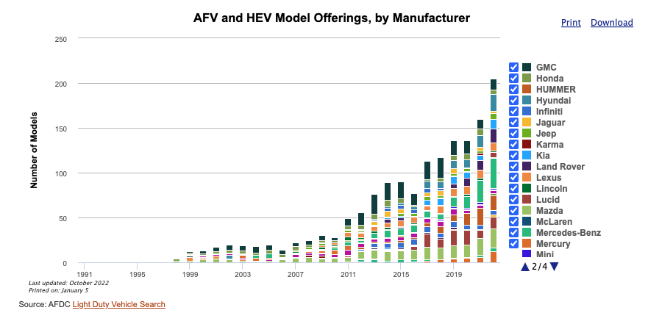
  + Registration: <https://afdc.energy.gov/data/10962>
  + *Light Duty EV Monthly Sales Updates:* <https://www.anl.gov/esia/reference/light-duty-electric-drive-vehicles-monthly-sales-updates-historical-data>
  + Consumer data/demographics: <https://hedgescompany.com/blog/2019/01/new-car-buyer-demographics-2019/>
  + National Household Travel Survey: <https://nhts.ornl.gov/---Stopped> here, revisit in the AM (no vehicle type but by state – So EV by state by travel behavior?)

Federal Highway Administration (FHWA) National Household Travel Survey (NHTS):  
NHTS is the authoritative source on the travel behavior of the American public. It is the only source of national data that allows one to analyze trends in personal and household travel.  
It includes daily non-commercial travel by all modes, including characteristics of the people traveling,  
their household, and their vehicles. National and State. Use this data to analyze trends in personal and household travel

* + Misery Index: <https://www.miseryindex.us/>

It is simply the unemployment rate added to the inflation rate. It is assumed that both a higher rate of unemployment and a worsening of inflation both create economic and social costs for a country

* + Incentives:
    - Incentives by state: <https://afdc.energy.gov/laws/matrix?sort_by=tech>
    - Incentives by fuel type: <https://afdc.energy.gov/data/10360>

**Appendices: Project 2 and Final Project Explorations**

* Other model types: i.e., truck
* EV development correlation with lithium procurement
* Self-driving vehicles (?): <https://waymo.com/blog/2023/12/waymo-significantly-outperforms.html?utm_source=www.superhuman.ai&utm_medium=newsletter&utm_campaign=scientists-claim-they-ve-built-an-ai-that-can-predict-when-people-die>
* Microgrid strategies on peak demand
* National risk index (natural risks): <https://hazards.fema.gov/nri/learn-more>
* Environmental justice:
  + - Electric Vehicle Charging and the Justice40 Initiative

<https://www.anl.gov/esia/electric-vehicle-charging-equity-considerations>

[https://anl.maps.arcgis.com/apps/webappviewer/index.html?](https://anl.maps.arcgis.com/apps/webappviewer/index.html?id=33f3e1fc30bf476099923224a1c1b3ee) id=33f3e1fc30bf476099923224a1c1b3ee

* + - CDC/ATSDR Social Vulnerability Index: <https://www.atsdr.cdc.gov/placeandhealth/svi/index.html>
* Battery degradation: According to a study by [Findings](https://findingspress.org/article/21459-impact-of-charging-rates-on-electric-vehicle-battery-life), rapid and ultra-rapid charging can cause more degradation of the most common electric vehicle batteries than fast charging, although this degradation is limited to an extent by battery management system
* The correlation between charging level and fuel economy is not straightforward. [The charging rate can vary based on vehicle model for all charging types, and charge rate also depends on other factors, such as the battery’s state of charge and the ambient temperature 3](https://www.fueleconomy.gov/feg/charging.shtml).
* New Car Loan Analysis: People have been financing higher car values over longer amounts of time. Explore what is driving this trend. Search for answers by using data collected from the [Federal Reserve Economic Data (FRED)Links to an external site.](https://fred.stlouisfed.org/series/DTCTLVENANQ)
* Trip by purpose: Oak Ridge National Laboratory: Trip by purpose: Only to 2017 <https://afdc.energy.gov/data/10317>

<https://tedb.ornl.gov/data/>