NYC Grocery Subsidy Model Specification
Study area: Bronx Community District 2 (Hunts Point / Longwood), New York City
Policy context: NYCEDC Request for Proposals — NYC Groceries initiative. The RFP solicits a city-operated or city-partnered full-service grocery store offering a 30% discount on a defined core basket of staple items, with NYCEDC covering rent, property taxes, and any remaining Affordability Payment required to deliver the discount.
Model vintage: September 2026 · data vintage: 2024 ACS / Aug 2026 CPI-adjusted prices

Causal Chain
flowchart LR
s["Subsidy s*"] --> Rj["Cost reduction\n(Rent_j + Tax_j + AP_j)"]
Rj --> Dpj["Δp_j (price cut)"]
Dpj --> Vij["V_ij (utility)"]
Vij --> sij["s_ij (choice prob.)"]
sij --> DCS["ΔCS (consumer welfare)"]

Part 1 — Model Equations

1.1 Consumer Demand

1.1.1 Utility
$$V_{ij}=β_{\text{sqft}}⋅{\text{sqft}}_{j} − β_{p,i}⋅p_{j} − β_{d,i}⋅d_{tj}$$
Symbol | Type | Description | Value / Source
$V_{ij}$​ | output | Indirect utility for consumer group $i$ choosing store $j$ | derived
$β_{\text{sqft}}$​ | param | Marginal utility of store floor area; common across groups | design decision — no dataset
${\text{sqft}}_{j}$​ | data | Store floor area (sq ft) | data/stores/large_grocery_stores_cd2.csv
$β_{p,i}$​ | param | Price dis-utility per dollar; varies by income group $g$ | design decision — no dataset
$p_{j}$​ | data | 10-item Crossa basket price, CPI-adjusted to Aug 2026 ($/basket) | data/prices/p_j_cd2_candidate_stores.csv
$β_{d,i}$​ | param | Distance dis-utility per mile; varies by income group $g$ | design decision — no dataset
$d_{tj}$​ | data | Straight-line distance (miles) from tract $t$ centroid to store $j$ | data/distance/d_tract_store_miles.csv

1.1.2 Consumer Groups
Index $i$ runs over 45 consumer groups: 15 non-zero-population census tracts $t$ × 3 income groups $g∈\{\text{Low, Mid, High}\}$.
$$i ≡ (t, g), n_{i}≡n_{t,g}$$
i​ni=NHH=19,922
Distance $d_{tj}$ is identical for all three income groups within tract $t$; it varies only across tracts.
Symbol | Description | Value (2024) | Source
$t$​ | Census tract index | 15 active tracts | data/geography/bronx_cd2_tract_centroids.csv
$g$​ | Income group | Low ($<$$25K$),Mid($$25$–$50K$), High ($>\$50K$) | —
$n_{t,g}$​ | Households in tract $t$, group $g$ | — | data/acs/cd2_B19001_2024.csv
$N_{\text{HH}}$​ | Total CD2 households | 19,922 (Low 7,683 · Mid 4,795 · High 7,444) | data/acs/cd2_B19001_2024.csv

1.1.3 Choice Probability
$$s_{ij}=\frac{exp(V_{ij})}{\sum_{k=1}^{J}{exp}(V_{ik})}$$
Symbol | Description
$s_{ij}$​ | Probability that consumer group $i$ chooses store $j$
$J$​ | Number of stores in choice set (9 existing; 10 with planned NYC Groceries)

1.1.4 Aggregate Market Share
Sj=1NHHi​ni⋅sij
Symbol | Description
$S_{j}$​ | CD2-wide market share of store $j$

1.1.5 Consumer Welfare (Annual Logsum)
$$W_{i}=\frac{T}{β_{p,i}}ln​\left[\sum_{k=1}^{J}{exp}(V_{ik})\right]$$
ΔCS=i​ni⋅Tβp,ilnk​exp​Vikpost − lnk​exp​Vikpre
Symbol | Description | Value | Source
$T$​ | Shopping trips per year | 52 | design decision
$W_{i}$​ | Annual consumer welfare for group $i$ (in utils, scaled by $1/β_{p,i}$) | derived | —
$ΔCS$​ | Annual change in consumer surplus across all 45 groups ($) | derived | —
Issue #4 fix: v3 welfare was per trip; multiplying by $T=52$ converts to annual.

1.2 Store Price and Volume

1.2.1 Revenue and Basket Volume
$$Q_{j}=\frac{R_{j}}{p_{j}}$$
M=g​Ng⋅fg⋅52 ≈ $112.98M/yr (2024)
Symbol | Description | Value | Source
$Q_{j}$​ | Annual basket-equivalent volume at store $j$ | derived | —
$R_{j}$​ | Annual revenue ($) | see store table below | data/revenue/revenue_j_cd2_candidate_stores.csv (Option A, ReferenceUSA) or data/revenue_census_estimate/revenue_j_census_cd2_candidate_stores.csv (Option B, census-based $828.62/sqft/yr) — design decision
$p_{j}$​ | Basket price ($/basket) | $27.76–$30.32 | data/prices/p_j_cd2_candidate_stores.csv
${\overset{‾}{f}}_{g}$​ | Average weekly food-at-home expenditure, income group $g$ (NYC-scaled, Northeast CES) | Low $81.64 · Mid $94.17 · High $146.94 | data/bls/ces_fbar_by_income_group_northeast_cd2weighted.csv
$N_{g}$​ | Total households in income group $g$ (all tracts) | Low 7,683 · Mid 4,795 · High 7,444 | data/acs/cd2_B19001_2024.csv
$M$​ | Annual CD2 grocery market size | $112.98M | data/bls/cd2_market_size_M_northeast_cd2weighted.csv
Store-level data table (2024 vintage):
Store | Address | sqft | $p_{j}$ ($/basket) | $R_{j}$ — ReferenceUSA | $R_{j}$ — Census-based | ${\text{Tax}}_{j}$​ | ${\text{Rent}}_{j}$​
Key Food | 1050 Westchester Ave | 15,000 | $27.76 | $8,032,000 | $12,430,000 | $105,311 | $276,450
Food Fair Fresh Market | 1065 E 163rd St | 13,000 | $28.95 | $8,032,000 | $10,771,000 | $409,408 | $239,590
Fine Fare Supermarket | 950 Westchester Ave | 10,000 | $30.32 | $618,000 | $8,286,000 | $15,711 | $184,300
C-Town Supermarket | 564 Southern Blvd | 8,000 | $28.82 | $2,884,000 | $6,629,000 | $24,691 | $147,440
Food Universe | 724 Hunts Pt Ave | 8,000 | $29.93 | $2,884,000 | $6,629,000 | $49,764 | $153,200
C Town Supermarket | 809 Southern Blvd | 7,500 | $28.82 | $3,090,000 | $6,215,000 | $47,269 | $129,900
JJ Southern Farm Fruit | 1046 Southern Blvd | 1,600 | $28.95 | $577,000 | $1,326,000 | $17,155 | $69,008
Antillana Fresh Meat Market | 1025 Westchester Ave | 3,000 | $28.95 | $824,000 | $2,486,000 | $12,036 | $68,520
Sagal Meat Market | 1091 Southern Blvd | 2,500 | $28.95 | $299,000 | $2,072,000 | $9,067 | $66,800
Census-based $R_{j}={\text{sqft}}_{j}×\$828.62$/sqft/yr (Bronx NAICS 4451 central estimate).
Tax and Rent sources: data/tax/tax_j_cd2_candidate_stores.csv, data/rent/rent_j_cd2_candidate_stores.csv.

1.3 Subsidy Pass-Through — Two Model Versions

1.3.1 — v1: Lump-sum Subsidy, Variable Pass-Through
$$Δp_{j}=θ⋅\frac{s}{Q_{j}}$$
$$V_{ij}^{\text{post}}=V_{ij}^{\text{pre}}+β_{p,i}⋅Δp_{j}$$
Symbol | Description | Values
$s$​ | Annual lump-sum subsidy instrument ($) | e.g. $s=τ⋅{\text{Tax}}_{j}$ (tax break) or $s=σ$ (direct rent subsidy)
$θ$​ | Pass-through rate: fraction of instrument that reduces shelf price | {0.40, 0.65, 0.85} — three sensitivity runs
$Q_{j}$​ | Annual basket volume at store $j$ | from §1.2.1
$Δp_{j}$​ | Reduction in basket price | derived

1.3.2 — v2: NYC Groceries Contract (30% Core Basket Discount)
Core basket share $κ_{g}$ is applied per income group (base version; see sensitivity below).
Price reduction entering the utility function:
$$Δp_{j,g}=0.30⋅κ_{g}⋅p_{j}$$
$$V_{ij}^{\text{post}}=V_{ij}^{\text{pre}}+β_{p,i}⋅0.30⋅κ_{g}⋅p_{j}$$
Each income group $g$ in tract $t$ experiences a different effective price cut because $κ_{g}$ varies by income.
Revenue cost of the 30% discount:
The store-level demand-weighted core basket share is:
κj=i​sij⋅ni⋅κgi​sij⋅ni
$$\text{Gross discount cost}=0.30⋅κ_{j}⋅R_{j}$$
Affordability Payment and total subsidy cost:
NYCEDC covers ${\text{Rent}}_{j}$ and ${\text{Tax}}_{j}$ directly (store does not pay these). If the gross discount cost exceeds rent plus tax relief, NYCEDC pays an additional Affordability Payment:
$${\text{AP}}_{j}=max​\left(0, 0.30⋅κ_{j}⋅R_{j} − {\text{Rent}}_{j} − {\text{Tax}}_{j}\right)$$
Total annual subsidy cost to NYCEDC:
$$s_{j}^{*}={\text{Rent}}_{j}+{\text{Tax}}_{j}+{\text{AP}}_{j}=max​\left({\text{Rent}}_{j}+{\text{Tax}}_{j}, 0.30⋅κ_{j}⋅R_{j}\right)$$
Symbol | Description | Value | Source
$κ_{g}$​ | Core basket share by income group | Low 0.6247 · Mid 0.6218 · High 0.6059 (base, 2024) | data/bls/kappa_core_basket_share_northeast_cd2weighted.csv
$κ_{j}$​ | Demand-weighted store-level core basket share | derived from $s_{ij}$ | —
${\text{AP}}_{j}$​ | Affordability Payment: subsidy over and above rent+tax coverage ($) | derived | —
$s_{j}^{*}$​ | Total annual NYCEDC cost per store ($) | derived | —
${\text{Rent}}_{j}$​ | Annual rent ($) | $66,800–$276,450 (central estimate) | data/rent/rent_j_cd2_candidate_stores.csv
${\text{Tax}}_{j}$​ | Annual property tax, store share ($) | $9,067–$409,408 | data/tax/tax_j_cd2_candidate_stores.csv
$κ$ sensitivity (base run primary; low/high as bounds):
Income group | $κ_{\text{low}}$​ | $κ_{\text{base}}$​ | $κ_{\text{high}}$​
Low ($<$$25K$)|0.4026|0.6247|0.8468||Mid($$25$–$50K$) | 0.3957 | 0.6218 | 0.8480
High ($>\$50K$) | 0.3681 | 0.6059 | 0.8437
CD2 overall | 0.3838 | 0.6146 | 0.8455
The $κ$ version controls which grocery sub-categories count as “core basket”:
- low: only unambiguous staples (meat, dairy, produce, grains — RFP-clear items)
- base: “partly in” categories (frozen foods, snacks, condiments) weighted 0.5
- high: all “partly in” items at full weight
Sensitivity output table (populated when model runs):
Store | ${\text{AP}}_{j}$ ($κ_{\text{low}}$) | ${\text{AP}}_{j}$ ($κ_{\text{base}}$) | ${\text{AP}}_{j}$ ($κ_{\text{high}}$) | $ΔCS$ ($κ_{\text{low}}$) | $ΔCS$ ($κ_{\text{base}}$) | $ΔCS$ ($κ_{\text{high}}$)
Key Food | — | — | — | — | — | —
Food Fair Fresh Market | — | — | — | — | — | —
Fine Fare Supermarket | — | — | — | — | — | —
C-Town (564) | — | — | — | — | — | —
Food Universe | — | — | — | — | — | —
C-Town (809) | — | — | — | — | — | —
JJ Southern Farm | — | — | — | — | — | —
Antillana | — | — | — | — | — | —
Sagal | — | — | — | — | — | —

1.4 Welfare Update Steps
Applies identically to v1 and v2.
Step A — Pre-subsidy utility (baseline):
$$V_{ij}^{\text{pre}}=β_{\text{sqft}}⋅{\text{sqft}}_{j}−β_{p,i}⋅p_{j}−β_{d,i}⋅d_{tj}$$
Step B — Post-subsidy utility:
$$V_{ij}^{\text{post}}=V_{ij}^{\text{pre}}+β_{p,i}⋅Δp_{j,g}$$
where $Δp_{j,g}$ is from §1.3.1 (v1) or §1.3.2 (v2).
Step C — Logsum welfare by group:
$$L_{i}^{\text{pre}}=ln​\sum_{k=1}^{J}{exp}​\left(V_{ik}^{\text{pre}}\right), L_{i}^{\text{post}}=ln​\sum_{k=1}^{J}{exp}​\left(V_{ik}^{\text{post}}\right)$$
Step D — Annual consumer surplus change:
$$ΔCS=\sum_{i=1}^{45}{\frac{n_{i}⋅T}{β_{p,i}}}\left(L_{i}^{\text{post}}−L_{i}^{\text{pre}}\right)$$

1.5 Optimization and Store Ranking
Store selection (9 existing stores):
For v1, find $s_{j}^{*}$ such that $ΔCS(s_{j}^{*})≥ΔCS_{min}$ via grid search over $s$. For v2, $Δp_{j,g}$ is fixed by contract; compute $ΔCS$ directly and $s_{j}^{*}$ from §1.3.2.
Rank stores by welfare per dollar of subsidy:
$${\text{efficiency}}_{j}=\frac{ΔCS_{j}}{s_{j}^{*}}$$
Store addition — NYC Groceries (static comparison):
Add the planned store to the choice set with $J=10$. Set $p_{j}^{\text{post}}=p_{j}⋅(1−0.30⋅κ_{g})$ per income group. Compute $ΔCS$ relative to the 9-store baseline. ${\text{Rent}}_{j}$ and ${\text{Tax}}_{j}$ are covered by NYCEDC and included in $s_{j}^{*}$.

Part 2 — NYC Groceries Store Inputs
Input | Value | Source / Method
Store name | N.Y.C. Groceries | RFP
Address | 1215 Spofford Ave, Bronx, NY 10474 | RFP Appendix D
Coordinates | lat 40.8149, lon −73.8921 | RFP Appendix D
${\text{sqft}}_{j}$​ | 15,000 | RFP Appendix D
$p_{j}$​ | $28.95/basket | All-Bronx CPI-adjusted average (no chain match); data/prices/p_j_cd2_candidate_stores.csv method
$p_{j}^{\text{post}}$​ | $p_{j}⋅(1−0.30⋅κ_{g})$ per income group | Derived; base: Low ≈ $22.52 · Mid ≈ $22.57 · High ≈ $22.68
$R_{j}$ (census-based) | $12,429,300 (= 15,000 × $828.62) | data/revenue_census_estimate/bronx_sales_per_sqft_census.csv central estimate
$R_{j}$ (ReferenceUSA alt.) | $15,280,000 (size-based, 15,000 sqft × median ReferenceUSA rate) | data/revenue/revenue_j_cd2_candidate_stores.csv — design decision
${\text{Rent}}_{j}$​ | $276,450 (= 15,000 × $18.43/sqft) | Median rent/sqft of 6 large (≥5,000 sqft) CD2 stores; data/rent/rent_j_cd2_candidate_stores.csv
${\text{Tax}}_{j}$​ | $93,900 (= 15,000 × $6.26/sqft, est.) | Median tax/sqft of 6 large CD2 stores (excl. Food Fair outlier); data/tax/tax_j_cd2_candidate_stores.csv
$\text{snap_eligible}$​ | 1 | SNAP authorization on opening per RFP policy goals
Store status | Planned (opening 2027) | RFP
Note on Rent and Tax: NYCEDC covers both per the RFP. They are nonetheless modeled as explicit line items in $s_{j}^{*}$ to show the full public cost and to compute ${\text{AP}}_{j}$.

Part 3 — Map Figure
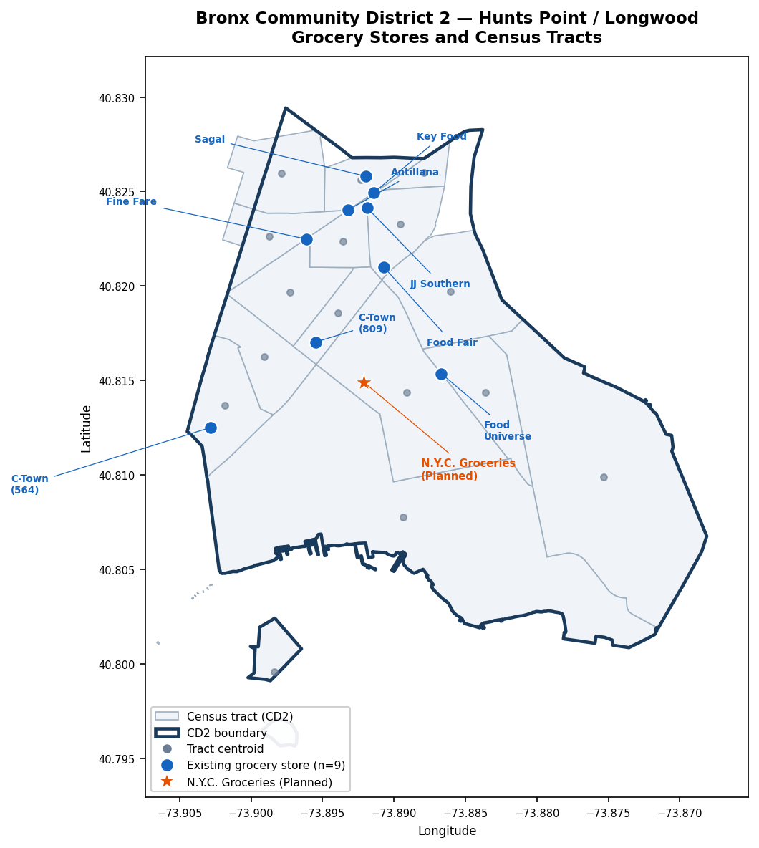
CD2 store map
Figure 1. Bronx CD2 (Hunts Point / Longwood): census tract boundaries and centroids, 9 existing large grocery stores (blue circles), and the planned N.Y.C. Groceries location at 1215 Spofford Ave (orange star).

Appendix — Parameter and Dataset Reference

A.1 Full Symbol Table
Symbol | First used | Type | Dataset path | Decision needed?
$V_{ij}$​ | §1.1.1 | Derived | — | No
$β_{\text{sqft}}$​ | §1.1.1 | Parameter | no dataset | YES — must set before running
${\text{sqft}}_{j}$​ | §1.1.1 | Data | data/stores/large_grocery_stores_cd2.csv | No
$β_{p,i}$​ | §1.1.1 | Parameter | no dataset | YES — must set before running
$p_{j}$​ | §1.1.1 | Data | data/prices/p_j_cd2_candidate_stores.csv | No
$β_{d,i}$​ | §1.1.1 | Parameter | no dataset | YES — must set before running
$d_{tj}$​ | §1.1.1 | Data | data/distance/d_tract_store_miles.csv | No — already built for 16 tracts × 10 stores
$n_{t,g}$​ | §1.1.2 | Data | data/acs/cd2_B19001_2024.csv | No
$N_{\text{HH}}$​ | §1.1.2 | Data | data/acs/cd2_B19001_2024.csv | No — 19,922 (2024)
$s_{ij}$​ | §1.1.3 | Derived | — | No
$J$​ | §1.1.3 | Data | — | No — 9 existing; 10 with NYC Groceries
$S_{j}$​ | §1.1.4 | Derived | — | No
$T$​ | §1.1.5 | Parameter | — | YES — use 52 or income-differentiated? (recommend 52)
$ΔCS$​ | §1.1.5 | Derived | — | No
$R_{j}$​ | §1.2.1 | Data | Option A: data/revenue/revenue_j_cd2_candidate_stores.csv (revenue_rusa_2024) · Option B: data/revenue_census_estimate/revenue_j_census_cd2_candidate_stores.csv (revenue_census_central) | YES — choose Option A or B
$Q_{j}$​ | §1.2.1 | Derived | — | No
$M$​ | §1.2.1 | Data | data/bls/cd2_market_size_M_northeast_cd2weighted.csv | No — $112.98M (2024)
${\overset{‾}{f}}_{g}$​ | §1.2.1 | Data | data/bls/ces_fbar_by_income_group_northeast_cd2weighted.csv | No
$θ$​ | §1.3.1 | Parameter | — | No — {0.40, 0.65, 0.85} for v1 sensitivity
$s$​ | §1.3.1 | Instrument | — | v1 scenario input
$κ_{g}$​ | §1.3.2 | Data | data/bls/kappa_core_basket_share_northeast_cd2weighted.csv | YES — κ version: primary = base; low/high as sensitivity
$κ_{j}$​ | §1.3.2 | Derived | — | No
${\text{AP}}_{j}$​ | §1.3.2 | Derived | — | No
$s_{j}^{*}$​ | §1.3.2 | Derived | — | No
${\text{Rent}}_{j}$​ | §1.3.2 | Data | data/rent/rent_j_cd2_candidate_stores.csv (Rent_j) | YES — central vs. Rent_j_low / Rent_j_high?
${\text{Tax}}_{j}$​ | §1.3.2 | Data | data/tax/tax_j_cd2_candidate_stores.csv (Tax_j) | No

A.2 Design Decision Flags
Decisions required before the model can produce numerical output:
# | Symbol(s) | Decision | Status
1 | $β_{\text{sqft}}, β_{p,i}, β_{d,i}$​ | Set parameter values (no dataset exists; must come from literature calibration or assumption) | OPEN
2 | $R_{j}$​ | Choose revenue source: Option A (ReferenceUSA revenue_rusa_2024) or Option B (census-based revenue_census_central) | OPEN
3 | ${\text{Rent}}_{j}$ bound | Use central Rent_j, Rent_j_low, or Rent_j_high | OPEN
4 | $κ$ version | Primary run = κ_base; κ_low and κ_high reported as sensitivity bounds | Resolved
5 | $κ_{g}$ per income group vs. single κ | Use per income group $κ_{g}$ | Resolved
6 | $d_{tj}$ file | Use data/distance/d_tract_store_miles.csv (already built, 15 active tracts × 10 stores) | Resolved
7 | $T$ trips/year | Use 52 (weekly shopping) | Pending confirmation
8 | $θ$ scenarios (v1) | {0.40, 0.65, 0.85} | Pending confirmation
9 | $J$ for baseline | 9 existing stores | Resolved

A.3 Data File Index
File | Description
data/stores/large_grocery_stores_cd2.csv | 9 candidate stores: name, address, sqft, lat/lon, SNAP eligibility
data/prices/p_j_cd2_candidate_stores.csv | Basket price $p_{j}$ ($/10-item basket), CPI-adjusted to Aug 2026
data/revenue/revenue_j_cd2_candidate_stores.csv | ReferenceUSA 2024 revenue; size-based fallback
data/revenue_census_estimate/revenue_j_census_cd2_candidate_stores.csv | Census-based revenue; revenue_census_central column
data/revenue_census_estimate/bronx_sales_per_sqft_census.csv | Bronx NAICS 4451 sales/sqft variants; central = $828.62/sqft/yr
data/tax/tax_j_cd2_candidate_stores.csv | DOF property tax FY2025, store share (Tax_j)
data/rent/rent_j_cd2_candidate_stores.csv | DOF notice rent estimates (Rent_j, Rent_j_low, Rent_j_high)
data/bls/ces_fbar_by_income_group_northeast_cd2weighted.csv | Weekly food-at-home ${\overset{‾}{f}}_{g}$ by income group, Northeast CES, CD2-weighted
data/bls/cd2_market_size_M_northeast_cd2weighted.csv | Annual CD2 grocery market size $M$
data/bls/kappa_core_basket_share_northeast_cd2weighted.csv | Core basket share $κ_{g}$ (low/base/high) by income group and ACS year
data/bls/fbar_core_noncore_by_income_group_northeast.csv | ${\overset{‾}{f}}_{g}$ split into core / non-core components
data/distance/d_tract_store_miles.csv | Tract-to-store distances (miles); 16 tracts × 10 stores
data/geography/bronx_cd2_tract_centroids.csv | Tract centroid coordinates (lat/lon) for 16 CD2 tracts
data/geography/bronx_cd2_tracts.geojson | Tract polygon boundaries
data/geography/bronx_cd2_boundary.geojson | CD2 district boundary polygon
data/acs/cd2_B19001_2024.csv | ACS B19001 household counts by tract and income bracket
figures/cd2_store_map.png | Map figure (generated by code/generate_cd2_store_map.py)

