Raumflugbetrieb und Astronautentraining

Space Situational Awareness

Description of the BACARDI Software

Document-No. SSA-GEN-xxxx
Issue 1.0
Date 25.01.2017
NOTICE!!! All Information above and in the header are MS Word fields and are filled in automatically. Please fill in the correct information under File > Properties > Advanced Properties in the tabs Summary (Title, Author) and Custom (Date, Number, Version, Classification). Then update all fields (including header and footer) by macro. To run the macro please press the “runner button” in the Add-Ins menu 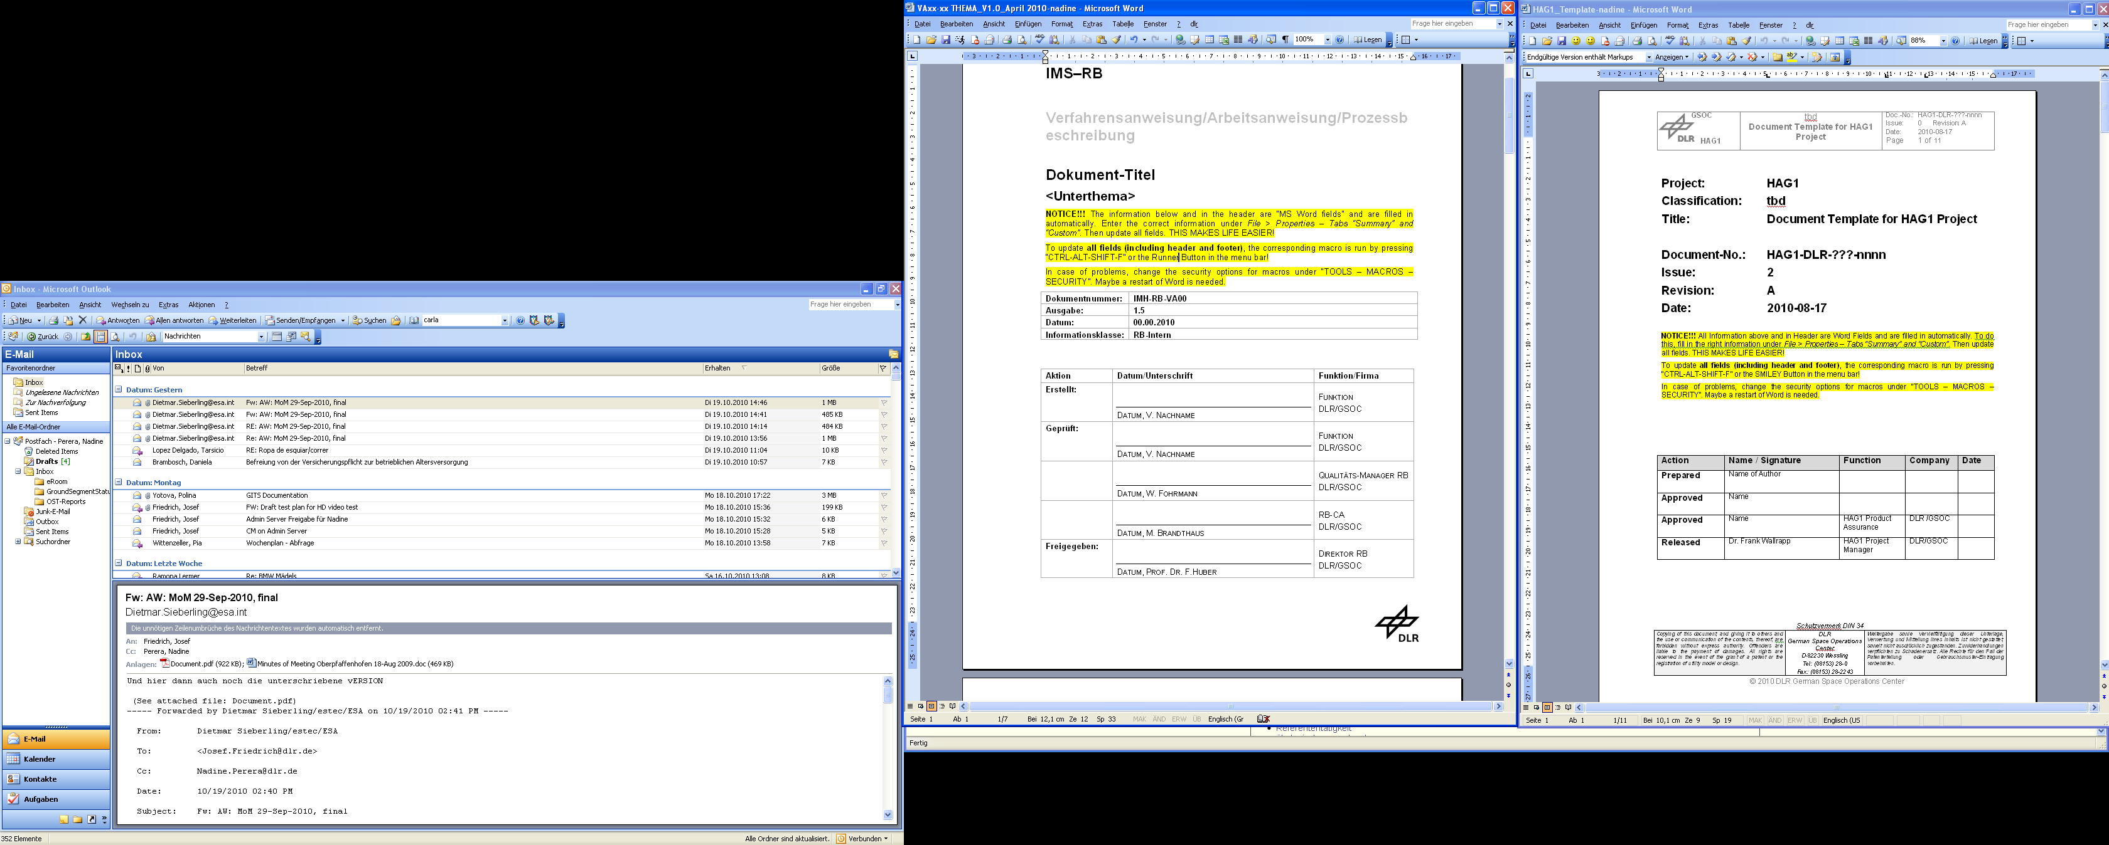
To activate macros, you may have to change the security settings for macros under File > Options > Trust Center and restart Word.
 | Date/Signature | Function/Department
Prepared: | F. Last name | SSA S/W Engineer  RB-RFT
Approved: | F. Last name | SSA PA  RB-RFT
Released: | F. Last name | SSA Manager  RB-RFT

Document Information

Authors and Contributors
Organisation / Unit | Name | Function
DLR / RB-RFT |  | S/W Engineer
DLR / RB-RFT
…

Document Change Control
Issue | Revision | Date | Affected pages/chapters | Change

Table of Contents
1 Document Information 2
1.1 Authors and Contributors 2
1.2 Document Change Control 2
1.3 Table of Contents 3
2 Introduction 4
2.1 Scope 4
2.2 Applicability 4
3 References 5
3.1 Applicable Documents 5
3.2 Normative Documents 5
3.3 Reference Documents 5
4 Software Requirements 6
5 Software Design 7
5.1 General Description 7
5.2 Software Structure 7
5.3 Software Interfaces 7
5.4 Unit Description 8
6 User’s Guide 9
6.1 Running the Program 9
6.2 Common Files 9
6.3 Input Files 9
6.4 Output Files 9
6.5 Restrictions 9
6.6 Assumptions 9
6.7 Error Stop Codes 9
7 Mathematical/Functional/Algorithm Description (?) 10
7.1 Subchapter 10
8 Software Installation 11
8.1 System Requirements 11
8.2 Compilation and Linking 11
Annex A : Exemplary Annex A 12
A-1 Annex 1 12

Tables
Table 1 Example for table marking 8

Figures
Figure 1 Example for figure marking 7

Introduction

Scope

Applicability
This document is the generic software description and follows the standard guideline for flight dynamics software engineering activities at DLR-RB-RFT, spanning the following software life cycle phases:
- Design
- Implementation and
- Operations.

References
For the following dated references, subsequent amendments to or revisions of any of these publications do not apply. For undated references, the latest edition of the applicable document referred to applies.

Applicable Documents
Following documents contain rules which – through reference in this text – are also applicable to this RB document.
- Description of the GSOC Flight Dynamics System; FDS-SYS-0010; Issue x.x; DLR-GSOC (Mmm 20YY).
- FD Software Engineering; RB-IMS-450-06-0100; Issue x.x, DLR-GSOC (Mmm 20YY)
- Coding Standards for Fortran 90 Flight Dynamics Software; RB-IMS-370-01-0001; Issue x.x; DLR-GSOC (Mmm 20YY).
- Definition of Common Flight Dynamics Interface Files; FDS-SRD-0110; Issue x.x; DLR-GSOC (Mmm 20YY).
- NAVLIB/F90 - A Package Based Fortran 90 Library for Flight Dynamics Applications; FDS-GEN-0010; Issue x.x; DLR-GSOC (Mmm 20YY).
- NAVTOOLS/F90 - A Fortran-90 Toolbox for Flight Dynamics Applications; FDS-GEN-0020; Issue x.x; DLR-GSOC (Mmm 20YY).
- FDTOOLS/F90 - A Fortran-90 Toolbox for Flight Dynamics Applications; FDS-GEN-0040; Issue x.x; DLR-GSOC (Mmm 20YY).
- (Project Design …)

Normative Documents
The following documents provide rules, guidelines or characteristics for the content of this document. These are usually standards, specifications and norms.
- (CCSDS, ECSS …)

Reference Documents
The following documents give further information that may be of interest in the context of this document. They are neither applicable nor normative.
- FDS Software Development PlanReport; FDS-DRP-xxxx (for software); Issue x.x; DLR-GSOC (Mmm 20YY).
- FDS Software Development PlanReport; FDS-DRP-xxxx-<module> (for modules of libraries) Issue x.x; DLR-GSOC (Mmm 20YY).
- FDS Manual (in preparation)
- (all other documents, e.g. TNs, papers, books)

Software Requirements
The software XXX shall meet the following requirements (copy from S/W Plan/Report):

Req. Types: F (Functional) / P (Performance) / I (Interface)
Req. No. | Specification | Type | Remarks | Covered by module / routine
XXX-001 | description | F |  | module1/  subroutine3
XXX-002 | description | I

Software Design

General Description
The Backend Catalog for Relation Debris Information (BACARDI) is a multi-tier system. In the backend (“catalogue”) it consists of a database and a number of data processors. The processors can be combined to form a workflow that transforms input data from the database or external sources into data products.

Software Structure
The BACARDI system is written in Fortran 90 and Python. Computational parts are implemented in Fortran 90 libraries NAVLIB, NAVTOOLS, FDTOOLS and COLALIB ([AD5], [AD6], [AD7], and Fehler! Verweisquelle konnte nicht gefunden werden.) which consist of different Fortran 90 modules themselves. These libraries are wrapped by an interoperability layer to allow their usage from Python. They are referred to as FDLIB below.

The overall program context is shown in … The BACARDI system consists of two main subsystems (frontend “Website” and backend “Catalogue”). The “Website” provides access to the catalog by offering a web application and ReSTful API similar to those found at “space-track.org”. It also contains parts of the user authentication. The detailed structure of the “Catalogue” backend is discussed below.

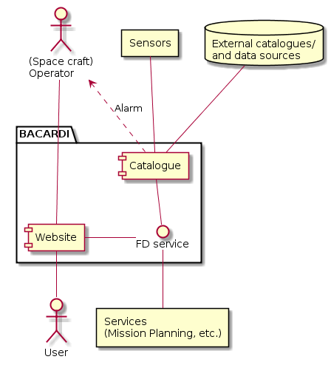

It is important to note that the website is meant as primary access point to the catalogue. Both systems should be isolated as much as possible to avoid leakage of internal data. In practice this means that both systems are in different subnetworks that only share a defined communication channel. However, for internal GSOC use it should be possible to directly access the catalogue system (“Services”). In case of an alarm (e.g. close approach), existing notification channels should be triggered directly by the catalogue.

The structure of the catalogue is shown in … Two main interfaces exist.
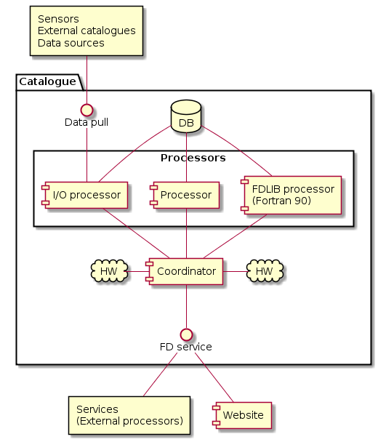

The processors directly access the database. A decentralized coordinator allocates hardware to the different processes and controls the execution of workflows. It also provides an interface to the services that are made available by the catalog. This is closely related to the FD-Services project. This interface is also used by the frontend.

To get new data into the catalog there is a second interface that allows pulling data into the catalogue. This is realized by a shared storage space (drop point) that is periodically scanned for new data.

Processors are generally written in Python. The FDLIB modules are wrapped by F2x to be available as processors. The data pull interface is provided by special I/O processors.

The xxxxx software XXXXX is written in Fortran 90. It comprises a main program unit, which is based on modules from the NAVLIB, NAVTOOLS, FDTOOLS and COLALIB library ([AD5], [AD6], [AD7], and Fehler! Verweisquelle konnte nicht gefunden werden.). The source code of each program unit is contained in a file <unit>.f90, where <unit> is the corresponding name of the main program or module.

Software Interfaces

Example for a figure including figure marking:
Figure 1 Example for figure marking

Example for a table including table marking:
Table 1 Example for table marking

Unit Description
The following NAVLIB modules are used [AD5]:
- <Module1>

The following NAVTOOLS modules are used [AD6]:
- <Module1>

The following FDTOOLS modules are used [AD7]:
- <Module1>

The following S/W-specific units are used:

UNIT/MODULE1

General Description
The XXX unit …

Cross Reference
The unit XXX provides the main program/routines for …. It contains the following public procedures:

PROCEDURE1 | …
PROCEDURE2 | …

The following routines are used internally:

internal_PROCEDURE1 | …
internal_PROCEDURE2 | …

MODULE2
… description …(like module1)

User’s Guide

Running the Program

Common Files
The following common files ([AD4]) are used by XXXX:
Description | File Name
Earth Rotation Parameter Table | ERP_TABLE
Leap Seconds Table | LEAP_TABLE
Solar Flux Data Table | FLUX_TABLES

Input Files

Output Files

Restrictions

Assumptions

Error Stop Codes

Mathematical/Functional/Algorithm Description (?)

Subchapter

Software Installation

System Requirements

Compilation and Linking

- Exemplary Annex A
- Annex 1

- Annex 1.1

