**Administrative**

* **Poster Session** on Wednesday!
  + <http://cs231n.stanford.edu/postersession.html>
  + Facebook group: [https://www.facebook.](https://www.facebook.com/events/1024309900974098/) [com/events/1024309900974098/](https://www.facebook.com/events/1024309900974098/)
* **If using AWS, use EBS**
  + Instructions on Piazza
* **A3 Grades** out soon



Fei-Fei Li & Andrej Karpathy & Justin Johnson Lecture 15 1 7 Mar 2016

Together, we’ve defined Score Functions...

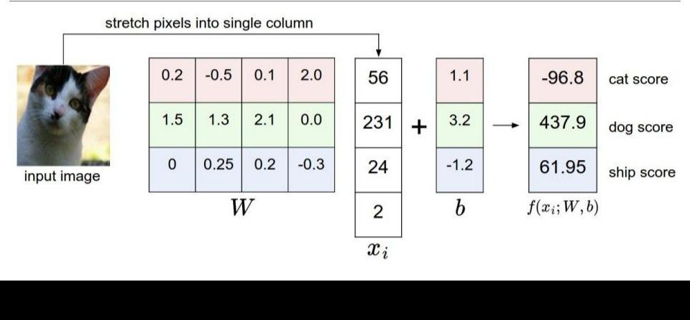

Fei-Fei Li & Andrej Karpathy & Justin Johnson Lecture 15 2 7 Mar 2016

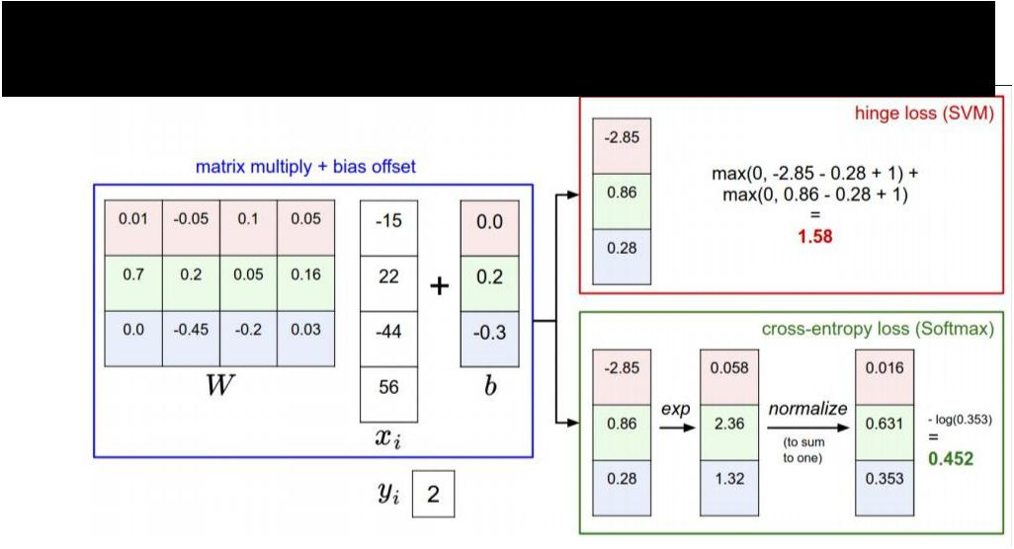And Loss Functions...



Fei-Fei Li & Andrej Karpathy & Justin Johnson Lecture 15 3 7 Mar 2016

We’ve learned how to optimize them...



Chain rule:

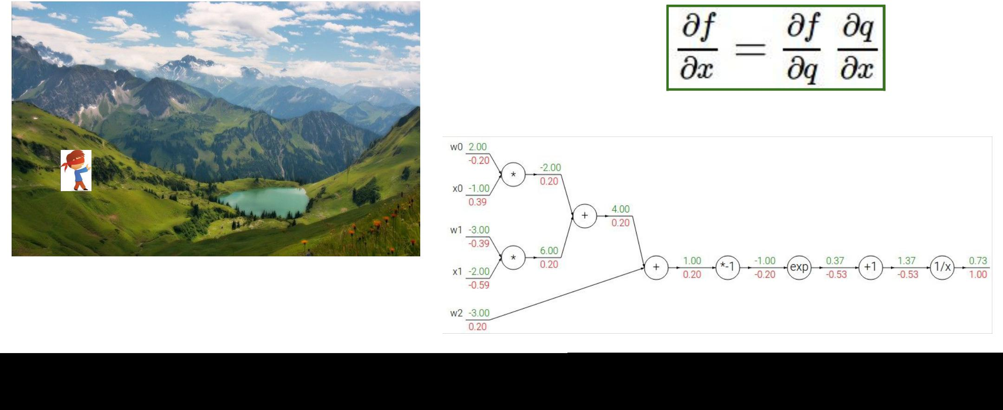

Fei-Fei Li & Andrej Karpathy & Justin Johnson Lecture 15 4 7 Mar 2016

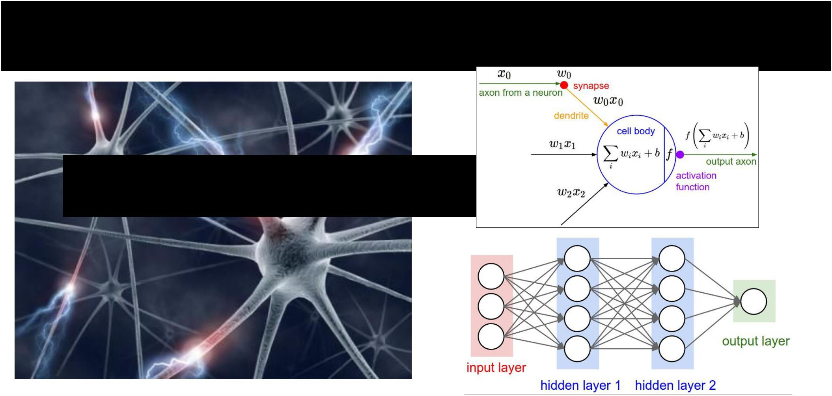We learned to express more powerful Score Functions...

**NEURAL NETWORKS**



Fei-Fei Li & Andrej Karpathy & Justin Johnson Lecture 15 5 7 Mar 2016

For an extra wiggle...

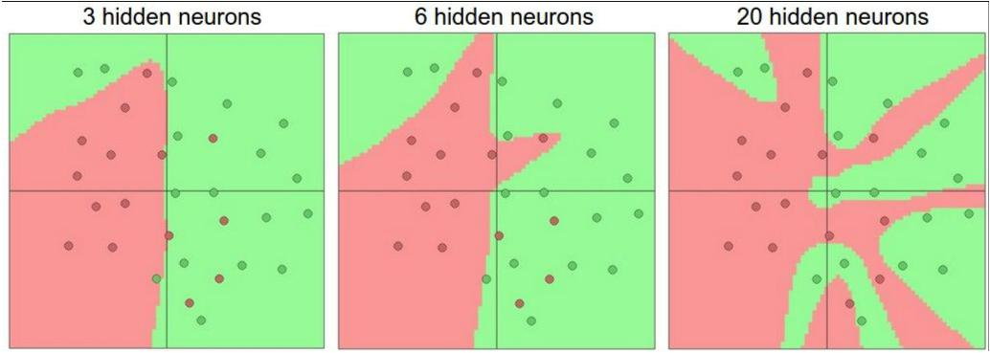

Fei-Fei Li & Andrej Karpathy & Justin Johnson Lecture 15 6 7 Mar 2016

Together we tamed the learning process...

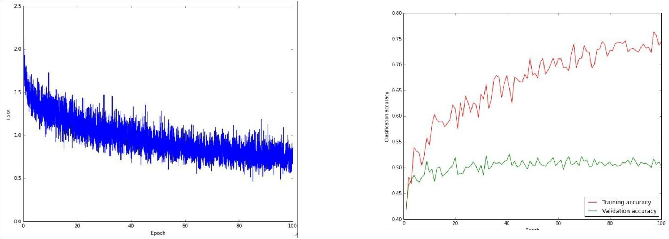

Fei-Fei Li & Andrej Karpathy & Justin Johnson Lecture 15 7 7 Mar 2016

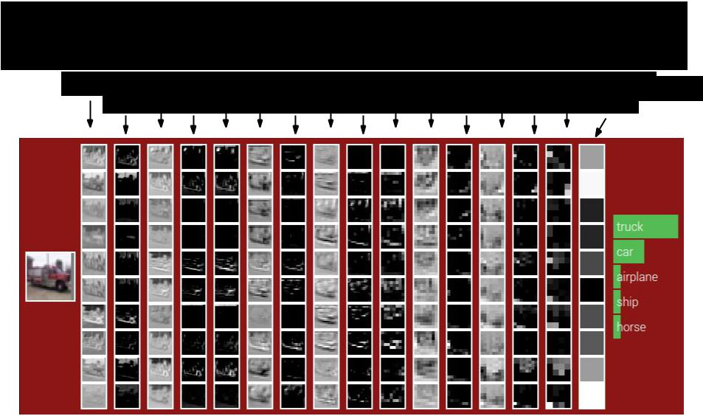Together we explored image-specific Neural Nets...

|  |  |  |  |  |  |  |  |
| --- | --- | --- | --- | --- | --- | --- | --- |
| CONV | CONV POOL CONV | ReLU | CONV POOL CONV | ReLU | CONV POOL FC | |  |
| ReLU | ReLU | ReLU | ReLU | (Fully-connected) |  |
|  |  |  |  |  |  |  |



Fei-Fei Li & Andrej Karpathy & Justin Johnson Lecture 15 8 7 Mar 2016

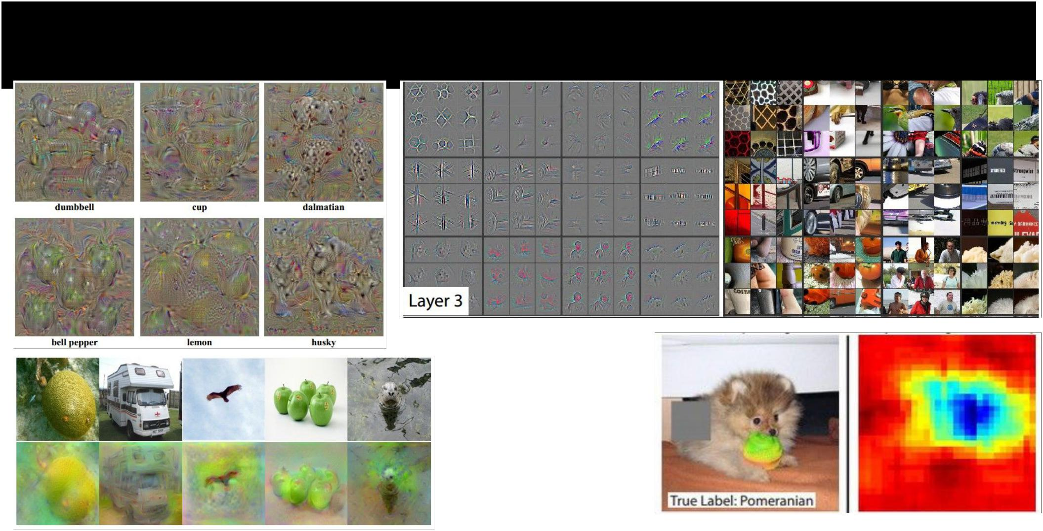We explored how they work...



Fei-Fei Li & Andrej Karpathy & Justin Johnson Lecture 15 9 7 Mar 2016

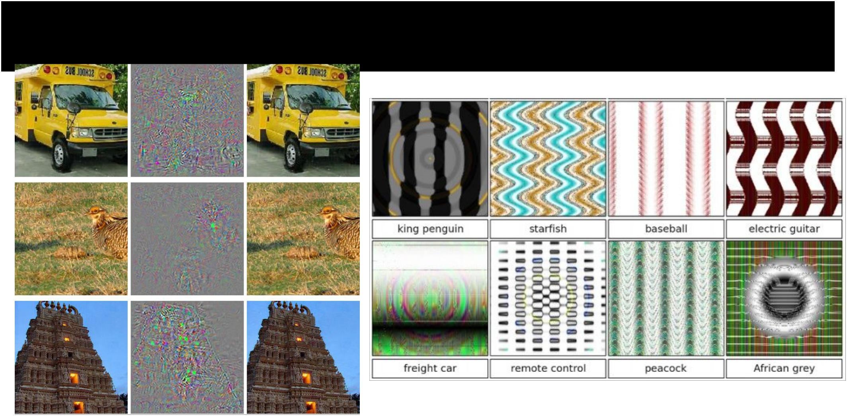And how they don’t… (but really they still do)



Fei-Fei Li & Andrej Karpathy & Justin Johnson Lecture 15 10 7 Mar 2016

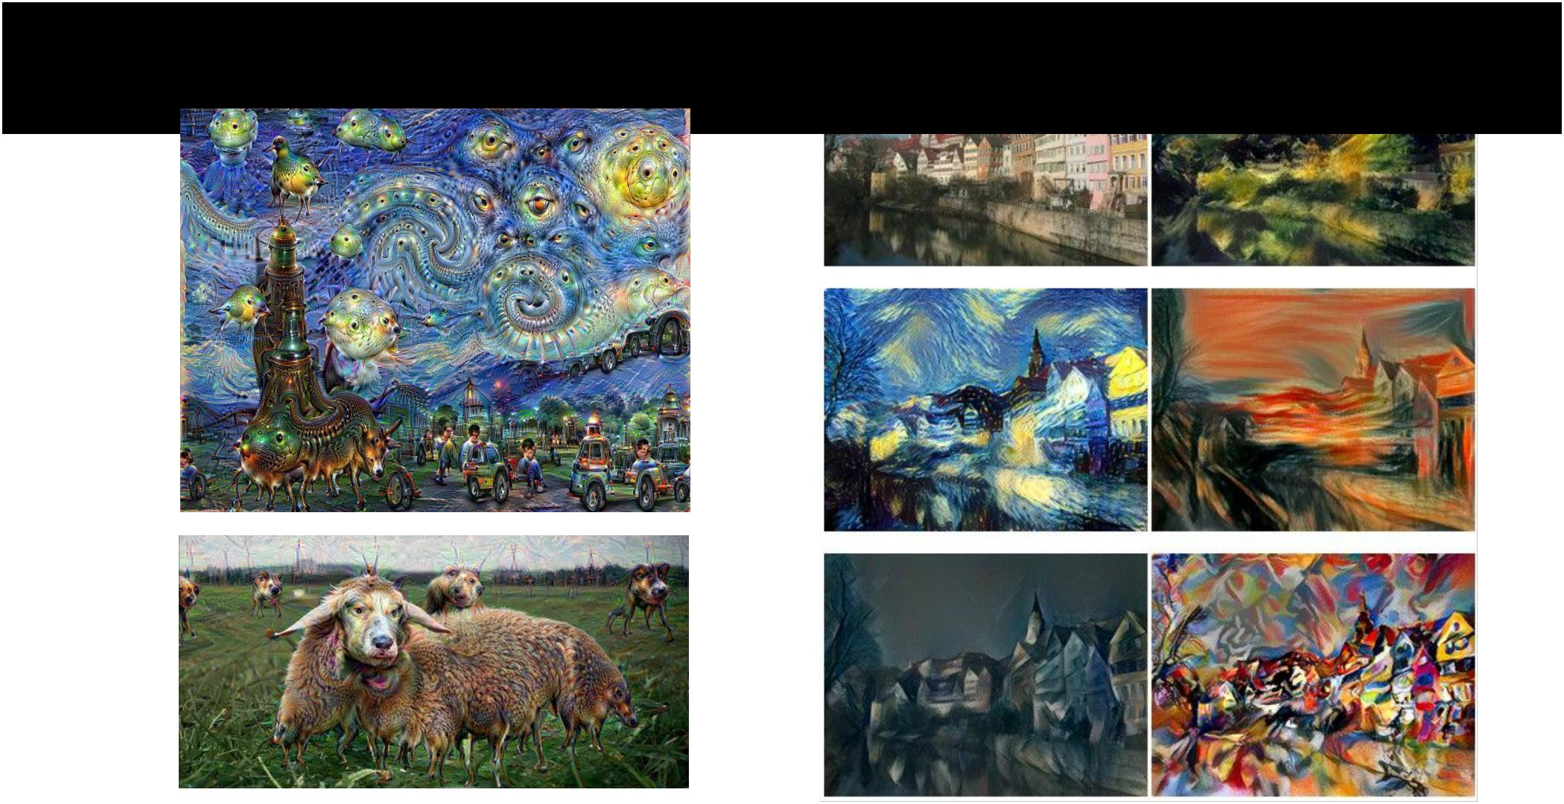And how to make art



Fei-Fei Li & Andrej Karpathy & Justin Johnson Lecture 15 11 7 Mar 2016

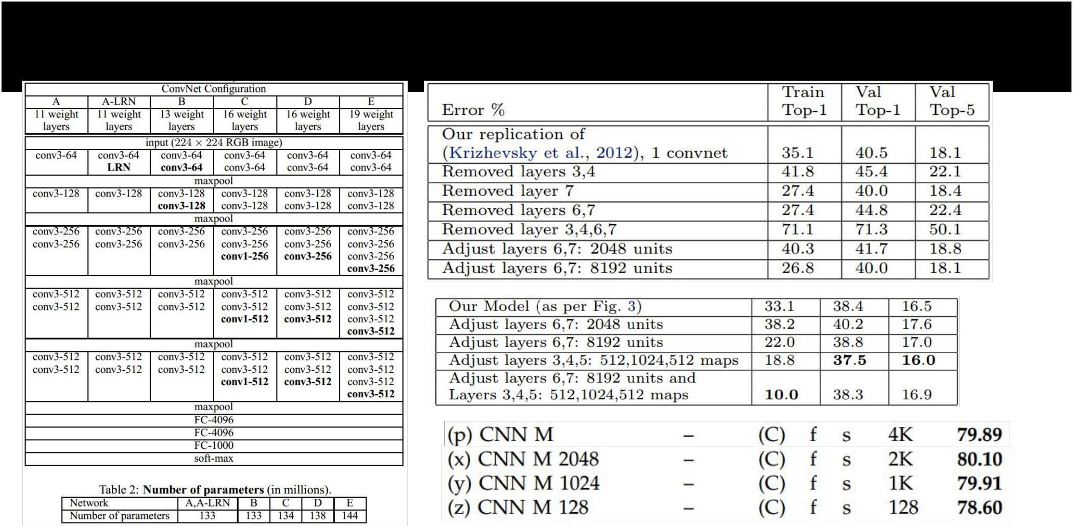We looked at what makes ConvNets “tick”...



Fei-Fei Li & Andrej Karpathy & Justin Johnson Lecture 15 12 7 Mar 2016

We learned tips/tricks for

making ConvNets work well in practice

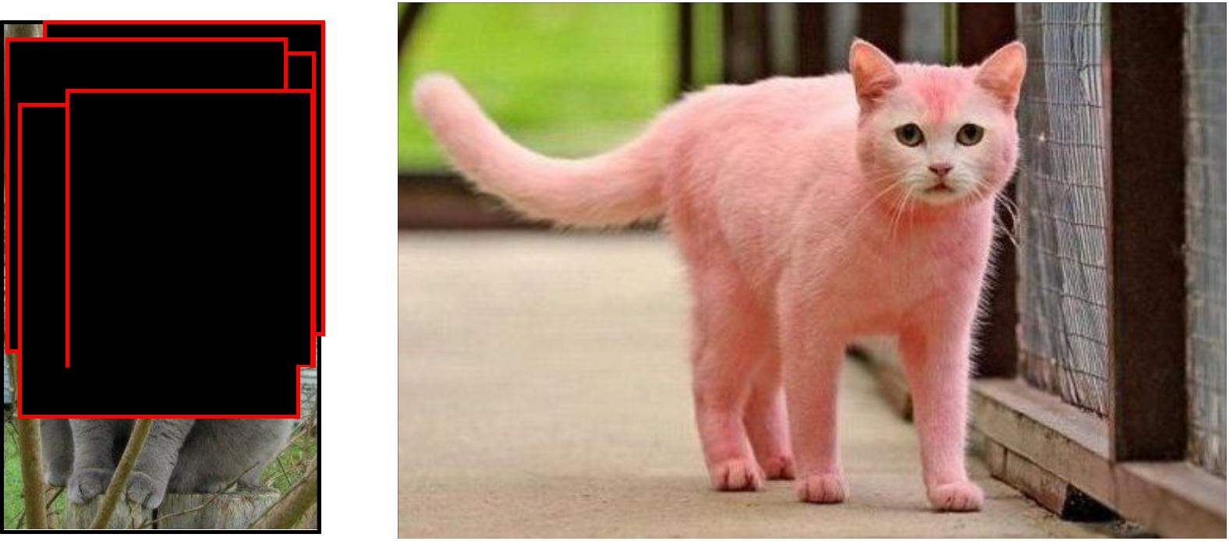

Fei-Fei Li & Andrej Karpathy & Justin Johnson Lecture 15 13 7 Mar 2016

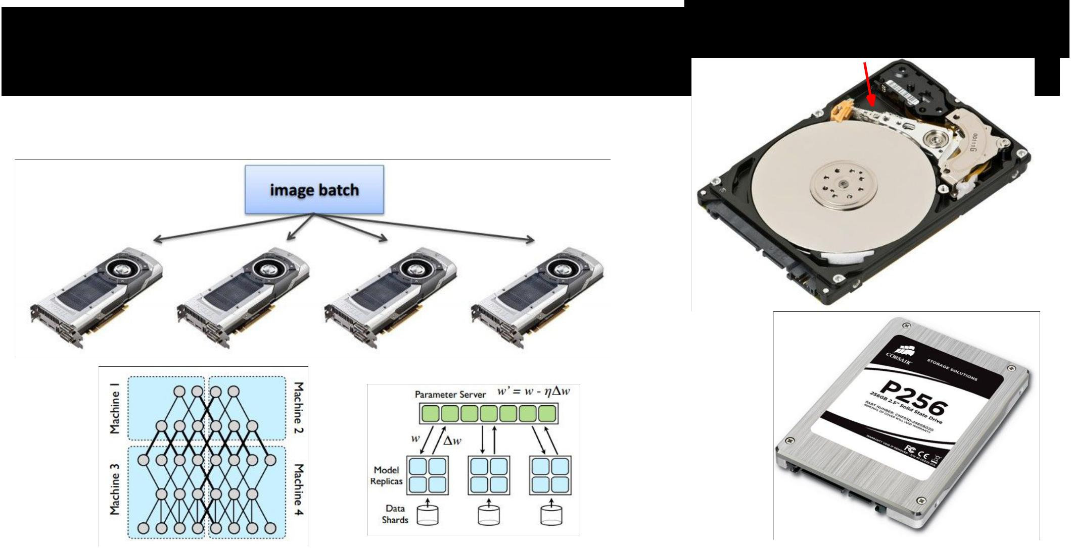

And explored their practical bottlenecks...



Moving parts lol

Fei-Fei Li & Andrej Karpathy & Justin Johnson Lecture 15 14 7 Mar 2016

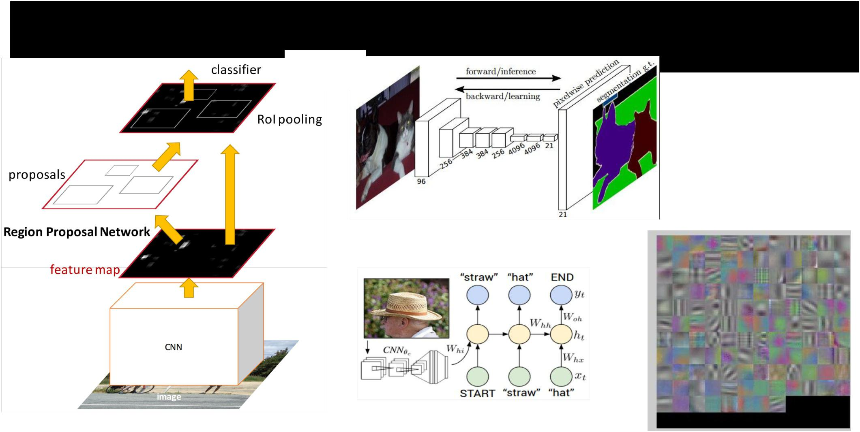And we bravely ventured beyond Image Classification...



Fei-Fei Li & Andrej Karpathy & Justin Johnson Lecture 15 15 7 Mar 2016

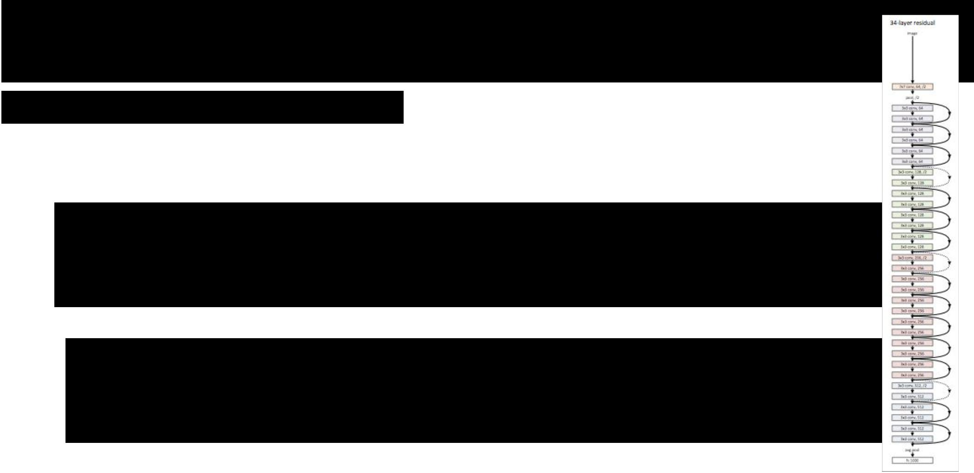And developed an understanding of cutting-edge research

We saw **2015 & 2016** citations...

e.g.

**Deep Residual Learning for Image Recognition**

*[He et al., CVPR 2016] (MSR)*

**Inception-v4, Inception-ResNet and the**

**Impact of Residual Connections on Learning**

*[Szegedy et al., 2016] (Google)*



Fei-Fei Li & Andrej Karpathy & Justin Johnson Lecture 15 16 7 Mar 2016

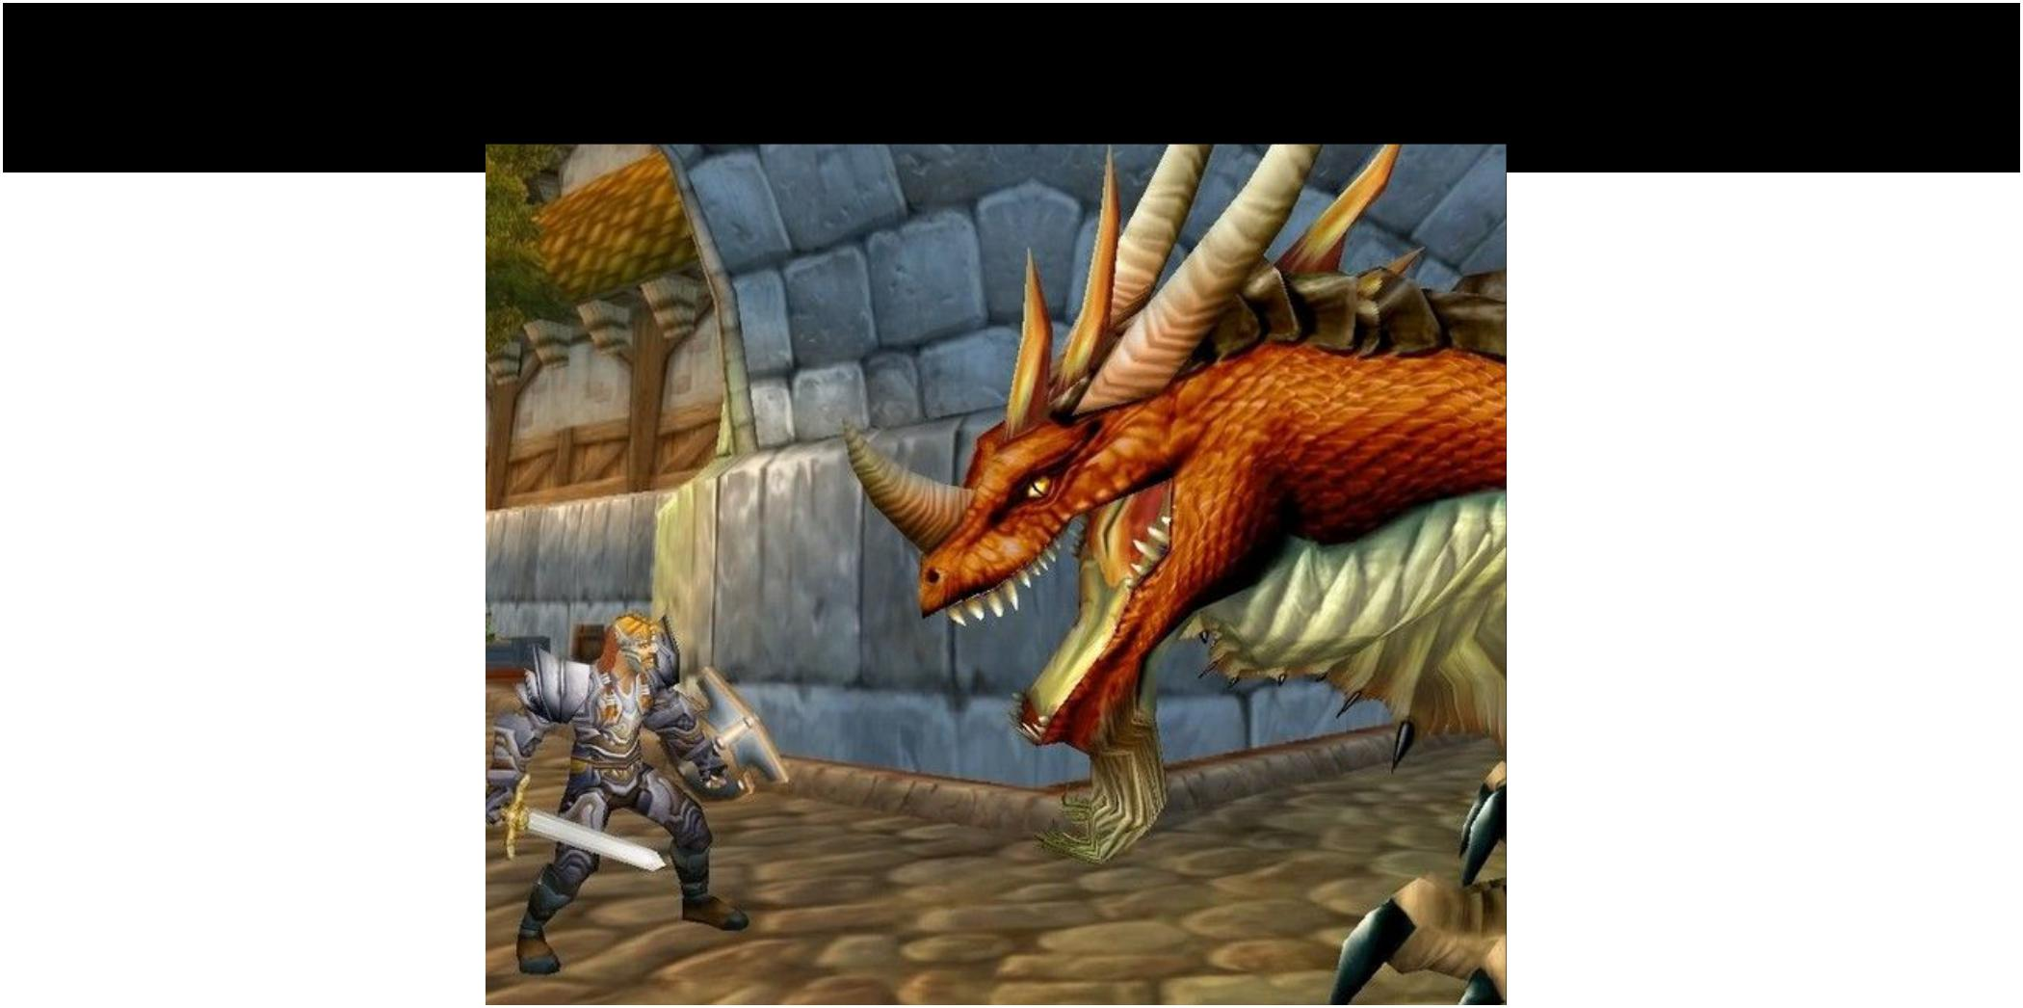You are now ready.



Fei-Fei Li & Andrej Karpathy & Justin Johnson Lecture 15 17 7 Mar 2016

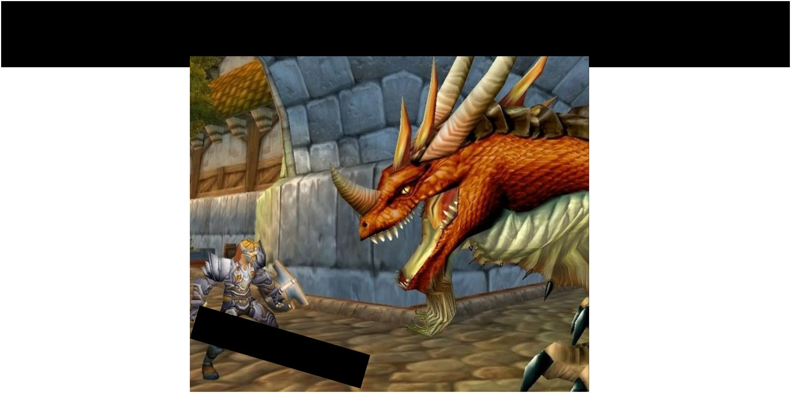You are now ready.



Fei-Fei Li & Andrej Karpathy & Justin Johnson Lecture 15 18 7 Mar 2016

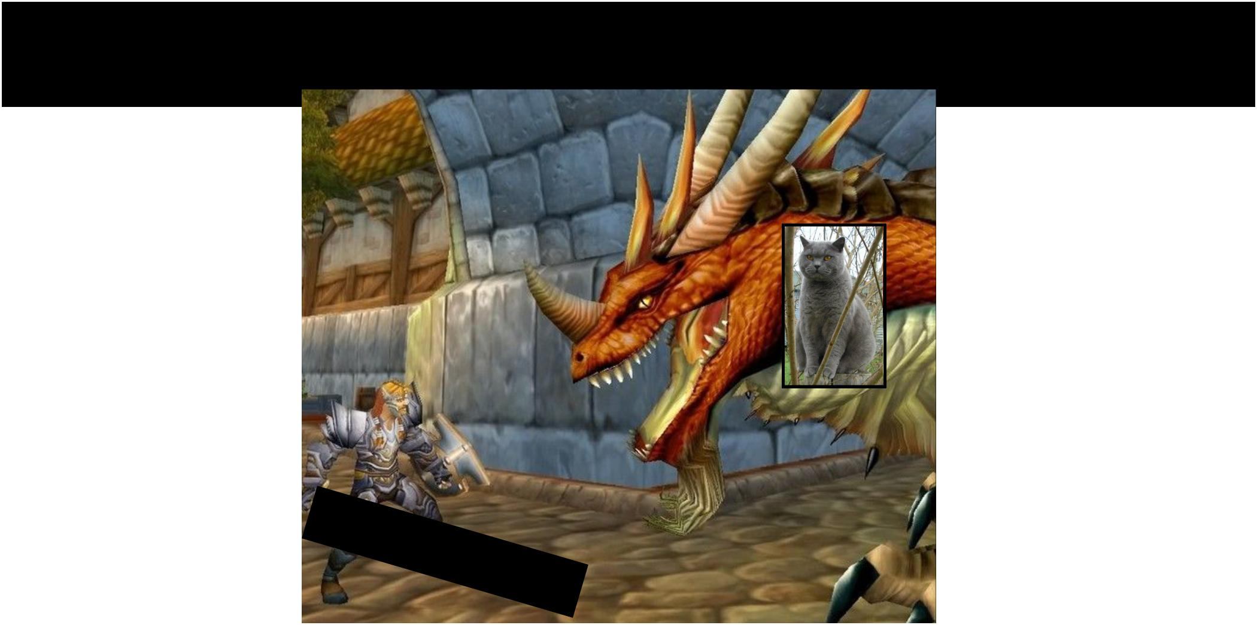You are now ready.



Fei-Fei Li & Andrej Karpathy & Justin Johnson Lecture 15 19 7 Mar 2016

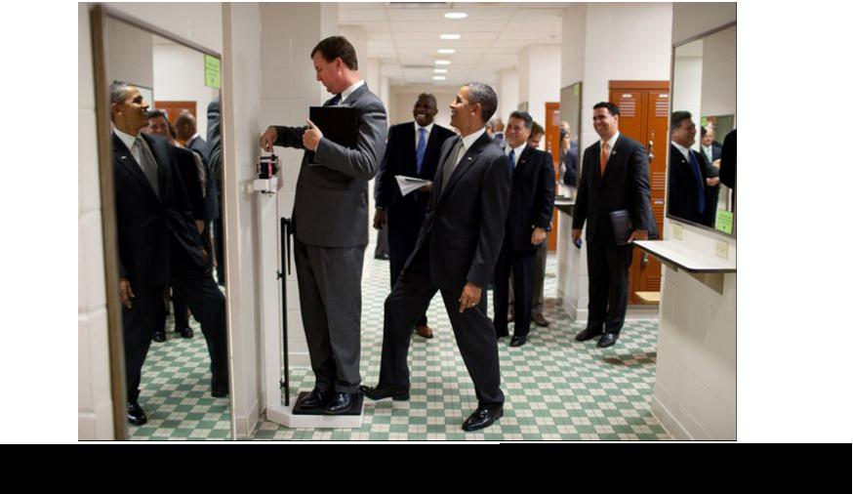

|  |  |  |
| --- | --- | --- |
| Fei-Fei Li & Andrej Karpathy & Justin Johnson | Lecture 15 20 | 7 Mar 2016 |
|  |  |  |



END



Fei-Fei Li & Andrej Karpathy & Justin Johnson Lecture 15 21 7 Mar 2016

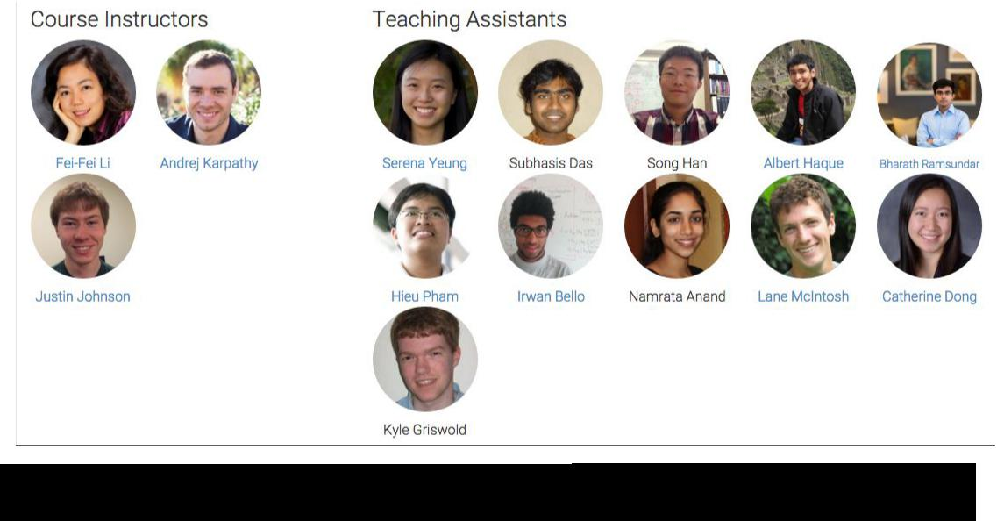

|  |  |  |
| --- | --- | --- |
| Fei-Fei Li & Andrej Karpathy & Justin Johnson | Lecture 15 22 | 7 Mar 2016 |
|  |  |  |