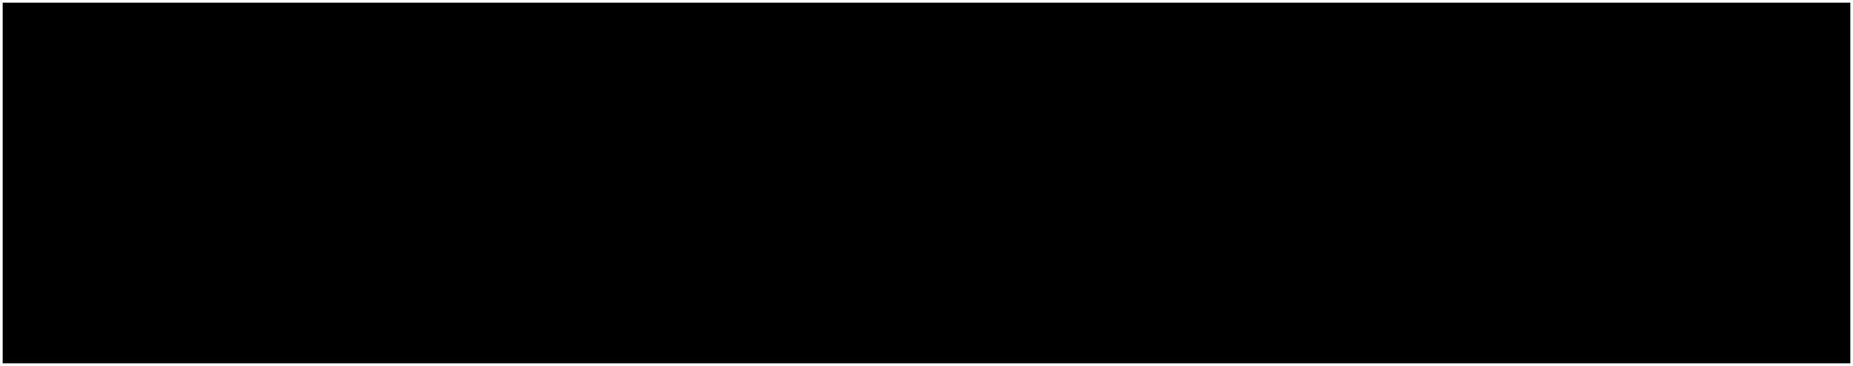

Lecture 2:

Image Classification pipeline



Fei-Fei Li & Andrej Karpathy & Justin Johnson Lecture 2 1 6 Jan 2016

Administrative

First assignment will come out tonight (or tomorrow at worst)

It is due **January 20** (i.e. in two weeks). Handed in through CourseWork It includes:

* Write/train/evaluate a kNN classifier
* Write/train/evaluate a Linear Classifier (SVM and Softmax)
* Write/train/evaluate a 2-layer Neural Network (backpropagation!)
* Requires writing numpy/Python code

**Warning**: don’t work on assignments from last year!

Compute: Can use your own laptops, or Terminal.com



Fei-Fei Li & Andrej Karpathy & Justin Johnson Lecture 2 2 6 Jan 2016

http://cs231n.github.io/python-numpy-tutorial/

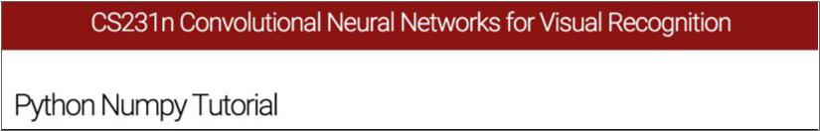

Fei-Fei Li & Andrej Karpathy & Justin Johnson Lecture 2 3 6 Jan 2016

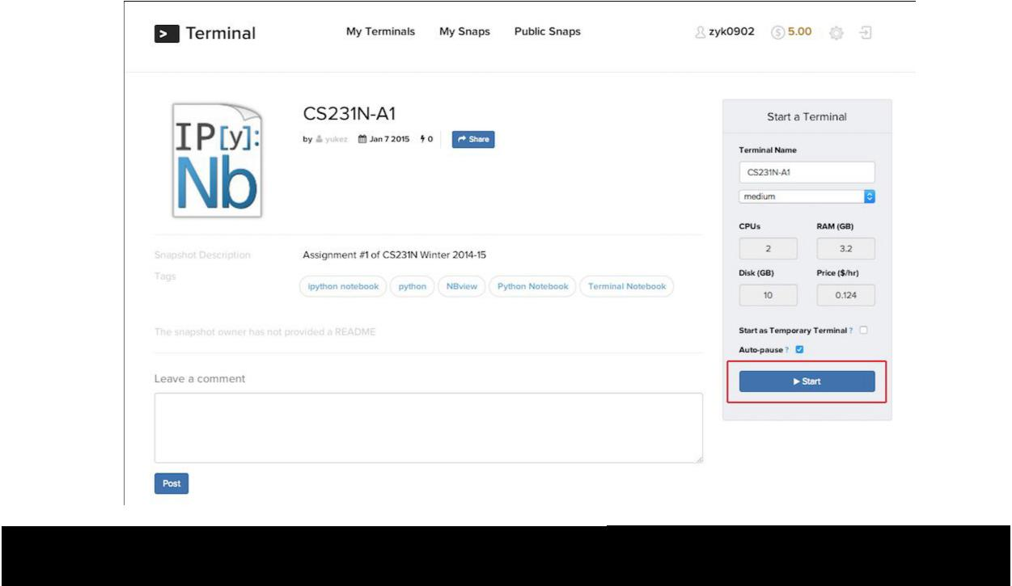

|  |  |  |
| --- | --- | --- |
| Fei-Fei Li & Andrej Karpathy & Justin Johnson | Lecture 2 4 | 6 Jan 2016 |
|  |  |  |

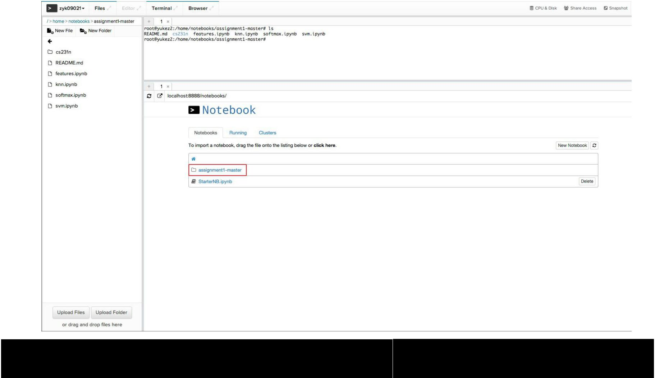

|  |  |  |
| --- | --- | --- |
| Fei-Fei Li & Andrej Karpathy & Justin Johnson | Lecture 2 5 | 6 Jan 2016 |
|  |  |  |

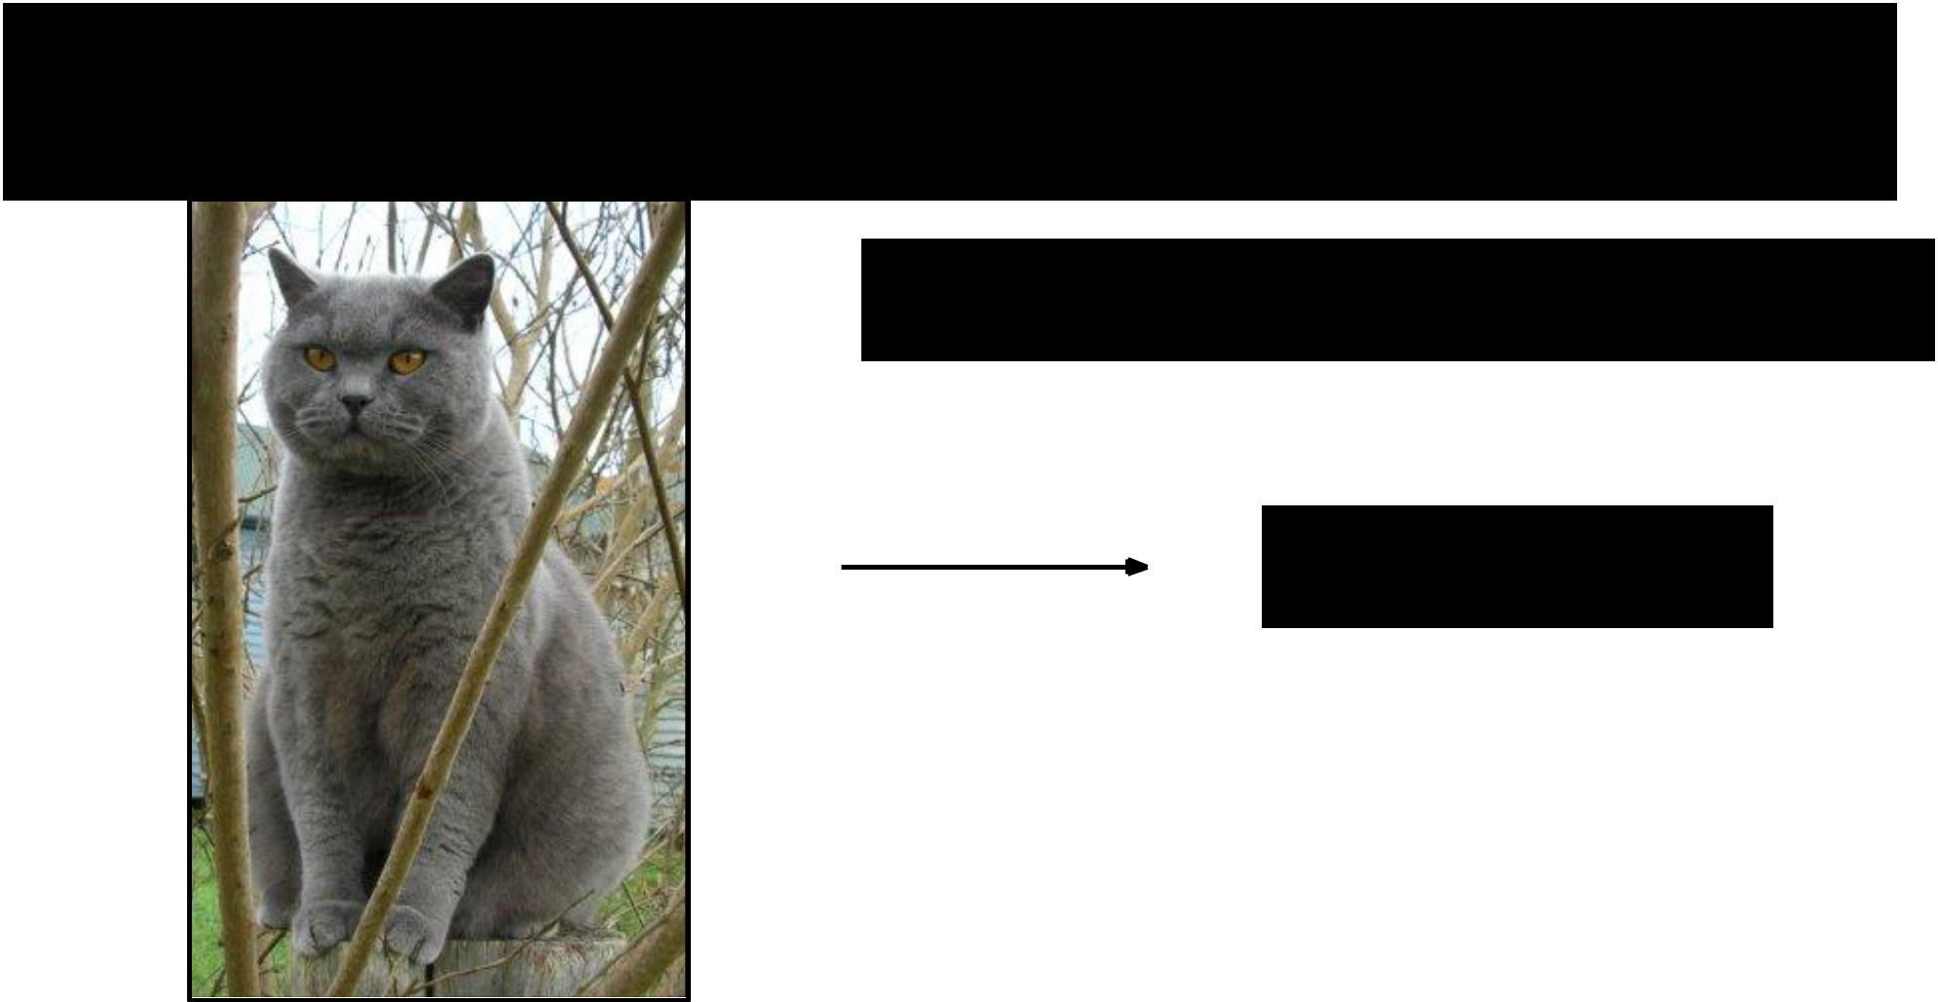**Image Classification**: a core task in Computer Vision

(assume given set of discrete labels)

{dog, cat, truck, plane, ...}

cat



Fei-Fei Li & Andrej Karpathy & Justin Johnson Lecture 2 6 6 Jan 2016

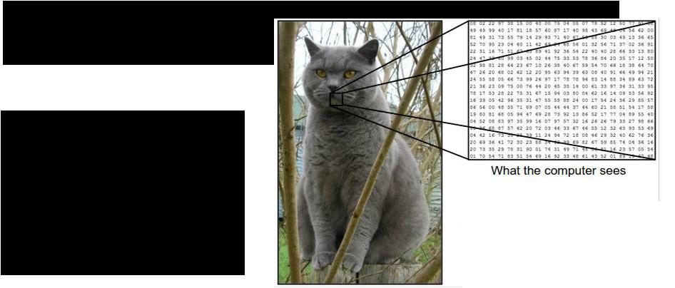**The problem:**

*semantic gap*

Images are represented as 3D arrays of numbers, with integers between [0, 255].

E.g.

300 x 100 x 3

(3 for 3 color channels RGB)



Fei-Fei Li & Andrej Karpathy & Justin Johnson Lecture 2 7 6 Jan 2016

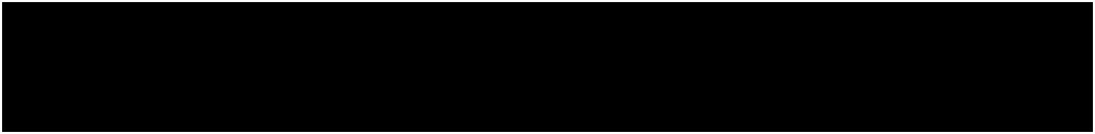Challenges: Viewpoint Variation

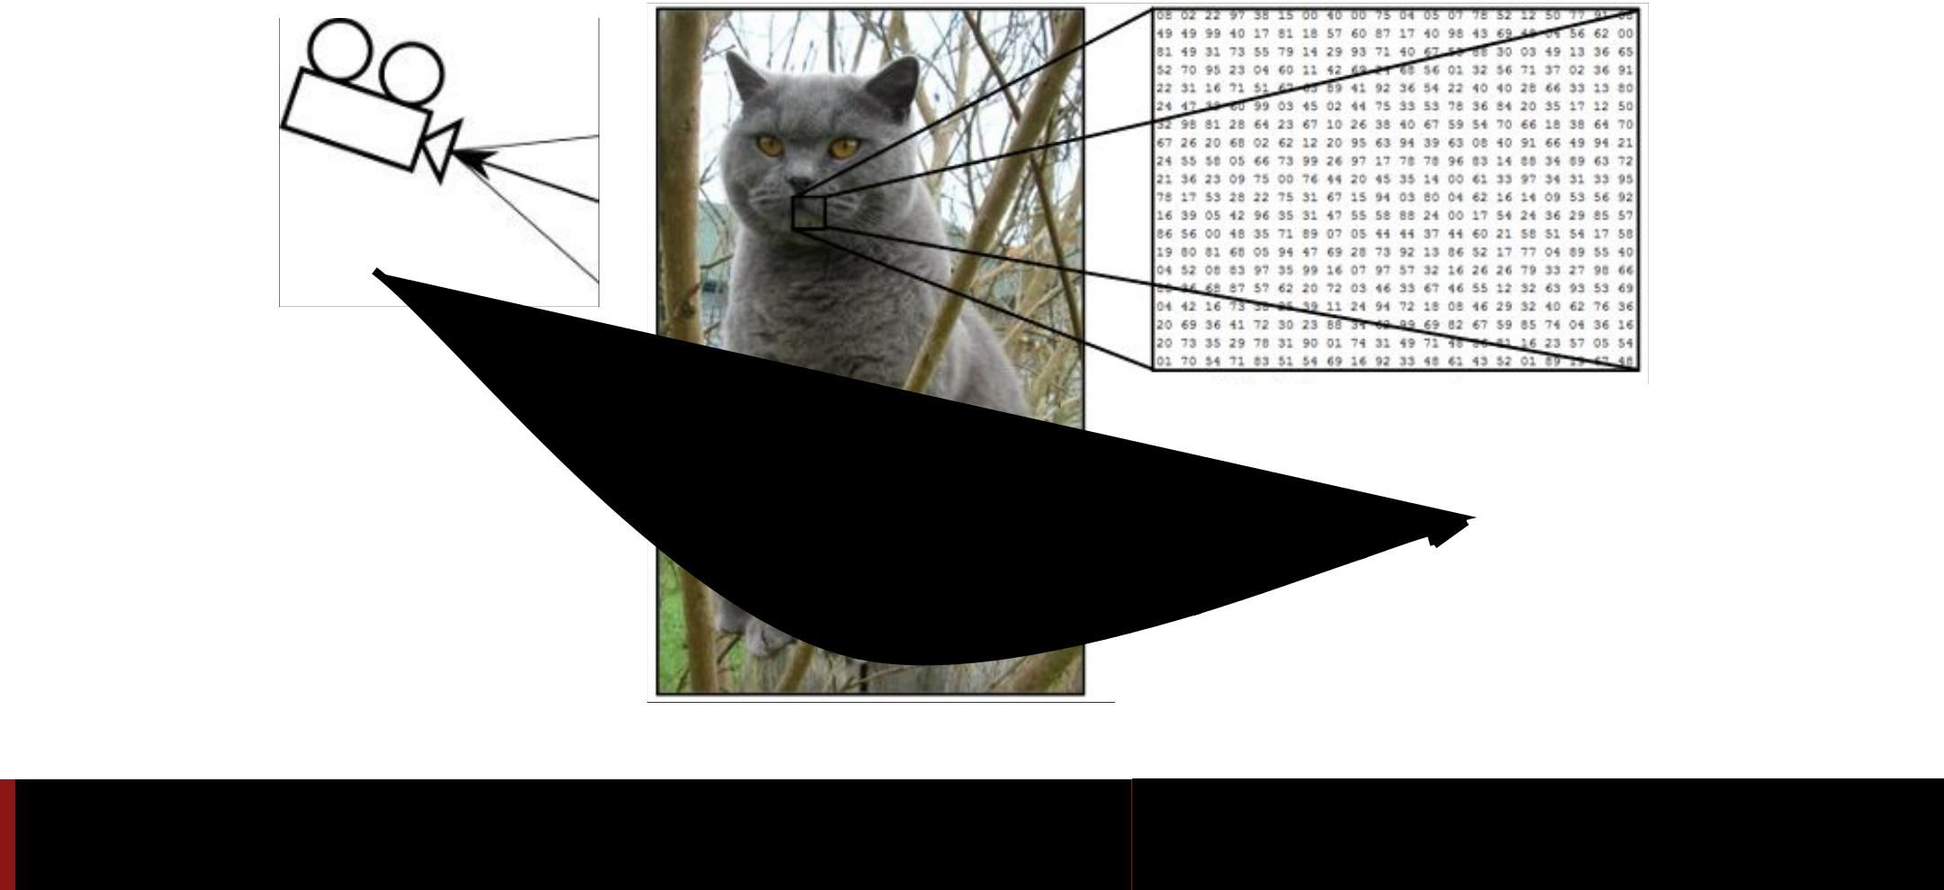

Fei-Fei Li & Andrej Karpathy & Justin Johnson Lecture 2 8 6 Jan 2016

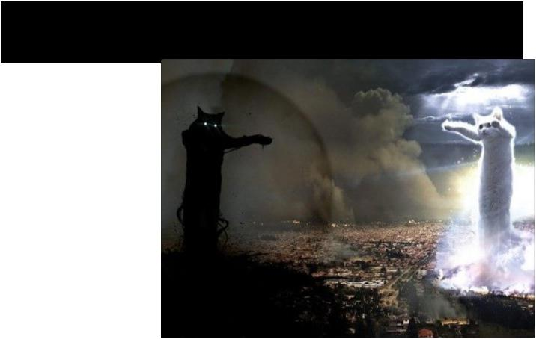Challenges: Illumination



Fei-Fei Li & Andrej Karpathy & Justin Johnson Lecture 2 9 6 Jan 2016

Challenges: Deformation

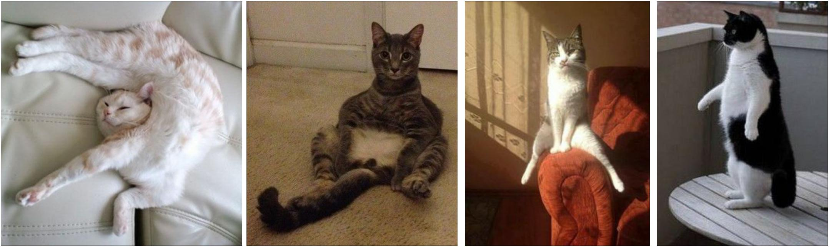

Fei-Fei Li & Andrej Karpathy & Justin Johnson Lecture 2 10 6 Jan 2016

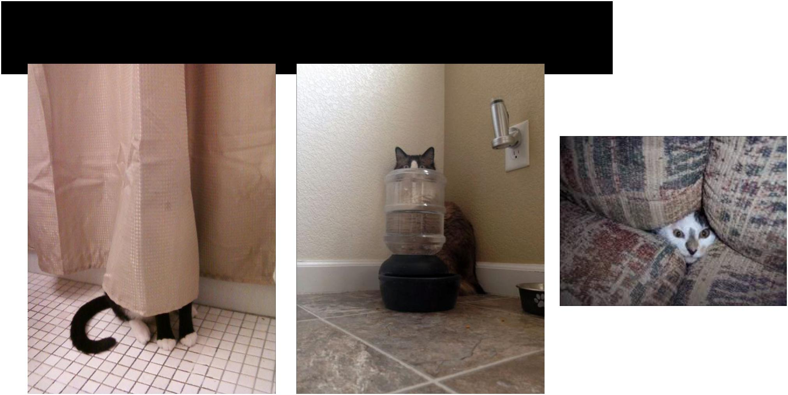Challenges: Occlusion



Fei-Fei Li & Andrej Karpathy & Justin Johnson Lecture 2 11 6 Jan 2016

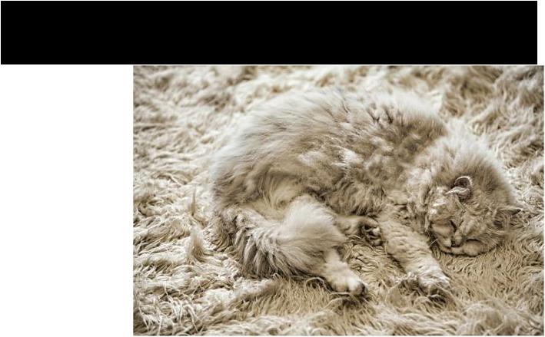Challenges: Background clutter



Fei-Fei Li & Andrej Karpathy & Justin Johnson Lecture 2 12 6 Jan 2016

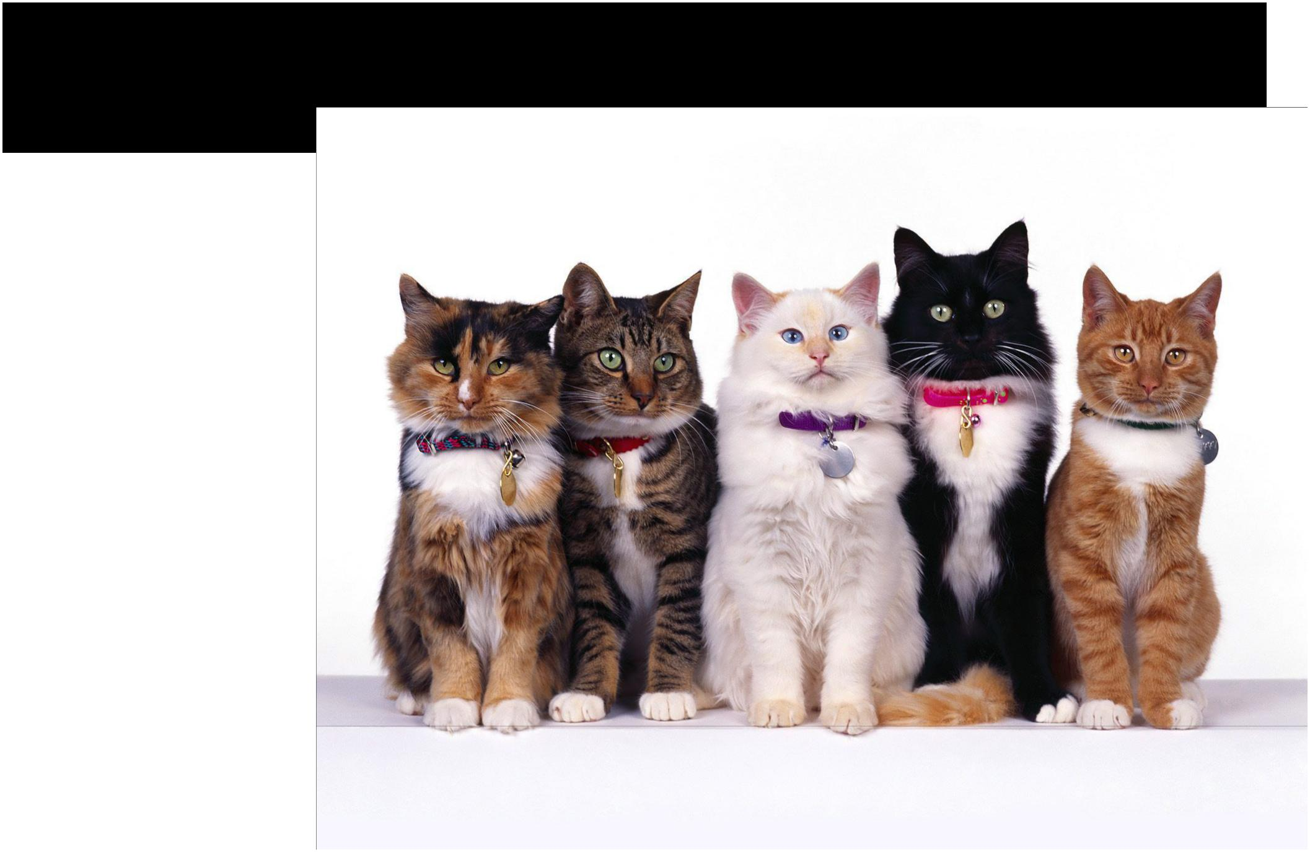Challenges: Intraclass variation



Fei-Fei Li & Andrej Karpathy & Justin Johnson Lecture 2 13 6 Jan 2016

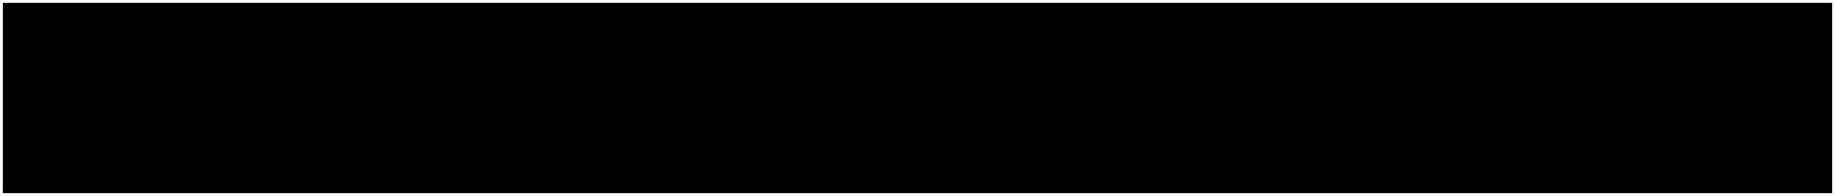**An image classifier**

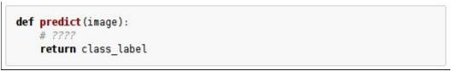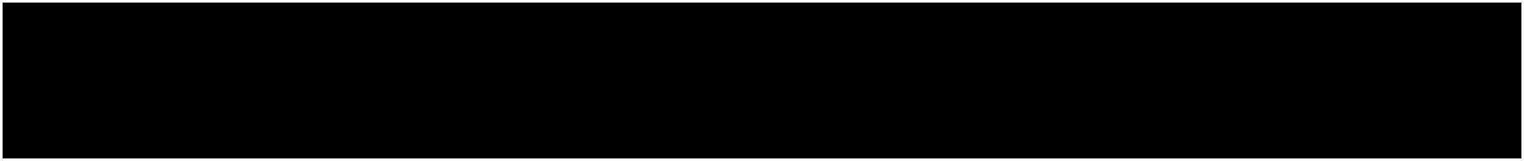

Unlike e.g. sorting a list of numbers,

**no obvious way** to hard-code the algorithm forrecognizing a cat, or other classes.



Fei-Fei Li & Andrej Karpathy & Justin Johnson Lecture 2 14 6 Jan 2016

Attempts have been made

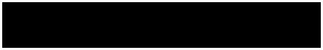

???

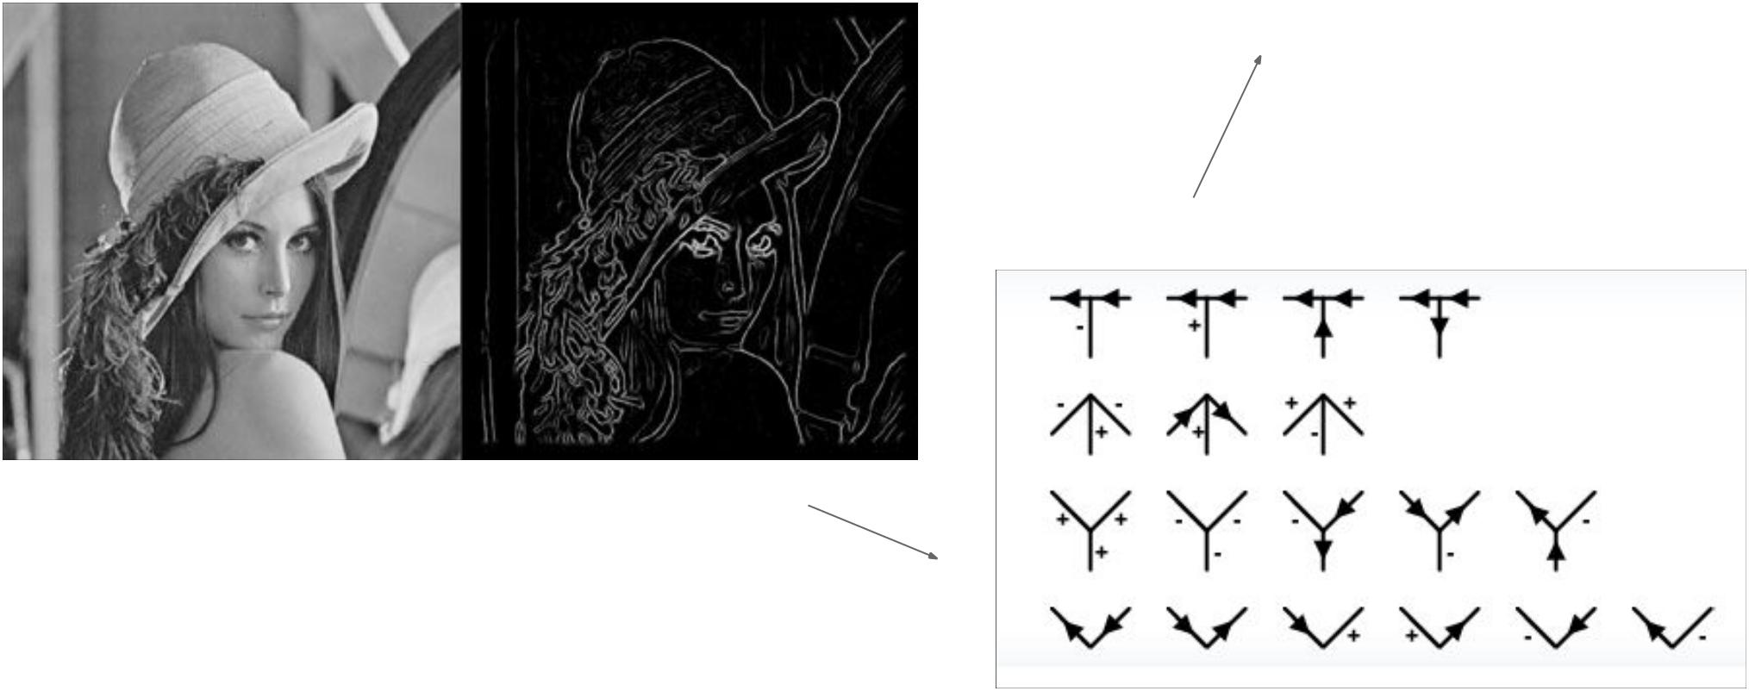

Fei-Fei Li & Andrej Karpathy & Justin Johnson Lecture 2 15 6 Jan 2016

**Data-driven approach:**



1. Collect a dataset of images and labels
2. Use Machine Learning to train an image classifier
3. Evaluate the classifier on a withheld set of test images



**Example training set**

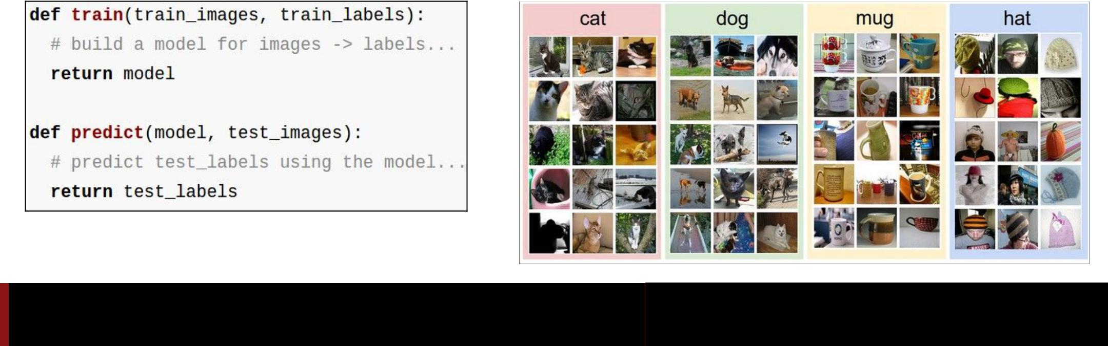

Fei-Fei Li & Andrej Karpathy & Justin Johnson Lecture 2 16 6 Jan 2016

First classifier: **Nearest Neighbor Classifier**



Remember all training images and their labels

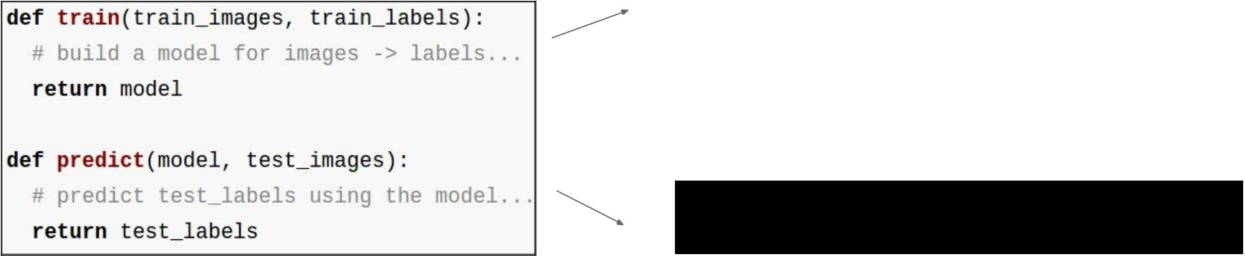

Predict the label of the most similar training image



Fei-Fei Li & Andrej Karpathy & Justin Johnson Lecture 2 17 6 Jan 2016

Example dataset: **CIFAR-10**

1. labels

**50,000** training images, each image is tiny: 32x32

**10,000** test images.

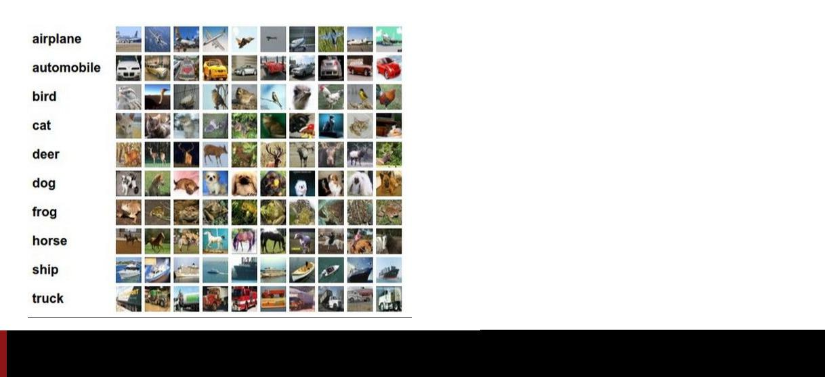

Fei-Fei Li & Andrej Karpathy & Justin Johnson Lecture 2 18 6 Jan 2016

Example dataset: **CIFAR-10**

1. labels

**50,000** training images

examples of nearest neighbors in rows

**10,000** test images.

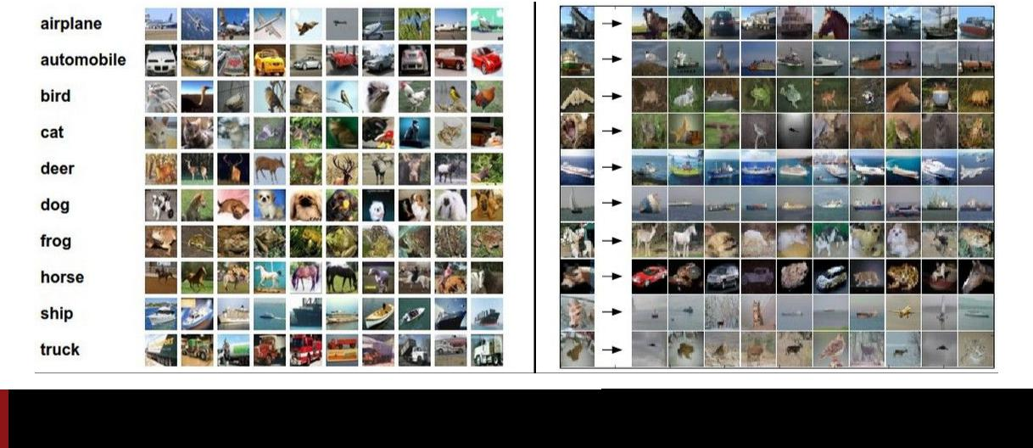

Fei-Fei Li & Andrej Karpathy & Justin Johnson Lecture 2 19 6 Jan 2016

How do we compare the images? What is the **distance metric**?

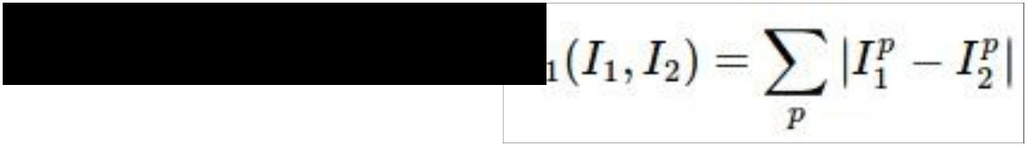

**L1 distance:**

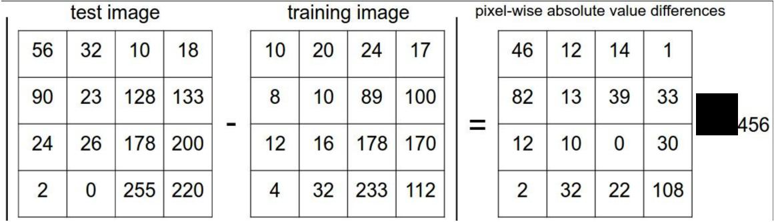

add



Fei-Fei Li & Andrej Karpathy & Justin Johnson Lecture 2 20 6 Jan 2016

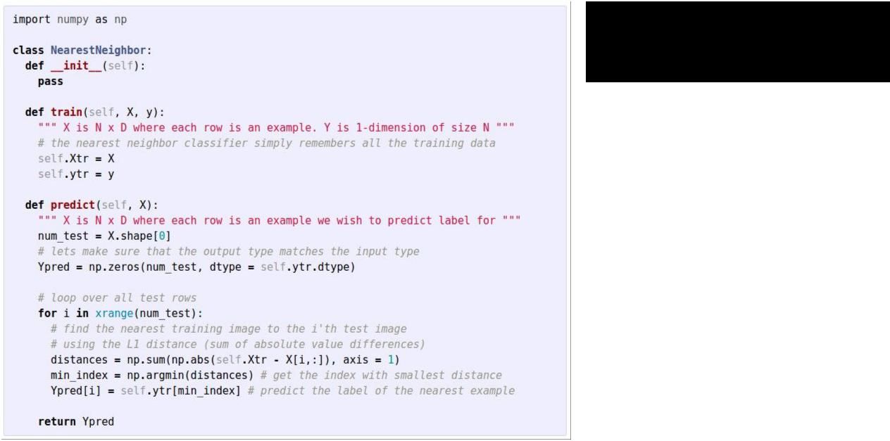Nearest Neighbor classifier



Fei-Fei Li & Andrej Karpathy & Justin Johnson Lecture 2 21 6 Jan 2016

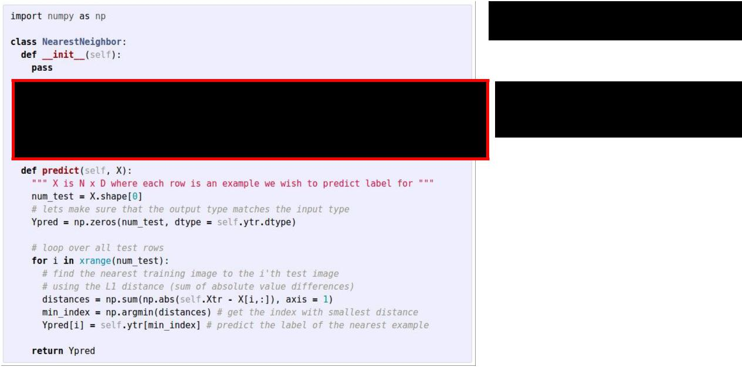Nearest Neighbor classifier

remember the training data



Fei-Fei Li & Andrej Karpathy & Justin Johnson Lecture 2 22 6 Jan 2016

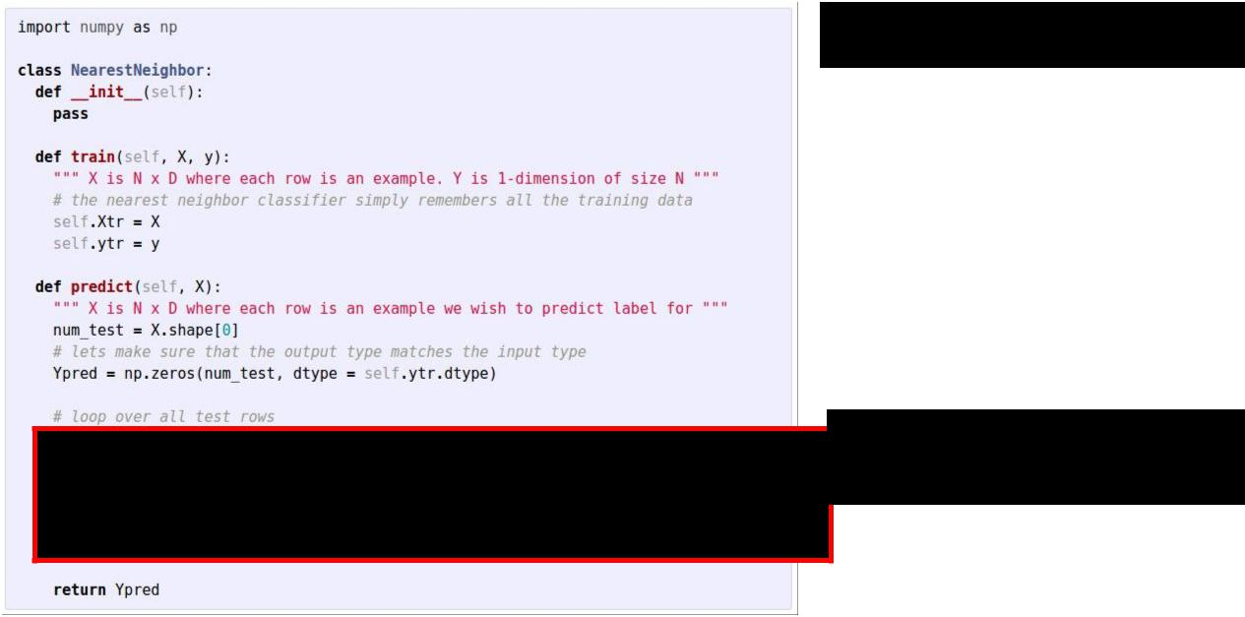

Nearest Neighbor classifier

for every test image:

- find nearest train image with L1 distance

- predict the label of nearest training image



|  |  |  |
| --- | --- | --- |
| Fei-Fei Li & Andrej Karpathy & Justin Johnson | Lecture 2 23 | 6 Jan 2016 |
|  |  |  |

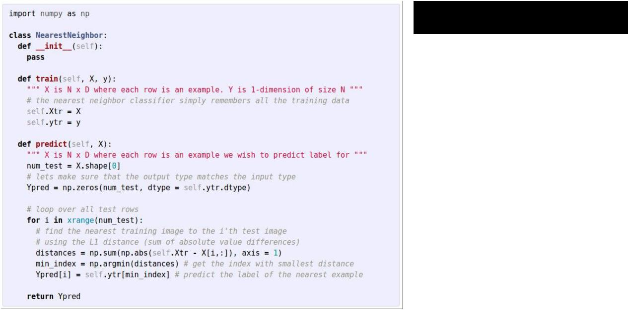Nearest Neighbor classifier



1. **how does the classification speed depend on the size of the training data?**



Fei-Fei Li & Andrej Karpathy & Justin Johnson Lecture 2 24 6 Jan 2016



Nearest Neighbor classifier



Q: how does the classification speed depend on the size of the training data? **linearly :(**

This is **backwards**:

- test time performance is usually much more important in practice.

- CNNs flip this: expensive training, cheap test evaluation



|  |  |  |
| --- | --- | --- |
| Fei-Fei Li & Andrej Karpathy & Justin Johnson | Lecture 2 25 | 6 Jan 2016 |
|  |  |  |

**Aside: Approximate Nearest Neighbor**

find approximate nearest neighbors quickly

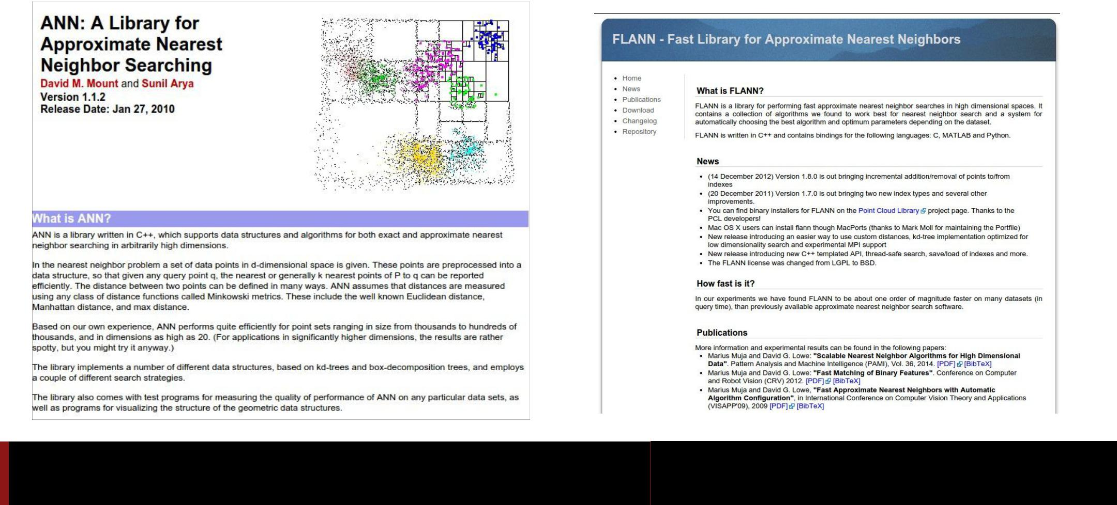

Fei-Fei Li & Andrej Karpathy & Justin Johnson Lecture 2 26 6 Jan 2016

The choice of distance is a **hyperparameter** common choices:



L1 (Manhattan) distance L2 (Euclidean) distance

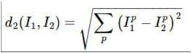

Fei-Fei Li & Andrej Karpathy & Justin Johnson Lecture 2 27 6 Jan 2016

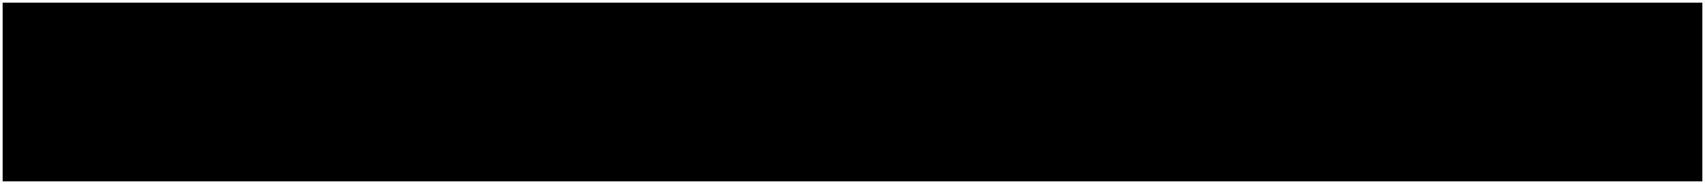k-Nearest Neighbor

find the k nearest images, have them vote on the label

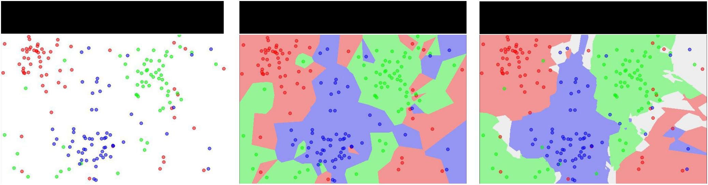

the data NN classifier 5-NN classifier



http://en.wikipedia.org/wiki/K-nearest_neighbors_algorithm



Fei-Fei Li & Andrej Karpathy & Justin Johnson Lecture 2 28 6 Jan 2016

Example dataset: **CIFAR-10**

1. labels

**50,000** training images

examples of nearest neighbors in rows

**10,000** test images.



Fei-Fei Li & Andrej Karpathy & Justin Johnson Lecture 2 29 6 Jan 2016

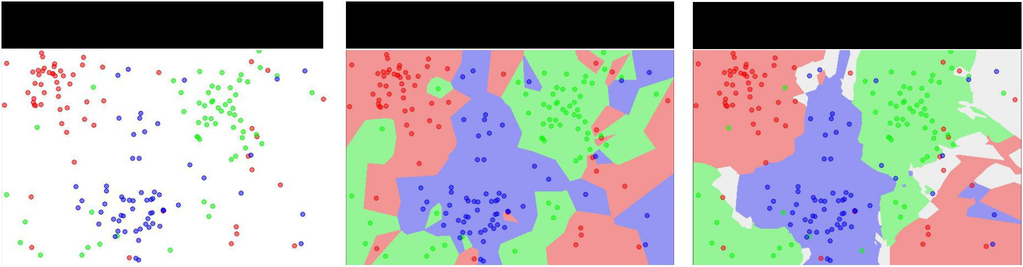the data NN classifier 5-NN classifier

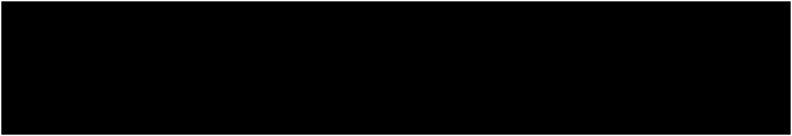

1. what is the accuracy of the nearest neighbor classifier on the training data, when using the Euclidean distance?



Fei-Fei Li & Andrej Karpathy & Justin Johnson Lecture 2 30 6 Jan 2016

the data NN classifier 5-NN classifier



Q2: what is the accuracy of the **k-**nearest neighbor classifier on the training data?



Fei-Fei Li & Andrej Karpathy & Justin Johnson Lecture 2 31 6 Jan 2016

What is the best **distance** to use?

What is the best value of **k** to use?

i.e. how do we set the **hyperparameters**?



Fei-Fei Li & Andrej Karpathy & Justin Johnson Lecture 2 32 6 Jan 2016

What is the best **distance** to use?

What is the best value of **k** to use?

i.e. how do we set the **hyperparameters**?

Very problem-dependent.

Must try them all out and see what works best.



Fei-Fei Li & Andrej Karpathy & Justin Johnson Lecture 2 33 6 Jan 2016

Try out what hyperparameters work best on test set.

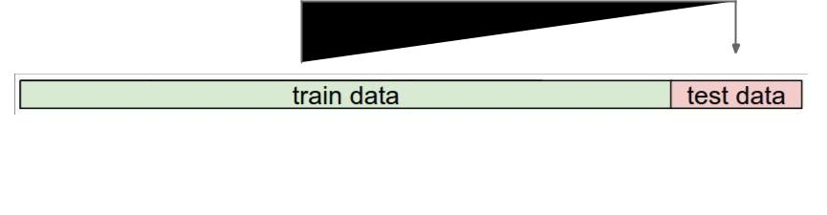

Fei-Fei Li & Andrej Karpathy & Justin Johnson Lecture 2 34 6 Jan 2016

Trying out what hyperparameters work best on test set:

Very bad idea. The test set is a proxy for the generalization performance! Use only **VERY SPARINGLY,** at the end.



Fei-Fei Li & Andrej Karpathy & Justin Johnson Lecture 2 35 6 Jan 2016

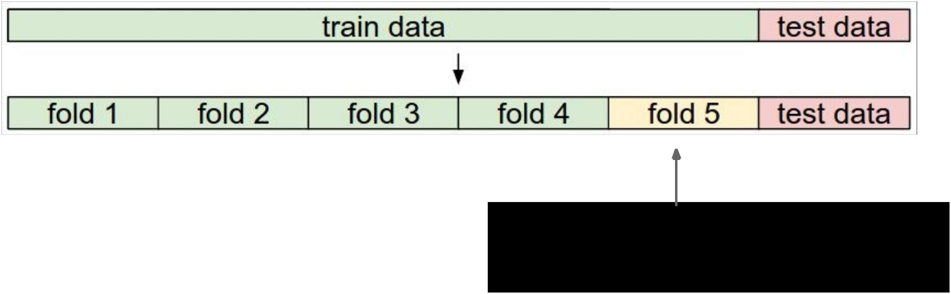

Validation data

use to tune hyperparameters



Fei-Fei Li & Andrej Karpathy & Justin Johnson Lecture 2 36 6 Jan 2016

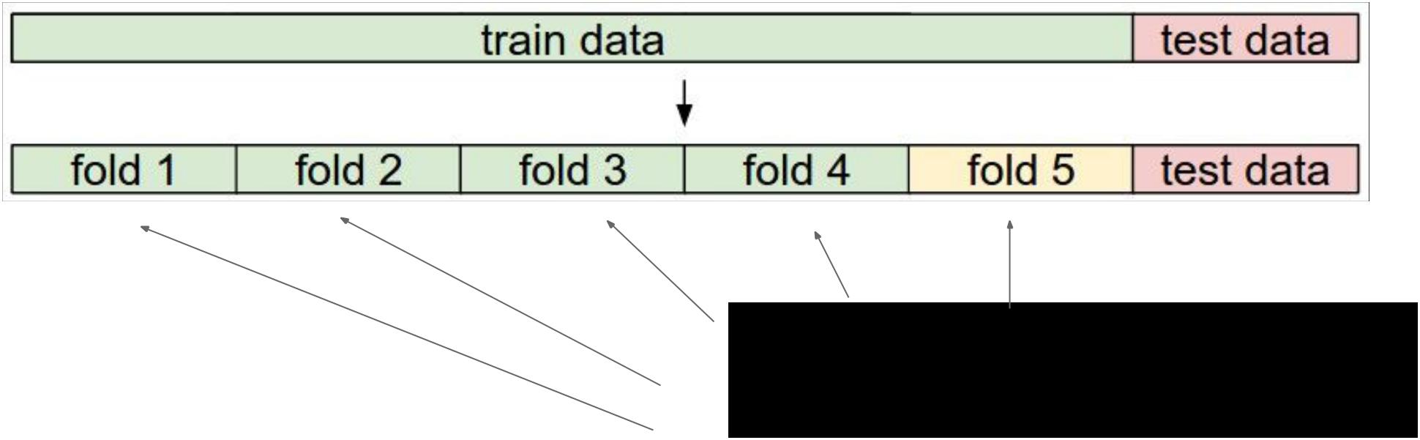

**Cross-validation**

cycle through the choice of which fold

is the validation fold, average results.



|  |  |  |
| --- | --- | --- |
| Fei-Fei Li & Andrej Karpathy & Justin Johnson | Lecture 2 37 | 6 Jan 2016 |
|  |  |  |

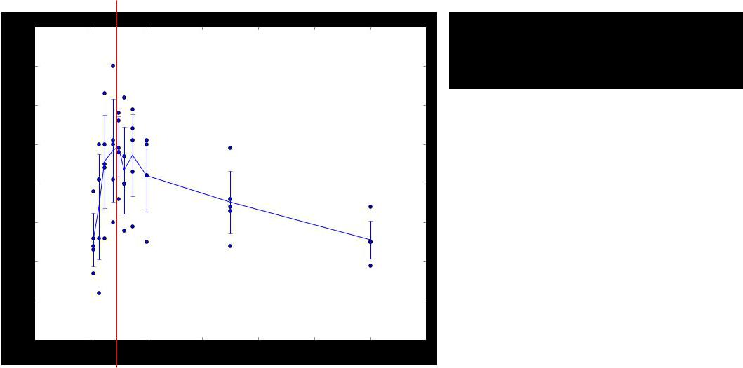Example of 5-fold cross-validation for the value of **k.**

Each point: single outcome.

The line goes

through the mean, bars indicated standard deviation

(Seems that k ~= 7 works best for this data)



Fei-Fei Li & Andrej Karpathy & Justin Johnson Lecture 2 38 6 Jan 2016

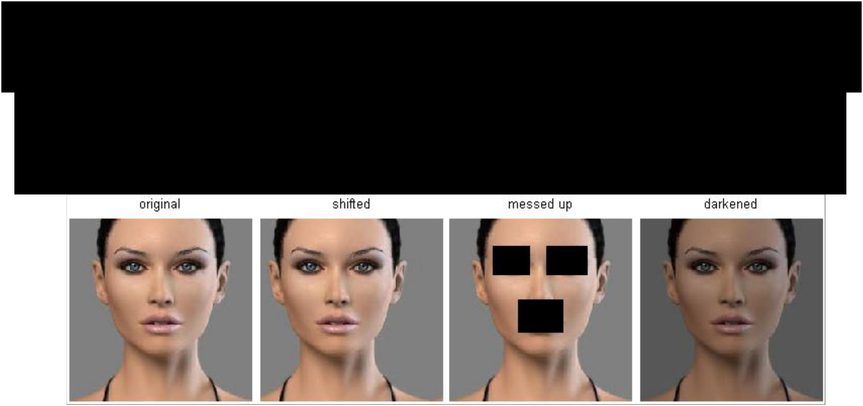

k-Nearest Neighbor on images **never used.**

* terrible performance at test time
* distance metrics on level of whole images can be very unintuitive



(all 3 images have same L2 distance to the one on the left)



|  |  |  |
| --- | --- | --- |
| Fei-Fei Li & Andrej Karpathy & Justin Johnson | Lecture 2 39 | 6 Jan 2016 |
|  |  |  |

Summary



* **Image Classification:** We are given a **Training Set** of labeled images, askedto predict labels on **Test Set**. Common to report the **Accuracy** of predictions (fraction of correctly predicted images)
* We introduced the **k-Nearest Neighbor Classifier**, which predicts the labels based on nearest images in the training set
* We saw that the choice of distance and the value of k are **hyperparameters** that are tuned using a **validation set**, or through **cross-validation** if the size of the data is small.
* Once the best set of hyperparameters is chosen, the classifier is evaluated once on the test set, and reported as the performance of kNN on that data.



Fei-Fei Li & Andrej Karpathy & Justin Johnson Lecture 2 40 6 Jan 2016



Linear Classification



Fei-Fei Li & Andrej Karpathy & Justin Johnson Lecture 2 41 6 Jan 2016

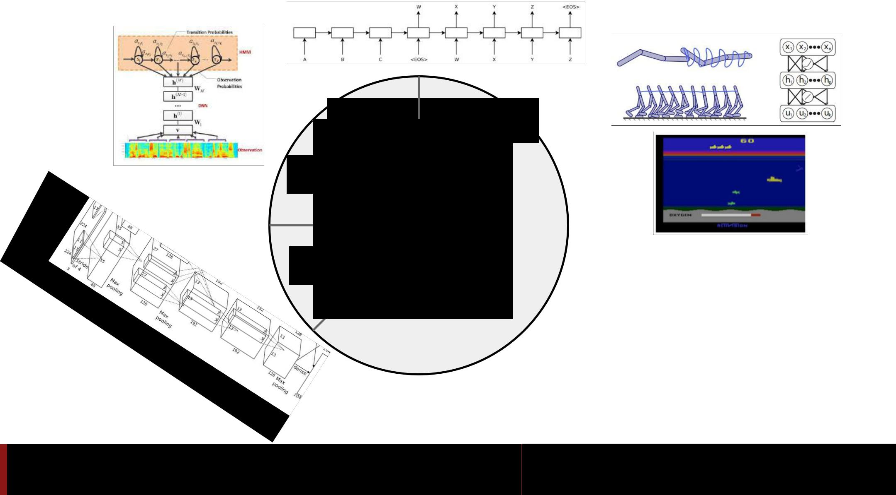

language control



see

Fei-Fei Li & Andrej Karpathy & Justin Johnson Lecture 2 42 6 Jan 2016

Neural Networks practitioner

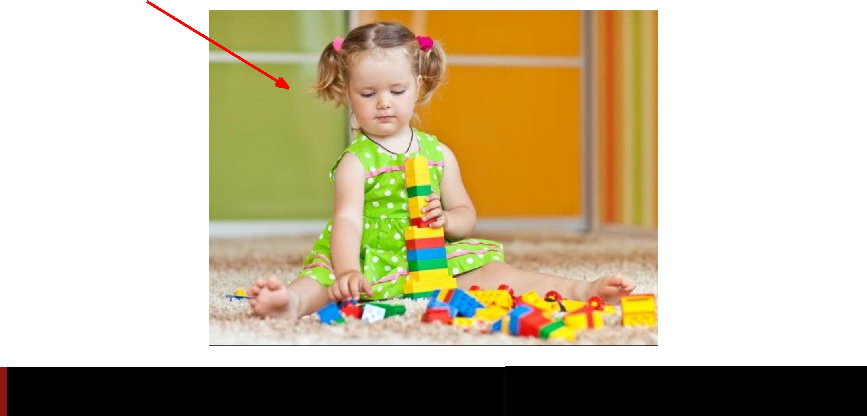

Fei-Fei Li & Andrej Karpathy & Justin Johnson Lecture 2 43 6 Jan 2016

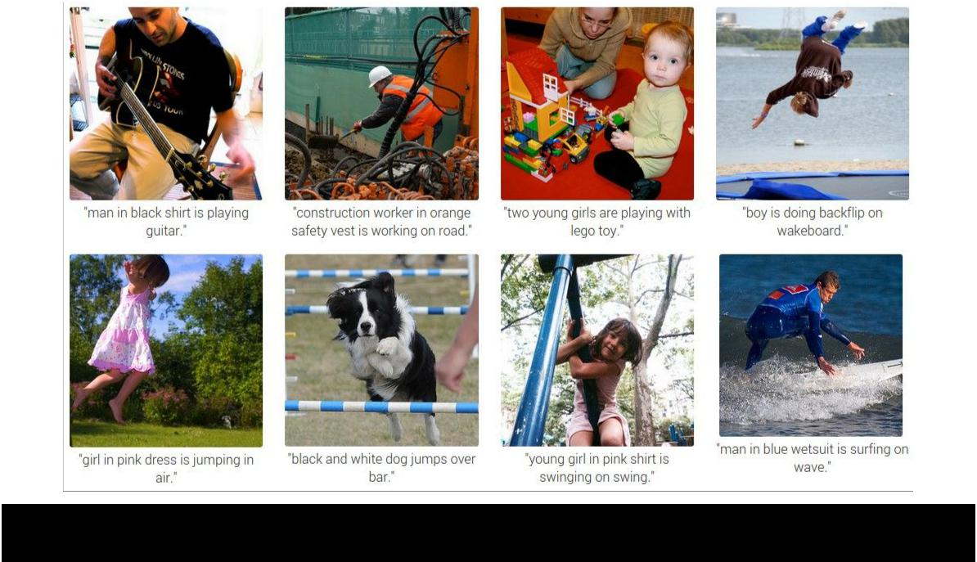

|  |  |  |
| --- | --- | --- |
| Fei-Fei Li & Andrej Karpathy & Justin Johnson | Lecture 2 44 | 6 Jan 2016 |
|  |  |  |

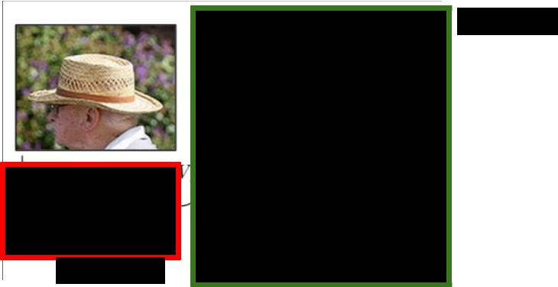**RNN**

**CNN**



Fei-Fei Li & Andrej Karpathy & Justin Johnson Lecture 2 45 6 Jan 2016

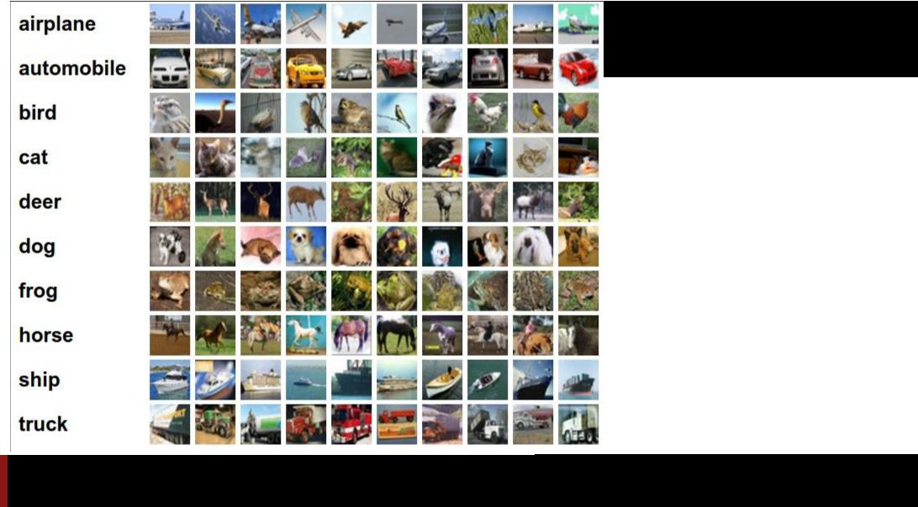Example dataset: **CIFAR-10**

1. labels

**50,000** training imageseach image is **32x32x3**

**10,000** test images.

Fei-Fei Li & Andrej Karpathy & Justin Johnson Lecture 2 46 6 Jan 2016

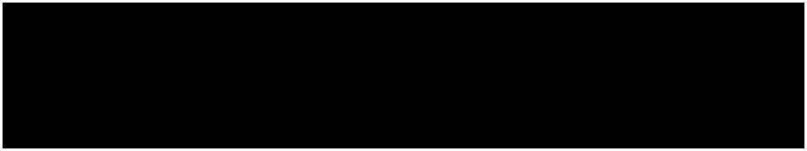Parametric approach

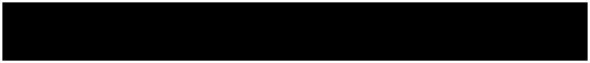

|  |  |
| --- | --- |
| image parameters |  |
| f(**x**,**W**) | **10** numbers, |
|  | indicating class |
|  | scores |

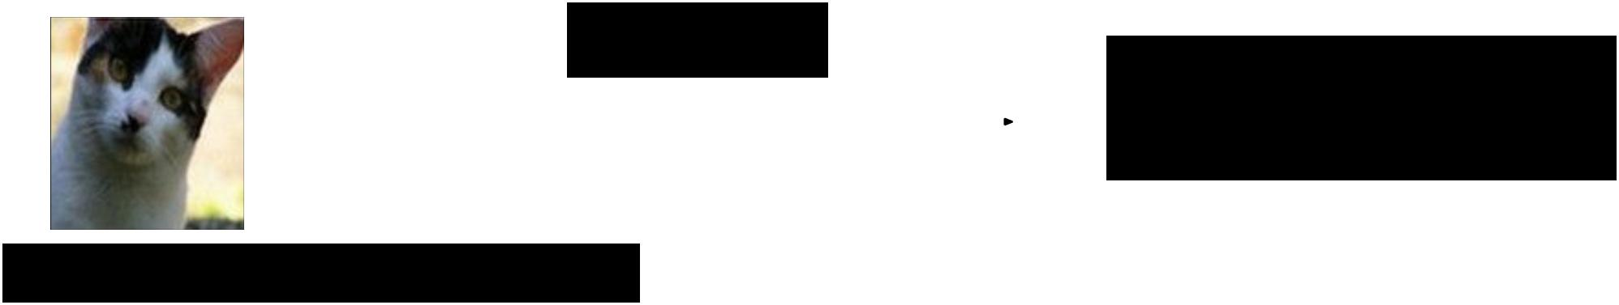

**[32x32x3]**

array of numbers 0...1

(3072 numbers total)



Fei-Fei Li & Andrej Karpathy & Justin Johnson Lecture 2 47 6 Jan 2016

Parametric approach: **Linear classifier**

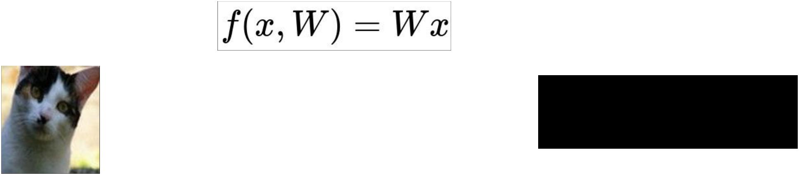

**10** numbers,



indicating class

scores



**[32x32x3]**

array of numbers 0...1



Fei-Fei Li & Andrej Karpathy & Justin Johnson Lecture 2 48 6 Jan 2016

Parametric approach: **Linear classifier**

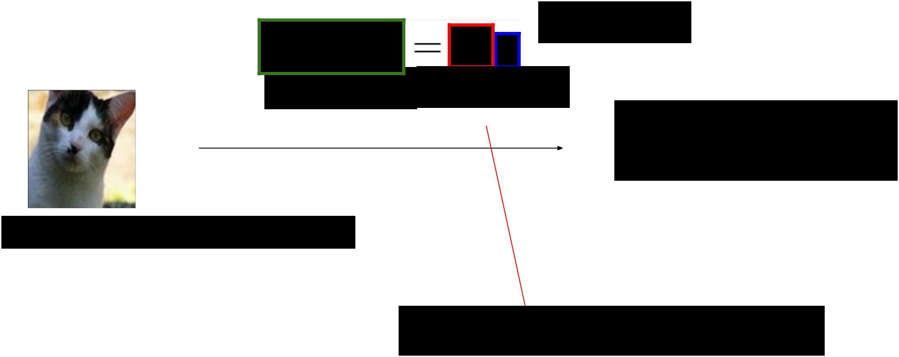

**3072x1**

**10x1** **10x3072**

**10** numbers,



indicating class

scores

**[32x32x3]**

array of numbers 0...1

parameters, or “weights”



Fei-Fei Li & Andrej Karpathy & Justin Johnson Lecture 2 49 6 Jan 2016

Parametric approach: **Linear classifier**

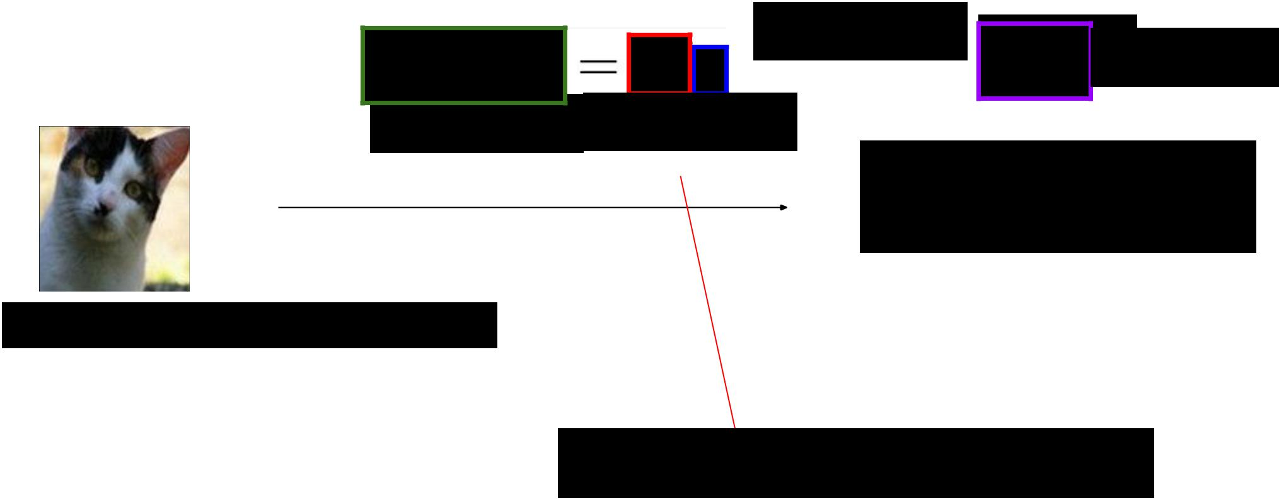

**3072x1**

**10x1**

**10x1** **10x3072**

**10** numbers,



indicating class

scores

**[32x32x3]**

array of numbers 0...1

parameters, or “weights”



Fei-Fei Li & Andrej Karpathy & Justin Johnson Lecture 2 50 6 Jan 2016

Example with an image with 4 pixels, and 3 classes (cat/dog/ship)

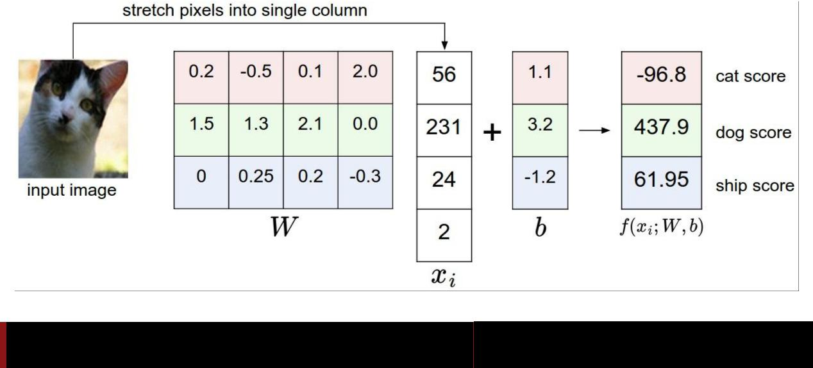

Fei-Fei Li & Andrej Karpathy & Justin Johnson Lecture 2 51 6 Jan 2016

**Interpreting a Linear Classifier**

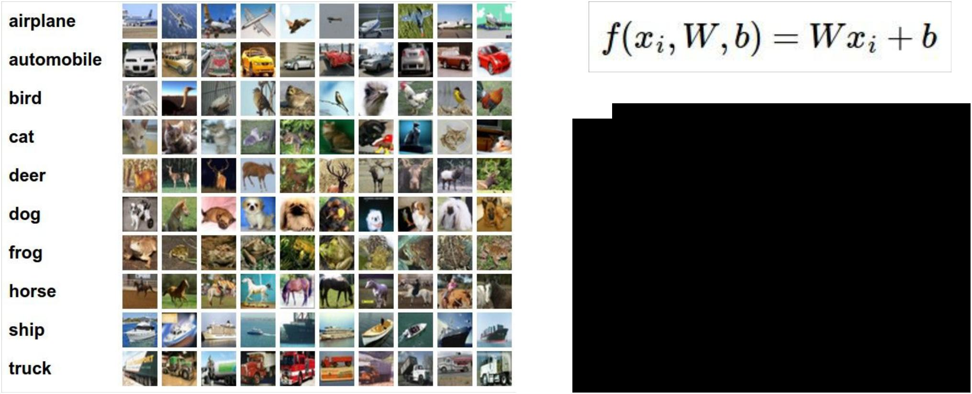

Q: what does the linear classifier do, in English?



Fei-Fei Li & Andrej Karpathy & Justin Johnson Lecture 2 52 6 Jan 2016

**Interpreting a Linear Classifier**

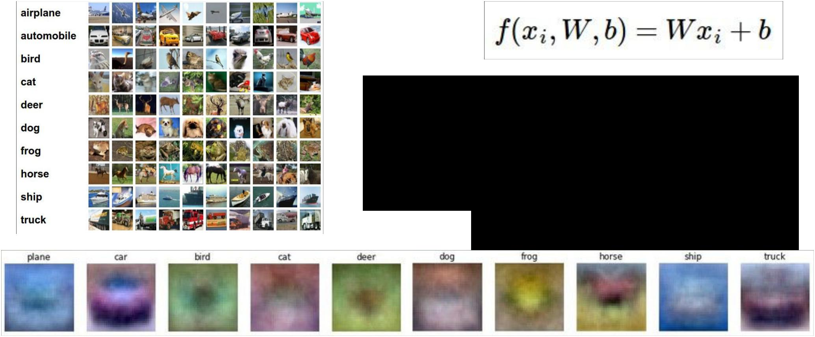

Example trained weights of a linear classifier trained on CIFAR-10:



Fei-Fei Li & Andrej Karpathy & Justin Johnson Lecture 2 53 6 Jan 2016

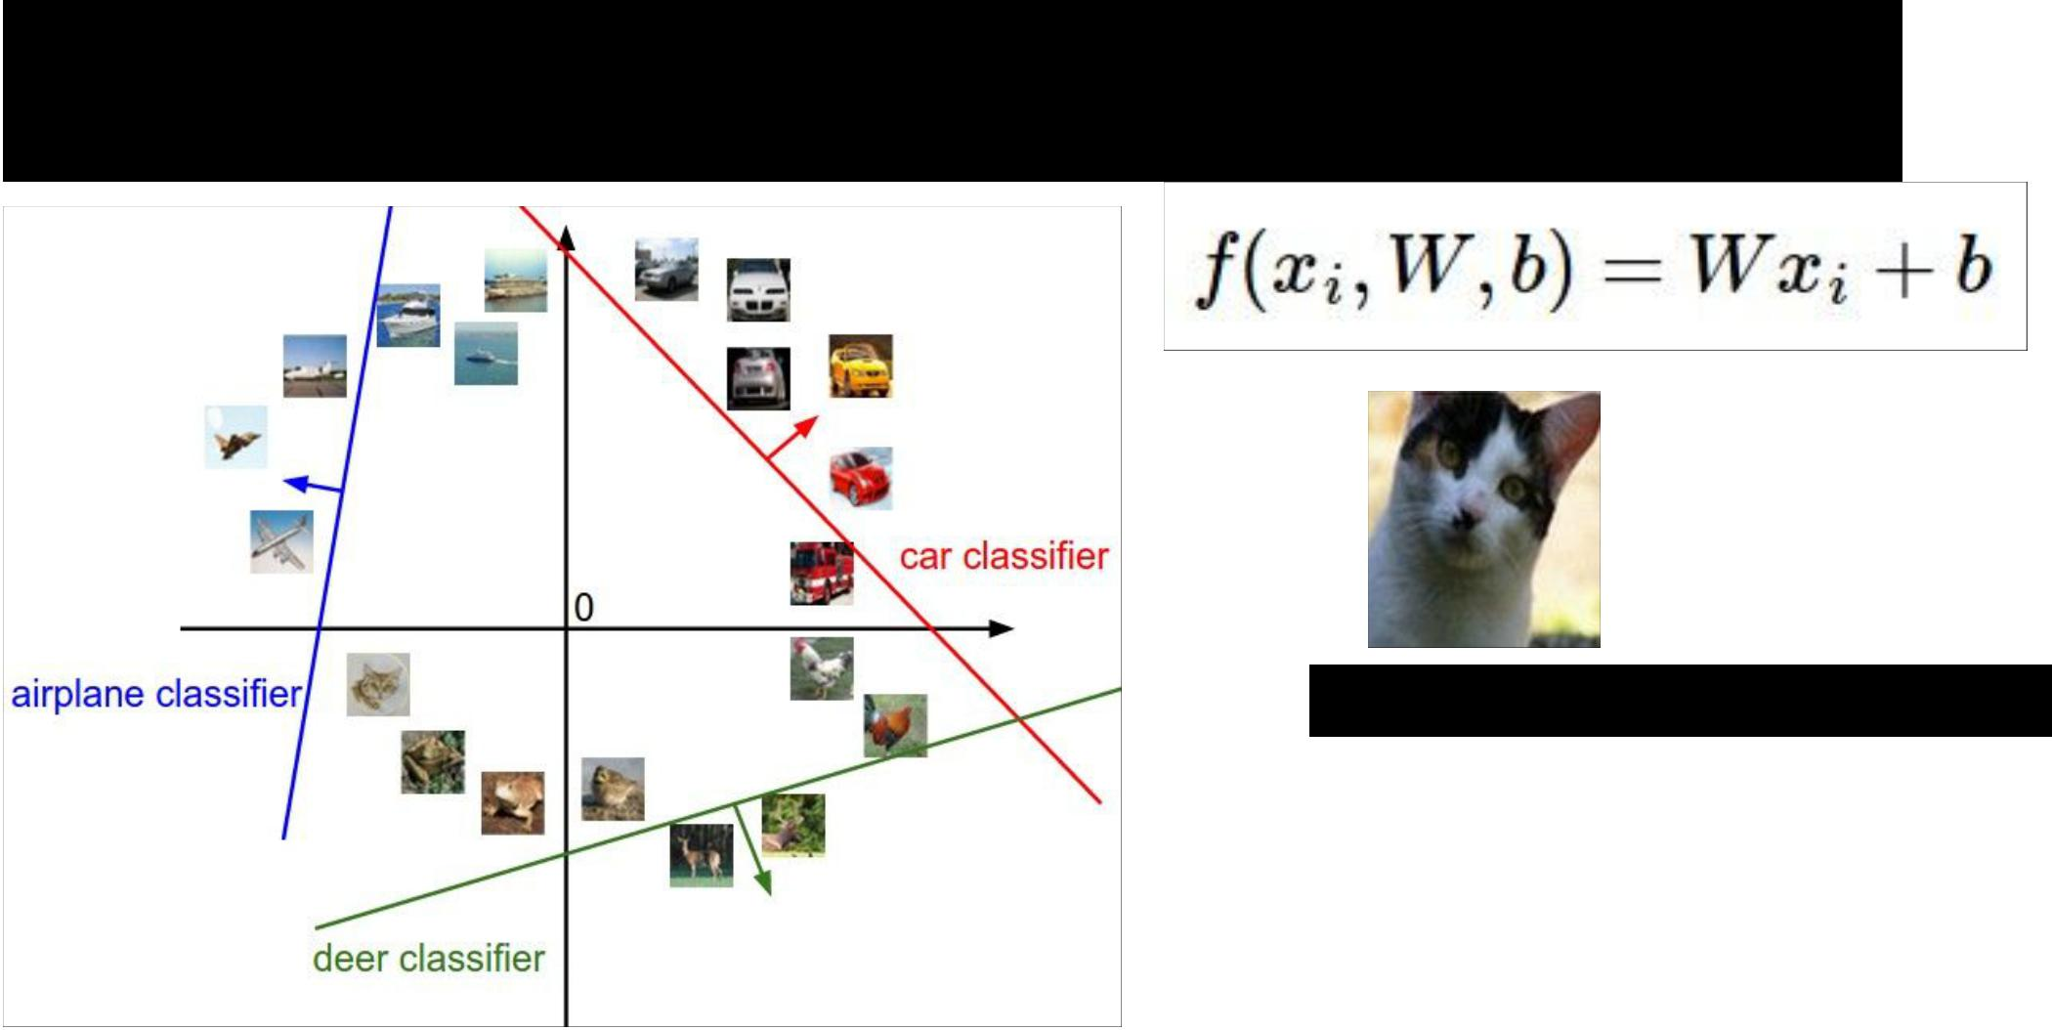**Interpreting a Linear Classifier**

**[32x32x3]**

array of numbers 0...1 (3072 numbers total)



Fei-Fei Li & Andrej Karpathy & Justin Johnson Lecture 2 54 6 Jan 2016

**Interpreting a Linear Classifier**

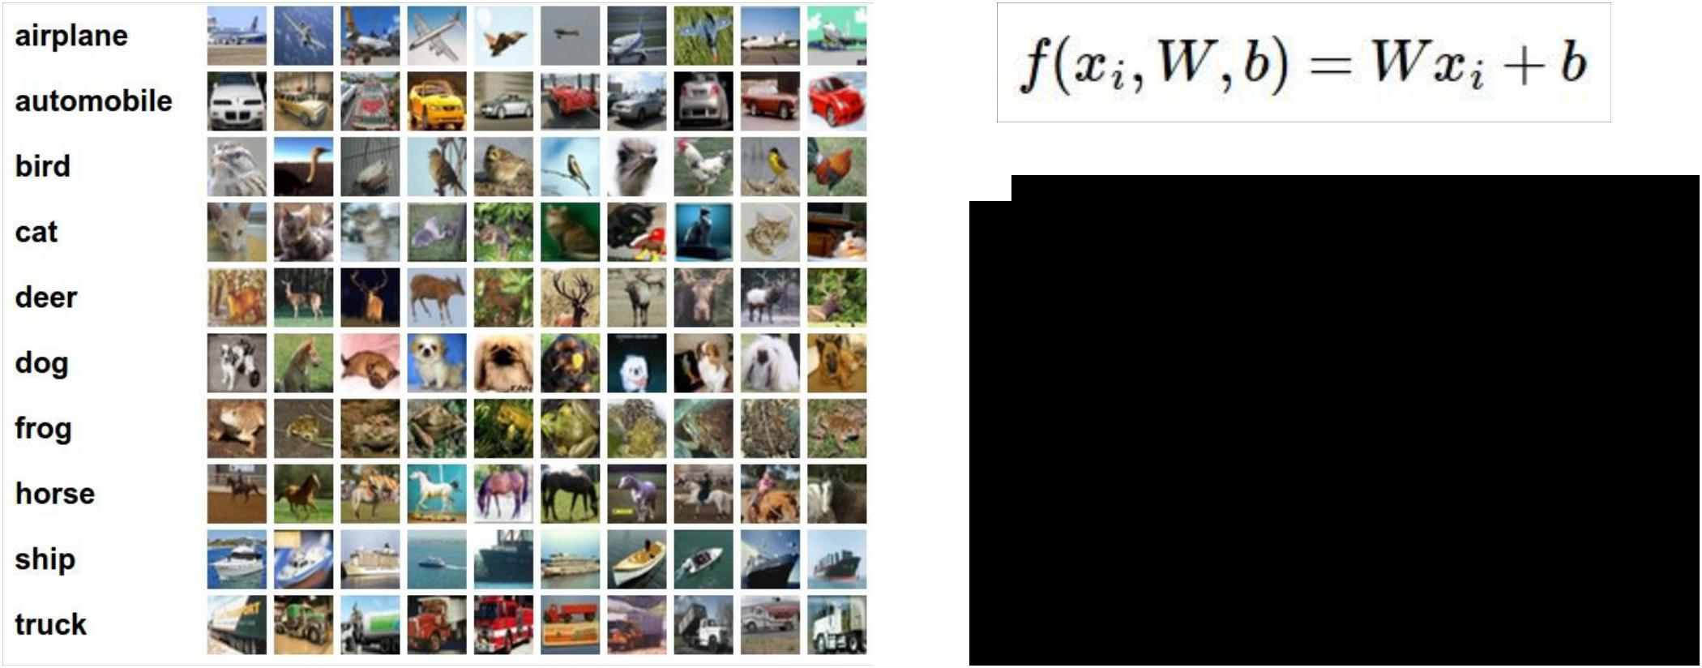

Q2: what would be a very hard set of classes for a linear classifier to distinguish?



Fei-Fei Li & Andrej Karpathy & Justin Johnson Lecture 2 55 6 Jan 2016

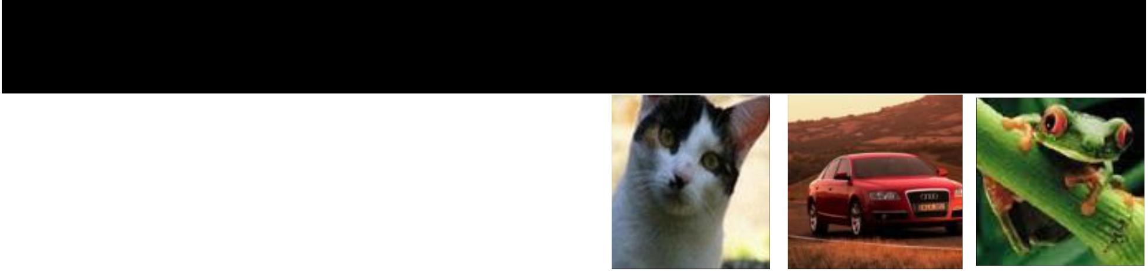**So far:** We defined a (linear) **score function:**



Example class scores for 3 images, with a random W:

-3.45 -0.51 3.42

-8.87 **6.04** 4.64

0.09 5.31 2.65

**2.9** -4.22 5.1

4.48 -4.19 2.64

8.02 3.58 5.55

3.78 4.49 **-4.34**

1.06 -4.37 -1.5

-0.36 -2.09 -4.79

-0.72 -2.93 6.14

Fei-Fei Li & Andrej Karpathy & Justin Johnson Lecture 2 56 6 Jan 2016

Coming up:

* Loss function
* Optimization
* ConvNets!

(quantifying what it means to have a “good” W)

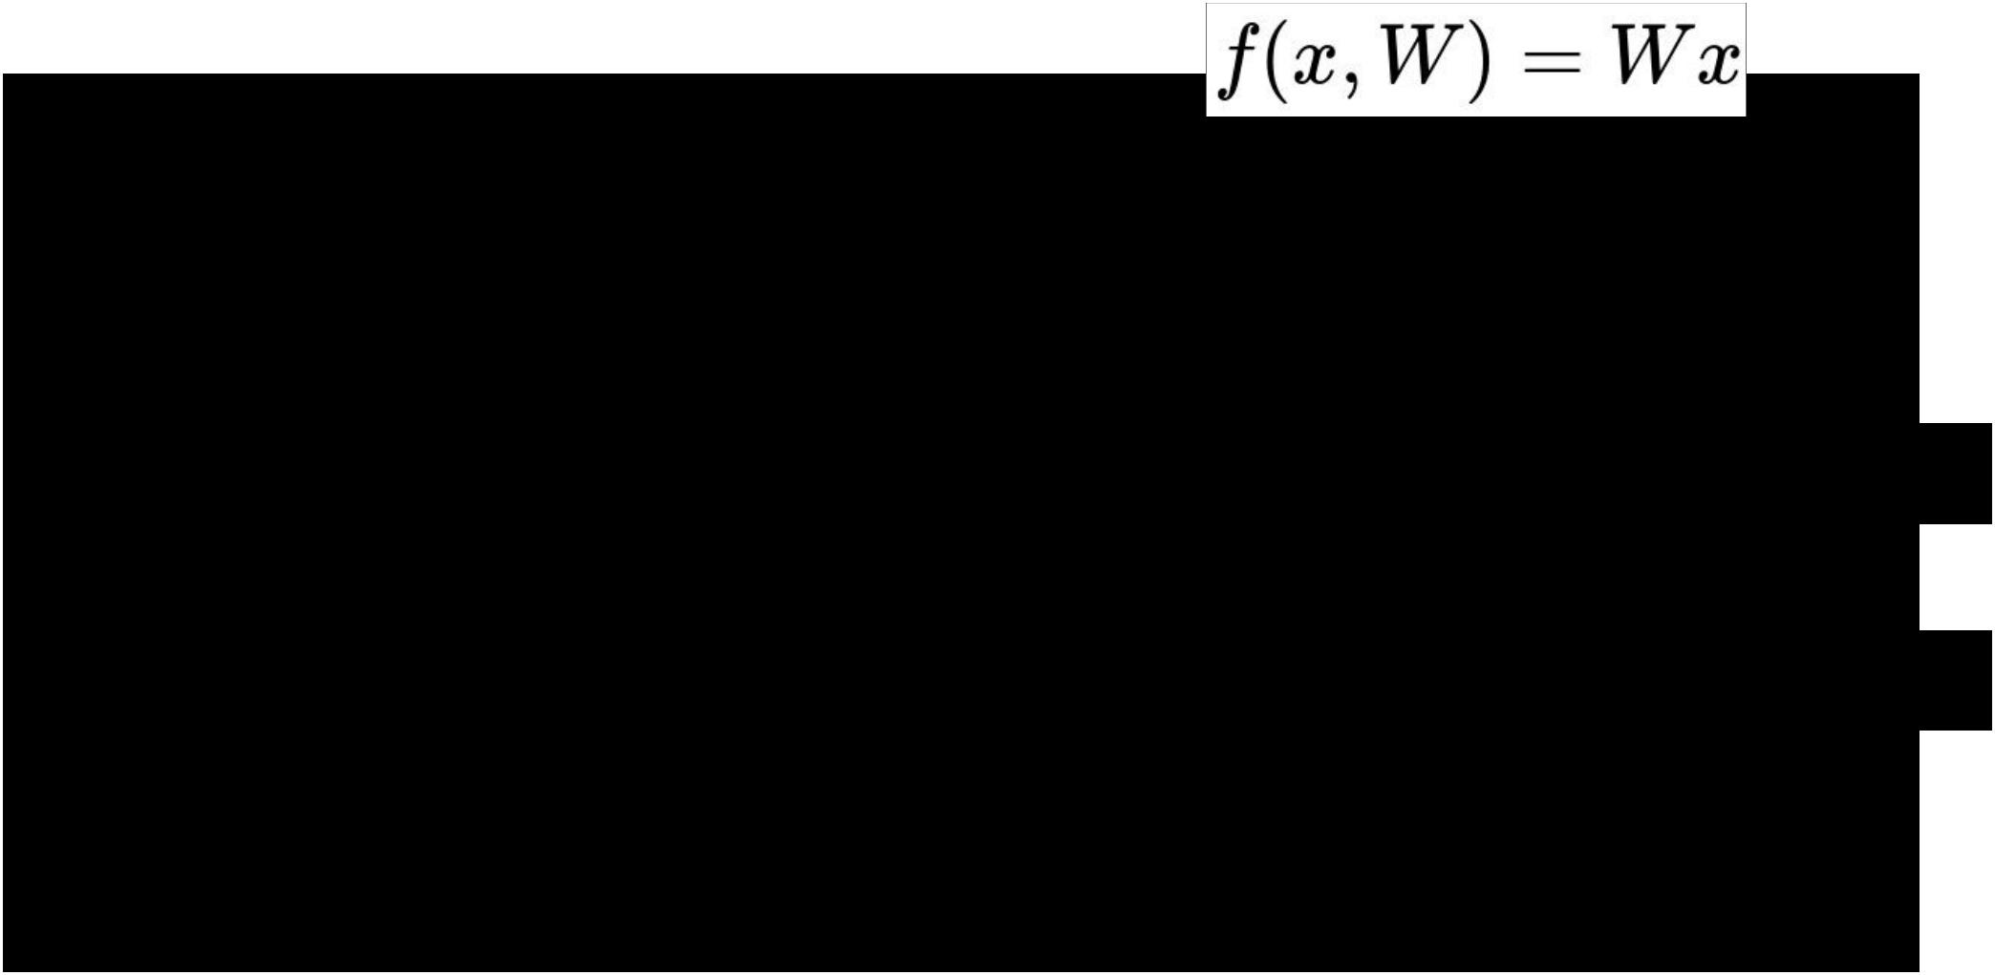

(start with random W and find a W that minimizes the loss)

(tweak the functional form of f)



Fei-Fei Li & Andrej Karpathy & Justin Johnson Lecture 2 57 6 Jan 2016