ACME ERP Risk Assessment Project

A Personal Reflection

The learning outcomes stated for the project include the development of professional skills such working on a team in a real-life scenario (University of Essex, 2021). As with real world consulting engagements, there was considerable confusion among the students regarding the interpretation of the simulated consulting engagement requirements, technical problems with the initial course lecture and logistical delays with assigning team members. While it is unclear if the obstacles are part of the learning design or circumstance, from the perspective of my professional experience they are not uncommon and raises questions regarding learning effectiveness. While online learning has strong academic proponents and detractors, student satisfaction appears to be commensurate with active learning and high-level interaction with instructors (Markova, et al., 2017). Time will tell if the student experience improves, while I personally took steps on behalf of my team to clarify potential miscommunication by contacting the tutors, those with less experience may have felt reluctant to do so.

The project deliverables, two business reports with supporting documentation, though not trivial, are reasonable expectations of an information technology or security professional. The tightly constrained word count for the first report limited writing contribution options. To resolve this, an experienced team member created a report outline for which I created most of the content and edited the remaining contributions to ensure the report had a singular voice (Team4, 2021a). The team decided to summarize the cost benefit analysis and proposed information risks using tables. To support the qualitative analysis required, I developed the PERT model (Fig. 1), facilitated weighting discussion, managed data collection and processing. This methodology was further extended for the final report, incorporating Monte Carlo simulations into risk prioritization analysis.

Academic group projects often have unequal contributions from group members (Payne & Monk-Turner, 2006), this first deliverable was no exception despite being a graduate level course. Payne and Monk’s survey reported forty percent perceived one or more team members were slacking. A second report focused on group effectiveness within information systems projects (Hasan & Ali, 2007) affirms the opportunities for IT professional skills development while also noting the impact differences in effort have on group effectiveness. Understandably groups will contain members with different experience levels, those with more experience should provide a degree of mentorship when need. I am supportive of those seeking knowledge and was very pleased when a team member I was supporting expanded the small final report section they were tasked with into an entire application recovery framework (Team4, 2021b). Conversely another team member with limited cybersecurity experience failed to participate in the group to any significant degree (Team4, 2021c) missing a positive formative opportunity.

Recent research indicates team dynamics training can increase higher education group project success (Fittipaldi, 2020), which may be an improvement considered for future cohorts. That said, it is not unreasonable to expect good faith participation from master’s program students since ad hoc groups are quickly created and tasked with deliverables in professional situations regularly.

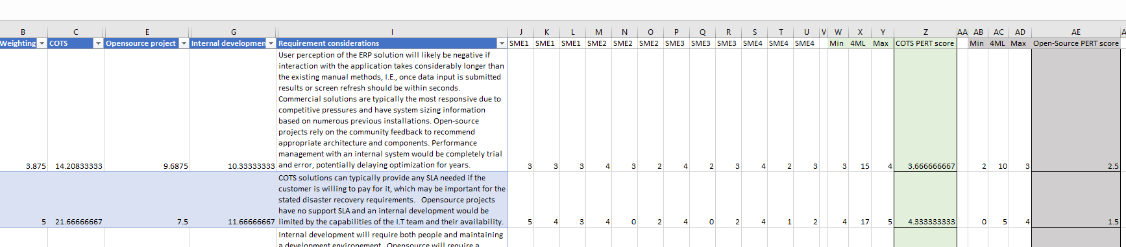

Figure Cost Benefit Analysis using PERT

Figure Open FAIR assessment using Monte Carlo

# References

Fittipaldi, D. (2020) Managing the Dynamics of Group Projects in Higher Education: Best Practices Suggested by Empirical Research. *Universal Journal of Educational Research,* 8(5):1778-1796. Avaliable from: <https://www.researchgate.net/publication/341290278_Managing_the_Dynamics_of_Group_Projects_in_Higher_Education_Best_Practices_Suggested_by_Empirical_Research> [Accessed 19 September 2021].

Hasan, B. & Ali, J. (2007) An Empirical Examination of Factors Affecting Group Effectiveness in Information Systems Projects. *Decision Sciences Journal of Innovative Education,* 5(2): 229-243.

Markova, T., Glazkova, I. & Zaborova, E. (2017) Quality Issues of Online Distance Learning. *Procedia - Social and Behavioral Sciences,* 237(21): 685-691.

Payne, B. K. & Monk-Turner, E. (2006) Students’ Perceptions of Group Projects: The Role of Race, Age, and Slacking. *College Student Journal,* 40(1): 132-139.

Team4. (2021a), Initial Project Status Report. Available from: <https://irmteam4.github.io/ACME_IRM_Project_Status_Report.pdf> [Accessed 19 September 2021]

Team4. (2021b), Initial Project Status Report. Available from: https://irmteam4.github.io/IRM_GRP4_ApplicationRecoveryPlan.pdf [Accessed 19 September 2021]

Team4. (2021c), Initial Project Status Report. Available from: https://irmteam4.github.io/TEam4_Meeting_notes.pdf [Accessed 19 September 2021]

University of Essex. (2021) Development Team Project: Status Report*.* Available from: <https://www.my-course.co.uk/mod/assign/view.php?id=526894> [Accessed 18 August 2021].