# WALKER

# Problem description

In the provided solution named “Walker”, the end goal is to move the walkers tool head from one selected position to the other with respect to given constraints.

# Implementation details

The problem is divided into three smaller sections:

## 2.1.) Tubesheet visualization

-in the provided “Tubesheet.txt” file the applicants can find the necessary tubesheet details. The first task is to visualize the tubesheet using that data. The user must be able to determine which tube is which (for example, tube row and column is shown on mouse hover). An example and the formats explanation can be found in chapter 5.

## 2.2.) Walker modelling and tubesheet interaction

-using the descriptions in chapter 5, create the walker model and link it to the tubesheet. The end goal of this task is to be able to set the walker at a position on the tubesheet by selecting a tube and walker orientation, and to select a tube where it should go.

## 2.3.) Pathing algorithm

-implement an algorithm that will, using all the given constraints in chapter 5, move the walker from the current position to the selected position.

-the algorithm must determine whether the selected tube can or can not be reached with respect to given constraints.

- **NOTE**: extra points will be gained if the traversed path is optimal!

# Use case

In the finished application, the user must be able to set the Walker at a valid initial position by selecting a tube and orientation of the Walker, select the destination tube and have the Walker position its tool head on the selected tube by traversing a path with respect to given constraints.

# Technology and libraries

The applicants are required to use the Visual Studio IDE to create the solution. WPF and C# organized in the MVVM pattern should be used to create the project.

# Domain explanations

## 5.1.) Tubesheet and tubesheet file format

A tubesheet is a collection of tubes organized in a square pattern and forming a horizontal wall:

(R56,C56)

(R1,C1)

Each tubes position is defined by Row and Column, where numbering starts in the lower left corner. The distance between the tubes is determined by the „TubesheetPitch“ in millimeters. This represents the distance between two tube centers.The color coding of the tube depends on the tubes status read from the tubesheet file format, which can differ between:

* Unknown: grey color
* Plugged: black color
* Critical: red color

The diameter of the tube is 16.8 mm, as specified in the format.

## 5.2.) Walker model

The walker consists of two axes and a tool head. On the picture, the main axis is colored green and the secondary axis is colored brown. On the ends of each axis there is a pincer (purple). The tool head is located on one end of the main axis (dark red).

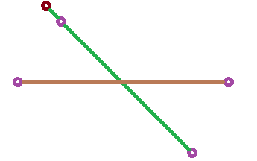

Since the Walker is traversing a horizontal tubesheet wall, it uses the pincers to lock into tubes and prevent falling. This means that at all times, at least one axis has to have its pincers locked. The main axis can only be locked diagonally, while the secondary axis can only be locked horizontally or vertically. The orientation is defined by the way the tool head is facing (up left, up right, down right, down left). By specifying an orientation and the tube where the tool heads pincer is the user can define the position of the Walker on the tubesheet (pincers on tubes, rotation -45 or 45, translation 0).

## 5.2.1.) Dimensions

The main (green) axis length between the two (purple) pincer centers equals sqrt(2) * 14 pitches (543.13mm). The distance between the pincer and tool head centers equals sqrt(2) * 1 pitch (38.78mm). The pincers and the tool head can be simplified to be the same diameter as the tubes. The secondary axis length between the two pincer centers is 24 pitches (658.32mm).

## 5.2.2.) Allowed movements for traversal

To move, the Walker always has to have only one pair of pincers locked. Once a pair is locked, the axes can either rotate or translate.

Example of translation while secondary axis is locked (primary axis is translating):

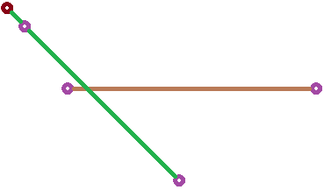

Example of translation while main axis is locked (secondary axis is translating):

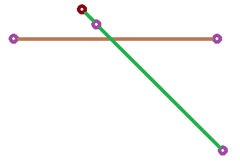

Example of rotation while secondary axis is locked (primary axis is rotating):

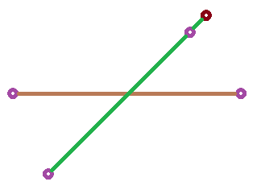

Example of rotation while primary axis is locked (secondary axis is rotating):

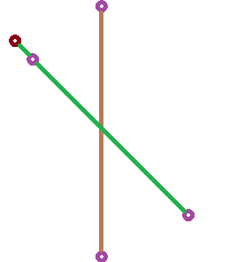

## 5.2.3.) Limitations

1. The rotation is considered to be at 0 degrees when the axes are perpendicular. An axis can then rotate [-60,60] degrees.
2. The translation is considered to be at 0mm when an axis is at the center distance between two pincers of the other axis (as in the picture above). It can then translate from one pincers outer edge to the other.
3. The dimensions of the main axis limit it to only be able to lock on the diagonal, while the secondary axis can only be locked either vertically or horizontally.
4. The pincers can not be locked on a tube with the status „Plugged“.
5. Bonus: The tool head can never exit the outer limit of the tubesheet.