**Lesson Guide** **Sheath Dress/Scoop Neck** **Draping: Beginner**

**Module 1 – Prepare the Dress Form**

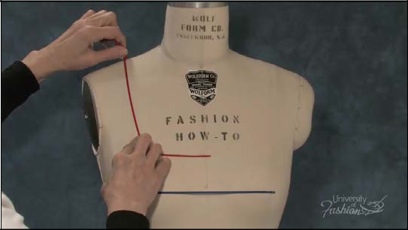

**Step 1** The first step when draping the sheath dress is to apply style tape to your dress form to establish your guidelines and neckline style line. For bust level, tape from the left apex to the side seam. Make sure that the style tape is parallel to the floor.

1

**Module 1 – Prepare the Dress Form**

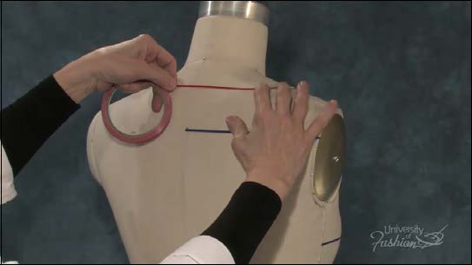

**Step 2** Tape the desired neckline both front and back.

2

**Module 1 – Prepare the Dress Form**

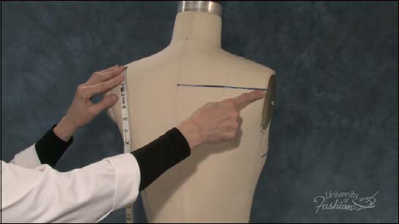

**Step 3** Tape the shoulder blade level, which is 1 /4 th the distance from your neckline to the middle of the waist tape. Tape from the center back to the armhole ridge. Be sure that this line is parallel to the floor.

3

**Module 1 – Prepare the Dress Form**

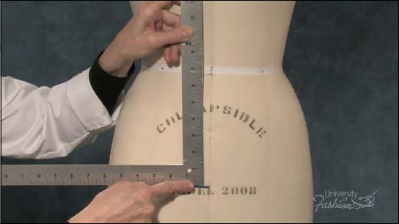

**Step 4A** Place style tape 7” down from the center of the waist tape.

4

**Module 1 – Prepare the Dress Form**

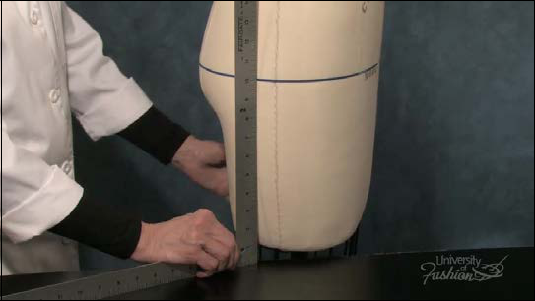

**Step 4B** Use you straight ruler against the table to check that your hip is parallel to the floor.

5

**Lesson Guide** **Sheath Dress/Scoop Neck** **Draping: Beginner**

**Module 2 – Extract Measurements**

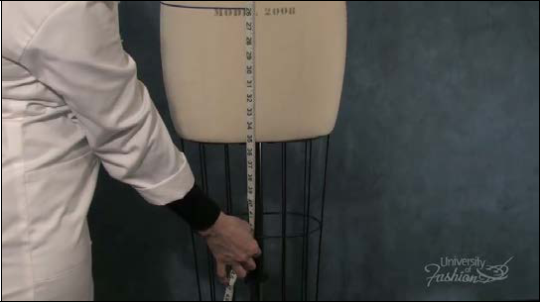

**Step 1 To prepare your front muslin block measure from the neckband to the desired dress length and add 3”. Record this measurement. This is your front block’s lengt**