1. We are proposing a DBMS for a system of libraries. This system is essential because it will allow a library to keep track of its users, books and DVDs available, and share books and DVDs between libraries.
2. (see below)
3. 1. Students check out a book or DVD(students, books, DVDs, libraries)
   2. Librarians check other libraries for available books or DVDs (staff, libraries, book, DVDs)
   3. Students check online if a library has a book or DVD (students, libraries, books, DVDs)
   4. Students check in books or DVDs (students books, DVDs libraries)
   5. Librarians check for overdue book or DVDs (librarians, books, DVDs, students)
   6. Libraries supply books and DVDs (libraries, books, DVDs)
   7. 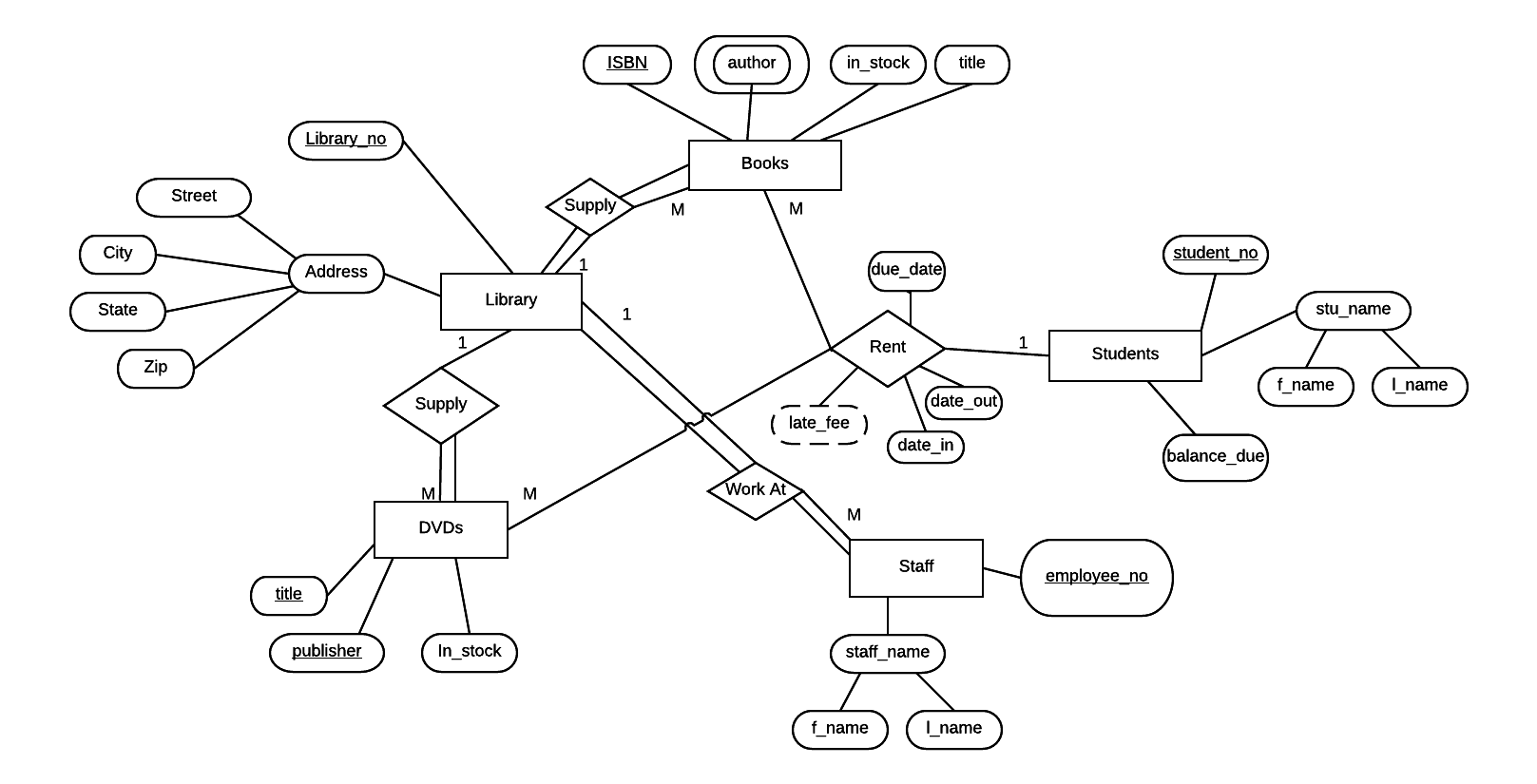Staff members work at libraries

Assumptions:

* A library doesn’t have to have DVDs
* A library must supply books
* Books and DVDs must be supplied by libraries
* DVDs have to be supplied by libraries
* A library must have staff
* Staff must work for a library
* Students don’t have to rent out books or DVDs
* DVDs and books don’t have to ever be rented out
* Libraries in the network have unique identification numbers already