CS5405HW06 (Due Thursday October 27, 2016 in class) Your Name_______________________

**Deliverables**

1. **Place .java files in source directory, compiled byte code will be in “code” directory**
2. **Create a jar file Demo.jar containing the folders: source and code , and a manifest file.**
3. **Upload Demo.jar file to Canvas**
4. **Bring to class a printed copy of java source code, a sample of program execution output of the program**
5. **Attach assignment on top of the printed copy for grade feedback. Write your name on it.**
6. **You will write your own code. If any sort of plagiarism occurs, guidelines were given in the class. Copying the program will result in loss of ALL credit and will be reported to dept for proper credit.**

**I showed you the demo in the class with circles. You are to implement the problem with two triangles. You have already got the credit for HW05. Now you make your program fail-safe i.e. it works on every possible case. If it fails on graders/user’s data, then the grader will NOT give any credit for triangle implementation. Read and understand GUI code instead of just plug in triangles. In the next assignment, you will be writing your own GUI if you have understood this one.**

**This problem is a variation of previous HW.**

You have three pages which can be displayed on click of a button as shown in the class.

In this you will input parameters of triangles.

Use ONE textField to read input for the two triangles: x1 y1 w1 h1 x2 y2 w2 h2 **(pixels are integers)** ( x1 y1 w1,h1 means that triangle vertices are (x1,y1),(x1+w1,y1), (x1+w1/2,y1+h1)). You will need polygon class to draw the triangle. Fill the triangles with color.

If you decide to use any other means of input for triangle. Describe it in a prompt label above the textField ) . Do not leave it to the grader to guess- like click tab, carriage return etc as needed

Output on a label to describe what kind of spatial relation is detected: interiors disjoint (DR) , proper overlap PO), equal (EQ), PP triange1 is inside the triangle2, conversely PPc triangle2 is inside the triangle1.

Do not use anything beyond that. Do not submit IDE program. If you use IDEs, you will convert it to the required format, see the rubrics for grading. No credit will be given for such IDE submission. You will be required to explain/demonstrate your understanding of the program individually.

Turn in the Demo.jar file on the Canvas.

Turn in the printed copy of source code and sample screenshots of program output in the class.

**Use javadoc style comments*. No UML diagram required*. Use java conventions for naming classes, methods and variables. Name your program and files names accurately. You may use any java code from the examples in the book or demos on the Canvas. Any other source should be cited accurately to credit the original author(s).**

**Self assessment**

**[2] Does it have author page/Does it work**

**[2] Does it have Problem Description/does it work**

**[1] Does it have javadoc documentation for varaibles and methods in the class.**

**[10] Does it cover all 5 cases – check mark the following**

**DR PO EQ PP PPc**

**[2] Does it have Demo.jar file, Does it work?**

**[1] Does Demo.jar have source code/javadoc documentation**

**[2] Does printout have sample out of all the five cases.**

**[2] are the files correctly named for the following script to work.**

**How to submit assignment**

**Upload the Demo.jar file On Convas**

**The TA will grade it like it.**

**Sample Demo (as shown in class) your sample output will be similar.**

**This is not test data. Your programs will be tested on a different data set.**

8. Have the ability to use current techniques, skills and tools necessary for computing practice and be able to apply or evaluate a computer-based system to solve a problem. (ABET Criterion 3: c, i)

|  |  |  |  |  |
| --- | --- | --- | --- | --- |
| HW | The program doesn’t have correct interaction and produces incorrect results. Does not meet naming specifications. Not turned in on time. Or Does not compile as specified. | The program had correct interaction, does not produce correct results, does not meet specifications. | The program has correct interaction, produces correct results. It does not meet all the requirements like, naming conventions, documentation. | The program has correct interaction, produces correct results. It meets all the requirements like naming conventions, documentation. |
| Syntax(Prog) | Inadequate  0-10 | Need help  10-13 | Adequate  13-17 | Excellent  17-20 |
| Your Score |  |  |  |  |

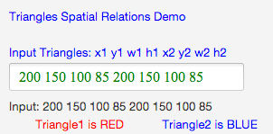

**DR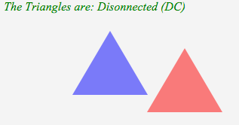 DR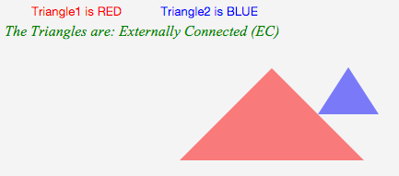EQ**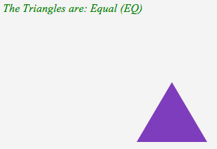

**PO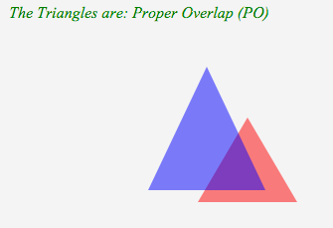PPc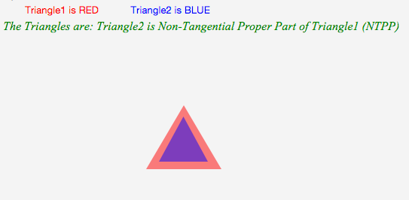PPc**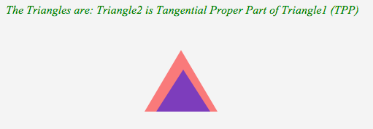

**Grading script**

#!/bin/sh

#

# grading.sh

#

# Created by Sabharwal, Chaman L. on 10/08/16.

# Copyright (c) 2016 __MyCompanyName__. All rights reserved.

#

# extract (xvf orxf) all files from Demo.jar

jar -xvf Demo.jar

# retain Demo.jar

mv Demo.jar DemoOld.jar

# remove old code and docs directories

rm -r code

rm -r docs

#

# compile source code

javac -d . source/*.java

# make javadoc documentation

javadoc -d docs -version -author -private -quiet source/*.java

#

# make Demo.jar (cvmf or cmf)

jar -cmf m.txt Demo.jar *

#

# execute application

java -jar Demo.jar