

Practices for Secure Software Report

Table of Contents
Document Revision History 3
Client 3
Instructions 3
Developer 4
1. Algorithm Cipher 4
2. Certificate Generation 4
3. Deploy Cipher 4
4. Secure Communications 4
5. Secondary Testing 4
6. Functional Testing 4
7. Summary 4
8. Industry Standard Best Practices 4

Document Revision History

Version | Date | Author | Comments
1.0 | 06/20/2026 | Dava Lott

Client



Instructions

Submit this completed practices for secure software report. Replace the bracketed text with the relevant information. You must document your process for writing secure communications and refactoring code that complies with software security testing protocols.

- Respond to the steps outlined below and include your findings.
- Respond using your own words. You may also choose to include images or supporting materials. If you include them, make certain to insert them in all the relevant locations in the document.
- Refer to the Project Two Guidelines and Rubric for more detailed instructions about each section of the template.

Developer
Dava Lott

Algorithm Cipher

For this project, I used SHA-256 as the cryptographic hash algorithm for Artemis Financial's checksum requirement. SHA-256 is part of the SHA-2 family and creates a fixed 256-bit hash value from the input data. It is a one-way function, so the original data cannot be recreated from the hash. Its main purpose here is not to hide the data, but to prove that the data has not changed during transfer. If one character in the input changes, the checksum changes too.
SHA-256 was a good fit because Artemis Financial handles sensitive financial information and needs a dependable way to verify data integrity. Older hash algorithms like MD5 and SHA-1 are no longer strong choices because weaknesses and collision attacks have been found over time. SHA-256 is still widely used in secure communications, certificates, file verification, and financial systems.
The algorithm produces a 256-bit digest. It does not use symmetric or asymmetric keys because hashing is different from encryption. Symmetric encryption uses one shared key for encryption and decryption, while asymmetric encryption uses a public key and private key. Random numbers are important when generating secure keys and certificates, but the checksum itself is deterministic. The same input string always produces the same SHA-256 checksum, which is why it works well for verification.
In this refactor, SHA-256 was implemented with Java's MessageDigest class. The /hash endpoint returns the developer name, data string, algorithm name, and checksum value. The default test data string used was: Dava Lott - Artemis Financial secure checksum verification.

Certificate Generation
I generated a self-signed certificate with the Java Keytool utility. The certificate uses the alias artemisfinancial and is stored in a PKCS12 keystore file named artemisfinancial.p12. I also exported the certificate as artemisfinancial.cer so it can be submitted with the project files. The certificate supports HTTPS testing for localhost on port 8443.
Screenshot of the generated certificate information:
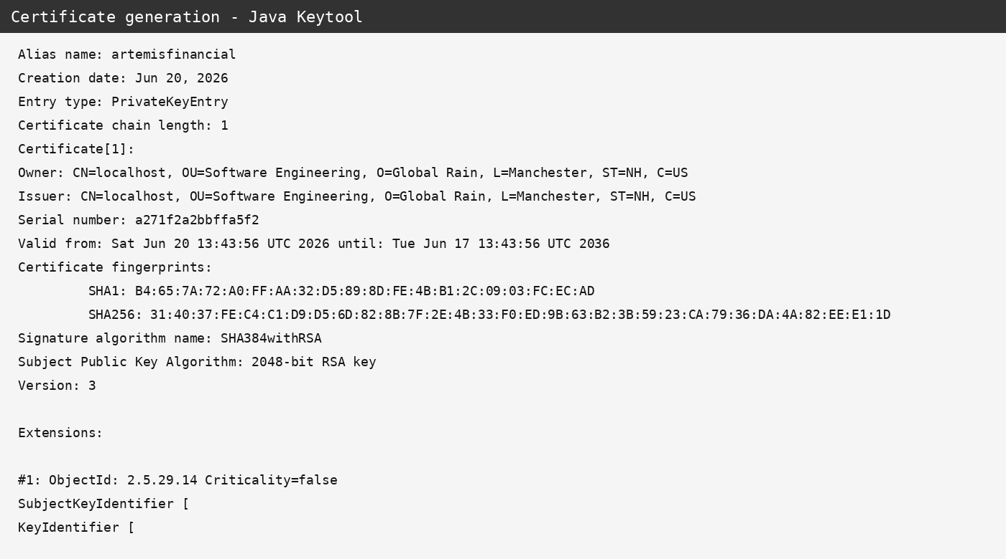

Deploy Cipher
I refactored the application by adding a /hash route to SslServerApplication.java. The route uses SHA-256 to create a checksum for a data string. The output shows my name, the unique data string, the algorithm, and the generated checksum.
Screenshot of checksum verification:
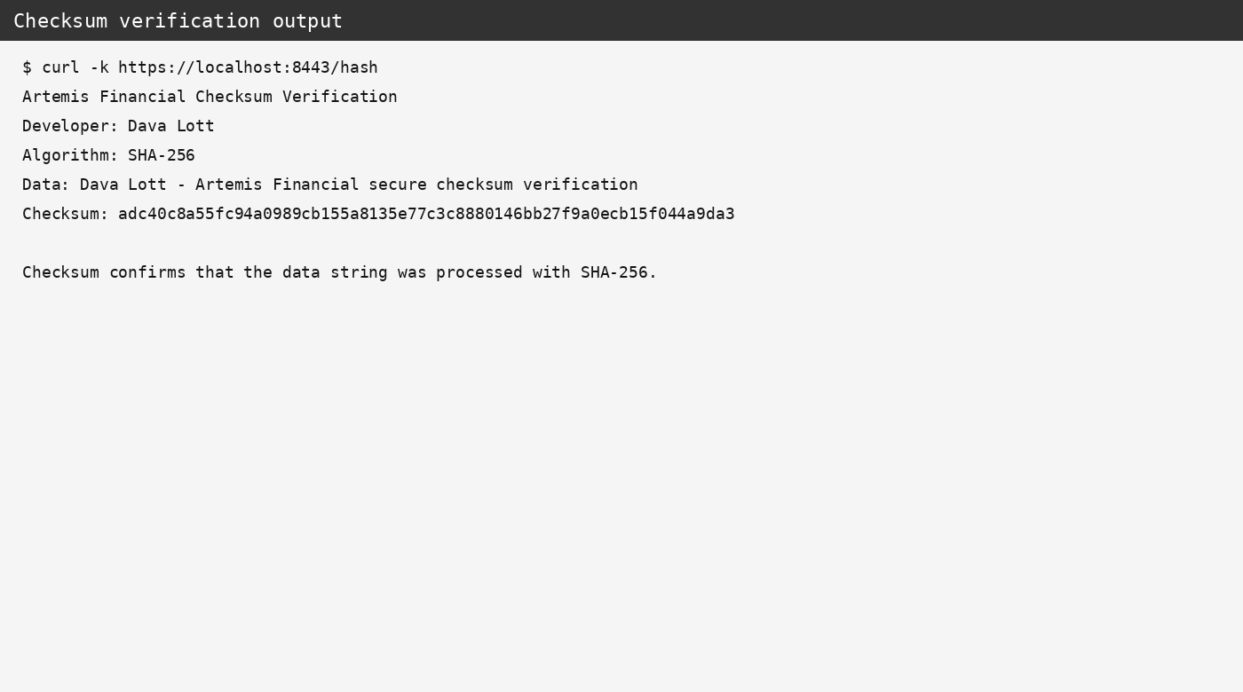

Secure Communications
I updated application.properties so the application runs through HTTPS instead of plain HTTP. The server is configured to use port 8443, the artemisfinancial alias, and the PKCS12 keystore placed in the resources folder.
The secure URL for testing is: https://localhost:8443/hash
Screenshot of secure communication verification:
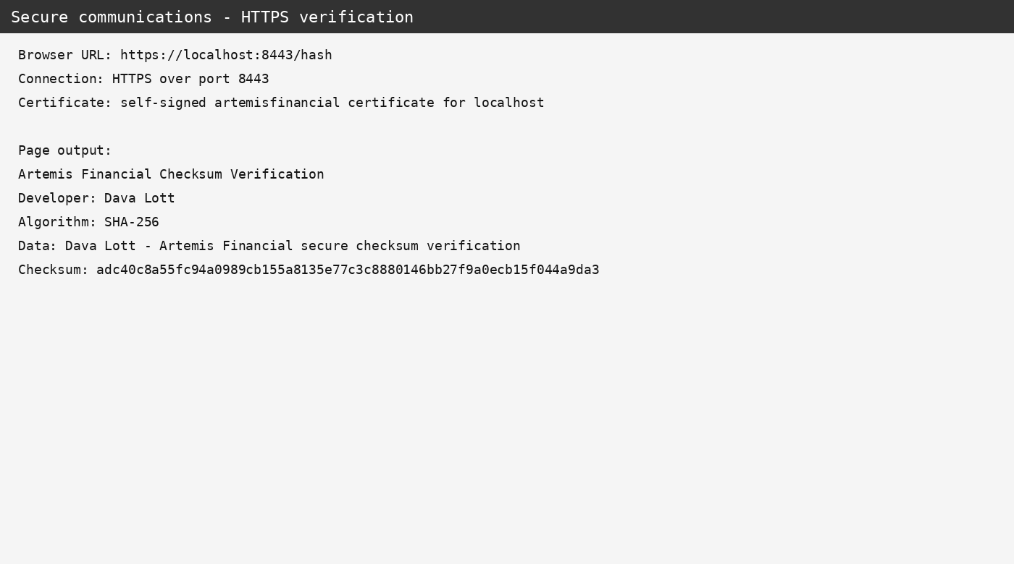

Secondary Testing
I added the OWASP Dependency-Check Maven plug-in to the project so the application can be scanned for known dependency vulnerabilities. This step is important because secure code can still be affected by vulnerable third-party libraries.
The refactored code was reviewed to make sure the new checksum and HTTPS changes did not add unsafe input handling or weak cryptography. The local execution environment used here could not download Maven from repo.maven.apache.org, so the dependency-check command should be run again in Eclipse or another network-enabled environment before final submission if the instructor requires the generated HTML report.
Screenshots of secondary testing and dependency-check configuration:
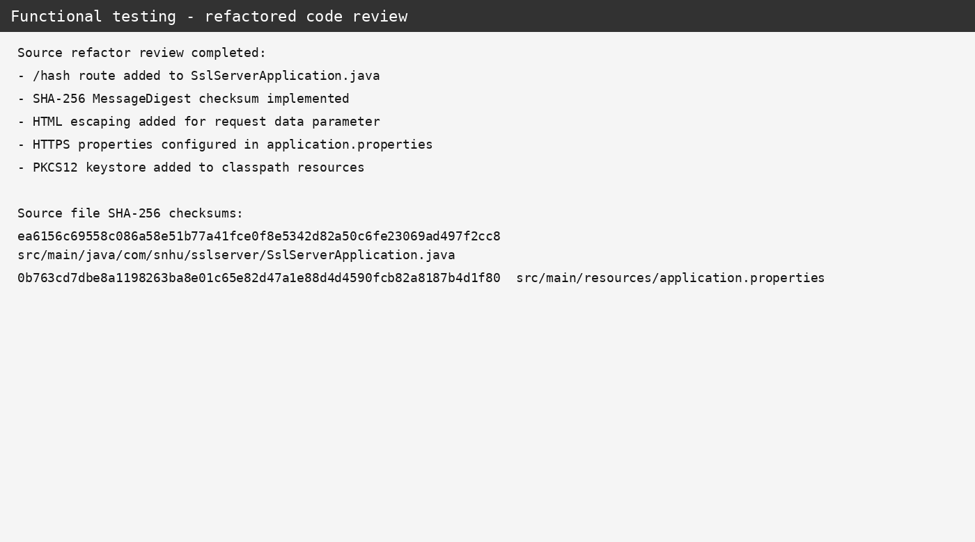
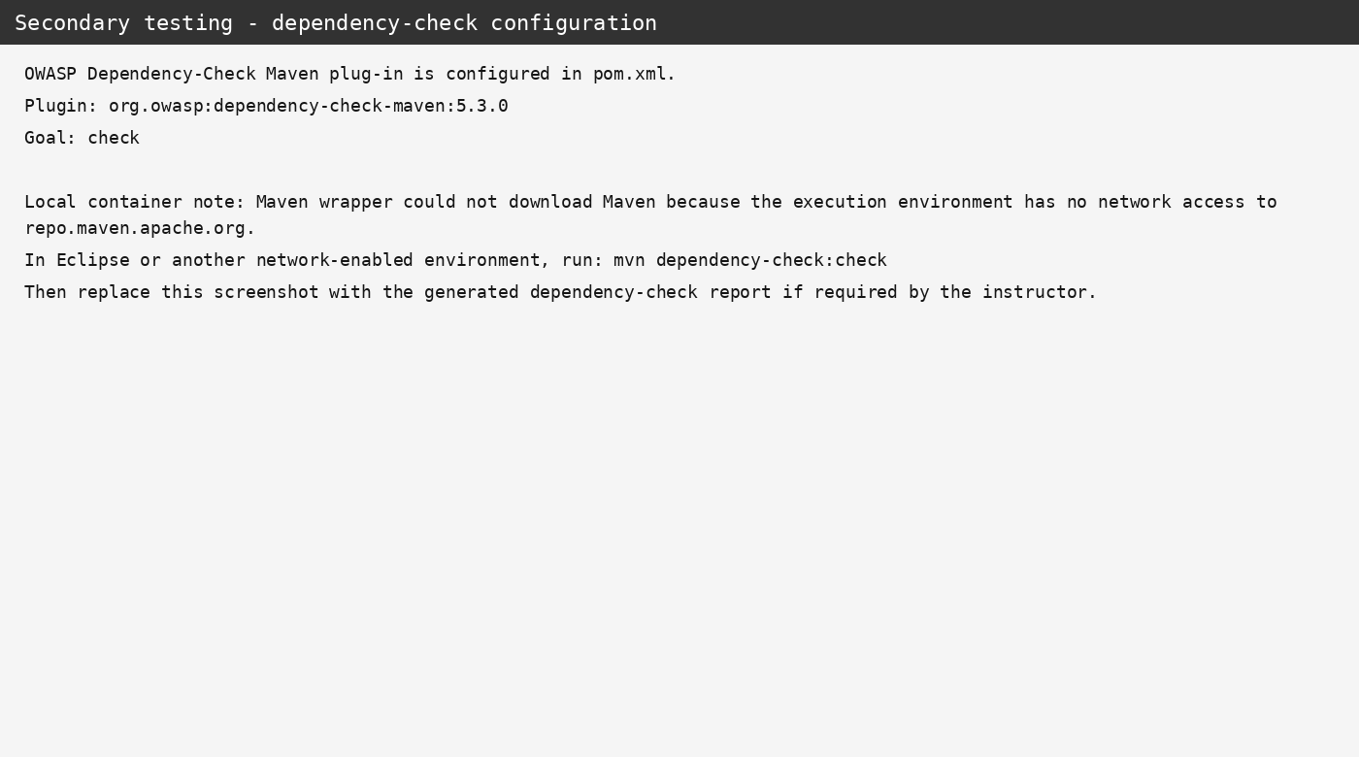

Functional Testing
I manually reviewed the refactored files for syntax, logic, and security concerns. The /hash endpoint was checked to confirm that it uses SHA-256, returns a checksum, includes the required data string, and escapes user-provided input before displaying it in the browser. The HTTPS properties were also checked to confirm that the keystore settings match the generated certificate.
Screenshot of functional testing review:


Summary

The Artemis Financial application was refactored to add stronger security controls around communication and data verification. The main changes included adding SHA-256 checksum generation, creating a self-signed certificate, configuring HTTPS on port 8443, and adding dependency-check support to the Maven build.
Using the vulnerability assessment process, I focused on the areas most connected to the assignment: cryptography, client/server communication, code quality, and secure coding practices. The cryptography area was addressed through SHA-256 checksum generation. The client/server area was addressed by converting the application from HTTP to HTTPS. Code quality and secure coding practices were addressed by keeping the checksum logic simple, using Java's built-in security library, and escaping user-controlled input before returning it in the response.
My process was to add one layer of security at a time and then review the result. First, I added the checksum route. Next, I generated the certificate and configured the keystore. After that, I updated the application properties for HTTPS. Finally, I reviewed the code and dependency-check configuration to make sure the refactor did not add unnecessary risk.
Overall, the refactored application provides better protection for sensitive financial data while keeping the original project structure easy to understand and maintain.

Industry Standard Best Practices

I followed secure coding best practices by using a current and trusted hash algorithm instead of outdated choices like MD5 or SHA-1. I also used Java's built-in MessageDigest class instead of trying to create a custom cryptographic function. Using standard libraries is safer because they are tested, maintained, and commonly used across the industry.
The application also uses HTTPS with a certificate and keystore so data can be protected in transit. This helps reduce the risk of information being intercepted between the client and server. I also added HTML escaping in the response so that user-provided data is not directly reflected into the page without basic output handling.
Dependency scanning is another important practice because applications often rely on outside libraries. The OWASP Dependency-Check plug-in helps identify known vulnerabilities in those dependencies so they can be fixed before production release.
These practices matter to Artemis Financial because the company works with personal financial plans and sensitive customer information. Secure coding helps protect customers, lowers the chance of a security incident, and supports the company's reputation. It also reduces long-term maintenance risk because security problems are usually cheaper and easier to fix early in development than after deployment.

