Practice 2, Deniss Lučkins st78712

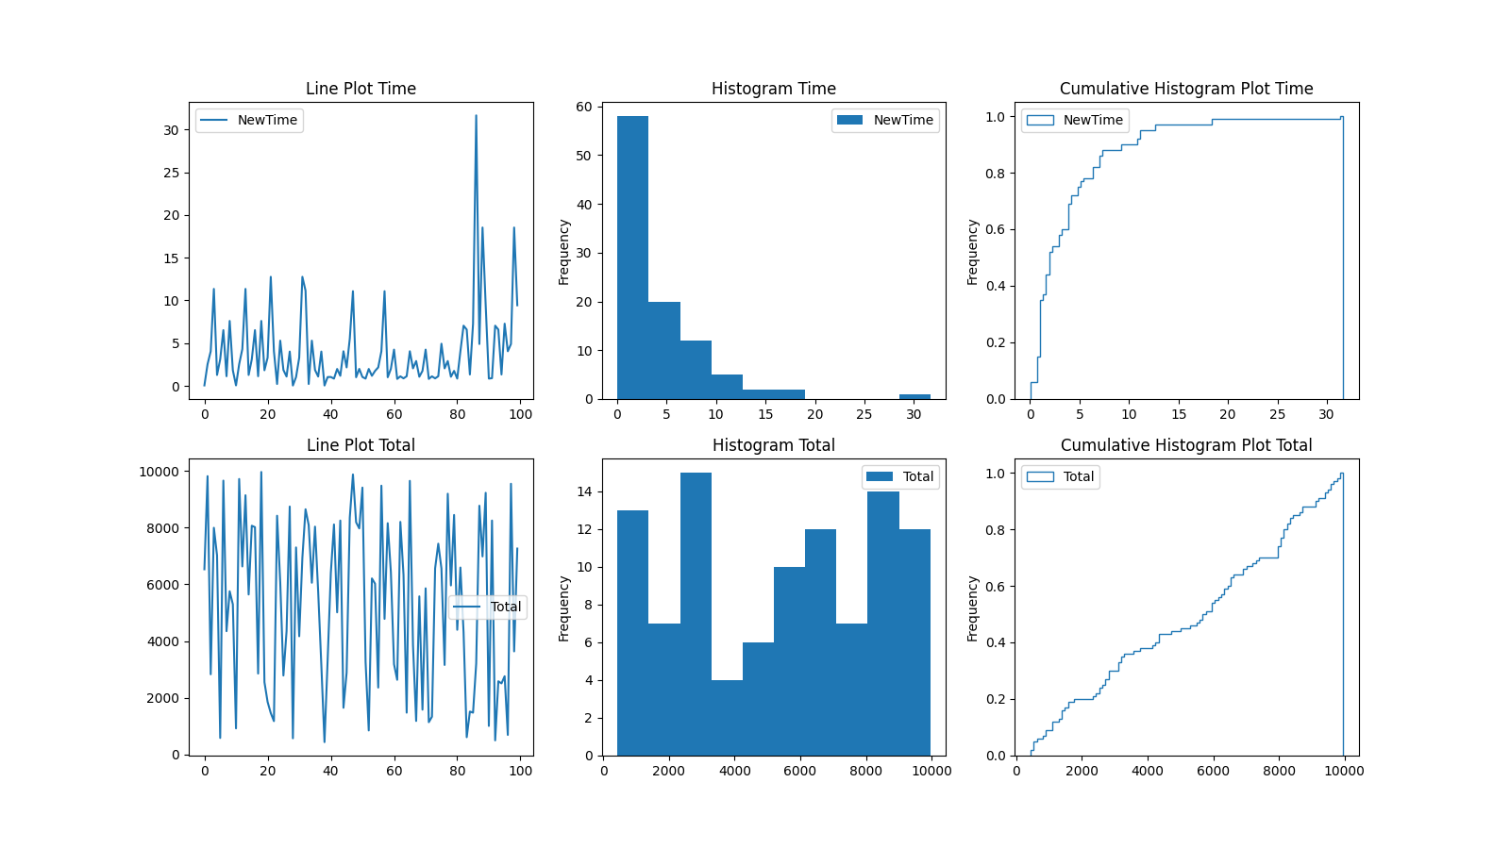

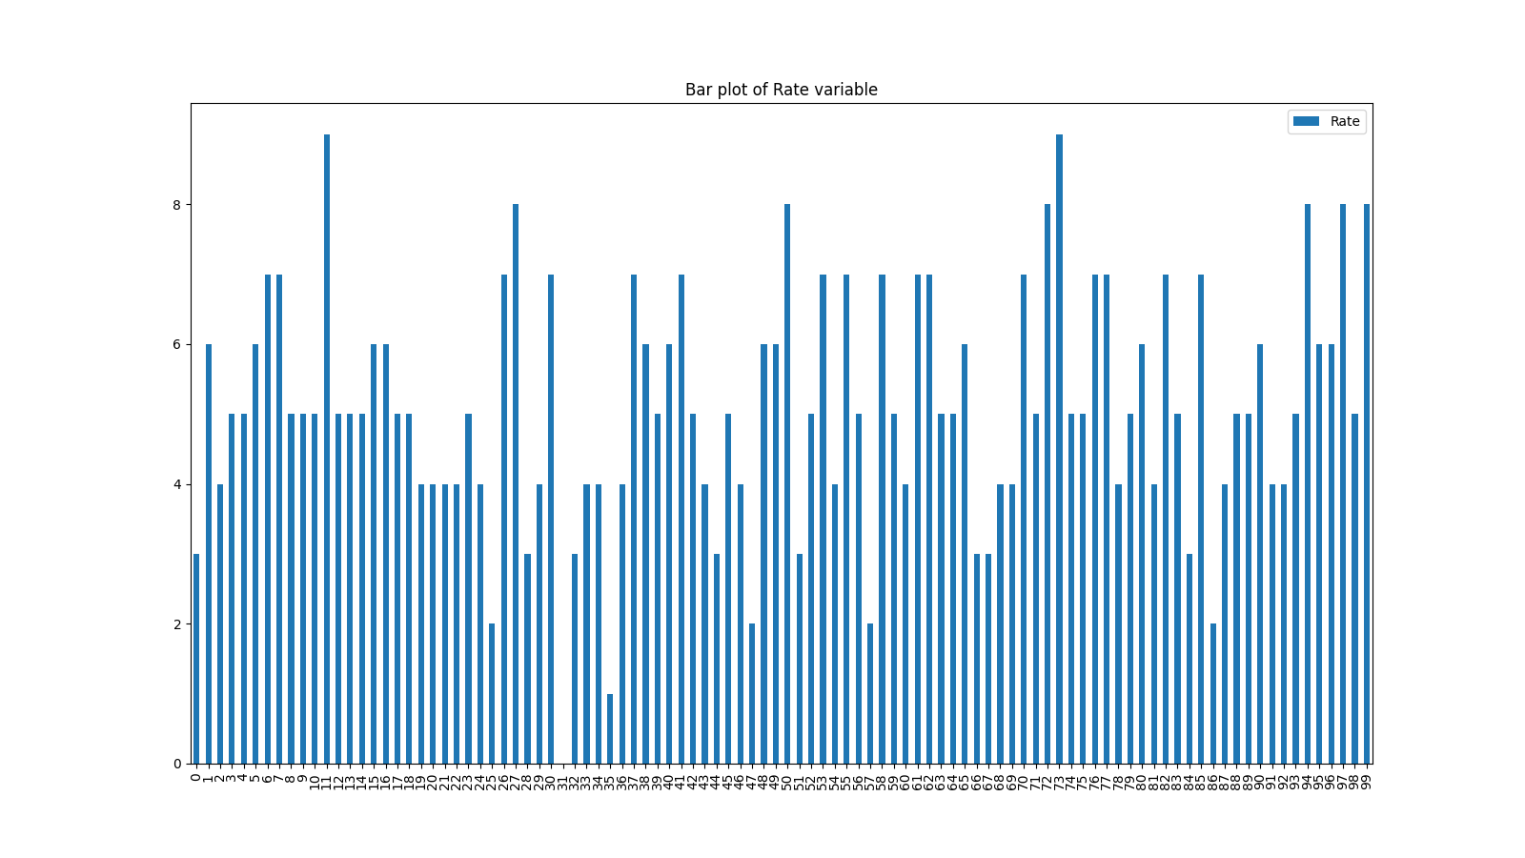

Descriptive statistics for Time:  
count 100.000000  
mean 4.048768  
std 4.707972  
min 0.039749  
50% 2.103396  
90% 9.595758  
95% 11.416996  
99% 18.659151  
max 31.649080  
Name: NewTime, dtype: float64  
Skewness:2.4976604857950875  
Kurtosis:6.588506896096529

Descriptive statistics for Total:  
count 100.000000  
mean 5292.540000  
std 2973.472545  
min 435.000000  
50% 5805.000000  
90% 9196.200000  
95% 9647.400000  
99% 9872.880000  
max 9960.000000  
Name: Total, dtype: float64  
Skewness:-0.4273870283176621  
Kurtosis:-1.5645815052918226

Descriptive statistics for Rate:  
count 100.000000  
mean 5.130000  
std 1.715379  
min 0.000000  
50% 5.000000  
90% 7.000000  
95% 8.000000  
99% 9.000000  
max 9.000000  
Name: Rate, dtype: float64  
Skewness:2.9431220100827784  
Kurtosis:8.752781985851604