To summarize the large amount of data generated in this study, the stacked histograms in Figures SError: Reference source not found and SError: Reference source not found (below) were created. As thes efigures are complex and summarize large amounts of data, we introduce some notation to ensure clarity of interpretation.
Denote all comparisons (groupings) as the set (e.g. g₁ = "LEARN: task v rest", g₂ = "OSTEO: allpain v nopain"). Let be the set of the eight RMT features examined. Let represent the different classifiers (e.g. "LR, logistic regression", "LDA"), let i.e. ( ) be the unfolding degrees. We wish to examine, via LOOCV, the prediction accuracies for every point (over 9500 points). If there are samples for some , LOOCV will yield prediction accuracies. Define the function to be the mean of those accuracies. Then the real value is equal to the mean LOOCV prediction accuracy of the binary classifier for feature unfolded with a polynomial degree , for comparison. Figure SError: Reference source not found thus depicts:

Different features in Figure SError: Reference source not found are encoded by color. For example, the black bars (raw eigenvalues) depict the set (i.e. . The black bars in the first subplot then are the histogram for the set .
The central, vertical black comparison line "Guess" in each subplot indicates the accuracy of a naive classifier that always predicts membership in the larger of the subgroups. Thus, when most of the bars of one colour are right of this line, it suggests predictions using that feature mostly outperform guessing, and contrariwise when most are to the left. So for example, focusing on the subplot labeled PSYCH_VIGILANCE_SES-2 in Figure S Error: Reference source not found, we can see that overall (ignoring colour) the RMT features led to predictions better than a naïve classifier in this dataset, but that the reverse was the case for the unshifted noise ratio (light green). Similar figures and additional descriptions are available in the supplementary material.
From Figure Error: Reference source not found it is clear that with the exception of the LEARNING dataset, the RMT-inspired features demonstrated some predictive utility. For example, there were strong differences in RMT features between task and rest conditions for the REFLECT dataset, but the features were of variable predictive utility over the naïve classifier in the PSYCH dataset, sometimes outperforming the naïve classifier, and sometimes not. Although the RMT features were useful in the comparison involving duloxetine and controls (no pain) in the OSTEO dataset, these features did not aid in classifying between any of the other possible pairings of subgroups in this dataset (Figure Error: Reference source not found). Although the performance of classifiers trained on RMT features was variable, there was a tendency for the raw and largest eigenvalues to be most predictively useful, especially in the REFLECT data (but see discussion).
The raw eigenvalues were useful in discriminating between Parkinson's and controls; however, the predictive utility of the unfolded features in this comparison was dependent on the unfolding and trimming procedure.

Supplementary Appendix
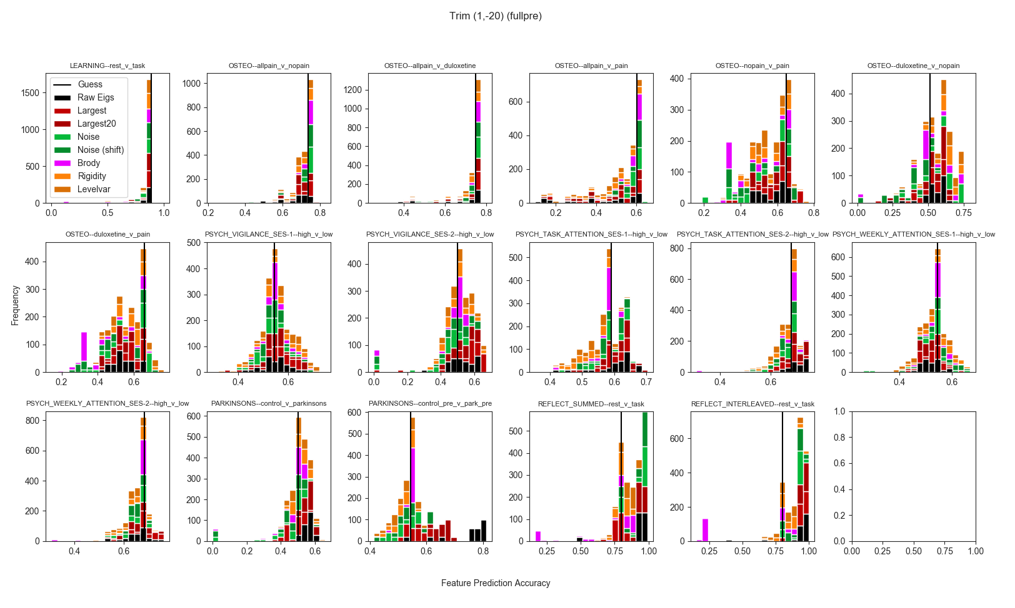
Supplementary Figure 1. LOOCV prediction accuracies for all features for all unfoldings and classifiers, after trimming largest 20 eigenvalues. Values left of the vertical "Guess" line indicate prediction accuracies worse than simply guessing membership in the largest group.
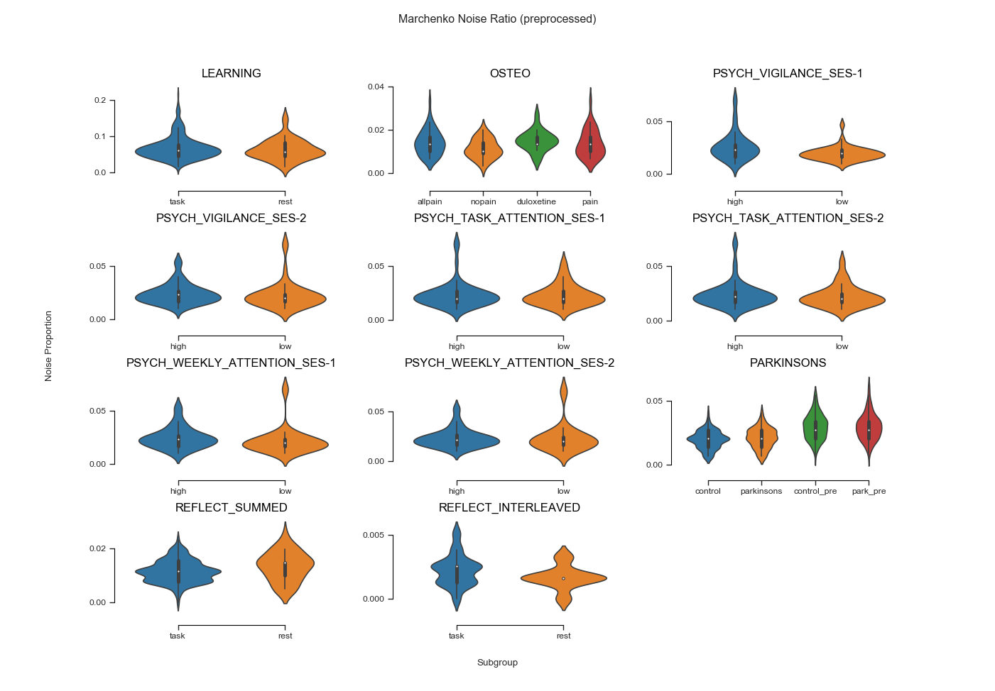
Supplementary Figure 2. Noise ratios (unshifted) across comparisons and subgroups.
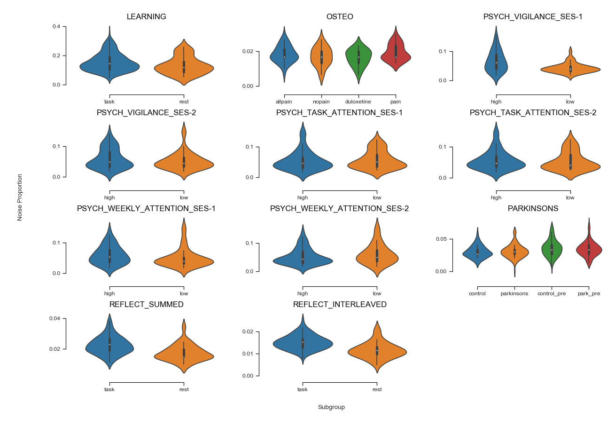
Supplementary Figure 3. Noise ratios (shifted) across comparisons and subgroups.
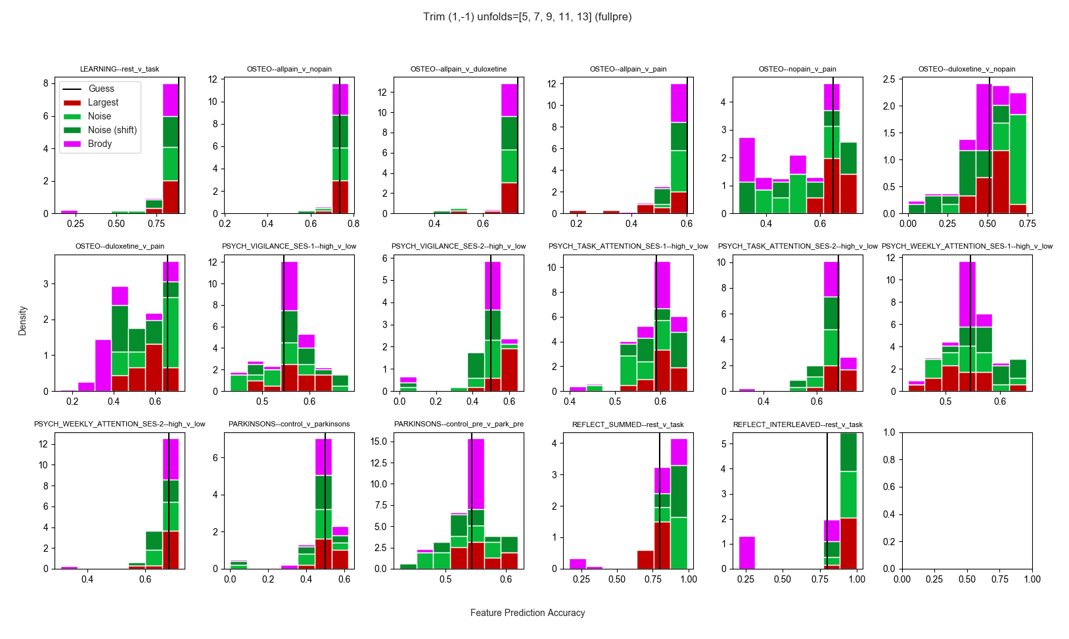
Supplementary Figure 4. LOOCV mean prediction accuracies of scalar features across classifiers. Brody parameter mean LOOCV prediction accuracies shown across all unfoldings, trimming only the largest eigenvalue. Values left of the vertical "Guess" line indicate prediction accuracies worse than simply guessing membership in the largest group.

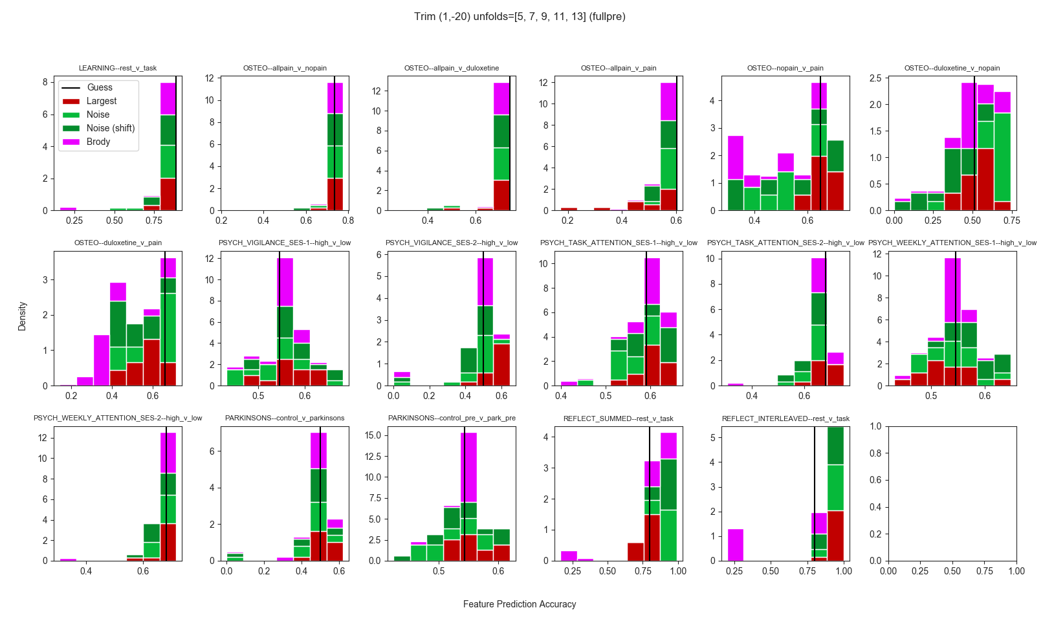
Supplementary Figure 4b. LOOCV mean prediction accuracies of scalar features across classifiers. Brody parameter mean LOOCV prediction accuracies shown across all unfoldings, trimming the largest 20 eigenvalues. Values left of the vertical "Guess" line indicate prediction accuracies worse than simply guessing membership in the largest group.

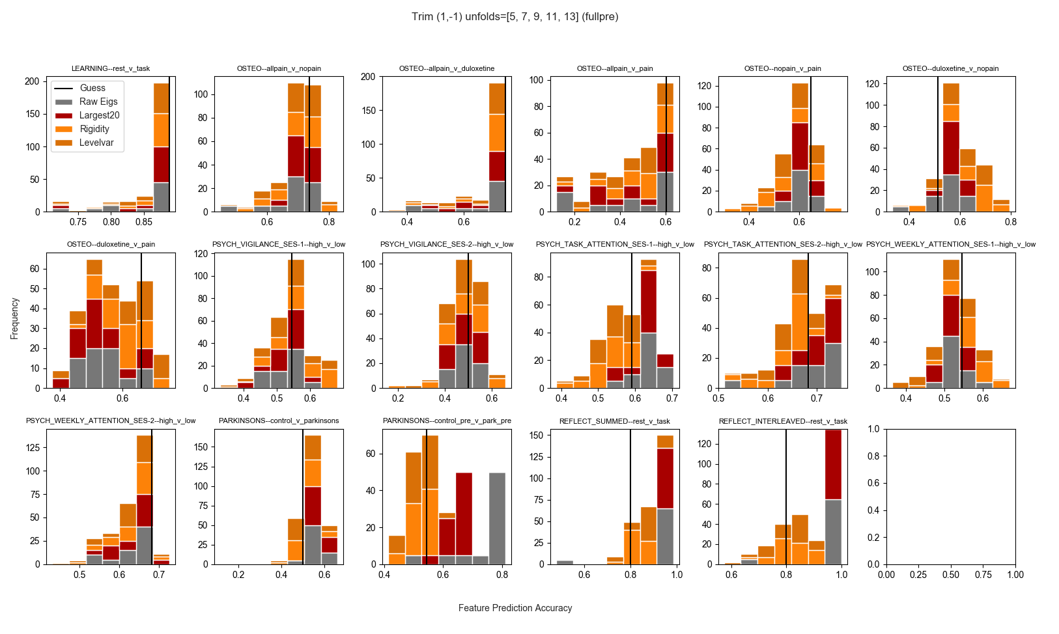
Supplementary Figure 5a. LOOCV mean prediction accuracies of nonscalar, unfolded features across classifiers and unfoldings, trimming only the largest eigenvalue. Values left of the vertical "Guess" line indicate prediction accuracies worse than simply guessing membership in the largest group.

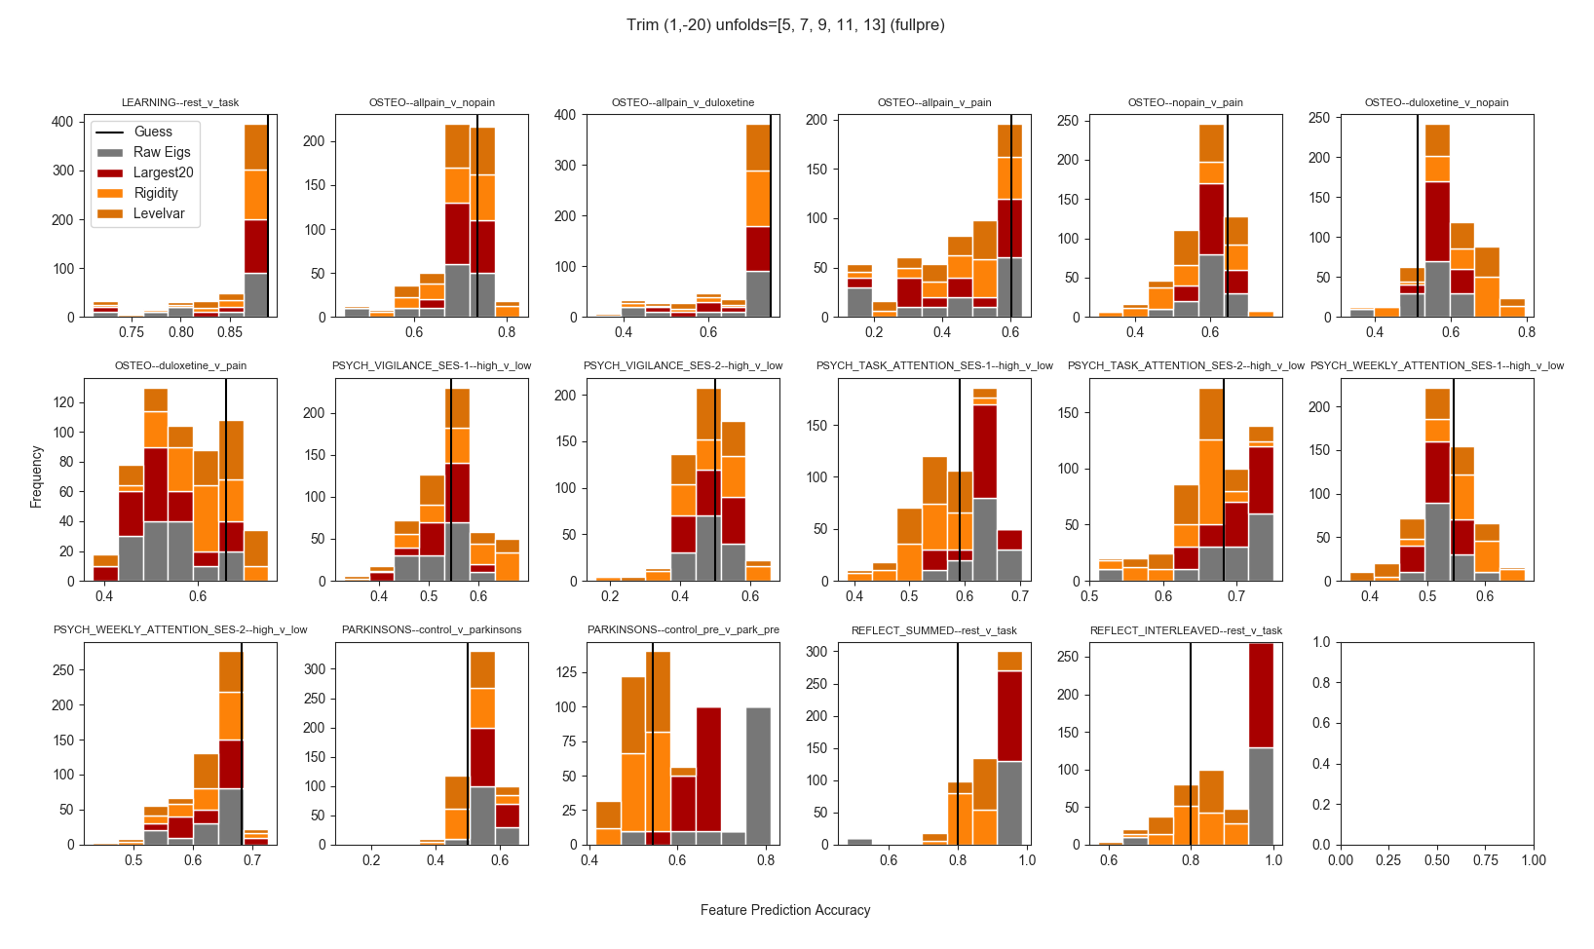
Supplementary Figure 5b. LOOCV mean prediction accuracies of nonscalar, unfolded features across classifiers and unfoldings, trimming the largest 20 eigenvalues. Values left of the vertical "Guess" line indicate prediction accuracies worse than simply guessing membership in the largest group.

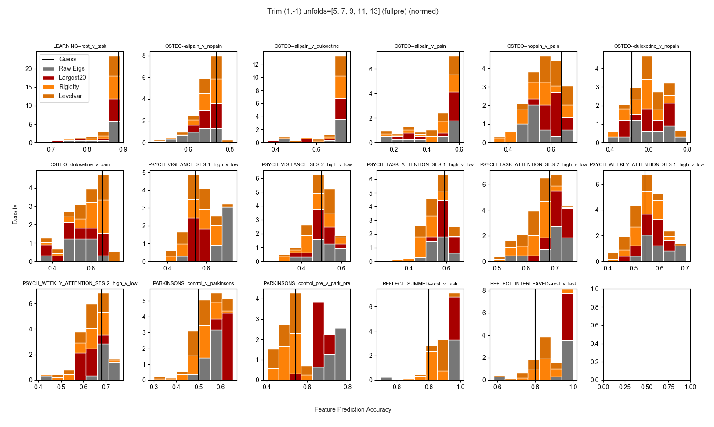
Supplementary Figure 5c. LOOCV mean prediction accuracies of nonscalar, unfolded features across classifiers and unfoldings, trimming the largest 20 eigenvalues., and min-max normalizing features to [0,1] prior to prediction. Values left of the vertical "Guess" line indicate prediction accuracies worse than simply guessing membership in the largest group.

Tables

From the main paper, we introduced some notation. We repeat and extend that here to ensure readers understand exactly what information is present in the tables below.

Denote all comparisons (groupings) as the set (e.g. g₁ = "LEARN: task v rest", g₂ = "OSTEO: allpain v nopain"). Let be the set of the eight RMT features examined. Let represent the different classifiers (e.g. "LR, logistic regression", "LDA"), let i.e. () be the unfolding degrees. Let be the two different amounts of trimming. We wish to examine, via LOOCV, the prediction accuracies for every point . If there are samples for some , LOOCV will yield prediction accuracies. Define the function to be the mean of those accuracies. Then is the real value equal to the mean LOOCV prediction accuracy of the binary classifier for feature , trimed via trim method and unfolded with polynomial degree , for comparison .

Given a function with positional parameters , with denote the set of possible values of interest for each ith parameter as , where (i.e. each parameter in position admits different valid values, and only the values in are valid for the parameter in position ). Let denote the average over all possible valid combinations of the parameters of . That is, if we have , , , then :

.

If we set , then . Thus a set with a single wrapped value in the subscript means those wrapped values are fixed (e.g. we are only averaging across sets in the subscript that have more than one element).

Then depicted in the first row, column i of each large supplementary table (e.g. Tables S1-2, S11-18) is a value:, or , where and (or ) are identified in the table caption, and is the classifier named at the top of column i. Likewise, the bottom of row each such table, "max", for column i is the value:

or:

where and (or ) are identified in the table caption. The "min" and percent rows are as above for "max", but where e.g. the % row means replacing "max" above with a function that returns the th percentile value.

Thus, each table summarizes the distribution of the values of across unfolding degrees and trims, either across all comparisons (Tables S11-18) or specific comparisons (Tables S1-10). Each column always depicts a specific classifer, and each row always contains a measure of scale (or location, for the second row) for the distribution of values. Short tables depict only average values (e.g. all column values are of the form or ).
Supplementary Table 1. Spectral rigidity mean LOOCV prediction accuracy by classifier across all unfoldings and trims for comparison of controls vs. osteopathic pain with duloxetine. LR = Logistic Regression, LDA = Linear Discriminant Analysis; SVM = Support Vector Machine; KNN-m = m-nearest neighbors; std = standard deviation; 25%, 50%, and 75% = percentiles. Dummy classifier accuracy = 0.51.

Supplementary Table 2. Level number variance mean LOOCV prediction accuracy by classifier across all unfolding degrees, and trims for comparison of controls vs. osteopathic pain with duloxetine. LR = Logistic Regression, LDA = Linear Discriminant Analysis; SVM = Support Vector Machine; KNN-m = m-nearest neighbors; std = standard deviation; 25%, 50%, and 75% = percentiles. Dummy classifier accuracy = 0.51.

Supplementary Table 3. Average (across unfolding degrees, and trims) mean LOOCV prediction accuracies of Raw (sorted, non-unfolded) eigenvalues by classifier for comparison of controls vs. osteopathic pain with duloxetine. No normalization prior to classification. LR = Logistic Regression, LDA = Linear Discriminant Analysis; SVM = Support Vector Machine; KNN-m = m-nearest neighbors. Dummy classifier accuracy = 0.51.

Supplementary Table 4 . Average (across unfolding degrees, and trims) mean LOOCV prediction accuracies of raw (sorted, non-unfolded) eigenvalues by classifier for comparison of controls vs. osteopathic pain with duloxetine. Normalizing prior to classification. LR = Logistic Regression, LDA = Linear Discriminant Analysis; SVM = Support Vector Machine; KNN-m = m-nearest neighbors. Dummy classifier accuracy = 0.51.

Supplementary Table 5. Average (across unfolding degrees, and trims) mean LOOCV prediction accuracies of noise ratio for OSTEO data, duloxetine versus nopain (control) comparison. Guess = 0.51.

Supplementary Table 6. Average (across unfolding degrees, and trims) mean LOOCV prediction accuracies of largest eigenvalue for PSYCH data, both sessions, high vs. low self-reported vigilance comparison. Session-1 guess = 0.55, session-2 guess = 0.50.

Supplementary Table 7. Average (across unfolding degrees, and trims) mean LOOCV prediction accuracies of raw eigenvalues (not normalized) for PSYCH data, both sessions, high vs. low self-reported vigilance comparison. Session-1 guess = 0.55, session-2 guess = 0.50.

Supplementary Table 8. Average (across unfolding degrees, and trims) mean LOOCV prediction accuracies of raw eigenvalues (min-max normalized to [0,1]) for PSYCH data, both sessions, high vs. low self-reported vigilance comparison. Session-1 guess = 0.55, session-2 guess = 0.50.

Supplementary Table 9. Average (across unfolding degrees, and trims) mean LOOCV prediction accuracies of raw eigenvalues (Raw = unscaled, Normed = min-max normalized to [0,1]) for PARK data, Parkinson's vs. controls comparison. Guess = 0.50.

Supplementary Table 10. Average (across unfolding degrees, and trims) mean LOOCV prediction accuracies of raw eigenvalues (Raw = unscaled, Normed = min-max normalized to [0,1]) for OSTEO data, duloxetine vs. controls comparison. Guess = 0.51.

Supplementary Table 11. Mean LOOCV prediction accuracies (minus the accuracy of a dummy classifier) for raw eigenvalues (unnormalized) across all comparisons, unfolding degrees, and trims. Negative values indicate that using the eigenvalues for prediction resulted in accuracies worse than guess, by that amount. std = standard deviation, 25%, 50%, 75% indicate percentiles.

Supplementary Table 12. Mean LOOCV prediction accuracies (minus the accuracy of a dummy classifier) for raw eigenvalues (min-max normalized to [0,1]) across all comparisons, unfolding degrees, and trims.. Negative values indicate that using the eigenvalues for prediction resulted in accuracies worse than guess, by that amount. std = standard deviation, 25%, 50%, 75% indicate percentiles.

Supplementary Table 13. Mean LOOCV prediction accuracies (minus the accuracy of a dummy classifier) for spectral rigidity across all comparisons, unfolding degrees, and trims.. Negative values indicate that using the spectral rigidity for prediction resulted in accuracies worse than guess, by that amount. std = standard deviation, 25%, 50%, 75% indicate percentiles.

Supplementary Table 14. Mean LOOCV prediction accuracies (minus the accuracy of a dummy classifier) for level number variance across all comparisons, unfolding degrees, and trims. Negative values indicate that using the number level variance for prediction resulted in accuracies worse than guess, by that amount. std = standard deviation, 25%, 50%, 75% indicate percentiles.

Supplementary Table 15. Mean LOOCV prediction accuracies (minus the accuracy of a dummy classifier) for the largest eigenvalue across all comparisons, unfolding degrees, and trims. Negative values indicate that using the largest eigenvalue for prediction was worse than guess. std = standard deviation, 25%, 50%, 75% indicate percentiles.

Supplementary Table16. Mean LOOCV prediction accuracies (minus the accuracy of a dummy classifier) for the unshifted noise ratio across all comparisons, unfolding degrees, and trims. Negative values indicate that using the unshifted noise ratio for prediction was worse than guess. std = standard deviation, 25%, 50%, 75% indicate percentiles.

Supplementary Table 17. Mean LOOCV prediction accuracies (minus the accuracy of a dummy classifier) for the shifted noise ratio across all comparisons, unfolding degrees, and trims. Negative values indicate that using the shifted noise ratio for prediction was worse than guess. std = standard deviation, 25%, 50%, 75% indicate percentiles.

Supplementary Table 18. Mean LOOCV prediction accuracies (minus the accuracy of a dummy classifier) for the largest 20 eigenvalues across all comparisons, unfolding degrees, and trims. Negative values indicate that using the largest 20 eigenvalues for prediction was worse than guess. std = standard deviation, 25%, 50%, 75% indicate percentiles.
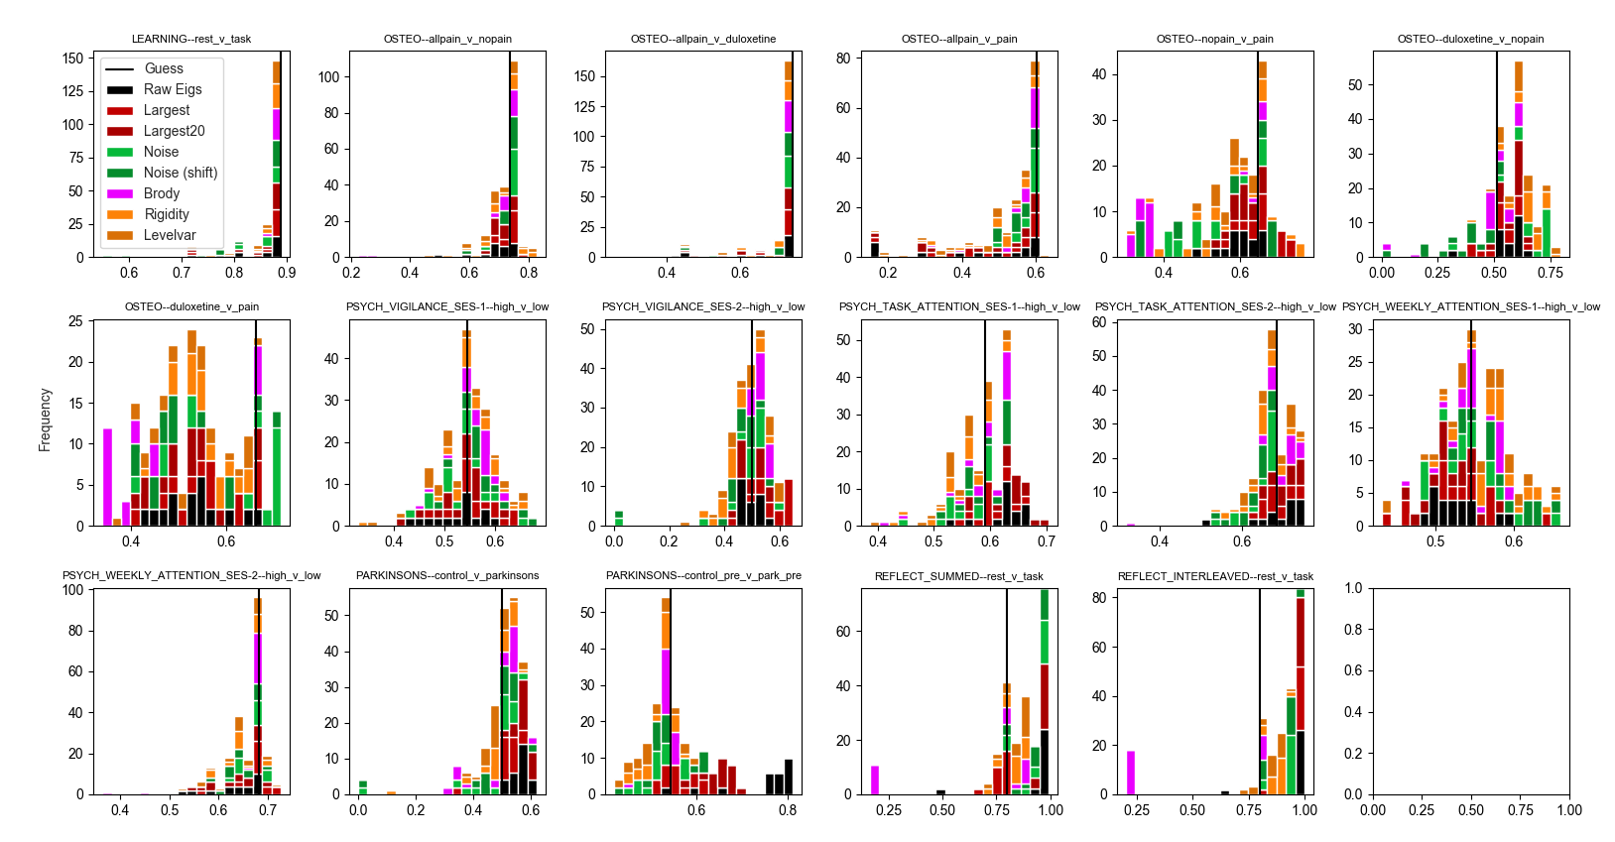
Supplementary Figure 19. Effect of lower unfolding polynomial degrees (5 and 7) on RMT feature prediction accuracies.

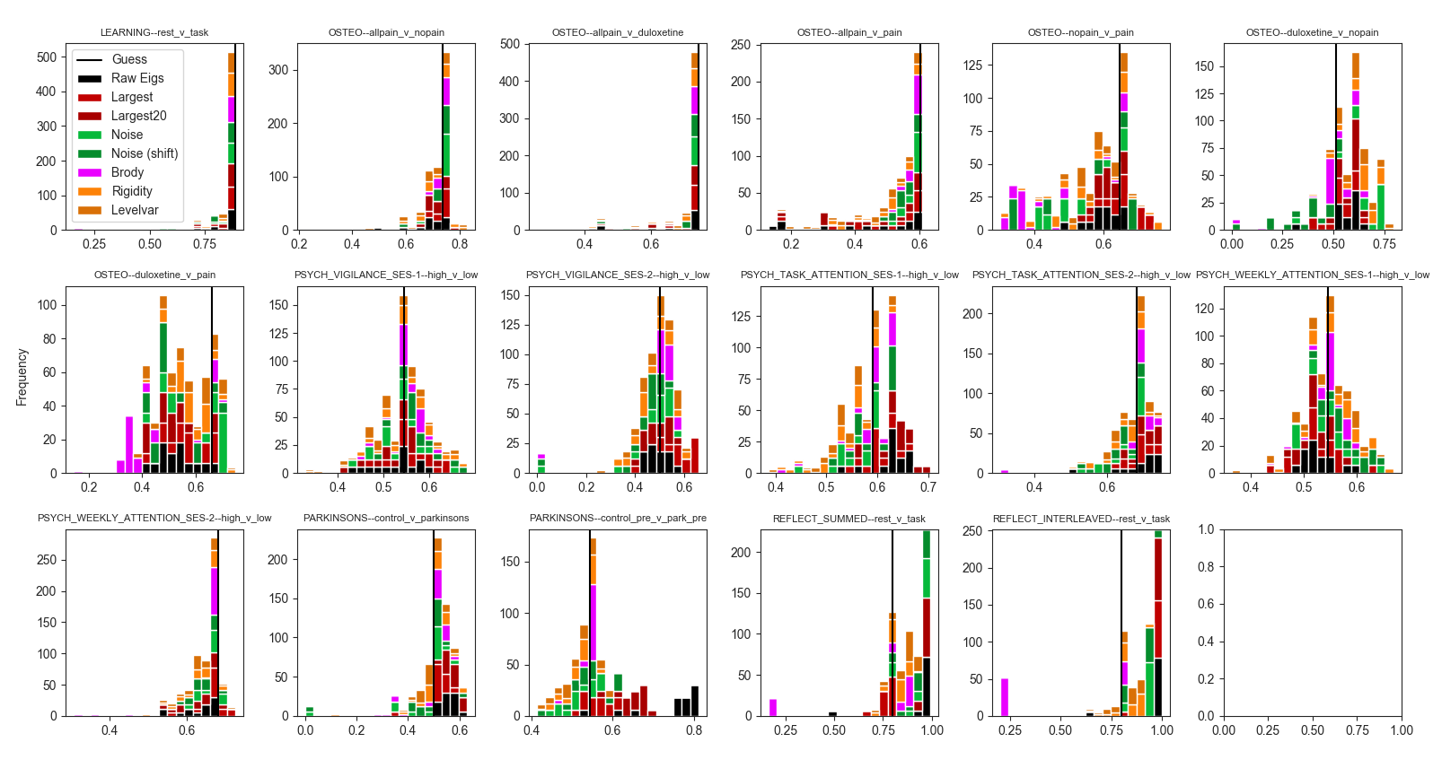
Supplementary Figure 20. Effect of higher unfolding polynomial degrees (11 and 13) on RMT feature prediction accuracies.

