Figures

To summarize the large amount of data generated in this study, the stacked histograms in Figures S1-8 and Figures S11-13 (below) were created. As these figures are complex and summarize extremely large amounts of data, we introduce some notation to ensure clarity of interpretation.
Denote all comparisons (groupings) as the set (e.g. g₁ = "LEARN: task v rest", g₂ = "OSTEO: allpain v nopain"). Let be the set of the eight RMT features examined. Let represent the different classifiers (e.g. "LR, logistic regression", "LDA"), let i.e. ( ) be the unfolding degrees. We wish to examine, via LOOCV, the prediction accuracies for every point (over 9500 points). If there are samples for some , LOOCV will yield prediction accuracies. Define the function to be the mean of those accuracies. Then the real value is equal to the mean LOOCV prediction accuracy of the binary classifier for feature unfolded with a polynomial degree , for comparison. Using set-builder notation, Figures S1-2 thus depict:

Different features in Figure S1-8, S11-12 are encoded by color. For example, the black bars (raw eigenvalues) in Figures S1-4 depict the set (i.e. . The black bars in the first (upper left) subplot of each of these figures then are the histogram for the set .
The central, vertical black comparison line "Guess" in each subplot of Figures S1-8, S11-13 indicates the accuracy of a naive classifier that always predicts membership in the larger of the subgroups. Thus, when most of the bars of one colour are right of this line, it suggests predictions using that feature mostly outperform guessing, and contrariwise when most are to the left. So for example, focusing on the subplot labeled PSYCH_VIGILANCE_SES-2 in Figure S1, we can see that overall (ignoring colour, i.e. examining the stacked histrogram as if all colours were identical and no boundaries separated those colours) the RMT features led to predictions better than a naïve classifier in this dataset, but that the reverse was the case for the unshifted noise ratio (light green). Similar figures and additional descriptions are available in the supplementary material.

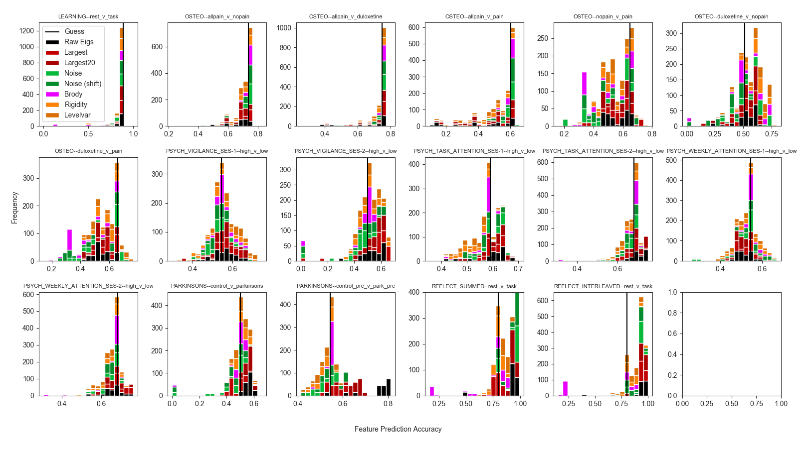
Supplementary Figure 1. LOOCV prediction accuracies across all features for all unfoldings, trimming largest eigenvalue only. Values left of the vertical "Guess" line indicate prediction accuracies worse than simply guessing membership in the largest group. . Accuracies for the PARK (PARKINSONS) data calculated from the full preprocessing pipeline in (cite) are labeled as "pre", and visible in the third plot on the bottom row. Accuracies from this study’s minimal preprocessing pipeline are shown in the second figure of the bottom row.
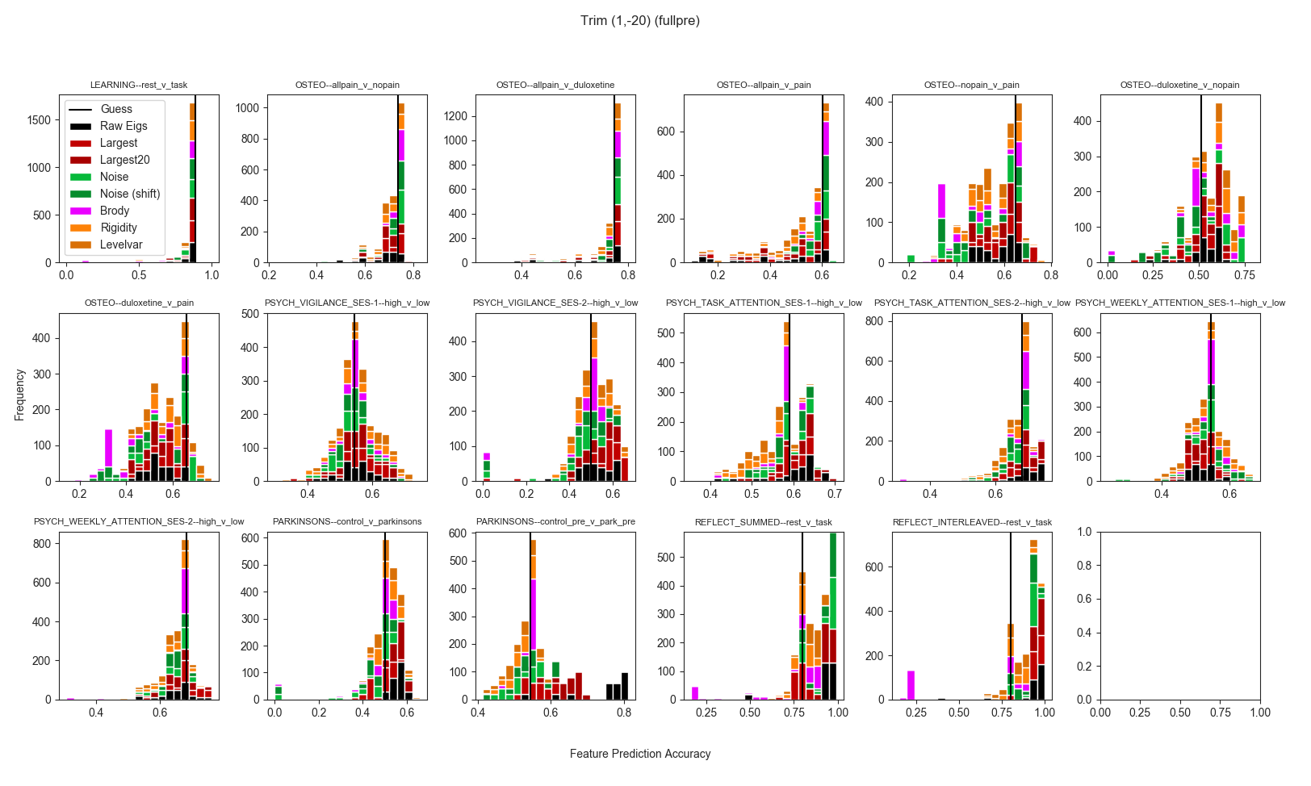
Supplementary Figure 2. LOOCV prediction accuracies for all features for all unfoldings and classifiers, after trimming largest 20 eigenvalues. Values left of the vertical "Guess" line indicate prediction accuracies worse than simply guessing membership in the largest group.
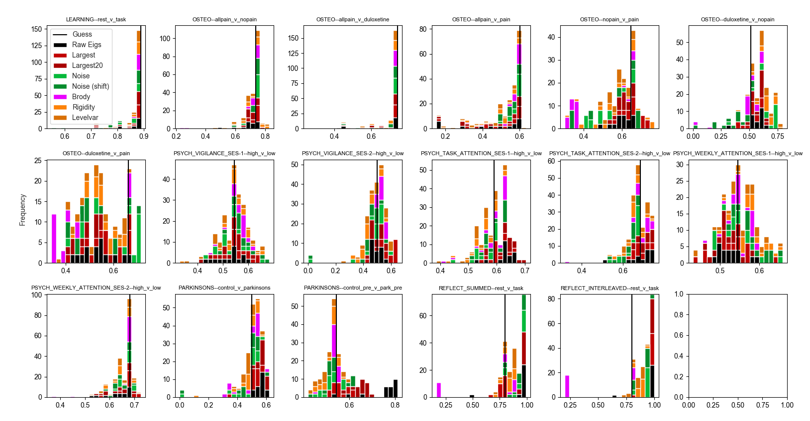
Supplementary Figure 3. LOOCV prediction accuracies for only lower unfolding degrees, for all features for all classifiers, after trimming largest eigenvalue only. Values left of the vertical "Guess" line indicate prediction accuracies worse than simply guessing membership in the largest group.
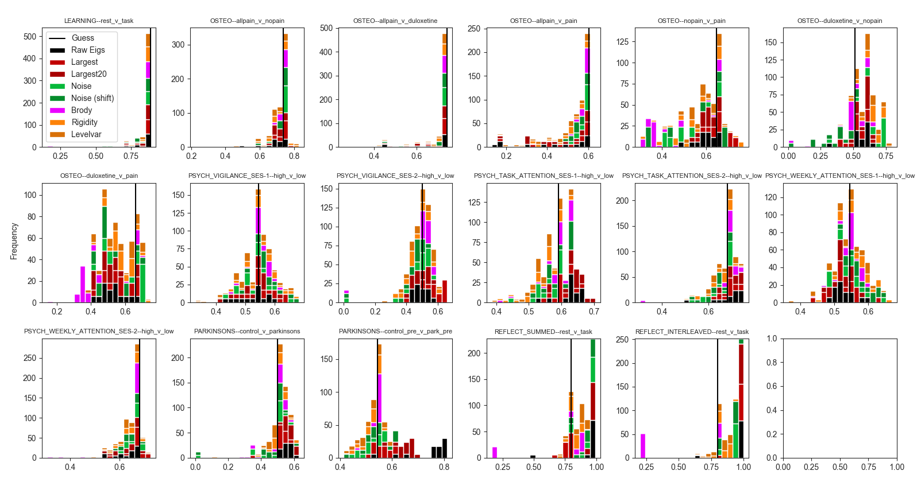
Supplementary Figure 4. LOOCV prediction accuracies for only higher unfolding degrees, for all features for all classifiers, after trimming largest eigenvalue only. Values left of the vertical "Guess" line indicate prediction accuracies worse than simply guessing membership in the largest group.
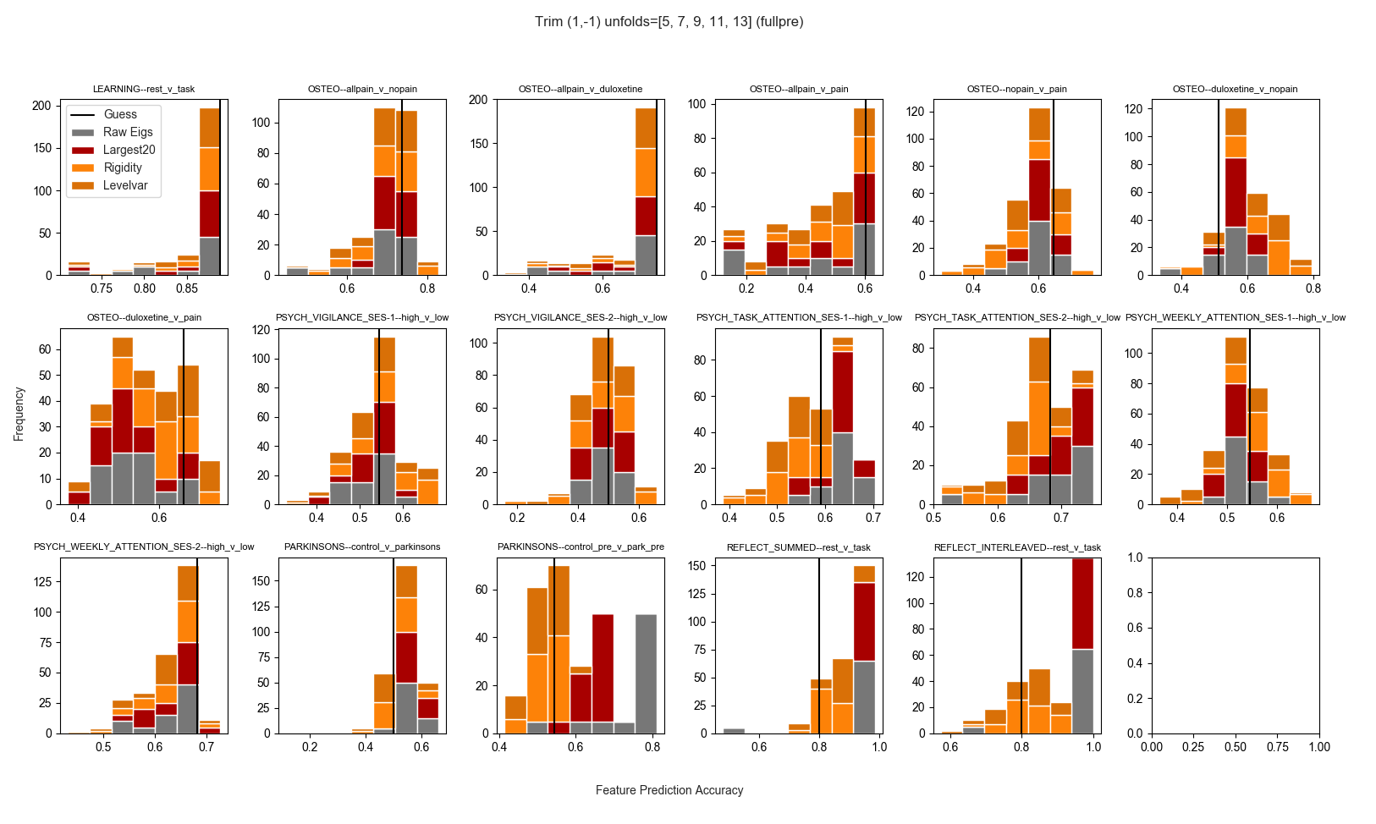
Supplementary Figure 5. LOOCV mean prediction accuracies of nonscalar, unfolded features across classifiers and unfoldings, trimming only the largest eigenvalue. Values left of the vertical "Guess" line indicate prediction accuracies worse than simply guessing membership in the largest group.
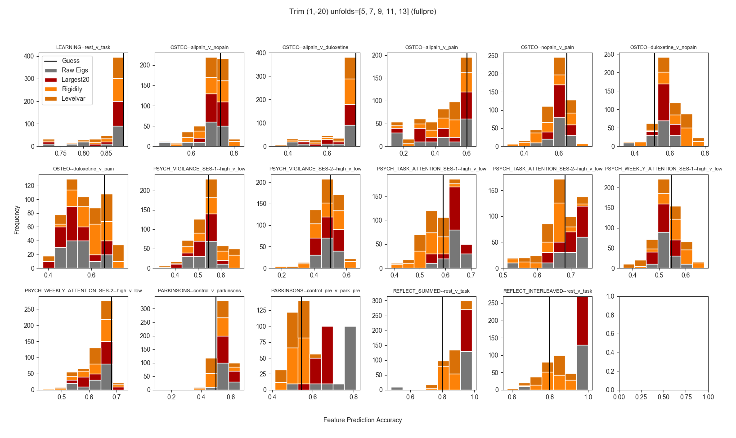
Supplementary Figure 6. LOOCV mean prediction accuracies of nonscalar, unfolded features across classifiers and unfoldings, trimming the largest 20 eigenvalues. Values left of the vertical "Guess" line indicate prediction accuracies worse than simply guessing membership in the largest group.
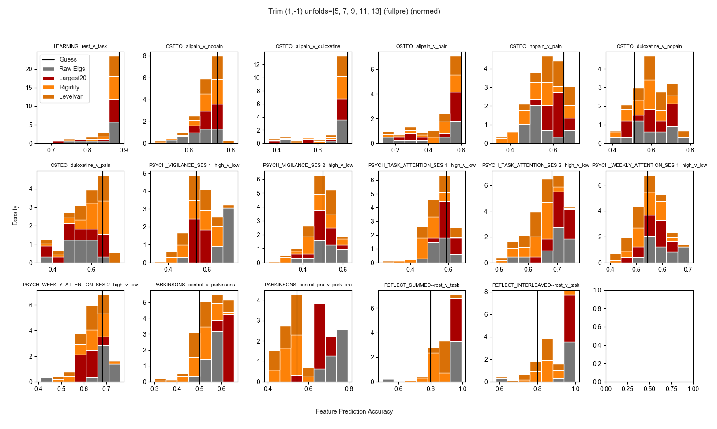
Supplementary Figure 7. LOOCV mean prediction accuracies of nonscalar, unfolded features across classifiers and unfoldings, trimming the largest 20 eigenvalues., and min-max normalizing features to [0,1] prior to prediction. Values left of the vertical "Guess" line indicate prediction accuracies worse than simply guessing membership in the largest group.
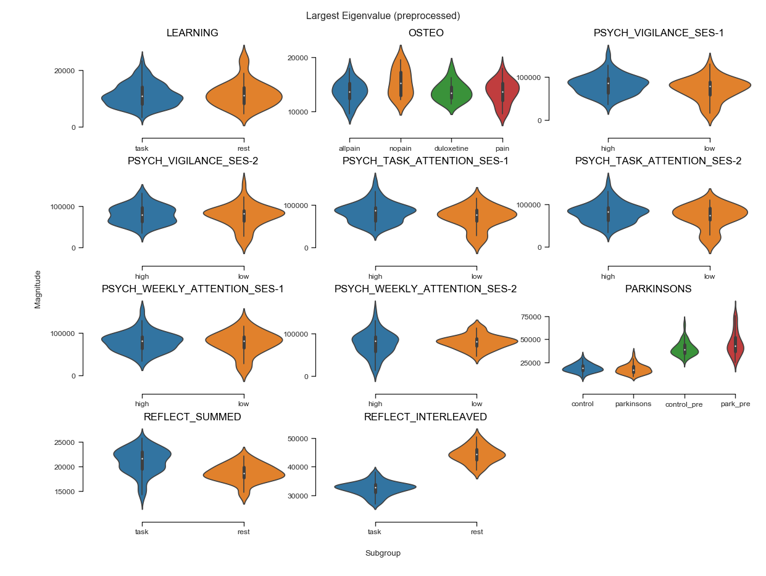
Supplementary Figure 8. Distributions of the largest eigenvalue across datasets and subgroups. For OSTEO data, ”pain” condition is subjects with osteopathic pain who are given placebo.
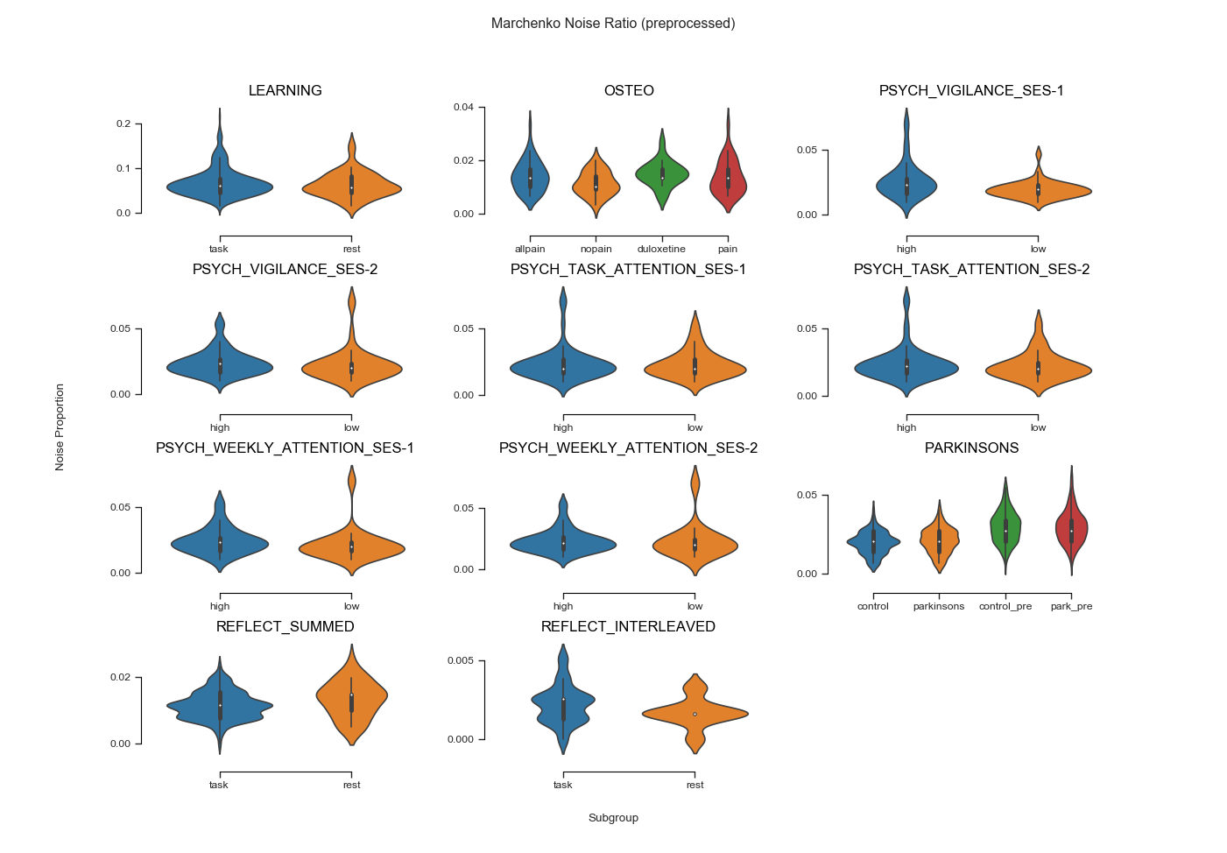
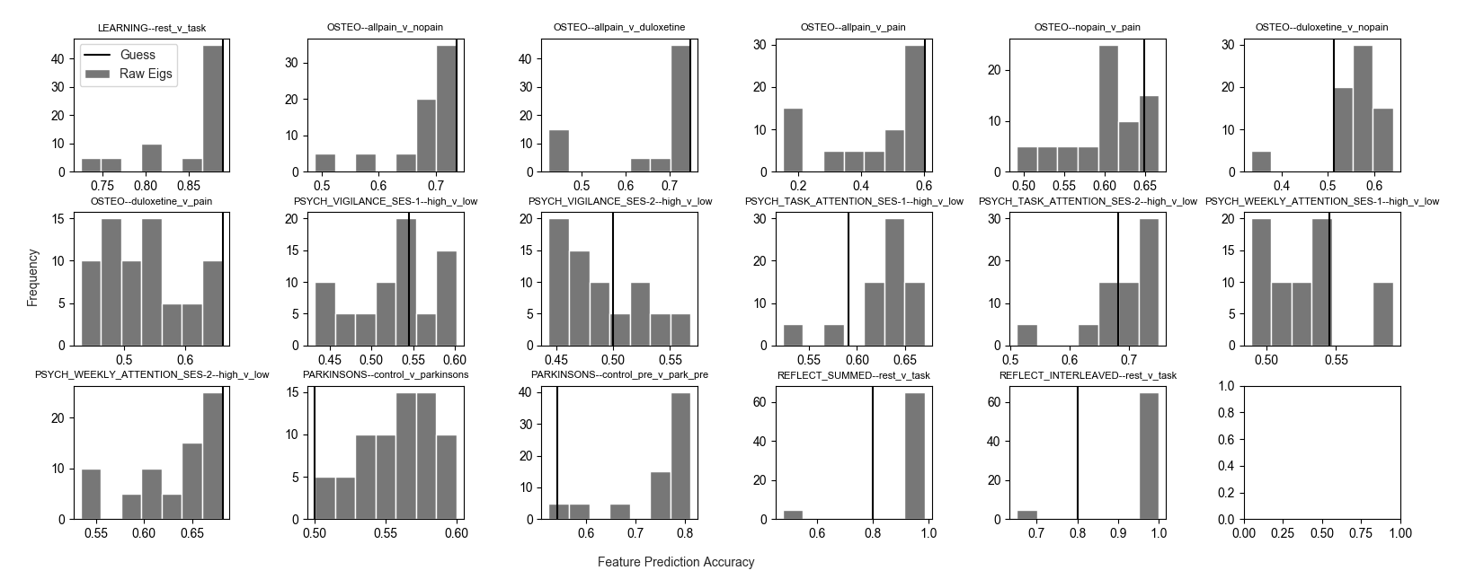
Supplementary Figure 9. Distributions of the noise ratios (unshifted) across datasets and subgroups. For OSTEO data, ”pain” condition is subjects with osteopathic pain who are given placebo.
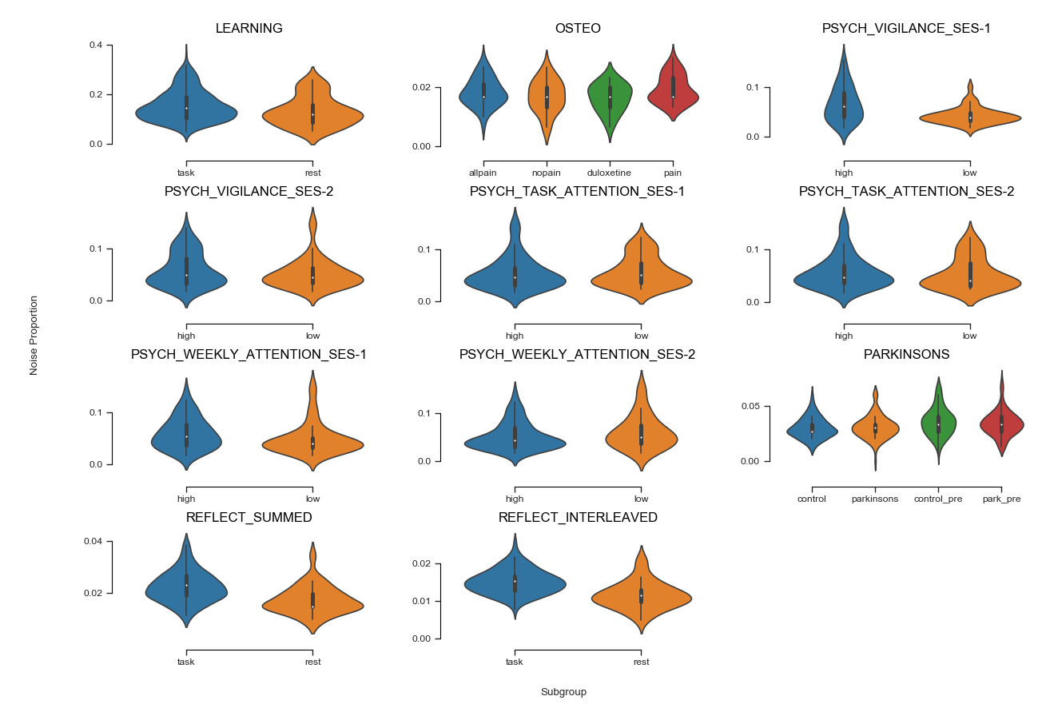
Supplementary Figure 10. Distributions of the noise ratios (shifted) across datasets and subgroups. For OSTEO data, ”pain” condition is subjects with osteopathic pain who are given placebo.
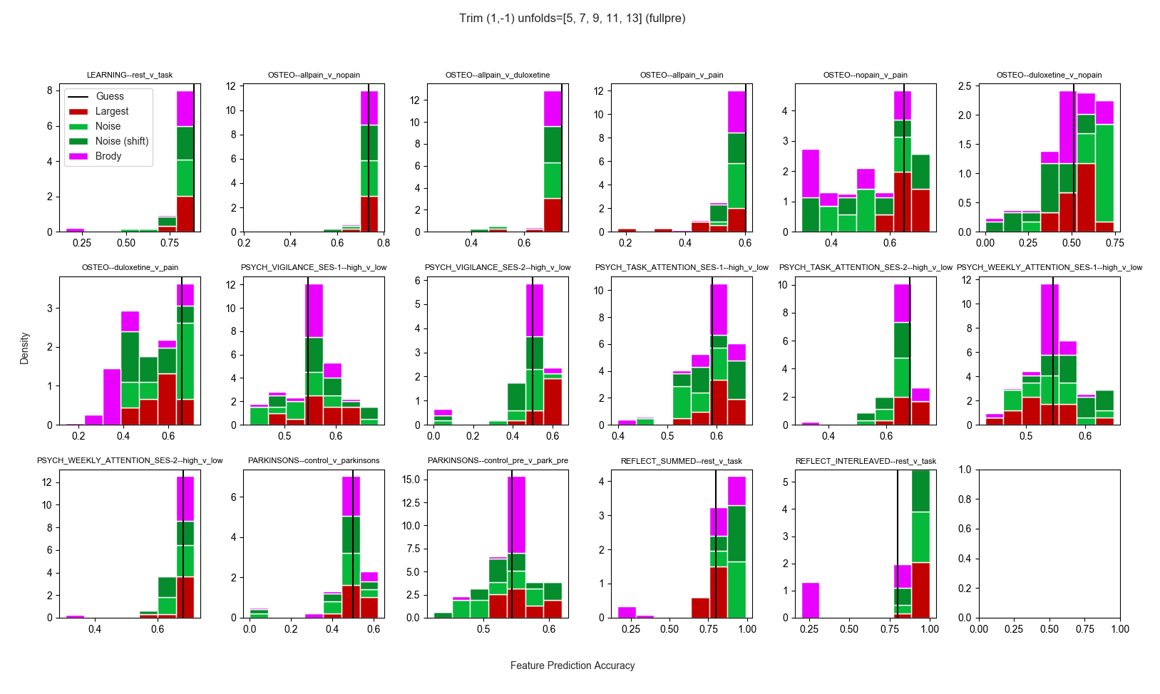
Supplementary Figure 11. LOOCV mean prediction accuracies of scalar features across classifiers. Brody parameter mean LOOCV prediction accuracies shown across all unfoldings, trimming only the largest eigenvalue. Values left of the vertical "Guess" line indicate prediction accuracies worse than simply guessing membership in the largest group.
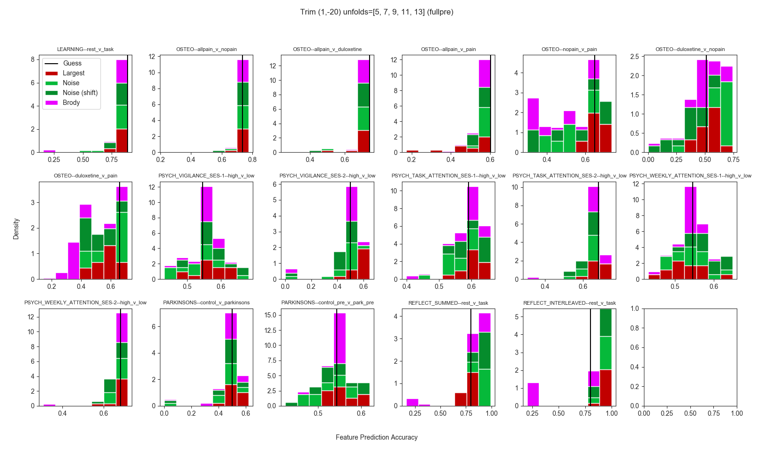
Supplementary Figure 12. LOOCV mean prediction accuracies of scalar features across classifiers. Brody parameter mean LOOCV prediction accuracies shown across all unfoldings, trimming the largest 20 eigenvalues. Values left of the vertical "Guess" line indicate prediction accuracies worse than simply guessing membership in the largest group.

Supplementary Figure 13.Prediction accuracy of raw eigenvalues across classifiers (no normalization of eigenvalues).

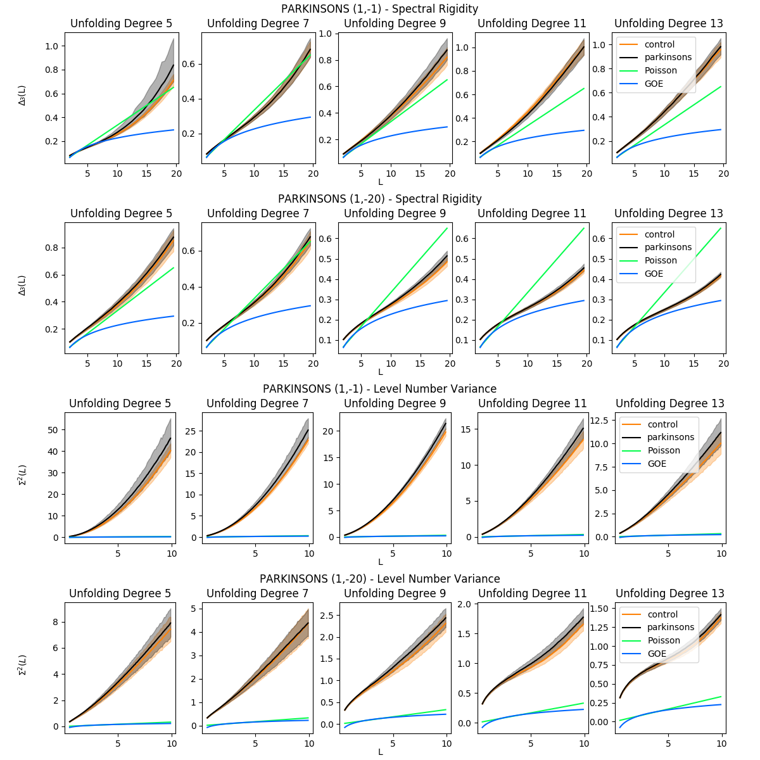
Supplementary Figure 14. Spectral rigidity and level number variance across unfolding degrees and trim regions for PARK data. Solid lines indicate group mean rigidity, and shaded regions correspond to 99% percentile bootstrapped intervals for each group. Titles with (1,-1) indicate trimming of only the largest eigenvalue, whereas titles with (1,-20) indicate trimming of the 20 largest eigenvalues. Note varying vertical axes.

Tables

From the main paper, we introduced some notation. We repeat and extend that here to ensure readers understand exactly what information is present in the tables below.

Denote all comparisons (groupings) as the set (e.g. g₁ = "LEARN: task v rest", g₂ = "OSTEO: allpain v nopain"). Let be the set of the eight RMT features examined. Let represent the different classifiers (e.g. "LR, logistic regression", "LDA"), let i.e. () be the unfolding degrees. Let be the two different amounts of trimming. We wish to examine, via LOOCV, the prediction accuracies for every point . If there are samples for some , LOOCV will yield prediction accuracies. Define the function to be the mean of those accuracies. Then is the real value equal to the mean LOOCV prediction accuracy of the binary classifier for feature , trimed via trim method and unfolded with polynomial degree , for comparison .

Given a function with positional parameters , with denote the set of possible values of interest for each ith parameter as , where (i.e. each parameter in position admits different valid values, and only the values in are valid for the parameter in position ). Let denote the average over all possible valid combinations of the parameters of . That is, if we have , , , then :

.

If we set , then . Thus a set with a single wrapped value in the subscript means those wrapped values are fixed (e.g. we are only averaging across sets in the subscript that have more than one element).

Then depicted in the first row, column i of each large supplementary table (e.g. Tables S1-2, S11-18) is a value:, or , where and (or ) are identified in the table caption, and is the classifier named at the top of column i. Likewise, the bottom of row each such table, "max", for column i is the value:

or:

where and (or ) are identified in the table caption. The "min" and percent rows are as above for "max", but where e.g. the % row means replacing "max" above with a function that returns the th percentile value.

Thus, each table summarizes the distribution of the values of across unfolding degrees and trims, either across all comparisons (Tables S11-18) or specific comparisons (Tables S1-10). Each column always depicts a specific classifer, and each row always contains a measure of scale (or location, for the second row) for the distribution of values. Short tables depict only average values (e.g. all column values are of the form or ).

Supplementary Table 1. Spectral rigidity mean LOOCV prediction accuracy by classifier across all unfoldings and trims for comparison of controls vs. osteopathic pain with duloxetine. LR = Logistic Regression, LDA = Linear Discriminant Analysis; SVM = Support Vector Machine; KNN-m = m-nearest neighbors; std = standard deviation; 25%, 50%, and 75% = percentiles. Dummy classifier accuracy = 0.51.

Supplementary Table 2. Level number variance mean LOOCV prediction accuracy by classifier across all unfolding degrees, and trims for comparison of controls vs. osteopathic pain with duloxetine. LR = Logistic Regression, LDA = Linear Discriminant Analysis; SVM = Support Vector Machine; KNN-m = m-nearest neighbors; std = standard deviation; 25%, 50%, and 75% = percentiles. Dummy classifier accuracy = 0.51.

Supplementary Table 3. Average (across unfolding degrees, and trims) mean LOOCV prediction accuracies of Raw (sorted, non-unfolded) eigenvalues by classifier for comparison of controls vs. osteopathic pain with duloxetine. No normalization prior to classification. LR = Logistic Regression, LDA = Linear Discriminant Analysis; SVM = Support Vector Machine; KNN-m = m-nearest neighbors. Dummy classifier accuracy = 0.51.

Supplementary Table 4 . Average (across unfolding degrees, and trims) mean LOOCV prediction accuracies of raw (sorted, non-unfolded) eigenvalues by classifier for comparison of controls vs. osteopathic pain with duloxetine. Normalizing prior to classification. LR = Logistic Regression, LDA = Linear Discriminant Analysis; SVM = Support Vector Machine; KNN-m = m-nearest neighbors. Dummy classifier accuracy = 0.51.

Supplementary Table 5. Average (across unfolding degrees, and trims) mean LOOCV prediction accuracies of noise ratio for OSTEO data, duloxetine versus nopain (control) comparison. Guess = 0.51.

Supplementary Table 6. Average (across unfolding degrees, and trims) mean LOOCV prediction accuracies of largest eigenvalue for PSYCH data, both sessions, high vs. low self-reported vigilance comparison. Session-1 guess = 0.55, session-2 guess = 0.50.

Supplementary Table 7. Average (across unfolding degrees, and trims) mean LOOCV prediction accuracies of raw eigenvalues (not normalized) for PSYCH data, both sessions, high vs. low self-reported vigilance comparison. Session-1 guess = 0.55, session-2 guess = 0.50.

Supplementary Table 8. Average (across unfolding degrees, and trims) mean LOOCV prediction accuracies of raw eigenvalues (min-max normalized to [0,1]) for PSYCH data, both sessions, high vs. low self-reported vigilance comparison. Session-1 guess = 0.55, session-2 guess = 0.50.

Supplementary Table 9. Average (across unfolding degrees, and trims) mean LOOCV prediction accuracies of raw eigenvalues (Raw = unscaled, Normed = min-max normalized to [0,1]) for PARK data, Parkinson's vs. controls comparison. Guess = 0.50.

Supplementary Table 10. Average (across unfolding degrees, and trims) mean LOOCV prediction accuracies of raw eigenvalues (Raw = unscaled, Normed = min-max normalized to [0,1]) for OSTEO data, duloxetine vs. controls comparison. Guess = 0.51.

Supplementary Table 11. Mean LOOCV prediction accuracies (minus the accuracy of a dummy classifier) for raw eigenvalues (unnormalized) across all comparisons, unfolding degrees, and trims. Negative values indicate that using the eigenvalues for prediction resulted in accuracies worse than guess, by that amount. std = standard deviation, 25%, 50%, 75% indicate percentiles.

Supplementary Table 12. Mean LOOCV prediction accuracies (minus the accuracy of a dummy classifier) for raw eigenvalues (min-max normalized to [0,1]) across all comparisons, unfolding degrees, and trims.. Negative values indicate that using the eigenvalues for prediction resulted in accuracies worse than guess, by that amount. std = standard deviation, 25%, 50%, 75% indicate percentiles.

Supplementary Table 13. Mean LOOCV prediction accuracies (minus the accuracy of a dummy classifier) for spectral rigidity across all comparisons, unfolding degrees, and trims.. Negative values indicate that using the spectral rigidity for prediction resulted in accuracies worse than guess, by that amount. std = standard deviation, 25%, 50%, 75% indicate percentiles.

Supplementary Table 14. Mean LOOCV prediction accuracies (minus the accuracy of a dummy classifier) for level number variance across all comparisons, unfolding degrees, and trims. Negative values indicate that using the number level variance for prediction resulted in accuracies worse than guess, by that amount. std = standard deviation, 25%, 50%, 75% indicate percentiles.

Supplementary Table 15. Mean LOOCV prediction accuracies (minus the accuracy of a dummy classifier) for the largest eigenvalue across all comparisons, unfolding degrees, and trims. Negative values indicate that using the largest eigenvalue for prediction was worse than guess. std = standard deviation, 25%, 50%, 75% indicate percentiles.

Supplementary Table16. Mean LOOCV prediction accuracies (minus the accuracy of a dummy classifier) for the unshifted noise ratio across all comparisons, unfolding degrees, and trims. Negative values indicate that using the unshifted noise ratio for prediction was worse than guess. std = standard deviation, 25%, 50%, 75% indicate percentiles.

Supplementary Table 17. Mean LOOCV prediction accuracies (minus the accuracy of a dummy classifier) for the shifted noise ratio across all comparisons, unfolding degrees, and trims. Negative values indicate that using the shifted noise ratio for prediction was worse than guess. std = standard deviation, 25%, 50%, 75% indicate percentiles.

Supplementary Table 18. Mean LOOCV prediction accuracies (minus the accuracy of a dummy classifier) for the largest 20 eigenvalues across all comparisons, unfolding degrees, and trims. Negative values indicate that using the largest 20 eigenvalues for prediction was worse than guess. std = standard deviation, 25%, 50%, 75% indicate percentiles.

