Random Matrix Theory Based Tools for the Analysis of Functional Magnetic-Resonance Imaging Examinations

Author List:
Derek Berger, Gurpreet Matharoo, Jacob Levman
Abstract
Previous studies have investigated the potential of using analytic techniques from Random Matrix Theory (RMT) to investigate magnetic resonance imaging (MRI) data. We assess the potential application of RMT-based features for the analysis of functional MRI (fMRI) across diverse datasets. As novel contributions, we (1) assess the potential for RMT-inspired, whole-brain features extracted from voxel-wise functional connectivity to contain information useful for classifying between various psychological processes, (2) assess these features’ predictive—rather than explanatory—value, (3) investigate the effect of varying RMT analysis methods on the robustness of study findings, and (4) make general-purpose code publicly available for users to extract these features from a wide variety of data. We find preliminary evidence suggesting that RMT-inspired features may have unique potential in analyses of fMRI functional connectivity.

I. Introduction
In functional magnetic resonance imaging (fMRI) changes in the blood-oxygenation-level-dependent (BOLD) signals are related to neural activity. It is common to investigate statistical relationships between the BOLD signals through functional connectivity analyses, where correlations between collections of these signals are examined to infer connections between different voxels or regions of interest (ROIs) within the brain.
Whether in the presence of experimental stimuli, or the relative absence, as in a resting state, complex functional connectivity networks are ubiquitous [1]–[4]. This complexity suggests fMRI is a candidate to be studied using Random Matrix Theory (RMT), a set of mathematical tools originally developed some 50 years ago to solve complex problems in nuclear physics [5], [6]. In various physical systems where nuclei can have different possible states, precisely modeling the entirety of the interactions between nuclei is often intractable. For such large, complex systems, the eigenvalues (or spectra) efficiently summarize the totality of the interactions between components of the system, and RMT often describes the expected behaviour of such eigenvalues. By analysing the spectrum statistically, complex systems can be investigated by comparison to the universal properties predicted by RMT.
These universal properties have been observed in diverse phenomena. In small-scale systems, RMT universalities have been observed in quantum chaotic systems, complex nuclei, atoms, molecules and disordered mesoscopic systems [5]–[11], and at larger scales, RMT has been applied to atmospheric physics[12], stock cross-correlations[13], social networks[14], random networks[15], network-formation in liquids[16], [17] and amorphous clusters[18]–[21]. Within biological systems, RMT has also been used to successfully model aspects of amino acid functional relationships[22], synchrony in epileptic seizures[23], and protein-protein interactions in different species[24] and breast cancer[25].
In recent years, RMT analyses have been applied to study brain functioning. The earliest study demonstrated that spectra of the correlations between electroencephalographic (EEG) signals closely resemble those of the Gaussian Orthogonal Ensemble (GOE) from RMT[26]. Somewhat more recently, RMT was used to evaluate the quality of whole brain features extracted from fMRI data[27], [28]. RMT has also been used in diffusion MRI to aid in the selection of the number of components to employ in principal-component reduction analysis and denoising[29]–[31].
Finally, RMT has been used in ROI-based fMRI functional-connectivity studies to investigate differences between rest and task states[32], between subjects with and without ADHD[33], and between pain and non-pain states[34]. Across these three studies, the spectra of resting or low-attention states exhibited properties closest to the GOE.
These findings suggest that certain aspects of psychological processes might be characterized, in part, by features computed from the eigenvalues of fMRI correlation matrices, and that these features might vary in an interpretable manner across psychological processes. If this is the case, RMT could have unique potential in characterizing the functioning of the human brain.
Here, we use a novel, voxel-based approach, and expand the applications of RMT to analyze fMRI scans from diverse datasets. We extract RMT-inspired whole-brain features from voxelwise functional connectivity data, and assess the predictive value of these features. We also exmaine in detail the robustness of the RMT methodology to various common analytic choices.
II. Materials and Methods
Datasets
In this study, our primary intention is to examine the potential utility of RMT-derived features across a wide variety of data, and not to decisively put forward or refute any specific hypotheses relating RMT to psychological processes. We thus examine a wide selection of fMRI datasets available on the OpenNeuro platform[35], including studies employing within-subject and between-subject designs, different scanning modalities (rs-fMRI, task-based fMRI, and multi-echo fMRI), and with different degrees of preprocessing. This allows for a broad assessment of the potential of voxelwise RMT features.
However, since previous studies employing RMT for feature extraction[33], [34] have partially interpreted their findings with respect to the attention and attentional processes, we have elected to use datasets that involve attention in some focal way. This includes measures of attention or vigilance, or comparisons between a condition involving more attention and focus (e.g. a task state) or conditions which should involve considerably less attention or focus (e.g. resting-state).
For the datasets, various scan parameters and acquisition details are summarized in Table 1, and sample and subgroup sizes are summarized in Table 2. For all datasets, we use the raw (unpreprocessed) scans, and perform our own preprocessing (detailed later). Given the complexity of these datasets, we highlight below only those aspects relevant to the current paper.
ID | Authors | FOV (mm) | Dimensions | Voxel Size (mm) | TR | Volumes / Time | Physiological Data | Field Map
PSYCH | Gorgolewski et al. [36] | 192 | 128 × 128 × 70 | 1.5 × 1.5 × 1.5 | 3.0 | 300 / 15 | cardiac, respiratory, oxygen saturation | ✓
OSTEO | Tétreault et al. [37] | - | 64 × 64 × 36 | 3.4 × 3.4 × 3.0 | 2.5 | 300 / 12.5 | - | ×
REFLECT | DuPre et al. [38] (rest) | 210 | 72 × 72 × 46 | 3.0 × 3.0 × 3.0 | 3.0 | 204 / 10.2 | cardiac, respiratory | ×
 | DuPre et al. [38] (task) | 240 | 64 × 64 × 33 | 3.8 × 3.8 × 3.8 | 2.0 | 260 / 8.7 | cardiac, respiratory | ×
PARK | Madhyastha et al[39] | 240×240×129 | 80 × 80 × 43 | 3.0 × 3.0 × 3.0 | 2.4 | 149 / 5.96 | - | ×
LEARN | Schapiro et al. [40] | - | 64 × 64 × 36 | 3.0 × 3.0 × 3.0 | 2.0 | 195 / 6.5 | - | ✓
Table 1. Summary of scan parameters. ID = Identifier for this paper. FOV = Field of View. TR = Time of Repetition (seconds). Time = total duration (minutes) of each scan. Dimensions listed as M × N × P, indicate P slices with dimensions M × N.
Dataset 1
Dataset 1 (referred to in figures and tables with the label "PSYCH") has detailed and extensive information available in Gorgolewski et al. [36]. Subjects completed a battery of psychological measurements, and various resting-state fMRI (rs-fMRI) images were obtained. Only the whole-brain 7-Tesla rs-fMRI scans were used for the current paper, to make the results comparable to the other included datasets. For the purpose of keeping with the "attention" theme of the analyses in this paper, three pairings of subgroups were constructed via z-score splits of the various sum-scores of scale items involving concepts closely related to attention.
Trait Attention. The PANAS-X [41] is a 9-point Likert-type self-report measure that queries the extent to which subjects agree particular affective terms have applied to them over a recent time period (e.g. a few weeks). An ad hoc (i.e. face-valid) sum-score was constructed from the scale items: "attentive", "alert", "interested", "concentrating", and reverse-scored items "sluggish", "tired", "sleepy", "drowsy". Subjects with a z-score greater / less than zero on this sum-score were placed in the high / low "trait attention" category
Task Attention. The Conjunctive Continuous Performance Task (CCPT [42]) is a behavioural measure of sustained attention where subjects must react only if they see a red square among other different coloured figures. For this paper, a sum score was constructed by subtracting the number of false positive and false negative responses from the number of success responses, and subjects with a z-score greater / less than zero on this scale were placed in high / low "task attention" category.
ID | Authors | Subgroup / Condition | Subjects | Task | Scans per Task per Subj
PSYCH | Gorgolewski et al. [36] | high_vigilance | 12 / 11 | resting-state | 2
 |  | low_vigilance | 10 / 11 | resting-state | 2
 |  | trait_attend | 12 / 15 | resting-state | 2
 |  | trait_nonattend | 10 / 7 | resting-state | 2
 |  | task_attend | 13 / 15 | resting-state | 2
 |  | task_nonattend | 9 / 7 | resting-state | 2
LEARN | Schapiro et al. [52] | task | 24 | learn "satellite" image sketches | 16
 |  | rest | 24 | resting-state | 2
REFLECT | Tétreault et al. [46] | control (no pain) | 20 | resting-state | 1
 |  | duloxetine | 19 | resting-state | 1
 |  | placebo | 37 | resting-state | 1
 |  | allpain (duloxetine + placebo) | 56 | resting-state | 1
PARK | Madhyastha et al. [50] | Parkinson's | 17 | Attention Network Task [51] | 6
 |  | control | 17 | Attention Network Task [51] | 6
ECHO | DuPre at al. [47] | summed / interleave | 31 | resting-state | 1
 |  | summed / interleave | 31 | imagery, reflection tasks, | 4
Table 2. Summary of comparison subgroups. Subject counts of the format 11 / 12 indicate counts for the first session / second session.
Vigilance. The Mini New York cognition questionnaire assesses various elements of the subject's cognitive state, e.g. "my thoughts involved other people", "I thought about something positive" (translated from German)[45]. One question assesses alertness ("I was fully awake" / "war ich vollkommen wach") and was used to create high / low "vigilance" conditions in the same manner as the previous two splits.
Dataset 2
Dataset 2 (referred to in figures and tables with the label "OSTEO") is detailed in Tétreault et al.[46]. Subjects included healthy controls ("nopain" condition) and individuals with knee osteoarthritis ("pain" condition) treated for 2 weeks with either placebo ("pain" condition) or duloxetine ("duloxetine" condition). An additional grouping was also created with both the placebo and duloxetine data ("allpain" condition), allowing for six subgroup comparisons. All subjects were imaged with whole-brain rs-fMRI. Scan parameters are documented in Table 1. Although it is not a priori obvious whether we should expect the most focused attention in pain, placebo, or duloxetine conditions, one would hope, if voxelwise RMT can extract useful information, that there will be differences in some of the above. In addition, the use of rs-fMRI and RMT for examining pain makes these results complementary to those of [34].
Dataset 3
Dataset 3 (referred to in figures and tables with the label "REFLECT", due to the "reflective” nature of the cognitive tasks) is described in full detail by DuPre, Luh and Spreng[47]. Both multi-echo rs- and task-fMRI scans were conducted with scan parameters summarized in Table 1. Tasks involved viewing various affective images (see [48] for details) and performing tasks related to autobiographical memory, prospection, or theory-of-mind reasoning. Continuing with the theme of broadly comparing high versus low attention throughout this paper, the different tasks were simply treated generically as "attending", in contrast to the non-attentive resting-state scans. This results in four task state scans and one resting-state scan per subject.
In order to combine the multi-echo data into a single, usable matrix, two methods were employed. In the "summed" condition, echoes were combined via summation, a method which has value in providing an image with overall increased contrast[49]. In the "interleave" condition, echoes were interleaved at each voxel: that is, if we denote the voxel's ith signal value from echo j as , then the interleaved voxel of the new image has the time-series . This creates a physically-meaningful 4D image that contains the full, original multi-echo fMRI time-series data without any alterations. It should be noted that the purpose of these combination methods is not to create a 4D volume that allows optimal detection of the purely task-linked BOLD signal, but to ensure all scan information was used with minimal additional analytic assumptions.
Dataset 4
Dataset 4 (referred to in figures and tables with the label "PARK" or "PARKINSONS") is documented and described in detail in Madhyastha et al. [50]. Scan parameters are documented in Table 1. Subjects with non-demented Parkinson’s Disease (PD) and healthy controls performed a number of repetitions of the Attention Network Task (ANT) [51]. Subgroup details are available in Table 2. As the ANT task demands high attention[51], it is not as straightforward to create "high" or "low" attention groups. Instead, since attention presumably is high and varies little in this dataset, and subgroups instead differ by virtue ofthe presence or absence of PD, any results here serve as a useful comparison point for the results from studies that do clearly involve attentional differences. This dataset also included extensively preprocessed scans, which were included in analyses to examine the effects of preprocessing on the extracted RMT features.
Dataset 5
Dataset 5 (referred to in figures and tables with the label "LEARN") is documented and described in detail by Schapiro et al.[52]. In this study, both rs-fMRI and task fMRI scans were available for all subjects, allowing for within-subject comparisons. The task involved multiple phases, wherein subjects were exposed to named, black-and-white outlined satellite images related by family-resemblance of the components (see Figure 1 of [52]). After this learning task, subjects were tested on their memory of the various learned features. Scans corresponding to both the initial learning and subsequent testing phase were included in the high-attention "task" subgroup for the purposes of the analysis of this paper. Resting state scans were included in the low-attention "rest" subgroup.
Preprocessing
Some consideration should be given to whether it is appropriate to apply standard preprocessing steps before extracting RMT features, as preprocessing steps should be developed, tested, and employed always with respect to a set of inferential goals and a specific analytic framework. However, these preprocessing steps are increasingly recognized to have complex effects on fMRI analyses [53]. For example, spatial smoothing has clear benefits when employing a general linear model [54]–[56], but is less motivated in functional network analyses with small ROIs, where the effect of smoothing can be considerable [55], [57], [58], with these effects interacting complexly with factors like field strength and image resolution [59]. Similarly, image registration is usually required to allow comparisons across (or even within) subjects, but the choice of registration strategy can have dramatic effects on functional network analyses [60].
The RMT features extracted here are based on functional correlations rather than ROI activations, and are somewhat unique in being completely insensitive to voxel location. That is, any spatial re-arrangement of an image’s voxels will result in the exact same eigenvalues from the correlation matrix, and so identical RMT features. This means the RMT features summarize all voxel-wise correlations in a whole-brain and location-free manner, which brings into question much of the usual motivations for performing spatial smoothing, or registration to identify ROIs. In addition, if image dimensions are identical between subjects (as is the case within any dataset in this study, except the REFLECT dataset), the RMT features already allow for direct comparisons between subjects. For the NNSD, spectral rigidity, and level number variance, the unfolding procedure and mathematical definitions already allow comparisons of matrices of even different spatial dimensions. Thus, the usual motivations for registration are also no longer clear when extracting RMT features.
Given these particularities, as well as the novelty of the RMT-based methods and the diversity of the chosen datasets (Table 1), we have elected to minimize the complexity of the preprocessing pipeline. This ensures that data processing is kept as standardized as possible. Ultimately, different preprocessing pipelines for RMT fMRI analyses can be expected to have different benefits and shortcomings depending on the question being investigated, and possibly also the specific RMT features being relied upon, but such an investigation is beyond the scope of the current study.
For this paper’s analyses, skull-stripping is necessary in order to limit analyses to the appropriate voxels, motion correction is necessary to allow proper skull-stripping, and both motion-correction and slice-time correction make the interpretation of voxel-voxel correlations consistent across voxel locations. Whereas physiological noise regression and bias field correction would perhaps be appropriate here, there is insufficient data to perform these steps for all datasets (Table 1). Thus, motion-correction was performed with FSL's MCFLIRT [61], slicetime correction with the default method in FSL, and brain extraction was performed with BET [62]. Due to differences in the size of the REFLECT data, the higher-resolution resting-state data was interpolated to have the same spatial dimensions as the task data.
RMT-Derived Features
This paper examines features informed by various aspects of RMT, and which can be extracted from empirical correlation matrices. To keep with previous studies, we limit our analyses to features extracted only from the
eigenvalues of the matrices of correlations between all voxel signals. To efficiently compute the correlation eigenvalues from the large number of voxels, we make use transposes, as documented in Appendix A.
Two classes of features were examined in this study: those that require unfolding, and those that do not. In order to compare the observed eigenvalue distribution to some theoretical predictions, the eigenvalues must be unfolded[5], [6]. The details and motivation behind the unfolding procedure are well documented by Guhr et al.[5]. Practically, the unfolding process can be viewed as a smoothing and rescaling procedure where the originally observed spectrum is smoothly mapped to the unfolded spectrum , such that , if . For most empirical data, the true smoothing function is not known, and so must be approximated[5], [6]. Typically, a polynomial is chosen[43].
A number of statistics (or "spectral observables"[6]) can then be computed from this unfolded spectrum. In the literature, the two most common points of comparison for these unfolded features are typically (see e.g. [12], [14], [15], [24]–[26], [32], [33]) the features of the GOE and the Poisson or Gaussian Diagonal Ensemble (GDE).The GOE (or GDE) consists of real, symmetric matrices where entries (or only diagonal entries) are normal random variables with zero mean and unit variance. When the empirically observed features are close to those of the GOE, this is usually interpreted as indicating a high degree of randomness and statistical independence in the data, and when the observed features are closer to those expected in the GDE or Poisson case, this is interpreted as indicating a high degree of coherence or dependence[12], [14], [15], [24]–[26], [32]–[34].
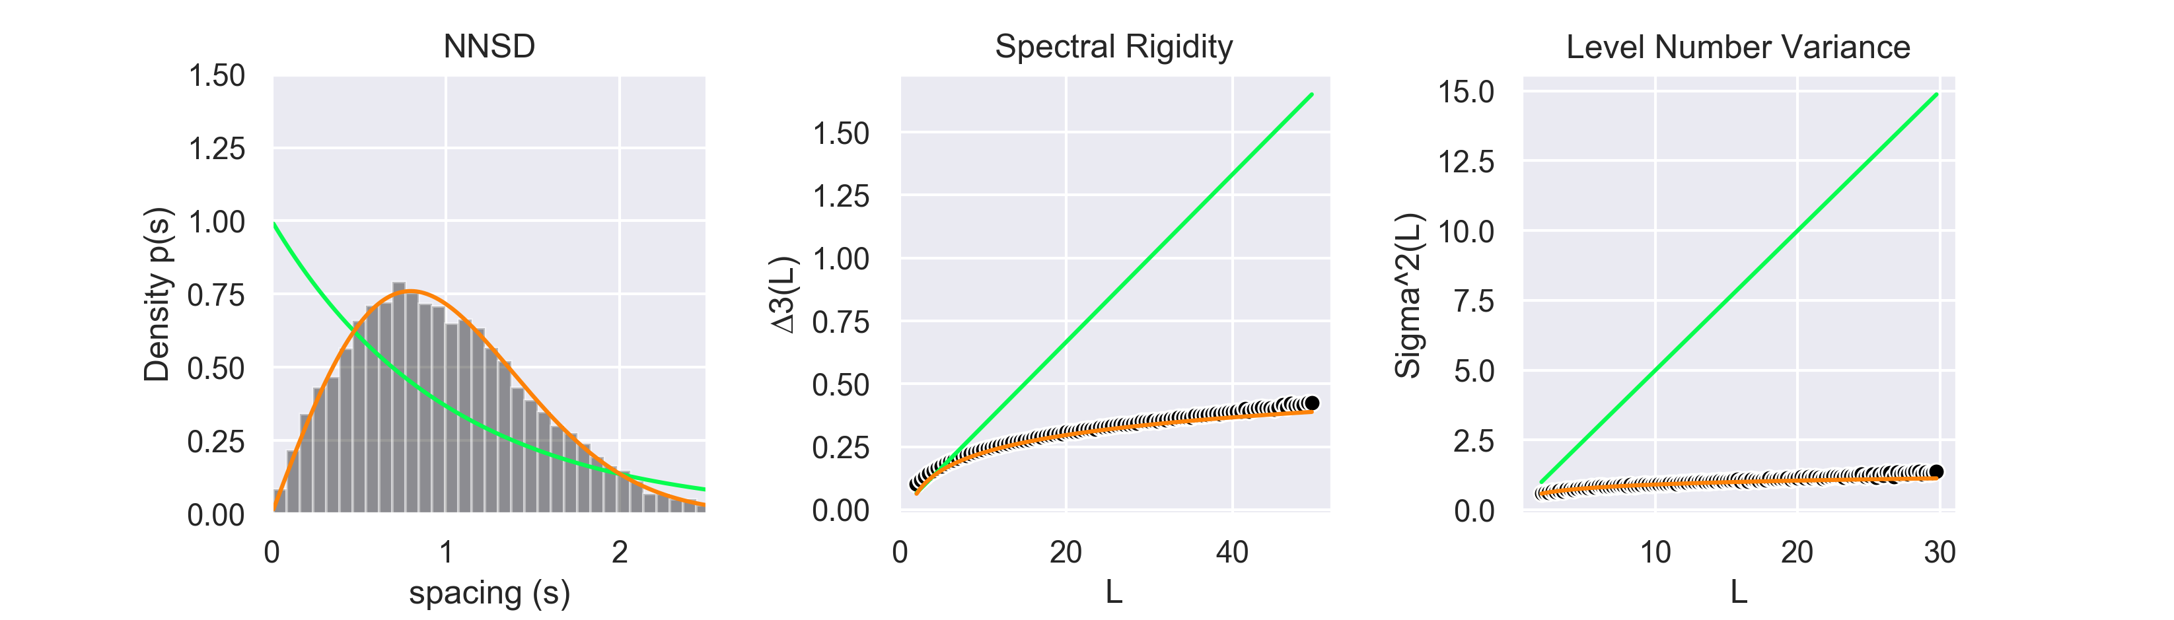
Figure 1. NNSD, spectral rigidity, and level number variance for a simulated 10 000 x 10 000 GOE matrix. Theoretically expected curves for GOE shown in orange, and for the GDE in green. Observed values shown in grey (NNSD) or black (rigidity and level number variance).

The Nearest-Neighbours Spacings Distribution (NNSD) is the most basic, being the distribution of the spacings (differences) of adjacent unfolded eigenvalues. Normally, the NNSD is analysed visually via a histogram of the distribution of spacings (see e.g. Figure 1, left pane), however it is also possible to analyse it more rigorously by fitting the Brody distribution[44]:

where is free to vary within , with producing the expected NNSD for the GDE case, and producing the expected NNSD for the GOE case. In this paper, we fit, via maximum likelihood, the empirically observed spacings with the Brody distribution, and report the Brody parameter, , as an important unfolded feature to investigate.
Whereas the NNSD and Brody parameter characterize the local properties of eigenvalues close on the spectrum, the long-range properties relating eigenvalues distant on the spectrum can be characterized by both the spectral rigidity and level number variance[5], [6]. The spectral rigidity, Δ₃(L), is calculated for any real value L as:

where is the number of unfolded eigenvalues less than or equal to , denotes the average with respect to all starting points , and where and denote the slope and intercept, respectively, of the least squares fit of a straight line to on [5]. The level number variance, , is closely related to the spectral rigidity[6], and is calculated as:

where is the number of unfolded eigenvalues in , and where c, L, and are as above[5]. Both the spectral rigidity and level number variance are also computed and investigated in this study.
In addition to the unfolded features suggested by RMT, there are some potential "raw" features that do not require an unfolding procedure. The entire eigenvalue spectrum likely contains important information related to the system, and is also investigated as an RMT-inspired feature.
The distribution of eigenvalues of large rectangular matrices with finite-variance, independent and identically distributed (i.i.d.) entries also converges to the Marchenko-Pastur distribution[45], [46]:

where is the true variance of the distribution of each i.i.d. entry (equal to 1 in the case of correlation matrices), and where , for matrices of dimension . While real-world data will not, in general, be i.i.d., the extent to which spectra overlap with or are well-described by the MP distribution has been used to guide analytical decisions regarding the relevance of empirically observed eigenvalues. That is, since the majority of the eigenvalues of random correlation matrices will fall within , wigenvalues observed to fall within this region are typically considered to be the result of noise[29]–[31], [47]. We examine as a potential feature the proportion of eigenvalues that fall within this range, and call this the noise ratio. In addition, we calculate a broader, shifted noise ratio, based on the adjustments of[48] which takes into account the larger degree of correlation in empirical data.
RMT Feature Extraction.
The entire 4-dimensional m × n × p × t scan array for each run, excluding voxels with constant signals (which lead to undefined correlations), and excluding voxels identified as non-brain via preprocessing, was flattened to a two-dimensional m·n·p × t matrix, and then the t – 1 eigenvalues of that correlation matrix were calculated as documented in Appendix A. The value of t for a scan can be inferred from the number of volumes in Table 1. The various RMT features mentioned above were then extracted via the empyricalRMT library[49] developed and made publicly available by the authors, as well as via specific code for this paper (which is documented and available online[50]).
As both the spectral rigidity and level number variance can be highly sensitive to the choice of smoothing procedure used in the unfolding method[43], [51]–[54], all unfolded features in this study were calculated using polynomials of degree 5, 7, 9, 11, and 13 as the smoothing technique. As much of the variance in the unfolded spectral statistics can be due to the largest eigenvalues acting as anchor points during smoothing[51], [54], all unfolded features were also calculated twice (in addition to each polynomial degree), to examine the effects of trimming on the spectral observables: once with only the largest eigenvalue omitted, and once with the largest 20 eigenvalues omitted.
Investigation of RMT-Derived Features
In this study, our primary intention is to examine the potential utility of RMT-derived features across a wide variety of data, and not to decisively put forward or refute any specific hypotheses relating RMT to psychological processes. We thus examine a wide selection of fMRI datasets available on the OpenNeuro platform[35], including studies employing within-subject and between-subject designs, different scanning modalities (rs-fMRI, task-based fMRI, and multi-echo fMRI), and with different degrees of preprocessing. This allows for a broad assessment of the potential of voxelwise RMT features.
However, since previous studies employing RMT for feature extraction[33], [34] have partially interpreted their findings with respect to the attention and attentional processes, we have elected to use datasets that involve attention in some focal way. This includes measures of attention or vigilance, or comparisons between a condition involving more attention and focus (e.g. a task state) or conditions which should involve considerably less attention or focus (e.g. resting-state).
III. Results
Overview
Visual summaries of the prediction accuracies for all features are presented in Figure 2. Prediction accuracies for only the multivariate RMT features are summarized in Figure 3, and the distributions of the scalar features are presented in Figures 4 and S2-4. Additional visual summaries for larger trimming amounts are available in Figures S1 and S5, and numeric (mean) summaries across datasets, broken down by classifier and feature are available in Tables S5-14. Complete (unsummarized) tables of all predictions for all combinations of features, unfolding degree, and trimming are available as supplementary material in the spreadsheet prediction_tables_fullpre.ods. Unless otherwise noted, subsequent figures and analyses were computed using the preprocessed data: full results for the raw data are available as spreadsheets in the supplementary material in prediction_tables.ods.
To summarize the large amount of data generated in this study, the stacked histograms in Figures 2 and 3 were created. To describe these figures unambiguously, we introduce some notation.
Denote all comparisons (groupings) as the set (e.g. g₁ = "LEARN: task v rest", g₂ = "OSTEO: allpain v nopain"). Let be the set of the eight RMT features examined. Let represent the different classifiers (e.g. "LR, logistic regression", "LDA"), let i.e. ( ) be the unfolding degrees. We wish to examine, via LOOCV, the prediction accuracies for every point (over 9500 points). If there are samples for some , LOOCV will yield prediction accuracies. Define the function to be the mean of those accuracies. Then is the real value equal to the mean LOOCV prediction accuracy of the binary classifier for feature unfolded with a polynomial degree , for comparison . Figure 2 thus depicts:

.
Different features are encoded by color. For example, the black bars in Figure 2 (raw eigenvalues) depict the set (i.e. , and the black bars in the first subplot then are the histogram for the set . Figure 3 is identical, but with scalar features excluded.
The central, vertical black comparison line "Guess" in each subplot indicates the accuracy of a naive binary classifier which always predicts membership in the larger of the two subgroups. Thus, to examine the spread of accuracies across unfoldings and classifiers for a single feature, we focus on the colour of that feature, and look at how those coloured bars are distributed about the comparison line. However, to examine whether the RMT features overall were predictively useful for a dataset, colour should be ignored (i.e. the total distribution or top edges of all the stacks are all that mattters). So for example, focusing on the subplot labelled PSYCH_VIGILANCE_SES-2 in Figure 2, we can see that overall the RMT features led to predictions better than a naïve classifier in this dataset, but that the reverse was the case for the unshifted noise ratio (light green).
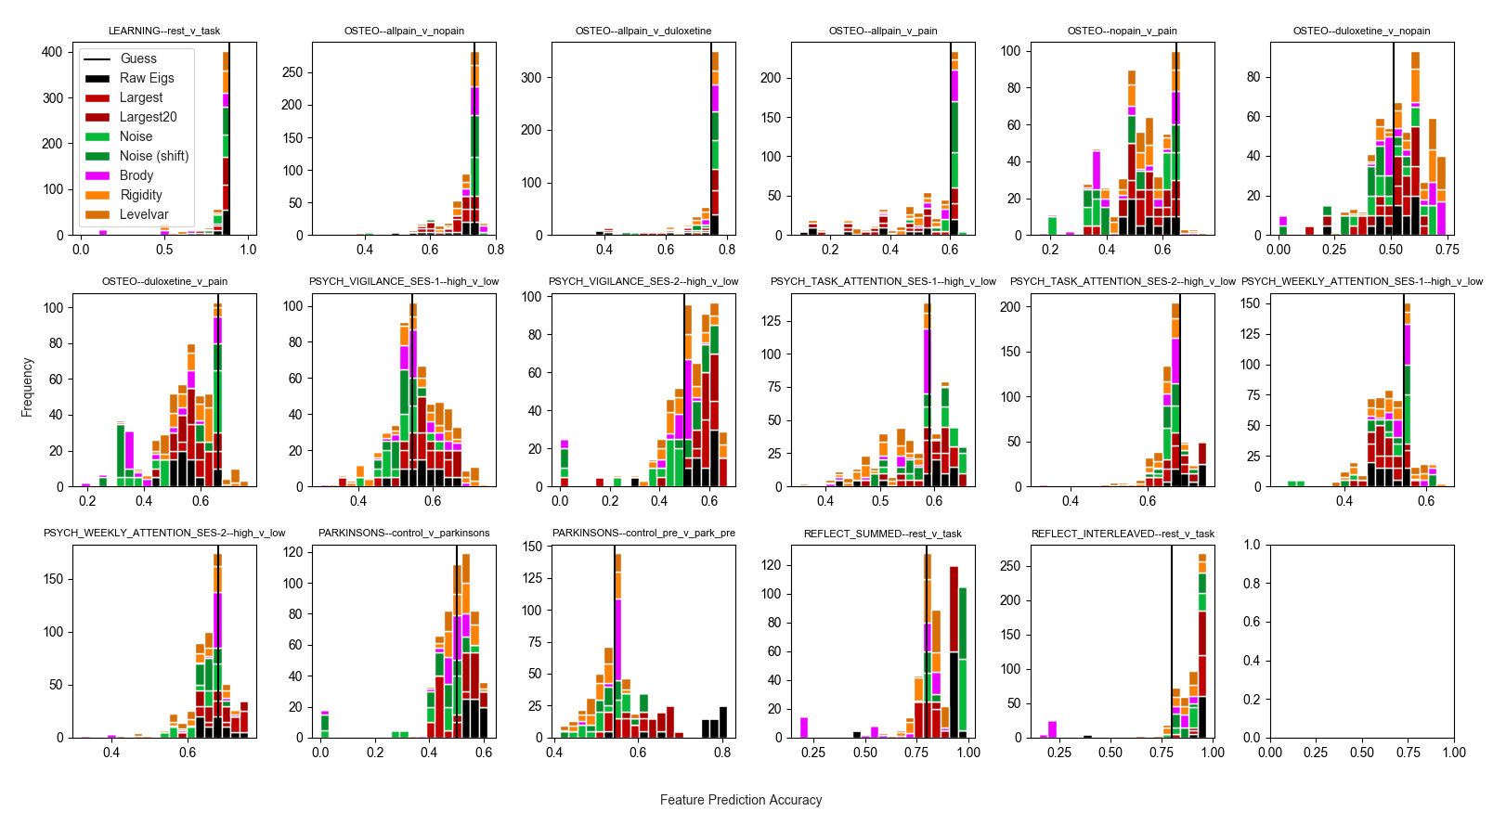
Figure 2. LOOCV prediction accuracies across all features for all unfoldings, trimming largest eigenvalue only. Values left of the vertical "Guess" line indicate prediction accuracies worse than simply guessing membership in the largest group. . Accuracies for the PARK (PARKINSONS) data calculated from the full preprocessing pipeline in (cite) are labeled as "pre", and visible in the third plot on the bottom row. Accuracies from this study’s minimal preprocessing pipeline are shown in the second figure of the bottom row.

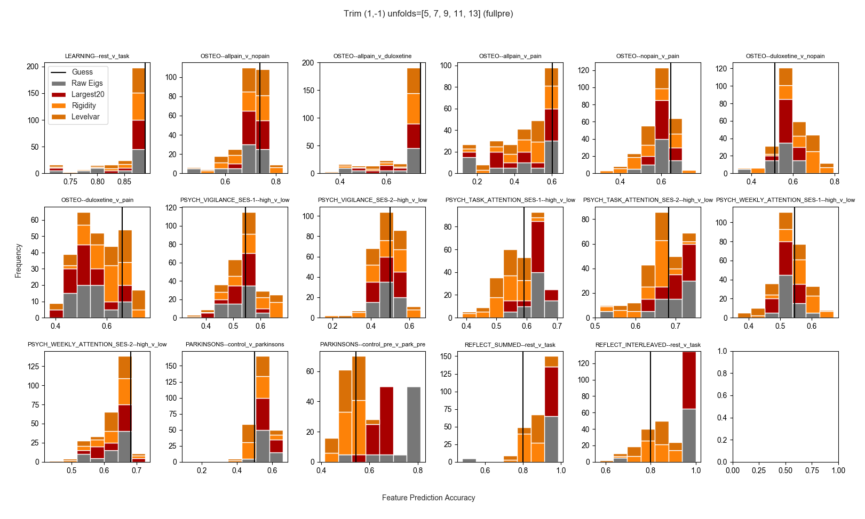
Figure 3. LOOCV prediction accuracies for all non-scalar (multidimensional) unfolded features across all unfoldings and classifiers, after trimming only the largest eigenvalue. Plots are as described in Figure 2 caption.
From Figure 2 it is clear that only in the LEARNING dataset did all the RMT-inspired features extract information that led to predictions worse than the guesses of a naive classifier. There were strong differences in RMT features between task and rest conditions for the REFLECT dataset. The features were of variable predictive utility over the naïve classifier in the PSYCH dataset, sometimes outperforming the naïve classifier in distinguishing between subgroups formed via median-split of either self-reported vigilance, or of performance on an attention-related task. Although the RMT features were useful in the comparison involving duloxetine and controls (no pain) in the OSTEO dataset, these features did not aid in classifying between any of the other possible pairings of subgroups in this dataset (Figure 2). It should be noted that although the performance of classifiers trained on RMT features is variable, there is a tendency to produce performance improvements in group separation with the inclusion of some RMT features in particular, including the raw eigenvalues and the largest eigenvalues, especially in the REFLECT data (but see discussion).

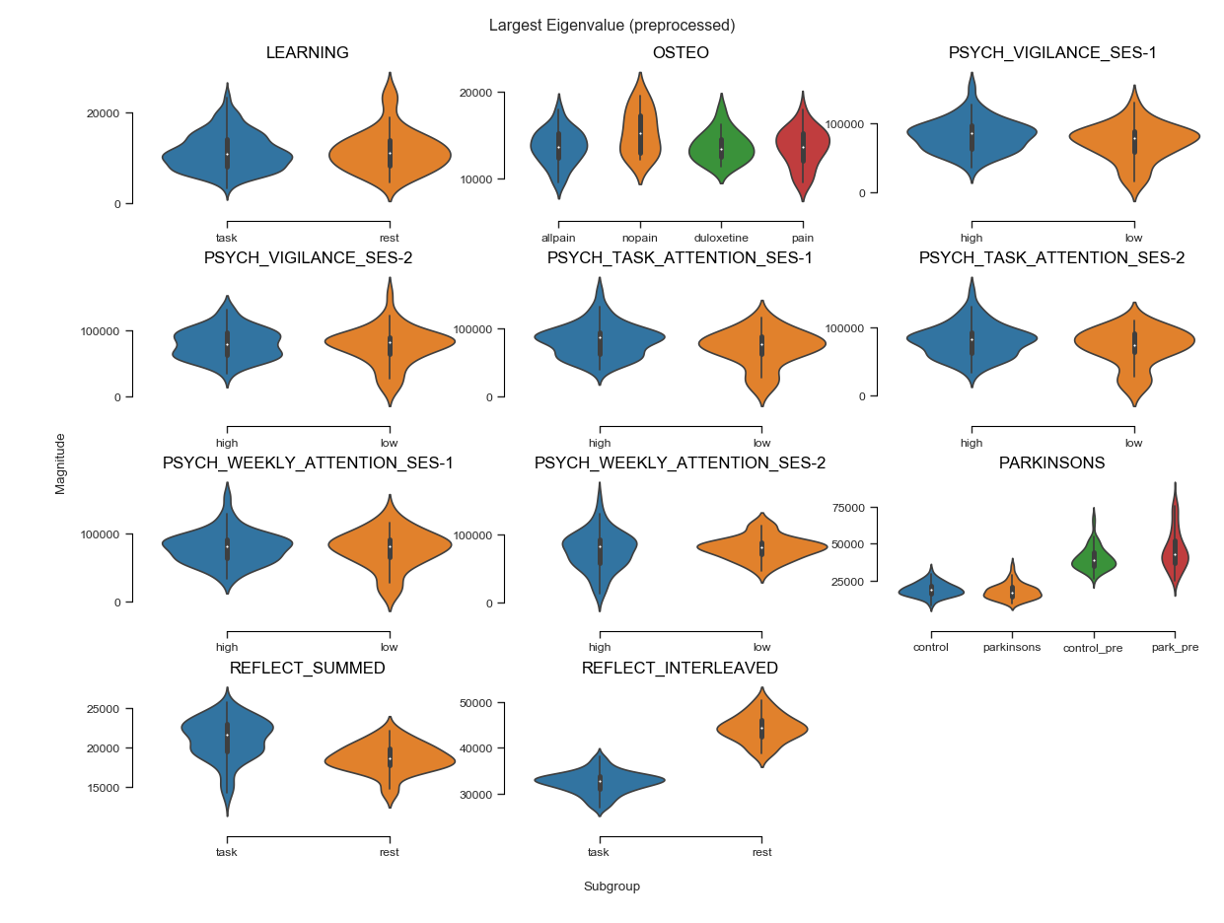
Figure 4. Distributions of the largest eigenvalue across datasets and subgroups. For OSTEO data, ”pain” condition is subjects with osteopathic pain who are given placebo.
The raw eigenvalues were useful in discriminating between Parkinson's and controls; however, the utility of the unfolded features in this comparison was dependent on the unfolding and trimming procedures. Although it is clear from Figure 3 that the spectral rigidity and level number variance could sometimes be more useful in classifying subgroups than the raw eigenvalues, they were often less useful than simply guessing via a naïve classifier.
Raw Features
As evident from Figures 4, S2 and S3, the scalar raw features (noise ratio, shifted noise ratio, and largest eigenvalue) varied more within than between subgroups. They were not generally useful for classifying conditions (Tables S15-17), with two or three notable exceptions.
The noise ratio (but not shifted noise ratio) differed consistently between the duloxetine and control groups in the OSTEO data, allowing for prediction accuracies of up to 72% (compared to 51% for the naïve classifier; supplementary appendix Figure 5). The largest eigenvalue was also useful in distinguishing between subjects self-reporting high versus low vigilance across sessions: accuracies up to 64% and 65% (compared to naïve accuracies of 55% and 50%) for the first and second sessions, respectively (Table S6). Finally, for the REFLECT data, task and rest were perfectly distinguishable with various features and with some classifiers.
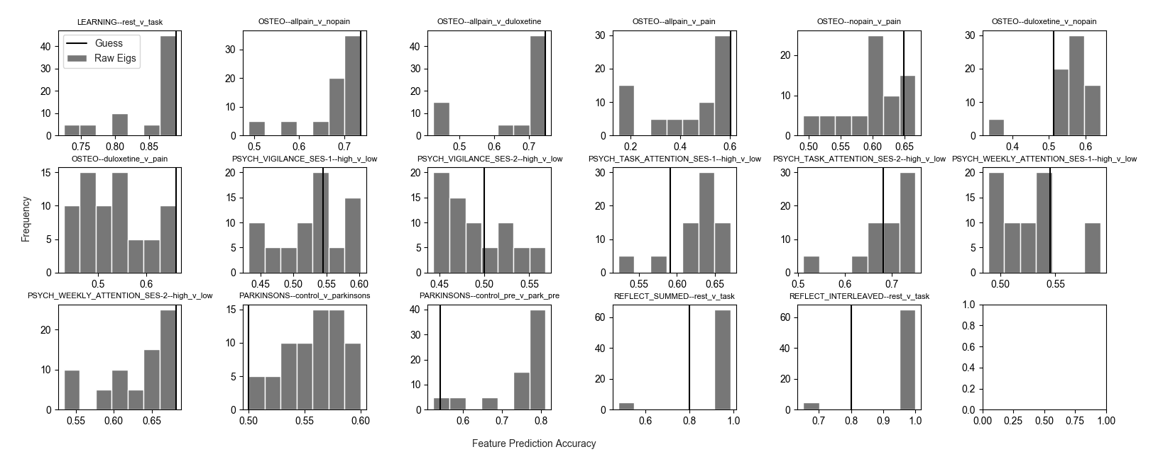
Figure 5. Prediction accuracy of raw eigenvalues across classifiers (no normalization of eigenvalues).
The sorted, raw eigenvalues, however, frequently contained information that allowed some separation of subgroups. In fact, averaging across all datasets and comparisons, the raw eigenvalues consistently demonstrated predictive utility (Tables S3-4). As visible in Figure 5, the eigenvalues had the most consistent predictive value for distinguishing individuals with Parkinson's from controls, or distinguishing those with osteopathic pain and taking duloxetine from controls ("nopain" in Figure 3). The raw eigenvalues sometimes had predictive value for the PSYCH data, most notably in comparing those differing in self-reported vigilance and high vs. low scorers in the attention task (Table S6). In all these relationships, normalizing the eigenvalues to the interval [0,1] prior to prediction considerably improved prediction accuracy (Tables S8-10).
Role of Classifier. The raw eigenvalues had the most predictive utility when employing either an SVM classifier or KNN classifier with k > 3. When the raw eigenvalues were min-max normalized prior to prediction, an SVM classifier was clearly the most consistent in predicting subgroup memberships, however without normalization, KNN with k = 8 or k = 9 generally best predicted subgroup membership across datasets (Tables S11, S12).
Unfolded Features
The Brody parameter rarely resulted in predictions exceeding naïve accuracies in these comparisons: for most unfoldings and comparisons, the Brody parameter was either constant and equal for all subjects (e.g. exactly 0.999 or 0.0001) or deviated from these values only for a small number of subjects. This is because the observed NNSDs (and in fact all unfolded features) were usually well outside of the GOE-GDE bounds.
As is evident from Figures 2 and 3, the predictive utility of the unfolded RMT features varied considerably across datasets and classifiers. However, some results were robust: for example, the spectral rigidity and level number variance strongly differentiated controls from individuals prescribed duloxetine for osteopathic pain, and this
differentiation persisted regardless of unfolding degree or trimming (Figures 6-8).
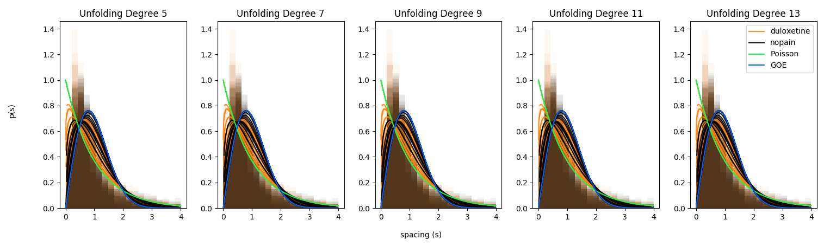
Figure 6. Nearest Neighbours Spacings Distribution for controls (nopain) vs. those with osteopathic pain taking duloxetine. Solid lines indicate Brody distribution maximum likelihood estimates, and transparent regions depict the overlapping spacings histograms for all subjects.
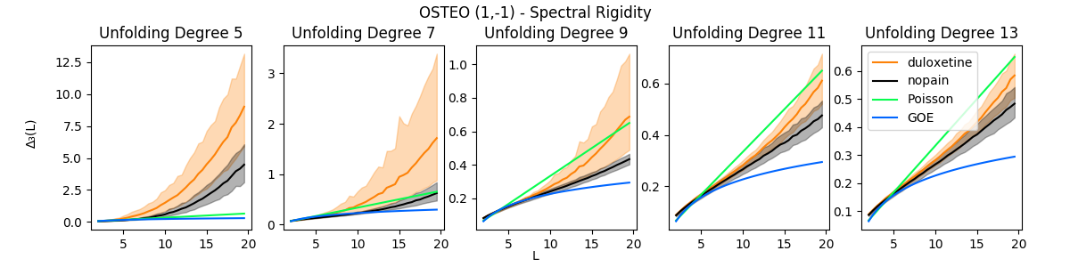
Figure 7. Spectral rigidity for controls (nopain) vs. those with osteopathic pain taking duloxetine. Solid lines indicate group mean rigidity, and shaded regions correspond to 99% percentile bootstrapped intervals for each group. Vertical axes vary to better depict overlap.
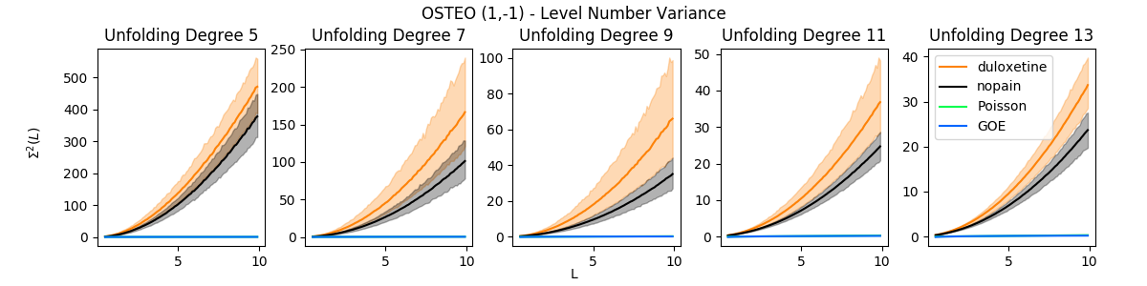
Figure 8. Level variance for controls (nopain) vs. those with osteopathic pain taking duloxetine. Solid lines indicate group mean rigidity, and shaded regions correspond to 99% percentile bootstrapped intervals for each group. Vertical axes vary to better depict overlap.
Despite the insensitivity to unfolding in this dataset, there was still nontrivial variability in accuracy across classifiers when classifying duloxetine vs controls, with the least flexible classifiers (logistic regression, SVM, and KNN with k=10, 20) generally performing best (Tables S1 and S2).
For other datasets, the predictive utility of the unfolded features was highly dependent on the unfolding degree, and sometimes trim proportions. These differences are illustrated with the Parkinson's data in Figure 8. For example, with minimal trimming, subgroup overlap in spectral rigidity was minimized for unfolding degrees 5 and 9 (Fig. 8, first row), but with greater trimming, this was not the case (second row). For the level number variance with minimal trimming, subgroup overlap appeared smaller for lower unfolding degrees (third row), however, with a greater degree of trimming, separation was clearer for slightly larger degrees (fourth row).
Across datasets, the unfolding degree, compared to trimming, was a much more significant source of variance in the overall predictive utility of the unfolded features (Figures S5a-c).
Role of Classifier. Across all datasets, unfoldings, and trimmings, the spectral rigidity was best able to separate between subgroups when either k was large (10 or 20) in KNN, or Logistic Regression or SVM was employed (Table S13). The pattern was similar for the level number variance, although in general the predictive utility of the level number variance was, overall, slightly more variable than the spectral rigidity (Table S14).
Neither the choice of unfolding degree nor amount of trimming had any easily summarizable effects on the predictive value of the various RMT metrics. The optimal trimming and unfolding degree was different for each dataset and comparison.
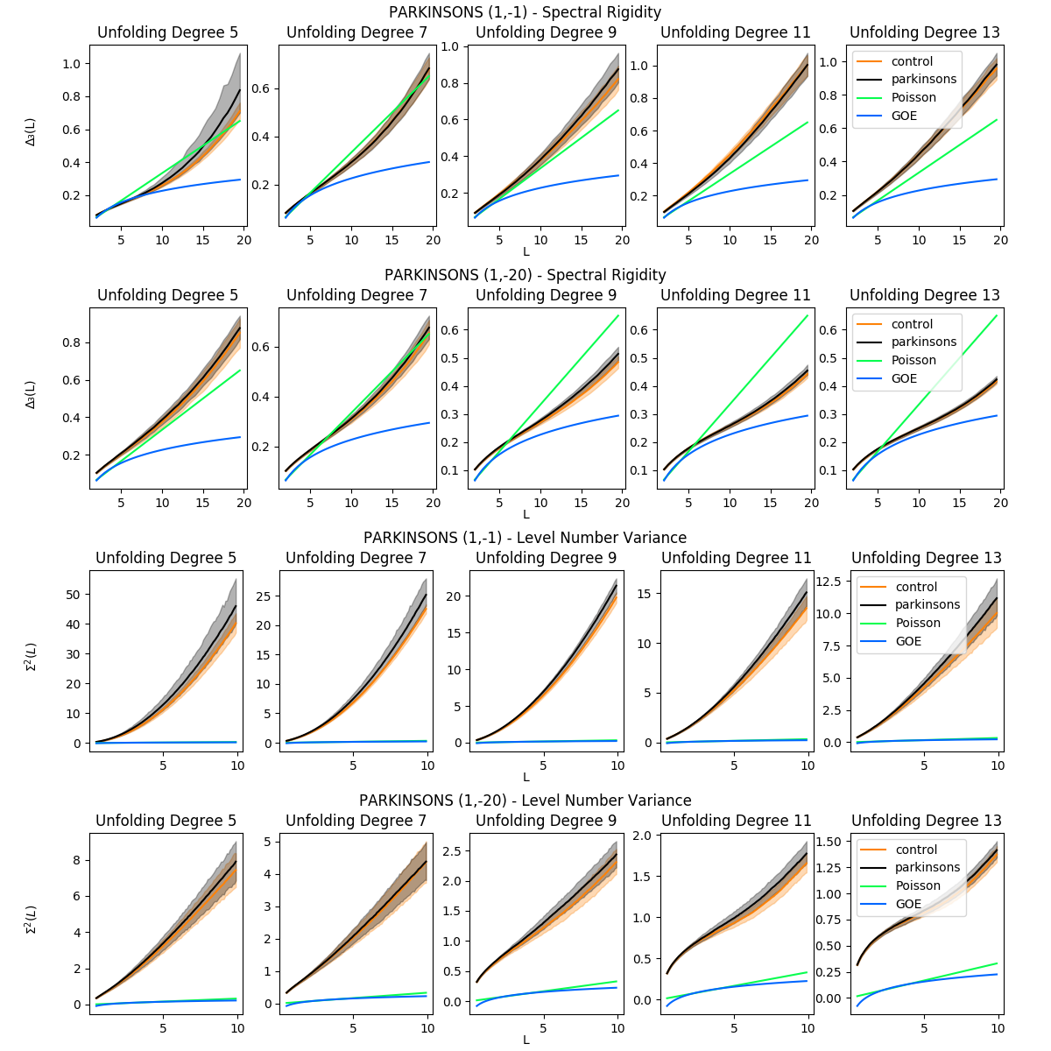
Figure 9. Spectral rigidity and level number variance across unfolding degrees and trim regions for PARK data. Solid lines indicate group mean rigidity, and shaded regions correspond to 99% percentile bootstrapped intervals for each group. Titles with (1,-1) indicate trimming of only the largest eigenvalue, whereas titles with (1,-20) indicate trimming of the 20 largest eigenvalues. Note varying vertical axes.

Discussion
In this study, certain features inspired by RMT, and derived from the sorted eigenvalues of the full, whole-brain voxelwise correlation matrix were found to contain information with the potential to meaningfully differentiate between different neuropsychological phenomena. In addition to the evidence produced from previous studies [26], [33], [34], this suggests RMT may be a useful analytic and theoretical tool for understanding functional connectivity.
Although the choice of unfolding and trimming often had nontrivial effects on the overall shape and values of the various spectral observables, and thus the predictive utility, in cases where there was predictive utility, there was some evidence that the unfolding and trimming procedures did not reverse the relations between subgroups (Figures 6-9). That is, in Figures 6-8, regardless of the unfolding methodology, it was always the case that controls had spectral observables farthest from those of the GOE, whereas in Figure 9, this was the case for subjects with Parkinson's.
In particular, for some psychological phenomena examined in this study (specifically, the resting-state, voxelwise functional connectivity of those prescribed duloxetine for osteopathic pain versus the resting-state, voxelwise functional connectivity of controls), the spectral rigidity and level number variance contained information that was valuable in differentiating between subgroups. These subgroup differences were also robust to unfolding and trimming procedures (Figures 7, 8). Across classifiers for this subgroup comparison, maximum mean LOOCV classification accuracies improved upon the 51% accuracy of the naïve classifier by 11-26% for the spectral rigidity and 16-26% for the level number variance.
In the above case, these unfolded features allowed for significantly improved predictions over those using the raw (not unfolded) eigenvalues (Table S3). However, it is possible that much of these predictive improvements are because both the unfolding procedure and calculation of the spectral observables both smooth and transform all data to common scales. For example, simply rescaling the raw eigenvalues to the interval [0, 1] also resulted in comparable prediction accuracies (Table S4).
For comparison, for small datasets of rs- or task-fMRI data, binary classification using whole-brain features is challenging. For subject level classification, state of the art deep learning methods improve upon guessing by 17% for autism [70] or 3-30% for ADHD [71], 16% for severe depression [72], and 23% for obsessive compulsive disorder [73]. Manual feature engineering with more easily separable conditions (e.g. schizophrenia) can result in classification accuracies well above 90% [74], and with very large data, sophisticated custom feature extraction methods can achieve near perfect accuracies at classifying task vs. rest [75]. However, for functional connectivity data and with classical machine learning algorithms (such as SVM) we in general only expect large prediction accuracies (e.g. greater than 80%) when the group functional connectivities are already strongly separated (e.g. Cohen’s d > 1.0; [76]). Nevertheless, the features extracted in this study are somewhat unique in that they are spatially-insensitive summaries of the full functional connectivity. In particular, reducing the functional connectivity to just the largest 20 eigenvalues results in predictions comparable to using the entire set of eigenvalues (Tables S11-12, S18). That such a reduction can lead to accuracies comparable to other methods suggests that the system eigenvalues have utility beyond information reduction, and should perhaps be regarded as actual signatures of functional connectivity themselves.
Confounds
While some of the RMT features allowed some classifiers to nearly perfectly separate conditions for the REFLECT dataset, this should almost certainly be regarded as an artifact of the differing scan parameters between task and rest conditions (Table 1). The size of the largest eigenvalue of a correlation matrix is primarily determined by such differences in dimensions [77], as are the noise ratios, which include these dimensions in their definitions [29], [30]. Likewise, similar strong separation was observed in the PARK data when comparing the minimally pre-processed to fully pre-processed data (Figures 2-4). The pre-processing in this case involved numerous steps (spike removal, spatial smoothing, co-registration to larger T1 image [50]) which will also almost certainly alter the size of the largest eigenvalue.
With the exception of the specific cases just mentioned, the unfolded features had limited predictive utility overall, and almost always led to accuracies worse than simply guessing that a subject belongs to the largest subgroup (Tables S13-14). When there was predictive utility in the unfolded features, this utility was dependent on the unfolding procedure and choice of classifier . For example, the highest nontrivial LOOCV mean accuracy across all datasets was 0.79 (Table S1-2), corresponding to the duloxetine vs. controls subgroup comparison in the OSTEO dataset. But as is also clear from Table S2, the average and median accuracies across unfoldings and classifiers are somewhat more modest.
This is likely because the unfolded features varied considerably based on the degree of the smoothing polynomial and extent of trimming. For example, the spread of the spectral rigidity and level number variance curves are shown for all subjects in the PARK data in Figure 8. Clearly, both curve shape and extent of overlap is dependent on the unfolding and trimming procedure.
The unidimensional features, such as the largest eigenvalue or those based on the Marchenko-Pastur distribution, were most useful in predicting subgroup membership in trivial cases, such as in the REFLECT data, where the underlying scan dimensions differed between comparison groups, or in the PARK data, where the largest eigenvalue clearly distinguished the degree of preprocessing. As these differences are due to methods, and not neuropsychological phenomena, they are perhaps of limited interest. To the extent that these features are scalar summaries of much higher-dimensional, 4D data, the limited utility of the scalar features should not be particularly surprising—it would be quite extraordinary if different neuropsychological states could be reliably separated based on such a reduction. However, that there are not consistently strong differences in these unidimensional features between subgroups across various datasets also suggests that employing these features in, e.g. noise-reduction procedures (such as [29], [30]), is unlikely to introduce bias into subsequent analyses. It perhaps also suggests these scalar features might be useful for quality control within a dataset: if there are differences between subgroups or individuals on one of the individual RMT features, then perhaps this is cause for more careful investigation.
The unfolded, multidimensional features (i.e. the spectral rigidity and level number variance) were more promising, however their sensitivity to the unfolding procedure means that great caution must be employed by the researcher / study designer if they are to be used as features in future research. In addition, as simply using the raw, min-max normalized eigenvalues generally resulted in similar classification accuracies as the unfolded features (except with much more consistent value across datasets), it is perhaps difficult to justify the use of the more complicated unfolded features for reliable group comparisons across studies.
Preprocessing
Across datasets, the features extracted from the minimally preprocessed images resulted in slightly lower prediction accuracies than the raw images for the unfolded features (rigidity, level variance), and slightly improved accuracies for some of the raw features (all eigenvalues, largest eigenvalue(s), noise ratio). However, these differences were quite small relative to the performance differences between datasets or between classifiers.
Similar patterns were observed in the PARK dataset. Figure 3 shows that more extensive preprocessing resulted in greater prediction accuracies for raw and largest eigenvalue(s), but decreased accuracies for the unfolded features. Given a particular level of preprocessing, however, it is clear from the spread of prediction accuracies that there was still more overall variance in prediction accuracy due to the choices of unfolding and classifier.
Comparison with Previous Studies
We generally find quite different results when compared with previous studies [26], [33], [34] which have used the spectral rigidity or level number variance to differentiate between attention conditions. As Šeba [26] extracted rigidity curves from the correlations of electroencephalographic (EEG) signals, and Matharoo and Hashmi [34] and Wang et al. [33] extracted spectral observables from the correlations of the mean signals of anatomical ROIs, different results are to be expected. A single voxel signal amalgamates information from far fewer neurons than an EEG or mean ROI signal, and it is possible that any broad connections between RMT spectral observables and attention arise only at higher levels of organization, or after certain pre-processing steps (e.g. spatial smoothing) not performed in this study.
We do find some modest evidence of greater overall correlation in high attention conditions: there was a slight tendency for the largest eigenvalue to be smaller when attention is low (Figure 2). However, this is only suggestive, and future studies will be needed to determine how and under what conditions these RMT features reliably relate to neuropsychological phenomena.
Limitations
To make analyses across datasets at least minimally comparable, only limited preprocessing (motion and slicetime correction, skull-stripping) was performed in this study. In particular, in the absence of physiological noise regression, there must be caution in assuming any of the observed patterns are uniquely due to changes in functional connectivity. This is perhaps especially notable as the RMT features were most consistently capable of distinguishing between individuals taking duloxetine versus controls, or between controls and individuals with Parkinson's. It seems much more likely that physiological confounds could be involved in these comparisons, in contrast to other comparisons, such as task-state versus resting-state, or in the differing levels of attention in the PSYCH dataset.
The correlation matrices calculated for each run are computed from the full time-series data. No attempt was made to control for stimulus presentation times, under the assumption that the broad, whole-brain summarizing nature of the RMT features should be able to detect broad, overall differences between subgroups or conditions. However, differences were not consistently observed between conditions across all datasets. It is possible more careful selection of regions of the time-series in task conditions will be necessary in order for RMT features to reflect the differences between these conditions.
While the extraction of eigenvalues from the correlations of all voxels has the advantage of not relying on a specific parcellation scheme, and does not impose anatomical or locality assumptions that ROI-based analyses do, it is also possible that this limited the utility of the RMT features. In particular, we found the spectral observables (NNSD, spectral rigidity, level number variance) to frequently fall outside the GOE/GDE bounds that have typically been observed in previous studies. Future studies should examine the sensitivity of these RMT features to the level of locality of analyses, or choice of size and location of ROIs.

Conclusion

RMT-inspired features demonstrate potential for the analysis of fMRI examinations, including predictive analyses. This study suggests that the eigenvalues extracted from the correlations of all voxel time-series may be a useful, whole-brain feature for distinguishing between a variety of psychological phenomena.

References
[1] R. L. Buckner, J. R. Andrews-Hanna, and D. L. Schacter, “The Brain’s Default Network: Anatomy, Function, and Relevance to Disease,” Annals of the New York Academy of Sciences, vol. 1124, no. 1, pp. 1–38, Mar. 2008, doi: 10.1196/annals.1440.011.
[2] M. D. Fox, A. Z. Snyder, J. L. Vincent, M. Corbetta, D. C. Van Essen, and M. E. Raichle, “From The Cover: The human brain is intrinsically organized into dynamic, anticorrelated functional networks,” Proceedings of the National Academy of Sciences, vol. 102, no. 27, pp. 9673–9678, Jul. 2005, doi: 10.1073/pnas.0504136102.
[3] J. Gonzalez-Castillo and P. A. Bandettini, “Task-based dynamic functional connectivity: Recent findings and open questions,” NeuroImage, vol. 180, pp. 526–533, Oct. 2018, doi: 10.1016/j.neuroimage.2017.08.006.
[4] A. M. Hermundstad et al., “Structural foundations of resting-state and task-based functional connectivity in the human brain,” Proceedings of the National Academy of Sciences, vol. 110, no. 15, pp. 6169–6174, Apr. 2013, doi: 10.1073/pnas.1219562110.
[5] T. Guhr, A. Müller–Groeling, and H. A. Weidenmüller, “Random-matrix theories in quantum physics: common concepts,” Physics Reports, vol. 299, no. 4–6, pp. 189–425, Jun. 1998, doi: 10.1016/S0370-1573(97)00088-4.
[6] M. L. Mehta, Random matrices, 3rd ed. Amsterdam ; San Diego, CA: Academic Press, 2004.
[7] T. A. Brody, J. Flores, J. B. French, P. A. Mello, A. Pandey, and S. S. M. Wong, “Random-matrix physics: spectrum and strength fluctuations,” Rev. Mod. Phys., vol. 53, no. 3, pp. 385–479, Jul. 1981, doi: 10.1103/RevModPhys.53.385.
[8] C. W. J. Beenakker, “Random-matrix theory of quantum transport,” Rev. Mod. Phys., vol. 69, no. 3, pp. 731–808, Jul. 1997, doi: 10.1103/RevModPhys.69.731.
[9] O. Bohigas, R. U. Haq, and A. Pandey, “Higher-Order Correlations in Spectra of Complex Systems,” Phys. Rev. Lett., vol. 54, no. 15, pp. 1645–1648, Apr. 1985, doi: 10.1103/PhysRevLett.54.1645.
[10] D. Wintgen and H. Marxer, “Level statistics of a quantized cantori system,” Phys. Rev. Lett., vol. 60, no. 11, pp. 971–974, Mar. 1988, doi: 10.1103/PhysRevLett.60.971.
[11] A. Pandey and S. Ghosh, “Skew-Orthogonal Polynomials and Universality of Energy-Level Correlations,” Phys. Rev. Lett., vol. 87, no. 2, p. 024102, Jun. 2001, doi: 10.1103/PhysRevLett.87.024102.
[12] M. S. Santhanam and P. K. Patra, “Statistics of atmospheric correlations,” Phys. Rev. E, vol. 64, no. 1, p. 016102, Jun. 2001, doi: 10.1103/PhysRevE.64.016102.
[13] V. Plerou, P. Gopikrishnan, B. Rosenow, L. A. N. Amaral, T. Guhr, and H. E. Stanley, “Random matrix approach to cross correlations in financial data,” Phys. Rev. E, vol. 65, no. 6, p. 066126, Jun. 2002, doi: 10.1103/PhysRevE.65.066126.
[14] S. Jalan, C. Sarkar, A. Madhusudanan, and S. K. Dwivedi, “Uncovering Randomness and Success in Society,” PLoS ONE, vol. 9, no. 2, p. e88249, Feb. 2014, doi: 10.1371/journal.pone.0088249.
[15] J. N. Bandyopadhyay and S. Jalan, “Universality in complex networks: Random matrix analysis,” Phys. Rev. E, vol. 76, no. 2, p. 026109, Aug. 2007, doi: 10.1103/PhysRevE.76.026109.
[16] S. Sastry, N. Deo, and S. Franz, “Spectral statistics of instantaneous normal modes in liquids and random matrices,” Phys. Rev. E, vol. 64, no. 1, p. 016305, Jun. 2001, doi: 10.1103/PhysRevE.64.016305.
[17] G. S. Matharoo, M. S. G. Razul, and P. H. Poole, “Spectral statistics of the quenched normal modes of a network-forming molecular liquid,” The Journal of Chemical Physics, vol. 130, no. 12, p. 124512, Mar. 2009, doi: 10.1063/1.3099605.
[18] S. K. Sarkar, G. S. Matharoo, and A. Pandey, “Universality in the Vibrational Spectra of Single-Component Amorphous Clusters,” Phys. Rev. Lett., vol. 92, no. 21, p. 215503, May 2004, doi: 10.1103/PhysRevLett.92.215503.
[19] G. S. Matharoo, S. K. Sarkar, and A. Pandey, “Vibrational spectra of amorphous clusters: Universal aspects,” Phys. Rev. B, vol. 72, no. 7, p. 075401, Aug. 2005, doi: 10.1103/PhysRevB.72.075401.
[20] G. S. Matharoo, “Universality in the Vibrational Spectra of Amorphous Systems,” arXiv:0812.4613 [cond-mat], Dec. 2008, Accessed: Sep. 07, 2020. [Online]. Available: http://arxiv.org/abs/0812.4613.
[21] G. S. Matharoo, “Universality in the vibrational spectra of weakly-disordered two-dimensional clusters,” J. Phys.: Condens. Matter, vol. 21, no. 5, p. 055402, Feb. 2009, doi: 10.1088/0953-8984/21/5/055402.
[22] P. Bhadola and N. Deo, “Targeting functional motifs of a protein family,” Phys. Rev. E, vol. 94, no. 4, p. 042409, Oct. 2016, doi: 10.1103/PhysRevE.94.042409.
[23] I. Osorio and Y.-C. Lai, “A phase-synchronization and random-matrix based approach to multichannel time-series analysis with application to epilepsy,” Chaos, vol. 21, no. 3, p. 033108, Sep. 2011, doi: 10.1063/1.3615642.
[24] A. Agrawal, C. Sarkar, S. K. Dwivedi, N. Dhasmana, and S. Jalan, “Quantifying randomness in protein–protein interaction networks of different species: A random matrix approach,” Physica A: Statistical Mechanics and its Applications, vol. 404, pp. 359–367, Jun. 2014, doi: 10.1016/j.physa.2013.12.005.
[25] A. Rai, A. V. Menon, and S. Jalan, “Randomness and preserved patterns in cancer network,” Sci Rep, vol. 4, no. 1, p. 6368, May 2015, doi: 10.1038/srep06368.
[26] P. Šeba, “Random Matrix Analysis of Human EEG Data,” Phys. Rev. Lett., vol. 91, no. 19, p. 198104, Nov. 2003, doi: 10.1103/PhysRevLett.91.198104.
[27] M. Voultsidou, S. Dodel, and J. M. Herrmann, “Feature evaluation in fMRI data using random matrix theory,” Comput. Visual Sci., vol. 10, no. 2, pp. 99–105, Jun. 2007, doi: 10.1007/s00791-006-0037-6.
[28] A. A. Vergani, S. Martinelli, and E. Binaghi, “Resting state fMRI analysis using unsupervised learning algorithms,” Computer Methods in Biomechanics and Biomedical Engineering: Imaging & Visualization, vol. 0, no. 0, pp. 1–14, Jul. 2019, doi: 10.1080/21681163.2019.1636413.
[29] J. Veraart, E. Fieremans, and D. S. Novikov, “Diffusion MRI noise mapping using random matrix theory: Diffusion MRI Noise Mapping,” Magn. Reson. Med., vol. 76, no. 5, pp. 1582–1593, Nov. 2016, doi: 10.1002/mrm.26059.
[30] J. Veraart, D. S. Novikov, D. Christiaens, B. Ades-aron, J. Sijbers, and E. Fieremans, “Denoising of diffusion MRI using random matrix theory,” NeuroImage, vol. 142, pp. 394–406, Nov. 2016, doi: 10.1016/j.neuroimage.2016.08.016.
[31] M. O. Ulfarsson and V. Solo, “Dimension Estimation in Noisy PCA With SURE and Random Matrix Theory,” IEEE Trans. Signal Process., vol. 56, no. 12, pp. 5804–5816, Dec. 2008, doi: 10.1109/TSP.2008.2005865.
[32] R. Wang, Z.-Z. Zhang, J. Ma, Y. Yang, P. Lin, and Y. Wu, “Spectral properties of the temporal evolution of brain network structure,” Chaos, vol. 25, no. 12, p. 123112, Dec. 2015, doi: 10.1063/1.4937451.
[33] R. Wang, L. Wang, Y. Yang, J. Li, Y. Wu, and P. Lin, “Random matrix theory for analyzing the brain functional network in attention deficit hyperactivity disorder,” Phys. Rev. E, vol. 94, no. 5, p. 052411, Nov. 2016, doi: 10.1103/PhysRevE.94.052411.
[34] G. S. Matharoo and J. A. Hashmi, “Spontaneous back-pain alters randomness in functional connections in large scale brain networks: A random matrix perspective,” Physica A: Statistical Mechanics and its Applications, vol. 541, p. 123321, Mar. 2020, doi: 10.1016/j.physa.2019.123321.
[35] R. A. Poldrack and K. J. Gorgolewski, “OpenfMRI: Open sharing of task fMRI data,” NeuroImage, vol. 144, pp. 259–261, Jan. 2017, doi: 10.1016/j.neuroimage.2015.05.073.
[36] K. J. Gorgolewski et al., “A high resolution 7-Tesla resting-state fMRI test-retest dataset with cognitive and physiological measures,” Sci Data, vol. 2, no. 1, p. 140054, Dec. 2015, doi: 10.1038/sdata.2014.54.
[37] P. Tétreault, A. Mansour, E. Vachon-Presseau, T. J. Schnitzer, A. V. Apkarian, and M. N. Baliki, “Brain Connectivity Predicts Placebo Response across Chronic Pain Clinical Trials,” PLOS Biology, vol. 14, no. 10, p. e1002570, Oct. 2016, doi: 10.1371/journal.pbio.1002570.
[38] E. DuPre, W.-M. Luh, and R. N. Spreng, “Multi-echo fMRI replication sample of autobiographical memory, prospection and theory of mind reasoning tasks,” Sci Data, vol. 3, Dec. 2016, doi: 10.1038/sdata.2016.116.
[39] T. M. Madhyastha, M. K. Askren, P. Boord, and T. J. Grabowski, “Dynamic Connectivity at Rest Predicts Attention Task Performance,” Brain Connectivity, vol. 5, no. 1, pp. 45–59, Feb. 2015, doi: 10.1089/brain.2014.0248.
[40] A. C. Schapiro, E. A. McDevitt, T. T. Rogers, S. C. Mednick, and K. A. Norman, “Human hippocampal replay during rest prioritizes weakly learned information and predicts memory performance,” Nat Commun, vol. 9, Sep. 2018, doi: 10.1038/s41467-018-06213-1.
[41] D. Watson and L. A. Clark, “The PANAS-X: Manual for the Positive and Negative Affect Schedule - Expanded Form.” University of Iowa, 1994, doi: 10.17077/48vt-m4t2.
[42] L. Shalev, A. Ben-Simon, C. Mevorach, Y. Cohen, and Y. Tsal, “Conjunctive Continuous Performance Task (CCPT)—A pure measure of sustained attention,” Neuropsychologia, vol. 49, no. 9, pp. 2584–2591, Jul. 2011, doi: 10.1016/j.neuropsychologia.2011.05.006.
[43] A. A. Abul-Magd and A. Y. Abul-Magd, “Unfolding of the spectrum for chaotic and mixed systems,” Physica A: Statistical Mechanics and its Applications, vol. 396, pp. 185–194, Feb. 2014, doi: 10.1016/j.physa.2013.11.012.
[44] T. A. Brody, “A statistical measure for the repulsion of energy levels,” Lett. Nuovo Cimento, vol. 7, no. 12, pp. 482–484, Jul. 1973, doi: 10.1007/BF02727859.
[45] V. A. Marčenko and L. A. Pastur, “DISTRIBUTION OF EIGENVALUES FOR SOME SETS OF RANDOM MATRICES,” Math. USSR Sb., vol. 1, no. 4, pp. 457–483, Apr. 1967, doi: 10.1070/SM1967v001n04ABEH001994.
[46] J. Yao, S. Zheng, and Z. Bai, “Large Sample Covariance Matrices and High-Dimensional Data Analysis,” Cambridge Core, Mar. 2015. /core/books/large-sample-covariance-matrices-and-highdimensional-data-analysis/9450C33A0FB19D1974FDB0B4CAF41040 (accessed Mar. 16, 2020).
[47] M. MacMahon and D. Garlaschelli, “Community Detection for Correlation Matrices,” Phys. Rev. X, vol. 5, no. 2, p. 021006, Apr. 2015, doi: 10.1103/PhysRevX.5.021006.
[48] A. Almog et al., “Uncovering functional signature in neural systems via random matrix theory,” PLoS Comput Biol, vol. 15, no. 5, May 2019, doi: 10.1371/journal.pcbi.1006934.
[49] D. Berger, stfxecutables/empyricalRMT: Preliminary Release. Zenodo, 2020.
[50] Berger, Derek M. and Levman, Jacob, DM-Berger/random-matrix-fmri: v0.1-alpha. Zenodo, 2020.
[51] I. O. Morales, E. Landa, P. Stránský, and A. Frank, “Improved unfolding by detrending of statistical fluctuations in quantum spectra,” Phys. Rev. E, vol. 84, no. 1, p. 016203, Jul. 2011, doi: 10.1103/PhysRevE.84.016203.
[52] S. M. Abuelenin, “On the spectral unfolding of chaotic and mixed systems,” Physica A: Statistical Mechanics and its Applications, vol. 492, pp. 564–570, Feb. 2018, doi: 10.1016/j.physa.2017.08.158.
[53] R. Fossion, G. T. Vargas, and J. C. L. Vieyra, “Random-matrix spectra as a time series,” Phys. Rev. E, vol. 88, no. 6, p. 060902, Dec. 2013, doi: 10.1103/PhysRevE.88.060902.
[54] S. M. Abuelenin and A. Y. Abul-Magd, “Effect of Unfolding on the Spectral Statistics of Adjacency Matrices of Complex Networks,” Procedia Computer Science, vol. 12, pp. 69–74, 2012, doi: 10.1016/j.procs.2012.09.031.

Appendix A – Proof of Transposition

If is a real n x p matrix with n > p, and , where denotes the column , and we let denote the (unordered) set of eigenvalues of , and , then:

Likewise, if , (and so that ) then the eigenvalues of the correlation matrix of , , can be obtained more easily via:
`

Although the features not requiring unfolding are constant regardless of the unfolding polynomial degree, predictions for these features were re-calculated each time to allow for a fair comparison (i.e. each colour gets the same total area in Figure 2, up to pixel-rounding). Figure 3 thus provides a more fine-grained look at the accuracies for only the multivariate RMT features.
Full data for the unpreprocessed and processed images are available in the supplementary material as prediction_tables.ods and prediction_tables_fullpre.ods, respectively. Summaries across datasets, by algorithm, are in spreadsheets all_predictions_*_by_algo.ods, with "*" replaced by a feature descriptor .

