Dhanlowel Makaveli Lugo BSIT 1B

ACTIVITY 1

1. Create data base named school_db

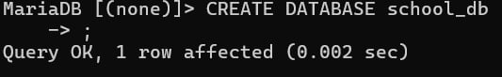

1. Show all databases

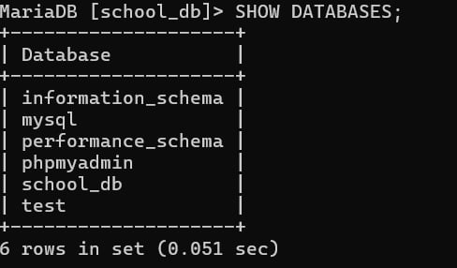

1. Use database that you have created



1. Create a table named students with the following columns

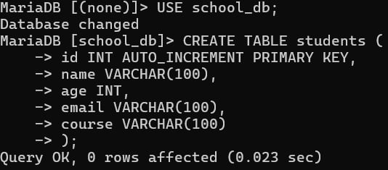

1. Show table structure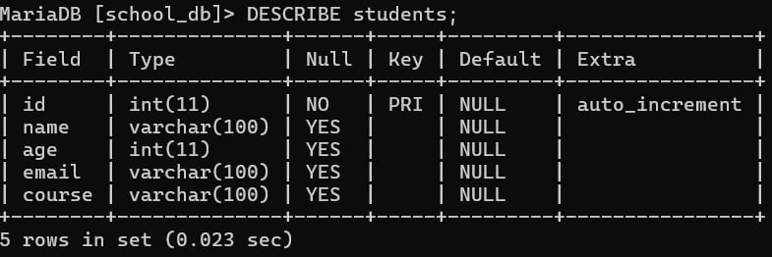
2. Insert 3 students into the table

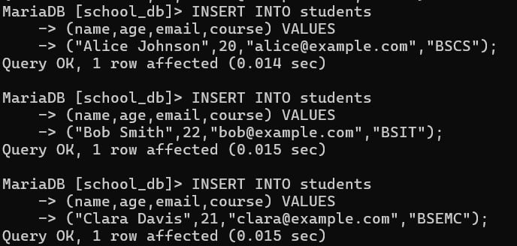

1. Display all records in the students table

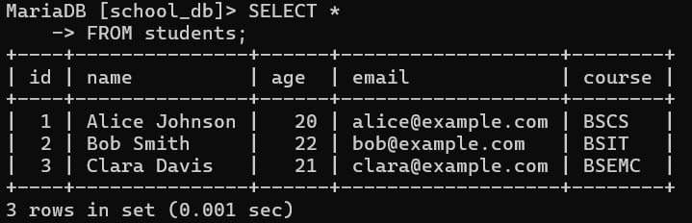

1. Display names and email of the students

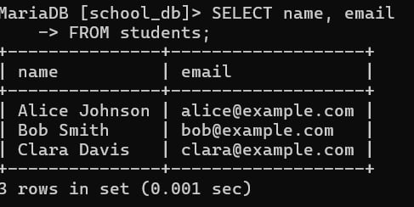

1. Display students older than 20

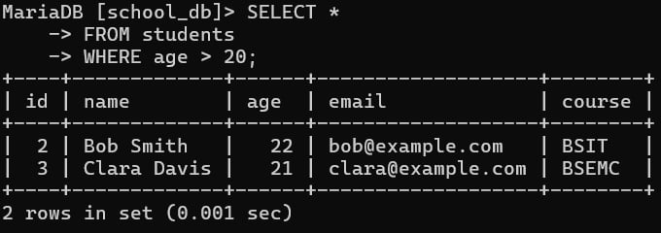

1. Change Clara’s course to Data Science

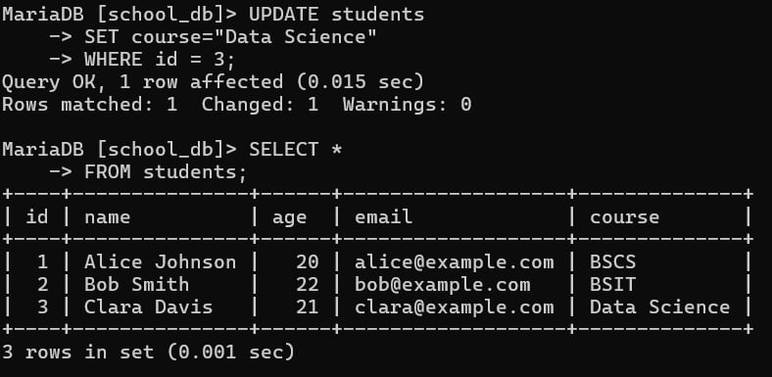

1. Delete the student named Bob Smith

