DOTMAPPERS / TRAFFICRADIUS
MARKETING-IN-A-BOX · WORKFLOW ANALYSIS

How the Marketing-in-a-Box Engine Works
A Plain-English Analysis of Every Output, the End-to-End Workflow, and the Agentic System Behind It
Prepared for: dotmappers / TrafficRadius
Reference documents analysed: Marketing_in_a_Box_Architecture.html (System Architecture Specification v1.0) and Asset_Wiring_Technical_Specification.pdf (Manus AI, July 29, 2026)
Version 1.0 — August 2026

1. Executive Summary
This document explains, in plain business language, how TrafficRadius's “Marketing-in-a-Box” content engine produced the 54 files currently sitting in the manual_execution folder — and how that manual process maps onto the automated system described in the two reference documents supplied for this analysis.
The short version: every file in the folder is one link in a chain. A client's basic details go in one end; a persona, a rewritten website, a funnel, a lead magnet, a stream of blog and text content, a content calendar, and a set of long-form authority assets (webinars, a book, a podcast) come out the other end. Each link only starts once the link before it has been checked and approved, and each link leaves behind a clearly named file that the next link reads — nothing is regenerated from scratch, and nothing downstream contradicts what was approved upstream.
The folder shows this chain executed three times, at three different depths, for three different TrafficRadius service lines: fully, for Social Media Marketing; partially, for LinkedIn Marketing & Ads; and via a new, not-yet-formally-documented pattern, for Google Ads. It also shows a second, parallel chain (“Remarketing”) that the wiring specification describes but that has not been executed at all — a genuine gap, not an oversight in this analysis.
This report walks through every file, reconstructs the full data flow, converts the manual process into a named AI-agent workflow, presents a jargon-free architecture view, provides four diagrams, checks the actual outputs against the two reference documents, and lists what is missing, what is inconsistent, and what should happen next.

2. Overview of All Files
The 54 files (48 at the top level of manual_execution, plus 6 inside the Social-Content-Audits sub-folder) fall into six natural groups. No file has been left out of this analysis.
Group | What it is | Count | Where it sits in the chain
Foundational client research | The one-time buyer persona, the extracted brand design rules, and the master competitor list — built once and reused by every service line. | 3 | Stage 1 + shared reference
Social Media Marketing (SMM) outputs | The full run of the primary chain for TrafficRadius's own flagship service line, plus the competitor research spreadsheets feeding each stage. | 29 | Stages 2–16, run in full
LinkedIn Marketing & Ads outputs | A second, partial run of the same chain for a second service line, reusing the client-level persona rather than rebuilding it. | 8 | Stages 3, 4, 6, 7, 8, 11 only
Google Ads outputs | One pre-existing input document, plus three new deliverables built with a pattern that does not yet exist as a named stage in either reference document. | 5 | Stage 11 input, then a new branch
Reusable master prompts | The written-down instructions (“recipes”) for producing each stage's output, authored after each stage was first built successfully by hand. | 7 | The “Prompt Recipe Library”
Social content audit spreadsheets | Six identically-structured spreadsheets — TrafficRadius and five competitors — feeding the SMM social content strategy stage. | 6 (sub-folder) | Stage 12 research input

Total: 48 files at the top level + 6 files in the Social-Content-Audits sub-folder = 54 files analysed. Zero files were skipped.

3. File-by-File Analysis
Every file is listed below, grouped by the service line or function it belongs to. “Depends on” shows what had to exist first; “Feeds into” shows what reads it next.

3.1 Foundational Client Research
File | What it is | Depends on | Feeds into
ICP-TrafficRadius-ProblemAware-Melbourne-ProfessionalServices.md | The buyer persona: demographics, pain points, objections, awareness stage. | Operator-entered client intake only | Every downstream stage, across all three service lines
design-system-extracted.md | Brand rules pulled from the live TrafficRadius site: colours, fonts, button and card styles, layout patterns. | The live TrafficRadius website | Every page-build stage (Pillar Page, SEO Pillar Page, and both other service lines' pages)
traffic_radius_au_competitors.xlsx | Master shortlist of ~10 direct competitors, scored by similarity. | Competitor research pass | The niche competitor lists below, and the Content Marketing Strategy

3.2 Social Media Marketing (SMM) — the full chain
File | What it is | Depends on | Feeds into
CRO-Audit_Social-Media-Marketing.md | An early, shorter conversion audit of the live SMM page. | ICP persona | Superseded by PART-1 (below), produced 35 minutes later the same day
PART-1_CRO-Audit-Report_Social-Media-Marketing.md | The full conversion audit: page scored 58/100 across 6 psychological layers, with specific faults (dead CTA buttons, wrong-service page title, copy-paste contamination from other industries). | ICP persona + the live page | PART-2 (the rewrite) and Rebuilt-Copy
Rebuilt-Copy_Social-Media-Marketing.md | An earlier draft rewrite of the page copy. | PART-1 audit findings | Superseded by PART-2 (below)
PART-2_Rewritten-Pillar-Page_Social-Media-Marketing.md | The locked, final rewritten page copy — 13 sections, each tagged with which psychological layer it serves, with certain section names marked “locked” so later stages cannot reword them. | PART-1 audit + Rebuilt-Copy draft | social-media-marketing.html and every later SMM content stage
social-media-marketing.html | The finished, coded web page. | PART-2 copy + design-system-extracted.md | Funnel-Document, Lead-Magnet-Brief, Blog, and every SMM page-referencing stage
funnel_competitors_australia.xlsx | 10 competitor agencies branded around “sales funnels”, for benchmarking. | Competitor research pass | Funnel-Document_Social-Media-Marketing.md
Funnel-Document_Social-Media-Marketing.md | The full customer journey: landing → thank-you → follow-up sequence. | ICP + PART-2 copy + competitor funnel research | Value-Ladder and Lead-Magnet-Brief
Offers_Competitors_TR_SMM.xlsx | Competitor pricing and package benchmarks (e.g. $480/mo tiered, $2,500/mo). | Competitor research pass | Value-Ladder_TrafficRadius-SMM_All-Wishes.md
Value-Ladder_TrafficRadius-SMM_All-Wishes.md | The full offer ladder: lead magnet → tripwire → core offer → high-ticket retainer. | ICP pain points + Funnel-Document + pricing research | Lead-Magnet-Brief and downstream offer references
smm_best_lead_magnets_australia.xlsx | Competitor lead-magnet benchmark (e.g. a $4,000-valued free audit, a gated e-book). | Competitor research pass | Lead-Magnet-Brief_TrafficRadius-SMM.md
Lead-Magnet-Brief_TrafficRadius-SMM.md | The selection brief: scores 4 candidate lead-magnet concepts and picks the winner (the Four Causes Scorecard). | ICP + Value-Ladder + competitor lead-magnet research | four-causes-scorecard.html
four-causes-scorecard.html | The finished, interactive scoring tool a prospect fills in to get a personalised result. | Lead-Magnet-Brief | SMS-Sequence_TrafficRadius-LeadMagnet.md (as the trigger point)
smm_best_blogs_australia.xlsx | Competitor blog-topic benchmark. | Competitor research pass | Blog_Social-Media-Marketing_TrafficRadius.md
Blog_Social-Media-Marketing_TrafficRadius.md | A full SEO blog post plus keyword/content brief. | ICP + PART-2 copy (voice) + blog research | Content-Marketing-Strategy_TrafficRadius-SMM.md
SMS-Sequence_TrafficRadius-LeadMagnet.md | A 5-message SMS nurture sequence triggered by the Scorecard/Audit request. | ICP + Funnel-Document | Plan-of-Action_TrafficRadius-SMM.md
Plan-of-Action_TrafficRadius-SMM.md | A synthesis of everything built so far into sub-service rankings, keyword clusters, and a monthly execution timeline. | Every SMM stage completed before it | Content-Marketing-Strategy_TrafficRadius-SMM.md and the later LinkedIn/Google Ads work (as the source of “which sub-service is ranked #1”)
content_marketing_for_smm_australia.xlsx | Competitor benchmark of content-to-social pipelines. | Competitor research pass | Content-Marketing-Strategy_TrafficRadius-SMM.md
Content-Marketing-Strategy_TrafficRadius-SMM.md | The full content strategy: personas, topic clusters, keyword tables, editorial calendar, distribution plan. | ICP + Blog + Plan of Action + content research | Social-Content-Audit and Webinar stages
Social-Content-Audit_TrafficRadius-vs-Top5.md | A synthesis comparing TrafficRadius's own social presence against 5 competitors. | The 6 audit spreadsheets below | Downstream social strategy decisions
Social-Content-Audits/ (6 spreadsheets: TrafficRadius, FirstPageAustralia, OnlineMarketingGurus, SIXGUN, SOUPAgency, nimbl) | Six identically-structured, manually-observed social content audits (platform × format, topics, content purpose, gaps). | Live browsing of each company's social accounts | Social-Content-Audit_TrafficRadius-vs-Top5.md
webinars_for_smm_australia_v2.xlsx | Competitor webinar/masterclass benchmark. | Competitor research pass | Webinar-Package_TrafficRadius_CompetitorSynthesis.md
Webinar-Package_TrafficRadius_CompetitorSynthesis.md | A webinar package built by studying real competitor webinars. | ICP + webinar research | Webinar-Package_TrafficRadius_LLM-Only.md
Webinar-Package_TrafficRadius_LLM-Only.md | A second webinar package, built without competitor transcripts, for comparison. | ICP + competitor-sourced webinar package | Book_TrafficRadius-SMM_WhySocialIsntWorking.md
Book_TrafficRadius-SMM_WhySocialIsntWorking.md | A 10-chapter book outline and sample content. | ICP + Content Marketing Strategy + Plan of Action | Podcast-Package (as a long-form synthesis precedent)
Podcast-Package_TrafficRadius_CompetitorSynthesis.md | A full podcast concept, framework, episode script, and repurposing plan. | ICP + webinar package + external podcast research | End of the SMM chain

3.3 LinkedIn Marketing & Ads — a partial second run
File | What it is | Depends on | Feeds into
linkedin-marketing-ads.html + LinkedIn-Marketing-Ads_Content-and-Design-Build-Notes.md | The finished LinkedIn service pillar page, reusing the SMM page's exact design system. | ICP (reused) + design-system-extracted.md | Partner-Voice-Audit-Funnel
Partner-Voice-Audit-Funnel_LinkedIn-Marketing-Ads.md | The funnel document — combines what the wiring specification treats as two separate stages (Funnel and Offers) into one. | ICP + linkedin-marketing-ads.html | Lead-Magnet-Brief_LinkedIn-Marketing-Ads.md
Lead-Magnet-Brief_LinkedIn-Marketing-Ads.md + partner-voice-audit.html | The selection brief and finished interactive scoring tool for this service line's lead magnet. | Partner-Voice-Audit-Funnel | Blog and SMS stages
Blog_LinkedIn-Company-Page-vs-Personal-Profile.md | A full SEO blog post for this service line (~2,480 words, verified by word count). | ICP + linkedin-marketing-ads.html copy | Content-Marketing-Strategy_LinkedIn-Marketing-Ads.md
SMS-Sequence_LinkedIn-Strategy-Session-Booking.md | A booking-confirmation/reminder/no-show-recovery SMS sequence — a genuinely new use case, not a duplicate of the SMM SMS sequence. | ICP + Partner-Voice-Audit-Funnel | End of this stage group
Content-Marketing-Strategy_LinkedIn-Marketing-Ads.md | The full content strategy for this service line, reusing and reframing the SMM personas. | ICP + Blog + Plan-of-Action_TrafficRadius-SMM.md (for ranking context) | Not yet continued further
Not built for this service line: a dedicated CRO audit, an Offers/Value-Ladder document, an SEO-focused page variant, a Plan of Action, a Social Content Strategy, or Webinars/Book/Podcast. See Section 9 for what this means.

3.4 Google Ads — a pre-existing input plus a new, undocumented pattern
File | What it is | Depends on | Feeds into
TrafficRadius_Google_Ads_Content_Marketing_Strategy.docx | A full content marketing strategy for Google Ads (competitor analysis, personas, 4 topic clusters, keyword lists) — already present in the folder before this analysis began. | Not built in this project; treated as a supplied input | The three files below
Google-Ads-Funnel-Mindmap.html + TrafficRadius_Google-Ads-Funnel-Strategy_Topics-and-Ranking.docx | 18 standard funnel types grouped by paid/organic fit, mapped to real Google Ads topics, with a purchase-intent ranking. | The Content Marketing Strategy docx | The Hub document below
TrafficRadius_Google-Ads-Funnel-Hub_All-Roads-Lead-to-Rome.docx | The same 18 funnels restructured into a many-funnels-converge-to-one-offer “hub” model, with 3 new scoring metrics added. | The Funnel Mindmap + Ranking document | The Commitment Ladder below
Google-Ads-Commitment-Ladder.html | The same 18 funnels re-ordered by customer commitment (email-only through to a fully vetted high-ticket ask). | The Hub document's metrics | Funnel-Hub-Media-Architect-Prompt.md (the generalised template)
None of these four files correspond to a named stage in the Wiring Document — this is new work invented mid-project. See Section 9 and Section 10.

3.5 Reusable Master Prompts
File | What it is | Depends on | Feeds into
Lead-Magnet-Architect-Prompt.md | The reusable recipe for the Lead Magnet stage. | Written after the first successful Lead Magnet build | Reused for both SMM and LinkedIn lead magnets
Plan-of-Action-Architect-Prompt.md | The reusable recipe for the Plan of Action stage. | Written after the first Plan of Action build | Available for future service lines
Value-Ladder-Genie-Prompt.md | The reusable recipe for the Offers/Value-Ladder stage. | Written after the first Value-Ladder build | Available for future service lines
Content-Marketing-Strategy-Architect-Prompt.md | The reusable recipe for the Content Marketing stage. | Written after the SMM Content Marketing Strategy build | Reused for the LinkedIn Content Marketing Strategy
Social-Content-Strategy-Audit-Architect-Prompt.md | The reusable recipe for the Social Content Strategy/Audit stage. | Written after the SMM social audit build | Available for future service lines
Webinar-to-Book-Architect-Prompt.md | The reusable recipe covering both the Webinar and Book stages. | Written after those SMM builds | Available for future service lines
Funnel-Hub-Media-Architect-Prompt.md | The reusable, industry-agnostic recipe for the new Google Ads funnel-mapping pattern (media grouping, hub model, commitment ladder). | Written after the Google Ads funnel work | Available for any future client or service line

4. End-to-End Data Flow
Stripped of every file name, this is the shape of the process. Three steps (marked ▲) stop and wait for a person to approve the draft before anything continues; every step after that runs automatically once started.
Client Intake (company, industry, region, competitors)
↓
Build Buyer Persona (ICP) ▲ human approval
↓
Audit Current Page + Rewrite Copy (CRO) ▲ human approval
↓
Build the Web Page (Pillar Page) ▲ human approval ── this is the last gate ──
↓
Map the Funnel + Build the Offer Ladder
↓
Build the Lead Magnet Tool
↓
Write the Blog + Write the SMS Nurture Sequence
↓
(gap — SEO-focused Page Variant: specified, not built for any service line)
↓
Synthesise the Plan of Action + Visual Maps
↓
Build the Content Marketing Strategy + Social Content Strategy
↓
Build the Webinars + the Book + the Podcast
↓
FINAL ASSET BUNDLE (one complete service line, ready to publish)
⇢ parallel, dependent branch: Remarketing Track (Phase 2) — reuses the persona,
the audit findings and the design rules; not yet executed for this client.
Why each stage exists: the persona exists so every later stage argues to the same person instead of a generic audience. The audit exists so the rewrite fixes real, named faults rather than a guess. The page is the one physical asset every other stage points back to. The funnel and offer ladder exist so the lead magnet, blog and SMS all aim at the same next step instead of three different ones. The plan-of-action stage exists purely to force a synthesis check before the larger authority assets (which are expensive to produce) get built on a shaky foundation.

5. Agentic Workflow
The same process, redrawn as ten named AI agents. Each agent does one job, hands off one finished artefact, and never needs to “remember” a conversation — everything it needs is handed to it explicitly, which is also how the actual Claude API wiring in the reference specification works.
Discovery Agent → Persuasion Agent → Page Builder Agent → Funnel Architect Agent → Lead Magnet Agent →
Nurture Agent → Synthesis Agent → Authority Agent → Signature Asset Agent
↓ (parallel, dependent)
Remarketing Agent (designed, not yet run)
1. Discovery Agent
Objective | Build the buyer persona that every later agent argues to.
Inputs | Operator-entered company name, industry, region, service focus, competitor URLs.
Processing | Runs the ICP master prompt once against the intake fields; no prior context exists yet.
Outputs | A named persona: demographics, psychographics, pain points, objections, awareness stage.
Next agent | Persuasion Agent — receives the persona so the page audit is judged against a real person, not a generic reader.
2. Persuasion Agent
Objective | Audit the existing page and rewrite it into persuasive, on-brand copy.
Inputs | The persona, plus a supplied competitor analysis document, a CRO framework document, and the existing page copy.
Processing | Runs the two-part CRO master prompt: first produces a scored audit, then a full rewrite organised into the site's section architecture, with certain sections marked “locked”.
Outputs | Audit findings, rewritten copy, and the locked-sections list.
Next agent | Page Builder Agent — receives the rewritten copy and the locked-sections list, which it is not allowed to reword.
3. Page Builder Agent
Objective | Turn approved copy into a finished, on-brand web page (and, separately, an SEO-focused variant).
Inputs | Rewritten copy, locked sections, and a reference to the brand's existing design system.
Processing | Follows the existing design system exactly — colours, fonts, buttons, layout — and never invents new visual design; never alters locked wording.
Outputs | The extracted design tokens and the finished page file.
Next agent | Funnel Architect Agent — and, separately, the Remarketing Agent, since brand design is reused rather than rebuilt for that track. This is the last stage that requires human approval before the rest of the chain auto-runs.
4. Funnel Architect Agent
Objective | Map the customer's journey and design the ladder of offers they can buy.
Inputs | The persona, the rewritten copy, and the design tokens.
Processing | Extends the approved page into a full journey (landing → thank-you → follow-up) and then a value ladder (lead magnet → tripwire → core offer → high-ticket retainer).
Outputs | The funnel map and the offer ladder.
Next agent | Lead Magnet Agent.
5. Lead Magnet Agent
Objective | Design the interactive tool that turns a visitor into a named lead.
Inputs | The persona and the offer ladder.
Processing | Scores multiple lead-magnet concepts against competitor benchmarks before selecting and building the winner, so nothing is assumed to be the right answer by default.
Outputs | The lead-magnet brief and the finished interactive tool.
Next agent | Nurture Agent.
6. Nurture Agent
Objective | Keep a captured lead warm until they are ready to talk to a person.
Inputs | The persona, the rewritten copy (for voice), and the funnel map.
Processing | Writes an SEO blog post (after an internal keyword/gap check) and a short, staged SMS sequence, deliberately built so neither channel repeats the other's argument.
Outputs | Blog posts and an SMS sequence.
Next agent | Synthesis Agent.
7. Synthesis Agent
Objective | Pull every approved fact built so far into one master plan, before the larger authority assets are built on top of it.
Inputs | Every fact written by every agent so far.
Processing | A synthesis pass, not a new content type — checks that everything lines up, then produces a plan and two visual maps.
Outputs | The plan-of-action summary and an interactive asset mindmap/tree.
Next agent | Authority Agent.
8. Authority Agent
Objective | Turn the plan into an ongoing content programme and a competitive social read.
Inputs | The persona, the blog posts, the offer ladder, and the plan summary.
Processing | Builds a full content marketing strategy (personas, topic clusters, keyword tables, editorial calendar) and a social content audit against named competitors.
Outputs | A content marketing strategy and a social content strategy/audit.
Next agent | Signature Asset Agent.
9. Signature Asset Agent
Objective | Build the large, slower-to-produce authority assets that compound brand credibility over time.
Inputs | The persona, the content marketing strategy, the plan summary, plus separately supplied competitor webinar and podcast transcripts.
Processing | Builds a competitor-sourced webinar pass first, then an LLM-only webinar pass for comparison, then a book outline, then a podcast package — each explicitly building on the one before it rather than duplicating it.
Outputs | A webinar package (x2), a book outline, and a podcast package.
Next agent | End of this service line's chain.
10. Remarketing Agent
Objective | Re-run a lighter version of the same chain aimed at past or lost customers.
Inputs | The persona, the audit findings, and the design tokens — all reused from Phase 1 rather than rebuilt.
Processing | Same read/write pattern as agents 3, 4, 5, 6 and 8, but writing to its own separate set of named fields so it can never overwrite the primary chain's data.
Outputs | A remarketing pillar page, funnel, lead magnet, blog, SMS sequence, and content marketing strategy.
Next agent | Designed in the reference specification; not executed for this client in the files reviewed.

6. Data Flow Explanation
What enters the system: only the facts a human already knows about the client — company name, industry, region, service focus, and (if known) competitor names. Nothing else is assumed.
How it is transformed: every stage does the same four things, in the same order — it reads a small number of named facts left behind by earlier stages, it runs one purpose-built set of instructions (a “recipe”) against those facts, it produces one new piece of content, and it writes a small number of new named facts back for the next stage to read. No stage ever re-reads an entire past conversation; it only ever reads the specific named facts it actually needs.
Which component performs each transformation: for the first three stages (persona, audit, page), a person must look at the draft and approve it before the fact gets written down as final — these are the three “gates”. From the fourth stage onward, the same read-run-write pattern continues automatically, stage after stage, without waiting for a person, because the wiring specification treats everything from the funnel stage onward as safe to auto-chain once the page itself is locked in.
What moves from one stage to the next: never a raw file and never a full conversation — always a small set of named facts (for example: “pain points”, “locked sections”, “design tokens”, “offer ladder”). This is deliberate: it means any single stage can be re-run on its own later without re-running everything before it, as long as the facts it depends on haven't changed.
Why each stage exists: every stage in this chain exists to stop a specific, real failure mode observed in the source documents — the audit stage exists because the live page was found to have a wrong-service page title and dead buttons; the “locked sections” rule exists because a design pass was found to silently reword approved treatment/pricing language in earlier work; the plan-of-action synthesis stage exists so that the expensive, long-form authority assets (webinars, book, podcast) are never built on top of an unreconciled foundation.

7. High-Level Architecture
Five plain-English building blocks make up the whole system. The same five blocks repeat for every single deliverable, for any client, in any industry — nothing here is specific to marketing agencies or to TrafficRadius.
Building block | What it does | Technical name (for reference only)
Information Collector | Gathers the facts the system doesn't already know — about the client, their competitors, and their existing website — before anything gets written. | (In the technical documents: the site scraper, ICP extractor, and competitor intelligence tools.)
Decision Engine | Checks what has already been approved and what is still missing before allowing the next piece of work to start — this is what stops a page being built before its copy is approved. | (In the technical documents: the pipeline orchestrator and its “prerequisite enforcer”.)
Draft Writer | Does the actual writing — the persona, the audit, the copy, the page, the funnel, the tools, the blog posts, the scripts. | (In the technical documents: the prompt recipe library and the specialised generation agents.)
Human Check-In | A real person looks at a draft before it becomes final, at three specific points in the chain (persona, audit, page) — everything after that runs unattended. | (In the technical documents: the Human-in-the-Loop strategist dashboard.)
Report & Page Builder | Turns an approved draft into the finished file a client can actually use — a web page, a document, an interactive tool, or a text message sequence. | (In the technical documents: the multi-format production renderer.)

Sitting underneath all five is a Memory Folder — every approved fact and every finished piece of content is kept here under a clear name, so no later step ever has to guess, assume, or ask the earlier step to repeat itself.

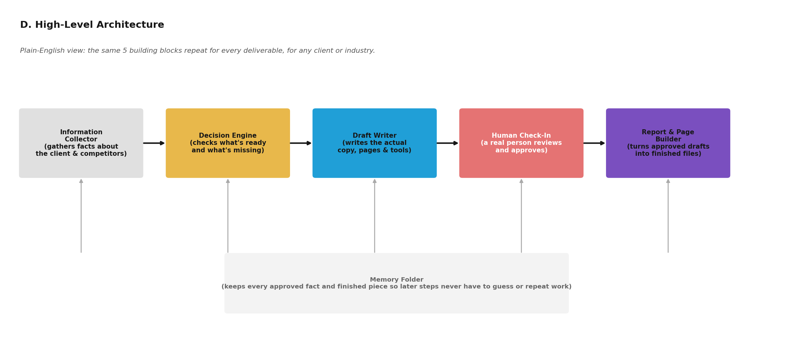

8. Mermaid Diagrams
Each diagram below is provided as portable Mermaid source (so it can be pasted into any Mermaid-compatible tool and edited) and as a rendered image (for readability in this document).

A. End-to-End Workflow
flowchart LR
A[Client Intake] --> B[Build Buyer Persona - ICP]
B --> C[Audit + Rewrite Page Copy - CRO]
C --> D[Build the Web Page - Pillar Page]
D --> E[Map Funnel + Offer Ladder]
E --> F[Build Lead Magnet Tool]
F --> G[Write Blog + SMS Nurture]
G --> H[Plan of Action + Visual Maps]
H --> I[Content + Social Strategy]
I --> J[Webinars + Book + Podcast]
J --> K[Final Asset Bundle]
D -.-> R[Remarketing Track - Phase 2]
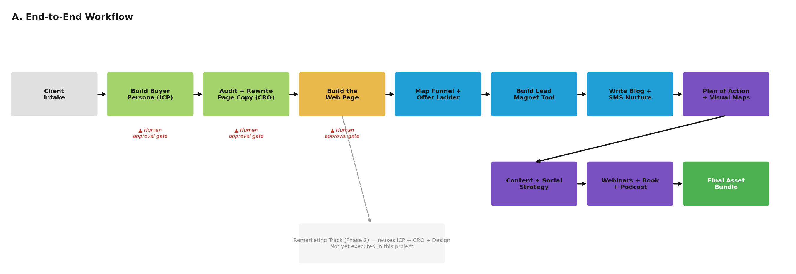

B. Agent Workflow
flowchart LR
A1[Discovery Agent] --> A2[Persuasion Agent]
A2 --> A3[Page Builder Agent]
A3 --> A4[Funnel Architect Agent]
A4 --> A5[Lead Magnet Agent]
A5 --> A6[Nurture Agent]
A6 --> A7[Synthesis Agent]
A7 --> A8[Authority Agent]
A8 --> A9[Signature Asset Agent]
A3 -.-> A10[Remarketing Agent]
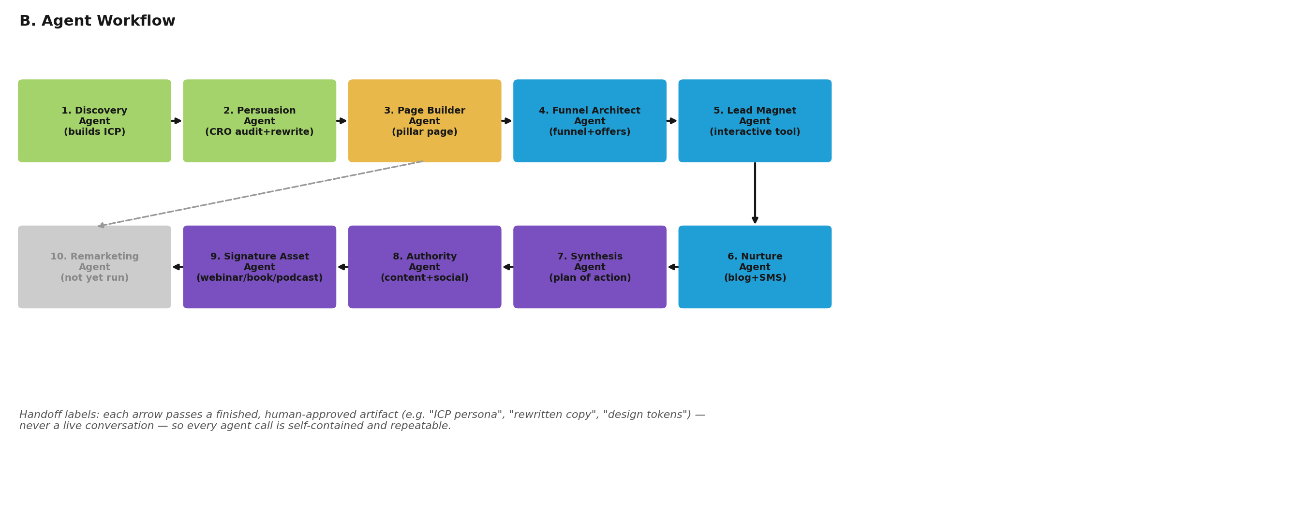

C. Data Flow Diagram
flowchart TD
Intake[Client Intake] --> ICP[Build Buyer Persona]
ICP --> CRO[Audit + Rewrite Copy]
CRO --> Page[Build the Web Page]
Page --> Funnel[Map Funnel + Offer Ladder]
Funnel --> Magnet[Build Lead Magnet Tool]
Magnet --> Nurture[Write Blog + SMS]
Nurture --> Plan[Plan of Action]
Plan --> Content[Content + Social Strategy]
Content --> Authority[Webinars + Book + Podcast]
Notes[(Shared Project Notes)]
Intake -.writes.-> Notes
ICP -.writes.-> Notes
CRO -.writes.-> Notes
Page -.writes.-> Notes
Funnel -.writes.-> Notes
Magnet -.writes.-> Notes
Nurture -.writes.-> Notes
Plan -.writes.-> Notes
Content -.writes.-> Notes
Authority -.writes.-> Notes
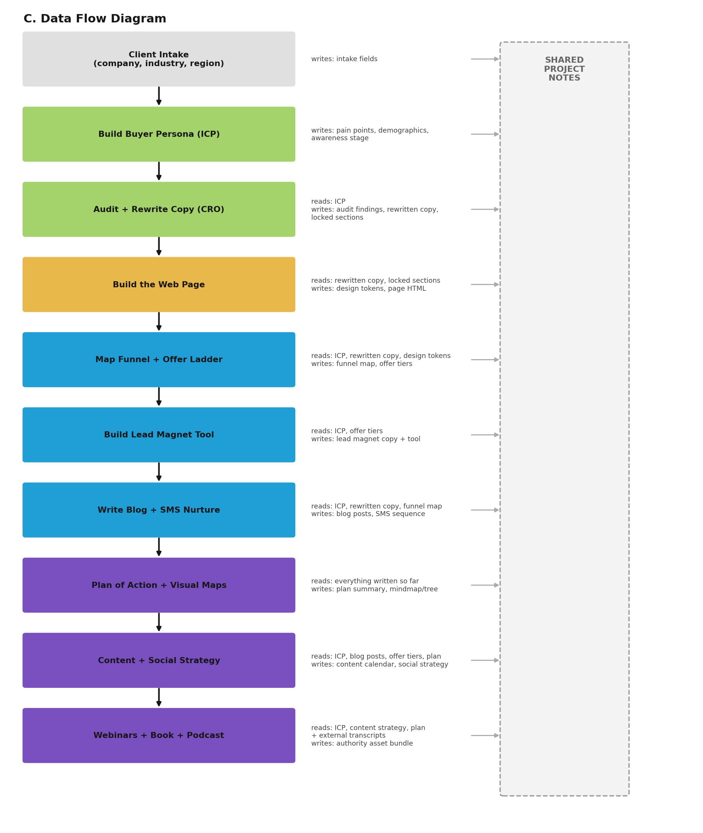

D. High-Level Architecture
flowchart LR
IC[Information Collector] --> DE[Decision Engine]
DE --> DW[Draft Writer]
DW --> HC[Human Check-In]
HC --> RB[Report and Page Builder]
MF[(Memory Folder)]
IC --- MF
DE --- MF
DW --- MF
HC --- MF
RB --- MF


9. Mapping to the Wiring Document
The Wiring Document (Asset Wiring — Names, Order, and Model Connectivity, Manus AI, 29 July 2026) specifies a 16-stage Phase 1 chain and a 6-stage Phase 2 “Remarketing” chain. The Architecture Document (Marketing_in_a_Box_Architecture.html) describes the same stage order at a conceptual level, plus a 27-item asset catalogue. The two reference documents agree with each other on stage names and order — no contradiction was found between them. The table below checks the actual files against both.
Stage (Wiring Doc) | Built for SMM? | Built for LinkedIn / Google Ads? | Finding
1. ICP | Yes | Reused, not rebuilt, for both | Consistent with the Wiring Doc's own “additive, never overwritten” rule — but the Wiring Doc never explicitly states whether ICP is scoped per-client or per-service-line. See Assumptions.
2. CRO | Yes (2 drafts + final) | Not built for either | Gap for LinkedIn and Google Ads — their page copy was written without a documented audit step.
3. Pillar Page | Yes | Yes (LinkedIn) / N/A (Google Ads has no page in this project) | Matches the Wiring Doc exactly for SMM and LinkedIn.
4. Funnel | Yes | Yes (LinkedIn, merged with Offers into one document) | LinkedIn's funnel document does the job of two Wiring Doc stages (Funnel + Offers) at once — a compression, not a contradiction.
5. Offers | Yes | No | Gap for LinkedIn and Google Ads — no formal value-ladder document for either.
6. Lead Magnet | Yes | Yes (LinkedIn) | Matches.
7. Blog | Yes | Yes (LinkedIn) | Matches.
8. Text/SMS | Yes | Yes (LinkedIn) | Matches.
9. SEO Pillar Page | No | No | Not built for any service line in this project — the clearest single gap against the Wiring Doc.
10. Plan of Action | Yes | No | Gap for LinkedIn and Google Ads.
11. Content Marketing | Yes | Yes (both) | Matches — Google Ads' version pre-existed this project.
12. Social Content Strategy | Yes (built as a competitor audit) | No | The Wiring Doc describes this stage as reading the content strategy and writing a forward “social_strategy” — what was actually built is closer to a competitive audit. Related, but not the same document type.
13–14. Webinars | Yes (both variants) | No | Gap for LinkedIn and Google Ads.
15. Book | Yes | No | Gap for LinkedIn and Google Ads.
16. Podcast | Yes | No | Gap for LinkedIn and Google Ads.
Phase 2: Remarketing (all 6 stages) | No | No | Not started for any service line — zero matching files exist anywhere in the folder.

The Google Ads funnel-mapping work (media grouping, hub model, commitment ladder) does not appear in this table at all, because it has no corresponding stage_type in the Wiring Document. It is a genuinely new pattern — see Section 10.

10. Gaps and Recommendations
Gap 1 — Remarketing track (Phase 2) has never been run
The Wiring Document fully specifies a 6-stage Remarketing chain that reuses the ICP, CRO output, and design tokens from Phase 1. No file in the folder — for any of the three service lines — corresponds to any of its 6 stages.
Recommendation: Before building anything new, run the Remarketing track once for the Social Media Marketing service line, since it already has every Phase 1 dependency (ICP, CRO output, design tokens) approved and ready to reuse.
Gap 2 — the SEO-focused Pillar Page (Stage 9) was never built
This is the one stage inside the fully-executed SMM chain that is missing. Every other Phase 1 stage exists for SMM.
Recommendation: Build this stage for SMM before starting it for any other service line, since the Wiring Document treats it as reading directly from the already-approved rewritten copy and design tokens — no new upstream work is required.
Gap 3 — LinkedIn Marketing & Ads and Google Ads stop partway through the chain
LinkedIn has 6 of 16 Phase 1 stages; Google Ads effectively has none of the documented 16 stages, only a pre-existing Content Marketing input plus new work outside the documented taxonomy. Neither has a CRO audit, an Offers/Value-Ladder document, an SEO Pillar Page, a Plan of Action, Webinars, a Book, or a Podcast.
Recommendation: Decide deliberately whether each service line needs the full 16-stage treatment or a defined lighter subset — right now the stopping point looks like it was set by how much time was available in each work session, not by a documented decision about what each service line actually needs.
Gap 4 — the Google Ads funnel work is a new pattern with no formal stage definition
The media-grouping, hub-model, and commitment-ladder deliverables are genuinely useful, but they do not correspond to any stage_type in the Wiring Document, so nothing in the automated system (as currently specified) would know how to reproduce them for the next client.
Recommendation: The Funnel-Hub-Media-Architect-Prompt.md file already written for this pattern is the right first step — the next step is to add it to the Wiring Document itself as a new, formally numbered stage, with its own read/write fields, the same way every other stage is documented.
Gap 5 — the Prompt Recipe Library is being built retroactively, not upfront
All 7 “Architect Prompt” files in the folder were written after a stage was first produced successfully by hand, not before. This works, but it means the library's completeness always lags one step behind actual production work, and a stage type could be run inconsistently more than once before its recipe is ever written down.
Recommendation: Formalise this into the process itself: the last step of building any new stage type, for the first time, should always be “write its Architect Prompt”, before that stage is ever run for a second client or service line.
Gap 6 — no file in the folder shows the ICP or CRO steps actually being re-run per service line
Every service line after SMM reuses the same single ICP file. The Wiring Document itself does not explicitly say whether a persona should be per-client or per-service-line — this project's actual behaviour (reuse) is one reasonable reading, but it is an inferred convention, not a documented rule.
Recommendation: Add one sentence to the Wiring Document stating explicitly whether ICP and CRO are scoped to the client as a whole or to each individual service line, so this stops being an assumption.
Gap 7 — the Architecture Document's asset catalogue and the actual folder are not fully aligned
The catalogue's item 11 (“Website Content Blueprint”) is marked “Completed”, but no file in the folder is named or clearly scoped as that specific deliverable — it may be intended to mean the pillar page and its supporting content collectively, but that is not stated anywhere.
Recommendation: Either rename catalogue item 11 to match an actual file, or add a short note in the catalogue clarifying which existing file(s) satisfy it.

11. Assumptions
Everything above is traced directly to a file, or to one of the two reference documents. The points below are the places where this analysis had to infer something the source material does not state outright — listed separately, as instructed, rather than folded into the findings above as if they were confirmed fact.
- ICP and CRO outputs are assumed to be scoped to the client as a whole, and intentionally reused across service lines, rather than each service line silently missing its own persona/audit by omission. This is inferred from the pattern actually observed (one ICP file, reused three times) — the Wiring Document does not state this rule explicitly.
- The TrafficRadius_Google_Ads_Content_Marketing_Strategy.docx file is assumed to have been produced by an earlier process outside this project, since no file in the folder documents its creation and it is referenced in this project only as an existing input. It is treated here as a supplied external document, consistent with the Wiring Document's own rule that “external source documents are separate from generated context.”
- The two earlier CRO/copy drafts for SMM (CRO-Audit_Social-Media-Marketing.md and Rebuilt-Copy_Social-Media-Marketing.md) are assumed to be superseded drafts rather than separate, still-relevant deliverables, based on their timestamps (both precede the “PART-1”/“PART-2” files by the same day) and their overlapping subject matter.
- The Social-Content-Audit_TrafficRadius-vs-Top5.md file is assumed to satisfy the Wiring Document's Stage 12 in spirit, even though it is structured as a competitive audit rather than a forward-looking “social_strategy” document, because no other file in the folder addresses this stage at all.
- Where the Architecture Document's asset catalogue marks an item “Completed” without an exact matching filename (for example, item 11, “Website Content Blueprint”), this analysis assumes the intended reference is the Pillar Page and its immediate supporting content, rather than a missing, separate file — this is a best-fit interpretation, not a confirmed mapping.
- The three human-approval “gates” (ICP, CRO, Pillar Page) are assumed, per the Wiring Document, to have actually been exercised as real approval checkpoints during this project's manual execution, even though the files themselves do not carry an explicit approval timestamp or sign-off record — the project's own turn-by-turn conversational structure is the de facto approval mechanism referred to in the Wiring Document's closing note that this mirrors “how the process worked manually.”

12. Conclusion
The manual_execution folder is not a random collection of 54 files — it is one repeatable production chain, executed at three different depths for three different TrafficRadius service lines, plus a fourth branch of genuinely new work that has outgrown its current documentation. Every file traces cleanly back to something before it and forward to something after it, with exactly two structural exceptions: the SEO-focused Pillar Page, which the specification calls for but which was never built for any service line, and the entire Remarketing track, which is fully designed but has not been run once.
The two reference documents — the Architecture Document and the Wiring Document — agree with each other and, for the most part, agree with what was actually built. The clearest way to move this from a manually-run process to the automated system both documents describe is threefold: close the two structural gaps above (starting with the SEO Pillar Page, since it has zero unmet dependencies), decide and document how deep each new service line is meant to go through the 16-stage chain rather than letting that be decided implicitly, and formally add the new Google Ads funnel-mapping pattern to the Wiring Document as its own named stage now that it has already been generalised into a reusable prompt.
None of this requires new invention — the discipline the manual process already follows (never invent design, never reword locked content, never regenerate a fact that already exists, always write down a reusable recipe after building something new) is exactly the discipline an automated version of this system would need to enforce mechanically. The manual execution captured in this folder has, in effect, already prototyped the automated system by hand.

