TRAFFICRADIUS
OWNED MEDIA · FUNNEL HUB MODEL

All Roads Lead to Rome
The Google Ads Funnel Hub — Convergent Entry, Dual Convert Offer, Cascading Upsell
Prepared for TrafficRadius Pty Ltd | Melbourne, VIC
Version 1.0 — August 2026

1. The Hub Model
Instead of running 18 disconnected funnels, this model restructures the same 18 funnel types into a single hub: many different TOFU and MOFU funnels — built for different audiences, formats and channels — all converge into two Convert-stage main offers. From there, every converted lead or client is cascaded through a sequential upsell/cross-sell path rather than being left with a single next step.
Three new metrics are layered onto every funnel in this model:
- Ease of Implementation (1-5) — how much build effort this funnel requires before it can run, 5 being the easiest.
- Time Decay + Effort — whether the underlying content/offer is Evergreen (reusable indefinitely) or Viral/Temporary (time-bound, needs refreshing), cross-referenced against the production effort (Low/Medium/High) it took to build.
- Audience Awareness Level — where the visitor sits on the Unaware -> Problem-Aware -> Solution-Aware -> Product-Aware -> Most-Aware spectrum when they enter that funnel, cross-mapped against relevance to three roles: Accountable Andrew (business owner, 50% weight), Marketing Mia (reviewer/coordinator, 30% weight), and the Technical Lead (developer/ops sign-off, 20% weight).

2. The Hub, Visualised
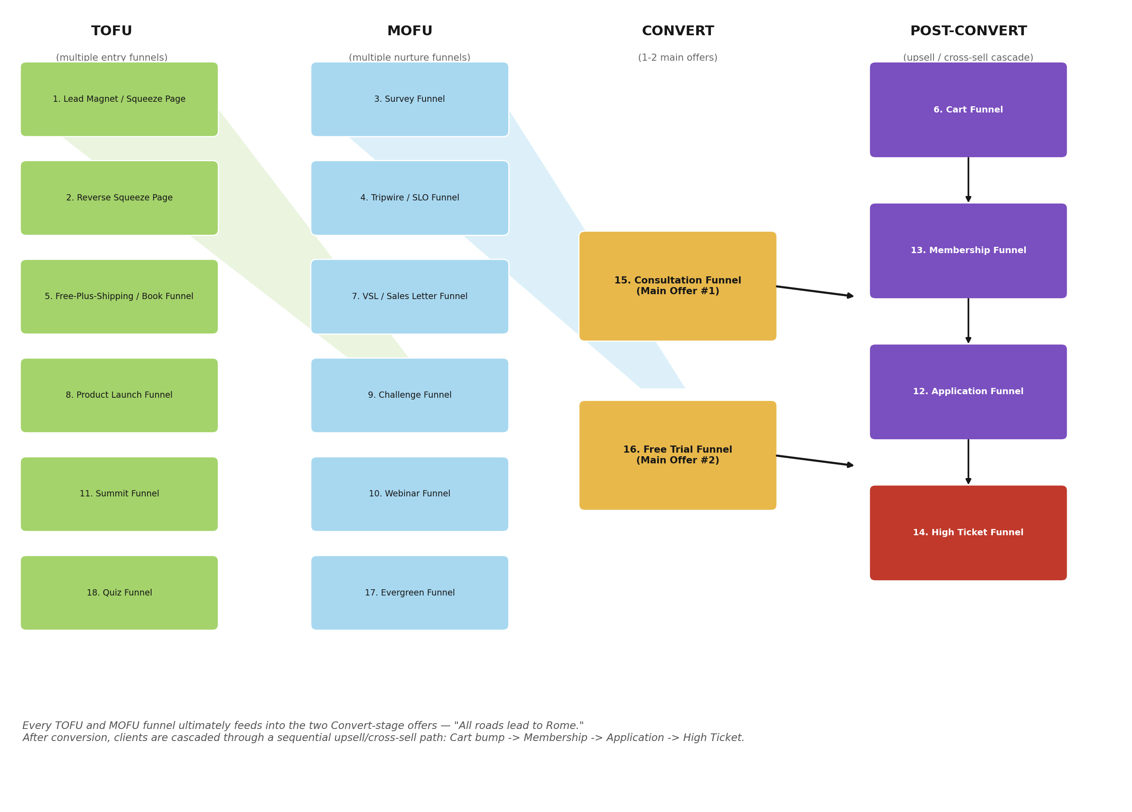
Figure 1 — TOFU (6 funnels) and MOFU (6 funnels) converge into two Convert-stage offers (Consultation Funnel, Free Trial Funnel), which then cascade into a 4-stage post-convert upsell path.

3. TOFU — Multiple Entry Funnels
Six different funnel types draw in cold, largely Problem-Aware traffic from different channels and formats. None of them ask for more than light engagement — their only job is to start the relationship.
# | Funnel | Ease | Time Decay + Effort | Awareness Level | Owner/Reviewer/Tech %
1 | Lead Magnet / Squeeze Page | 5/5 | Evergreen / Low | Problem-Aware | 55% / 30% / 15%
2 | Reverse Squeeze Page | 4/5 | Evergreen / Low | Problem-Aware | 50% / 35% / 15%
5 | Free-Plus-Shipping / Book Funnel | 2/5 | Evergreen / High | Problem-Aware | 60% / 25% / 15%
8 | Product Launch Funnel | 2/5 | Viral/Temporary / High | Solution-Aware | 50% / 35% / 15%
11 | Summit Funnel | 1/5 | Viral/Temporary / High | Problem-Aware | 40% / 40% / 20%
18 | Quiz Funnel | 3/5 | Evergreen / Medium | Problem-Aware | 45% / 35% / 20%

1. Lead Magnet / Squeeze Page
What Should You Actually Spend on Google Ads? (Free AUD Calculator)
Instant budget range + benchmark CPC by industry, no call required.
The 30-Minute Google Ads Budget Framework
A downloadable worksheet SMB owners fill in themselves before talking to any agency.
2. Reverse Squeeze Page
Watch First: What's a Good CPC in Your Industry? (Then Unlock the Full AU Data Table)
Video-first benchmark reveal, full dataset gated after.
5. Free-Plus-Shipping / Book Funnel
The Australian Google Ads Benchmark Report — Free Copy, You Just Cover Postage
Physical, mailed booklet version of the flagship data report.
8. Product Launch Funnel
The Australian Google Ads Benchmark Report Is Here — See Where You Rank
Launch-week release of the flagship annual data asset.
11. Summit Funnel
The Australian Google Ads Growth Summit
Free 3-day virtual event, co-hosted with tracking, CRO and ecommerce-feed specialists.
18. Quiz Funnel
What's Your Google Ads Waste Score?
10-question diagnostic quiz, scored 0-100, same proven mechanic as the Four Causes Scorecard.

4. MOFU — Multiple Nurture Funnels
Six funnel types nurture and qualify the audience TOFU brought in, moving them from Problem-Aware toward Solution-Aware and Product-Aware before they ever see the main offer.
# | Funnel | Ease | Time Decay + Effort | Awareness Level | Owner/Reviewer/Tech %
3 | Survey Funnel | 4/5 | Evergreen / Medium | Problem-Aware | 45% / 35% / 20%
4 | Tripwire / SLO Funnel | 3/5 | Evergreen / Medium | Solution-Aware | 55% / 25% / 20%
7 | VSL / Sales Letter Funnel | 3/5 | Evergreen / High | Product-Aware | 55% / 30% / 15%
9 | Challenge Funnel | 2/5 | Evergreen / High | Solution-Aware | 45% / 40% / 15%
10 | Webinar Funnel | 3/5 | Evergreen / Medium | Solution-Aware | 50% / 35% / 15%
17 | Evergreen Funnel | 5/5 | Evergreen / Low | Solution-Aware | 45% / 35% / 20%

3. Survey Funnel
Are You Actually Ready to Run Google Ads? (7-Question Readiness Check)
Diagnoses which of the 7 prerequisites are missing before spending a dollar.
4. Tripwire / SLO Funnel
$97 Google Ads Account Audit — 12 Points, Your Actual Account, 48 Hours
A paid, hands-on-your-account audit that pays for itself in the first fixed waste it finds.
Get Your Quality Score Diagnosed for $97
Narrower, cheaper variant focused solely on the 3 Quality Score levers from Cluster C.
7. VSL / Sales Letter Funnel
Why Most Businesses Plateau at $3K/Month in Google Ads Spend (And How to Scale Past It)
Long-form persuasion asset closing into a strategy call.
9. Challenge Funnel
The 5-Day Google Ads Waste-Finder Challenge
Self-guided version of the audit checklist, run over 5 days with daily prompts.
10. Webinar Funnel
Live Webinar: How Much Should You Really Spend on Google Ads in 2026?
Benchmark-data session ending in a strategy session offer.
17. Evergreen Funnel
Watch On-Demand: The Google Ads Benchmark Masterclass
Always-available recorded version of the live webinar.

5. Convert Stage — The Two Main Offers ("Rome")
Every TOFU and MOFU funnel above ultimately routes here. Rather than one single main offer, TrafficRadius runs two parallel doors so a Product-Aware visitor can choose the lower-commitment proof path (trial) or the higher-touch relationship path (consultation) — both lead to the same place.
# | Funnel | Ease | Time Decay + Effort | Awareness Level | Owner/Reviewer/Tech %
15 | Consultation Funnel | 5/5 | Evergreen / Low | Product-Aware | 55% / 30% / 15%
16 | Free Trial Funnel | 3/5 | Evergreen / Medium | Most-Aware | 55% / 25% / 20%

15. Consultation Funnel
Book a Free Google Ads Strategy Session
The main, low-friction convert-stage offer most other funnels feed into.
16. Free Trial Funnel
2-Week Managed Test Campaign — No Management Fee
Live proof-of-capability trial, capped budget, no long-term commitment.

6. Post-Convert — The Upsell / Cross-Sell Cascade
Once a lead converts through either main offer, they enter a fixed sequence rather than a single upsell: an immediate small add-on (Cart), a recurring lower-commitment option for those not ready to go all-in (Membership), a formal qualification step for graduating clients (Application), and the full-service retainer as the final destination (High Ticket).
# | Funnel | Ease | Time Decay + Effort | Awareness Level | Owner/Reviewer/Tech %
6 | Cart Funnel | 3/5 | Evergreen / Medium | Product-Aware | 50% / 25% / 25%
13 | Membership Funnel | 2/5 | Evergreen / High | Most-Aware | 50% / 40% / 10%
12 | Application Funnel | 4/5 | Evergreen / Low | Product-Aware | 60% / 20% / 20%
14 | High Ticket Funnel | 2/5 | Evergreen / High | Product-Aware | 65% / 20% / 15%

6. Cart Funnel
Add Express 48-Hour Turnaround to Your Audit
One-click bump at checkout.
Add a Conversion Tracking Fix-It Session
Technical add-on aimed at the developer/ops sign-off audience.
13. Membership Funnel
Google Ads Insiders — Monthly Benchmark Data + Live Office Hours
Low-commitment recurring community for DIY-managing owners.
Insiders Annual — 2 Months Free
Annual-commitment variant with a modest discount for retention.
12. Application Funnel
Apply for a Google Ads Management Partnership
A qualifying application, not a booking form — filters for real fit before a call happens.
14. High Ticket Funnel
Google Ads Management — Growth, Scale, Enterprise
Tiered retainer proposal following consultation or application.

