JAVA: it is an object-oriented programming language

WHERE JAVA:
- Banking: To deal with transaction management.

- Retail: Billing applications that you see in a store/restaurant are completely written in Java.

- Information Technology: Java is designed to solve implementation dependencies.

- Android: Applications are either written in Java or use Java API.

- Financial services: It is used in server-side applications.

- Stock market: To write algorithms as to which company they should invest in.

- Big Data: Hadoop MapReduce framework is written using Java.

- Scientific and Research Community: To deal with huge amount of data.

WHAT MORE JAVA CAN DO:

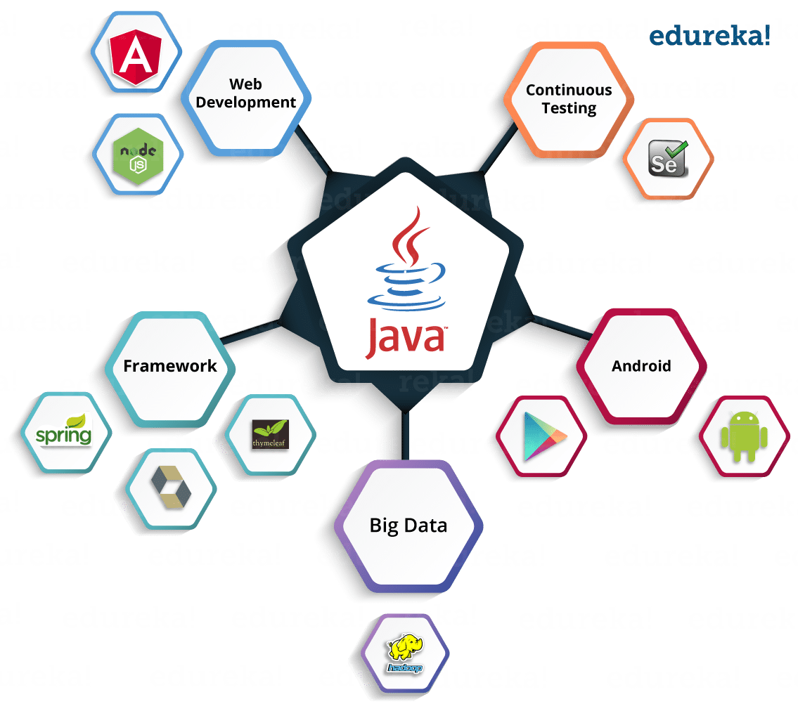

History of Java:
Java is a programming language developed by James Gosling with other team members named Mike Sheridan and Patrick Naughton also called as Green Team in 1995 for Sun Microsystems for digital devices such as set-top boxes, televisions etc.

What is Java?
It is an object-oriented language similar to C++, but with advanced and simplified features. Java is free to access and can run on all platforms.

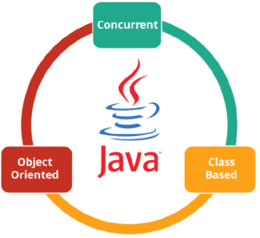

Concurrent where you can execute many statements instead of sequentially executing it.
Class-based and an object-oriented programming language.
Independent programming language that follows the logic of “Write once, Run anywhere” i.e. the compiled code can run on all platforms which supports java.

FEATURES OF JAVA:

Simple: Java has made life easier by removing all the complexities such as pointers, operator overloading as you see in C++ or any other programming language.

Portable: Java is platform independent which means that any application written on one platform can be easily ported to another platform.

Objected-oriented: Everything is considered to be an “object” which possess some state, behavior and all the operations are performed using these objects.

Secured: All the code is converted in bytecode after compilation, which is not readable by a human. and java does not use an explicit pointer and run the programs inside the sandbox to prevent any activities from untrusted sources

Dynamic: It has the ability to adapt to an evolving environment which supports dynamic memory allocation due to which memory wastage is reduced and performance of the application is increased.

Distributed: Java provides a feature which helps to create distributed applications. Using Remote Method Invocation (RMI), a program can invoke a method of another program across a network and get the output.

Robust: Java has a strong memory management system. It helps in eliminating error as it checks the code during compile and runtime.

COMPONENTS IN JAVA:

JVM (Java Virtual Machine):
It is an abstract machine. It is a specification that provides a run-time environment in which Java bytecode can be executed. It follows three notations:
Specification
Implementation
Runtime instance

JRE (Java Runtime Environment):
JRE refers to a runtime environment in which Java bytecode can be executed. It implements the JVM (Java Virtual Machine) and provides all the class libraries and other support files that JVM uses at runtime.

JDK (Java Development Kit):

It is the tool necessary to:

- Compile
- Document
- Package Java programs
.
The JDK completely includes JRE which contains tools for Java programmers. The Java Development Kit is provided free of charge. Along with JRE, it includes an interpreter/loader, a compiler (java c), an archiver (jar), a documentation generator (Javadoc) and other tools needed in Java development.

