**Reports**

- Related work

Image segmentation is an important part of image processing and is a low-level operation that allows you to segment an image into discrete, homogeneous regions. The image segmentation result directly affects the efficiency of subsequent image processing.

Otsu's image segmentation method selects an optimal threshold by maximizing the within-group variation in grayscale images. However, as the number of classes increases, the total execution time also increases exponentially. This is because calculating the mean of the within-group variance requires many iterations. In this article [1], we use the Firefly algorithm to optimize execution time and segmentation accuracy. The Firefly algorithm has several features that are suitable for solving optimization problems, such as high convergence speed and low computation speed. Here, we propose the Firefly algorithm to optimize Otsu's method. This method is called maximum variance within groups based on the Firefly algorithm. The proposed method is compared with the Otsu method and the recursive Otsu method. Experimental results show that the proposed method is much more efficient than the Otsu method and the recursive Otsu method. The proposed method is very efficient for segmentation as it can search for optimal multiple thresholds. The number of thresholds has much less of an impact on total execution time.

Therefore, the efficiency of the existing maximum class variance method is low. This article [2] uses the cuckoo algorithm to optimize the traditional maximum class variance method to achieve a better partitioning effect. These image segmentation methods combined with optimization theory can achieve the goal of finding the optimal segmentation.

Also, of the many image segmentation methods, the easiest procedure to implement is thresholding. In this paper, we present a unique heuristic approach to image segmentation that automatically determines multilevel thresholds by sampling a histogram of a digital image. This approach focuses on selecting valleys with optimal thresholds. This approach has been shown to outperform the popular Otsu method in terms of CPU computation time. A speedup of up to 35.58x and a minimum speedup of 10.21x can be seen in popular image processing benchmarks [3].

To preserve image details and automatically determine the segmentation threshold of image segmentation, [4] proposes an image segmentation method based on wavelet transform. Detailed information in horizontal, vertical and diagonal directions can be obtained through image decomposition based on wavelet transform theory. The proposed method has been tested on different images and has better visual effects than other existing methods such as maximum variance segmentation and histogram valley threshold segmentation. Among the three image quality evaluation indicators, the proposed method has a clear advantage, especially in segmentation of medical images.

With the rapid development of artificial intelligence, especially deep learning (DL), image segmentation methods based on deep learning have achieved good results in the field of image segmentation. Compared to traditional machine learning and computer vision methods, deep learning has certain advantages in segmentation accuracy and speed. Therefore, medical image segmentation using deep learning can effectively identify the size of a diseased tumor and quantitatively evaluate the effects before and after treatment, thereby greatly reducing the workload of clinicians [5].

- Chaotic Teaching Learning Based Optimization

The TLBO algorithm is one way to solve the optimization problem. This algorithm was inspired from the classroom environment of the students. That is, this algorithm is a population-based meta-heuristic optimization technique that optimizes a given objective function by simulating a classroom environment.

In the classroom, the teacher studies hard and educates every learner in the class. The learner then interacts with other students to further refine and improve the knowledge gained.

This algorithm consists of two steps.

1) Teacher stage

Every student learns and gains knowledge from a teacher. The goal of this step is to make significant the learning ability of the students to improve the outcome of the lesson. This can lead to an average result in the class. Usually, the teacher can improve the result to some extent.

Indeed, many constraints affect outcomes, such as teaching methods, teacher skills, ability to understand learners, interactions between learners and others, and knowledge of learners.

At the teacher level, 'Xi, Lmean' represents the learner's mean of knowledge and 'XTeacher' represents all repeated teachers. The primary responsibility of teachers is to increase the current knowledge of learners. To achieve this, the learner's current average knowledge, 'Xi, Lmean', goes to the teacher knowledge, 'XTeacher', which can be described using (1).



In (1), ‘XTeacher’ and ‘Xi, Lmean’ represent the mean of knowledge for the teacher and the i-th learner, Tf represents the learning factor, and r represents a random number in the range of 0 and 1. Xi,new describes the i-th learner's updated knowledge and Xi,old represents the i-th leaner's previous knowledge. The teaching factor is calculated using (2).



2) Learner stage

The goal of the learner phase is to advance the learner's knowledge from others. Thus, learners can randomly interact with other learners to improve their own learning skills. In the learner phase of the TLBO algorithm, learners learn knowledge from others. This learner's learning ability can be expressed as follows. If the i-th learner wants to interact with the k-th learner, and the fit of the k-th learner is higher than that of the i-th learner, the k-th learner's location is updated if the i-th learner's location is not updated. This can be summarized in (3, 4) as follows.



Else



If the new position of the i-th learner is more suitable than the previous position, the new position takes over. Otherwise, it won't.

But the teaching learning based optimization (TLBO) algorithm suffers with premature convergence and lack of tradeoff between local search and global search. Hence, to address the above mentioned short comings of TLBO algorithm, a chaotic version of TLBO algorithm is proposed with different chaotic mechanisms.

In the chaotic TLBO algorithm, chaotic maps are incorporated into TLBO to over-come effect of random numbers on the performance of algorithm. Further, chaotic maps are used to generate random numbers instead of random number generator. The generated random number sequence is differing from the random number generated through random function. The random numbers generated through random function are unordered. While chaotic maps generate random numbers in particular pattern. This is also one of a reason to incorporate chaotic maps into optimization algorithm for enhancing its performance. It is observed that in TLBO algorithm, the convergence of algorithm depends on teacher phase and learner phase. Both of phases use random numbers that can affect the performance of algorithm. Especially, in teacher phase, solution search equation contains two random factors, one is a random number (r) and another is a teaching factor which is also computed through random number. But there is no predefined method to control on successive random number generations. So there is large variation in random number generation and this variation can affect the convergence of algorithm. There is no predefined pattern in random number generation. But in case of chaotic operator, the random number is generated into increasing order and the variation between successive random numbers is not so large. It is also noticed that the chaotic maps are deterministic in nature. However, chaos can help order to arise from disorder. Same in case of optimization algorithms that are inspired from biological systems, the order arises from disorder. Hence, due to these common properties between chaos and optimization algorithms, chaos opera-tor can improve the convergence problem of algorithms.

In this work, logistic chaotic maps are used to optimize the different parameters of TLBO algorithm.

Thus, a chaotic map step is added to the TLBO algorithm.

3) Chaotic stage

The rand parameter of (2) is updated using chaotic during entire execution of experiment. The updated teaching factor equation can be rewritten as:



In TLBO algorithm, rand is a random number in the range of 0 and 1; but Chaotic TLBO algorithm, it can be described as a chaotic number in the range of 0 and 1.



where  is 4 and .

As a result, in the chaotic TLBO algorithm, chaotic maps are used to generate the random number instead of pseudo random generator. This is an important key to proceed with the global optimization.

- Result analysis

The type of dataset: real face dataset and fake face dataset.

So this classification problem is binary classification.

Firstly, I have proceeded the classification without applying the chaotic TLBO algorithm.

Next, I have proceeded the classification after apply the chaotic TLBO algorithm to all images. And then I compare these two methods. Classification results are as follows.

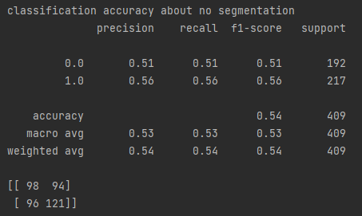

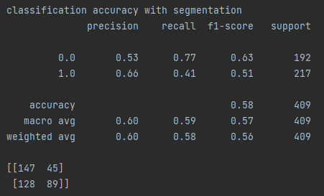

References

# [1] High-dimensional multi-level maximum variance threshold selection for image segmentation: a benchmark of recent population-based metaheuristic algorithms, 2020

## [2] An improved image segmentation algorithm based on the maximum class variance method, 2020

# [3] Image Segmentation using Multi-Threshold technique by Histogram Sampling, 2019

[4] A wavelet transform-based image segmentation method, 2020

# [5] A Review of Deep-Learning-Based Medical Image Segmentation Methods 2021

[6]A Survey on Image Segmentation Using Deep Learning 2021