**Methodology**

MCRW.m file is simulation code about adsorption of non-ionic surfactants on organoclays in drilling fluid investigated by Monte Carlo random walk simulations.

Here I will give the explanation how this matlab file is executed in details. That doesn't mean you should think I'm looking down on you. I am just for the convenience of the user. Then I will start explanation.

7 and 8 line is setting about boundary points. See the bellow figure 1. Here region of red points.

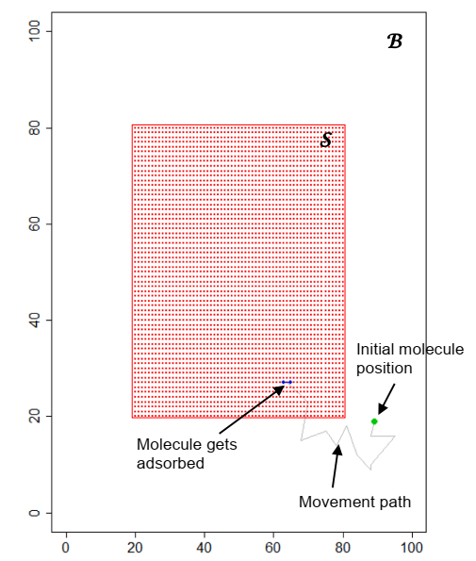

Fig.1

In 9 line nB is variable for laying in the region B, when the particle is out of boundary B. And there are setting about number of steps, number of molecules, size of step, and adsorption probability in from 10 line to 13 line.

In from 15 line to and 19 lines I performed setting related to molecules generation.

The part from 20 line to 103 line shows the adsorption of molecules with 2 chains (Fig.2).

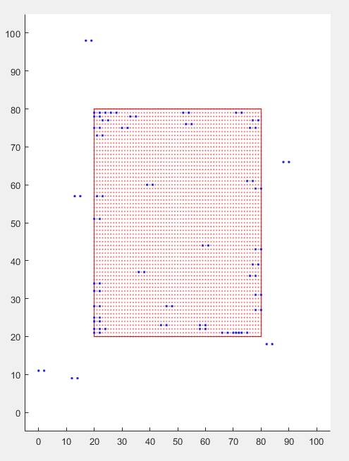

Fig.2

Here ‘acc1’ of 99 line is the “%organoclay sites occupied” and ‘ac1’ of 100 line is “%surfactant adsorbed”. In figure blue points show the molecules adsorbed.

And the part from 107 line to 194 line shows the adsorption of molecules with 3 chains (Fig.3).

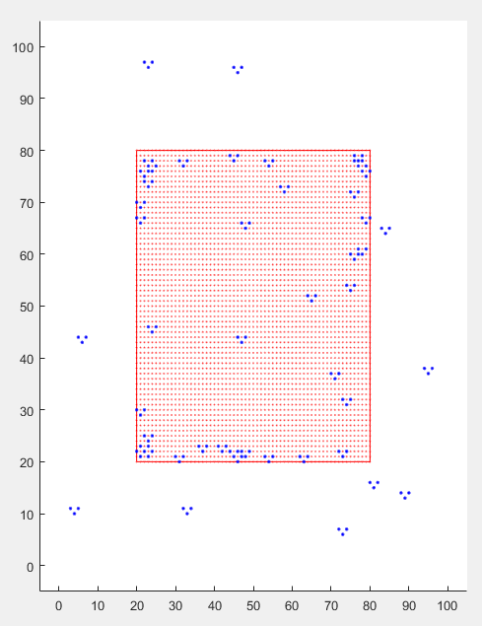

Fig.3

Then the part from 197 line to 288 line shows the adsorption of molecules with 4 chains (Fig.4).

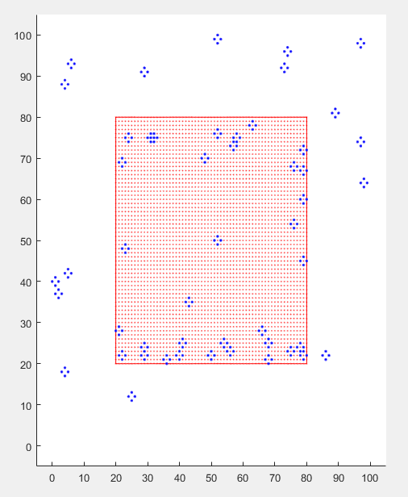

Fig.4

Next the experiment for showing how percents are changed according to change the number of steps was performed from 291 line to 537 line. Here experiment was repeated 5 times and the average percents were calculated (Fig.5,6).

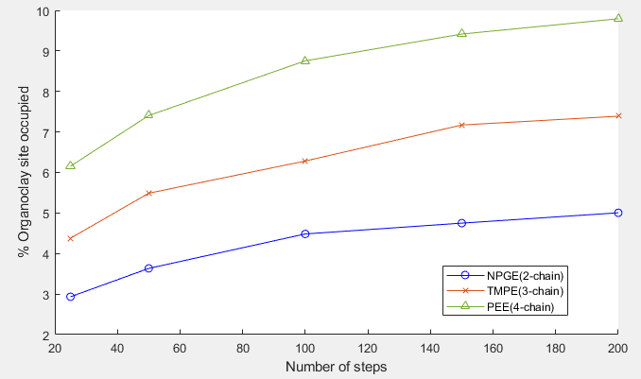

Fig.5

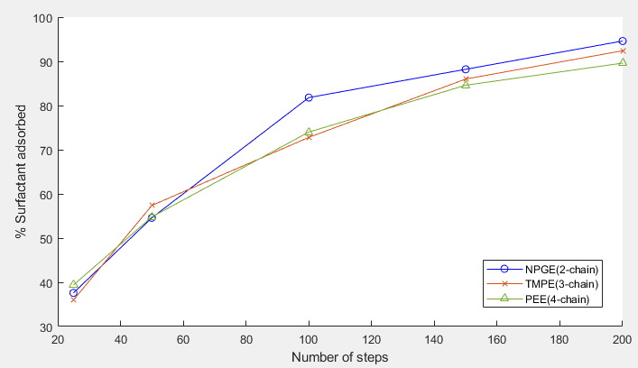

Fig.6

And the part from 541 line to 787 line show how percents are changed according to change the number of surfactant molecules. The principle of this part is similar to first case(when the number of steps is changed) (Fig.7,8).

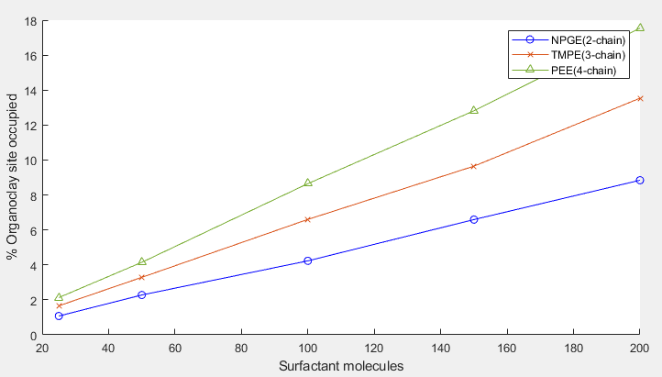

Fig.7

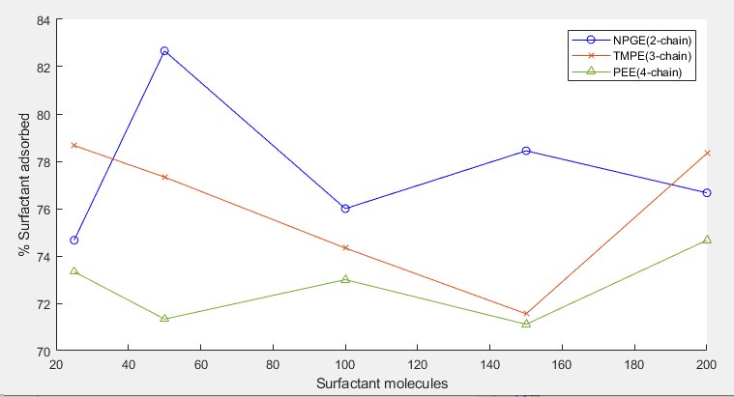

Fig.8

Next experiment shows how percents are changed according to change the length of random walks(step size). This is reflected in the lines from 791 line to 1034 line (Fig.9,10).

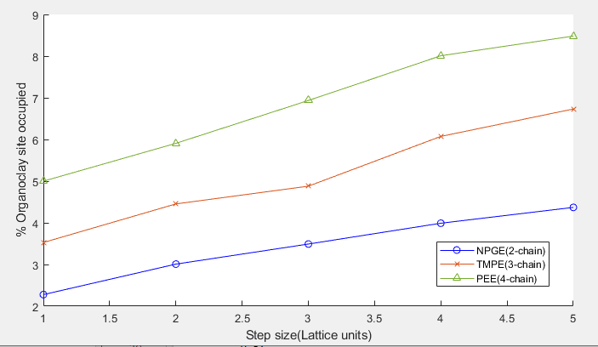

Fig.9

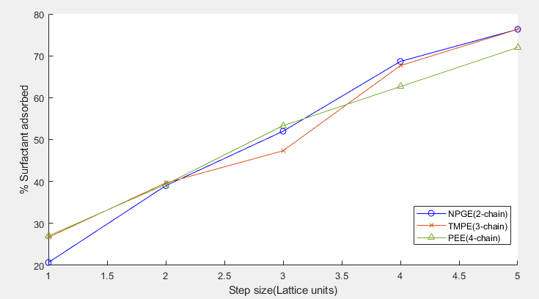

Fig.10

Lastly, the part from 1038 line to 1281 line show how percents are changed according to change the adsorption probability (Fig.11,12).

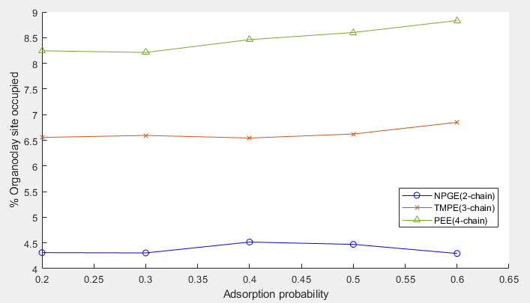

Fig.11

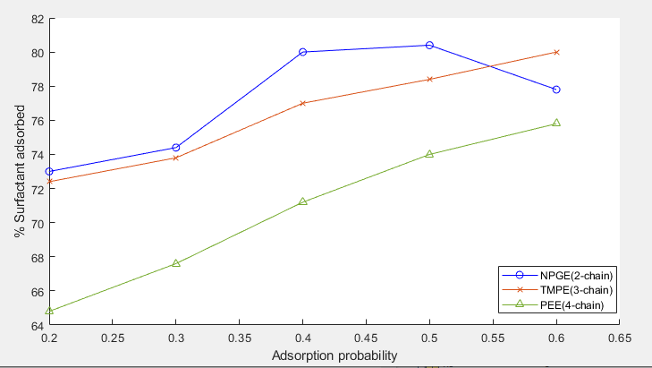

Fig.12

Because I gave the analysis result in the “Result Report.docx”, refer to it.