Report

Highs and Lows

EBusiness

msc computer science

Daniel Elstob

14011862@hope.ac.uk

Contents

1. Introduction 3

2. Initial Design 3

2.1 Functional Requirements 3

2.2 Non-Functional Requirements 3

2.3 Initial Design Template 5

2.4 Use Case Narratives 6

2.4.1 Adds Products to Cart 6

2.4.2 Purchase Product 6

2.5 Use Case Diagram 6

2.6 Navigation Diagram 7

3. Review 8

3.1 Electronic Payment 8

4. Design and Implementation 10

4.1 Functional Requirements 10

4.2 Non-Functional Requirements 10

4.3 Final Design Template 11

4.4 Use Case Narratives 13

4.4.1 Customer Registration 13

4.4.2 Customer Login Externally 13

4.4.3 Adds Products to Cart 14

4.4.4 Edits or Update Cart 14

4.4.5 Purchase Product 14

4.4.6 Payment of Product 15

4.4.7 Admin Manage Stock 15

4.5 Use Case Diagram 15

4.6 Navigation Diagram 16

4.7 Flow Chart 17

4.8 Sequence Diagram 18

4.9 Entity Relationship Diagram 19

5. Critical Evaluation 20

6. References 22

Figures

Figure 1 -Initial Design 5

Figure 2 - Initial Use Case 6

Figure 3 - Initial Navigation Diagram 7

Figure 4 - Final Design 12

Figure 5 - Final Use Case 15

Figure 6 - Final Navigation Diagram 16

Figure 7 - Payment Flowchart 17

Figure 8 - Register/Log in Sequence Diagram 18

Figure 9 - Entity Relationship Diagram 19

# Introduction

A small local business called Highs & Lows that sells rock climbing products from their shop run by three people. They would like to expand their business to an online store in order to sell to a larger consumer base.

The current system is a paper based stock control which is distributed among the staff by post and email. The current payment system is debit cards or cash in hand. The current system faces several issues. For example, if a certain product is popular and one of the staff does not make note of the stock in the paper they could sell out or take order they could not complete. Also if a large order of products is made they may not have the stock capacity to handle it. As well as this, the system currently used would not allow for memberships for revisiting or frequent customers. The new system shall be an IT based solution and for this purpose an ecommerce website is to be designed and implemented.

In order to complete this research will be done into how to create an ASP.NET website that can complete these requirements, how to connect external accounts and how to ensure secure payments can be made.

# Initial Design

The type of ecommerce website that the clients want to design is one that will sell products over looking nice. A list of functional and non-functional requirements has been made of the desired website.

## 2.1 Functional Requirements

* The systems shall show products
* The system shall allow products to be purchased
* The system shall allow for an easy purchase process

## 2.2 Non-Functional Requirements

* The systems shall have a logo
* The system shall display the latest or most popular products

Due to the unclear project requirements the chosen systems development methodology will be Rapid Application Development (RAD). This approach aims for minimal planning to develop a section of the system as fast as possible which is then delivered to the client so that they can offer amendments.

The approach of RAD that will be used is Prototyping. *“System prototyping performs the analysis, design and implementation phases concurrently in order to quickly develop a simplified version of the system”* (Dennis et al. 2012). This will allow for a quick template to be made and reviewed and then through iteration keep repeating until the project is complete or the client is satisfied with the result.

## 2.3 Initial Design Template

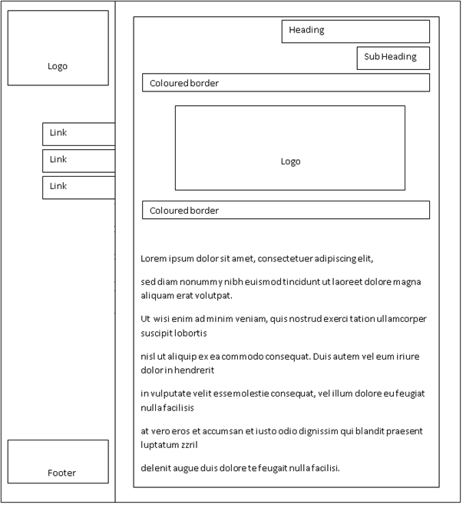

Figure 1 -Initial Design

Design Information:  
Left navigation will be fixed allowing the content on the right to scroll whilst keeping easy navigation. The links will be Home, Products and Cart and clear two areas for a clear logo meeting the initial requirements. The colours of the business are black which will be the navigation section and white for the content section.

## 2.4 Use Case Narratives

### 2.4.1 Adds Products to Cart

|  |  |  |  |
| --- | --- | --- | --- |
| Use Case Name: Customer Adds To Cart | | ID: 1 | Importance Level: 1 |
| Primary Actor: Customer | | | |
| Short Description: Customer adds a product to the shopping cart | | | |
| Trigger: Add to cart button in product view  Type: External | | | |
| Major Inputs | | Major Outputs | |
| Description  Add to cart | Source  Product View | Description  Cart Details | Destination  Cart Database |
| Major Steps Performed:   1. Customer navigates to desired product 2. Customer adds a desired product to cart | | | Information for Steps:  Product Details |

### 2.4.2 Purchase Product

|  |  |  |  |
| --- | --- | --- | --- |
| Use Case Name: Customer Purchasing | | ID: 1 | Importance Level: 1 |
| Primary Actor: Customer | | | |
| Short Description: Customer purchases a product | | | |
| Trigger: Customer goes to checkout  Type: External | | | |
| Major Inputs | | Major Outputs | |
| Description  Name  Address1  Address2  Card Details  Security Code | Source  Checkout Form Checkout Form Checkout Form  Checkout Form  Checkout Form | Description  Checkout Details | Destination  Checkout Database |
| Major Steps Performed:   1. User clicks checkout 2. User enters details for purchase 3. User submits details 4. User Reviews order | | | Information for Steps:  Name Address1 Address2 Card details Security code |

## 2.5 Use Case Diagram

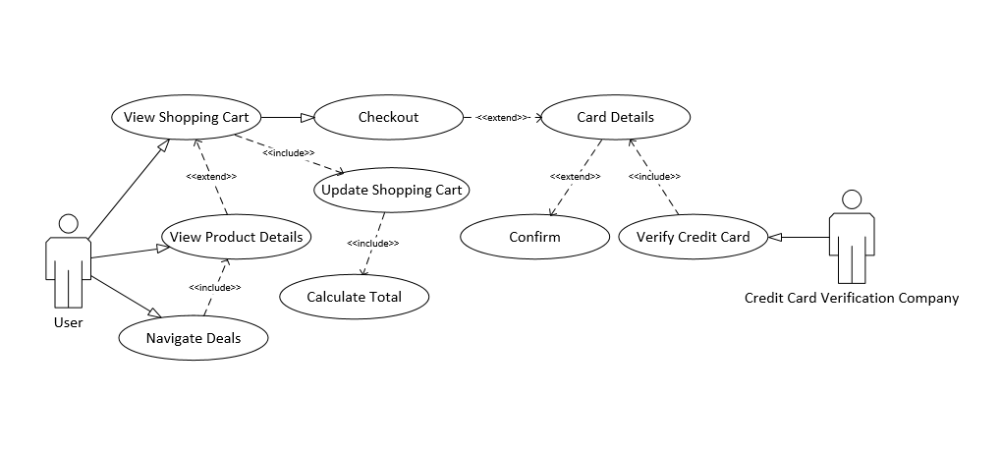

Figure 2 - Initial Use Case

## 2.6 Navigation Diagram

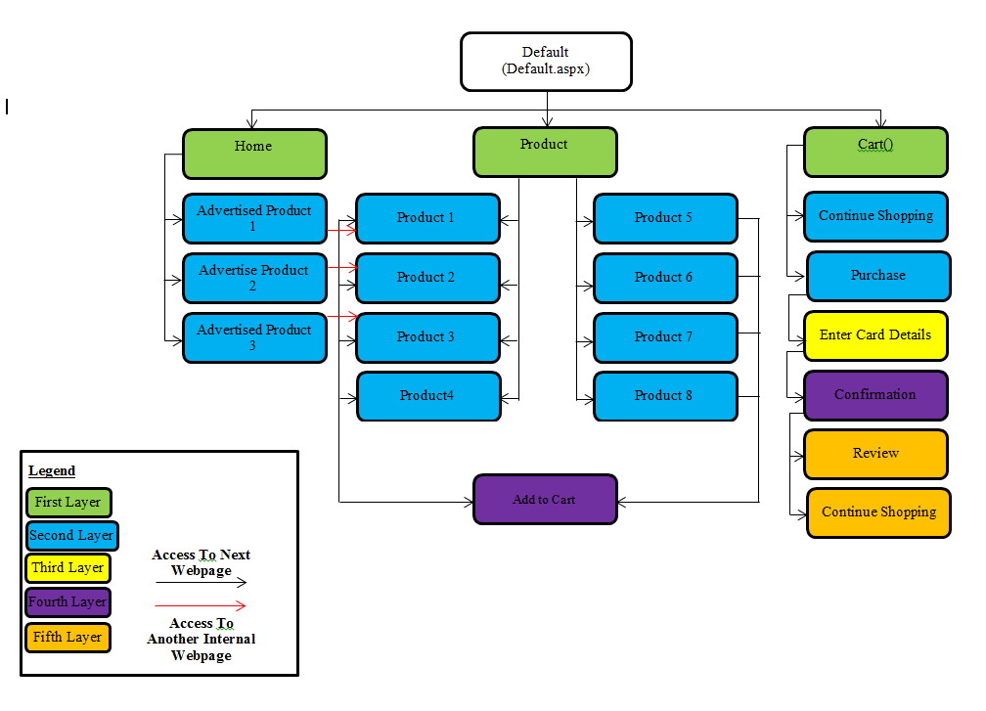

Figure 3 - Initial Navigation Diagram

# 3. Review

## 3.1 Electronic Payment

“*All credit cards related transactions are approved offline and given the high incidence of frauds, the banks are extremely wary of approving them*” (Rahman, 2014). Within this book Rahman discusses the advantages of electronic payment such as increase sales, improved marketing, running costs and customer support as well as the disadvantages such as online security, missed error and fees.

The increase in sales is due to “*The increased availability of your products to a larger customer base via an electronic payment system extends your current mail-order services, and reaches other potential customers and local businesses through increased exposure*” (Rahman 2014) and through the use PayPal which allows for quick payment due to there being “*no restrictions and limitation on what you can do with your electronic money*” (Rahman 2014) Furthermore according to Javelin Strategy & Research and Digital Transactions (Laudon and Traver, 2014, pp. 288-289), global online payments are dominated by cards even if there usage has been declining with alternative payment such as PayPal being the next biggest (Xu, 2014). With this research the current initial payments design of credit cards will be replayed with PayPal for easy and speed.

Research has also been done on the shopping cart to make it better. The main focus was on Bidigare who presents eight features that a shopping cart should have which included rich functionality such as a continue shopping option forms and secure transaction which will be covered by PayPal. Another feature was simple order, “*Order forms should be as simple as possible to help users complete them quickly and without confusion, but should have the necessary functionality to meet a user’s needs*” (Bidigare, 2000). By having the only requirement of the website being the user logged in and leaving the personal details to PayPal this will be much safer as the only information return to the website will be a delivery address.

Customer retention and relationship is something that every ecommerce need to pay attention to. Zhang et al. conducted a survey looking as repurchase intention in business to customer ecommerce and “*results showed that online relationship quality and perceived website usability positively impacted customer repurchase intention*” (Zhang et al., 2011). Furthermore “*online relationship quality was positively influenced by perceived vendor expertise in order fulfilment, perceived vendor reputation, and perceived website usability, whereas distrust in vendor behaviour negatively influenced online relationship quality. Implications of these findings are discussed*” (Zhang et al., 2011). For this reason a way of being able to easily contact the business will be implemented in the final design. A contact form that will allow the user to easily send messages that the business can reply to.

# 4. Design and Implementation

## 4.1 Functional Requirements

Managing Products

* The system shall allow addition of new products to the system.
* The system shall allow the editing of the products details on the system.
* The system shall allow the deletion of a product.

Managing Products

* The system shall allow addition of new categories to the system.
* The system shall allow the editing of the categories details on the system.
* The system shall allow the deletion of a category.

Purchasing

* The system shall allow products to be purchasable.
* The system shall allow the secure payment option when purchasing.

Accounts

* The systems shall allow an individual to register.
* The system shall allow an individual to log in.
* The system shall allow the individual to change their password.
* The system will allow for log in with a Google account.

Product Information

* The system Show as much relevant product info - It will show the advantages of the products, full billing price, larger image of products

## 4.2 Non-Functional Requirements

* The system shall be user friendly.
* The system shall be easy to navigate.
* The system shall be able to hold a large number of accounts, internal and external.
* The system shall have a look and feel that is professional.

## 4.3 Final Design Template

With these requirements and based off the research from the review a new design was made (Figure 4). This new design implemented the new register/login features so that users could create account which would now be required in order to purchase a product. A feature to log in with an external Google account was made optional this bypasses the need to register an account and creates one if there isn’t already one with that email. The second major change was to the payment system where instead of paying by card PayPal will be used. A few minor changes were made to make a catalogue to split up the product allowing for easy navigation by types and for the shopping cart to be able to migrate between an anonymous user and a logged in account. An about page containing information about the shop and the team that runs it as well as a contact page that would allow for quick and easy messaging to the staff for any queries.

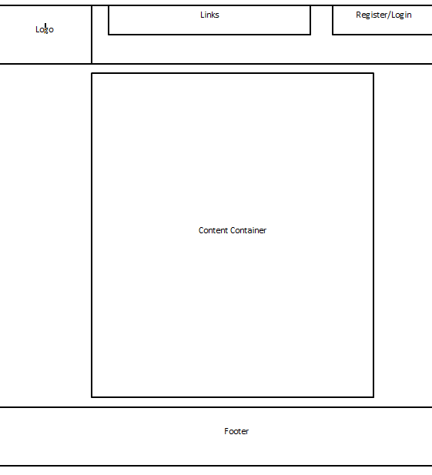

Figure 4 - Final Design

Design Information:  
The navigation will still be fixed but moved to the top of the website and allows the content below to scroll whilst keeping easy navigation. The links will be Home, Products, About Us, Contact Us, the shopping cart and a hidden Admin page for product and category management. The new register and log in to the right of the navigation and there will be just one logo to the left of the navigation meeting the updated requirements. The colours stay the same with black as the navigation section and white for the content section.

## 4.4 Use Case Narratives

To show all the processes of the website use case narratives and a use case diagram (Figure 5) have been created.

### 4.4.1 Customer Registration

|  |  |  |  |
| --- | --- | --- | --- |
| Use Case Name: Customer Registration | | ID: 1 | Importance Level: 1 |
| Primary Actor: Customer | | | |
| Short Description: Customer registers to a website | | | |
| Trigger: Register link in navigation bar  Type: External | | | |
| Major Inputs | | Major Outputs | |
| Description  Email Username Password | Source  Registration Form Registration Form Registration Form | Description  User Account | Destination  Account Database |
| Major Steps Performed:   1. New user register details into a registration form 2. New user submit form 3. Data entered is validated 4. Email is checked if unique 5. Email confirmation sent 6. Customer account created | | | Information for Steps:  Email Username Password |

### 4.4.2 Customer Login Externally

|  |  |  |  |
| --- | --- | --- | --- |
| Use Case Name: Customer Login | | ID: 2 | Importance Level: 1 |
| Primary Actor: Customer | | | |
| Short Description: Customer logs into to a website | | | |
| Trigger: Log in link in navigation bar  Type: External | | | |
| Major Inputs | | Major Outputs | |
| Description  Email Username Password | Source  Log in Form Log in Form Log in Form | Description  User Account | Destination  Account Database |
| Major Steps Performed:   1. Existing user enters log in details into the log in form 2. User submit form 3. Data entered is validated 4. User is logged in | | | Information for Steps:  Email Username Password |

### 4.4.3 Adds Products to Cart

|  |  |  |  |
| --- | --- | --- | --- |
| Use Case Name: Customer Adds To Cart | | ID: 3 | Importance Level: 1 |
| Primary Actor: Customer | | | |
| Short Description: Customer adds a product to the shopping cart | | | |
| Trigger: Add to cart button in product view  Type: External | | | |
| Major Inputs | | Major Outputs | |
| Description  Add to cart | Source  Product View | Description  Cart Details | Destination  Cart Database |
| Major Steps Performed:   1. Customer navigates to desired product 2. Customer adds a desired product to cart | | | Information for Steps:  Product Details |

### 4.4.4 Edits or Update Cart

|  |  |  |  |
| --- | --- | --- | --- |
| Use Case Name: Customer Edit Cart | | ID: 4 | Importance Level: 2 |
| Primary Actor: Customer | | | |
| Short Description: Customer edits or update the cart | | | |
| Trigger: Customer edits the quantity of products or clicks the delete checkbox then update button  Type: External | | | |
| Major Inputs | | Major Outputs | |
| Description  Quantity Change Delete Checkbox | Source  Cart Form Cart Form | Description  Cart Details | Destination  Cart Database |
| Major Steps Performed:   1. User edits the cart 2. User clicks the update button | | | Information for Steps:  Quantity Delete Checkbox |

### 4.4.5 Purchase Product

|  |  |  |  |
| --- | --- | --- | --- |
| Use Case Name: Customer Purchasing | | ID: 5 | Importance Level: 3 |
| Primary Actor: Customer | | | |
| Short Description: Customer purchases a product | | | |
| Trigger: Customer goes to checkout  Type: External | | | |
| Major Inputs | | Major Outputs | |
| Description  Name  Address1  Address2  Card Details  Security Code | Source  Checkout Form Checkout Form Checkout Form  Checkout Form  Checkout Form | Description  Checkout Details | Destination  Checkout Database |
| Major Steps Performed:   1. User clicks checkout 2. User enters details for purchase 3. User submits details 4. User Reviews order | | | Information for Steps:  Name Address1 Address2 Card details Security code |

### 4.4.6 Payment of Product

|  |  |  |  |
| --- | --- | --- | --- |
| Use Case Name: Payment for Product | | ID: 6 | Importance Level: 1 |
| Primary Actor: User | | | |
| Short Description: User pays for a product | | | |
| Trigger: User pay with PayPal  Type: Temporal | | | |
| Major Inputs | | Major Outputs | |
| Description  PayPal Account email PayPal password | Source  PayPal PayPal | Description  Customer Account | Destination  Account Database |
| Major Steps Performed:   1. User inputs PayPal email 2. User input PayPal password 3. User confirms payment for booking | | | Information for Steps:  PayPal Account email  PayPal password |

### 4.4.7 Admin Manage Stock

|  |  |  |  |
| --- | --- | --- | --- |
| Use Case Name: Admin Manage Stock | | ID: 7 | Importance Level: 3 |
| Primary Actor: Administrator | | | |
| Short Description: Admin manages the stock (add, edit, delete) | | | |
| Trigger: Admin logs in and accesses hidden manage page  Type: External | | | |
| Major Inputs | | Major Outputs | |
| Description  Email Username Password | Source  Log in Form Log in Form Log in Form | Description  Admin Account | Destination  Account Database |
| Major Steps Performed:   1. Admin logs in 2. Admin navigates to hidden manage page 3. Admin adds, edits or deletes a product | | | Information for Steps:  Email Username Password |

## 4.5 Use Case Diagram

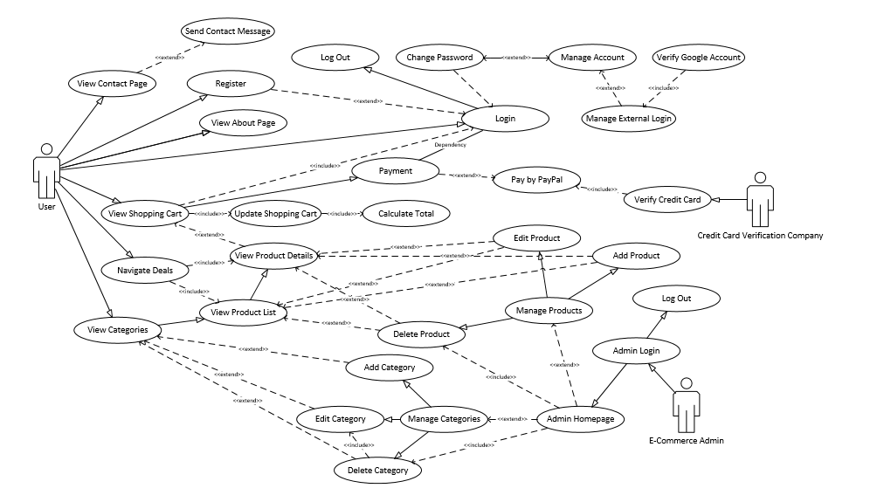

Figure 5 - Final Use Case

## 4.6 Navigation Diagram

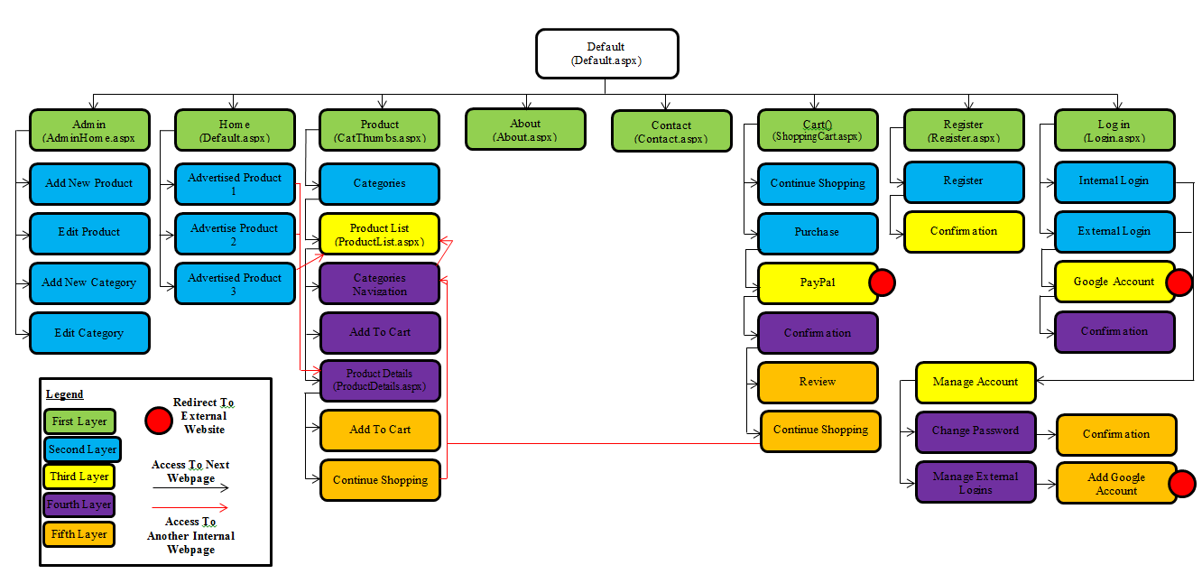

Figure 6 - Final Navigation Diagram

## 4.7 Flow Chart

As the payment systems the most important part of the shopping experience a flow chart has been created to show how the new process of how a user goes from browsing an item to purchasing via PayPal (Figure 7).

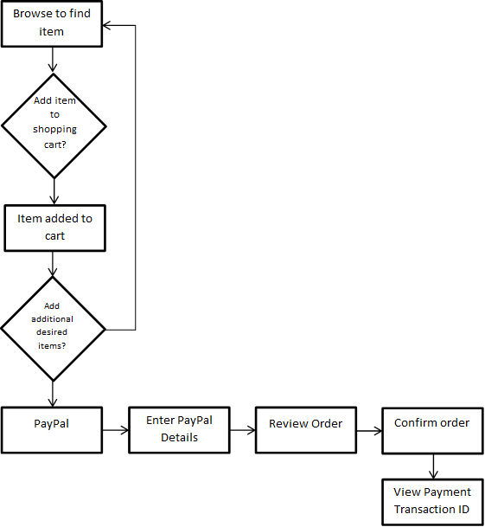

Figure 7 - Payment Flowchart

## 4.8 Sequence Diagram

Another important feature that has been implemented is user accounts. To show the process of both an unregistered and registered user would log in a sequence diagram has been used (Figure 8).

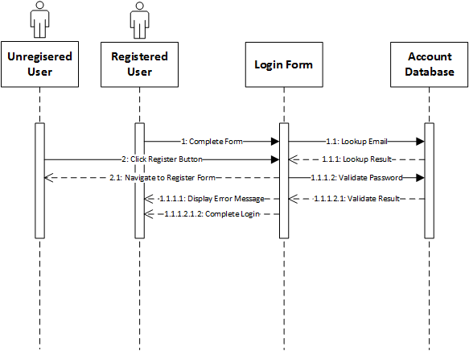

Figure 8 - Register/Log in Sequence Diagram

## 4.9 Entity Relationship Diagram

To show how the database tables will interact with each other in order to store information added or to provide it to webpages that request the data to fill section such as products pages.

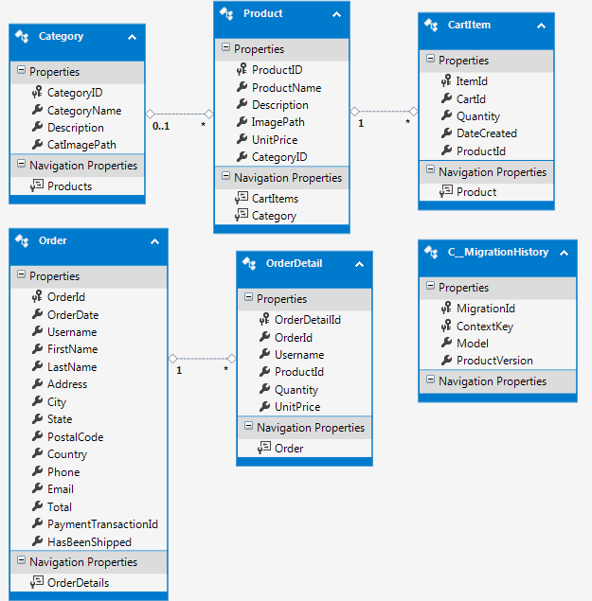

Figure 9 - Entity Relationship Diagram

# 5. Critical Evaluation

The objectives that were set for this project of creating an online shopping environment for the client were mostly, if not all achieved. The websites main structure begins from the homepage with hyperlinked advertisements of some of the products. The navigation with thinks to the most important section of the website have been clearly place and always on show so that if a user scrolls down on a page the header navigation will stay in view.

The benefits from RAD are that it promotes collaboration and gathering of requirement from the client. It allows for the client to actively work with the developing team in prototyping and testing. There are however disadvantages from RAD as it requires collaboration between teams and the clients in order to produce a system for their needs after seeing the prototype.

The prototype approach of RAD allows for user involvement and as an information-gathering technique allowing developer to develop based on feedback. This gives the potential for changing the system early in its developments or stopping development on an unworkable system. There is however the difficulty in managing the process because of its rapid and iterative nature. It also requires feedback otherwise further development may not be possible however as there was frequent feedback the system could be improved upon very quickly.

When the ecommerce website was first designed the choice of database was MySQL. This would allow for the creation and editing of tables as well as any editing that needed to be done prior to starting the website designing. Once the website had been produced to a certain level the MySQL database could be added in. Whilst developing the website the choice in database structure changed. It was instead going to be code first in C# that could be easily integrated into the website during development.

The use of font, colour and layout was consistent throughout the website with the use of the master page that had control over the layout and loaded the requested webpages into the designated content area. This consistency allowed for meeting the non-functional requirements of ‘looking professional’ whilst being ‘easy to navigate’ and ‘user friendly’. This was further met with the category and product list pages which had clear navigation. As part of this design the shopping cart and the amount of content in it is always on display and can be revise at any point which include the editing of quantity and the deleted of undesired products.

With the initial designs there was not going to be an account system. The website was to be an online store that sold products however after research it was decided that an account should be done for at least the purchases. This would allow the used to have an account that could later be synced with PayPal or social media. It could also be used for newsletters or promotional services if implemented. To ensure no annoyances for the customer the shopping cart with migrate from the anonymous user to the registered account meaning they won’t need to redo their shopping cart.

Originally the clients choice of payment transaction were to be done in a similar fashion as the store, with debit card, however given the research into online payment methods this was advised not to and the choice became PayPal. The use of PayPal as the payment method means that the client business can start to sell their products securely and immediately that meet the requirement of ‘the system shall allow the secure payment option when purchasing’ as well as allowing for the system testing to iterative through a PayPal developer account.

After doing research on customer retention it was found that a way of communicating between customer and business was necessary for a good relationship so a feature where a customer would essentially email the business from a form within the website was implemented so that the business could then reply to any comments or queries if needed.

The current implementation of the website allows for association with a Google account which can be used to log in to the website instead of a ‘@HaL.com’ structure. The website address can also be synced with the Google account to allow management between the two. This was possible through the Google developer account that allows Google related API and services to be integrated into the website. Users would also be able to change passwords or manage and current or future social media accounts. The shopping cart uses a GUID for anonymous users when they are browsing and this will be carried over to their account when they register or log in allowing for an easier purchase process. The admin page, which is hidden to all but the admin, allows access the database from online and meets the core requirement of being able to add, edit and delete products and categories.

Further work on this website will be to include a related item / customers also bought feature of the product details page. This is a feature that would query the ‘Order Details’ database that has stored the item information during a purchase and could be used to show what items are bought together. As this is a developing project and there have not been enough sales to use it effectively however as it is an important feature to increase sales it is something that should be implemented.

Another feature to include would be a wish list option for accounts that would allow customers to browse and save an item they desired but did not want to purchase straight away. They would also be able to manage, edit or delete any of the items in the list.

# 6. References

Rahman, S. (2014). *Introduction to E-Commerce Technology in Business*.

Dennis, A., Wixom, B., H., & Roth, R., M. (2012) *Systems Analysis & Design*, Wiley, 5th Edition.

Laudon, K. C., & Traver, C. G. (2014). E-commerce 2014: Business, technology, society (10th ed. Global Edition). London: Pearson.

Xu, J. (2014). *Digital Payment Systems*. Managing Digital Enterprise, Atlantis Press.

Bidigare, S. (2000)*. Information Architecture of the shopping cart*. Argus Associates.

Zhang, Y., Fang, Y., Wei, K. K., Ramsey, E., McCole, P., & Chen, H. (2011). *Repurchase intention in B2C e-commerce—A relationship quality perspective*. *Information & Management*, *48*(6), 192-200.