Report

For the work experience I took a placement at Neston Youth and Community Centre, a centre that offers a range of activities, classes, meetings and room hire. The main purpose of my being there was to help design and create a website to help advertise and bring in new clients. I worked with a staff to plan and design the website and later to create it. What I offer the centre was my up to date website design knowledge as the other staff had limited website designing skills.

After being introduced to the staff that I would be with, a meeting was then organised to start designing the website. This is where I was able to start my first transferable target, communication skills, as I had to plan the meeting with the members of staff who all worked in different areas. Once the meeting had begun I was involved in the design of the website itself giving a youth’s point of view as I was the youngest in the group. Time management is my second transferable target which is also involved, not so much for me but for having to plan the meeting around each of the groups work schedule. The group eventually decided upon the design below (Figure 1 the chosen design) to be the website. Afterwards I had to plan a meeting to talk to my supervisor to see how I was doing, what the next steps were and if there were any new tasks. Around the same time a company from Manchester called stardotstar were holding their own project called WeMakeJam and offered NC&YC a position in a trail for their new website building software. I would become a middleman between the two.

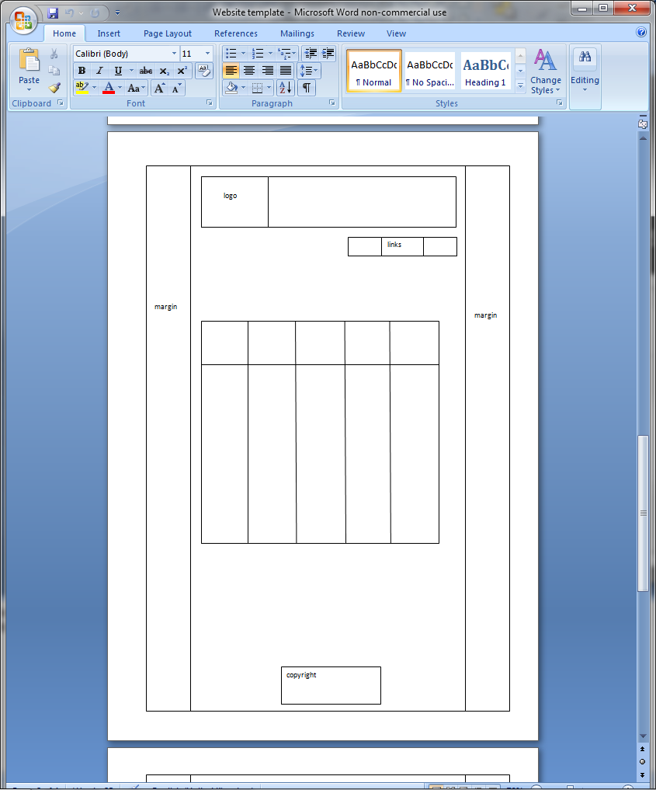

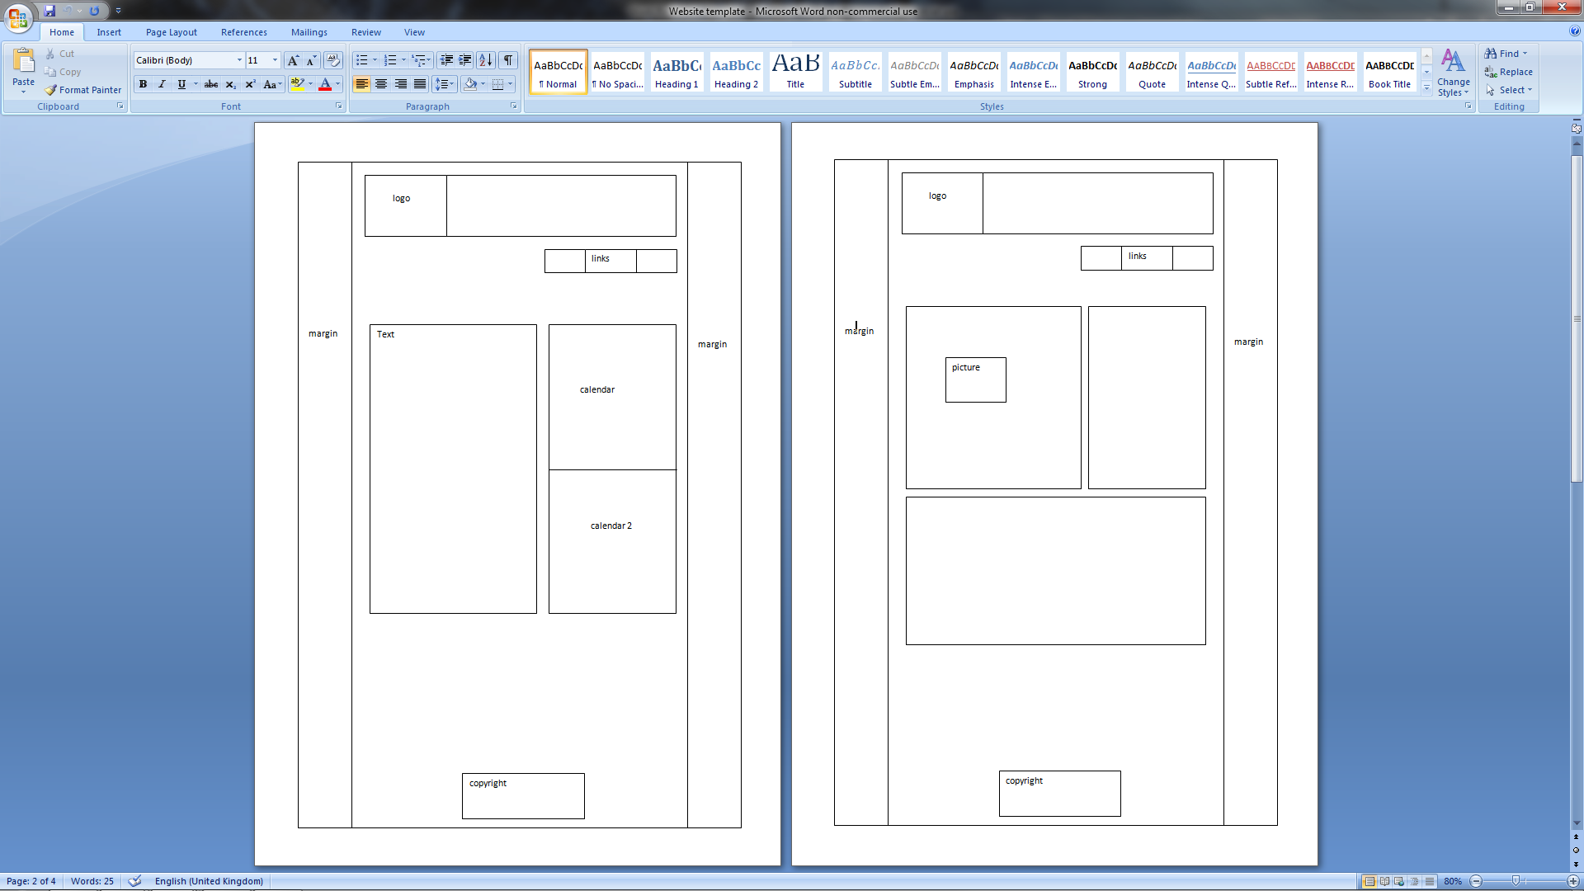

Figure

With the designs make the first draft of the website could be created with a few alterations in the design as it was created. This allowed me to begin with my first practical target. The first practical target was to learn and implement new website languages. The languages that I had chosen are html 5, JavaScript and MySQL. While some feature will not be available to certain browsers or older versions of browsers, the staff and I decide that HTML 5 would allow more flexibility when creating the website and would load faster. This was the next task set, for me to learn HTML5 and some JavaScript. The screenshots show the learned languages being used (Figure2a, b, c, d. Screenshots of the code) and the final product (Figure 3 the website).

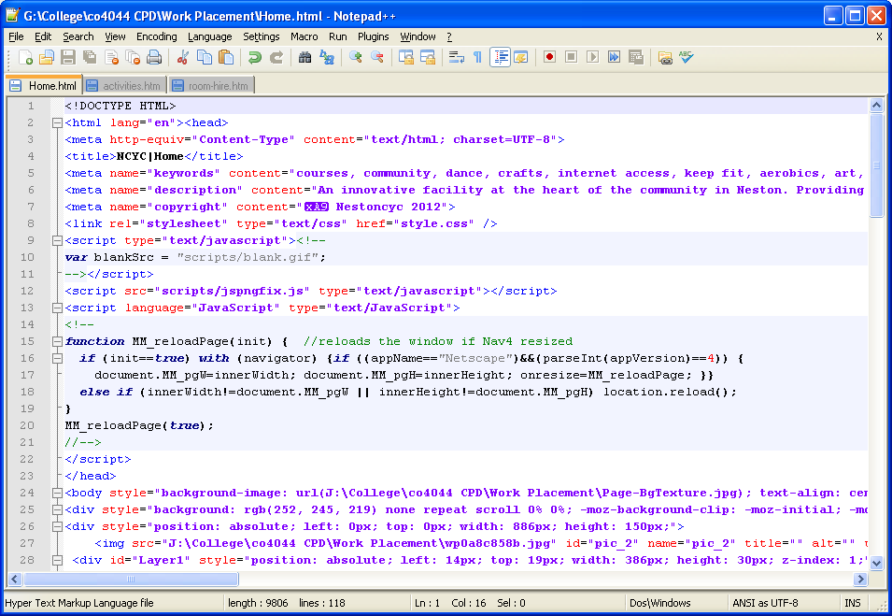

Figure 2a

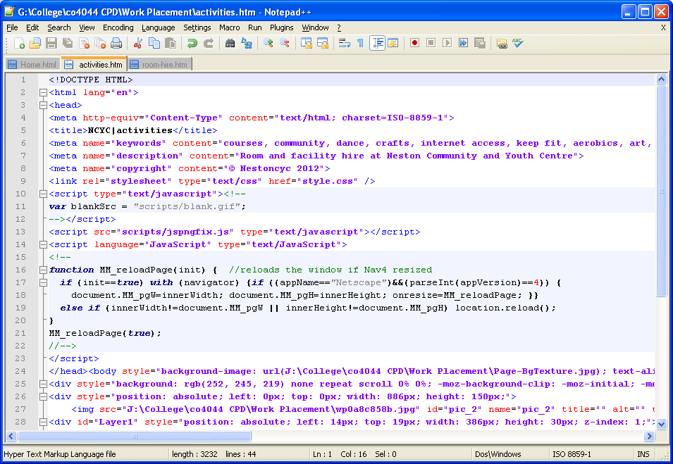

Figure 2b

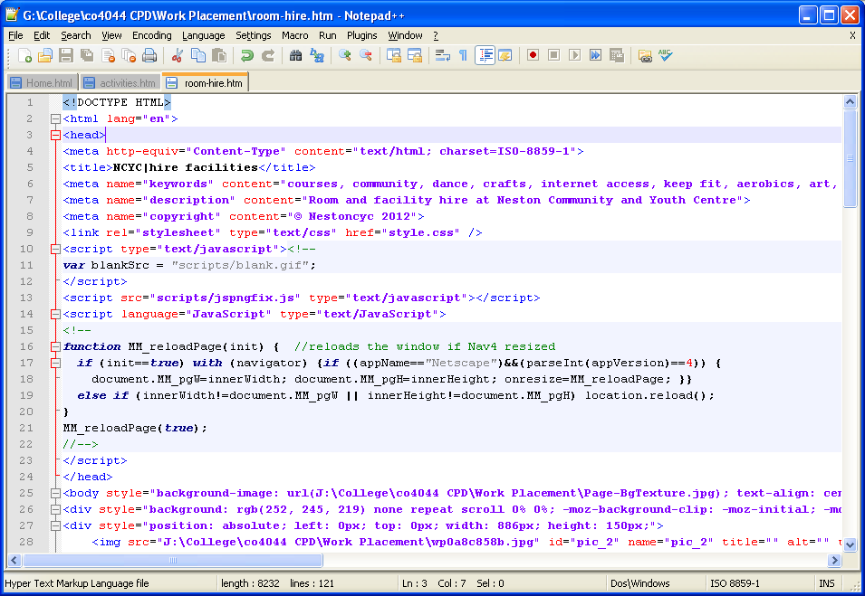

Figure 2c

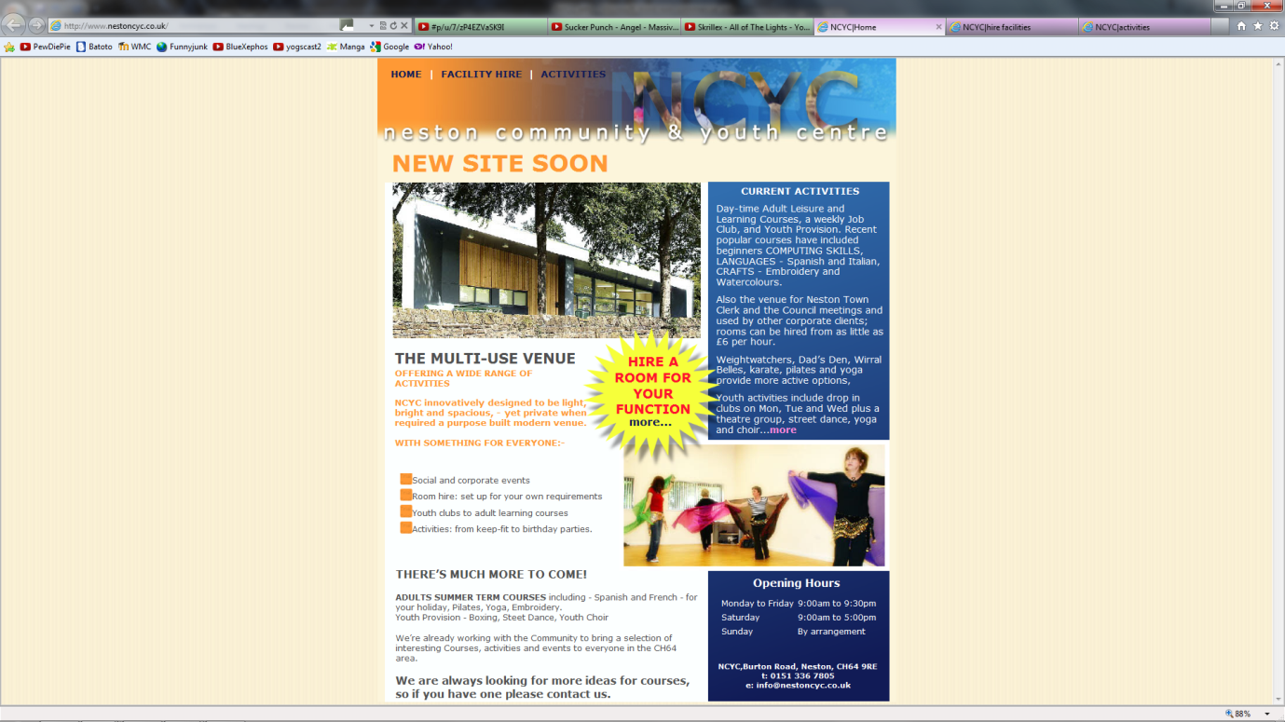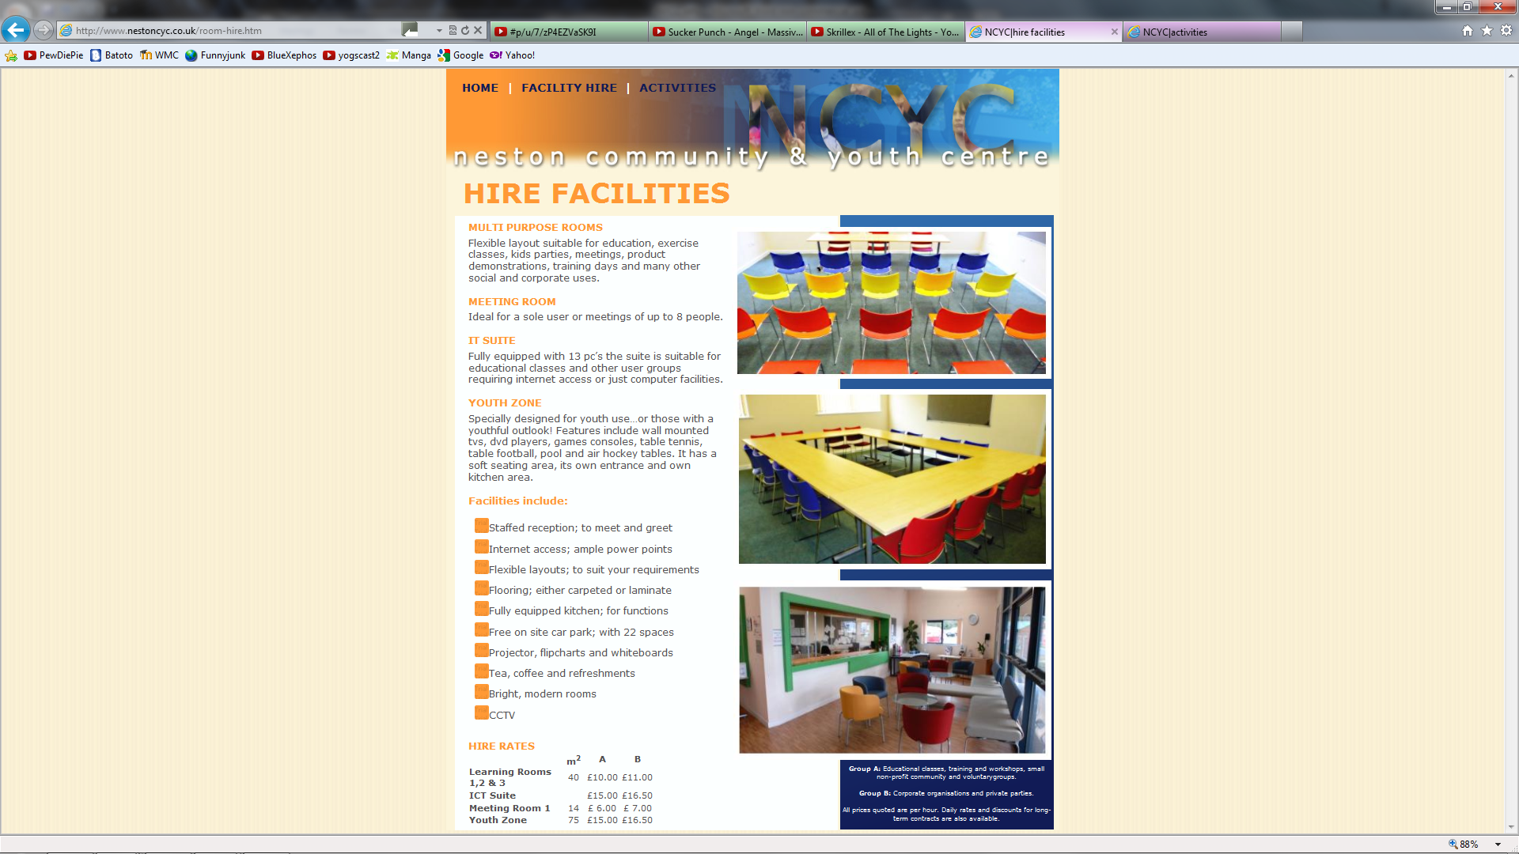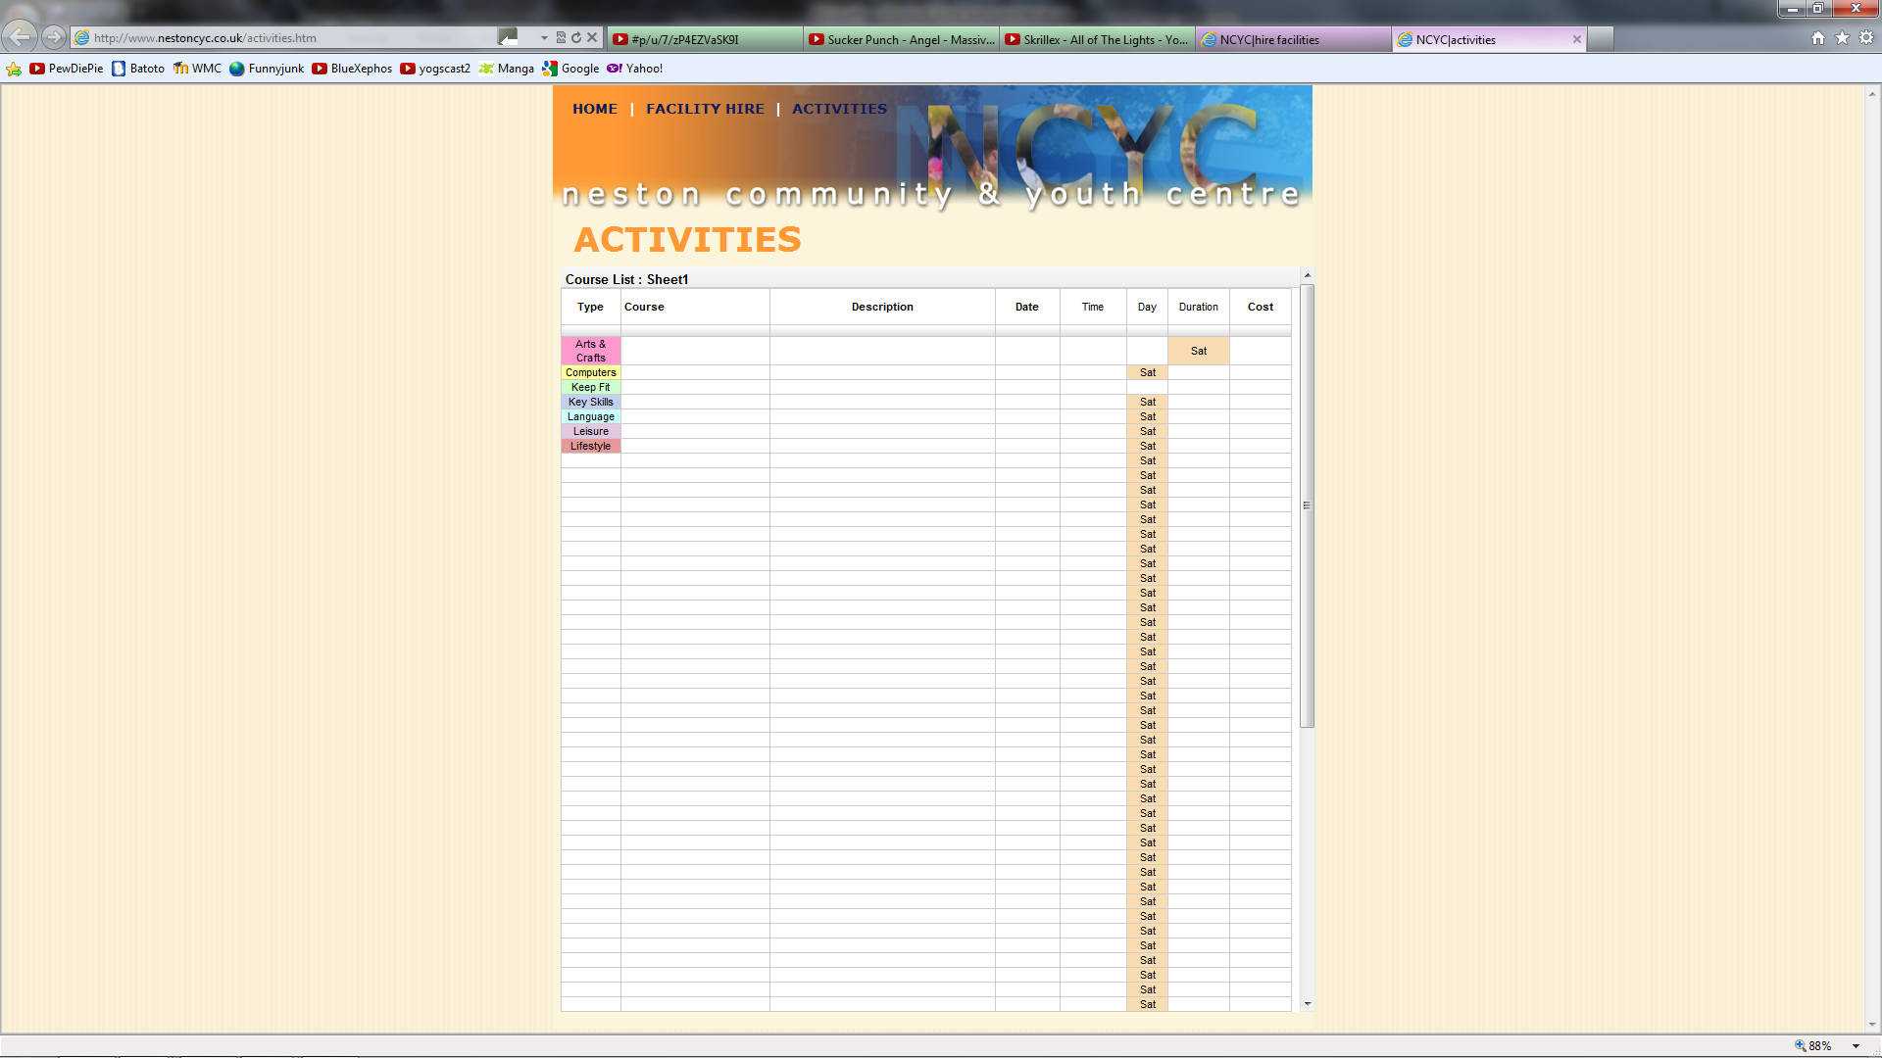

Figure 3

The next tasks for me were to create a database of the courses held at NC&YC and the different rooms that could be hired which would be put into the website through MySQL. As creating a database was my second practical target and MSQL was a language from my first practical target I was very happy to have been given a task that incorporated both. The database I created is shown below (Figure 4 the NCYC database)

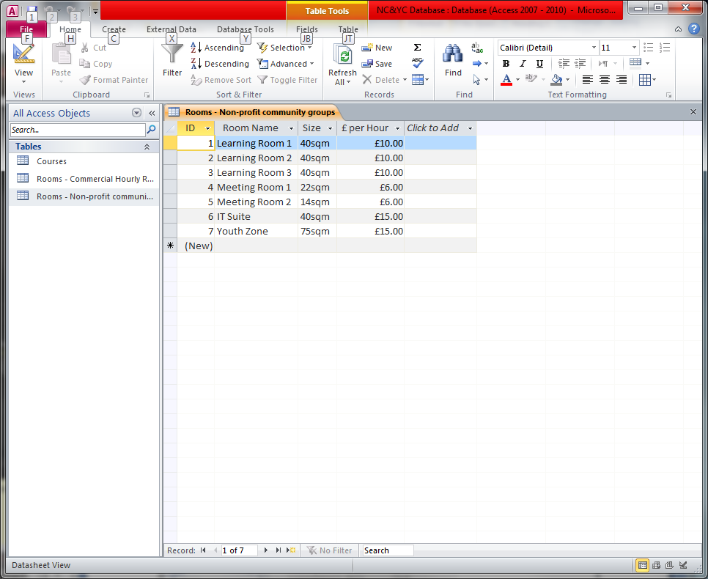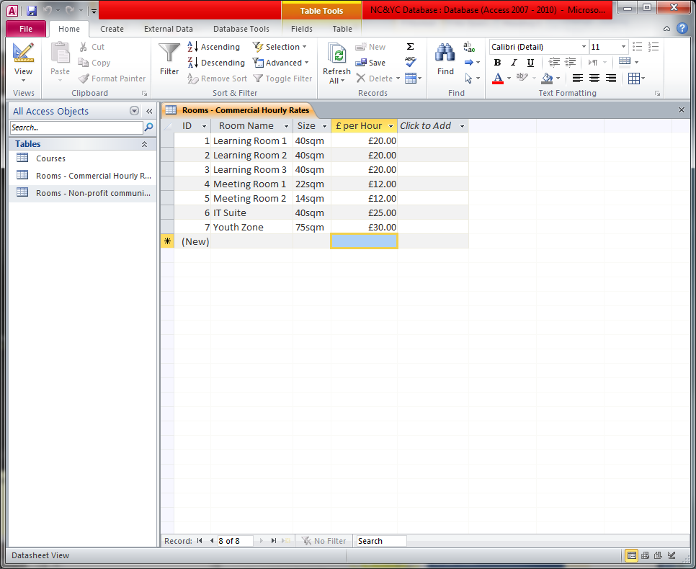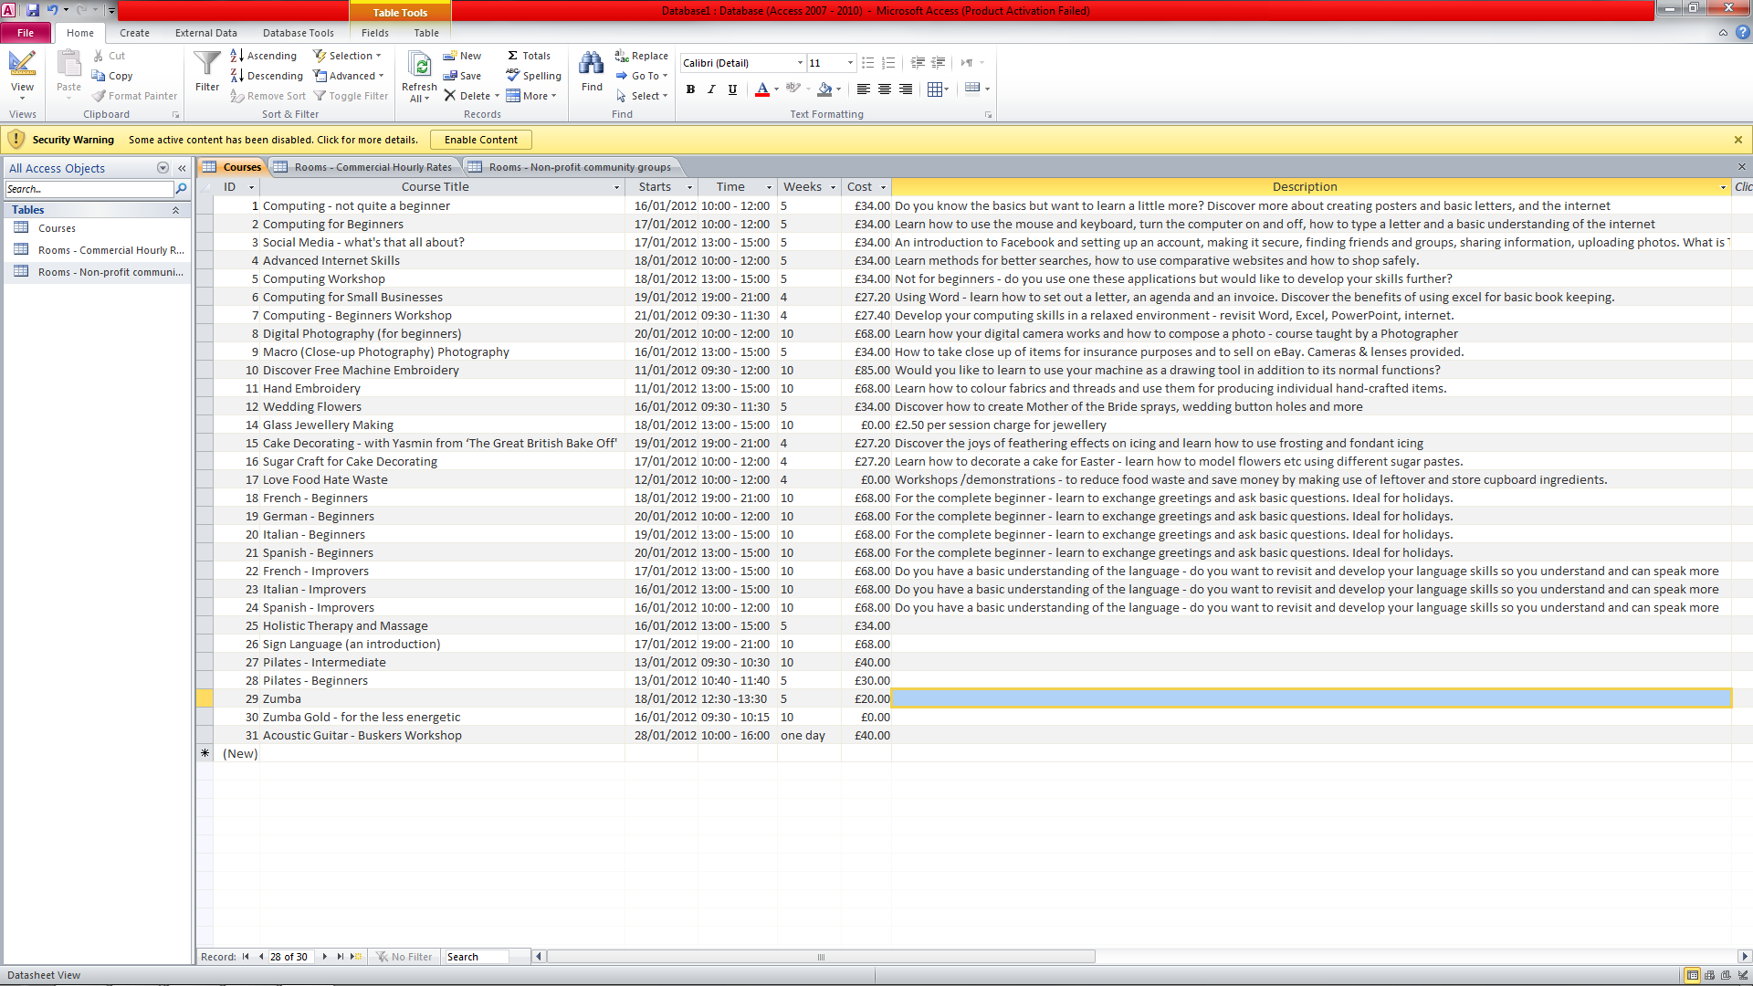

Figure 4

The next meeting with the staff was accompanied with a member of WeMakeJam who had a project to build a software tool designed for those in the voluntary sector. The tool would be a straightforward way to create and look after a website. They would also help NC&YC to formulate their online goals better. In the meeting the WeMakeJam member advised us to change the design of the current website in order to be able to express the information effectively. With the influence of the WeMakeJam member, my supervisor decided to change the design of the website and started planning another meeting. Due to this change I did not have the chance to study and implement MySQL which was a target I would have like to have met.

After another meeting, the team came up with the new design (Figure 5 the redesigned website). The website would now, instead of a three page website with links, be a one page website which showed all the information that NCYC wanted to show.

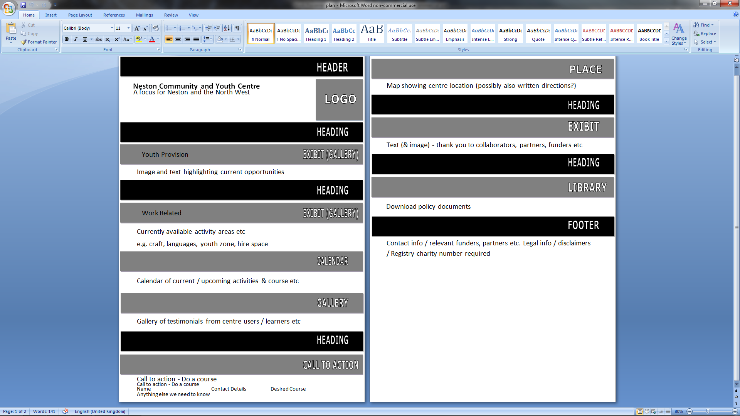

Figure 5

In that same meeting with the WeMakeJam the group was invited to a lecture held Abhay Adhikari who works for Dhyaan Design. The lecture was called Digital Identities in Interesting Spaces lecture. One of the aims of this project is to enable organisations to re-imagine how they engage with digital media and social networks to make and engage new audiences online, to rethink the tagline in more detail and about the audience in more depth. To do this there were many different activities to help such as creating mind maps (Figure 6 showing a photo of the lecture, my group in the right side of the photo with other volunteer organisations on the left side) (Figure 7 the mind map activity).

After this lecture the group had focused more on the content that they were going to have on the website and how they word the information.

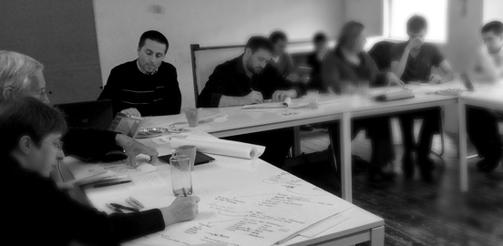

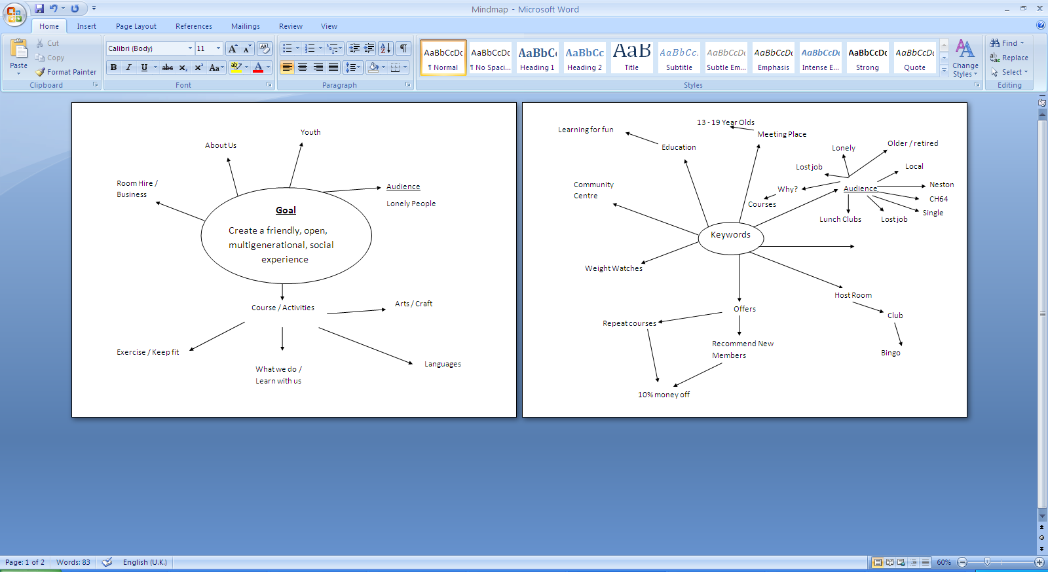Figure 6

Figure 7

I set myself two practical targets and two transferable targets. The two practical targets I set are to create a database and to further develop my website designing skills. The two transferable targets are communication skills and time management with the other staff members.

The first practical target is to learn more website languages. I was able to learn the two main languages HTML5 and JavaScript which I wanted to learn however the 12 weeks ended before the website could be created and therefore I couldn’t learn and use MySQL with the database and website. Other than this one setback it was still an eventful placement as I met my other language targets.

The second practical target I decide was to a database that would store the different courses that are offered and the different rooms that would either be hired out or used for those courses. The first table was for the courses. It contained the courses, when they started, how long they ran for, their cost and a small description. The second table is for the rooms that can be hired will commercial prices and the sizes of the rooms. This helps those that wish to hire a room for a onetime event. The third table is similar to the second table however the prices are cheaper as they are for the non-profit groups if they wish to hire a room for a onetime event. The database was to be linked into the website however as it has not been finished due to redesigning. I still feel this target has been met regardless.

The first transferable target is to improve my communication skills. Being part of the team that is creating the website I had many opportunities to voice my opinions and give input in how the website should be designed and how the information should be portrayed to the audience. An example where my input has been put in is the tagline/goal of the centre "Create a friendly, open, multigenerational, social experience". I believe that this target has been met allowing me to be more comfortable with the group and communicating.

The second transferable target is time management. This involves not only planning meetings with my supervisor but also getting the other member of the staff together. As they all had their own different areas it was hard to coordinate meeting we could all attend. Time management also involved producing plans and basic website designs to a schedule in order to show where the team was at. This target has been met.

As well as getting many benefits from the organisation the organisation also received a few from me. One benefit I gave to the organisation was to aid the design from the youth point of view as I was the youngest there. Another benefit was that I had the most up to date website creating knowledge which sped up the creation of the website. The final benefit was that I became the link between Neston Community and Youth Centre and the WeMakeJam project.