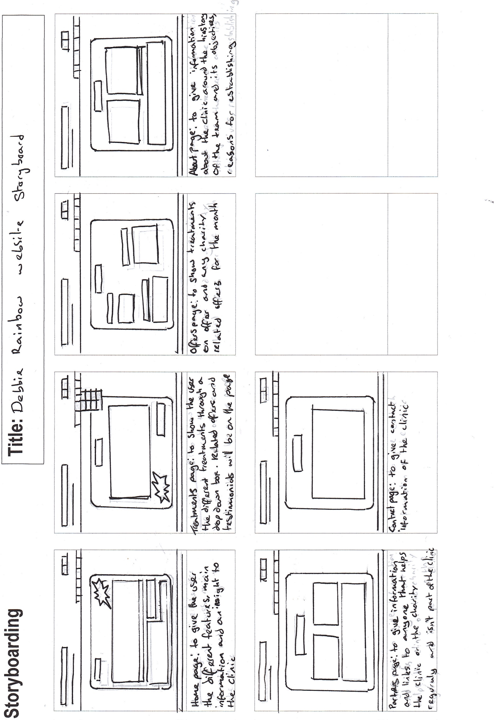

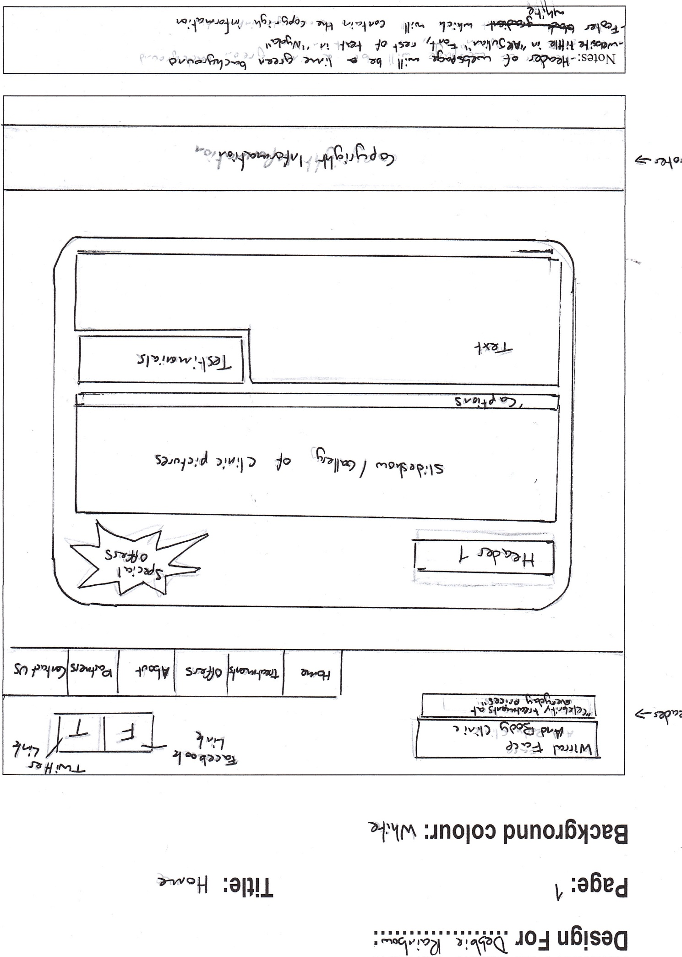

Twitter[Facebook](http://www.cisco.com/web/learning/netacad/Unica/IconFacebookRedirect.html)

"Celebrity Treatments at Everyday Prices"

Home

Treatments

Offers

About

Partners

Contact Us

Special Offers

Welcome

Slide Show / Gallery

Text

Testimonials

Copyright Information

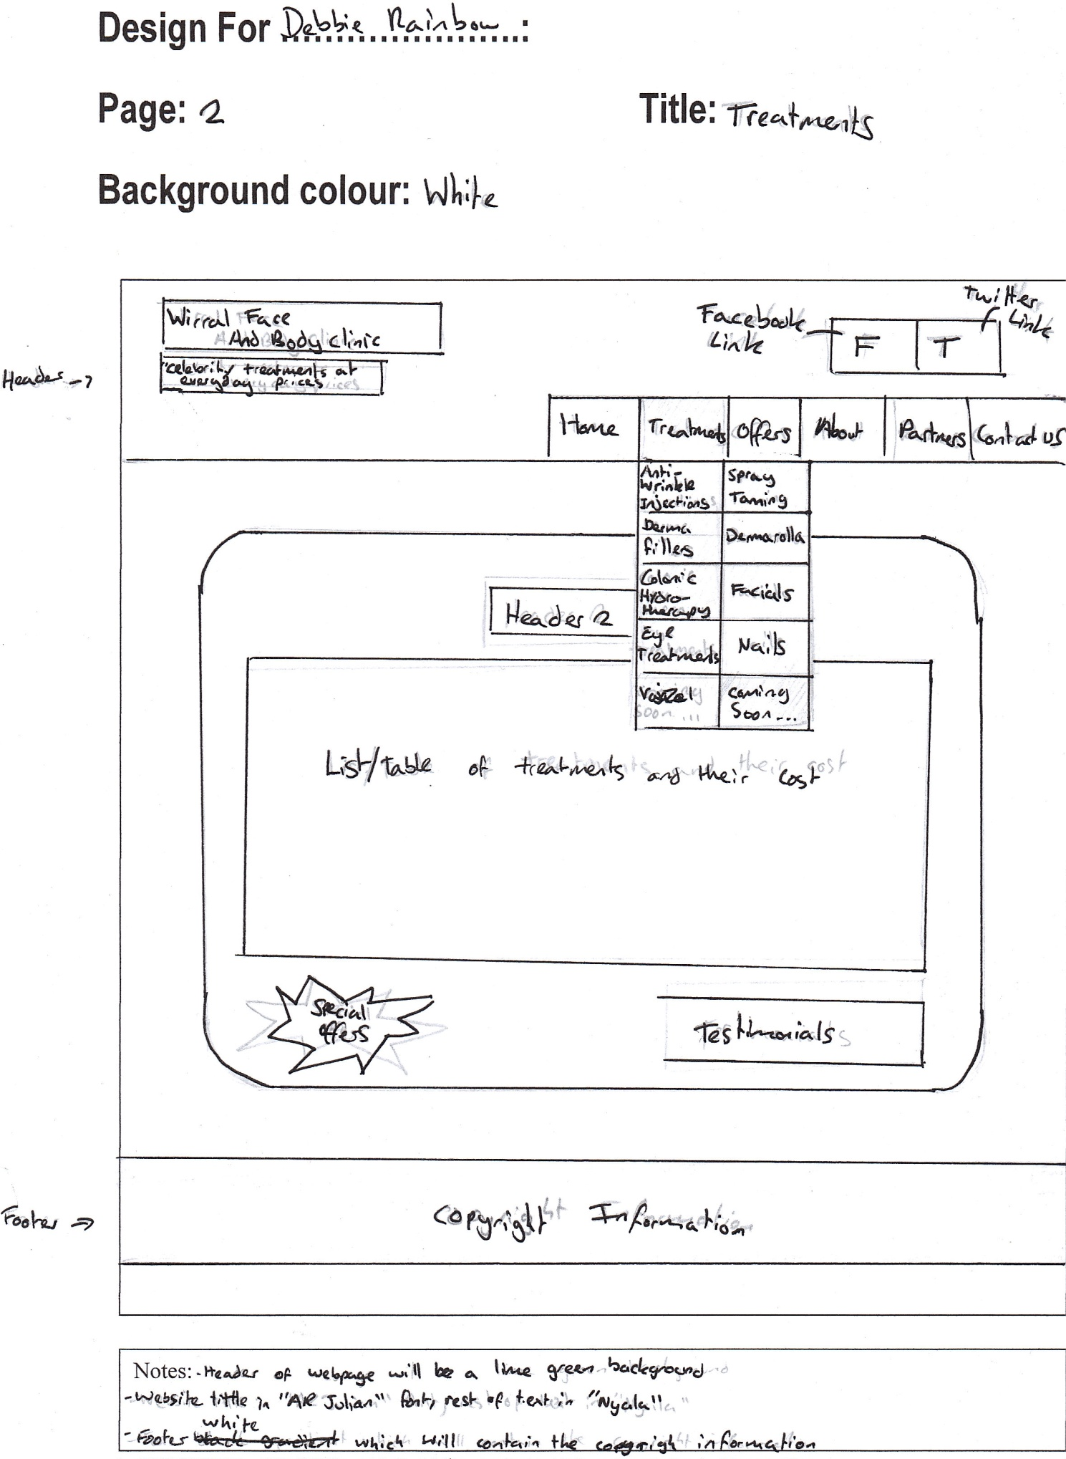

[Facebook](http://www.cisco.com/web/learning/netacad/Unica/IconFacebookRedirect.html)Twitter

Dermaroller

Spray Tanning Tanning

Dermal Fillers

Anti-Wrinkle Injections

Treatments

"Celebrity Treatments at Everyday Prices"

Home

Partners

About

Offers

Contact Us

Facials

Vajazzel

Eye Treatments

Colonic Hydrotherapy

Nails

Facials

Coming Soon ...

Treatments and costs

Related Testimonials

Special Offers

Copyright Information

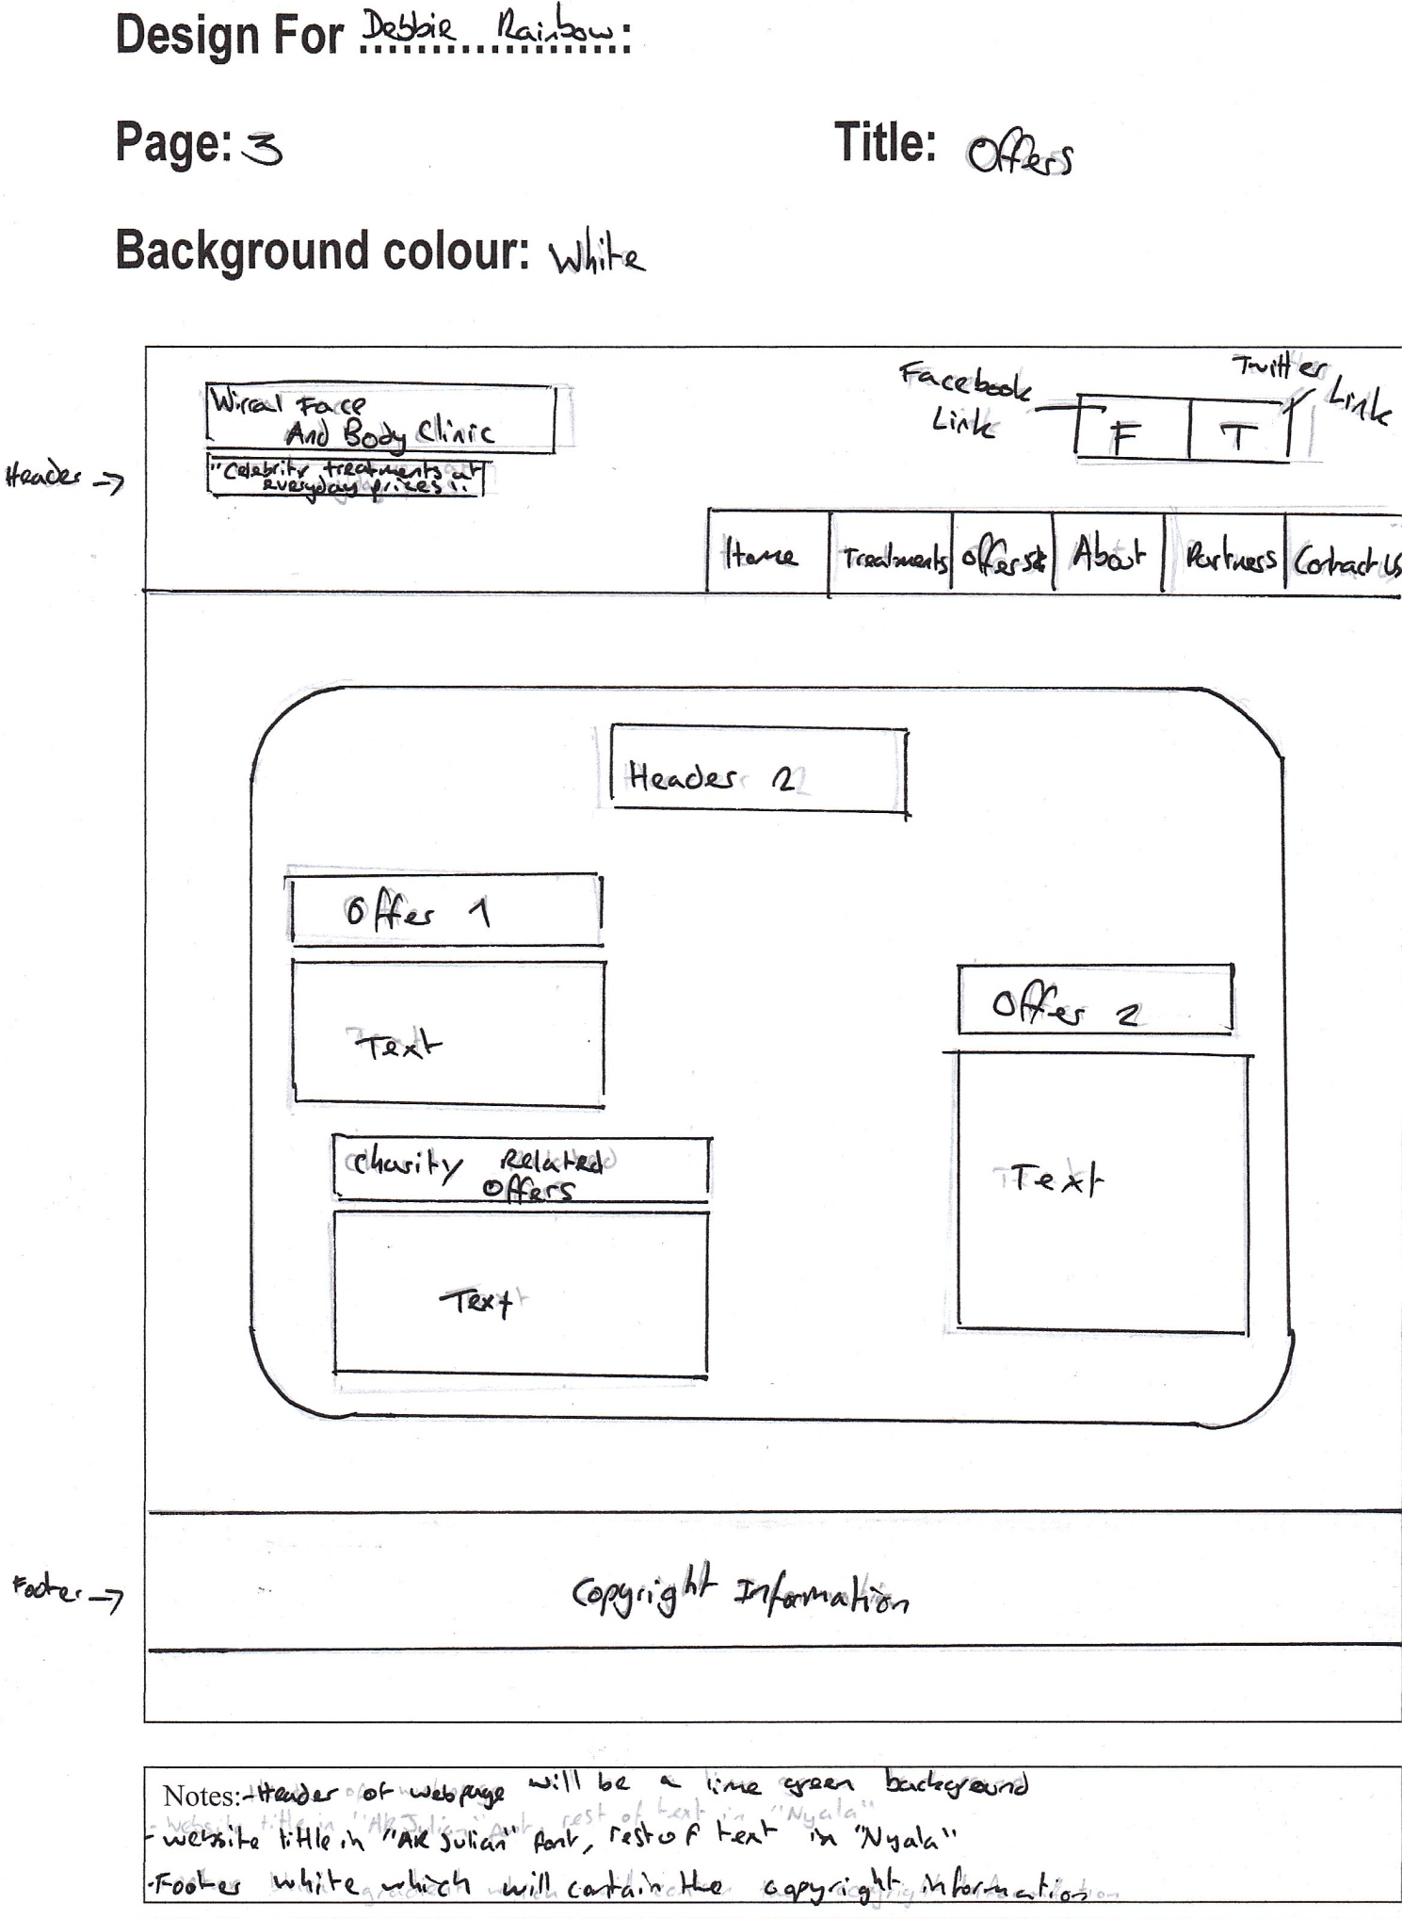

[Facebook](http://www.cisco.com/web/learning/netacad/Unica/IconFacebookRedirect.html)Twitter

"Celebrity Treatments at Everyday Prices"

Treatments

Home

Contact Us

Partners

About

Offers

Offers

Offers 1

Text

Offers 2

Text

Charity Related Offers

Text

Copyright Information

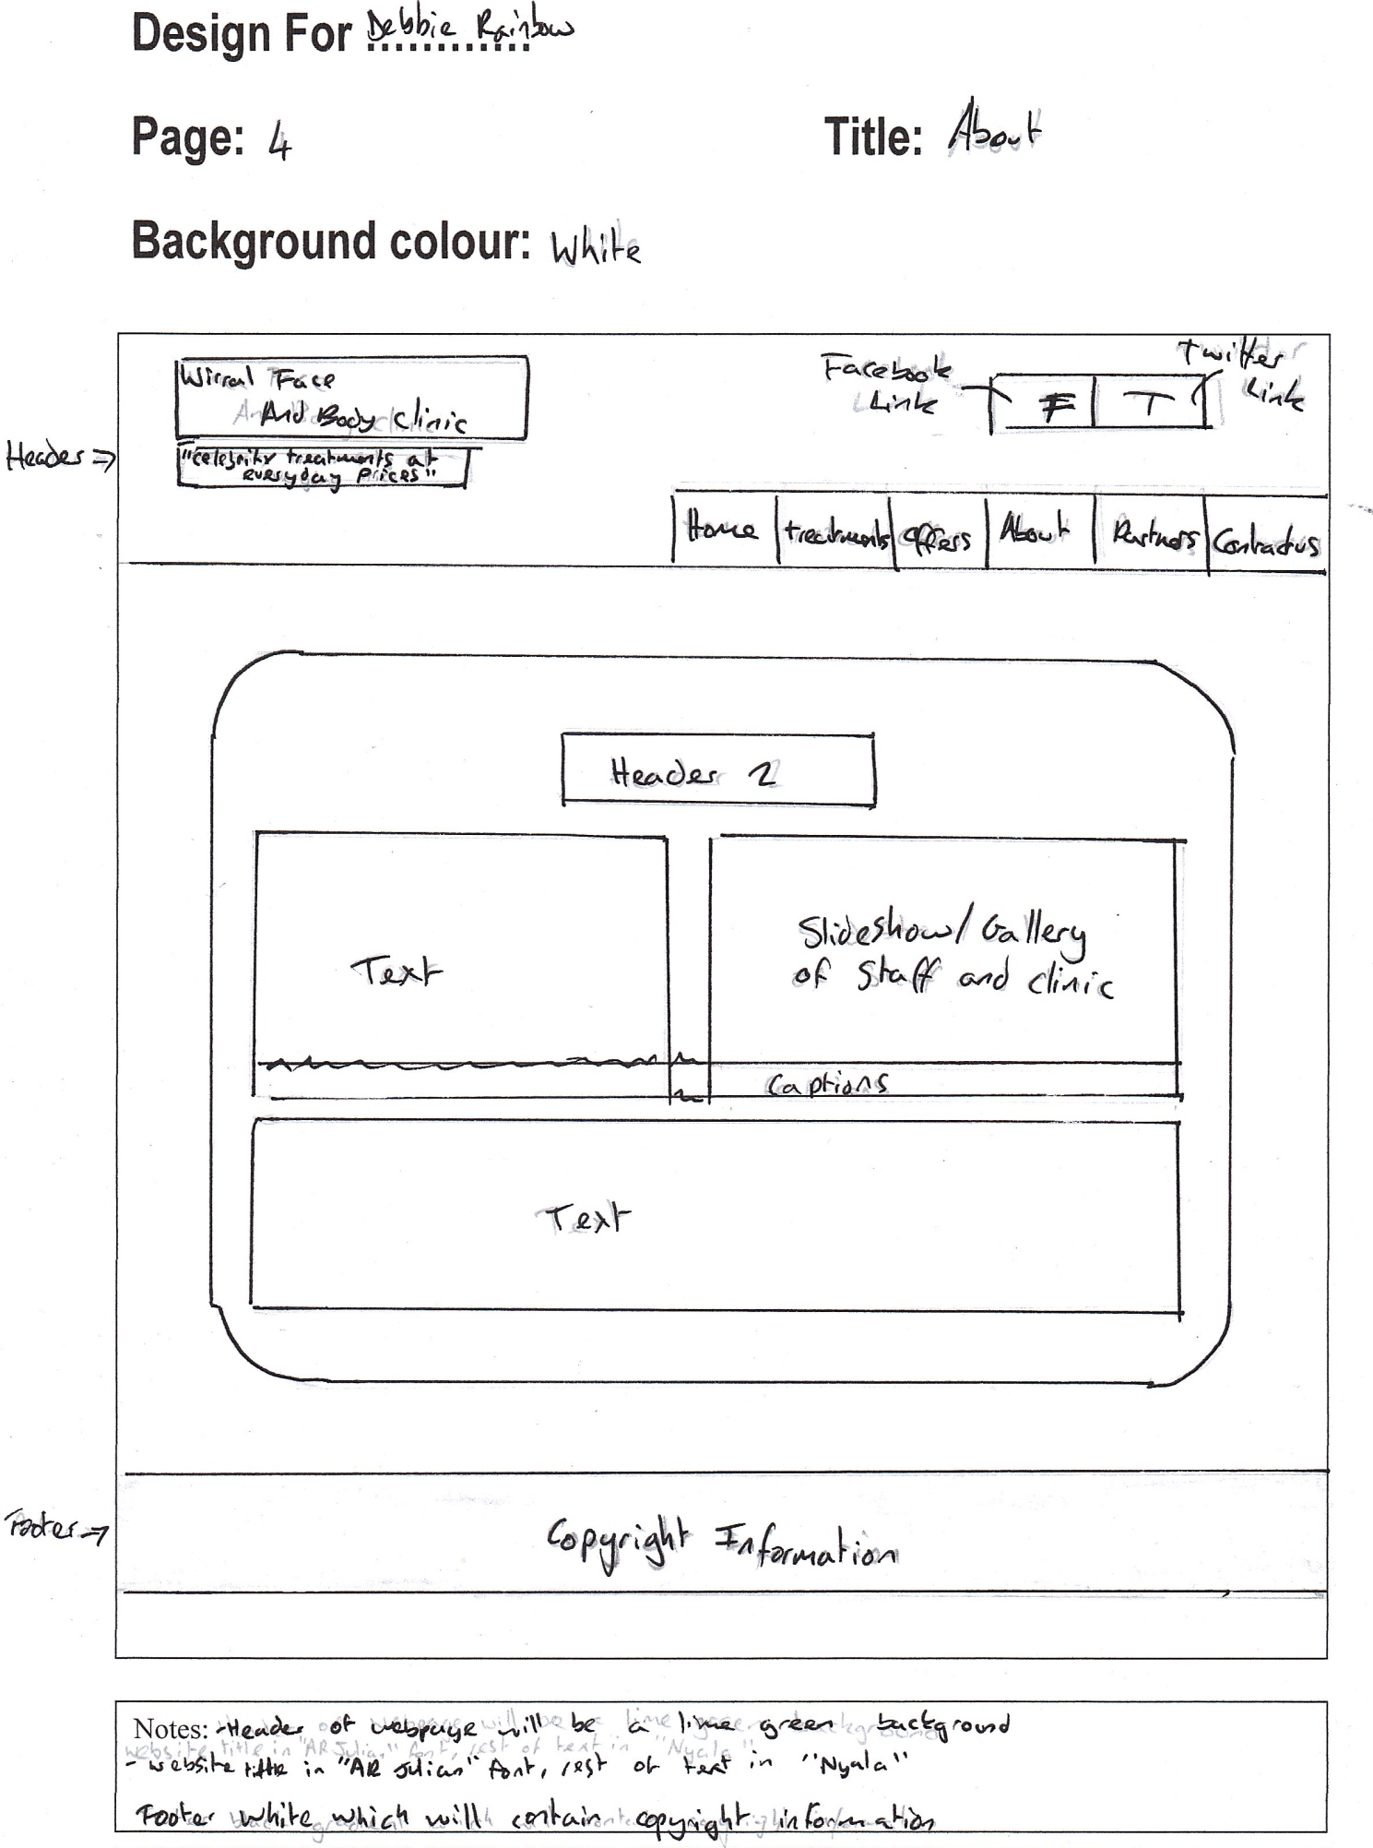

Twitter[Facebook](http://www.cisco.com/web/learning/netacad/Unica/IconFacebookRedirect.html)

"Celebrity Treatments at Everyday Prices"

About

Offers

Treatments

Home

Contact Us

Partners

About Us

Text

Slide Show / Gallery of staff and clinic

Caption

Text / Links to charity

Copyright Information

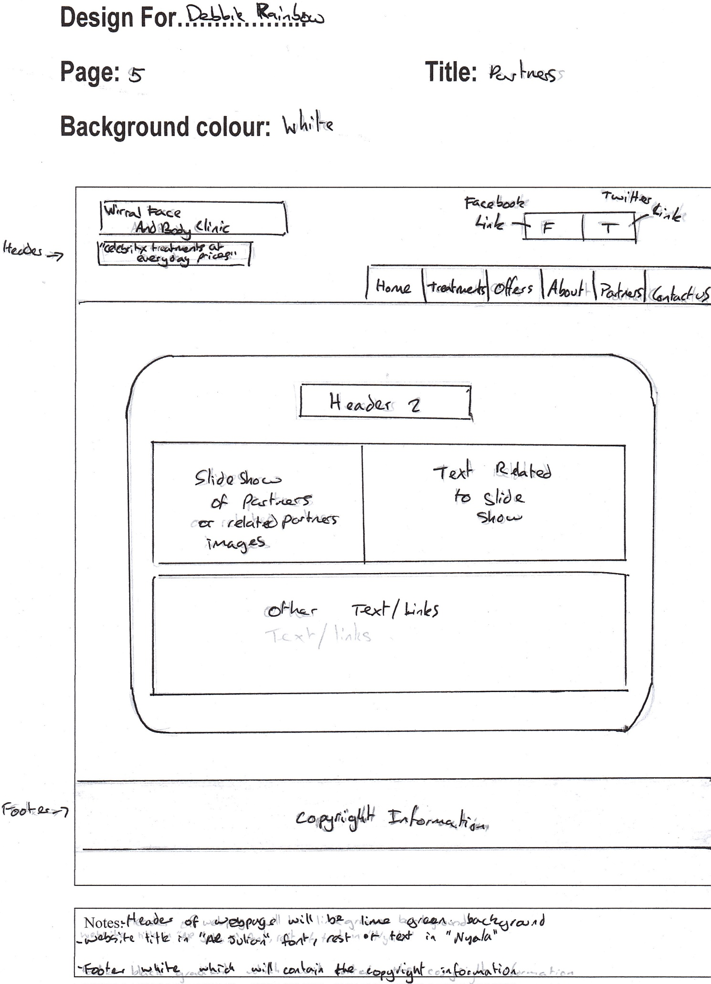

Twitter[Facebook](http://www.cisco.com/web/learning/netacad/Unica/IconFacebookRedirect.html)

"Celebrity Treatments at Everyday Prices"

Contact Us

Partners

About

Offers

Treatments

Home

Partners

Text related to

Slide show

Text / Links

Slide Show / Gallery of partners or partner related images

Copyright Information

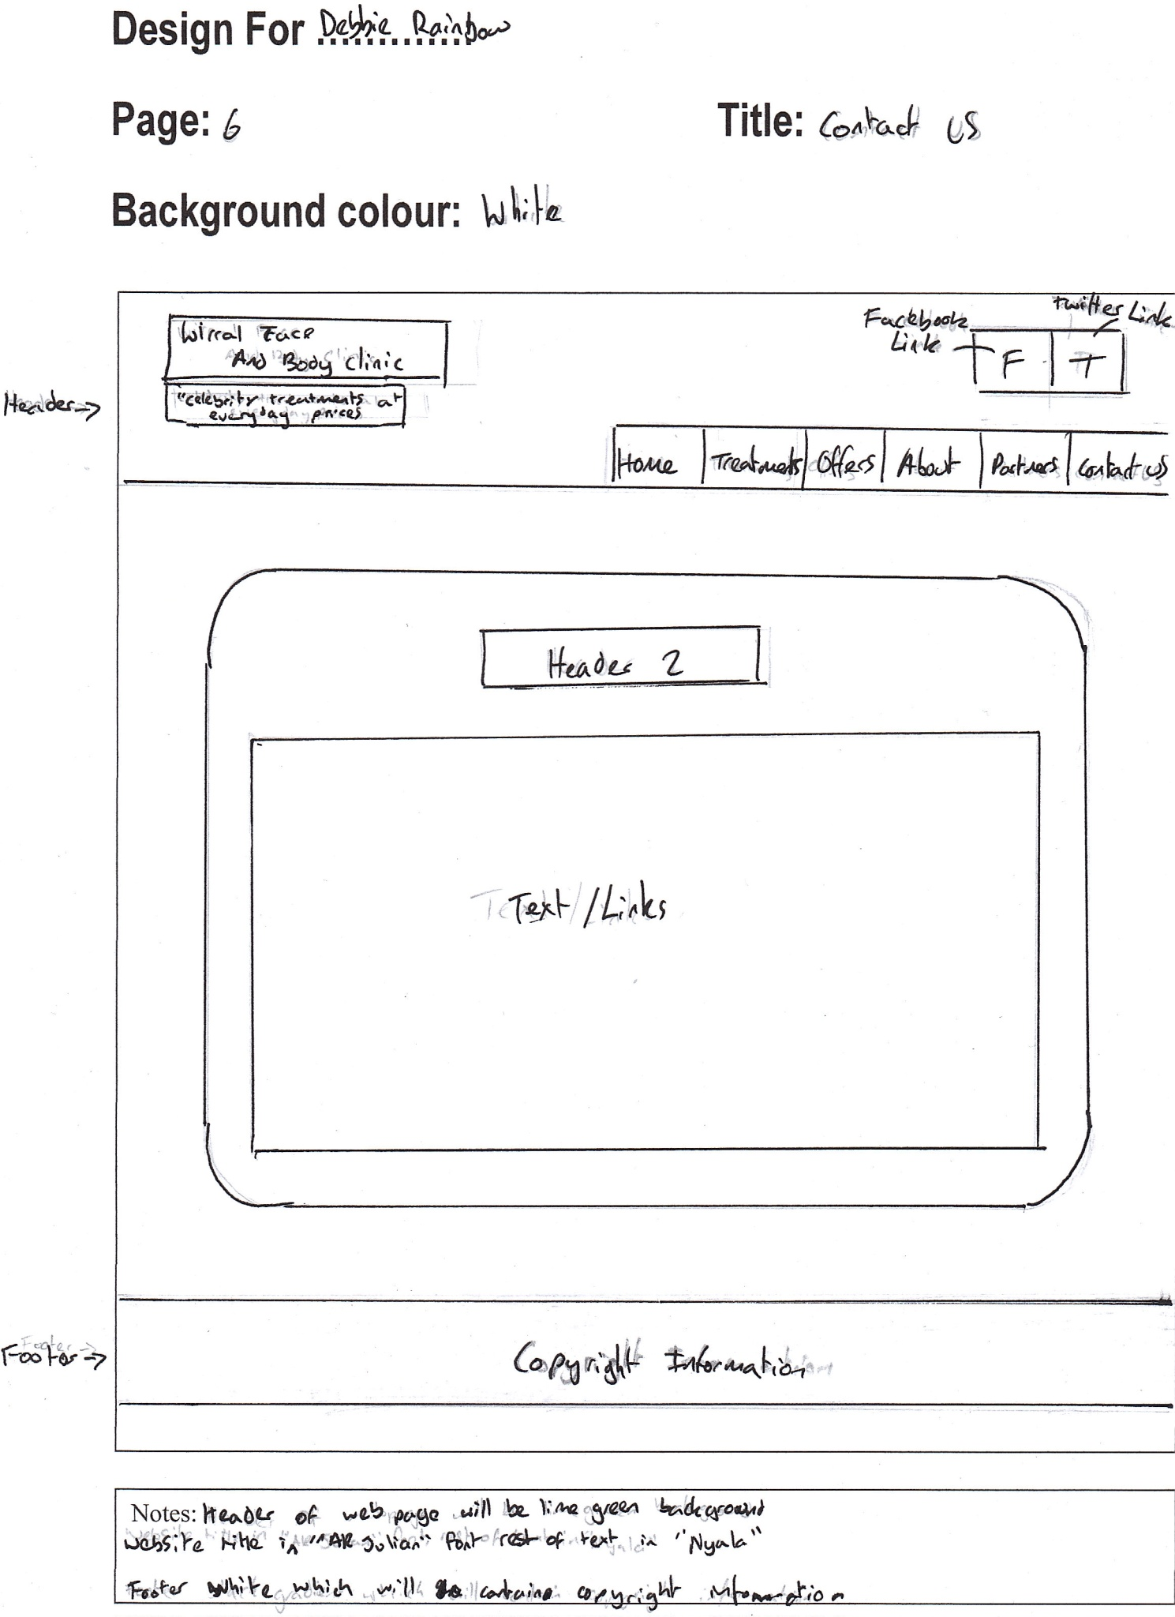

[Facebook](http://www.cisco.com/web/learning/netacad/Unica/IconFacebookRedirect.html)Twitter

"Celebrity Treatments at Everyday Prices"

Contact Us

Partners

About

Offers

Treatments

Home

Contact Us

Text / Links

Copyright Information